ANALYZING THE USE OF GENRE AND MULTIMODALITY IN ENGLISH LANGUAGE TEACHING
A PAPER
Submitted to the English Education Program of IPI Garut as partial fulfilment of the requirements for a Bachelor’s Degree

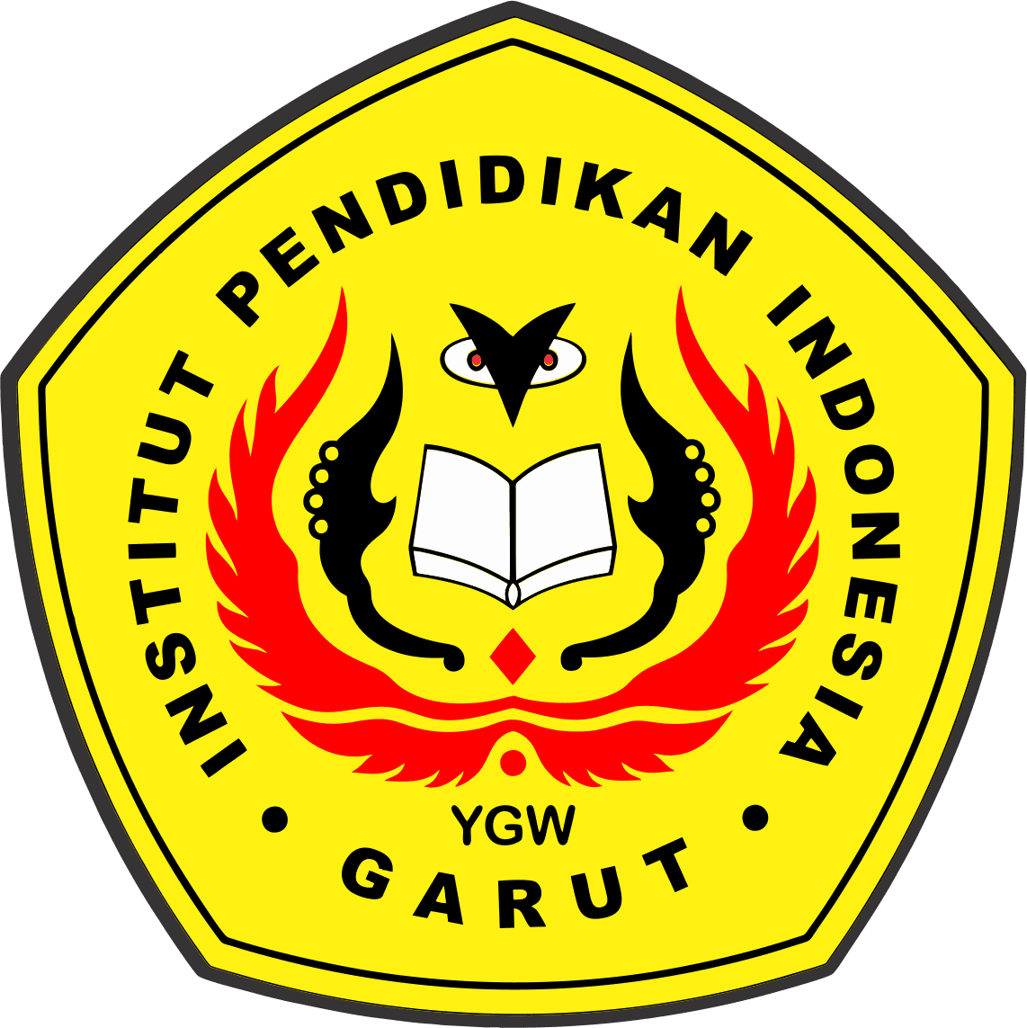

Written by:
Tazkia Hatsna Nadiva
21226031

ENGLISH EDUCATIONAL PROGRAM
FACULTY OF SOCIAL SCIENCE, LANGUAGE AND LITERATURE EDUCATION
INSTITUT PENDIDIKAN INDONESIA GARUT
2025

APPROVAL SHEET

ANALYZING THE USE OF GENRE AND MULTIMODALITY
IN ENGLISH LANGUAGE TEACHING

Written by:
TAZKIA HATSNA NADIVA
NIM. 21226O31

Approved by:
First Supervisor Second Supervisor

Irsyad Nugraha, M.Pd Dr.Eva Devi Sofyawati, M.Pd
NIDN 0408038304 NIDN 0010075102

Acknowledged by:
Head of English Education Program

Anne Ratna Suminar, M.Pd.
NIDN 0415038601

LEGITIMATION OF EXAMINATION BOARD

ANALYZING THE USE OF GENRE AND MULTIMODALITY
IN ENGLISH LANGUAGE TEACHING

Written by:
TAZKIA HATSNA NADIVA
NIM. 21226031

This paper has been examined on

First Examiner Second Examiner Third Examiner

Acknowledged by:
Dean of Faculty of Social Science, Language, and Literature Education,

Dr. Lina Siti Nurwahidah, M.Pd.
NIP 196805271993032001

DECLARATION

The researcher stated that the thesis entitled “Analyzing the Use of Genre and Multimodality in English Language Teaching” was produced entirely by the researcher and acknowledged as the intellectual property of the researcher. References, citations, and quotations of linked and related have been done to comply with legal and scientific procedures. Therefore, this publication's contents are the research's original work. If there is a complaint or the researcher violates this statement, the researcher would be responsible for all the consequences.

Garut, August 2025

Tazkia Hatsna Nadiva
NIM. 21226031

PERNYATAAN

Peneliti menyatakan bahwa skripsi yang berjudul “Analisis Penggunaan Genre dan Multimodal Dalam Pengajaran Bahasa Inggris” diproduksi sepenuhnya oleh peneliti dan diakui sebagai kekayaan intelektual peneliti. Referensi, kutipan, dan kutipan terkait dan terkait telah dilakukan untuk memenuhi prosedur hukum dan ilmiah. Oleh karena itu, isi publikasi ini merupakan karya asli dari penelitian tersebut. Jika ada keluhan atau peneliti melanggar pernyataan ini, peneliti akan bertanggung jawab atas segala akibatnya.

Garut, August 2025

Tazkia Hatsna Nadiva
NIM. 21226031

PREFACE

In the Name of Allah, the Most Beneficent, the Most Merciful. All the praises and thanks are due to Allah, who has given the writer His guidance, mercy, blessing, and health to finish this paper. Shalawat and salam are for a noble character, the prophet Muhammad Saw, who led people from the darkness to lightness.
This paper is intended to fulfill one of the requirements for the Sarjana Pendidikan degree at Indonesia Institute of Education. The title of this paper is “Analyzing the Use of Genre and Multimodality in English Language Teaching” The writer realizes that this paper still needs improvement. For that reason, the writer hopes for correction and suggestions in terms of content and linguistic aspects.

Garut, August 2025

Tazkia Hatsna Nadiva
NIM. 21226031

ACKNOWLEDGEMENTS

Praise Allah SWT., the almighty, for this merciful and beneficent blessing to me with mercy and guidance to finish this thesis. The peace is upon our prophet Muhammad SAW., with his family and followers. This paper entitled “Analyzing the Use of Genre and Multimodality in English Language Teaching.” was submitted as compulsory fulfillment of the requirements for the Bachelor of Education Degree of the English Education Program at Social Science, Language, and Literature Education faculty of Indonesia Institute of Education Garut.
Therefore, special gratitude and appreciation are extended to Mr. Irsyad Nugraha, M.Pd. the first supervisor, and Dr Eva Devi Sofyawati, M.Pd. The second supervisor. Throughout the completion of this thesis, they have offered guidance and counsel. Furthermore, gratitude and appreciation are also expressed to:
- Dr. H. Nizar Alam Hamdani, M.T., M.M., M.Si, the rector of Indonesia Education Institution.
- Dr. Lina Siti Nurwahidah, M.Pd, the Dean of Social Science, Language, and Literature Education faculty.
- Anne Ratna Suminar, M.Pd, the Head of the English Education Program of IPI Garut, for allowing the writer to conduct the research at the English Education Program.
- To my beloved abeh Jajang M Abduh and mamah Ai Yulianti, S.Pd.I, my first love and my eternal paradise, thank you for the endless prayers, unwavering support, affection, and sense of security you have always given me, which enabled me to complete my studies successfully and earn my bachelor’s degree.
- My dearest siblings, Rizalil Fikri Achmadin and Ummu Hani Maryam, thank you for your guidance, prayers, and wholehearted support throughout my journey.
- My best in-laws, Mela Nurmalasari and Rizki Purnomi Aji, who have never ceased to provide encouragement and prayers for me.
- My beloved younger brother, Muhammad Husni Mubarok, who has always supported me during my studies. Uni, may you always find happiness and achieve all that you aspire to.
- Dearest nieces and nephew, Ichika Abrar Shafiq, Ghaida Nur Khalisah, thank you for your sincere love which gave me more spirit and motivation to complete my studies up to this thesis.
- Best friend, Devie Fitriani, who has always been an extraordinary companion, providing continuous support, prayers, and affection.
- To my dear friends, Gina Aulia and Triyana Tania Agustina, who have accompanied me throughout my college years, being the best companions and constantly giving me support and encouragement.
- To all my classmates in Class C, who have been with me for almost four years, sharing experiences, stories, joy, kindness, and motivation, until at last we were able to complete our studies together and earn our bachelor’s degree.
- Mrs. Emma Rosmawati, S.Pd., teacher at SMPN 1 Kersamanah, who kindly assisted me in conducting school observations, which greatly contributed to the success of my research.
- All parties who have helped me in completing this thesis.

ABSTRACT
This qualitative study investigates the integration of genre and multimodality in English Language Teaching (ELT) at a junior high school in West Java, Indonesia. Participants included one English teacher and two eighth-grade classes, with data collected through classroom observations, interviews, and document analysis. Using a case study design, the research examined how instructional strategies combined genre-based pedagogy and multimodal resources. Findings show that teachers employed model texts, scaffolding, audio dialogues, visual aids, and collaborative tasks to support students’ learning and gradually move them toward independent production. Challenges included limited class time, students’ varied proficiency levels, and digital infrastructure constraints, which affected the consistency of implementation.
Keywords: genre, multimodality, English Language Teaching

ABSTRAK
Penelitian kualitatif ini meneliti integrasi genre dan multimodalitas dalam pembelajaran Bahasa Inggris di salah satu SMP di Jawa Barat, Indonesia. Partisipan penelitian terdiri dari seorang guru Bahasa Inggris dan dua kelas VIII, dengan pengumpulan data melalui observasi kelas, wawancara, dan analisis dokumen. Dengan desain studi kasus, penelitian ini mengkaji strategi pengajaran yang memadukan pendekatan berbasis genre dan sumber daya multimodal. Hasil penelitian menunjukkan bahwa guru menggunakan teks model, scaffolding, dialog audio, media visual, serta tugas kolaboratif untuk mendukung pembelajaran siswa dan secara bertahap mengarahkan mereka menuju produksi mandiri. Namun, beberapa tantangan muncul, seperti keterbatasan waktu, perbedaan tingkat kemampuan siswa, serta kendala infrastruktur digital yang memengaruhi konsistensi penerapan pembelajaran berbasis genre dan multimodal.
Kata kunci: genre, multimodalitas, pengajaran bahasa Inggri

TABLE OF CONTENTS
APPROVAL SHEET i
LEGITIMATION OF EXAMINATION BOARD ii
DECLARATION i
PERNYATAAN ii
PREFACE iii
ACKNOWLEDGEMENTS iv
ABSTRACT vi
ABSTRAK vii
LIST OF PICTURES 13
LIST OF TABLE 15
LIST OF APPENDICIES 16
CHAPTER I 1
INTRODUCTION 1
1.1 Background of the Study 1
1.2. Reasons for Choosing the Topic 2
1.3. Research Question 4
1.4. Objective of the Study 4
1.5. Significance of the Study 4
1.5.1. Theoretical Significance 4
1.5.2. Practical Significance for Educators 5
1.5.3. Policy and Curriculum Implications 5
1.5.4. Students Benefits 5
1.5.5. Teachers Benefit 6
1.5.6. Research Advancement 6
1.6. Scope and Limitation of the Study 7
1.7. Definiton of Key Terms 8
1.8. Organization of the Paper 9
CHAPTER II 11
LITERATURE REVIEW 11
2.1 Theoretical Framework 11
2.2 Genre in English Language Teaching 12
2.2.1. Definition of Genre in ELT 12
2.2.2. Genre-Based Approach in Language Education 14
2.2.3. Teaching Stages 15
2.2.4. Benefits and Challenges of Using Genre in Classroom 20
2.3 Multimodality in Language Learning 21
2.3.1. Definition and Key Concepst of Multimodality 21
2.3.2. Types of Modes 21
2.3.3. The Role of Multimodal Texts in English Teaching 23
2.3.4. Examples of Multimodal Materials in ELT 24
2.4 The Integration of Genre and Multimodality in ELT 25
2.5 Teachers’ and Students’ Roles in Multimodal genre-Based Classroom 28
2.5.1. Roles in Multimodal Teaching 28
2.5.2. Teachers’ and Students’ Roles in Multimodal Genre-Based Classrooms 29
2.6 Previous Studies 30
CHAPTER III 34
METHODOLOGY 34
3.1 Research Method 34
3.2 Research Design 34
3.3 Research Subjects and Location 34
3.4 Research Instruments 35
3.4.1. Observation 35
3.4.2. Interview 36
3.4.3. Documentation Checklist 37
3.5 Data Collection Techniques 37
3.5.1. Classroom Observation 37
3.5.2. Semi-Structured Interviews 38
3.5.3. Document Analysis 38
3.5.4. Data Collection Timeline 38
3.6 Data Analysis Technique 39
CHAPTER IV 40
FINDINGS AND DISCUSSION 40
4.1 Overview of the Data Collection Process 40
4.2 Description of the Teaching Context 41
4.2.1. Media and Teaching Approach 42
4.2.2. Local Learning Environment 43
4.3 Implementation of the Genre-Based Approach 46
4.3.1. Building Knowlage of the Field 47
4.3.2. Modelling of the Text 48
4.3.3. Joint Construction of the Text 49
4.3.4. Independent Construction of the Text 50
4.4 Use of Multimodality in the Classroom 51
4.5 The Implementation of instructional Strateges on Genre and Multimodal Resources 53
CHAPTER V 55
CONCLUTION AND SUGGESTION 55
5.1 Conclution 55
5.2 Suggestions 56
5.2.1. For Teachers 56
5.2.2. For Schools 56
5.2.3. For Future Researchers 56
5.2.4. For Policy Makers 56
References 57
APPENDICES 61
APPENDIX A.1 61
APPENDIX A.2 62
APPENDIX A.3 67
APPENDIX A.4 70
APPENDIX A.5 75
APPENDIX A.6 82
Figure. Observation 88

LIST OF PICTURES
Figure 2.1. Conceptual Framework Diagram
Figure 2.2 Teaching-learning cycle (Adapted from Derewianka, 1990; Hyland 2004; Rothery, 1996)
Figure 4.1 Bluetooth Speakers
Figure 4.2 Student Worksheets
Figure 4.3 Verb Card Games
Figure 4.4 Posters
Findings 4.5 Smart Board
Findings 4.6 Lessons Plans
Finding 4.7 Conversation at Sungai Lestari
Findings 4.8 Talk About Past Insident
Findings 4.9 seven group in the class
Findings 4.10 New Vocabulary
Findings 4.11 Students Highlighting the use of Past Tense
Findings 4.12 New Vocabulary
Findings 4.13. Conversation at Sungai Lestari
Findings 4.14 Learning Together
Findings 4.15Table Format Assigment

LIST OF TABLE
Table 2.4 Particularly Suited for Indonesian Secondary EFL Contexts

LIST OF APPENDICIES
APPENDIX A.1 The Following Questions of Interview
APPENDIX A.2 Classroom Observation Sheet (Pertemuan Ke-1)
APPENDIX A.3 Classroom Observation Sheet (Pertemuan Ke-2)
APPENDIX A.4 TRANSCRIPT OF INTERVIEW
APPENDIX A.5 LESSON PLAN (Pertemuan Ke-1)
APPENDIX A.6 LESSON PLAN (Pertemuan Ke-2)

