THE IMPLEMENTATION OF HIGHER ORDER THINKING SKILLS (HOTS) IN EFL TEACHING SENIOR HIGH SCHOOL

A PAPER
Submitted to the English Education Program of IPI Garut in Partial Fulfillment of the Requirements for the Bachelor of Education Degree

By :
Rita Juwita
20226016

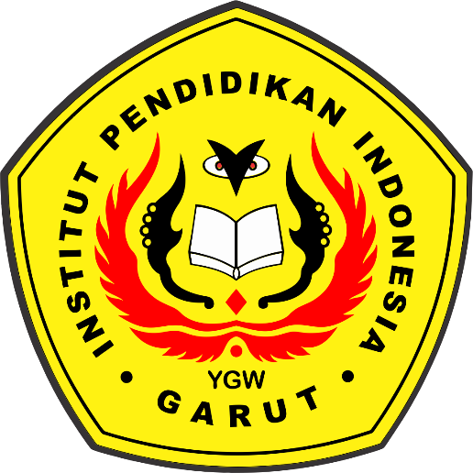

ENGLISH EDUCATION PROGRAM
FACULTY OF SOCIAL SCIENCES, LANGUAGE AND LITERATURE EDUCATION
INSTITUT PENDIDIKAN INDONESIA
2025

