EXPLORING STUDENTS’ UNDERSTANDING ON THE ETHICAL RISKS OF USING CHATGPT IN RESEARCH ARTICLE WRITING

A PAPER
Submitted to the English Education Program of IPI Garut as partial fulfilment of the requirements for the Bachelor of Education Degree

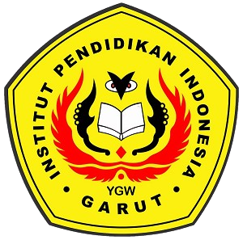

Written by:
Risma Nurmalasari
21222017

ENGLISH EDUCATION PROGRAM
FACULTY OF SOCIAL SCIENCE, LANGUAGE, AND LITERATURE EDUCATION
INSTITUT PENDIDIKAN INDONESIA GARUT
2025

