EXPLORING ATTENTION AND BEHAVIORAL ISSUES OF YOUNG LEARNERS THROUGH REFLECTIVE TEACHING
A PAPER
Submitted to the English Education Program of Institut Pendidikan Indonesia (IPI) Garut as the Partial Fulfilment of the Requirement for the Bachelor of Education Degree.

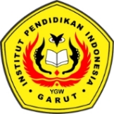

Written By:
Ose Anita Rahman
21226016

ENGLISH EDUCATION PROGRAM
FACULTY OF SOCIAL SCIENCE LANGUAGE AND
LITERATURE EDUCATION
INSTITUT PENDIDIKAN INDONESIA GARUT
2025

