SELF-REGULATED LEARNING BEHAVIORS STRATEGY IN ENHANCING STUDENTS’ ORAL PRESENTATION SKILLS IN ENGLISH CLASS

A THESIS
Submitted to the English Education Program of IPI Garut as partial fulfillment of the requirements for the Bachelor of Education Degree

Written by:
YOLANDA NURULITA ADRIYANTI
23223044



ENGLISH EDUCATION DEPARTMENT
FACULTY OF SOCIAL SCIENCES, EDUCATION, LANGUAGES, AND LITERATURE
INSTITUT PENDIDIKAN INDONESIA (IPI) GARUT
2024

APPROVAL SHEET
SELF-REGULATED LEARNING BEHAVIORS STRATEGY IN ENHANCING STUDENTS’ ORAL PRESENTATION SKILLS IN ENGLISH CLASS
Written by:
YOLANDA NURULITA ADRIYANTI
NIM 23223044

This thesis has been approved to be examined in the thesis seminar on July, 2024

First Supervisor, | Second Supervisor,
IRSYAD NUGRAHA, M.Pd | MOHAMMAD SONI,S.Pd., M.Pd
NIDN. 0408038304 | NIDN. 0425069104

Acknowledged by
Head of English Education Program
ANNE RATNA S, M.Pd
NIDN. 0415038601

LEGITIMATION OF EXAMINATION BOARD
SELF-REGULATED LEARNING BEHAVIORS STRATEGY IN ENHANCING STUDENTS’ ORAL PRESENTATION SKILLS IN ENGLISH CLASS
Written by:
YOLANDA NURULITA ADRIYANTI
NIM 23223044

This thesis has been examined in thesis seminar on 27 July, 2024

First Examiner, | Second Examiner, | Third Examiner,
Dr. Lucky Nurjamin, M.Pd | Wahid Hasyim, M.Pd | Pipih Setiawati, M.Pd
NIDN. 0410098901 | NIDN. 0428078043 | NIDN. 0410059701

Acknowledged by,
Dean of Faculty of Social Sciences, Education, Languages, And Literature
Dr. Lina Siti Nurwahidah, M.Pd
NIP. 196805271993032001

MOTTO

“YAKINKAN DENGAN IMAN, USAHAKAN DENGAN ILMU,
SAMPAIKAN DENGAN AMAL PERBUATAN.
BERIMAN, BERILMU, BERAMAL.
YAKIN USAHA SAMPAI!”

This thesis is dedicated to my beloved mother, (almh) Dalis Nurlaelasari

DECLARATION
The researcher hereby grants that this thesis, entitled ”Self-Regulated Learning Behaviors In Enhancing Oral Presentation Skills In English Class”, is really written by the researcher and acknowledges as her own intellectual property. In accordance with the use of references, the quotations, and the citation of the related literature. The researcher had been conducted this research based on the rightfully legal and scientific procedures. Therefore the contents of this thesis are an original work of the researcher. In this case, if there are many complaints, she will be fully responsible for all the consequences given.

Garut, 27 July 2024
The Researcher,

Yolanda Nurulita Adriyanti
NIM. 23223044

ABSCTARCT
This study aims to identify spesific SRL behaviour that enhance oral presentation skill. To fulfill this aim, qualitative method with a case study design was chosen, followed by 20 students in Class XI (11th grade), second semester at one of the senior high school in Garut. Furthermore, the data were collected by classroom observation, and semi-structured interviews. Those data were analyzed through some stages including data collections and conlusions. As the result, eleven students valued the Forethought Phase for goal setting and organization. Three preferred the Performance Phase for real-time adjustments. Another three valued the Self-Reflection Phase for continuous improvement. Three recognized the benefits of integrating all SRL phases.
Keywords: Self-Regulated Learning, Oral Presentation Skills

PREFACE
In the name of Allah SWT, most gracious most merciful. The praise to be Allah the lord of the world, who has gives mercy and blessing to the writer in finishing this thesis entitled ”Self-Regulated Learning Behaviors In Enhancing Oral Presentation Skills In English Class”, Blessing and salutation be upon to the prophet Muhammad SAW, his family his companion and his adherent.
This thesis is submitted to the English Education Program of IPI Garut as a partial fulfillment of the requirements for the Bachelor od Education Degree.
The researcher realizes that this thesis is far from being perfect. Therefore, the researcher will greatly appreciate to all comments and criticism.
Finally, the researcher hopes this thesis would be useful to all readers.

Garut, 27 July 2024
The Researcher,

Yolanda Nurulita Adriyanti
NIM. 23223044

ACKNOWLEDGEMENT
Alhamdulillahirobilalamin, first of all the researcher would like to express her deepest praise and gratitude to Allah SWT who has given His blessing and merciful to complete this thesis. Shalawat and salaam addressed to the final chosen religious messenger, the Prophet Muhammad SAW. The researcher realized that many people had given their helps and useful suggestion for the finishing of this thesis. Without the assistance of them, this thesis would never have existed. Appreciation and sincere thanks to my beloved parents, Mother Mrs. Dalis Nuralaelasari (almh), Father Mr. Ade Rudyanto, my lovely siblings Yudhistira Adryanto, and Rahajeng Selvina Adriyanti, my beloved partner Muhamad Hasanudin, who always given me uncountable love, care advices and supports. Thank you so much for your praying all days and all nights also for both material and spiritual to accomplish this thesis. No word can describe how much I love this family. I do love you all. The researcher would like to show her gratitude to all beloved people that have encouraged. Motivated even helped the researcher in finishing the thesis, they are:
- Prof. Dr. H. Nizar Alam Hamdani, M.M., M.T., M.I.Kom the Rector of Institut Pendidikan Indonesia, Dr. Abdul Hasyim, M.Pd as the Vice Rector I, Dr. Tetep, M.Pd as the Vice Rector II, Dr. H. Endang Dimyati, M.Pd as the Vice Rector III and all staff. Thanks for the kindness and the encouragement.
- Dr. Lina Siti Nurwahidah, M.Pd the Dean of Faculty of Social Sciences, Education, Languages, And Literature of Institut Pendidikan Indonesia, Dr. Lucky Rahayu Nurjamin, M.Pd as the Vice Dean I, Asep Suparman, M.Pd as the Vice Dean II, and all the staff. Thanks for the kindness and the encouragement.
- Anne Ratna S, M.Pd the Head of Department of English Education and all the staffs, who has given me correction, suggestion, support, advice, and guidance in completing the thesis.
- Irsyad Nugraha, M.Pd as the Supervisor I, Mohammad Soni, S.Pd., M.Pd as the Supervisor II, my beloved supervisors who has given me correction, suggestions, support, advice, and guidance in accomplishing this thesis.
- Dr. Lucky Nurjamin, M.Pd as the examiner I, Wahid Hasyim, M.Pd as the examiner II, and Pipih Setiawati, M.Pd as the examiner III who has given me correction, suggestions, support, advice, and guidance in accomplishing this thesis.
- All lecturers and staffs of English Education Department of Faculty of Social Sciences, Education, Languages, And Literature of Institut Pendidikan Indonesia, who has given knowledge,and supports during the sources from the first semester until now.
- The Headmaster of One of the senior high school in Garut, and all staffs who have helped me in accomplishing research.
- The students of One of the senior high school in Garut who has participated in collecting the data process.
- The researcher’s beloved family, Trias Amalia Sugiarti, S.Pd and Indah Yuliani, S.Pd, who has given me the trust, love, care, motivation, and all of the support during my journey.
- The researcher’s beloved family Yaumi Rachmadina Marzani, S.E., and all of Garut and Tasik family who has given me all of the love, and support.
- The researcher’s beloved best friends, Annisa Rahmawati S.Pd, Garti Intan Pratiwi, S.Pd, Non Rianti Permatasari A, S.Pd, Titha Dewi Hermawan, Risma Illa Alaih, S.Pd, Bela Tina Mulyati, Ramdani, S.Pd who has given me the support and motivation during my collage life.
- The researcher’s beloved partner in RPL Class, Sani Oktoviani, S.Pd, Rita Nuraeni, S.Pd, Aliet Fitriani, Ina Nurlina, M.Akbar Hanifa for all the support, and happiness during RPL class.
- All of my partners in HMI & KOHATI Cabang Garut 2021-2022, HMI Komisariat IPI, BEM IPI Kabinet Revolusi 2019-2020, Himadiksaris, PAMMUS, Class D 2016, thanks for the meaningful experience.
- All of my live streaming friends, Kak Nuna, Kak Alicha, Tuan Takur, Mas Maaf Nevermind, Ridwan Halim,Bang Ibee, Bang Sparta, Dimas Nico Alfarez, Bang Choir, Bang Rizal Putra Ambon, Mas Reyy, Lubis, Paman, Fatih, Dims, Ayah Mahdi, Ka Asella, Kak Fenilla, Mas Tofik, who has given me enjoy during this hard work.
- Last but not least, I want to thank my self for believing in my self, for doing all this hard work, for having no days off. I want to thank my self for never quitting, for just being me at all times.
Ultimately, the comments, constructive critiques and suggestions for the completeness of this thesis will be kindly appreciated. Hopefully this thesis can give the meaningful contributions to further researcher.

Garut, 27 July 2024
The Researcher,

Yolanda Nurulita Adriyanti
NIM. 23223044

TABLE OF CONTENT

APPROVAL SHEET i
LEGITIMATION OF EXAMINATION BOARD ii
MOTTO iii
DECLARATION iv
ABSCTARCT v
PREFACE vi
ACKNOWLEDGEMENT vii
TABLE OF CONTENT x
CHAPTER I 1
INTRODUCTION 1
1.1 The Background of The Study 1
1.2 Reason for Choosing the Topic 3
1.2.1 Pedagogical Importance 4
1.2.2 Addressing Specific Challenges in English Learning 5
1.2.3 Practical Relevance 5
1.3 The Research Question 6
1.4 The Objective of the Study 6
1.5 The Significant Of the Study 6
1.6 The Definition of Terminologies 7
1.6.1 Self-Regulated Learning 7
1.6.2 Oral Presentation Skills 7
1.6.3 Behavioral Strategies 7
CHAPTER II 9
A REVIEW OF RELATED LITERATURE 9
2.1 Theoretical Foundations of Self-Regulated Learning (SRL) 9
2.1.2 Self-Regulated Strategies and the Process of Speaking 12
2.2 Oral Presentasion Skill 14
2.2.1 Key Components of Oral Presentation Skills 14
2.2.2 Challenges in Developing Presentation Skills 15
2.3 SRL in Language Learning and Oral Presentation Skill 17
2.4 Review of Related Findings 18
CHAPTER III 20
RESEARCH METHODOLOGY 20
3.1 Research Method 20
3.2 Research Design 20
3.4 Technique of Data Collection 21
3.4.1 Classroom Observations 21
3.4.2 Semi-Structured Interviews 22
3.5 Research Setting and Participants 23
3.6 Technique of Data Analysis 23
Interactive Analysis Model by Miles and Huberman (2014), the analysis process in this research model is conducted in three stages: 23
3.6.1 Data Collection 23
3.6.2 Conclusions 24
CHAPTER IV 25
FINDING AND DISCUSSSION 25
4.1 Finding of The Research 25
4.1.1 Researcher's Observations on Self-Regulated Learning Implementation 26
4.1.5 The Interview Result 32
4.2 Discussion 34
CHAPTER V 39
CONCLUSION AND SUGGESTION 39
5.1 Conclusion 39
5.2 Suggestion 41
REFERENCES 45
APPENDIX II 50
Interview Result 50
APPENDIX III 60
Documentation 60

CHAPTER I

INTRODUCTION
This chapter provide the general introduction of the study. It concludes the background of the study, the reason for choosing the topic, the research question, the objective of the study, the significances of the study, and the definition of terminology.

The Background of The Study
Self-regulated learning (SRL) is becoming one of the bases to develop students’ oral presentation skill. As stated by Nawastheen, et al (2020) that students who have higher self-regulation skill will have better achievement then students who have lower self-regulated learning skill. SRL refers to the process by which learners actively manage their own learning experiences through goal setting, self-monitoring, self-assessment, and strategic planning. According to Zimmerman (2002), SRL involves three key phases: forethought, performance, and self-reflection. In the forethought phase, individuals set goals and plan strategies. During the performance phase, they implement these strategies and monitor their progress. In the self-reflection phase, they evaluate their performance and make necessary adjustments for future tasks. SRL is considered a critical factor in academic achievement and lifelong learning. It empowers learners to take control of their educational journeys, such as leading to improved motivation, engagement, and academic performance of students’ oral presentation skill.
Oral presentation skills encompass the ability to organize content logically, use appropriate language, engage the audience, and deliver information clearly and confidently. These skills are essential for academic success, particularly in higher education, where students often present their research and ideas. Additionally, in professional settings, effective presentation skills are necessary for conveying proposals, leading meetings, and representing organizations. Many individuals face significant challenges when it comes to developing oral presentation skills. Common issues include public speaking anxiety, lack of preparation, difficulty in organizing content, and limited audience engagement (Horwitz, 2001). These challenges can hinder an individual's ability to communicate effectively and achieve their desired outcomes. SRL behaviors can play a vital role in overcoming the challenges associated with oral presentations. By setting specific, achievable goals, learners can focus their efforts on improving particular aspects of their presentation skills. Self-monitoring allows individuals to track their progress and make real-time adjustments during their presentations. Reflective practices enable learners to evaluate their performances, identify areas for improvement, and implement changes in future presentations.
Several studies have highlighted the positive impact of SRL on various academic skills, including oral presentations. For instance, Nota, Soresi, and Zimmerman (2004) found that students who employed SRL strategies showed significant improvements in their presentation skills and overall academic performance. Similarly, Usher and Pajares (2008) demonstrated that self-efficacy, a key component of SRL, is closely linked to effective communication and presentation abilities. Despite the recognized importance of SRL, there is a lack of focused research on its application to enhancing oral presentation skills. Most existing studies on SRL concentrate on general academic performance or specific subject areas, with limited attention given to the unique demands of oral presentations. This study seeks to fill this gap by providing a comprehensive analysis of how SRL behaviors can specifically improve oral presentation skills. In conclusion, the integration of self-regulated learning behaviors holds great promise for enhancing oral presentation skills. By actively managing their learning processes, individuals can overcome common presentation challenges and achieve higher levels of performance and confidence. This study aims to contribute valuable insights into the application of SRL in this context, ultimately supporting the development of more effective and autonomous communicators.
Therefore, the researcher is interested in conducting the research entitled “Self-Regulated Learning Behaviors Strategy In Enhancing Students’ Oral Presentation Skills In English Class”.

Reason for Choosing the Topic
Choosing the topic ‘Self-Regulated Learning (SRL) Behaviors in Enhancing Oral Presentation in English Class’ is driven by a combination of pedagogical importance, the potential for addressing specific challenges faced by students in learning English, and partical relevance. This comprehensive rationale outlines the key reasons for focusing on this topic, emphasizing its significance in contemporary educational contexts and its benefits for students' overall academic and personal development.

Pedagogical Importance
- Enhancing Language Acquisition
Oral presentation skills are crucial for mastering a new language. In English classes, practicing oral presentations allows students to apply their language knowledge in real-world contexts, thus improving their speaking, listening, and comprehension skills. This practical application reinforces language acquisition and fluency.
- Promoting Active Learning
Self-regulated learning encourages students to take an active role in their education. By implementing SRL strategies in English classes, students become more engaged and responsible for their learning process. This active participation leads to deeper understanding and retention of language concepts.
- Critical Thinking and Reflection:
Self-regulated learning involves critical thinking and reflective practices. These skills are invaluable beyond the classroom, fostering a mindset of continuous improvement and adaptability that is crucial in today's fast-paced world.

1.2.2 Addressing Specific Challenges in English Learning
- Overcoming Speaking Anxiety
Many students experience anxiety when speaking in a non-native language. SRL strategies, such as goal setting, self-monitoring, and reflection, can help students manage their anxiety by providing a structured approach to practice and improvement. This reduces fear and builds confidence in their speaking abilities.
- Developing Presentation Skills
Oral presentations in English classes are a common requirement, but many students struggle with organizing their thoughts and delivering them effectively. SRL behaviors help students plan, practice, and refine their presentations, leading to improved performance and greater confidence.
- Encouraging Autonomy
Learning a new language requires significant practice and dedication. SRL behaviors empower students to take control of their learning journey, making them more autonomous and motivated. This independence is particularly important in language learning, where consistent practice is essential.

Practical Relevance
- Academic Success
Proficiency in oral presentation skills is linked to academic success. Students who can effectively communicate their ideas are more likely to perform well in assessments and classroom activities. By focusing on SRL strategies, this research aims to enhance students' overall academic performance in English classes.
- Future Career Benefits
English is often regarded as a global lingua franca, essential in many professional fields. Developing strong oral presentation skills in English not only benefits students academically but also prepares them for future career opportunities where English communication is a key requirement.

The Research Question
In response to the background of study, the formulated research question is ‘What SRL behaviors do students use to improve their oral presentation skills?’

The Objective of the Study
The objective of the study is to identify spesific SRL behaviour that enhance students’ oral presentation skill.

The Significant Of the Study
This study has significant implications for educators, students, and professionals. By understanding how SRL behaviors can enhance oral presentation skills, educators can design more effective instructional strategies and support systems. Students can benefit from targeted interventions that help them develop confidence and competence in their presentation abilities. Professionals can apply these insights to improve their communication skills, leading to greater success in their careers.

The Definition of Terminologies

Self-Regulated Learning
Self-Regulated Learning (SRL) refers to the process by which learners actively manage their own learning experiences through setting goals, monitoring progress, and reflecting on outcomes. It involves a series of cognitive, motivational, and behavioral strategies that help individuals control their learning activities. According to Zimmerman (2002), SRL includes three key phases: forethought (planning and goal setting), performance (implementing strategies and self-monitoring), and self-reflection (evaluating performance and adjusting strategies).

Oral Presentation Skills
According to Lucas (2015), an oral presentation is a form of verbal communication in which a speaker addresses a live audience with a prepared speech on a specific topic, aiming to inform, persuade, or entertain.Oral presentations are vital in academic, professional, and personal contexts, as they facilitate the dissemination of information, promote critical thinking, and enhance interpersonal skills.

Behavioral Strategies
Zimmerman (2002), behavioral strategies involve the proactive regulation of one's behavior and environment to enhance learning and performance. These strategies include time management, organizing study spaces, seeking feedback, and maintaining consistent study or practice schedules. Implementing behavioral strategies helps learners create conducive conditions for learning, stay focused, and systematically work towards their goals.

CHAPTER II

A REVIEW OF RELATED LITERATURE
This chapter deals with related literature and studies after the through and in-depth search that has been done. This chapter present about theoritical foundations of SRL, self-regulated strategies and the process of speaking, oral presentation skill, SRL in language learning and oral presentation skill, and review of related findings.

2.1 Theoretical Foundations of Self-Regulated Learning (SRL)
Self-Regulated Learning (SRL) is a concept that involves learners actively participating in their own learning process through various self-directed strategies. Barry J. Zimmerman, a prominent educational psychologist, has significantly contributed to the development of SRL theory. His framework provides a comprehensive understanding of how students can take control of their own learning through self-regulation. Zimmerman’s (2000) theory of self-regulated learning is rooted in social cognitive theory and emphasizes the role of self-efficacy, self-motivation, and metacognitive strategies. His model consists of three cyclical phases: Forethought, Performance, and Self-Reflection.
1. Forethought Phase
This phase involves processes that precede learning efforts and set the stage for effective self-regulation. It consists of:
- Task Analysis
- Goal Setting: Establishing specific, measurable, attainable, relevant, and time-bound (SMART) goals for the learning task. For example, a student might set a goal to deliver a 10-minute presentation without relying on notes.
- Strategic Planning: Developing a plan of action to achieve the set goals. This could involve outlining the steps to prepare for the presentation, such as researching the topic, creating slides, and practicing delivery.
- Self-Motivation Beliefs
- Self-Efficacy: Belief in one’s capability to succeed in specific tasks. Higher self-efficacy leads to greater effort and persistence. For instance, a student confident in their presentation skills is more likely to engage in extensive practice.
- Outcome Expectations: Beliefs about the consequences of performing the task. Positive outcome expectations can motivate students to engage in SRL strategies.
- Task Value: Perception of the importance and relevance of the task. If a student values the skill of giving presentations, they are more likely to invest effort in preparing.
2. Performance Phase
This phase involves processes that occur during learning activities, focusing on the execution and monitoring of the task. It includes:

- Self-Control
- Task Strategies: Implementing specific methods to facilitate learning, such as summarizing key points, creating visual aids, or using mnemonic devices.
- Imagery: Visualizing successful performance to enhance motivation and reduce anxiety. A student might visualize themselves confidently delivering their presentation.
- Attention Focusing: Concentrating on the task at hand and avoiding distractions. Techniques such as mindfulness or time management can help maintain focus.
- Self-Instruction: Self-talk to guide performance and maintain motivation. For example, reminding oneself to speak slowly and clearly during the presentation.
- Self-Observation
- Self-Recording: Keeping track of one’s performance and behaviors. This could involve recording practice sessions and reviewing them to identify areas for improvement.
- Self-Experimentation: Trying different strategies to see what works best. A student might experiment with different presentation techniques to find the most effective one.
3. Self-Reflection Phase
This phase involves processes that occur after learning activities, focusing on evaluating performance and making adjustments for future tasks. It includes:
- Self-Judgment
- Self-Evaluation: Comparing performance against a standard or goal. This could involve assessing how well the presentation met the established criteria (e.g., clarity, engagement).
- Causal Attribution: Determining the causes of success or failure. Attributing success to effort and strategy use can enhance motivation and future performance.
- Self-Reaction
- Self-Satisfaction/Affect: Emotional responses to the evaluation. Positive self-reactions can reinforce the use of SRL strategies, while negative reactions can prompt adjustments.
- Adaptive Inferences: Making decisions about future learning strategies based on past performance. For instance, a student might decide to allocate more time to practice based on their reflection.

2.1.2 Self-Regulated Strategies and the Process of Speaking
This involves connecting previous knowledge to the topic and the conditions in which the speech is given. This step is closely related to the forethought phase of self-regulation, wherein learners use strategies including planning, elaboration, and repetition.
During the planning phase of speaking, the appropriate linguistic forms (words and phrases) are found and matched with the grammatically correct markers (affixes, articles, auxiliaries). During the articulation stage, the speaker uses articulatory organs to articulate each word. These two processes are linked to the performance phase of self-regulation, in which students practice self- monitoring and self-control skills. In the final stage, which is similar to the self- reflection phase of self-regulated learning, the speaker checks his or her own speech and rectifies mistakes.
It was found that self-regulated learning had a significant impact on students' speaking abilities. The study's findings show that students in the experimental group increased their speaking efficacy significantly. And it seems that self-regulated learning intervention is accountable for this improvement. As a result, it seems that the experimental group students' knowledge and use of self-regulated learning strategies helped them succeed in oral communication and develop their speaking skills. Students in the control group, on the other hand, did not show significant improvements in their speaking abilities.
The study's findings show that students in the experimental group increased their speaking efficacy significantly. And it seems that self-regulated learning intervention is accountable for this improvement. As a result, it seems that the experimental group students' knowledge and use of self-regulated learning strategies helped them succeed in oral communication and develop their speaking skills. Students in the control group, on the other hand, did not show significant improvements in their speaking abilities.
Motivational strategies are those which try to boost various sorts of motivation. Trying to formulate a learning objective, valuing the task, and developing a positive feeling are examples of such strategies. The goal orientation is strengthened by the creation of a learning objective: the reason why one performs a task, which is either performance or mastery. -orientation.18 The task value beliefs, or the degree to which the task is considered relevant, important, and worthwhile, are improved through valuing the task.

2.2 Oral Presentasion Skill
Oral presentation skills encompass the ability to effectively communicate information, ideas, and arguments to an audience through spoken language. This involves not only the content of the presentation but also the delivery methods, including voice modulation, body language, and the use of visual aids.
According to Lucas (2015), an oral presentation is a form of verbal communication in which a speaker addresses a live audience with a prepared speech on a specific topic, aiming to inform, persuade, or entertain. Effective oral presentation skills are essential in academic, professional, and personal contexts as they facilitate clear and impactful communication.

2.2.1 Key Components of Oral Presentation Skills
a. Content Preparation:
- Researching and gathering relevant information.
- Organizing the material logically with a clear introduction, body, and conclusion.
- Creating supporting materials such as slides, handouts, or multimedia elements.
b. Delivery Techniques:
- Using clear and articulate speech.
- Maintaining appropriate pace, tone, and volume.
- Employing non-verbal cues such as eye contact, gestures, and body language.
c. Audience Engagement:
- Understanding the audience’s needs and interests.
- Encouraging interaction through questions or discussions.
- Utilizing storytelling or examples to make the presentation more relatable and engaging

2.2.2 Challenges in Developing Presentation Skills
Developing presentation skills is a multifaceted process influenced by cognitive, emotional, and social factors. Various theories provide insights into the challenges learners face when trying to enhance their presentation abilities.
- Social Interaction Anxiety
Constructivist Theory, rooted in Vygotsky (1978) emphasizes the importance of social interaction in learning. However, many learners experience anxiety during social interactions, particularly when speaking in front of an audience. This anxiety can hinder the collaborative learning process and reduce opportunities for constructive feedback.
- Dependence on Scaffolding
Instructors provide support structures that are gradually removed as learners gain competence. A challenge arises when students become overly dependent on this scaffolding and struggle to transition to independent performance.
- Low Self-Efficacy
According to Bandura’s Social Cognitive Theory, self-efficacy, or the belief in one’s capabilities, is crucial for successful skill development. Many learners have low self-efficacy regarding their presentation skills, leading to avoidance behaviors and a lack of practice.
- Lack of Observational Learning Opportunities
Social Cognitive Theory highlights the importance of observational learning, where learners model behaviors observed in others. A challenge arises when students lack access to effective role models or are unable to observe successful presentations, limiting their ability to learn through observation.
- Miscommunication and Misinterpretation
Barnlund’s Transactional Model of Communication views communication as a dynamic and reciprocal process. A major challenge is the potential for miscommunication and misinterpretation between the presenter and the audience, which can disrupt the flow and effectiveness of the presentation.

- Managing Audience Feedback
Effective presentations require real-time adaptation based on audience feedback. Many presenters find it challenging to interpret and respond to audience cues, leading to a disconnection and reduced engagement.

2.3 SRL in Language Learning and Oral Presentation Skill
Another study by Raoofi, Tan, and Chan (2012) explored the impact of SRL on oral presentation skills among university students. The research involved a workshop where students were taught SRL strategies specific to oral presentations. The strategies included:
- Planning: Students were guided to plan their presentations thoroughly, including content organization, timing, and the use of visual aids.
- Practice and Feedback: Learners practiced their presentations multiple times and received constructive feedback from peers and instructors.
- Self-Evaluation: After each presentation, students evaluated their performance based on predefined criteria and set goals for future improvement.
The results indicated that students who systematically applied SRL strategies demonstrated enhanced confidence, coherence, and effectiveness in their presentations. The study concluded that SRL strategies not only improved students’ presentation skills but also reduced their anxiety and increased their overall engagement in the learning process.

2.4 Review of Related Findings
A study by Zimmerman and Kitsantas (2005) found that students who made adaptive inferences based on their previous presentation experiences adjusted their SRL strategies effectively. For instance, they might decide to allocate more time to rehearsals or seek additional resources for topic research, which led to continuous improvement in their presentation skills.
A lot of studies using Zimmerman’s theory have been done, in a study by Mills, Pajares, and Herron (2006), higher self-efficacy in language learners positively correlated with their willingness to participate in oral presentations. Students with greater self-efficacy employed more effective SRL strategies, such as seeking feedback and rehearsing their presentations multiple times, which enhanced their performance and reduced anxiety. A study by Nicol and Macfarlane-Dick (2006) demonstrated that students who actively sought and reflected on feedback from peers and teachers improved their oral presentation skills significantly. They used the feedback to refine their strategies, set new goals, and increase their self-efficacy for future presentations. In a study by Usher and Pajares (2008), students who set specific and challenging goals for their oral presentations demonstrated higher levels of engagement and performance. These students were more likely to develop detailed presentation outlines and allocate time for practice sessions, leading to better-prepared and more confident presentations. Beside that, Van De Pol, Volman, and Beishuizen (2010) found that students who regularly monitored their progress during presentation practice, by recording and reviewing their speeches, were able to identify areas for improvement more accurately. This self-monitoring allowed them to make necessary adjustments in content, delivery, and visual aids, resulting in more polished presentations.
Futhemore, the study by Feng Teng (2019) identified the relationship between self-regulated learning, self-efficacy beliefs, and performance in English as a Foreign Language (EFL) writing and speaking tasks. The key finding are self-efficacy beliefs significantly predict the use of SRL strategies, which in turn enhance students' oral presentation performance and students who actively engage in SRL behaviors demonstrate higher levels of confidence and competence in delivering oral presentations.
From the numerous studies above, it is found that there are not so many related studies concerning SRL behaviors in enhancing oral presentation skills.Therefore, this study aims to identify spesific SRL behaviour that enhance oral presentation skill.

CHAPTER III

RESEARCH METHODOLOGY
This chapter present steps to answer the problems of the study. In particular, this chapter starts with an elaboration of research method, research design, research setting and participants. Further, this chapter also describes technique of data collection, and technique of data analysis.

3.1 Research Method
This study employ a qualitative research approach. Qualitative research is suitable for exploring and understanding the depth and complexity of self-regulated learning (SRL) behaviors and their impact on oral presentation skills. It allows for an in-depth investigation of participants' experiences, perspectives, and behaviors in natural settings. The study will be grounded in the interpretivist paradigm, which focuses on understanding the meanings and interpretations that individuals assign to their experiences. This paradigm is appropriate for examining how learners perceive and practice SRL strategies in the context of developing oral presentation skills.

3.2 Research Design
A case study design was choosen in this research. A case study design provides an in-depth understanding of complex phenomena within their real-life context. This research focuses on identifying specific self-regulated learning (SRL) behaviors that enhance oral presentation skills among students in an English class. By employing a case study approach, the research aims to provide detailed, contextual insights into the specific SRL behaviors that contribute to improved oral presentation performance. This is harmony with Creswell (2007) that case study research involves the study of an issue explored through one or more cases within a bounded system.

3.4 Technique of Data Collection
To gain an in-depth understanding of self-regulated learning (SRL) behaviors and their impact on oral presentation skills classroom observations and semi-structured interviews was employed.

Classroom Observations
Purpose to observe and document SRL behaviors in real-time during the preparation and delivery of oral presentations.
Procedure:
- Observation Schedule: Plan a series of classroom observations to capture different stages of the presentation process (e.g., initial planning, practice sessions, final presentations).
- Field Notes: Take detailed field notes during each observation to capture contextual information and specific examples of SRL behaviors.
Observation Focus:
- Evidence of planning and goal setting (e.g., use of notes, structured outlines)
- Self-monitoring strategies during practice sessions (e.g., timing, adjustments)
- Reflection and feedback activities (e.g., peer reviews, self-assessments)

Semi-Structured Interviews
Purpose: To explore students’ perspectives, experiences, and practices related to SRL and oral presentation skills.
Procedure:
- Interview Guide: Develop a semi-structured interview guide with open-ended questions to allow for detailed responses and flexibility in exploring relevant themes.
- Individual Interviews: Conduct individual interviews with each of the 20 selected students. Each interview will last approximately 5-10 minutes.
- Recording and Transcription: With participants' consent, interviews will be audio-recorded and subsequently transcribed for analysis.
Sample Questions:
- Can you describe your process for preparing for an oral presentation?
- What strategies do you use to monitor your progress while practicing your presentation?
- How do you reflect on your performance after delivering a presentation?
- Which phase among the Forethought Phase, Performance Phase, and Self-Reflection Phase is the most significant in improving your oral presentation?

Research Setting and Participants
The study conducted at one of senior high school in Garut. The focus was on 20 students in Class XI (11th grade), second semester. As this is a critical period for developing advanced language and presentation skills. The study took place in English language classes where oral presentations are a regular part of the curriculum. The classroom environment supports active learning and encourages student participation. The setting is equipped with the necessary resources, including audio-visual aids, to facilitate effective teaching and learning of presentation skills.

3.6 Technique of Data Analysis

Interactive Analysis Model by Miles and Huberman (2014), the analysis process in this research model is conducted in three stages:

3.6.1 Data Collection
Data obtained from observations, interviews, and documentation is recorded in field notes, which consist of two parts: descriptive and reflective. Descriptive notes are natural records (notes about what is seen, heard, witnessed, and personally experienced by the researcher without the researcher's opinions and interpretations of the phenomena experienced). Reflective notes contain the researcher’s impressions, comments, opinions, and interpretations of the findings encountered, and serve as material for planning data collection for the next stage.

3.6.2 Conclusions
Conclusions are drawn throughout the research process. After sufficient data has been collected, preliminary conclusions are made, and after the data is fully complete, final conclusions are drawn. From the beginning of the research, the researcher continuously seeks to understand the meaning of the collected data.

CHAPTER IV

FINDING AND DISCUSSSION
This chapter discusses the research finding and discussion about self-regulated learning behaviors in enhanching oral presentation skill in English class. Moreover, to analyzed those data, the researcher got findings of observation and interview of the students. Last, this chapter presents the discussion of the findings.

4.1 Finding of The Research
The findings of the research titled ‘Self-Regulated Learning Behaviors Strategy In Enhancing Students’ Oral Presentation Skills In English Class’ present a detailed examination of the data collected through various methods. This section will include the results of the researcher’s observations of the teacher’s implementation of Self-Regulated Learning (SRL) strategies, and the insights gained from student interviews.
By combining these different data sources, the research aims to provide a comprehensive understanding of how SRL behaviors impact students' oral presentation skills in English class. The observational data will provide a deeper understanding of the teacher's role in applying SRL techniques. Additionally, the student interviews will reveal personal experiences and perceptions, highlighting the effects of SRL on their learning process and presentation skills. This multi-faceted approach will help to illustrate the effectiveness of SRL in enhancing students' abilities in oral presentations, providing valuable insights and recommendations for educators aiming to implement SRL in their classrooms.

4.1.1 Researcher's Observations on Self-Regulated Learning Implementation
Throughout three observation sessions on May 15th, 22nd, and 29th, 2024, the researcher closely monitored a teacher's implementation of Self-Regulated Learning (SRL) across its three phases: forethought, performance, and self-reflection. The focus was on how these phases were integrated into teaching Oral Presentation Skills related to procedure text among 11th-grade students at MA Mabdaul Ulum.
- First Observation (May 15, 2024):
Criteria Observed: Organization, Content Structure, Audience Engagement
In the first session, students were introduced to the forethought phase of SRL. The teacher guided them through setting goals and planning their presentations strategically. The focus was on helping students improve their ability to organize their presentations logically, structure content effectively, and engage with their audience, following the criteria set by communication experts like Lucas (2015) and Zareva (2013).

Observations:
- Organization: Students began to show improvement in organizing their presentations, though some still struggled with maintaining a clear structure.
- Content Structure: The guidance on strategic planning helped students to better structure their content, with most presentations beginning to show a logical flow from introduction to conclusion.
- Audience Engagement: Students were more aware of the need to engage their audience, though many still relied heavily on reading from notes rather than interacting directly with listeners.
The teacher’s focus on goal-setting and task analysis during the phase laid the groundwork for students to approach their presentation more methodically.
Picture of 4.1.4
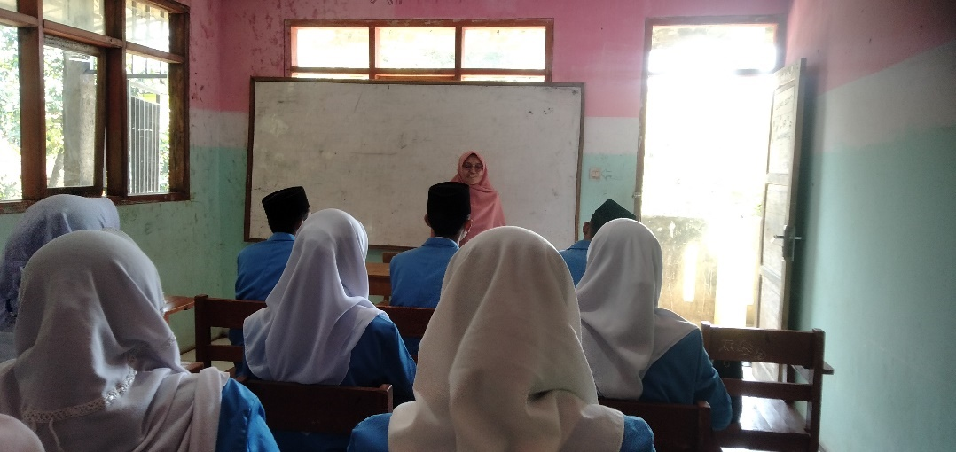
The techer giving explanation of SRL and Procedure Text

- Second Observation (May 22, 2024):
Criteria Observed: Delivery, Vocal Clarity, Non-Verbal Communication, Time Management
The second session emphasized the performance phase of SRL, where the focus was on the actual delivery of presentations. The teacher encouraged students to practice self-control, observe their own performance critically, and manage their time effectively—key elements of effective oral presentation as highlighted by experts like Berkun (2010) and Gallo (2014).
Observations:
- Delivery: Students showed marked improvement in their delivery, with many speaking more confidently and with better pacing.
- Vocal Clarity: There was a noticeable enhancement in vocal clarity, as students became more mindful of speaking clearly and audibly.
- Non-Verbal Communication: Some students made better use of gestures and eye contact, though others still needed to develop these skills further.
- Time Management: While most students managed their time more effectively, a few struggled to keep within the allotted time, indicating a need for further practice.
The emphasis on self-control and self-observation during this phase helped students to refine their presentation techniques, making them more effective communicators.
.Picture 4.1.4
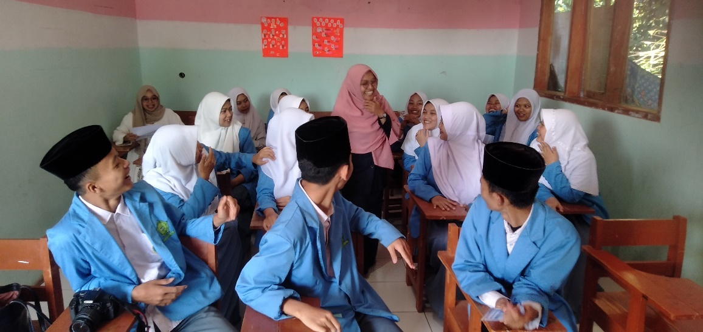
The teacher demonstrated improvements in implementing the performance phase of SRL
- Third Observation (May 29, 2024):
Criteria Observed: Self-Evaluation, Adaptability, Feedback Incorporation.
In the final session, the focus was on the self-reflection phase of SRL. The teacher guided students through the process of evaluating their own performance, adapting their strategies based on feedback, and improving their presentations accordingly.
Observations:
- Self-Evaluation: Many students demonstrated a strong ability to critically evaluate their own work, identifying specific areas for improvement.
- Adaptability: Students who focused on self-reflection were able to make significant adjustments to their presentations based on prior feedback, leading to noticeable improvements.
- Feedback Incorporation: The students effectively incorporated feedback from peers and the teacher, resulting in more polished and coherent presentations.
- This phase was particularly beneficial for students as it allowed them to internalize the feedback and make meaningful changes to their presentation style and content.
Picture 4.1.4

The teacher guided students in critically analyzing their presentation performances

- Progress Assessment
Overall, the teacher's gradual integration of SRL across the observed sessions showed commendable progress in enhancing students' Oral Presentation Skills in procedure text. While initial sessions focused on establishing foundational SRL principles through goal setting and strategic planning, subsequent sessions increasingly emphasized practical application and reflective practices. Students showed noticeable improvement in their ability to set meaningful goals, manage their presentation tasks effectively, and critically evaluate their own performance.
The teacher’s adept application of SRL strategies, combined with the students’ engagement with each phase, led to significant advancements in their oral presentation abilities. This progress underscores the value of a phased, criteria-based approach to enhancing oral presentation skills in an academic setting.
- Student Progress Review
Students responded positively to the structured implementation of SRL, showing increased engagement and ownership in their learning processes. Improved presentation clarity, organization, and confidence were evident indicators of their development. The progressive alignment of teaching strategies with SRL principles significantly contributed to students' skill development and overall academic growth in oral presentation.
Throughout the observation period, all students showed varying degrees of improvement in their oral presentation skills, aligning with the criteria set forth by communication experts. The SRL framework provided a structured approach that allowed students to gradually build their skills in a targeted manner. By the end of the study, students were more confident, organized, and reflective in their presentations.
In conclusion, the observed implementation of SRL underscored its effectiveness in fostering independent learning and enhancing students' proficiency in oral presentation skills. Continued refinement and reinforcement of SRL methodologies are recommended to further optimize learning outcomes and empower students at MA Mabdaul Ulum in their academic pursuits.

4.1.5 The Interview Result
After conducting three meeting to assess the impact of Self-Regulated Learning (SRL) behaviors on enhancing students' oral presentation skills in an English class, several insights emerged regarding students' preferences and perceptions of different SRL phases.Among the interviewed students, 11 emphasized the Forethought Phase as the most influential in improving their oral presentation skills. They highlighted that setting clear goals, planning their presentations strategically, and organizing their thoughts beforehand significantly enhanced their ability to deliver coherent and structured presentations. These students felt that the Forethought Phase provided them with a solid foundation, helping them to outline their ideas effectively and anticipate potential challenges during their presentations.
In contrast, 3 students expressed a preference for the Performance Phase of SRL. They emphasized the importance of self-control and self-observation during their presentations, noting that actively monitoring their delivery and adjusting their performance in real-time improved their confidence and overall presentation quality. These students found that being able to regulate their behavior and adapt their strategies during the actual presentation was crucial in achieving successful outcomes.
Additionally, 3 other students highlighted the Self-Reflection Phase as pivotal in their learning process. They valued the opportunity to critically evaluate their performance after presentations, identifying strengths to maintain and areas for improvement. Through self-assessment and reflective practices, these students believed they could enhance their presentation skills continuously by learning from their experiences and making necessary adjustments in their approach.
Interestingly, 3 students recognized the value of integrating all phases of SRL. They emphasized that a comprehensive approach, incorporating goal setting, real-time performance monitoring, and reflective analysis, provided a holistic framework for continuous improvement. These students felt that each phase complemented the others, offering a systematic method to enhance their overall oral presentation skills effectively.
The interviews revealed diverse perspectives among students regarding the effectiveness of different SRL phases in enhancing oral presentation skills. While the Forethought Phase was highlighted for its role in laying a strong foundation and planning, the Performance Phase was valued for its immediate impact on delivery and adaptation. The Self-Reflection Phase, meanwhile, was appreciated for its role in continuous improvement through critical analysis and adjustment. Overall, integrating all phases of SRL provided a comprehensive strategy for students to develop and refine their oral presentation skills systematically and effectively in the English classroom.

4.2 Discussion
The objective of this study is to identify specific Self-Regulated Learning (SRL) behaviors that enhance students' oral presentation skills, as evidenced by classroom observations and student interviews. All 20 participants in the study actively selected and implemented distinct SRL strategies to improve their oral presentation skills, with 11 choosing the Forethought Phase, 3 opting for the Performance Phase, 3 selecting the Self-Reflection Phase, and 4 integrating all phases. This discussion synthesizes these findings to explore how SRL behaviors influenced the students' progress in their oral presentation skills.
The observations made across three sessions revealed significant progress in students' oral presentation skills as a result of the teacher's strategic implementation of SRL phases. Each phase—forethought, performance, and self-reflection—was designed to target specific aspects of presentation skills, leading to a comprehensive enhancement in students' abilities.
- Forethought Phase:
During the forethought phase, students focused on goal-setting, strategic planning, and task analysis. The observations indicated that students became more organized in their presentations, with improved content structure and better audience engagement. This phase was particularly crucial as it laid the foundation for students to approach their presentations methodically. As a result, many students demonstrated a clear understanding of how to structure their presentations effectively, although some continued to struggle with maintaining a logical flow.
- Performance Phase:
The performance phase emphasized the actual delivery of presentations, including vocal clarity, non-verbal communication, and time management. Observations during this phase showed that students became more confident speakers, with noticeable improvements in vocal clarity and delivery. The use of gestures and eye contact also improved, although some students still needed to develop these skills further. The emphasis on self-control and self-observation in this phase allowed students to refine their presentation techniques, making them more effective in engaging their audience.
- Self-Reflection Phase:
In the self-reflection phase, students focused on evaluating their performance, adapting their strategies, and incorporating feedback. This phase was instrumental in helping students internalize feedback and make meaningful improvements to their presentations. Observations showed that students who engaged deeply in self-reflection were able to make significant adjustments, leading to more polished and coherent presentations. The ability to critically evaluate their own work and adapt based on feedback was a key factor in the overall improvement of their presentation skills.
The interviews conducted with students after the three sessions provided further insight into their perceptions of the SRL phases and their impact on their oral presentation skills. The majority of students identified specific SRL strategies that they found most beneficial.
- Forethought Phase:
Eleven students identified the forethought phase as the most influential in enhancing their oral presentation skills. They cited the importance of goal-setting and strategic planning in helping them organize their thoughts and structure their presentations more effectively. These students felt that the clear objectives and planning techniques they learned during this phase provided a solid foundation for their presentations, allowing them to approach the task with greater confidence and clarity.
- Performance Phase:
Three students highlighted the performance phase as the most impactful, emphasizing the importance of practicing delivery, managing anxiety, and improving vocal clarity. These students noted that the focus on self-control and observation during this phase helped them to become more effective speakers, enabling them to engage with their audience more confidently.
- Self-Reflection Phase:
Another three students identified the self-reflection phase as the most beneficial, stating that the ability to critically evaluate their performance and incorporate feedback was crucial to their improvement. These students valued the opportunity to reflect on their strengths and weaknesses, and they found that making adjustments based on this reflection led to significant progress in their presentation skills.

- All Phases:
Finally, four students recognized the importance of all three SRL phases, acknowledging that each phase contributed to different aspects of their learning and skill development. These students appreciated the comprehensive approach of SRL, which allowed them to build their skills gradually and holistically.
The convergence of the observation and interview findings highlights the effectiveness of SRL strategies in enhancing students' oral presentation skills. The teacher's adept application of SRL phases, combined with students' engagement with these phases, resulted in significant advancements in their presentation abilities. The significant improvement observed in students' skills, as well as their positive feedback on the SRL strategies, underscores the value of a structured, phased approach to learning.
Overall, the study demonstrates that SRL behaviors, particularly those related to goal-setting, strategic planning, self-control, self-observation, and self-reflection, play a crucial role in improving oral presentation skills. The majority of students were able to identify and utilize specific SRL strategies that worked best for them, leading to noticeable progress. The alignment between observation and interview data provides strong evidence that SRL is an effective framework for enhancing oral presentation skills in an academic setting.

CHAPTER V

CONCLUSION AND SUGGESTION
This chapter presents the conclusions derived from the analysis of the previous chapters in the study titled ‘Self-Regulated Learning Behaviors Strategy In Enhancing Students’ Oral Presentation Skills In English Class’. It synthesizes the findings from observations of teacher implementation, and student interviews. Additionally, this chapter provides targeted suggestions for teachers, students, and future researchers to further improve the application of self-regulated learning strategies and enhance oral presentation skills in educational settings.

5.1 Conclusion
This study, conducted over the span of one month from May 8 to May 29, 2024, at One of the senior high school in Garut, focused on 20 students from class XI, second semester, to identify specific Self-Regulated Learning (SRL) behaviors that enhance students' oral presentation skills. The research aimed to analyze the impact of SRL strategies on student performance through classroom observations and student interviews. Initially, classroom observations across the three sessions revealed a progressive and adept integration of SRL principles by the teacher. Initially, there were sporadic instances of goal-setting and strategic planning, but as the sessions progressed, the teacher effectively incorporated SRL phases—Forethought, Performance, and Self-Reflection—into lesson planning, student interactions, and feedback mechanisms. By the final session, there was a noticeable improvement in students' preparedness, engagement, and self-regulation during presentations, reflecting the teacher’s growing proficiency in applying SRL strategies.
Student interviews provided deeper insights into the specific SRL phases they found most beneficial. Eleven students identified the Forethought Phase, emphasizing its crucial role in goal setting, strategic planning, and organizing thoughts before presentations. This phase enabled them to approach presentations with confidence and deliver structured content effectively. Three students preferred the Performance Phase for its focus on real-time adjustments and self-regulation, which enhanced their delivery dynamics and audience engagement. Another three students valued the Self-Reflection Phase for its emphasis on continuous improvement through critical evaluation and adaptive learning, enabling iterative refinement of their presentation skills. Three students recognized the comprehensive benefits of integrating all SRL phases, highlighting the holistic framework's role in sustained skill development and enhanced presentation proficiency.
In summary, the study at One of the senior high school in Garut, demonstrates that deliberate adoption of specific SRL behaviors significantly contributes to the development of students' oral presentation skills. The substantial improvement from pre-test to post-test, supported by effective SRL implementation and student feedback, underscores the importance of embedding SRL strategies in educational practices. This approach empowers students to master critical communication skills, essential for their academic and professional success. The findings highlight the transformative potential of SRL in fostering student autonomy, engagement, and proficiency in oral presentations.

5.2 Suggestion
Based on the result of analysis and conclusion above, the writer would like to give suggestion not only the English teacher, but also to all students of education, and the future researcher.
    - For Teachers at MA Mabdaul Ulum and Teachers in General
- Teachers should regularly engage in professional development opportunities to stay updated on the latest SRL strategies and teaching methodologies. This will help in effectively integrating SRL principles in the classroom.
- Design lesson plans that explicitly incorporate the three phases of SRL: Forethought, Performance, and Self-Reflection. This structured approach will help students understand and apply SRL strategies more effectively.
- Foster a student-centered learning environment where students are encouraged to set their own goals, monitor their progress, and reflect on their learning. Provide guidance and support to help them become more autonomous learners.
- Provide regular, constructive feedback to students on their performance. Encourage self-reflection and peer feedback to help students recognize their strengths and areas for improvement.
- Integrate technology tools that support SRL, such as digital planners, reflection journals, and interactive presentations. These tools can enhance student engagement and facilitate the application of SRL strategies.
    - For Students at MA Mabdaul Ulum and Students in General
- Actively participate in class activities and discussions. Engage with the learning materials and take initiative in your learning process by setting personal academic goals.
- Develop clear and achievable goals for your studies. Plan your tasks and manage your time effectively to ensure you stay on track with your learning objectives.
- Regularly monitor your progress towards your goals. Use self-assessment tools and seek feedback from peers and teachers to understand your strengths and areas needing improvement.
- Practice self-reflection regularly. After completing tasks or presentations, take time to reflect on what you did well and what you could improve. Use this reflection to enhance your future performance.
- Don’t hesitate to seek support from your teachers, peers, or online resources when you encounter challenges. Collaborating with others can provide new perspectives and help overcome obstacles.
    - For Future Researchers
- Expand the research to include a more diverse sample of students from different educational backgrounds and regions. This will provide a broader understanding of the effectiveness of SRL strategies across various contexts.
- Conduct longitudinal studies to examine the long-term impact of SRL strategies on student performance and learning outcomes. This will help in understanding the sustained benefits of SRL.
- Implement experimental research designs with control and experimental groups to rigorously test the effectiveness of specific SRL interventions. This can provide more robust evidence of causality.
- Incorporate qualitative research methods, such as interviews and focus groups, to gain deeper insights into students' and teachers' experiences with SRL. This can complement quantitative data and provide a richer understanding of the findings.
- Explore the role of technology in supporting SRL. Investigate how digital tools and resources can enhance the implementation and effectiveness of SRL strategies in various educational settings.
- Study the application of SRL strategies across different subjects and disciplines. Understanding how SRL works in various academic contexts can help in developing tailored approaches that maximize its benefits.
By following these suggestions, teachers, students, and future researchers can contribute to the effective implementation and continuous improvement of Self-Regulated Learning strategies, ultimately enhancing educational outcomes for all learners.

REFERENCES
Bandura, A. (1991). Social cognitive theory of self-regulation. Organizational Behavior and Human Decision Processes, 50(2), 248-287.
Bjork, R. A., Dunlosky, J., & Kornell, N. (2013). Self-regulated learning: Beliefs, techniques, and illusions. Annual Review of Psychology, 64, 417-444.
Boekaerts, M. (1997). Self-regulated learning: A new concept embraced by researchers, policy makers, educators, teachers, and students. Learning and Instruction, 7(2), 161-186.
Butler, D. L., & Winne, P. H. (1995). Feedback and self-regulated learning: A theoretical synthesis. Review of Educational Research, 65(3), 245-281.
Carver, C. S., & Scheier, M. F. (1998). On the self-regulation of behavior. Cambridge University Press.
Cleary, T. J., & Zimmerman, B. J. (2004). Self-regulation empowerment program: A school-based program to enhance self-regulated and self-motivated cycles of student learning. Psychology in the Schools, 41(5), 537-550.
Dinsmore, D. L., Alexander, P. A., & Loughlin, S. M. (2008). Focusing the conceptual lens on metacognition, self-regulation, and self-regulated learning. Educational Psychology Review, 20(4), 391-409.
Efklides, A. (2011). Interactions of metacognition with motivation and affect in self-regulated learning: The MASRL model. Educational Psychologist, 46(1), 6-25.
Graham, S., & Harris, K. R. (2000). The role of self-regulation and transcription skills in writing and writing development. Educational Psychologist, 35(1), 3-12.
Greene, J. A., & Azevedo, R. (2010). The measurement of learners' self-regulated cognitive and metacognitive processes while using computer-based learning environments. Educational Psychologist, 45(4), 203-209.
Hadwin, A. F., & Winne, P. H. (2012). Promoting learning skills in undergraduate students. In N. J. Entwistle, & D. J. Hounsell (Eds.), Handbook of undergraduate education (pp. 37-57). Sage.
Hattie, J., & Timperley, H. (2007). The power of feedback. Review of Educational Research, 77(1), 81-112.
Kitsantas, A., & Dabbagh, N. (2010). Learning to learn with integrative learning technologies (ILT): A practical guide for academic success. Information Age Publishing.
McCardle, L., & Hadwin, A. F. (2015). Using multiple, contextualized data sources to measure learners' perceptions of their self-regulated learning. Metacognition and Learning, 10(1), 43-75.
Nelson, T. O., & Narens, L. (1990). Metamemory: A theoretical framework and new findings. In G. Bower (Ed.), The psychology of learning and motivation (pp. 125-173). Academic Press.
Paris, S. G., & Paris, A. H. (2001). Classroom applications of research on self-regulated learning. Educational Psychologist, 36(2), 89-101.
Paris, S. G., & Winograd, P. (1990). How metacognition can promote academic learning and instruction. In B. F. Jones & L. Idol (Eds.), Dimensions of thinking and cognitive instruction (pp. 15-51). Lawrence Erlbaum Associates.
Perry, N. E., & Rahim, A. (2011). Studying self-regulated learning in classrooms. In B. J. Zimmerman & D. H. Schunk (Eds.), Handbook of self-regulation of learning and performance (pp. 122-136). Routledge.
Pintrich, P. R. (2004). A conceptual framework for assessing motivation and self-regulated learning in college students. Educational Psychology Review, 16(4), 385-407.
Ryan, R. M., & Deci, E. L. (2000). Intrinsic and extrinsic motivations: Classic definitions and new directions. Contemporary Educational Psychology, 25(1), 54-67.
Schraw, G., & Moshman, D. (1995). Metacognitive theories. Educational Psychology Review, 7(4), 351-371.
Schunk, D. H. (2005). Self-regulated learning: The educational legacy of Paul R. Pintrich. Educational Psychologist, 40(2), 85-94.
Schunk, D. H., & Greene, J. A. (2017). Handbook of self-regulation of learning and performance. Routledge.
Sitzmann, T., & Ely, K. (2011). A meta-analysis of self-regulated learning in work-related training and educational attainment: What we know and where we need to go. Psychological Bulletin, 137(3), 421-442.
Usher, E. L., & Schunk, D. H. (2018). Acknowledging the complexity of self-efficacy: A response to Caprara. European Journal of Psychological Assessment, 34(2), 123-128.
Vansteenkiste, M., Lens, W., & Deci, E. L. (2006). Intrinsic versus extrinsic goal contents in self-determination theory: Another look at the quality of academic motivation. Educational Psychologist, 41(1), 19-31.
Whitebread, D., & Pino-Pasternak, D. (2010). Metacognition, self-regulation, and metacognitive knowledge about learning: Classroom applications. In H. Salatas Waters & W. Schneider (Eds.), Metacognition, strategy use, and instruction (pp. 59-85). Guilford Press.
Winne, P. H., & Hadwin, A. F. (1998). Studying as self-regulated learning. In D. J. Hacker, J. Dunlosky, & A. C. Graesser (Eds.), Metacognition in educational theory and practice (pp. 277-304). Lawrence Erlbaum Associates.
Wolters, C. A. (2011). Regulation of motivation: Evaluating an underemphasized aspect of self-regulated learning. Educational Psychologist, 46(3), 168-188.
Zimmerman, B. J. (2002). Becoming a self-regulated learner: An overview. Theory into Practice, 41(2), 64-70.

APPENDIX II

Interview Result

INTERVIEW RESULT
S1
- Can you describe your process for preparing for an oral presentation?
I start by setting specific goals for my presentation, such as key points I want to cover and the impact I want to make on my audience.
- What strategies do you use to monitor your progress while practicing your presentation?
I use a checklist to track the completion of each part of my presentation.
- How do you reflect on your performance after delivering a presentation?
After the presentation, I compare my goals with the outcomes to see how well I met my objectives.
- Which phase among the Forethought Phase, Performance Phase, and Self-Reflection Phase is the most significant in improving your oral presentation? Is it one of these three phases or all of them together?
The Forethought Phase is crucial as it sets a clear direction and objectives, which guide the preparation and execution of the presentation.
S2
- Can you describe your process for preparing for an oral presentation?
I conduct thorough research and create an outline of my presentation.
What strategies do you use to monitor your progress while practicing your presentation?
I break down my practice sessions into smaller goals and track them in a planner.
- How do you reflect on your performance after delivering a presentation?
I review my outline to ensure all critical points were covered and assess audience feedback.
- Which phase among the Forethought Phase, Performance Phase, and Self-Reflection Phase is the most significant in improving your oral presentation? Is it one of these three phases or all of them together?
Forethought Phase is essential because it helps in organizing and planning the content effectively.
S3
- Can you describe your process for preparing for an oral presentation?
I visualize the entire presentation, including potential questions from the audience.
- What strategies do you use to monitor your progress while practicing your presentation?
I keep a journal to note improvements and areas that need more practice.
- How do you reflect on your performance after delivering a presentation?
I revisit my visualization and see how closely the actual presentation matched it.
- Which phase among the Forethought Phase, Performance Phase, and Self-Reflection Phase is the most significant in improving your oral presentation? Is it one of these three phases or all of them together?
Forethought Phase is significant as visualization and goal-setting build confidence and structure.
S4
- Can you describe your process for preparing for an oral presentation?
I set both long-term and short-term goals, including mastering specific content and improving delivery techniques.
- What strategies do you use to monitor your progress while practicing your presentation?
I use a timeline to ensure I’m progressing as planned.
- How do you reflect on your performance after delivering a presentation?
I check if I met my goals and identify any discrepancies.
- Which phase among the Forethought Phase, Performance Phase, and Self-Reflection Phase is the most significant in improving your oral presentation? Is it one of these three phases or all of them together?
Forethought Phase is vital because it establishes clear, measurable objectives for success.
S5
- Can you describe your process for preparing for an oral presentation?
I focus on goal-setting and detailed planning.
- What strategies do you use to monitor your progress while practicing your presentation?
I track my preparation against the set goals.
- How do you reflect on your performance after delivering a presentation?
I reflect on how well I achieved my initial goals.
- Which phase among the Forethought Phase, Performance Phase, and Self-Reflection Phase is the most significant in improving your oral presentation? Is it one of these three phases or all of them together?
Forethought Phase is most significant for providing a structured and goal-oriented approach.
S6
- Can you describe your process for preparing for an oral presentation?
I start by rehearsing the content multiple times.
- What strategies do you use to monitor your progress while practicing your presentation?
I record my practice sessions and review them to self-assess my delivery and content coverage.
- How do you reflect on your performance after delivering a presentation?
I evaluate the recordings to identify strengths and areas for improvement.
- Which phase among the Forethought Phase, Performance Phase, and Self-Reflection Phase is the most significant in improving your oral presentation? Is it one of these three phases or all of them together?
Performance Phase is key because actual practice and self-monitoring directly enhance delivery skills.
S7
- Can you describe your process for preparing for an oral presentation?
I create cue cards for key points to stay on track.
- What strategies do you use to monitor your progress while practicing your presentation?
I use a mirror or video to practice and observe my body language.
- How do you reflect on your performance after delivering a presentation?
I compare my practice recordings with the actual presentation to identify gaps.
- Which phase among the Forethought Phase, Performance Phase, and Self-Reflection Phase is the most significant in improving your oral presentation? Is it one of these three phases or all of them together?
Performance Phase is key because actual practice and self-monitoring directly enhance delivery skills
S8
- Can you describe your process for preparing for an oral presentation?
I conduct mock presentations in front of friends.
- What strategies do you use to monitor your progress while practicing your presentation?
I gather feedback from these mock sessions and incorporate it into my practice.
- How do you reflect on your performance after delivering a presentation?
I assess the feedback and determine how effectively I incorporated it.
- Which phase among the Forethought Phase, Performance Phase, and Self-Reflection Phase is the most significant in improving your oral presentation? Is it one of these three phases or all of them together?
Performance Phase is significant due to the continuous improvement through practice and feedback.
S9
- Can you describe your process for preparing for an oral presentation?
I focus on mastering my timing and pacing.
- What strategies do you use to monitor your progress while practicing your presentation?
I time my practice sessions to ensure I stay within the allocated time.
- How do you reflect on your performance after delivering a presentation?
I check if I adhered to the timing and pacing during the actual presentation.
- Which phase among the Forethought Phase, Performance Phase, and Self-Reflection Phase is the most significant in improving your oral presentation? Is it one of these three phases or all of them together?
Forethought Phase is significant as visualization and goal-setting build confidence and structure.
S10
- Can you describe your process for preparing for an oral presentation?
I review past presentations to identify common mistakes and areas for improvement.
- What strategies do you use to monitor your progress while practicing your presentation?
I set milestones for practice sessions and review my progress at each milestone.
- How do you reflect on your performance after delivering a presentation?
I check if I adhered to the timing and pacing during the actual presentation.
- Which phase among the Forethought Phase, Performance Phase, and Self-Reflection Phase is the most significant in improving your oral presentation? Is it one of these three phases or all of them together?
Self-Reflection Phase is vital for learning from past experiences and applying those lessons to future presentations.
S11
- Can you describe your process for preparing for an oral presentation?
I outline key messages and rehearse delivering them convincingly.
- What strategies do you use to monitor your progress while practicing your presentation?
I use a rubric to evaluate my practice performances.
- How do you reflect on your performance after delivering a presentation?
I reflect on how well I delivered key messages and engaged the audience.
- Which phase among the Forethought Phase, Performance Phase, and Self-Reflection Phase is the most significant in improving your oral presentation? Is it one of these three phases or all of them together?
Self-Reflection Phase is significant because it focuses on evaluating and learning from the delivery to make improvements.
S12
- Can you describe your process for preparing for an oral presentation?
I plan my presentation structure and practice it several times.
- What strategies do you use to monitor your progress while practicing your presentation?
I use a rubric to evaluate my practice performances.
- How do you reflect on your performance after delivering a presentation?
I compare my self-assessment with peer feedback to identify discrepancies.
- Which phase among the Forethought Phase, Performance Phase, and Self-Reflection Phase is the most significant in improving your oral presentation? Is it one of these three phases or all of them together?
Self-Reflection Phase is crucial for understanding the effectiveness of delivery and making data-driven improvement.
S13
- Can you describe your process for preparing for an oral presentation?
I create a detailed script and practice until I’m comfortable with the content.
- What strategies do you use to monitor your progress while practicing your presentation?
I track my confidence levels during practice sessions.
- How do you reflect on your performance after delivering a presentation?
I reflect on my confidence and composure during the actual presentation.
- Which phase among the Forethought Phase, Performance Phase, and Self-Reflection Phase is the most significant in improving your oral presentation? Is it one of these three phases or all of them together?
Forethought Phase
S14
- Can you describe your process for preparing for an oral presentation?
I set goals, plan my content, and practice extensively.
- What strategies do you use to monitor your progress while practicing your presentation?
I use self-assessment and recordings to track my progress.
- How do you reflect on your performance after delivering a presentation?
I reflect on both the preparation and delivery to identify strengths and areas for improvement.
- Which phase among the Forethought Phase, Performance Phase, and Self-Reflection Phase is the most significant in improving your oral presentation? Is it one of these three phases or all of them together?
Forethought phase.
S15
- Can you describe your process for preparing for an oral presentation?
I define my goals, outline my presentation, and rehearse.
- What strategies do you use to monitor your progress while practicing your presentation?
I use feedback and self-evaluation tools during practice.
- How do you reflect on your performance after delivering a presentation?
I reflect on both the preparation and delivery to identify strengths and areas for improvement.
- Which phase among the Forethought Phase, Performance Phase, and Self-Reflection Phase is the most significant in improving your oral presentation? Is it one of these three phases or all of them together?
Combining all phases ensures thorough preparation, effective practice, and insightful reflection.
S16
- Can you describe your process for preparing for an oral presentation?
I set specific objectives, research my content, and create a structure.
- What strategies do you use to monitor your progress while practicing your presentation?
I practice and adjust based on self-assessment and external feedback.
- How do you reflect on your performance after delivering a presentation?
I analyze the entire process to identify lessons learned.
- Which phase among the Forethought Phase, Performance Phase, and Self-Reflection Phase is the most significant in improving your oral presentation? Is it one of these three phases or all of them together?
Utilizing all phases together provides a holistic approach to improving presentation skills.
S17
- Can you describe your process for preparing for an oral presentation?
I establish clear goals, develop content, and practice delivery.
- What strategies do you use to monitor your progress while practicing your presentation?
I use a combination of self-monitoring techniques and feedback loops.
- How do you reflect on your performance after delivering a presentation?
I evaluate my preparation and execution comprehensively.
- Which phase among the Forethought Phase, Performance Phase, and Self-Reflection Phase is the most significant in improving your oral presentation? Is it one of these three phases or all of them together?
All phases are integral as they address different aspects of preparation and improvement.
S18
- Can you describe your process for preparing for an oral presentation?
I emphasize thorough practice and rehearsal.
- What strategies do you use to monitor your progress while practicing your presentation?
I continuously evaluate my performance and make real-time adjustments.
- How do you reflect on your performance after delivering a presentation?
I reflect on my practice sessions to refine my delivery.
- Which phase among the Forethought Phase, Performance Phase, and Self-Reflection Phase is the most significant in improving your oral presentation? Is it one of these three phases or all of them together?
Forethoght Phase is most significant for improving oral presentation skill
S19
- Can you describe your process for preparing for an oral presentation?
I integrate goal-setting, practice, and reflection.
- What strategies do you use to monitor your progress while practicing your presentation?
I use detailed progress tracking and feedback.
- How do you reflect on your performance after delivering a presentation?
I conduct a comprehensive reflection post-presentation.
- Which phase among the Forethought Phase, Performance Phase, and Self-Reflection Phase is the most significant in improving your oral presentation? Is it one of these three phases or all of them together?
Forethoght Phase is most significant for improving oral presentation skill.
S20
- Can you describe your process for preparing for an oral presentation?
I plan meticulously, practice extensively, and reflect deeply.
- What strategies do you use to monitor your progress while practicing your presentation?
I use various monitoring strategies to ensure continuous improvement.
- How do you reflect on your performance after delivering a presentation?
I reflect on each phase to derive insights for future presentations.
- Which phase among the Forethought Phase, Performance Phase, and Self-Reflection Phase is the most significant in improving your oral presentation? Is it one of these three phases or all of them together?
Forethoght Phase is most significant for improving oral presentation skill.

APPENDIX III

Documentation

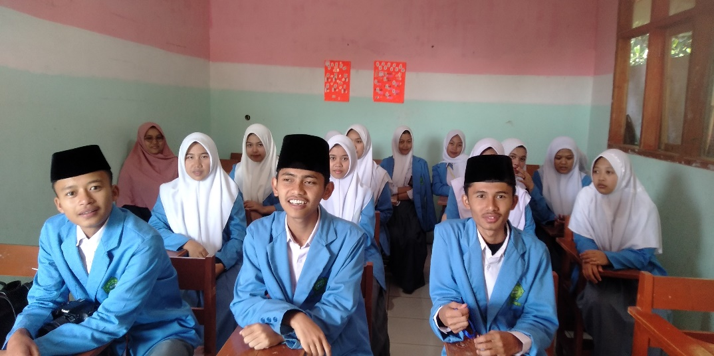
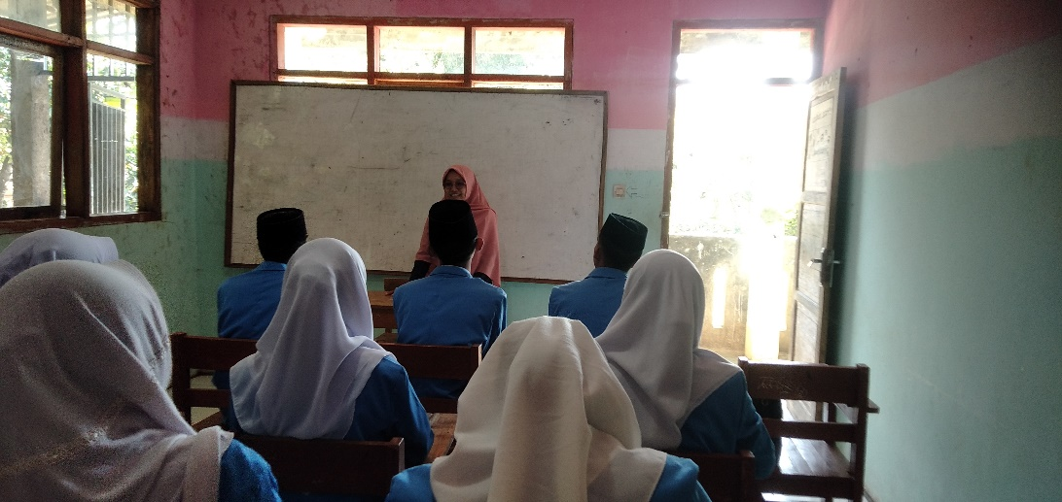
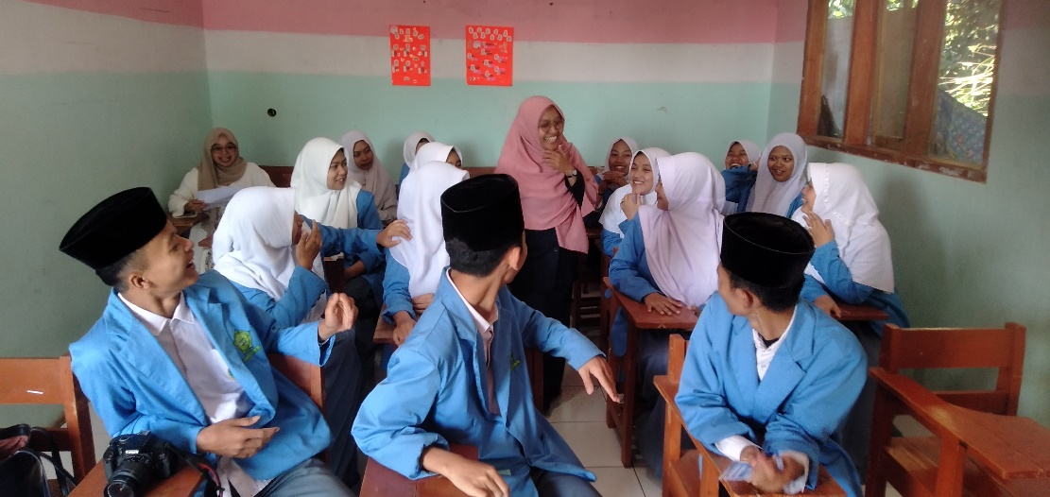
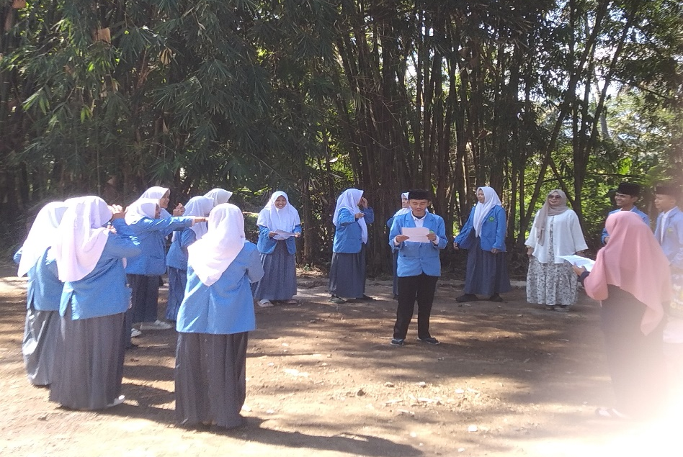

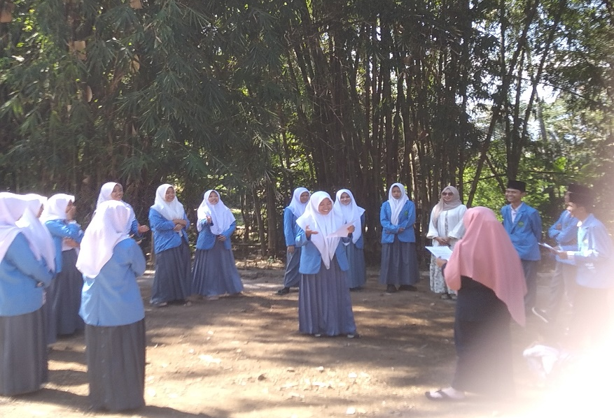
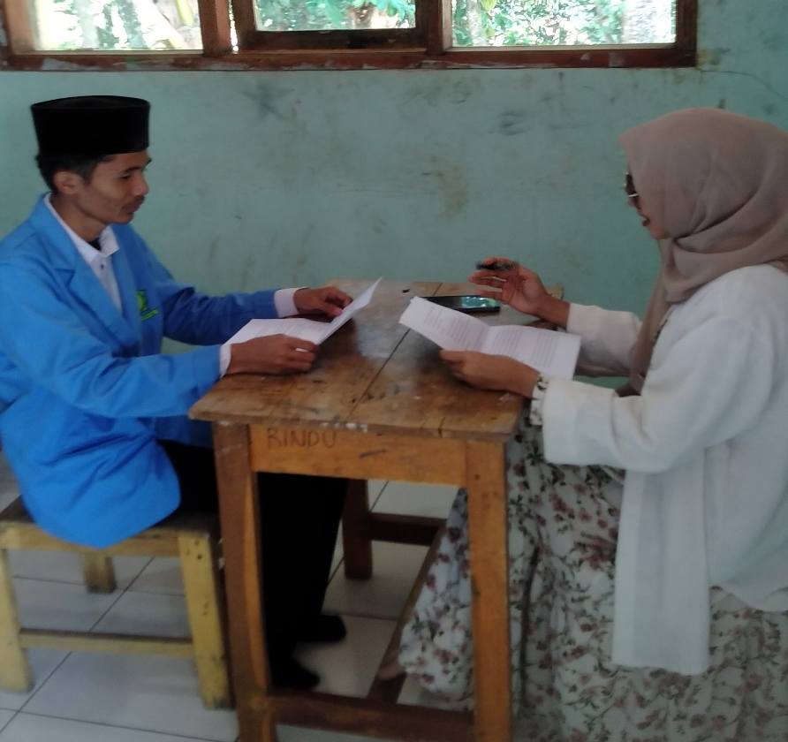
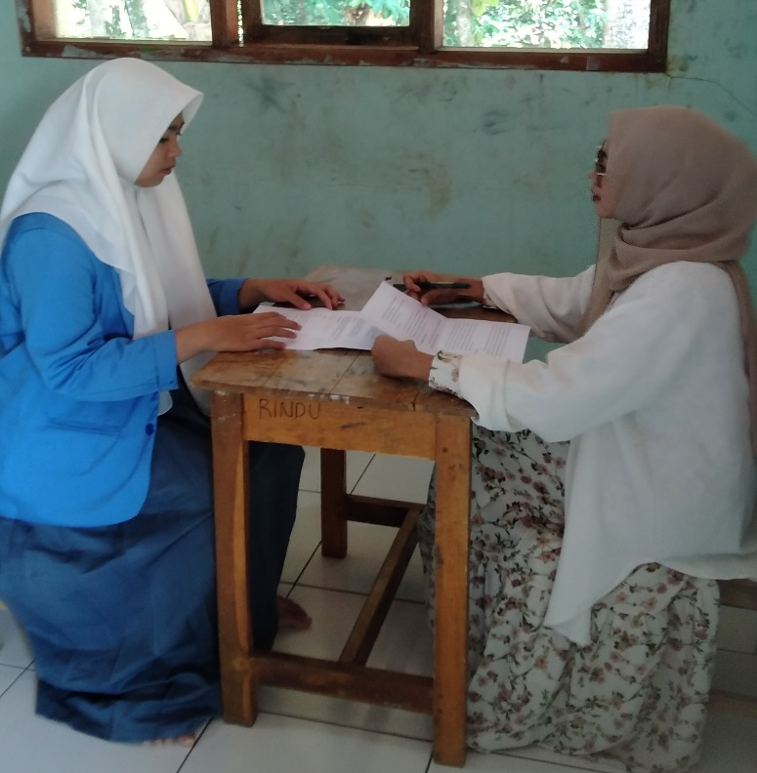
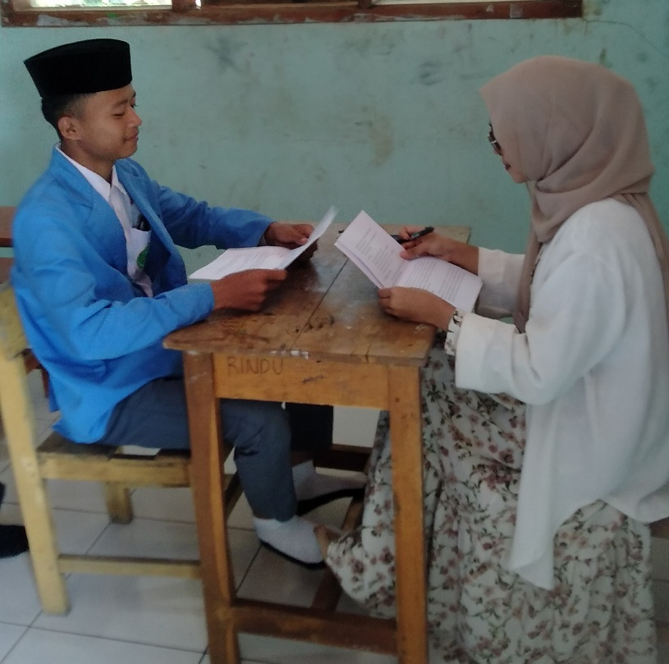
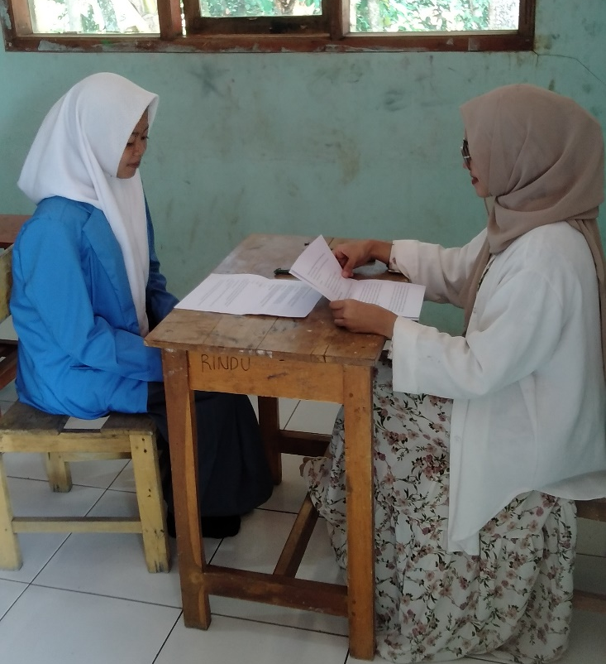
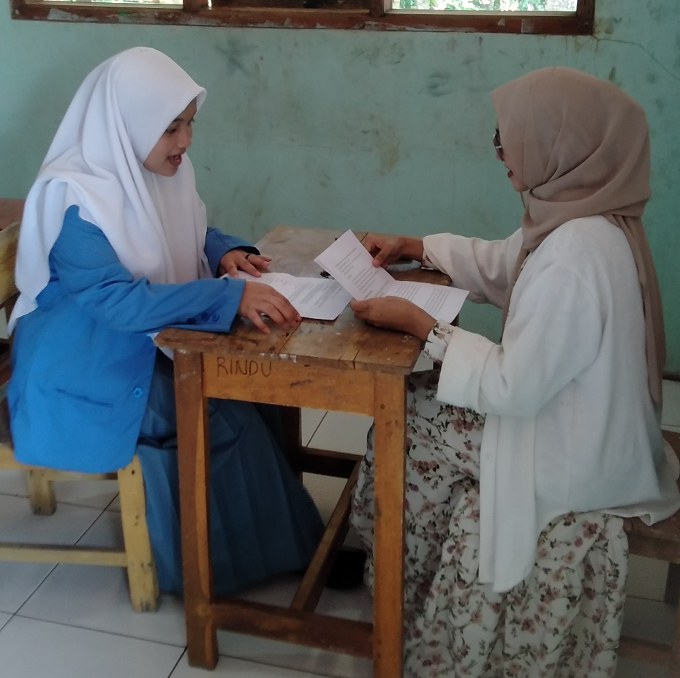



YOLANDA NURULITA A

I began my college journey in 2016, full of enthusiasm and a passion for exploring new experiences. Creativity has always been a key part of who I am, and it really flourished during my time at university. I loved getting involved in various student organizations, where I could not only develop my leadership and teamwork skills but also build meaningful friendships. Those years were some of the best in my life, filled with opportunities to grow, learn, and connect with people from all walks of life.
ACHIEVEMENTS
- 2019 Delegate of Youth Center to Act for Nation, YMM, Dumai,Riau- Kuala Lumpur, Malaysia
- 2019 Mahasiswa Berprestasi Institut Pendidikan Indonesia
- 2019 Juara I Duta Pendidikan Institut Pendiidkan Indonesia2019 Juara I Debat Pendidikan, Institut Pendidikan Indonesia
- 2019 Juara 1 English Debate Competition, Institut Pendidikan Indonesia
- 2018 Penerima Beasiswa Pemprov Jabar
- 2018 National Speech Competition UIN Sunan Gunung Djati
- 2018 Best Vocal Festival Music AMIK Garut 2017 2nd RU Duta GenRe Kabupaten Garut 2017 Duta Inspiratif GenRe Kabupaten Garut 2017 Best Presenter GenRe Kabupaten Garut 2016 Juara 1 English Poetry, Himadiksaris, Institut Pendidikan Indonesia
- 2014 Juara 1 English Speech Contest STAIPI EXPO
- 2014 Juara I English Speech Contest IMM STAIDA

ORGANIZATION EXPERIENCES
- 2021-2022 Ketua Umum Kohati Cabang Garut
- 2021-2022 Ketua Bidang Pemberdayaan Perempuan HMI Cabang Garut 2021-2022 Sekretaris Umum HIPMI Institut Pendidikan Indonesia
- 2019-2020 Presiden Mahasiswa BEM Institut Pendidikan Indonesia (IPI)
- 2019-2020 Ketua Umum Kohati IPI
- 2019-2020 Ketua Bidang Pemberdayaan Perempuan HMI Komisariat IPI
- 2018-2019 Ketua Bidang Kaderisasi Paduan Suara Mahasiswa dan Musik IPI
- 2018-2019 Anggota Paduan Suara Nada Remaja Dinas DPPKBPPPA Kabupaten Garut 2017-2018 Sekretaris Umum Paduan Suara Mahasiswa dan Musik IPI
- 2017-2018 Sekretaris Koperasi Hijau Hitam Sejahtera
- 2016 -2017 Anggota Bidang Pendidikan Himpunan Mahasiswa Pendidikan Bahasa Inggris (HIMADIKSARIS) IPI
- 2013-2015 Sekretaris IRMA Al-Hidayah

