ANALYZING THE INTEGRATION OF MULTIMODAL RESOURCES IN ENHANCING LEARNING OUTCOMES

A PAPER
Submitted to the English Education Program of IPI Garut as a Partial
Fulfillment of the Requirements for the Sarjana Pendidikan Degree
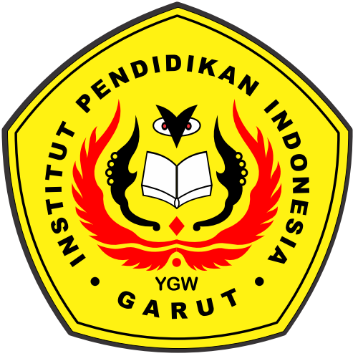

Written by:
Siti Farika
20222011

ENGLISH EDUCATION PROGRAM
FACULTY OF SOCIAL SCIENCE, LANGUAGE, AND LITERATURE EDUCATION
INSTITUT PENDIDIKAN INDONESIA
2024

APPROVAL SHEET

ANALYZING THE INTEGRATION OF MULTIMODAL RESOURCES IN ENHANCING LEARNING OUTCOMES

By:
Siti Farika
20222011

Approved by:

First Supervisor | Second Supervisor
Muhamad Taufik Hidayat, M.Pd | Dr. Eva Devi Sofyawati, M. Pd
NIDN. 0423038501 | NIDN. 0409057803

Acknowledged by:
Head of English Education Program
Anne Ratna Suminar, M. Pd.
NIDN. 0415038601

LEGITIMATION OF EXAMINATION BOARD

ANALYZING THE INTEGRATION OF MULTIMODAL RESOURCES IN ENHANCING LEARNING OUTCOMES

By:
Siti Farika
20222011

This paper has been examined on July 1st 2024
First Examiner, | Second Examiner, | Third Examiner,
Asep Suparman, M.Pd | Yustika Nur Fajriah, M.Pd | Surtiana, H., Drs., M.A
NIDN. 0401098405 | NIDN. 0412069004 | NIDN. 0010075102

Acknowledged by:
Dean of Faculty of Social Science,
Language, and Literature Education
Dr. Lina Siti Nurwahidah, M. Pd.
NIP. 196805271993032001

PERNYATAAN

Dengan ini, saya menyatakan bahwa skripsi yang berjudul “Analyzing The Integration Of Multimodal Resources In Enhancing Learning Outcomes” ini benar-benar karya sendiri. Pengutipan dari sumber-sumber lain telah saya lakukan berdasarkan kaidah-kaidah pengutipan yang sesuai dengan etika keilmuan yang berlaku sehingga isi skripsi serta semua kelengkapannya ini merupakan karya asli. Dalam hal ini, apabila kemudian hari ditemukan hal-hal yang tidak sesuai dengan isi pernyataan ini, maka saya akan bertanggung jawab dan bersedia menerima segala risiko dan sanksi.

Garut, 22 Juni 2024
Yang membuat pernyataan,

Siti Farika
20222011

DECLARATION

I hereby declare that this thesis entitled "Analyzing The Integration Of Multimodal Resources In Enhancing Learning Outcomes" is truly my own work. I have quoted from other sources based on citation rules that are in accordance with applicable scientific ethics so that the contents of this thesis and all its accessories are original work. In this case, if later things are found that are not in accordance with the contents of this statement, then I will be responsible and willing to accept all risks and sanctions.

Garut, June 22nd 2024
The Researcher
Siti Farika
20222011

MOTTO

Know that victory comes with patience, ease with hardship, and difficulty with ease.
[ HR Tirmidhi ]

Everyone has their process and in each process only you know what you have gone through. Remain patient because every bad thing will lead us to something better.
[ Siti Farika ]

My mother's prayers are as wide as the sky, and I take shelter under them
[ Siti Farika ]

PREFACE

In the name of Allah SWT, most gracious and most merciful, praise to be Allah, the lord of the world, who has given mercy and blessing to the writer in finishing this paper entitled “Analyzing The Integration of Multimodal Resources in Enhancing Learning Outcomes”. Blessing and salutation be upon to the prophet Muhammad SAW, his family, his companion and his adherent.
This paper is submitted to the English Education Program of IPI Garut as a partial fulfillment of the requirements for the Sarjana Pendidikan Degree.
The writer realizes that this paper is still far from being perfect. Therefore, the writer will greatly appreciate to all comments and criticism.
Finally, the writer hopes this paper can give valuable contribution in teaching and learning to writer and readers.

Garut, June 22nd 2024

The Researcher

ABSTRACT

Education has undergone significant development in the digital era with the introduction of increasingly popular video-based learning media. Multimodal videos, which integrate visual, text, and audio elements, offer a variety of opportunities to enhance learning. This study aims to qualitatively explore students' perceptions of the integration of multimodal video roles in improving student learning outcomes. This study combines classroom observation methods and questionnaires for high school students to evaluate students' perceptions of integrating multimodal videos in enhancing learning outcomes. Based on the data analysis in Chapter IV, it is concluded that this study covers three main aspects: knowledge, experience, and opinion. The knowledge aspect shows that videos are effective in improving English comprehension. The experience aspect confirms that videos attract students' attention, motivate learning, and improve learning outcomes. The opinion aspect is also very positive, indicating that videos are useful in helping students understand the material to achieve their learning goals and improve their learning outcomes in class.
Keywords: Multimodal approach, videos, learning outcomes

ABSTRAK

Pendidikan mengalami perkembangan yang signifikan di era digital dengan diperkenalkannya media pembelajaran berbasis video yang semakin populer. Video multimoda, yang mengintegrasikan elemen visual, teks, dan suara, menawarkan berbagai peluang untuk meningkatkan pembelajaran. Penelitian ini bertujuan untuk mengeksplorasi secara kualitatif yaitu persepsi siswa tentang integras peran video multimoda dalam meningkatkan hasil belajar siswa. Penelitian ini menggabungkan metode observasi kelas dan kuesioner untuk siswa sekolah menengah untuk mengevaluasi persepsi siswa tentang mengintegrasikan video multimoda dalam meningkatkan hasil belajar. Berdasarkan analisis data di Bab IV, disimpulkan bahwa penelitian ini mencakup tiga aspek utama: pengetahuan, pengalaman, dan pendapat. Aspek pengetahuan menunjukkan bahwa video efektif dalam meningkatkan pemahaman bahasa Inggris. Aspek pengalaman menegaskan bahwa video menarik perhatian siswa, memotivasi belajar, dan meningkatkan hasil pembelajaran. Aspek pendapat juga sangat positif, mengindikasikan video bermanfaat dalam membantu pemahaman siswa terhadap materi sehingga dapat mencapai tujuan pembelajaran mereka sehingga mereka dapat meningkatkan hasil belajar mereka di kelas.

Kata Kunci: Pendekatan multimodal, video, hasil Belajar

ACKNOWLEDGEMENTS

Alhamdulillaahirabbil’alamiin…
First of all, I would like to express my gratitude to Allah S.W.T, The Most Gracious and The Most Merciful, for the love, guidance, spirit, and strength He gives to me so I can finish this thesis and also to our beloved prophet, Muhammad SAW, who becomes my inspiration.
In this valuable chance, I would like to express gratitude and appreciation to the following people:
- Prof. Dr., Dr., Nizar Alam Hamdani, S.E, M.M., M.T., M.Si., M.Kom. as the Rector of Institut Pendidikan Indonesia (IPI) Garut.
- Dr. Lina Siti Nurwahidah, M.Pd. as the Dean of Faculty of Social Science, Language and Literature Education of Institut Pendidikan Indonesia (IPI) Garut.
- Anne Ratna Suminar, M.Pd. as the Head of English Education Program.
- My appreciation and gratitude to my supervisors, Muhamad taufik Hidayat, M.Pd. as the first supervisor, and Dra Eva Sofyawati, M.Pd. as the second supervisor. I really feel grateful for their willingness to be my thesis supervisor, for their time, patience, support, and guidance so I can finish this thesis. Without their help, I cannot finish this thesis on time as my plan. I would also like to thank the lecturers of the English Education Program for the knowledge they gave to me in this college.
- My superhero and first love, Mr. Aso, thank you for fighting for the writer's life. He did not have the opportunity to experience education until college. However, he was able to educate the writer, motivate and provide support until Iwas able to complete my studies until I graduated.
- My heavenly angel, Mrs. Siti Juabedah, who never stops giving affection with love and always providing support, motivation and prayers that have been offered all this time so that I was able to complete my studies until I graduated.
- My siblings Sagita Alfianti, Fahri Padilah, and Devina Lutfah Hunaijah also provided prayers, motivation, and support. Don't forget my beloved nephew, Muhammad Irsyadul Lutfi, who always entertains me when the writer feels bored while writing this work.
- My beloved friends Sintya Putri Nur Azizah, Hafidatun Nursalam, Fitria Amalia, Nina Anggia, and Rahayu Ningsih who never stop giving encouragementand prayers. Thank you for providing a shoulder to cry on and providing help when the author needed it.
- To someone whose presence is no less important, whose name the author cannot mention. Thank you for being a loyal companion in all things, who has taken the time, accompanied and supported and even comforted the author in his sadness. Never-ending encouragement to keep going forward without knowing the word giving up in achieving what has become the writer’s dream.
- And finally, to myself. Siti Farika. Thank you for sticking around this far. Thank you for continuing to choose to try and celebrate yourself up to this point, even though you often feel hopeless about what you have tried and have not succeeded, but thank you for still being a human being who is always willing to try and doesn't get tired of trying. Thank you for deciding not to give up no matter how difficult the process of preparing this thesis was and for completing it as best and as fully as possible, this is an achievement worth celebrating for yourself. Always be happy wherever you are, Ika. Whatever you have less or more, let's celebrate yourself.

TABLE OF CONTENTS

APPROVAL SHEET I
PERNYATAAN iii
DECLARATION iv
MOTTO v
PREFACE vi
ABSTRACT vii
ABSTRAK viii
ACKNOWLEDGEMENTS ix
TABLE OF CONTENTS xi
LIST OF TABLE xiii
LIST OF APPENDICES xiv
CHAPTER I INTRODUCTION 1
1.1 Background of the Study 1
1.2 The Reason for Choosing the Topic 4
1.3 Research Questions 4
1.4 Research Objectives 4
1.5 Scope and Limitations of Research 4
1.6 Significance of Research 4
1.6.1. Theoretical Significance 4
1.6.2. Practical Significance 4
1.7 Definition of Terminologies 5
1.7.1. Multimodality 5
1.7.2. Video 5
CHAPTER II LITERATURE REVIEW 6
2.1 Educational Technology 6
2.2 Multimodal 7
2.2.1. Multimodal Visual 8
2.2.2. Multimodal Text 8
2.2.3. Multimodal Sound 9
2.3 Video 9
2.4 Integrating of Multimodal Video 10
2.5 Benefit of multimodal video in learning 10
2.6 Challenges of multimodal video in learning 11
2.7 The Use of L1 and Target Language in Foreign Language Learning 12
2.8 Previous Studies 13
CHAPTER III RESEARCH METHOD 16
3.1 Research Method 16
3.2 Research Design 16
3.3 Research Setting and Participants 17
3.4 Technique of Data Collection 17
3.4.1 Observation 17
3.4.2 Questionnaire 18
3.5 Technique of Data Analysis 18
3.6 Research Procedure 19
CHAPTER IV RESEARCH FINDINGS AND DISCUSSION 20
4.1 Research findings 20
4.1.1 Observation 20
4.1.2 Questionnaire 21
4.2 Discussion 29
4.2.1 Observation 29
4.2.2 Questionnaire 30
CHAPTER V CONCLUSIONS AND SUGESTIONS 33
5.1 Conclusions 33
5.2 Suggestions 33
REFERENCES 35
APPENDICES 42

LIST OF TABLE

Table 4.1 Data Interval 21

Table 4.2 Results of recapitulation of the percentage of answers to the

knowledge aspect questionnaire. 21

Table 4.3 Results of recapitulation of the percentage of answers to the

experience aspect questionnaire. 23

Table 4.4 Results of recapitulation of the percentage of answers to the

opinion aspect questionnaire. 28

LIST OF APPENDICES
APPENDIX A RESEARCH INSTRUMENT 43
APPENDIX B TRANSCRIPT AND INFORMED CONSENT 47
APPENDIX C LETTERS 52
APPENDIX D PHOTO OBSERVATION 55

CHAPTER I
INTRODUCTION

This chapter consists of the background of the study, the research question, the aim of the study, the scope of the study, the significance of the study, research methodology, organization of paper, and definition of terms.

Background of the Study
Research has demonstrated that students achieve optimal learning outcomes when educators cater to several learning styles simultaneously, a feat made feasible by the use of multimodal learning. Utilizing multimodality can enhance the learner's comprehension of the subject, heighten levels of attention, and enhance learning performance (Gilakjani et al., 2011). According to Sartika et al. (2021), students had a favorable view of including multi-modality in English classrooms. They report feeling less stressed while utilizing the multi-learner approach. This is precisely why it is crucial to instruct both students and teachers in the concept of multimodal writing. While traditional composition and print media are indeed completed, it is crucial to recognize that multimodal composition is a significant and valuable trend in composition that deserves equal attention and consideration (Stowe, 2012).
Several studies have been undertaken to examine the quality of online education, develop individualized recommendations for learners, or emphasize the key aspects of lecture videos. Engaging with lecture videos allows for novel avenues to assess students' performance and analyze their learning development (Ghauri et al., 2020). Video is a widely utilized multimedia tool in language schools due to its ability to effectively present content, improve understanding, and facilitate the acquisition of vocabulary and grammar. Increasingly, educators are being urged to use multimedia elements, such as audio or videos, into language lessons due to their perceived convenience, entertainment value, and practicality (Gorjian, 2014). According to Osmanoglu (2016), the use of videos and discussions between students and teachers can create promising learning opportunities for prospective teachers. Such as, reward-based active learning activities in large classrooms effectively motivate students, increase conceptual understanding, and improve team spirit and performance through cooperative learning (George. 2021). In addition, Carmichael et al. (2018) state that video offers significant advantages for both teachers and learners. It enhances course performance in many settings and has a beneficial impact on student motivations, confidence, and attitudes. However, despite the benefits of videos and the eagerness of educators to use them, there has been limited research on creating videos for teaching language functions in Sociolinguistic classes and evaluating their effectiveness. (Purwanti, Et al. 2022).
Despite that, various obstacles and difficulties arise when acquiring knowledge through multiple modalities. Andriani (2021) states that teachers should prioritize the use of learning resources that are readily available and relevant to the content being taught. Furthermore, teachers face challenges such as limited resources, time constraints, a lack of creativity, and difficulty in finding appropriate materials. Hazna (2020) identified many obstacles encountered by teachers while utilizing audio-visual media, including insufficient teacher knowledge, inadequate teacher skills, time constraints, and a preference for other means. Consistent with Suranto's (2019), he asserted that, initially, the teacher has not yet attained mastery in creating instructional videos. Furthermore, there is currently a deficiency in the methods available for acquiring knowledge through video media. Furthermore, the language used in educational films does not suit the characteristics of students. Teachers face challenges in managing time effectively during the learning process. The presence of things in educational films that do not suit the background and character of students is a concern. The teacher experiences inconvenience when producing the instructional video media tools. In addition, Hamzah (2007) asserted that the teacher's function as a director is to guide the learning process in order to accomplish the learning objectives.
On this topic, numerous research have been conducted. Certain studies only concentrate on the implementation of multimodality within educational settings. First, Choi and Yi (2016) investigated how two teachers with limited experience in teaching English Language Learners (ELLs) utilized multimodality to instruct ELLs in their subject-specific classrooms. The findings indicate that using various methods to complement instruction in linguistic text allows teachers to assist English Language Learners (ELLs) in developing a deep understanding of subject-matter topic knowledge, effectively articulating their learning, and finding a psychological sanctuary. Second, (Sidik. 2022) this study attempts to explore the degree to which the SLM policy expectation of multimodal literacy development for students is implemented in the classroom-level practices of the English teaching and learning process. The findings indicate that teachers in all three cases have utilized multimodal artifacts, such as images and video-songs, in their English teaching resources. Third, Nikmah (2018) wants to investigate the use of videos as a medium for teaching English to pre-school children. The video examined in this study is sourced from the WOW ENGLISH TV channel on YouTube. After examining both the language and non-linguistic features, the findings indicate that the film is deemed appealing, engaging, and informative, making it appropriate for use with preschool children. This study has the potential to enhance the teaching of English to pre-school children by English teachers.
However, these studies only provide an explanation of the application of this topic. In other words, this research only investigates whether multimodal integration improving students' understanding or not. Only a few studies focus on explaining students' perceptions of multimodal video integration in enhancing learning outcomes. Therefore, the author's research aims to determine students' perceptions and responses to multimodal video integration in enhancing learning outcomes, and this research will contribute to teachers to use new media for use in the teaching and learning process, and for students to increase their understanding in the environment which is less stressful.

The Reason for Choosing the Topic
The researcher chose this topic because this research has major practical implications in the development of more effective teaching methods. In the independent curriculum or Kurikulum Merdeka, the use of videos as a teaching
method is commonplace. I want to know the perception of how multimodal video integration can influence learning outcomes is very important.

Research Questions
What are students' perceptions on the integration of multimodal video in enhancing learning outcomes?

Research Objectives
To determine students' perceptions on the integration of multimodal video in enhancing learning outcomes.

Scope and Limitations of Research
In accordance with the research objectives, the researcher limited the research data to teachers. Researchers only focus on analyzing the integration of multimodal video in enhancing learning outcomes in senior high school.

Significance of Research
Based on the following justification, this research offers two advantages based on theoretical significance and practical significance:

Theoretical Significance
It is hoped that this research can become a reference for motivation and knowledge about multimodal integration carried out by teachers using videos in the classroom. This research also anticipates that integrating multimodal video by teachers can improve student learning outcomes, and this research is expected to help in providing this solution.

Practical Significance
This research has several practical implications for teachers and students.

For Teacher
This research will add new knowledge about using this video as a media and know students’ perceptions towards this video so teachers can properly choose which video suits the best with students needs. For students

For Student
This research will help students to learn in an easy and fun method, and will be able to increase students’ motivation and comprehension in learning.

Other Researchers
It is hoped that the results of this research can become a further reference source for further research with different themes.

Definition of Terminologies
Based on the focus and formulation of the research problem, the definitions of the terms in this study are as follows.

Multimodality
According to Jewitt, C. (2008), the term "multimodality" encompasses the consideration of meaning as it arises from the contextual arrangements of several forms of communication, such as images, gestures, gazes, physical postures, sounds, writing, music, speech, and other media. Modes, such as image and action, are categorized as such from a multimodal perspective because they are structured collections of semiotic resources that aid individuals in comprehending the world.

Video
According to Kamelia (2019) video is a highly effective medium in EFL classrooms, as it facilitates student engagement and comprehension of the material.

CHAPTER II
LITERATURE REVIEW

This chapter presents the general literature review of educational technology, multimodal, video, and previous studies.

Educational Technology
Educational technology refers to the examination and ethical use of methods and tools that enhance learning and enhance performance. This involves the creation, utilization, and administration of suitable technological procedures and resources (Januszewski & Molenda, 2013). Cheung and Slavin (2012) found that educational technology apps often positively impact student reading performance. However, more promising results are observed when novel applications and integrated literacy treatments are implemented alongside comprehensive professional development. The potential of utilizing technology applications for alternative purposes is far higher. For instance, the combination of traditional classroom teaching with computer-based learning and the use of video, computer material, and multimedia in teaching children how to read have demonstrated significant potential. One example is PowerPoint presentations, which are an affordable way to introduce technology in the classroom. While they do not result in any significant improvement in student performance, they do have a favorable effect on learning styles (Daniels, L. 1999). Nai-me (2013) states that Multimodal PowerPoint can incorporate several modalities, including words, images, colors, sounds, and actions, to create significance and captivate students' interest in English language instruction. Conversely, the utilization of the Blackboard system has a beneficial influence on individuals in the field of education (Alhussain, T. 2017). El-Sawy (2018) discovered that incorporating a whiteboard in the EFL classroom yields several benefits, including enhanced pronunciation, improved vocabulary learning, better preparation for class tasks, increased reading time outside of class, and improved contact with the instructor.
6
The advent of technology has initiated a transformation in education, impacting the way students acquire the necessary skill sets for college and job readiness, as well as how educators incorporate digital instructional methodologies to facilitate teaching (Delgado et al., 2015). Joshi, S. (2023) states that the multimedia approach enhances the learning process. Educational technology is an emerging discipline that focuses on enhancing the process of learning and instruction. Utilizing digital information technology, the multimodal teaching mode greatly enhances college students' English performance, autonomous learning capacity, and overall language proficiency, improving English instruction quality (Wu, D. 2022).

Multimodal
According to Jewitt, C. (2008) teachers, curriculum designers, and policymakers can utilize multimodal tools, such as modal resources or modal affordances, to analyze the presence of images, actions, and other modes in the classroom. Multimodality provides novel perspectives on learning by emphasizing the creation of meaning via the process of design. By utilizing multimodal tools, individuals are able to enhance their understanding of classroom issues, develop insightful analyses, establish significant correlations, and express well-informed concepts in creative and relevant manners (Bailey and Elizabeth M. 2014). The implementation of multimodal synergistic tactics in high school English education aims to strengthen students' cognitive abilities and fundamental literacy skills by fostering student-centered pedagogical approaches and combining essential English language proficiencies (Zhi-qian, 2023). In order to fulfill the learning objectives, it is necessary to incorporate multimodal elements into the learning process.
According Huang et al (2022) found that the use of multimodal input greatly improved the learning of second language phrases compared to using only one mode of input. Additionally, students had a favorable attitude towards the use of multimodal resources. Similarly, the incorporation of audio-visual stimuli containing textual elements, such as subtitles and captions, seems to be advantageous in the process of acquiring a second or foreign language. This method enhances one's vocabulary, grammar, and listening abilities (Perez, 2022). According to Qin, Z et al (2023) define multimodality as the utilization of data from several sources, such as visual, text, or sound, to create a comprehensive representation. Multimodality has applications in diverse domains, including science communication, education, and media studies.

Multimodal Visual
According to Bailey et al. (2014), students seem to arrive at theoretical conclusions by using visual images, which could potentially predict effective teaching methods in the future. This can be accomplished as elucidated by Vungthong et al (2017). The framework incorporates clarification to capture elaboration relations, where the image enhances the understanding of words by introducing a change in generality. A visually constructed setting, participant, or process that is specific can help learners comprehend more general or abstract concepts and experiences that are expressed verbally. Furthermore, visuals are shown to be simultaneously beneficial and compelling. Visual resources encompass a wide range of materials, such as graphs, infographics, cartoons, pictures, films, artwork, flowcharts, and diagrams (Lawless, 2019). Visual modes aid learners in discerning the crucial elements of how specific colors, shapes, or proportions in an image might effectively convey the intended literal message. These qualities are also believed to facilitate the student's ability to quickly memorise the conveyed notion (Kress, 2010). Temirova, S., and Bakieva, G. (2020), visual stimuli enhance comprehension and consolidation of factual information and linguistic aspects of speech by stimulating attention and memory, while also promoting the development of listening and speaking abilities.

Multimodal Text
According to Droga and Humphrey (2003), as cited in Wang (2013), argue that multimodal texts, which combine written words and visual images, can establish connections between words and images and emphasize specific elements to capture viewers' attention. Additionally, the selection of thematic participants plays a role in shaping the overall meaning of a written text. A text is formed when significance is actualized through symbols. Alongside other objects, the written materials in a kindergarten serve as evidence of a pedagogical establishment where the children's activities take precedence. These writings provide information about the daily activities in a kindergarten, including trips, projects, games, and visitors. (Granly and Maagero, 2012). Furthermore, Kaminski (2019) asserts that the use of multimodal texts in basic EFL classes facilitates language development through various means of engagement, active involvement, and recurrent application, resulting in heightened vocal contributions. Subtitled films are suitable resources for young English as a Foreign Language (EFL) learners, as they prioritize textual content over visual stimuli, hence promoting enhanced reading involvement. (Mestres and Pellicer‐Sánchez, 2019).

Multimodal Sound
According to Sawe et al. (2020) state that data sonification, the conversion of data into sound, can help address challenges in science communication related to science literacy, numeracy, and visualization. This approach can facilitate the dissemination of scientific findings to a broader demographic. Using multimodal deep learning methodology, we can accurately recognize video sound environment, understand spoken content, and analyze sentimental context (Boztepe et al., 2022). Furthermore, Weaver et al. (2022) propose that the utilization of experimental electronic sound has the potential to serve as an effective educational instrument in the context of secondary science education. The essay discusses how sound may effectively convey scientific concepts and enrich the sensory experience in science education. In general, including multimodal sound in science communication and education can enhance the accessibility and engagement of complicated concepts for audiences.

Video
According to Brame (2016) suggests that the effectiveness of video lessons can be optimized by aligning the mode of instruction with the subject matter. Instructors can maximize the germane cognitive load of a learning experience by utilizing both the audio/verbal channel and the visual/pictorial channel to communicate new knowledge, and by matching the sort of material to the most suitable channel. Educational videos can be regarded as a potent instrument for augmenting individuals' knowledge. YouTube, in particular, serves as a conduit for disseminating scientific knowledge due to its accessibility and minimal obstacles (Kohler, S. and Dietrich, T. C. 2021). Additionally, it enhances their enthusiasm to engage in discussions about the videos with their teacher. Furthermore, the utilization of video materials in English as a Foreign Language (EFL) classrooms amplifies the focus on students, their involvement, their drive, and their self-assurance in the process of learning the English language (Bajrami and Ismaili, 2016).

Integrating of Multimodal Video
According to Shi, X. (2018) suggests that integrating multimodal videos, image, text, animations, and audios into English classroom practices can significantly enhance the efficacy of teaching. Moreover, the use of multimodal video in English as a Foreign Language (EFL) classrooms enhances students' comprehension of subject matter, enables them to effectively communicate their thoughts, and provides them with emotional support, hence boosting their feelings of achievement and self-worth (Choi & Yi, 2016). According to Ponzio and Deroo. (2021), integrating multimodal resources in language teacher education can expand monolingual-identifying teachers' understanding and capacity to enact translanguaging as an equity-based pedagogy of hope. Therefore, Utilizing multimodal teaching methods enables English Language Learners (ELLs) to develop a sophisticated comprehension of subject matter, effectively communicate their thoughts and ideas, and find a mental sanctuary, so improving their feelings of achievement and self-worth (Choi & Yi, 2016).

Benefit of multimodal video in learning
According to Ya, H. (2018) states that the process of creating videos using several modes of communication enhances students' ability to understand and use different forms of expression to create meaning. Examining video data in digital learning settings using multiple modes of analysis helps improve comprehension of different kinds of communication and how they affect learning results. (Jewitt, C., and Price, S. 2012). Furthermore, the utilization of Multimodal transcription in Early Years classrooms might yield significant insights into the patterns of interaction among children, hence augmenting analytical and rhetorical interpretations (Cowan, 2014). According to Bilalli (2019), incorporating videos into EFL classrooms has a beneficial effect on learners' language proficiency and enjoyment. According to Colliot, & Jamet, (2018), including a teacher video in an e-learning module had a notable positive impact on students' ability to remember spoken explanations, without negatively affecting their performance on diagram and transfer problems or the time required to process the materialasserts that assignments have a crucial role in instilling and maintaining specific habits and enhancing student competence. Assigning tasks can also be employed to enhance dexterity, precision, and proficiency, so facilitating the growth of students in bolstering their competence (Enanda. 2016). Therefore, using digital video as a multimodal tool in online learning can enhance the English language proficiency of young learners, allowing them to effectively produce and understand basic narratives, even in the presence of grammatical errors (Susanti et al. 2022).

Challenges of multimodal video in learning
Multimodal communication analysis (CA) encounters difficulties in precisely transcribing and examining many multimodal practices in interactions, such as gestures, gazes, body arrangements, and encounters with animals (Mondada, L. 2018). There is no text provided. Furthermore, the issues faced by multimodal video in learning include the absence of complementary inputs, disregard for temporal interdependence, and an inability to adequately capture spatial interdependence within facial images (Yu et al., 2021). Challenges in multimodal learning involve the integration of different types of data, such as video and audio, the handling of the length of audio-video feature representations, and the modeling of relationships over long distances (Piergiovanni et al., 2023). Multimodal instruction improves the feelings of achievement and self-worth among English language learners. However, it encounters obstacles related to technology and insufficient support from administration (Choi, J., & Yi, Y. 2016).

The Use of L1 and Target Language in Foreign Language Learning
For younger learners, allowing pupils to transition between English and their first language (L1) will enhance the effectiveness of some classroom activities, such as self-assessment exercises, learning strategy training, and the development of self-motivation (Kerr, P. 2019). Nurhayati et al (2016) found that the first language (Indonesian) had an impact on the speaking abilities of EFL learners at an intermediate level. The hurdles encompass several linguistic elements such as tenses, verbs, subjects, and agreement; word order, inappropriate word selection, reduced redundancy, and phonological issues. Studies conducted by Rusk et al. (2016); Anton and DiCamilla (1998); and Schweers (1999), have demonstrated that incorporating the usage of the first language (L1) in second language classes can enhance students' comprehension and communication. Utilizing multimodal videos and providing explanations in students' first language (L1) can enhance comprehension of visual and aural content, facilitating the resolution of linguistic obstacles and promoting a comprehensive grasp of the material.
Therefore, incorporating the use of the first language (L1) in teaching by utilizing multimodal films not only enhances the process of acquiring knowledge but also enhances the overall efficiency of English language instruction in the classroom. While L1 usage is allowed in English classes, it is not necessary for teachers to employ L1 in every instance, as pupils also require exposure to English (Hermini, 2019). According to Wang et al (2022) found that second language immersion experiences can enhance speech perception and the integration of sounds and letters for native Mandarin speakers. This enables them to read English like native English speakers, as well as providing exposure to listening and speaking English in an English-speaking environment. The utilization of both Indonesian and English in the process of learning a foreign language holds significant importance. Saputra and Asirah (2022) found that students perceive the integration of Indonesian into English language instruction as a means to enhance English language competency, expand vocabulary, and improve understanding. However, they express a preference for English to have a dominant role.

Previous Studies
Zhang, Dongsong, et al. (2006). Our research study looked at how interactive video affects how well people learn and how happy they are with their e-learning experiences. The trial results showed that using video to help with learning was only useful if it could be interacted with. Berina Karic et al. (2020). In this study, we looked at 40 highly suggested videos of laparoscopic appendectomy and cholecystectomy that were on public domain websites. We used eight criteria that were made by a group of third-year medical students and general surgeons. Out of the forty films that were looked at, none met all eight of the requirements. 26 out of 40 movies (65%) did not meet half of the requirements. Only 5/8 of the categories were met by the top 40 videos (17%). Simo et al. (2010). We used low-cost educational videos to help with face-to-face and online classes for the Degrees in Industrial Engineering, Industrial Organization, and Aeronautical Engineering at ETSEIAT (Terrassa's Technical School of Industrial Engineering and Aeronautical Engineering). This paper shows the results. The main study results showed that students were more motivated to learn and that they thought the learning and teaching process was more efficient, without costs going up by a lot.
According to Wijaya et al. (2012), their study looked into whether educational videos were good at teaching vocabulary to SMPN 4 Tanjung Raya 1 eighth-graders. These results show that using training videos as a way to teach worked well to help students learn new words. Researchers from Borba et al. (2022) will talk about the results of a study that looks into how using semiotic tools to show mathematical ideas in digital videos can help people understand math better. The research method used was qualitative, and to watch the video production process in the course forum that took place in the virtual learning setting, virtual participant observation was used. The multimodal analysis of the videos shows that the multimedia nature of videos lets students combine the semiotic resources of traditional written mathematical discourse (such as language, images, and mathematical symbolism) with audiovisual resources to make dynamic representations of mathematical content. This helps them learn and understand more about important mathematical ideas and concepts. Zhang et al. (2006), the researchers looked at how interactive videos affect how well students learn and how happy they are with their e-learning settings. Researchers looked at four different settings. Three of them were e-learning situations, one with interactive video and one without video. Fourth, there is the typical school setting. The benefits of video for learning rest on making it interactive, according to the results of experiments. Students who use e-learning environments with interactive movies do much better in school and are happier with their learning than students who use other environments. However, students who used e-learning platforms with films that could not be interacted with also did not get better.
Mekheimer (2011), this study uses data from experiments done over the course of one school year to look at how much students' listening, reading, and writing skills have improved. Students in the experimental group (n=33) did significantly better on all skills compared to their peers in the control group (n=31) after watching a lot of authentic videos as part of a program to improve their language skills and a lot of videos of famous literary works being adapted for the big screen. This research shows that using real movies in integrated language skills lessons, which help students understand what they're seeing, is a good way to teach language as a whole.
The writers of Grapin (2019) suggest weak and strong versions of multimodality to help us understand and start to deal with these differences. The weak version puts language first and sees nonlinguistic modes as important for ELs' language growth. The strong version, on the other hand, sees multiple modes as necessary for doing disciplinary activities. Using the strong version, the authors look at examples of work from a fourth-grade science class to show how use different modes in a smart way when they are modeling science. This study also shows how a multimodal view can take into account the unique strengths and weaknesses of language, which is especially important for ELs. The writers say that using a strong type of multimodality is not only important, but also transformative for ELs in this new age of content standards because it lets them use the tools they have at their disposal to make sense of things while doing academic tasks.
Yeh. (2019) This study's goal is to find out what benefits students think the multimodal video production process has for them. There were 69 advanced students of English as a foreign language who took a university course in Taiwan called Multimedia English for 18 weeks over the course of one term. Findings showed that a lot of students thought the process of making the video improved their multiliteracy and made them more aware of how different types of semiotic tools work together to make sense. This study also talks about what it means for language teachers to let their students make multimodal objects as a way to improve their multiliteracies. Olivier's (2019) study report looks at how student teachers feel about making and using short instructional videos as an open, multimodal teaching resource in Afrikaans language classes at the university level. A qualitative study method is used in this article. A questionnaire with both open and closed questions is used to get participants' thoughts. Following the analysis, it is clear that students have good views on making and using videos. It's also clear that things like social interaction, knowledge of multimodality, technical skill, gadget limitations, and the topic of the video all affect how short videos work in this setting, and students need help with this in class.
However, the study only talks about how the topic has affected things. That is, this study only looks into whether multimodal movies help students understand better or not. There haven't been many studies that try to figure out how kids think using multimodal videos to help them learn. As a result, the author's study aims to find out how students feel and react to multimodal video integration as a way to improve learning outcomes. This research will help teachers use new media in the teaching and learning process and help students understand the learning environment better which is not as stressful.

CHAPTER III
RESEARCH METHOD

This chapter discusses the research method to answer the statements of problems proposed in the first chapter. This chapter comprises research methodology, research design, research setting and participants, data collection, data analysis, and research timeline. The research questions of this study are: What are students' perceptions on the integration of multimodal video in enhancing learning outcomes, as explored through a questionnaire, influence their engagement and understanding of the educational content.

Research Method
In this study, the researcher used qualitative methods. This research strategy aims to evaluate paper titles and facilitate research success by simplifying conclusion drawing. According to Creswell, JW, & Miller, DL (2000). Qualitative research is a method that uses a second lens to validate reports, focusing on participants' realities, ensuring accurate representation in the final report. To conduct a qualitative study of the role of multimodal videos in enhancing learning outcomes through observation and questionnaire.

Research Design
In conducting the study, researchers use the case study design method, because this method is in line with the purpose of the study, which is to find out students' perceptions of a particular teaching in depth. According to Creswell (1988), a case study is research that explores a bound system or a case (or it could be several cases) that occurred over a certain period of time through the collection of in-depth and detailed data from various sources of information that can be trusted the truth of the testimony. Information collection in case studies according to Creswell can be done by conducting questionnaire with informants, direct field observations, as well as various pre-existing documents and reports and audiovisual materials.

Research Setting and Participants
The state senior high schools were chosen as research locations for several reasons. Firstly, this school consists of students from various backgrounds and socioeconomic status. Apart from that, the school has used the latest curriculum, namely the "Independent Curriculum". In the Independent Curriculum, learning using videos is normal for students. Second, teachers at the destination are selected as independent national teachers who are considered professionals in the use of technology as a learning medium. Third, students act as participants in this research through purposive sampling. Generally, they have the same background as students. However, they have different exposure to English. There are those who often use English on social media, there are also those who have minimal space to develop their English. They were chosen as participants because their class had used video as a learning medium. As a result, the location and participants involved here are in accordance with the research objectives, namely collecting information about students' perceptions of English language learning through multimodal videos.

Technique of Data Collection
There are several instruments that researchers use to obtain data that will be presented in several sections.

Observation
One of the most common methods used in qualitative research is observation. Creswell (2012) defines observation “as the process of gathering open-ended, firsthand information by observing people and places at a research site”. In addition, Wahyuni (2012) states that observation provides better understanding and enrich our knowledge of current event or phenomena. In this study, the researcher conducted non-participant observation to build natural classroom activities.
According to Creswell (2012), non-participant observer is watching and recording the situation under study without any involvements with the participants or current setting. Therefore, the researcher conducted non-
participant observation to build natural classroom activities. During the observations, the researcher attempted to record the situation implementation of multimodal video in the teaching and learning process. There are two instruments used by researchers to record the implementation of this activity, namely field notes and video recordings.

Questionnaire
To better understanding the research objectives, researchers conducted a questionnaire with students about their assumptions or perceptions regarding the learning process via video. Furthermore, according to Nugrahani (2014), a questionnaire is a list of questions for collecting data in research. In qualitative research, questionnaire techniques are usually used as the first step in collecting research data. According to Mirhosseini (2020), frequency calculations, percentages, and tables of numerical information do not necessarily represent probability tests based on positivist assumptions. They can be part of the required information for an in-depth understanding of a research issue in its context. Therefore, numbers do not necessarily mean quantitative research, and their presence in a qualitative study is not necessarily an indication of mixed methods.
The questionnaire consists of 12 items with positive and negative statements covering two dimensions, namely the way of teaching and the integration of multimodality used in English classes with the answers strongly disagree, disagree, agree, strongly agree. These questions are designed to measure students' experience and perceptions of the use of multimodal videos in enhancing learning outcomes.

Technique of Data Analysis
Data analysis is an ongoing process that requires continuous reflection on the data, asking analytical questions, and writing short notes throughout the research (Creswell, 2012).
The steps taken in data analysis are processing and preparing data for analysis. This step includes a transcript of the questionnaire, as well as the results of observations that have been made. The second step is to code the transcript of the questionnaire results and create a resume so that it is easy to see the facts found.

Research Procedure
The data collection procedure is given below:
  - Researchers are looking for participants as research objects
  - Researchers collect information about the school where the research is conducted by conducting a survey of the school.
  - The researcher selected a high school English teacher in the tenth grade as a participant based on the data obtained.
  - The researcher gave a permission letter to the school.
  - Then the researcher met the participants at school to determine the research schedule.
  - After obtaining permission from the high school principal and meeting with an English teacher who was willing to collaborate, the researcher made observations by taking documentation in the form of photos and providing a link to the questionnaire for students to complete.
  - After all the data has been collected, the researcher processes the data by selecting and sorting the data according to the rules.
  - Researchers transcribe the data from observations and questionnaires into written form.
  - Finally, the researcher processes the data and draws conclusions from the results of data collection

CHAPTER IV
RESEARCH FINDINGS AND DISCUSSION

This chapter presents of the research finding and discussion of the research that are designed to answer the research’s problem and research discussion. This research comprises the research findings, data analysis, and discussion. Besides, this chapter analyzed the data gained from the results of data analysis, observation and questionnaire.

Research findings
It was mentioned in chapter I that the aim of this research was to analyze "What are students' perceptions of the integration of multimodal video in enhancing learning outcomes".

Observation
To collect data from research problems, this research employed observation and questionnaires. Observations were conducted offline on March 5, 2024. In this process, observations were conducted in the classroom for research purposes, the researcher conducted non-participant observations to build natural classroom activities. It was found that teachers integrated multimodal videos in class, these videos were their learning media. Teachers incorporated several teaching methods into classroom practices through semiotic sources of text and video. Teachers did not use visuals and sound during learning. Likewise, teachers conducted learning by introducing topics, then teachers shared video links for students to watch and instructed students to write down the conversations in the video. Teachers focused on multimodal elements in the video, teachers did not use interactive CDs/programs and PowerPoint when researchers conducted classroom observations. However, teachers have used PowerPoint before. This was reinforced by the teacher's answer who said that he had used PowerPoint at the beginning of new material.

Questionnaire
The questionnaire was conducted online from 11 March to 24 March 2024. The questionnaire used a Google form consisting of 19 questions to 38 respondents. Researchers divide it into three aspects, namely; aspects of knowledge, aspects of experience and aspect of opinion. The questions are given once and take approximately 10 minutes to. The questionnaire contains on a 4-point Likert scale. In that questionnaire, each option of the statement has different score (strongly disagree: 1, disagree: 2, agree: 3, strongly agree: 4).
Data was analyzed quantitatively in this research. To find out students' perceptions that multimodal video integration can improve learning outcomes, researchers qualitatively interpreted the data scored in the table. The following table is the interval used to print data.
Table 4. 1 data interval
Perception | Mean
Very positive | 3.26-4
Positive | 2.51-3.25
Negative | 1.76-2.50
Very negative | 1-1.75

- Knowledge
Table 4.2 Results of recapitulation of the percentage of answers to the knowledge aspect questionnaire.
No | Statements | SA | A | D | SD | Mean | Category
1. | English learning videos help me connect concepts and ideas across various topics, thereby improving my overall understanding | 81.6%  (31) | 18.4%  (7) | 0%  (0) | 0%  (0) | 3.81 | Very Positive
2. | English learning videos help you understand the content better | 76.3%  (29) | 23.3%  (9) | 0%  (0) | 0%  (0) | 3.76 | Very Positive
3. | English learning videos provide clear and easy to understand explanations of the lesson content | 52,6%  (20) | 47,4%  (18) | 0%  (0) | 0%  (0) | 3.52 | Very Positive
Average |  | 70.1% | 29.7% | 0% | 0% | 3.69 | Very Positive
Table 4.2 presents descriptive statistics of students' perceptions of multimodal video integration in improving learning outcomes. The first question aims to determine students' perceptions of English learning videos to help improve understanding of the material. In the first statement, most students have very positive perceptions. This is in line with data which shows that 81.6% of students strongly agree and 18.4% of students agree with this statement. Therefore, the first statement received a mean score of 3.81. Based on the interval, it is included in the very positive category. This shows that most students strongly agree that English learning videos help me connect various concepts and ideas across various topics, thereby improving my overall understanding.
The second question aims to find out students' perceptions of English learning videos to help you understand the content better. The second statement also received a positive response from students. Data shows 76.3% of students strongly agree and 23.3% of students agree with this statement. . Thus, this statement obtained an average score of 3.76 which is included in the very positive category. These data provide insight into students' positive attitudes towards learning using videos. Based on their responses, most of them strongly agree that English learning videos help you understand the content better.
The purpose of the third question is to find out students' perceptions of English learning videos that provide clear and easy to understand explanations of the lesson content. A positive response was also obtained on the third statement, namely 52.6% of students strongly agreed and 23.3% of students agreed with this statement. The third statement received an average score of 3.52. Likewise, the previous questions are included in the very positive category. Data shows that the majority of students strongly agree that English learning videos provide clear and easy to understand explanations of lesson content.
Based on the table above, the average of all statements shows a very positive score, namely 3.69. Based on the data, students strongly agree that videos can make it easier for students to understand English material. This is supported by all the statements in this section which received very positive scores. Therefore, the data shows that videos have a good impact on learning English in the classroom.
- Experience
Table 4.3 Results of recapitulation of the percentage of answers to the experience aspect questionnaire.
No | Statement | SA | A | D | SD | Mean | Category
1. | I feel more motivated to learn when using videos in English learning. | 63.2%  (24) | 36.8%  (14) | 0%  (0) | 0%  (0) | 3.63 | Very Positive
2. | I find it helpful to see real-life applications or case studies in English learning videos | 34.2%  (13) | 65.8%  (25) | 0%  (0) | 0%  (0) | 3.34 | Very Positive
3. | The video materials used in class have the potential to improve my learning outcomes. | 76.3%  (29) | 23.7%  (9) | 0%  (0) | 0%  (0) | 3.76 | Very Positive
4. | The video materials used during class sessions effectively captured my attention and maintained my interest in the lesson content throughout the class. | 63.2%  (24) | 36.8%  (14) | 0%  (0) | 0%  (0) | 3.63 | Very Positive
5. | The video materials used in class stimulate my interest in learning and increase my engagement with the lesson content | 65.8%  (25) | 34.2%  (13) | 0%  (0) | 0%  (0) | 3.65 | Very Positive
6. | English learning videos make you feel more competent in understanding the lesson material. | 57.9%  (16) | 42.1%  (22) | 0%  (0) | 0%  (0) | 3.42 | Very Positive
7. | English learning videos are very positive and fun. | 60.5%  (23) | 39.5%  (15) | 0%  (0) | 0%  (0) | 3.60 | Very Positive
8. | Videos help you manage the amount of information you need to learn compared to traditional methods. | 55.3%  (21) | 42.1%  (16) | 2.6%  (1) | 0%  (0) | 3.10 | Positive
9. | English learning videos facilitate my ability to learn from a network of information sources | 52,6%  (20) | 47,4%  (18) | 0%  (0) | 0%  (0) | 3.52 | Very Positive
10. | My English teacher integrates video into English class practice, so that I can improve my English skills and achieve my goals in English learning | 76.3%  (29) | 23.7%  (9) | 0%  (0) | 0%  (0) | 3.76 | Very Positive
11. | My English teachers can maximize their teaching abilities to create effective English classes by integrating video into English classroom practices. | 68.4%  (26) | 31.6%  (12) | 0%  (0) | 0%  (0) | 3.68 | Very Positive
12. | My English teacher uses video in teaching English which makes students distracted from the learning process | 55.3%  (21) | 44.7%  (17) | 0%  (0) | 0%  (0) | 3.55 | Very Positive
13. | My English teacher adds visuals, sounds and related texts to English lessons helping students learn English better. | 55.3%  (21) | 44.7%  (17) | 0%  (0) | 0%  (0) | 3.55 | Very Positive
Average |  | 60.9% | 38.8% | 0.2% | 0% | 3.55 | Very Positive
Table 4.3 presents descriptive statistics of students' perceptions of multimodal video integration in improving learning outcomes. The first question aims to find out students' experiences regarding the use of English learning videos in class to motivate students. In the first statement, most students have very positive perceptions. This is in line with data which shows that 63.2% of students strongly agree and 36.8% of students agree with this statement. Therefore, the first statement received a mean score of 3.63. Based on the interval, it is included in the very positive category. This shows that the majority of students strongly agree that english learning videos help students increase their motivation in learning.
The second question aims to find out students' experiences with videos that can help with real life applications. The second statement also received a positive response from students. Data shows 34.2% of students strongly agree and 65.8% of students agree with this statement. Thus, this statement obtained an average score of 3.34 which is included in the very positive category. The data provides insight that students find it helpful to see real-life applications or case studies in English learning videos.
The third question was to find out students' experiences with English learning videos in improving student learning outcomes. A very positive response was also obtained on the third statement, namely 76.3% of students strongly agreed and 23.7% of students agreed with this statement. The third statement obtained an average score of 3.76. Likewise, the previous questions are included in the very positive category. Data shows that the majority of students strongly agree that videos used in class have the potential to improve student learning outcomes. The fourth question, the aim is to find out students' experiences with videos that can attract attention and interest in the lesson content. This question produced a very positive response with an average score of 3.63. There were 63.2% of students who strongly agreed and 36.8% of students who agreed. This shows that the videos used during class sessions are effective in attracting students' attention and maintaining students' interest in the lesson content throughout the duration of the class.
Next, the fifth question regarding students' experiences with the videos used can stimulate students' interest in learning. On this question, there were 65.8% of students who said they strongly agreed and 34.2% of students who said they agreed, resulting in a very positive response with an average of 3.65. It can be concluded that videos used in class stimulate interest in learning and increase student engagement with lesson content. In the sixth question, students showed very positive results regarding their experience of English learning videos making students feel more competent with an average result of 3.42. 57.9% of students said they strongly agreed and 42.1% of students said they agreed. This shows that English learning videos make students feel more competent in understanding class material.
The seventh question is to find out students' perceptions of the positive impact of the video. This question produced a very positive response in line with 60.5% of students stating that they strongly agreed and 39.5% of students stated that they agreed with the average result being 3.60. It can be concluded that English learning videos have a positive impact and provide a pleasant impression. The eighth question aims to find out students' experiences regarding videos helping to manage the amount of information compared to traditional methods. This question produced a positive response with a mean of 3.10. There were 55.3% who strongly agreed and 42.1% of students said they agreed. Meanwhile, 2.6% of students said they disagreed. Data shows that videos help students manage the amount of information they need to learn compared to traditional methods.
The ninth question, the aim is to find out students' experiences with English learning videos to facilitate students' ability to learn from a network of information sources. This question produced a very positive response with an average score of 3.52. There were 52.6% of students who strongly agreed and 47.4% of students who agreed. This shows that English learning videos facilitate my ability to learn from a network of information sources. In the tenth question, students showed very positive results regarding students' experiences regarding the integration of English learning videos by teachers to achieve learning objectives with an average result of 3.76. There were 76.3% of students who strongly agreed and 23.7% of students said they agreed. This shows that integrating videos into English classroom practice by teachers can improve my English skills and achieve my goals in English learning.
Next, the eleventh question regarding students' experiences with English teachers can maximize their teaching abilities to create effective English classes. On this question, there were 68.4% of students who said they strongly agreed and 31.6% of students who said they agreed, resulting in a very positive response with an average of 3.68. It can be concluded that by maximizing teaching abilities, English teachers can create effective English classes by integrating videos into English classroom practices. The twelfth question is to find out students' experiences with the use of videos to divert attention during learning. This question produced a very positive response in line with 55.3% of students stating that they strongly agreed and 44.7% of students stated that they agreed with the average result being 3.55. It can be concluded that integrating videos into English classroom practice can improve my English language skills and achieve students' goals in English learning.
The last question regarding multimodal resources can make learning English easier. This question generated positive responses with a mean of 3.55. There were 55.3% who strongly agreed and 44.7% of students said they agreed. Data shows that adding multimodal resources such as visuals, sounds, and related texts to English lessons helps students learn English better. Based on the table above, the average of all statements shows a very positive score, namely 3.55. Based on the data, students strongly agree that using or integrating videos has a positive impact on students in the process of learning English in class. This is supported by all the statements in this section which received very positive scores.

- Opinion
Table 4.4 Results of recapitulation of the percentage of answers to the opinion aspect questionnaire.
No | Statements | SA | A | D | SD | Mean | Category
1. | Integrating videos in English lessons is beneficial for students | 65.8%  (25) | 34.2%  (13) | 0%  (0) | 0%  (0) | 3.65 | Very Positive
2. | Interacting with English learning videos helps build your own understanding of the subject matter. | 52.6%  (20) | 47.4%  (18) | 0%  (0) | 0%  (0) | 3.52 | Very Positive
3. | The immediate feedback from interactive elements in English learning videos helps you learn better. | 63.2%  (24) | 36.8%  (14) | 0%  (0) | 0%  (0) | 3.63 | Very Positive
Average |  | 60.5% | 39.4% | 0% | 0% | 3.6 | Very Positive
Table 4.4 presents descriptive statistics of students' perceptions of multimodal video integration in improving learning outcomes. The first statement aims to find out students' opinions regarding the benefits of using videos. In the first statement, most students have very positive perceptions. This is in line with data which shows that 65.8% of students strongly agree and 34.2% of students agree with this statement. Therefore, the first statement received a mean score of 3.65. Based on the interval, it is included in the very positive category. This shows that the majority of students strongly agree that English learning videos are useful for students.
The second question, the aim is to find out students' opinions regarding interactions with English learning videos to help students' understanding. This question produced a very positive response with an average score of 3.52. There were 52.6% of students who strongly agreed and 47.4% of students who agreed. This shows that interaction with English learning videos helps you build your students' own understanding of the lesson material
The last question, students' showed very positive regarding students' opinions regarding feedback from interactive elements in the video with an average result of 3.63. There were 63.2% of students who strongly agreed and 36.8% of students said they agreed. This shows that direct feedback from interactive elements in English learning videos helps students learn better. Based on the table above, the average of all statements shows a very positive score, namely 3.6. Based on the data, students strongly agree that using or integrating videos can help students learn well in understanding the material. This is supported by all the statements in this section which received very positive scores.

Discussion

Observation
This section summarizes the results of a study on the use of multimodal video in English language learning at the senior high school level. Teachers integrate several teaching modes, such as visual, textual, and sound semiotic materials, into their classroom practice. In a similar manner, the teacher facilitates learning by initially presenting the topic, followed by providing students with a video link to watch. The teacher then asks the students to transcribe the dialogue from the video. According to Bilalli (2019), incorporating videos into EFL classrooms has a beneficial effect on learners' language proficiency and enjoyment. Additionally, it enhances their enthusiasm to engage in discussions about the videos with their teacher. Teachers impart knowledge and instruct students in the development of concentration and linguistic abilities. The teacher does not use sound and visuals during the learning process, but the teacher uses semiotic text in the form of subtitles in the video. Subtitles are provided to facilitate students' understanding of the video content. Mestres and Pellicer-Sánchez (2019) argue that subtitled videos are suitable for young English as a Foreign Language (EFL) learners because they prioritize textual content over visual stimuli, leading to improved reading involvement. For communication carried out in class, the teacher uses English when explaining the material and uses Indonesian when translating or explaining the material again. incorporating the use of the first language (L1) in teaching by using multimodal films not only enhances the process of acquiring knowledge but also enhances the overall efficiency of English language instruction in the classroom. While L1 usage is allowed in English classes, it is not necessary for teachers to employ L1 in every instance pupils also require exposure to English (Hermini, 2019). In-class instruction does not involve the utilization of interactive CDs/programs and PowerPoint slides by teachers. Researchers primarily prioritize the analysis of aspects inside multimodal movies, thereby excluding any discussion of elements that are not present in the video.

Questionnaire
Analysis of questionnaire data collected from students regarding their perceptions of the integration of multimodal video in improving learning outcomes at the upper secondary level in their classroom practice. As a result, study participants noted that this integration could provide many benefits. In the knowledge aspect, participants said that videos have many benefits, one of which is that they can improve and help understand English learning material. This is in line with the theory according to Brame (2016), the effectiveness of video lessons can be optimized by aligning the mode of instruction with the subject matter. Instructors can maximize the germane cognitive load of a learning experience by using both the audio/verbal channel and the visual/pictorial channel to communicate new knowledge, and by matching the type of material to the most suitable channel. It can be concluded that videos are very effective for English language learners.
In the experience aspect, participants reported that videos can stimulate interest in learning so that students become motivated when studying. Besides that, it also makes classes effective and can potentially improve their learning outcomes. This finding is in line with previous findings, namely Bajrami and Ismaili, (2016) who stated that the utilization of video materials in English as a Foreign Language (EFL) classrooms amplifies the focus on students, their involvement, their drive, and their self-assurance in the process of learning the English language. Apart from that, participants indicated that using videos can create fun and positive classes such as making students feel competent in understanding the material. The results of this research are in line with the findings of Susanti et al., (2022), which stated that using digital video as a multimodal tool in online learning can enhance the English language proficiency of young learners, allowing them to effectively produce and understand basic narratives, even in the presence of grammatical errors.
Participants also indicated that English teachers can improve their teaching skills by using videos in classroom English teaching, thereby creating more impactful English classes. Therefore, it can be concluded that incorporating components from videos can result in highly efficient learning sessions. In addition, participants reported that English teachers incorporated videos into English class activities to improve their English language proficiency and achieve their learning goals in English. Integrating videos can improve students' understanding and make it easier to achieve learning goals in class and videos are also able to manage the amount of information learned compared to other methods. The results of this study are in line with the findings of Choi and Yi (2016), who showed that including multimodal videos in English as a Foreign Language (EFL) lessons can improve students' understanding of topic information, enable them to express themselves effectively, and provide psychological support. support, thereby increasing their sense of accomplishment and self-confidence.
Furthermore, participants indicated that teachers' incorporation of videos in English classes diverted attention from the teaching and learning process. This was achieved through student-centred reforms and the integration of basic English skills. Therefore, implementing multimodal methods in teaching English in secondary schools can yield great benefits in developing students' academic and literacy skills through a more interactive and student-centered approach. In addition to other findings, participants also said that the teacher's incorporation of visuals, sounds and related texts in English sessions improved their command of the English language. This is in line with the findings of Huang, et al. (2022), multimodal input significantly improves second language phrase learning compared to unimodal input, with students showing a positive attitude towards using multimodal resources. From this it can be concluded that the inclusion of multimodal elements has a beneficial effect on students.
In the opinions aspect, participants stated that integrating videos is beneficial for students as it can help build their own understanding and thus help them learn more. This is in line with the findings of Colliot, & Jamet, (2018), which stated that including a teacher video in an e-learning module had a notable positive impact on students' ability to remember spoken explanations, without negatively affecting their performance on diagrams and transfer problems or the time required to process the material assertions that assignments have a crucial role in instilling and maintaining specific habits and enhancing student competence.

CHAPTER V
CONCLUSIONS AND SUGESTIONS
In the previous chapter, the research findings have been analyzed and discussed in accordance with the topic of analyzing the integration of multimodal resources in enhancing learning outcomes. This chapter consists of the conclusion in related with the research problems and suggestions for the further research of the study.

Conclusions
The aim of this research is to know students’ experiences and perception the integration of multimodal video in enhancing learning outcomes. Based on data analysis in chapter IV, it can be concluded that: there are three major categories aspect in this research namely; aspects of knowledge, ascpects of experience and aspect of opinion.
First, the knowledge aspect shows a very positive score. It can be concluded that videos have a very good impact on classroom learning, such as being able to improve and help understand English material. It can be concluded that videos are very effective for English language learners. secondly, in the experience aspect it also shows a very good score. Videos can attract students' attention so they become motivated when studying and can also improve learning outcomes because videos can improve my English skills and achieve my goals in learning English. Lastly, the participant opinion aspect gave a very positive score that videos are useful for students to help their understanding of learning.

Suggestions
In accordance with the topic of analyzing integration of multimodal video in enhancing learning outcome, there are several suggestions as follows:
- For Teachers
Researchers suggest that English teachers in teaching must be able to integrate multimodal videos. So teachers can correctly choose which videos
best suit students' needs. This can attract students' attention thereby enhancing their learning outcomes in learning English.
- For Students
English students should be more active when learning, because videos can make it easier for students to understand the context being studied. English students should be more active when studying, because videos can make it easier for students to understand the context being studied and enhancing learning outcomes.
- For future researchers,
Researchers suggest developing a more specific and effective model for integrating multimodality in English classes.

REFERENCES

Afrillia. L., and Istikharoh. L (2023). Developing English educational videos for senior high school students.
Alhussain, T. (2017). Measuring the Impact of the Blackboard System on Blended Learning Students. International Journal of Advanced Computer Science and Applications, 8. https://doi.org/10.14569/IJACSA.2017.080341.
Andriyani. Meyyana. (2021). Problematika Guru Dalam Mengembangkan Media Pembelajaran Pada Muatan Bahasa Indonesia Di Mi Nw Nurul Harmain Narmada Tahun Pelajaran.
Anton, M., & DiCamilla, F. (1998). Socio-cognitive functions of L1 collaborative interaction in the L2 classroom. The Canadian Modern Language Review/La Revue canadienne des langues vivantes, 54(3), 314-342.
Bailey, N. M., & Van Harken, E. M. (2014). Visual images as tools of teacher inquiry. Journal of Teacher Education, 65(3), 241-260.
Bajrami, L., & Ismaili, M. (2016). The Role of Video Materials in EFL Classrooms. Procedia - Social and Behavioral Sciences, 232, 502-506. https://doi.org/10.1016/J.SBSPRO.2016.10.068.
Berina Karic, Veronica Moino, Andrew Nolin, Ashley Andrews & Paul Brisson (2020) Evaluation of surgical educational videos available for third year medical students, Medical Education Online, 25:1, 1714197, DOI: 10.1080/10872981.2020.1714197.
Bilalli, E. (2019). The Impact of Videos in Efl Classroom. International Journal of Sciences: Basic and Applied Research, 48, 1-8.
Borba, M. C., O’Halloran, K. L., & Neves, L. X. (2022). Multimodality, systemic functional-multimodal discourse analysis and production of videos in mathematics education. In Handbook of Cognitive Mathematics (pp. 909-938). Cham: Springer International Publishing.
Boztepe, E., Karakaya, B., Karasulu, B., & Ünlü, İ. (2022). An Approach for Audio-Visual Content Understanding of Video using Multimodal Deep Learning Methodology. Sakarya University Journal of Computer and Information Sciences. https://doi.org/10.35377/saucis...1139765.
Brame. C. J. (2016). Effective Educational Videos: Principles and Guidelines for Maximizing Student Learning from Video Content. https://www.lifescied.org/doi/pdf/10.1187/cbe.16-03-0125.
Carmichael, M., Reid, A., & Karpicke, J. D. (2018). Assessing the impact of educational video on student engagement, critical thinking and learning. A SAGE white paper.
Cheung, A., & Slavin, R. (2012). How features of educational technology applications affect student reading outcomes: A meta-analysis. Educational Research Review, 7, 198-215. https://doi.org/10.1016/J.EDUREV.2012.05.002.
Choi, J., & Yi, Y. (2016). Teachers' Integration of Multimodality Into Classroom Practices for English Language Learners. TESOL Journal, 7, 304-327. https://doi.org/10.1002/TESJ.204.
Colliot, T., & Jamet, E. (2018). Understanding the effects of a teacher video on learning from a multimedia document: an eye-tracking study. Educational Technology Research and Development, 66, 1415-1433. https://doi.org/10.1007/S11423-018-9594-X.
Cowan, K. (2014). Multimodal transcription of video: examining interaction in Early Years classrooms. Classroom Discourse, 5, 21 - 6. https://doi.org/10.1080/19463014.2013.859846.
Creswell, J. W. (1998). Qualitative inquiry and research design: Choosing among five traditions. Sage Publications, Inc.
Creswell, J. W. (2012). Educational research: Planning, conducting, and evaluating quantitative and qualitative research (4th ed.). Boston, MA: Pearson.
Creswell, J. W., & Miller, D. L. (2000). Determining validity in qualitative inquiry. Theory into practice, 39(3), 124-130.
Danan, M. (2004). Captioning and Subtitling: Undervalued Language Learning Strategies. Meta: Translators' Journal, 49, 67-77. https://doi.org/10.7202/009021AR.
Daniels, L. (1999). Introducing technology in the classroom: PowerPoint as a first step. Journal of Computing in Higher Education, 10, 42-56. https://doi.org/10.1007/BF02948722.
Delgado, A. J., Wardlow, L., McKnight, K., & O’Malley, K. (2015). Educational technology: A review of the integration, resources, and effectiveness of technology in K-12 classrooms. Journal of Information Technology Education: Research, 14.
Ding, X., & Liu, J. (2011). Advantages and Disadvantages of PowerPoint in Lectures to Science Students. , 2, 448-450. https://doi.org/10.1109/ETCS.2011.299
El-Sawy, H. (2018). Flipping EFL University Classes with Blackboard System. English Language Teaching, 11, 31. https://doi.org/10.5539/ELT.V11N2P31.
Enanda, A. (2016). Penerapan Metode Pemberian Tugas Pembuatan Mind Mapping Untuk Meningkatkan Motivasi Dan Prestasi Belajar Siswa Kelas X Pada Mata Pelajaran Teknologi Mekanik Di Smk Negeri 2 Klaten
George, S., & R, S. (2021). A Reward-based Active Learning Approach for Motivating and Engaging Students in a Large Classroom. Journal of Engineering Education Transformations. https://doi.org/10.16920/JEET/2021/V34I0/157215.
Ghauri. J. A., Hakimov. S., Ewerth. R. 2020. Classification of Important Segments in Educational Videos using Multimodal Features.
Gilakjani, A. P., Ismail, H. N., & Ahmadi, S. M. (2011). The effect of multimodal learning models on language teaching and learning. Theory & Practice in Language Studies, 1(10).
Gorjian. B. 2014. The Effect of Movie Subtitling on Incidental Vocabulary Learning Among EFL Learners.
Granly, A., and Maagerø, A. (2012). Multimodal texts in kindergarten rooms.
Grapin, S. (2019). Multimodality in the new content standards era: Implications for English learners. Tesol Quarterly, 53(1), 30-55.
Hamzah, B. U. (2007). “Profesi Kependidikan. Jakarta: Bumi Aksara”.
Hazna. Maulidya. (2020). Hambatan Guru Terhadap Penggunaan Media Pembelajaran Berbasis Audio Visual Di Mts Yapi Pakem.
Hermini, (2019). The Use of L1 In Teaching English.
Huang, Y., Zhang, Z., Yu, J., Liu, X., & Huang, Y. (2022). English Phrase Learning With Multimodal Input. Frontiers in Psychology, 13. https://doi.org/10.3389/fpsyg.2022.828022.
Januszewski, A., & Molenda, M. (Eds.). (2013). Educational technology: A definition with commentary. Routledge.
Jewitt, C., & Price, S. (2012). Multimodal approaches to video analysis of digital learning environments. https://doi.org/10.14236/ewic/hci2012.105.
Jewitt. C. (2008). Multimodality and Literacy in School Classrooms.
Joshi, S. (2023). Technology In Education. Vidya - A Journal Of Gujarat University. https://doi.org/10.47413/vidya.v2i2.197.
Kamelia, K. (2019). Using Video as Media of Teaching in English Language Classroom: Expressing Congratulation and Hopes. Utamax : Journal of Ultimate Research and Trends in Education. https://doi.org/10.31849/utamax.v1i1.2742.
Kaminski, A. (2019). Young learners’ engagement with multimodal texts. ELT Journal. https://doi.org/10.1093/ELT/CCY060.
Karic, B., Moino, V., Nolin, A., Andrews, A., & Brisson, P. (2020). Evaluation of surgical educational videos available for third year medical students. Medical education online, 25(1), 1714197.
Kerr, P. (2019) The use of L1 in English language teaching. Part of the Cambridge Papers in ELT series. [pdf] Cambridge: Cambridge University Press
Kohler, S., & Dietrich, T. C. (2021). Potentials and limitations of educational videos on YouTube for science communication. Frontiers in Communication, 6, 581302.
Kress, G. (2010). Multimodality: A social semiotic aprroach to contemporary communication. New York, NY: Routledge.
Lawless, C. (2019, October 24). Multimodal Learning: Engaging Your Learner's Senses. Retrieved from Learn Upon Blog: https://www.learnupon.com/blog/multimodal-learning/
Mekheimer, M. A. A. G. (2011). The Impact of Using Videos on Whole Language Learning in EFL Context.
Mestres, E., & Pellicer‐Sánchez, A. (2019). Young EFL learners' processing of multimodal input: Examining learners’ eye movements. System. https://doi.org/10.1016/J.SYSTEM.2018.12.002.
Mirhosseini, S. A. (2020). Doing Qualitative Research in Language Education. Department of English Alzahra University Tehran, Iran.
Mondada, L. (2018). Multiple Temporalities of Language and Body in Interaction: Challenges for Transcribing Multimodality. Research on Language and Social Interaction, 51, 106 - 85. https://doi.org/10.1080/08351813.2018.1413878.
Munawir., Inayah., Firmansyah., dan Huda. (2022). Students’ Vocabulary Mastery By Using Animation Videos On English Language Teaching.
Nai-me, L. (2013). On the Effectiveness of Multimodal PPT in English Teaching. Journal of Beijing Institute of Graphic Communication.
Nikmah. M. (2018). Multimodal Analysis in English Teaching Video for Pre-School Children.
Nugrahani, Farida. (2014). Metode Penelitian Kualitatif dala, Penelitian Pendidikan Bahasa
Nurhayati, D. A. W., Djatmika, Santosa, R., and Wiratno, T. (2016). Indonesian Influence In Depeloving Speaking Skill In Learning English: EFL Learners Impediments.
Olivier, J. (2019). Short instructional videos as multimodal open educational resources in a language classroom. Journal of Educational Multimedia and Hypermedia, 28(4), 381-409.
Osmanoglu, A. (2015). Prospective teachers’ teaching experience: teacher learning through the use of video. Educational Research, 58(1), 39–55. doi:10.1080/00131881.2015.1117321
Perez, M. (2022). Second or foreign language learning through watching audio-visual input and the role of on-screen text. Language Teaching, 55, 163 - 192. https://doi.org/10.1017/S0261444821000501.
Piergiovanni, A., Noble, I., Kim, D., Ryoo, M., Gomes, V., & Angelova, A. (2023). Mirasol3B: A Multimodal Autoregressive model for time-aligned and contextual modalities. ArXiv, abs/2311.05698. https://doi.org/10.48550/arXiv.2311.05698.
Ponzio, C., & Deroo, M. (2021). Harnessing multimodality in language teacher education: expanding English-dominant teachers’ translanguaging capacities through a Multimodalities Entextualization Cycle. International Journal of Bilingual Education and Bilingualism, 26, 975 - 991. https://doi.org/10.1080/13670050.2021.1933893.
Purwanti. I. T., Eliwarti., Prawati. A., Aruan. R. R. (2022). Developing Educational Video Containing Aunthentic Interaction Video Clips forTeaching Language Functions.
Qin, Z., Zhao, P., Zhuang, T., Deng, F., Ding, Y., & Chen, D. (2023). A survey of identity recognition via data fusion and feature learning. Information Fusion, 91, 694-712.
Rusk, F. K. H., Pörn, M., & Sahlström, F. (2016). The management of dynamic epistemic relationships regarding second language knowledge in second language education: Epistemic discrepancies and epistemic (im)balance. Classroom Discourse, 7(2), 184–205. https://doi.org/10.1080/19463014.2016.1171160
Saputra, A., & Asirah, A. (2022). Students' perceptions of integrating Indonesian into English language instruction: Enhancing competency, expanding vocabulary, and improving understanding. Journal of Language Teaching and Research, 13(4), 325-338.
Sartika, Tobing, and Fitri (2021). 'Developing of Teaching Materials: Using Animation Media to Learning English Vocabulary For Early Childhood'.
Sawe. N., Chafe. C., and Trevino. J. (2020). Using Data Sonification to Overcome Science Literacy, Numeracy, and Visualization Barriers in Science Communication.
Schweers, C. W. (1999). Using L1 in the L2 classroom. English Teaching Forum, 37(2), 6-9.
Shi, X. (2018). Multimodal Application for IT English Teaching with the Use of Three-Dimensional Textbook. https://doi.org/10.2991/ceed-18.2018.119.
Sidik, Ezis Japar. (2022). The integration of multimodality in English teaching in Indonesian junior high schools.
Simo, P., Fernandez, V., Algaba, I., Salan, N., Enache, M., Albareda-Sambola, M., ... & Rajadell, M. (2010). Video stream and teaching channels: quantitative analysis of the use of low-cost educational videos on the web. Procedia-Social and Behavioral Sciences, 2(2), 2937-2941.
Stowe. S. (2012). Student Perceptions and Use of Multimodal and Traditional Forms of Composition.
Suranto. Agus. (2019). Problematika Guru Dalam Menerapkan Media Video Pada Pembelajaran Tematik Kelas Rendah Di Sdn Mukiran 03.
Susanti, A., Presdyasmara, C., Dewi, F., & Wardani, Y. (2022). Developing Students’ English Skill Through Digital Video as Multimodal for Young Learners in Online Learning. Proceedings of the International Joint Conference on Arts and Humanities 2021 (IJCAH 2021). https://doi.org/10.2991/assehr.k.211223.040.
Temirova, S., & Bakieva, G. (2020). Using authentic video for language skills development. Общество и инновации. https://doi.org/10.47689/2181-1415-vol1-iss2-pp329-339.
Vungthong, S., Djonov, E., and Torr, J. (2017). Images as a Resource for Supporting Vocabulary Learning: A Multimodal Analysis of Thai EFL Tablet Apps for Primary School Children.
Wahyuni, D. (2012) The Research Design Maze: Understanding Paradigms, Cases, Methods and Methodologies. Journal of Applied Management Accounting Research, 10, 69-80.
Wang, C., Flemming, K., Yang, Z., Cortiana, G., Lammert, J., Rafat, Y., Tao, S., & Joanisse, M. (2022). Second Language Immersion Experience Could Help the Brain Response to Second Language Reading for Native Chinese Speakers. Journal of Cognitive Neuroscience, 34, 2311-2319. https://doi.org/10.1162/jocn_a_01913.
Wang. K. (2013). Showing or Telling a Story: A Comparative Study of Public Education Texts in Multimodality and Monomodality.
Weaver. A., Firmer. G., Motion. A., O’Regan. J., O’Reilly. C., and Yeadon. D. (2022). Sounding Out Science: the Sonaphor and Electronic Sound Design as a Learning Tool in Secondary Science.
Wijaya. J., Salam. U., and Bunau. E. (2012). The Effectiveness Of Educational Video In Teaching Vocabulary.
Wu, D. (2022). College English Multimodal Teaching Based on Digital Information Technology. Computational Intelligence and Neuroscience, 2022. https://doi.org/10.1155/2022/2911215.
Yeh, H. C. (2018). Exploring the perceived benefits of the process of multimodal video making in developing multiliteracies.
Yu, X., Wang, Y., Zhang, L., & Zhao, Q. (2021). Issues in multimodal video learning: Complementary inputs, temporal interdependence, and spatial interdependence in facial images. Journal of Educational Technology, 18(2), 145-160.
Zhang, D., Zhou, L., Briggs, R. O., & Nunamaker Jr, J. F. (2006). Instructional video in e-learning: Assessing the impact of interactive video on learning effectiveness. Information & management, 43(1), 15-27.
Zhi-qian, Y. (2023). Multimodal Synergistic Strategies in High School English Teaching. Sino-US English Teaching. https://doi.org/10.17265/1539-8072/2023.11.001.

APPENDICES

APPENDIX A
RESEARCH INSTRUMENT
A.1 Observation List
A.2 Questionnaire List

A.1 Observation List
Adapted from Kriengkai. 2020 (Teachers’ Integration of Multimodality into 21st Century EFL Classrooms in Thailand: Practice and Perception)
No | Category and Item | Yes | No | Noted
Multimodality
1. | Visual
2. | Text
3. | Sound
4. | Communication
Technology
5. | Powerpoint slides
6. | Interactive CD/Program
7. | Audio/sound
8. | Video

A.2 Questinnaire List
- Knowledge
Teori | No | Statement | Sangat setuju | Setuju | Tidak setuju | Sangat tidak setuju
According to Brame (2016) suggests that the effectiveness of video lessons can be optimized by aligning the mode of instruction with the subject matter. Instructors can maximize the germane cognitive load of a learning experience by utilizing both the audio/verbal channel and the visual/pictorial channel to communicate new knowledge, and by matching the sort of material to the most suitable channel. | 1. | Video pembelajaran bahasa Inggris membantu saya menghubungkan berbagai konsep dan ide di berbagai topik, sehingga meningkatkan pemahaman saya secara keseluruhan
 | 2. | video pembelajaran bahasa Inggris membantu Anda memahami konten dengan lebih baik?
 | 3. | Video pembelajaran bahasa Inggris  memberikan penjelasan yang jelas dan mudah dipahami tentang isi pelajaran

- Experience
Teori | No | Statement | Sangat setuju | Setuju | Tidak setuju | Sangat Tidak setuju
According to Bajrami and Ismaili, (2016) the utilization of video materials in English as a Foreign Language (EFL) classrooms amplifies the focus on students, their involvement, their drive, and their self-assurance in the process of learning the English language | 1. | Saya merasa lebih termotivasi untuk belajar ketika menggunakan video dalam pembelajaran bahasa Inggris.
 | 2. | Saya merasa terbantu melihat penerapan kehidupan nyata atau studi kasus dalam video pembelajaran bahasa Inggris
 | 3. | Materi video yang digunakan di kelas berpotensi meningkatkan hasil belajar saya.
 | 4. | Materi video yang digunakan selama sesi kelas efektif dalam menarik perhatian saya dan mempertahankan minat saya terhadap isi pelajaran sepanjang durasi kelas.
 | 5. | Materi video yang digunakan di kelas merangsang minat saya dalam belajar dan meningkatkan keterlibatan saya dengan konten pelajaran.
According to Susanti et al., (2022), using digital video as a multimodal tool in online learning can enhance the English language proficiency of young learners, allowing them to effectively produce and understand basic narratives, even in the presence of grammatical errors. | 6. | Apakah video pembelajaran bahasa Inggris membuat Anda merasa lebih kompeten dalam memahami materi pelajaran.
 | 7. | Video pembelajaran bahasa Inggris sangatlah positif dan menyenangkan.
According to Choi & Yi, (2016), the use of multimodal video in English as a Foreign Language (EFL) classrooms enhances students' comprehension of subject matter, enables them to communicate their thoughts effectively, and provides them with emotional support, hence boosting their feelings of achievement and self-worth. | 8. | Apakah menurut Anda video membantu Anda mengelola jumlah informasi yang perlu Anda pelajari dibandingkan dengan metode tradisional?
 | 9. | Video pembelajaran bahasa Inggris memfasilitasi kemampuan saya untuk belajar dari jaringan sumber informasi?
 | 10. | My English teachers can maximize their teaching abilities to create effective English classes by integrating multimodality into English classroom practices.
 | 11. | My English teacher integrates multimodality into English class practice, so that I can improve my English skills and achieve my goals in English learning

- Opinion/Belief
Teori | No | Statement | Sangat setuju | Setuju | Tidak setuju | Sangat Tidak setuju
According to Colliot, & Jamet, (2018), including a teacher video in an e-learning module had a notable positive impact on students' ability to remember spoken explanations, without negatively affecting their performance on diagram and transfer problems or the time required to process the materialasserts that assignments have a crucial role in instilling and maintaining specific habits and enhancing student competence | 1. | Menurut kamu, mengintegrasikan video dalam pelajaran bahasa Inggris bermanfaat bagi siswa?
 | 2. | Apakah Anda yakin bahwa berinteraksi dengan video pembelajaran bahasa Inggris membantu Anda membangun pemahaman Anda sendiri tentang materi pelajaran?
 | 3. | Apakah menurut Anda umpan balik langsung dari elemen interaktif dalam video pembelajaran bahasa Inggris membantu Anda belajar lebih baik?

APPENDIX B
TRANSCRIPT AND INFORMED CONSENT
B.1 OBSERVATION
B.2 QUESTIONNAIRE

B.1 TRANSCRIPT OBSERVATION
No | Category and Item | Yes | No | Noted
Multimodality
1. | Visual |  | √ | The teacher did not use multimodal visuals when the researcher made observations in class.
2. | Text | √ |  | Some subtitles can make it easier for participants to understand the content of the video
3. | Sound |  | √ | The teacher did not use multimodal sound when the researcher made observations in class.
4 | Communication | √ |  | The teacher uses English when explaining the material and uses Indonesian when translating or explaining the material again.
Technology
5. | Powerpoint slides |  | √ | The teacher did not use PowerPoint when the researcher made observations in class.
6. | Interactive CD/Program |  | √ | The teacher did not use the interactive CD/Program when the researcher conducted classroom observations.
7. | Video | √ |  | The teacher uses videos from YouTube. The YouTube link is sent to the class group so students can access it.

B.2 TRANSCRIPT QUESTIONNAIRE
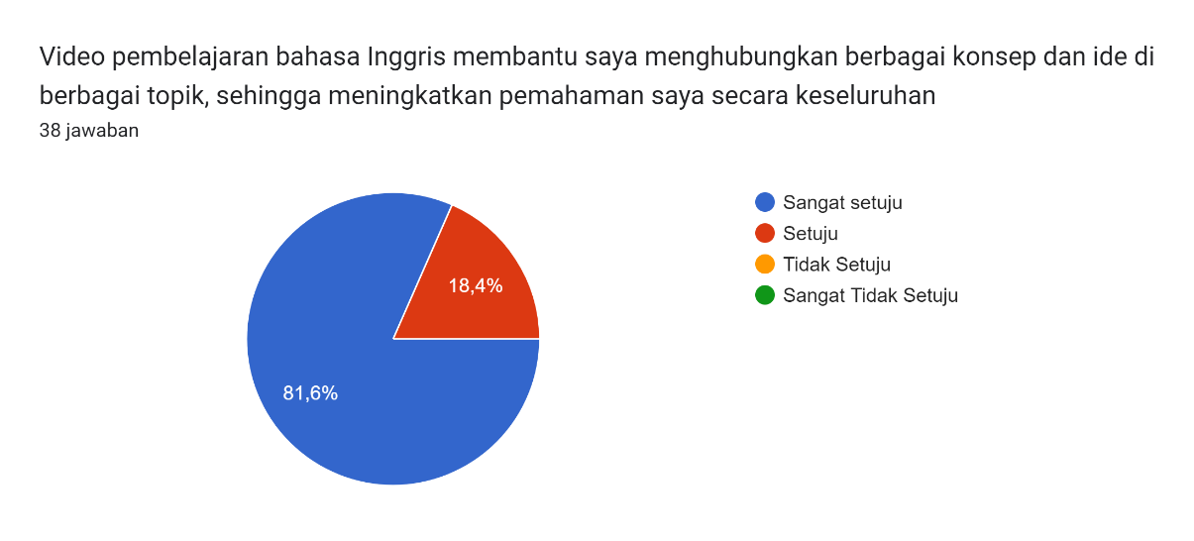
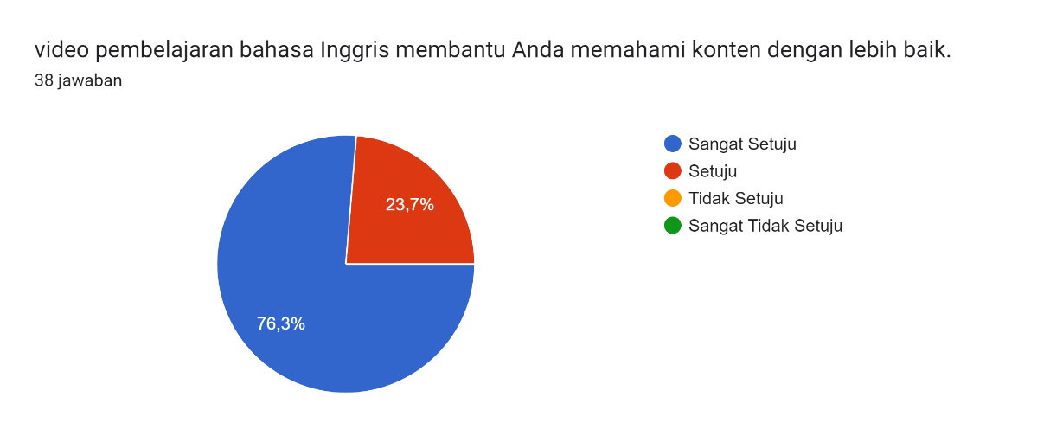
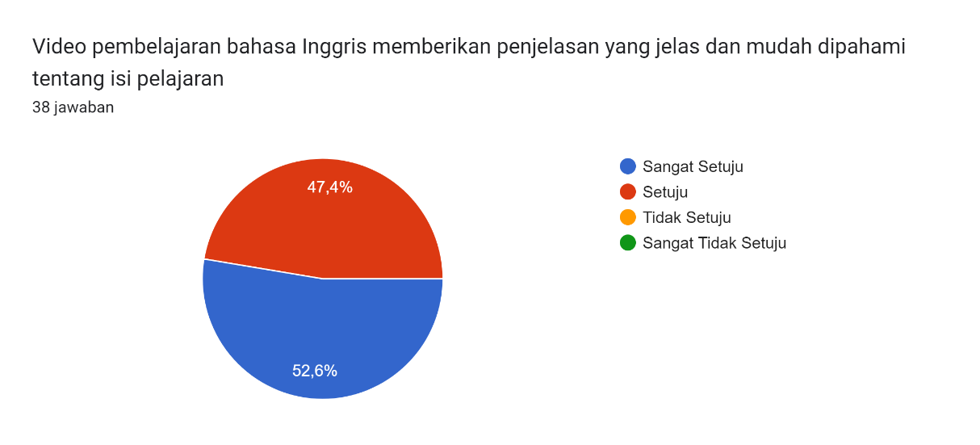

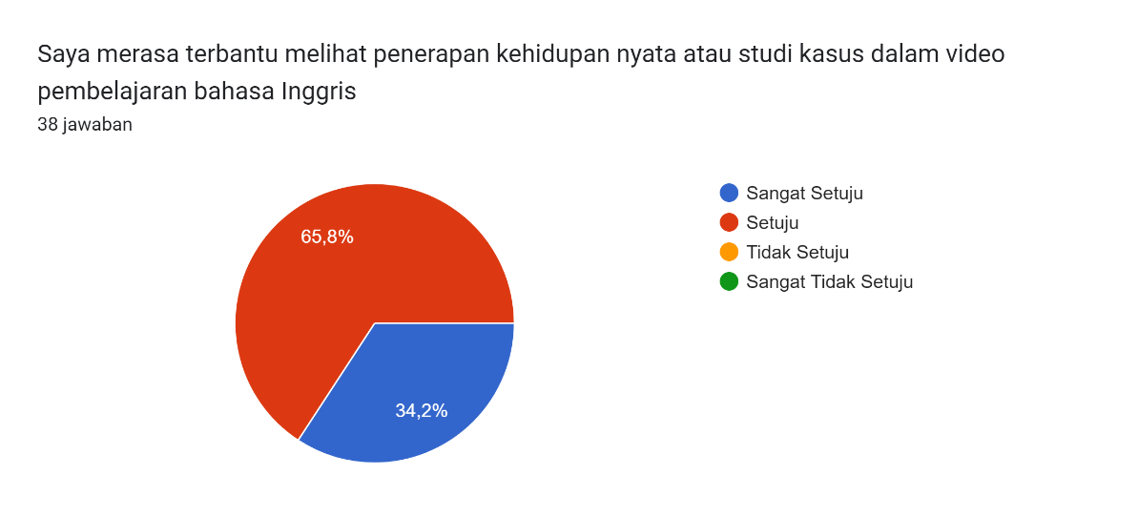
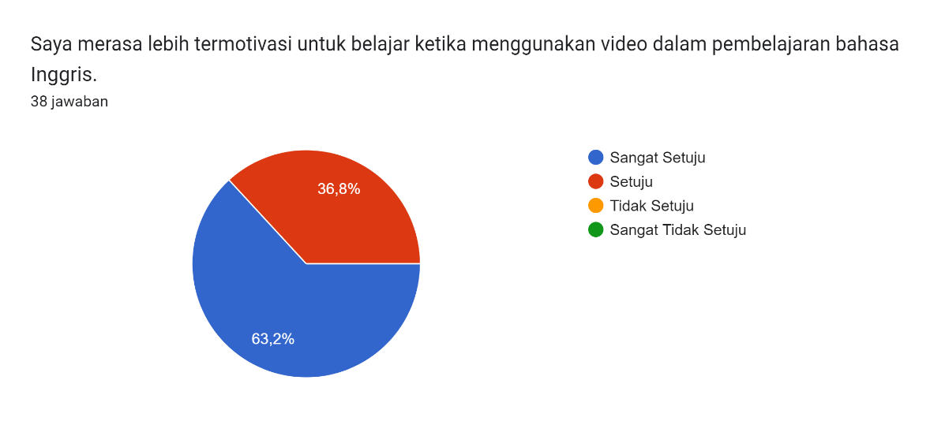
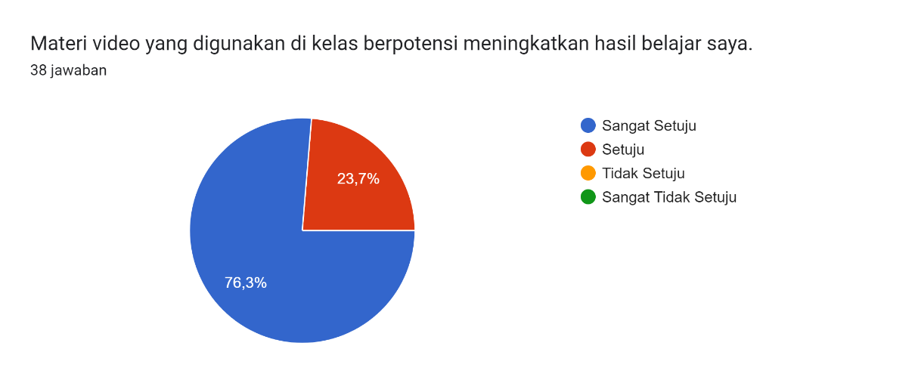

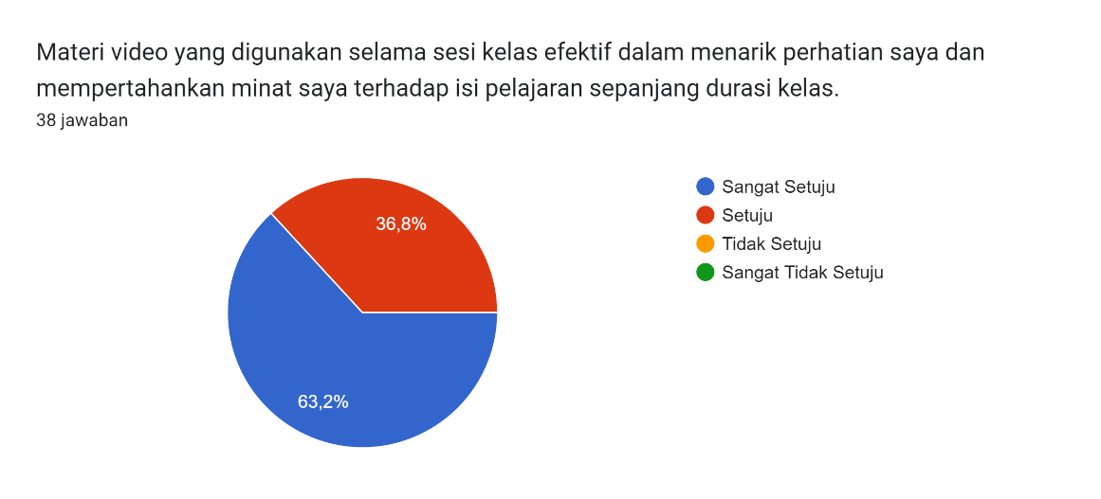

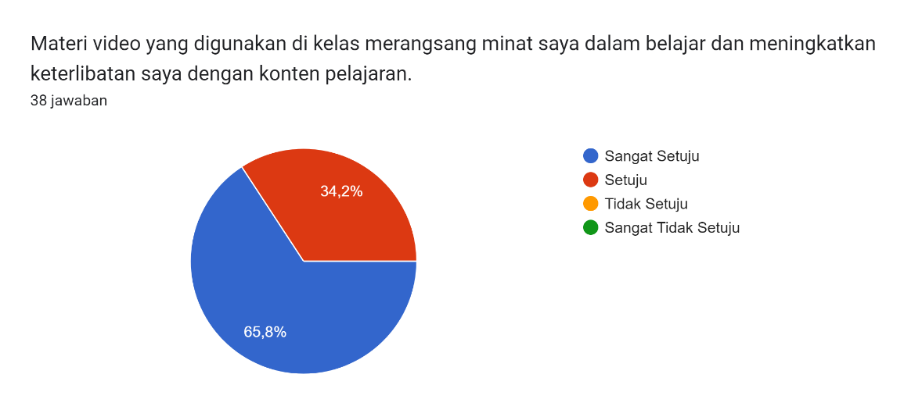

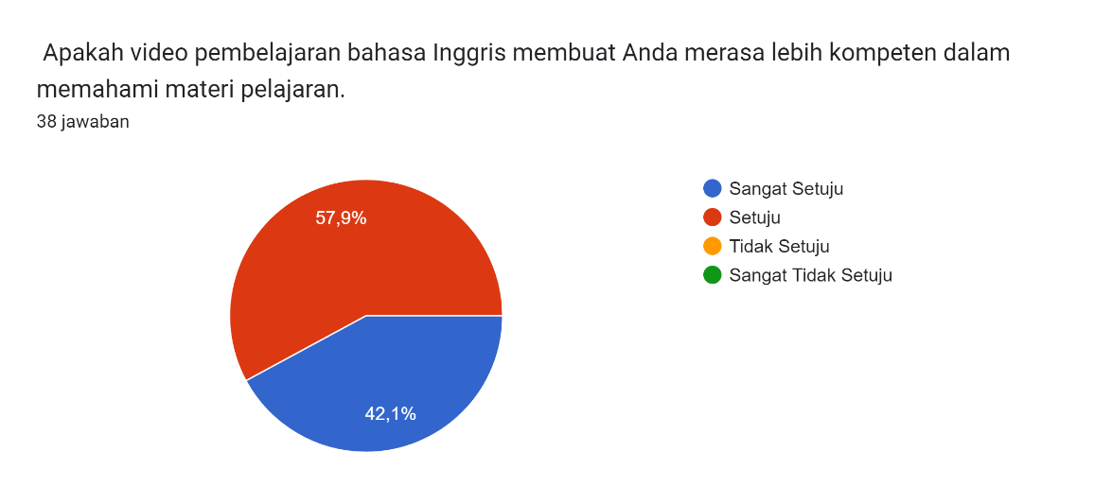

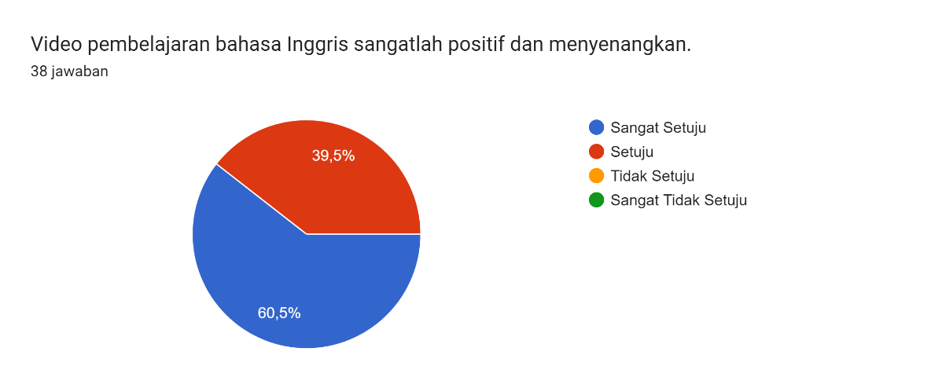
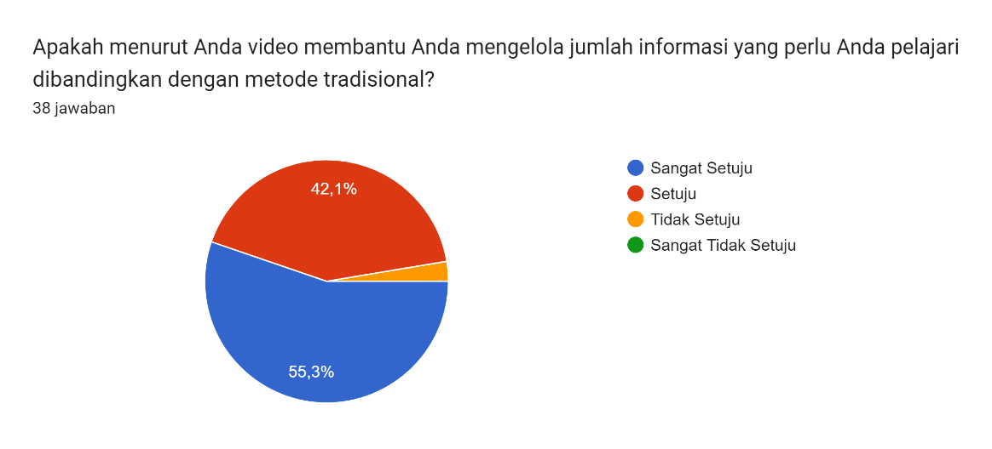
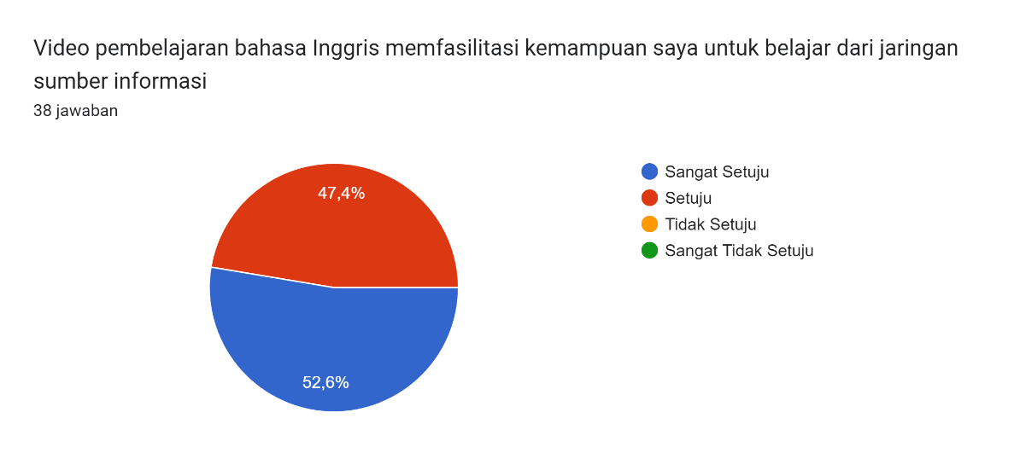
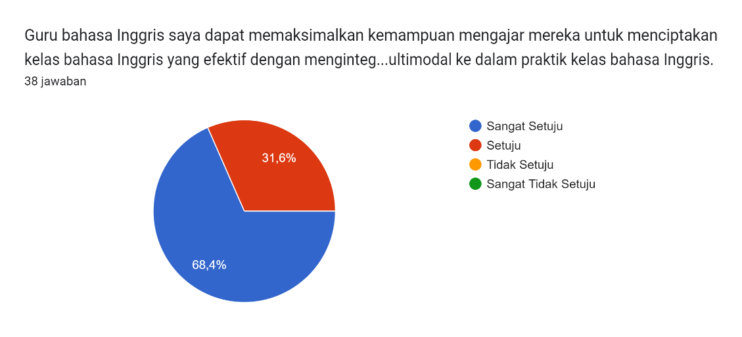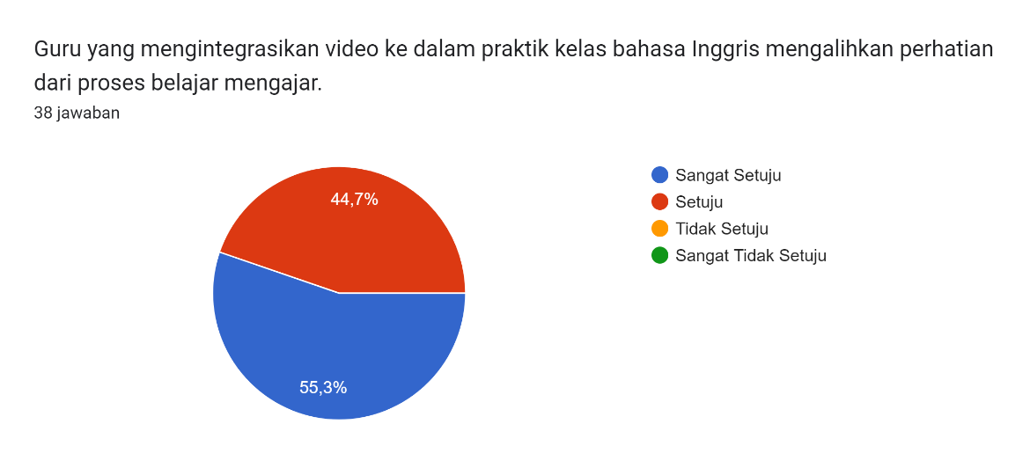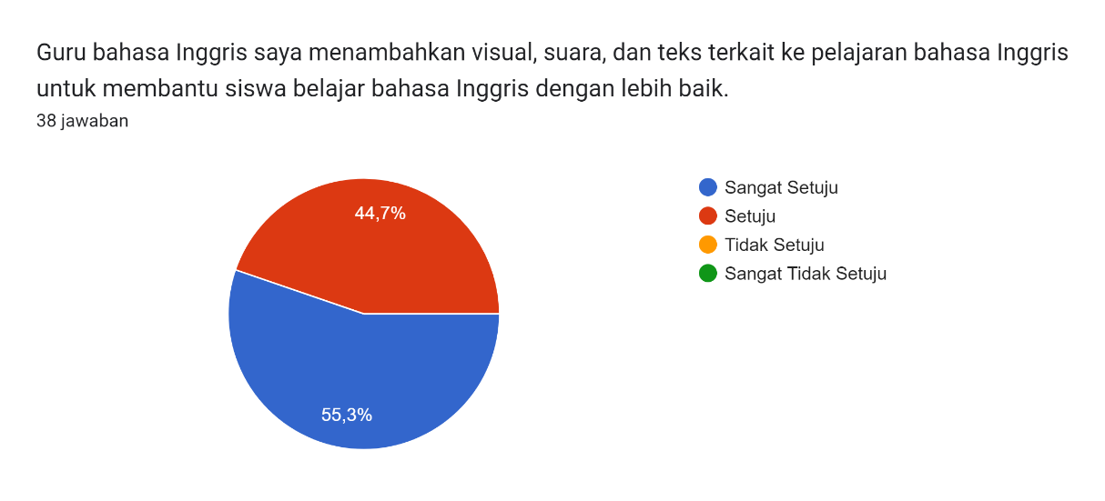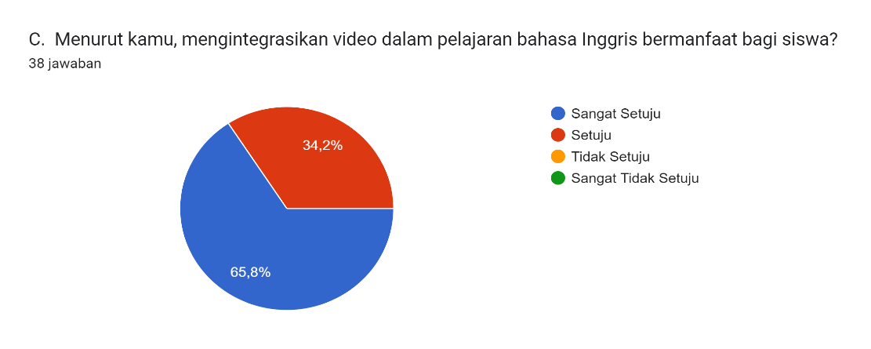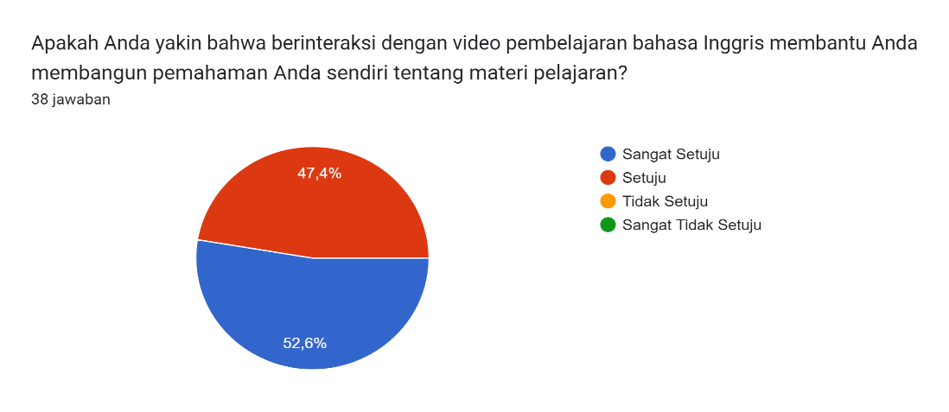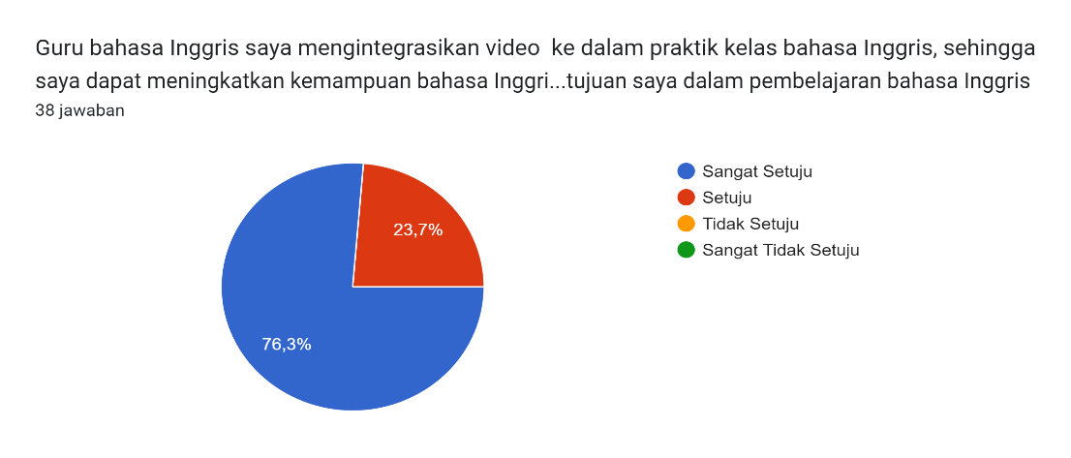
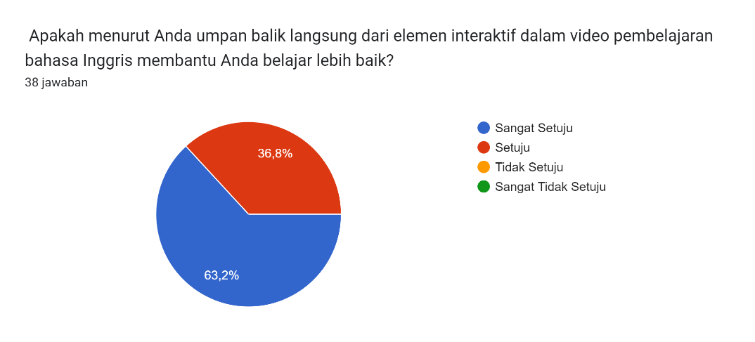

PERNYATAAN KESEDIAAN MENGIKUTI PENELITIAN
(INFORMED CONSENT)
Saya yang bertanda tangan di bawah ini:
Nama : Guru
Setelah mendapat penjelasan mengenai maksud dan tujuan serta memahami penelitian yang dilakukan dengan judul:
ANALYZING THE INTEGRATION OF MULTIMODAL VIDEO IN ENHANCING LEARNING OUTCOMES
Yang dibuat oleh:
Nama : Siti Farika
NIM : 20222011
Dengan ini saya menyatakan kesediaan untuk menjadi subjek penelitian dan bersedia melakukan pemeriksaan sesuai dengan data yang diperlukan.
Demikian pernyataan ini dibuat dengan penuh kesadaran tanpa ada paksaan dari pihak manapun.

Garut, 24 Juni 2024
Yang membuat pernyataan


Guru

APPENDIX C
LETTERS

SURAT PERMOHONAN IZIN PENELITIAN
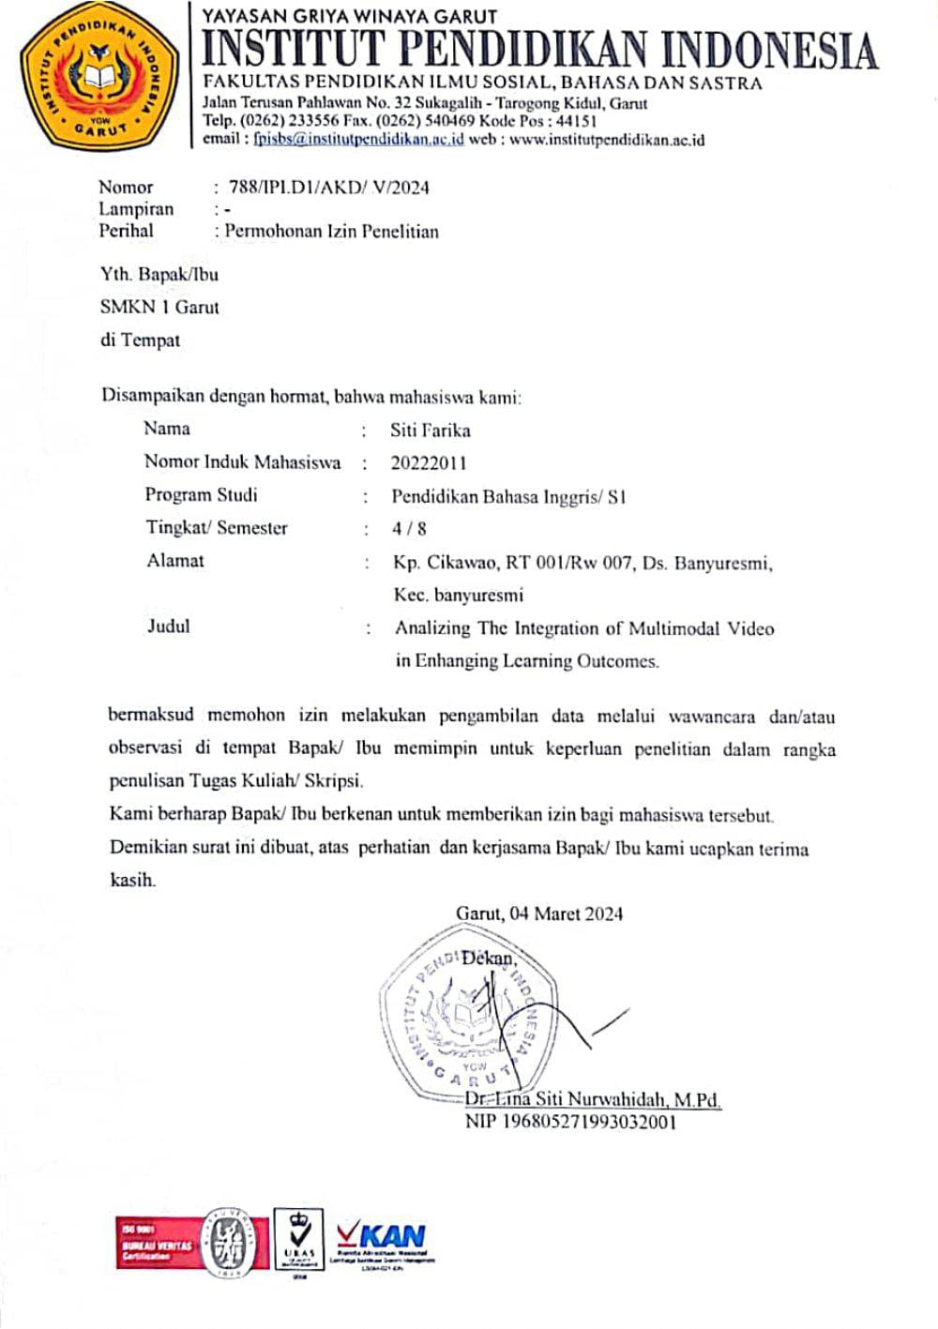

KARTU BIMBINGAN SKRIPSI
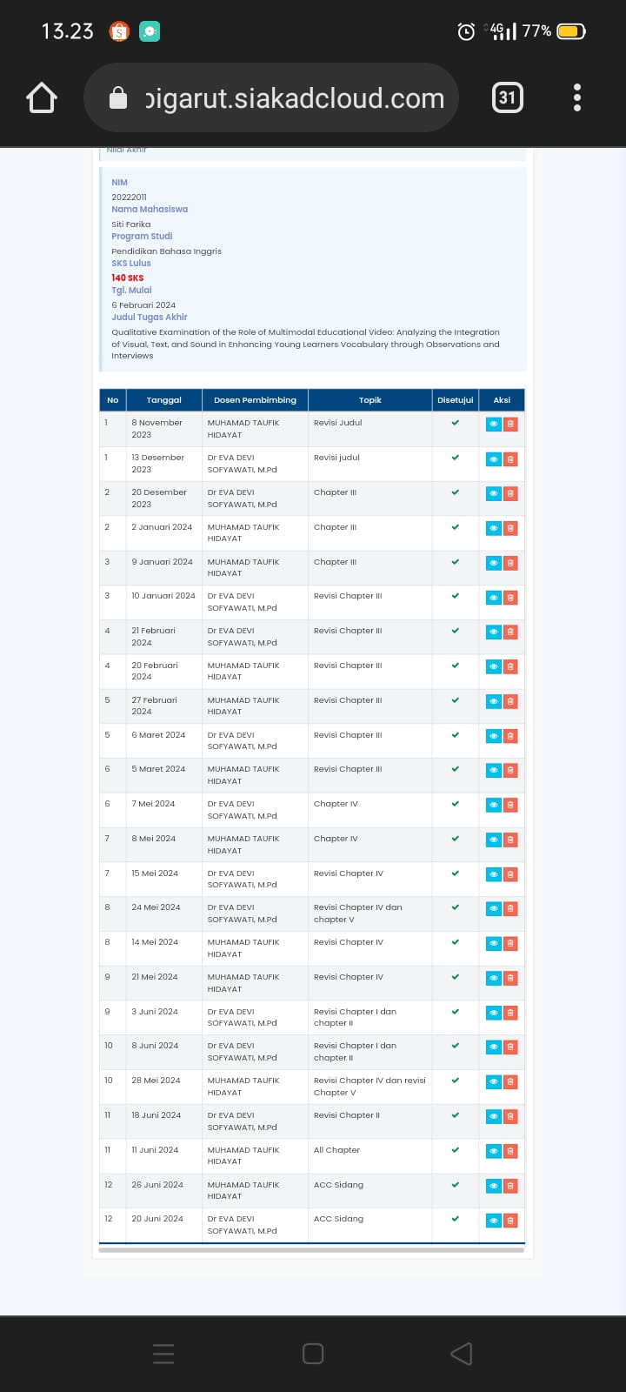

APPENDINCES D
PHOTO OBSERVATION

PHOTO OBSERVATION
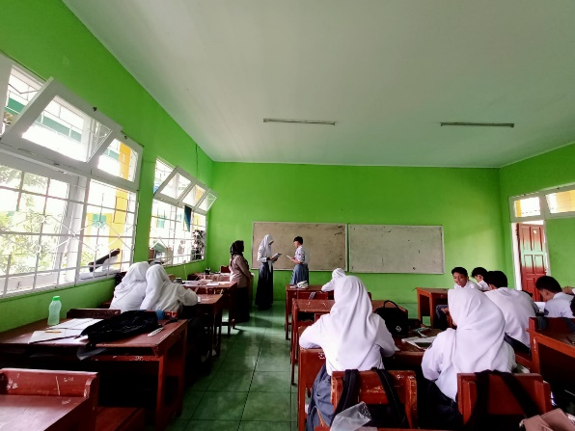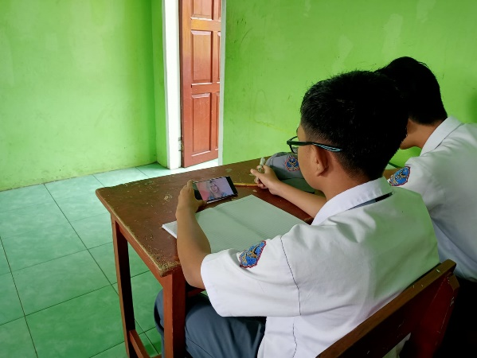
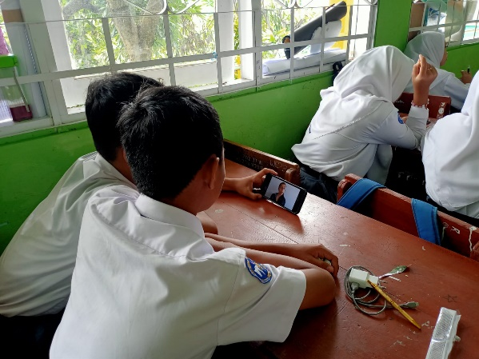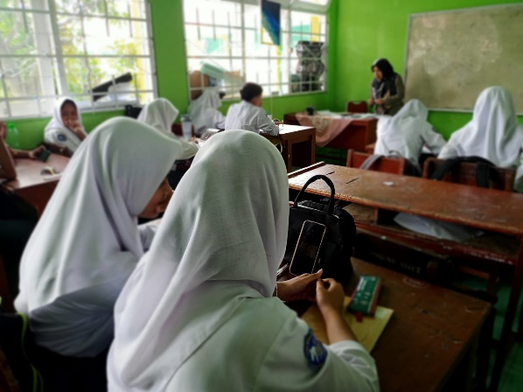

CURRICULUM VITAE


The author's name is Siti Farika. She is a student of the English Department of the Indonesian Education Institute (IPI) Garut. She was born on January 6 2001 in Garut. She is the second child of Aso and Siti Jubaedah. She has sisters named Sagita Alfianti and Devina Lutfah Hunaijah, and also a brother named Fahri Padilah. Her hobbies are writing quotes or poetry and listening to music. The author graduated from Al-Kautsar Kindergarten, Bandung in 2007. She continued to SDN 02 Banyuresmi, Garut, and graduated in 2013. Then he continued to Mts Darul Asyiqin, Garut, and graduated in 2016. After graduating she continued his studies at SMAN 25 Garut , and graduated in 2019. Next, the researcher decided to continue his studies at the English Language Education Program of the Indonesian Education Institute (IPI) Garut. She was able to complete his paper in 2024 with the title "Analyzing The Integration of Multimodal Resources In Enhancing Learning Outcomes." She has a strong determination to complete this paper so that he can make her parents proud and become a role model for her younger siblings.

