TEACHERS' CHALLENGES IN FACILITATING DIFFERENTIATED LEARNING: A CASE OF INDONESIAN ENGLISH TEACHERS IN IMPLEMENTING THE EMANCIPATED CURRICULUM
A PAPER
Submitted to the English Education Program of IPI Garut as partial fulfillment of the requirements for the Bachelor Education Degree


By:
Sintia Dewi
20224016

ENGLISH EDUCATION PROGRAM
FACULTY OF SOCIAL SCIENCE LANGUAGE AND LITERATURE EDUCATION
INSTITUT PENDIDIKAN INDONESIA GARUT
2024

APPROVAL SHEET

TEACHERS' CHALLENGES IN FACILITATING DIFFERENTIATED LEARNING: A CASE OF INDONESIAN ENGLISH TEACHERS IN IMPLEMENTING THE EMANCIPATED CURRICULUM

By:
Sintia Dewi
20224016

Approved by:

First Supervisor Second Supervisor

Dr. Setia Muljanto, M.Pd. Asep Suparman, M.Pd.
NIDN. 0419106705 NIDN. 0401098405

Acknowledged by:
Head of English Education Program

Anne Ratna Suminar, M.Pd.
NIDN. 0415038601

LEGITIMATION OF EXAMINATION BOARD

TEACHERS' CHALLENGES IN FACILITATING DIFFERENTIATED LEARNING: A CASE OF INDONESIAN ENGLISH TEACHERS IN IMPLEMENTING THE EMANCIPATED CURRICULUM
By:
Sintia Dewi
20224016
This paper has been examined on May 31st 2024
First Examiner, | Second Examiner, | Third Examiner,
Dr. Lucky R Nurjamin, M.Pd.  NIDN.0410098901 | Irsyad Nugraha, M.Pd.  NIDN. 0408038304 | Drs. Ateng Kurnia, M.Pd.  NIP. 196303231994031002
Acknowledged by:
Dean of Faculty of Social Science, Language, and Literature Education

Dr. Lina Siti Nurwahidah, M.Pd.
NIP. 196805271993032001

DECLARATION
The researcher hereby declares that the thesis entitled “Teachers’ Challenges In facilitating Differentiated Learning: A Case of Indonesian English Teachers in Implementing the Emancipated Curriculum” was absolutely written by the researcher. In connection with the use of any text, figure, data or either material copied from other source have been clearly acknowledged in references and citations with legal procedures. Therefore, the content of this paper is entirely the original work of the researcher. In this case, if there is any complaints or if the researcher infringes the statement, then the researcher is responsible for any consequences given.

Garut, May 2024
The Writer,

Sintia Dewi
NIM. 20224016

PERNYATAAN
Peneliti dengan ini menyatakan bahwa makalah yang berjudul “Teachers’ Challenges In facilitating Differentiated Learning: A Case of Indonesian English Teachers in Implementing the Emancipated Curriculum” ini benar-benar ditulis oleh peneliti. Penggunaan referensi, kutipan, dan sitasi dari literatur lain telah dilakukan berdasarkan kaidah pengutipan sesuai dengan etika ilmiah yang berlaku. Oleh karena itu, isi dan segala kelengkapannya merupakan karya asli peneliti. Dalam hal ini apabila ditemukan hal-hal yang tidak sesuai maka peneliti bertanggung jawab penuh atas segala akibat yang diberikan.

Garut, Mei 2024
Peneliti,

Sintia Dewi
NIM. 20224016

MOTTO

“Therefore remember, I will remember you, and be grateful to Me and never be ungrateful to Me’’
(Q.S. Al-Baqarah:152)

PREFACE
In the name of Allah and His permission the writer has completed this thesis. He who has blessed the writer with every amazing thing. This paper entitled “Teachers’ Challenges In facilitating Differentiated Learning: A Case of Indonesian English Teachers in Implementing the Emancipated Curriculum” is submitted to fulfill the requirement to get the Education Bachelor Degree of the English Education Program of IPI Garut. This thesis is also dedicated to everybody who supports the process. The writer admits the imperfection in writing this paper it is still far from being perfect. Thus, any suggestion and critic will be received openly.

Garut, May 2024
The Writer,

Sintia Dewi
NIM. 20224016

ABSTRACT

Differentiated learning is a significant aspect of the Emancipated Curriculum, tailored to accommodate individual student differences and learning styles. The aims of this research are to investigate the teachers’ challenges in facilitating differentiated learning based on the Emancipated Curriculum. The study employs qualitative methods, specifically semi-structured interviews with four English teachers from junior high schools in Garut who implement the Emancipated Curriculum. The results showed there are several teachers’ challenges in facilitating differentiated learning; the lack of time and effort in preparing and designing the learning process, mapping the diagnostic assessment, differentiated assessment, class size, student diversity, differentiated learning media, workload, lack of support fellow teachers, parental support. Based on the results that implementing differentiated learning is not easy. There are many challenges faced by teachers. Understanding and a lot of time and support are needed for the success of differentiated learning and motivating teachers to apply learning more optimally.
Keywords: Teachers’ Challenges, Emancipated Curriculum, Differentiated Learning

ABSTRAK

Pembelajaran yang terdiferensiasi merupakan aspek penting dari Kurikulum Merdeka, yang dirancang untuk mengakomodasi perbedaan individu siswa dan gaya belajar. Tujuan dari penelitian ini adalah untuk mengetahui tantangan guru dalam memfasilitasi pembelajaran berdiferensiasi berdasarkan Kurikulum Merdekai. Penelitian ini menggunakan metode kualitatif, khususnya wawancara semu-struktur terhadap empat guru bahasa Inggris SMP di Garut yang menerapkan Kurikulum Merdeka. Hasil penelitian menunjukkan terdapat beberapa tantangan guru dalam memfasilitasi pembelajaran berdiferensiasi; kurangnya waktu dan tenaga dalam mempersiapkan dan merancang proses pembelajaran, memetakan penilaian diagnostic, penilaian yang berbeda, ukuran kelas, keberagaman siswa, media pembelajaran yang berbeda, beban kerja, kurangnya dukungan sesama guru, dukungan orang tua. Berdasarkan hasil temuan bahwa menerapkan pembelajaran berdiferensiasi tidaklah mudah. Banyak sekali tantangan yang dihadapi oleh para guru. Pemahaman dan waktu serta dukungan yang banyak sangat diperlukan demi keberhasilan pembelajaran yang berdiferensiasi dan memotivasi guru untuk menerapkan pembelajaran dengan lebih maksimal.
Kata Kunci: Tantangan Guru, Kurikulum Emansipasi, Pembelajaran Diferensiasi

ACKNOWLEDGEMNT
In the name of Allah, the Beneficent, the Merciful, Praise to be Allah, for giving the strength and guidance to the writer for finish this paper. Peace and blessing be upon the prophet Muhammad SAW, His families, His friends, and His followers.
I would like to express my sincere gratitude for the advice, guidance, corrections, support, help, prayer, and encouragement from many people during writing this research paper. they are;
- Dr. H. Nizar Alam Hamdani, M.M., MT., M.Si., Rector of Institut Pendidikan Indonesia (IPI) Garut.
- Dr. Hj. Lina Siti N, M.Pd., the Dean of the Faculty of Social Science, Language, and Literature Education of Institut Pendidikan Indonesia (IPI) Garut.
- Anne Ratna Suminar, M.Pd., the Head of English Education Program.
- Dr. Setia Muljanto, S.E., as the first supervisor who has guided me with his solutions, suggestions and constructive corrections, to improve the quality of this research paper.
- Asep Suparman, M.Pd., as the second supervisor who has guided me with his solutions, suggestions and constructive corrections, to improve the quality of this research paper.
- My beloved mother and my father, Mrs. Eha Julaeha and Mr. Didi, who always praying for me every time and provide endless moral and financial support to researcher with patience, and sincerity. Thank you for giving me lots of love and surrounding me with kindness.
- My beloved brother and sister, Dodi and Ani, who always give prayers and encouragement.
- The big family of HIMADIKSARIS which has become a place to develop themselves, find talents in themselves, and provide extraordinary experiences and memories.
- All of my friends of English Education Program 2020, especially class C, You guys are incredible!

- My beloved comrade, Erik Kurniawan who always provides support, direction, and motivation to complete this thesis.
- My supportive friends, Hilsa, Ainun, Novia, Asti, Mitha, Salma, Zihan and Zeni, thank you for all the great memories.
- My dearest friends, Neneng, Irin, Firman, who always supported me.
- Other parties who cannot be mentioned one by one who have given support and prayers either directly or indirectly for the smooth preparation of this thesis.
- Lastly, thank you to myself for always trying my best and trying to complete a very challenging thesis. Thank you for sticking around and showing everyone that you can pass all stages well. I'm so proud of myself!

TABLE OF CONTENT
APPROVAL SHEET i
LEGITIMATION OF EXAMINATION BOARD ii
DECLARATION iii
PERNYATAAN iv
MOTTO v
PREFACE vi
ABSTRACT vii
ABSTRAK viii
ACKNOWLEDGEMNT ix
TABLE OF CONTENT xi
LIST OF TABLE xiv
CHAPTER I INTRODUCTION 1
1.1 The Background of the study 1
1.2 Reasons for Choosing the Topic 4
1.3 Research Question 4
1.4 Research Objective 4
1.5 The significant of the study 4
1.6 Research Methodology 5
1.7 Definition of Terminologies 5
CHAPTER II LITERATURE REVIEW 6
2.1 Curriculum 6
2.2 The Changes of Curriculum 6
2.3 The 2013 Curriculum 7
2.3.1 The Characteristic of 2013 Curriculum 7
2.3.2 Components of 2013 Curriculum 8
2.3.3 The advantages and disadvantages of the 2013 curriculum 10
2.4 Emancipated Curriculum 11
2.4.1 The Advantages and Disadvantages of the Emancipated Curriculum 11
2.5 The Differences between the 2013 Curriculum and the Emancipated Curriculum 12
2.6 Differentiated Learning 14
2.6.1 Components of Differentiated Learning 15
2.6.2 Principles of Differentiated Learning 16
2.6.3 Teaching Modules 17
2.7 Teachers' challenges in facilitating differentiated learning 18
2.7.1 Planning and Preparation 19
2.7.2 Classroom Management 19
2.7.3 Assessment 20
2.7.4 Professional Development and Support 21
2.8 Previous Related Studies 22
CHAPTER III RESEARCH METHODOLOGY 24
3.1 Research Method 24
3.2 Research Design 24
3.3 Research Setting and Participants 25
3.4 Research Instruments 25
3.5 Technique of Data Collection 25
3.5 Research Procedure 26
3.6 Technique of Data Analysis 26
CHAPTER IV FINDINGS AND DISCUSSION 28
4.1 Research Findings 28
4.1.1 Time and effort in preparing and designing the learning process 29
4.1.2 Mapping the Diagnostic Assessment 29
4.1.3 Differentiated assessment. 30
4.1.4 Class Size 31
4.1.5 Student diversity 31
4.1.6 Differentiated learning media 32
4.1.7 Workload 33
4.1.8 Lack of support fellow teachers 34
4.1.9 Parental Support 35
4.2 Research Discussion 35
CHAPTER V CONCLUSION, LIMITATION AND SUGGESTIONS 38
5.1 Conclusion 38
5.2 Limitations of the Study 38
5.3 Suggestions 38
5.3.1 For English Teachers 39
5.3.2 For the School 39
5.3.3 For Future Researchers 39
REFERENCES 40
APPENDICES 43
APPENDIX 1 44
INSTRUMENT GRID 44
APPENDIX 2 46
MODUL AJAR 46
APPENDIX 3 63
RESEARCH TRANSCRIPT AND INFORMED CONSENT 63
APPENDIX 4 79
LETTERS 79
APPENDIX 5 82
SUPERVISION CARD 82
APPENDIX 6 83
DOCUMENTATION OF THE INTERVIEW 83
CURRICULUM VITAE 84

LIST OF TABLE
Table 1.1 Research Procedure 38

CHAPTER I
INTRODUCTION

This introduction chapter provides the background of the research, the research questions, the purpose of the study, the reason for choosing the topic, the significances of the study, the limitations of the study and definition of terms.

1.1 The Background of the study
Education is a learning process activity to acquire knowledge and skills. To achieve educational goals, one of the important roles in the world of education is the curriculum. According to UU no. 20 (2003) Curriculum is a set of plans & arrangements relating to objectives, content, teaching materials & methods used as guidelines in organizing learning activities to achieve national education goals.
In Indonesia, the implementation of the curriculum has undergone changes from 1964 to 2013. Curriculum changes occurred due to adapting to advances in time and technology, because if no changes are made then education in Indonesia will experience delays compared to the education of other nations. Curriculum changes in Indonesia is not last long, so teachers as educators are expected to be able to adapt to these changes to improve the quality of education (Anwar, 2021).
One important aspect of the Emancipated Curriculum is differentiated learning, which recognizes students' individual differences and provides learning experiences that suit their needs and interests. According to Febrianti et al (2022) Differentiated learning is learning that can adapt to the needs of students by facilitating them according to each individual's readiness, interests and learning style. In line with Tomlinson (2001: 45), differentiated learning is an effort to adapt the learning process in the classroom to meet the individual learning needs of each student. In differentiated learning, the teacher's attention is completely taken over by the students so that they feel cared for.
This learning also trains teachers to know the differences in learning responses of each student so that students feel comfortable in the learning process (Febrianti et al., 2022).
Each student has uniqueness and diversity inherent in each child, including the child's learning style. According to Widayanti (2013) there are three types of learning styles consisting of visual, auditory and kinesthetic learning styles. Similarly, with differentiated learning, teachers divide groups of students according to their respective learning styles through an initial diagnostic assessment which is given with the aim of identifying or knowing the characteristics, competency conditions, strengths and weaknesses of students' learning models, so that learning can be designed according to their competencies and student conditions. According to Mardhiyati et al (2023), there are three main approaches to differentiated learning, namely content, process and product. 1) Content, students learn about topics with connections and learning sources. 2) Process, how students choose their learning style. 3) Product, students present what they have learned.
In learning there are learning plans such as in the Emancipation Curriculum, the learning plan is a Teaching Module where the module contains learning outcomes, objectives, learning media, learning methods and activities, as well as assessments required in one unit or topic based on the learning flow so that learning becomes more relevant. Like the Teaching Module that researchers get from the school to be investigated, there is self-introduction text and descriptive text material. In learning, students observe videos or illustrated stories presented by the teacher according to their respective learning styles, students are guided to observe information and learn vocabulary related to self-introduction (Drill and Practice), students develop and present the results of their work after that they analyze and evaluate problem solving process (Problem Based Learning). This teaching module places more emphasis on writing and speaking skills
Even though the differentiated learning is recognized as being able to provide learning experiences that suit students' needs and interests, differentiated learning is a challenge for teachers. Teachers need to understand students' needs and characteristics well, and provide various types of learning resources and learning activities that can be accessed and carried out by students in different ways. The various characters possessed by students are a challenge for teachers in differentiated learning, which is the practice of adapting the curriculum, teaching strategies, assessment strategies, and classroom environment to the needs of all students (Rofiul et al., 2023).
Many previous studies have studied teachers' challenges in differentiated learning, for example Suryati et al (2023) investigated Teachers’ Challenges in Implementing Differentiated Instruction in Teaching English At One of West Java Junior High School, and found that 1) Time and effort in preparing and designing the learning process. 2) Lack of support from fellow teachers.
In line with Shareefa et al (2019) investigated Differentiated Instruction: Definition and Challenging Factors Perceived by Teachers, and found that 1) Use of different strategies 2) Addressing student diversity 3) Advancement 4) Time 5) Resources 6) Knowledge 7) Class size 8) Support 9) Workload.
Febrianti et al (2023) investigated Analisis Kesulitan Guru Biologi SMAN 2 Pandeglang dalam Mengimplementasikan Pembelajaran Terdiferensiasi, and found that the limited time that causes teachers to be more careful in mapping time both in mapping the Cognitive Diagnostic Assessment (ADK) or mapping the material for each meeting.
Apart from that, A. Ahmed (2022) Investigated the Challenges Encountered by EFL Teachers in Practicing Differentiated Instruction in the Multiple – Intelligence Classes at University, and the result shows time constraints, heavy workloads, and large classes that would impede teachers’ objectives in maintaining differentiated instruction for tailoring every learner’s interest and achieve higher level of academic success in teaching multiple intelligence classes.
Although from the previous studies above, an investigation into the differentiated Learning was carried out. Investigations regarding the teachers’ challenges in facilitating differentiated learning in Indonesian English teachers at junior high school is still under research especially in Garut. Therefore, in line with this, this research attempts to fill this gap by investigating Teachers’ Challenges In facilitating Differentiated Learning: A Case of Indonesian English Teachers in Implementing the Emancipated Curriculum.

1.2 Reasons for Choosing the Topic
Based on the explanation above, researchers want to learn more about differentiated learning, especially teachers' challenges in facilitating in differentiated learning because in Indonesia there is still under research especially in Garut.

1.3 Research Question
From the background study above the research question of this study is:
What are teachers’ challenges in facilitating differentiated learning based on the Emancipated Curriculum?

1.4 Research Objective
Based on the research question above the research objective of this study is attempted to investigate the teachers’ challenges in facilitating differentiated learning based on the Emancipated Curriculum.

1.5 The significant of the study
- Teachers
This study will be useful as a reference source in implementing the differentiated learning in Emancipated Curriculum especially for four English teachers in Garut.
- Junior High School
This study may serve as information for improvements in Differentiated learning in implementing the Emancipated Curriculum especially in EFL English Classroom
- Future Researchers
Future researchers should explore more deeply the Differentiated Learning of the Emancipated Curriculum in English subjects. Apart from that, further research can also compare teachers' challenges in differentiated learning of the Emancipated Curriculum with other curricula used by schools.

1.6 Research Methodology
Researcher would like to investigate teacher’s challenges in facilitating differentiated learning based on the Emancipated Curriculum using qualitative methods by interviewing four English teachers in junior high school in Garut who implement the Emancipated Curriculum.

1.7 Definition of Terminologies
- Teacher
A teacher is a professional educator who educates, teaches knowledge, guides, trains, provides assessments, and evaluates students (Safitri, 2019).
- Challenges
According to Cambridge Dictionary (2020), Teacher challenges refer to the situation when a teacher is confronted with something that requires excessive mental and physical determination to be successful and consequently tests his/her capability.
- Emancipated Curriculum
The Emancipated Curriculum is a curriculum with diverse intracurricular learning where the content will be more optimal so that students have enough time to deepen concepts and strengthen competencies (Kemendibud.go.id, 2022).

CHAPTER II
LITERATURE REVIEW

In this chapter the researcher presents about theoretical description, previous study, rationale, and hypothesis. There were several theories relating to this study's foundation.

2.1 Curriculum
According to history, the linguistic curriculum was originally a curriculum found in the world of athletics in ancient Greece, which comes from the words curir, which means runner, and curere, which means a place to race or a place to compete. Meanwhile, curriculum means "distance" that must be covered by runners (Nurdin, 2002). According to Hamalik (2007: 65) Curriculum is a program education provided by an educational institution or in this case a school that is given to its students.

2.2 The Changes of Curriculum
Since 1945 the Indonesian education curriculum has undergone changes, namely in 1947, 1952, 1964, 1968, 1975, 1984, 1994, 2004, 2006 (KTSP), 2013, and currently is the emancipated curriculum. These changes are a logical consequence of changes in political, social, cultural, economic and science and technology systems in society. Curriculum changes occurred due to adapting to advances in time and technology, because if no changes are made then education in Indonesia will experience delays compared to the education of other nations. Curriculum changes in Indonesia is not last long, so teachers as educators are expected to be able to adapt to these changes to improve the quality of education (Anwar, 2021). The 2013 curriculum is considered inflexible and unable to adapt to changes that occur in the world of education and society. A curriculum that adapts to social changes, technological advances, and the needs of the world of work is needed in today's digital and global era (Gumilar et al., 2023). Therefore, the 2013 curriculum was changed to the emancipated curriculum. The emancipated curriculum is a real effort government to improve quality education related to demands era 5.0 society (Manalu et al., 2022).

2.3 The 2013 Curriculum
The 2013 curriculum is an educational curriculum introduced in Indonesia in 2013. This curriculum replaces the previously used Education Unit Level Curriculum (KTSP). The main objective of the 2013 Curriculum is to improve the quality of education in Indonesia by focusing on developing the competence of students. The 2013 curriculum combines three domains competencies: attitudes, knowledge, and skills. Core competency 1 (KI-1) includes spiritual attitude, Core Competency 2 (KI-2) includes social attitudes, competencies Core 3 (KI-3) includes knowledge, and Core Competency 4 (KI-4) includes skills (Gumilar et al., 2023).

2.3.1 The Characteristic of 2013 Curriculum
According to Kurikulum.kemendikbud.go.id there are has seven characteristics of the 2013 curriculum:
- Develop a balance between the development of specific and social attitudes, curiosity, creativity, cooperation with intellectual abilities with psychomotor.
- The school is part of a community that provides a planned learning experience where students apply what is learned in school to the community and use the community as a learning resource.
- Develop attitudes, knowledge and skills and apply them in various situations in schools and communities.
- Give ample time to develop various attitudes, knowledge and skills.
- Competencies are expressed in the form of class core competencies which are further detailed in the subject's basic competencies.
- The core competencies of the class become the organizing elements of the basic competencies and the learning process is developed to achieve the competencies stated in the core competencies.
- Basic competencies are developed based on the principle of accumulative, mutually reinforcing and enriching between subjects and levels of education (horizontal and vertical organization).

2.3.2 Components of 2013 Curriculum
The 2013 curriculum has five components. The five components are closely related and inseparable (Purwati et al., 2013).
- The Aims of curriculum
In Minister of Education and Culture Regulation No. 69 of 2013 stated that the aim education in the 2013 Curriculum, namely: The 2013 Curriculum aims to prepare Indonesian people to have abilities live as individuals and citizens who are faithful, productive, creative, innovative, and affective and able to contribute to life society, nation, state and world civilization.
- Learning materials
The study of learning materials is based on the research and educational theories developed, which are organized and systematic in the form of:
- Theories; a set of constructs or concepts, definitions or prepositions interconnected, which presents systematic opinion about symptoms by specifying the relationships between them variables with the intent of explaining and predicting these symptoms.
- Concepts; an abstraction formed by the organization of specificity, is a short definition of a group of facts or symptoms.
- Generalizations; general conclusions based on specific matters, originating from analysis, opinions or evidence in research.
- Principles, namely the main idea, the schematic pattern existing in the material that develops the relationship between several concepts.
- Procedures, namely a series of sequential steps in the material lessons that students must do.
- Facts; a number of special information in the material that is considered important, consisting of terminology, people and places and events.
- Terms, new and special vocabulary words introduced in the material.
- Examples/illustrations, namely things or actions or processes that have a purpose to clarify a description or opinion.
- Definition: namely an explanation of the meaning or understanding of a thing/word in outline.
- Prepositions, namely the method used to convey material lessons in an effort to achieve curriculum goals.
- Learning strategies
The implementation strategy is a curriculum that focuses on teaching, learning, planning, implementing, and implementing school activities effectively. According to Fadillah (2014), In K13 learning there are several principles that must be implemented be paid attention to by the teachers in implementing it learning (1) centered on students, (2) develop students' creativity; (3) creating conditions fun and challenging; (4) contains values, ethics, aesthetics, logic, and kinesthetics; (5) provide a good learning experience diverse through the application of various strategies and methods learning that is fun, contextual, effective, efficient, and meaningful.
- Curriculum organization
The use of rhetoric in curriculum development encourages the use of conflict in curriculum organization. There is six types of curriculum organization (Poerwati, 2013)
- Isolated subject; The curriculum consists of a number of separate subjects are taught independently without any connection with other subjects. Each is given at a certain time and does not take into account the interests, needs and abilities of the participants students, all material is given the same.
- Correlated subjects; correlation is held as an attempt to reduces weaknesses as a result of eye separation lesson. The procedure taken is to convey the main points that correlate with each other to make it easier for students understand certain lessons.
- Broad field; namely the organization of the curriculum in the form of a collection of several similar and similar subjects the same characteristics and are correlated (functionalized) in one teaching field.
- Child centered; namely a curriculum program that focuses on student activities, not on subjects.
- Core program; namely a program in the form of problem units, where problems are taken from a certain subject, and other subjects are given through learning activities in an effort to solve the problem. Subjects that become knives the analysis is provided in an integrated manner.
- Eclectic program; namely a program that seeks balance between subject-centered curriculum organization and learners.
- Curriculum Evaluation
Curriculum evaluation is an important process for evaluating the effectiveness, relevance and suitability of the curriculum to educational goals and the needs of students and society. This evaluation is usually carried out periodically to ensure that the curriculum meets established educational standards and continues to develop according to current developments and needs.

2.3.3 The advantages and disadvantages of the 2013 curriculum
According to Albantani (2015), the advantages and disadvantages of the 2013 curriculum are:
- The Advantages of the 2013 curriculum
- Creative and innovative
- Moral and character education integrated into all study programs and subjects
- The Disadvantages of the 2013 curriculum
- Seeing teachers and students have capacity the same one
- There is no balance between orientations learning process and in the 2013 curriculum and excluded examination subjects national

2.4 Emancipated Curriculum
The Emancipated Curriculum was developed as a more flexible curriculum framework, while remaining focused on essential material and developing the character and competencies of students (Kemendikbud.go.id). The aim of Emancipated Curriculum is to catch up with learning delays caused by the Covid-19 pandemic, develop students, and create enjoyable education. Emancipated Curriculum gives educators the freedom to create quality learning that suits students' needs and learning environment.
According to the Ministry of Education and Culture (2022), in the Emancipated Curriculum there are 2 structural stages, namely:
- Intracurricular learning with the main school activities carried out by allocating time that has been determined in the program structure
- The Pancasila student profile.
The Pancasila Student Profile Character is formulated from Indonesia's national education goals (Kahfi, 2022). The Pancasila Student Profile has 6 dimensions character, namely faith, devotion to God Almighty and noble character, working together, global diversity, critical reasoning, creativity and independence ('Inayah, 2021). The Pancasila Student Profile is realized through learning at school including face-to-face (Intracurricular), project-based extracurricular and co-curricular learning (Ismail, et al., 2020). Intracurricular learning covers 70-80% of lesson hours and co-curricular learning covers 20-30% of lesson hours (Wulandari, 2022). The Pancasila student profile encourages students to contribute to the surrounding environment, have potential, be intelligent and have character. The implementation project of strengthening the profile of Pancasila students is carried out flexibly, both in terms of content and implementation time and has been implemented in schools that use the Emancipated Curriculum.

2.4.1 The Advantages and Disadvantages of the Emancipated Curriculum
- The advantages of the Emancipated Curriculum according to Hamdani (2022) are as follows:
  - Simpler and deeper
The essential material is the focus of the Merdeka Curriculum. Simple and deep learning without haste will be more absorbed by students. Deep learning with a fun design will make students more focused and interested in learning.
  - More independent
The Merdeka Curriculum is a benchmark in designing learning. The concept of independence that is given gives freedom to the teacher in designing the learning process according to the needs and learning outcomes.
  - More relevant and interactive
Learning process activities that are more relevant and interactive will have a good impact when applied in the learning process. Interactive learning will make students more interested and able to develop their competencies.
- The Disadvantages of The Emancipated Curriculum according to Supriatna et al (2023)
- The emancipated curriculum is still far from perfect in terms of implementation
- Education system and the planned teaching has not been completely successful
- Unstructured system and shortage of human resources (HR)

2.5 The Differences between the 2013 Curriculum and the Emancipated Curriculum
According to Kemendikbud.go.id, there are three characteristics of Emancipated Curriculum:
- Soft Skills and Character Development
Developing soft skills and character through a project to strengthen the profile of Pancasila students.
- Focus on Essential Material
Focus on essential, relevant and in-depth material so that there is sufficient time to build students' creativity and innovation in achieving basic competencies such as literacy and numeracy.
- Flexible Learning
Freedom for teachers to carry out learning that is appropriate to the stage of achievement and development of each student and to make adjustments to the context and locale.
Based on Nisa’ (2022), the following is a comparison of the 2013 Curriculum and the 2022 Emancipated Curriculum:
- Basic framework
In 2013 Curriculum, Based on the objectives of the national education system and national education standards. While in Emancipated Curriculum based on the objectives of the national education system and national education standards and develop the Profil Pelajar Pancasila.
- Targeted competence
In 2013 Curriculum, Kompetensi Inti (KI) and Kompetensi Dasar (KD). While in Emancipated Curriculum, earning outcomes are compiled for each phase (KI and KD are integrated) and there is Alur Tujuan Pembelajaran.
- Curriculum structure
In 2013 Curriculum, use allocation of lesson hour is set every week and has been systemized. Still focused on intra-curricular learning. While in Emancipated Curriculum, the allocation of lesson hour is regulated every year according to the conditions of the education unit. The first two lessons, namely intra-curricular and co-curricular.
- Learning
In 2013 Curriculum learning uses a scientific approach for all subjects. While in Emancipated Curriculum strengthening differentiated learning according to the stage of student achievement.
- Assessment
In 2013 Curriculum;
- Formative and summative assessment to detect the need for continuous improvement of student learning outcomes.
- Authentic assessment of each lesson.
- Assessment of 3 domains, namely attitude, social, and spiritual.
While in Emancipated Curriculum;
    - Strengthening the formative assessment to design learning according to the stage of student achievement.
    - Authentic assessment, especially the P5
    - There is no separation of attitude, social, and spiritual assessment.
- Teaching tools provided by the government.
In 2013 Curriculum is using textbooks and non-text books. While in Emancipated Curriculum are using textbooks and non-text books. Examples of Modul Ajar, Alur Tujuan Pembelajaran, examples of P5, examples of the operational curriculum of education units.
Based on what researchers have read from these two differences, it can be concluded that 2013 curriculum is more structured with a competency approach while the emancipated curriculum provides more freedom and flexibility for students.

2.6 Differentiated Learning
Differentiated Learning is one of the important aspects of Emancipated Curriculum. According to (Breaux & Elizabeth, 2013), Differentiated learning is a teaching and learning process that allows students to learn subject matter according to their abilities, what they like, and their respective needs so that they are not frustrated and feel failed in their learning experience. This is one way that teachers can meet the needs of each student. In line with Tomlinson (2001: 45), differentiated learning is an effort to adapt the learning process in the classroom to meet the individual learning needs of each student. In differentiated learning, the teacher's attention is completely taken over by the students so that they feel cared for. Differentiated learning does not mean that teachers have to teach in 30 different ways to teach 30 students. Nor does it mean that teachers have to increase the number of questions for students who work faster than others. Differentiated learning also does not mean that teachers have to group the smart with the smart and the less with the less. Nor do you give different tasks to each child.

2.6.1 Components of Differentiated Learning
There are three components of differentiated learning according to Mardhiyati et al (2023):
- Content
Content refers to information presented to learners to understand and learn. The teacher must play a role in adjusting to the material to be taught. Learning that is differentiated based on its content attaches importance to the material provided to learners. Content grouping is done based on factors such as response, readiness, learning combination, interests, and learning profile. Strategies that can be applied by teachers to distinguish the content delivered to students, namely varied material, the use of consent in the learning process, organizing mini learning sessions, and presenting material with various learning models.
- Process
Differentiated learning in school processes refers to usage strategies adapted to meet the diverse needs, learning styles, and skill levels among students. Teachers do not understand the individual differences of students, trying to provide support and challenges appropriate to the level of ability of each. Differentiated learning also reflects a strategic delivery of the curriculum, allowing schools to provide relevant and meaningful learning experiences, motivating students to develop critical skills, problem solving, and collaboration. Efforts to differentiate the learning process have actions that need to be applied, namely ensuring that students have an equal understanding, providing guidance to encourage students, individualized learning programs, providing perfection, and creating various learning styles.
- Product
Differentiated learning in products in the school environment refers to strategies for developing educational products or services to meet the diverse needs among students. It involves providing a variety of learning tools, teaching materials, and teaching methods tailored to the learning style, interests, and level of understanding of students. Differentiated learning can include interactive learning software, customized textbooks, or applications that support personalized learning. Differentiated learning in products can help students with disabilities, facilitate independent learning, or help with customized feedback.
So it can be concluded that differentiated learning in schools involves teaching content based on individual needs, learning styles, and skill levels. Teachers use strategies such as varied material. Differentiated learning in the product includes individualized learning tools, materials, and methods, addressing diverse learning styles and interests, and encouraging the development of important skills.

2.6.2 Principles of Differentiated Learning
Principles are important when it comes to thinking, standing, and doing (Djanulis, 2006). As with differentiated learning, it also has principles. According to Tomlinson (2000) there are eight principles of differentiated learning.
a. Students who are not well-versed in their subject. The teacher constantly gathers information about how students should learn so they can be successful a learning plan tailored to each student's needs.
b. The instructor oversees the learning process that recognize each student's uniqueness. Learners are instructed based on their understanding, interest, and progress.
c. Equitably train the students. The teacher implements a lesson plan that enables all students to work together with various classmates at a given time. The student is expected to work with a peer mentor who shares the same learning objectives.
d. There is constant coordination and cooperation between the study team leader and the special education teacher.
e. The teacher and student work together to create a committee to assess the anticipated learning outcomes.
f. The use of flexible time in the assessment process and student learning results a student who is not well-versed in the subject being taught. The teacher continuously collects information.
g. A range of instructional strategies, including peer tutoring, learning centres, and centers for the development of interests and abilities in students.
h. Different methods are used to assess students based on their individual growth and development.
In line with previous research, Maulidin et al (2023) stated that differentiated learning involves adjustments to students' learning needs including interests, learning styles and students' level of learning readiness to suit their needs so that it will influence improving their learning outcomes. All students' learning needs are met through differentiated learning. Teachers must be able to consider that each student in the class has diverse and unique learning needs.

2.6.3 Teaching Modules
In learning there are learning plans such as in the Emancipation Curriculum, the learning plan is a Teaching Module where the module contains learning outcomes, objectives, learning media, learning methods and activities, as well as assessments required in one unit or topic based on the learning flows so that learning becomes more relevant. In line with Tiwan (2010) A module is a learning tool or facility that contains material, methods, limitations and evaluation methods that are designed systematically and interestingly to achieve the expected competencies according to the level of complexity. In differentiated learning, teaching modules are teaching materials that are specifically designed and adapted for various learning styles and levels of student understanding. Electronic differentiated learning modules become appropriate teaching materials in one unit by facilitating students' differences in learning styles, namely by using video, audio or visuals in textbooks.
As with the teaching modules that the researchers got from several teachers who were interviewed, the teaching modules were differentiated because they adapted to students' needs. Judging from the contents of the first module with introductory material, in the learning activities section the teacher first groups students based on each student's learning style, namely visual, auditory and kinesthetic. In the core activity section, students are given several trigger questions and students observe videos or picture stories presented by the teacher according to their learning style. Students are guided to observe information and learn vocabulary related to self-knowledge (drill and practice), develop and present the results of their work after which they analyze and evaluate the problem-solving process (problem based learning). This teaching module places more emphasis on writing and speaking skills. For the second teaching module, the process is the same but the learning material is different, namely descriptive text, the teaching material uses student worksheets, and the learning method used problem based learning. These two modules place more emphasis on writing and speaking skills.

2.7 Teachers' challenges in facilitating differentiated learning
In facilitating differentiated learning can be challenging for teachers because of various factors. However, there are yet additional researches about larger factors in facilitating differentiated learning as the fundamental aspects to be investigated by researcher. For the teachers, the factors that contribute to teachers challenges in facilitating differentiated learning.
Additionally, previous differentiated learning studies showed that teachers encountered a variety of difficulties that prevented them from implementing differentiated learning successfully in the classroom. This study highlights to Tomlinson (2001) who identifies some of the key challenges teachers face when implementing differentiated learning. which is stated below:

2.7.1 Planning and Preparation
Planning and preparation is very important in successful learning because it will help the learning process become more effective and efficient. In differentiated learning, planning and preparation is a challenge in the success of differentiated learning.
- Preparing and designing the learning process
Preparation and designing the learning process is one of the important components in education. According to Dick, Carey, and Carey (2005), lesson planning is the process of designing procedures and resources to achieve learning objectives, as well as organizing interactions between teachers, students, and learning situations.
- Differentiated Learning Media
Differentiated learning requires a flexible approach to meet the diverse needs and learning styles of each student. The use of different learning media can be an effective strategy in implementing this approach. According to Newby, Stepich, Lehman & Russel (2000:10), learning media is anything that can carry messages for achievement learning objectives.

2.7.2 Classroom Management
Managing a differentiated classroom involves creating a learning environment that supports multiple activities, different grouping arrangements, and varied pacing” (Tomlinson, 2001, p. 43).
- Class Size
Class size has a significant impact on the learning environment and educational outcomes. Class size has the potential to affect how students interact with each other (Ehrenberg et al., 2001), and peer interaction may influence student learning outcomes as much as interaction with teachers (Alderman, 2008)
- Student Diversity
Student diversity in differentiated learning refers to the recognition and accommodation of the varied backgrounds, abilities, interests, and learning styles that students bring to the classroom. In the context of differentiated learning, student diversity is viewed as a strength rather than a limitation. Teachers recognize that students come from diverse cultural, linguistic, socioeconomic, and academic backgrounds, and they strive to create learning experiences that are inclusive, accessible, and responsive to this diversity.

2.7.3 Assessment
Assessment is an assessment for continuous learning, and requires deep involvement on the part of learners in classifying outcomes, monitoring ongoing learning, gathering evidence, and presenting evidence of learning to others (Anne Davis, 2000). In differentiated learning, assessment is crucial for understanding each student's progress, strengths, and areas needing improvement. Here are three types of assessments commonly used in differentiated learning: 1) Diagnostic assessment plays a crucial role in understanding students' strengths, weaknesses, and prior knowledge before instruction begins. Used diagnostic assessments to gather information about students' diverse learning needs, including their academic skills, background knowledge, learning preferences, and interests. 2) Formative assessment: This type of assessment occurs during the learning process and provides ongoing feedback to both teachers and students. It helps teachers understand students' understanding of the material in real-time, allowing them to make necessary adjustments to instruction. 3) Summative assessment is another critical component of differentiated learning. Unlike formative assessment, which occurs during the learning process, summative assessment takes place at the end of a unit, course, or instructional period. Its primary purpose is to evaluate students' overall learning outcomes and mastery of content.

2.7.4 Professional Development and Support
Teachers need consistent opportunities for learning and reflection to implement differentiation effectively, including time to collaborate with colleagues and access to ongoing training (Tomlinson, 2001, p. 84).
- Workload
Implementing differentiated learning can indeed add to teachers' workloads, especially initially as they familiarize themselves with new strategies and adapt their lesson plans.
- Support Fellow Teachers
Supporting fellow teachers in implementing differentiated learning can make a significant difference in meeting the diverse needs of all students. Supporting fellow teachers in their learning journey has a profound impact not only on individual educators but also on the entire school community and student outcomes. 1) Improved Instructional Practices: When teachers support each other's learning, they have opportunities to exchange ideas, share best practices, and learn from each other's experiences. This collaborative approach leads to the adoption of more effective instructional strategies and methodologies. 2) Increased Teacher Confidence: Learning from and with peers fosters a sense of community and camaraderie among teachers. As educators gain new knowledge and skills through support from their colleagues, they become more confident in their abilities to meet the diverse needs of their students.
- Support Parent of students
Support from parents is crucial for the successful implementation of differentiated learning. Here are several ways parents can support teachers in this endeavor: 1) Communication: Encourage open communication between teachers and parents. Teachers can inform parents about the principles of differentiated learning and how it benefits their child's education. Parents can share information about their child's learning preferences, interests, and any specific needs or challenges they may have. 2) Understanding: Help parents understand the importance of differentiated instruction and its role in meeting the diverse needs of all students. Provide resources, such as articles, books, or videos, that explain the concept of differentiated learning and offer practical examples of how it works in the classroom. 3) Collaboration: Foster collaboration between teachers and parents in supporting students' learning. Encourage parents to share insights about their child's strengths, weaknesses, and learning goals, and work together with teachers to develop strategies for differentiation that align with the student's needs.

2.8 Previous Related Studies
Many previous studies have studied teachers' challenges in differentiated learning, for example Suryati et al (2023) investigated Teachers’ Challenges in Implementing Differentiated Instruction in Teaching English at One of West Java Junior High School, Indonesia. The subject was an English teacher who teaches grade 8 students, and found that 1) Time and effort in preparing and designing the learning process. 2) Lack of support from fellow teachers.
In line with Shareefa et al (2019) investigated Differentiated Instruction: Definition and Challenging Factors Perceived by Teachers. The aim of this study is to explore teachers’ definition of DI while identifying the challenges experienced in implementing DI strategies. A total of 368 mainstream teachers and 32 SEN teachers were surveyed with an open-ended questionnaire, and a semi-structured interview was conducted for 8 teachers purposively selected from survey participants, and found that 1) Use of different strategies 2) Addressing student diversity 3) Advancement 4) Time 5) Resources 6) Knowledge 7) Class size 8) Support 9) Workload
Febrianti et al (2023) investigated Analisis Kesulitan Guru Biologi SMAN 2 Pandeglang dalam Mengimplementasikan Pembelajaran Terdiferensiasi at SMAN 2 Pandeglang with teachers in SMAN 2 Pandeglang as participants. The purpose of this study was to analyze the difficulties of biology teachers at SMAN 2 Pandeglang in implementing differentiated learning, and found that the limited time that causes teachers to be more careful in mapping time both in mapping the Cognitive Diagnostic Assessment (ADK) or mapping the material for each meeting.
Apart from that, A. Ahmed (2022) Investigated the Challenges Encountered by EFL Teachers in Practicing Differentiated Instruction in the Multiple – Intelligence Classes at University. This study aims at exploring the challenges that EFL teachers face while practicing differentiated instruction in the multiple intelligence classes as well as examining the attitude of teachers towards the practice of differentiated instruction. It also aims at observing teachers’ differentiated instruction performance in their teaching classes and investigating the strategies teachers use in order to overcome those challenges. The study sample was made up of 28 instructors and assistant instructors at English Department for the questionnaire, and found that time constraints, heavy workloads, and large classes that would impede teachers’ objectives in maintaining differentiated instruction for tailoring every learner’s interest and achieve higher level of academic success in teaching multiple intelligence classes.
Although from the previous studies above, an investigation into the differentiated Learning was carried out. Investigations regarding the teachers’ challenges in facilitating differentiated learning in Indonesian English teachers at junior high school is still under research. Therefore, in line with this, this research attempts to fill this gap by investigating Teachers’ Challenges In facilitating Differentiated Learning: A Case of Indonesian English Teachers in Implementing the Emancipated Curriculum.

CHAPTER III
RESEARCH METHODOLOGY

This chapter discuss about the procedure of conducting this research. Also, in this chapter the researcher discussed about the research method, research design, setting and participants, data collection, and data analysis that are going to be implemented in this research.

3.1 Research Method
This research focuses on finding out teachers' challenges in facilitating differentiated learning. Researchers studied the phenomenon of teacher challenges in differentiated learning by asking about teachers' difficulties, obstacles and experiences. This study employed a qualitative method. According to (Creswell, 2014) qualitative research is research that explore and understand meaning across a number of individuals or a group of people who come from social problems. Qualitative research in general, it can be used for research on life society, history, behavior, concepts or phenomena, social problems, and others.

3.2 Research Design
This research used a case study because it only focuses on one case; that is, Teachers’ Challenges In facilitating Differentiated Learning. Researchers use case study design to describe in detail the experiences of individuals who have status as research subjects. Case studies can determine cause and effect, and indeed one of their strengths is that they observe effects in real contexts, realizing that context is a strong determinant of cause and effect (Cohen et al, 2007). Furthermore, according to Creswell (2014) a case study is a research strategy for researching something by collecting complete information using various data collection procedures. Case studies are carried out to obtain a deeper and more intensive analytical understanding of something regarding an individual, group or situation (Alsa, 2014).
In this study, researchers interviewed four 7th grade junior high school English teachers from three different schools that implemented an emancipated curriculum and which had challenges in differentiated learning.

3.3 Research Setting and Participants
This research was conducted in three junior high schools in Garut that have implemented the Emancipation Curriculum. The selection of research locations is based on the suitability of the school to the research topic. In line with Sumarwa (2015) stated that location selection must be based on considerations of attractiveness, uniqueness and suitability to the chosen topic.
Participants in this research consisted of four English teachers from schools that implemented an independent curriculum and they also implemented differentiated learning in the classroom. The number of participants in this research has reached data saturation where the researcher does not get new information from the same questions, so the researcher can stop collecting data (Tristiana, 2014).

3.4 Research Instruments
In conducting this research, researchers used semi-structured interviews. According to Busetto et al., (2020) said that the interview is a method used by researchers to obtain views based on one's subjective experience through the opinions expressed. Interviews are an important process in research, especially qualitative research (Rosaliza, 2015). This method is used by researchers to obtain initial data as a preliminary study and to obtain research data. Semi-structured interviews were chosen for this research to discover problems openly. Semi-structured interview is an interview using interview guidelines as a guide in the interview process but also allows the researcher flexibility in determining new ideas and responses in detail (Sultan, 2018). This allows researchers to interview participants to find out their overall views on the question being studied.

3.5 Technique of Data Collection
Data collection is a strategic step or procedure in research that has the main goal of collecting data in research (Indranata, 2008). According to Creswell (2009) said that the data collection of qualitative research consists of four basic types, these are observations, interviews, documentation, and audio-visual materials. In this study, researcher used interviews to collect data. In conducting the interview, the researcher prepared interview questions based on several previous studies that were in accordance with the research topic, namely teachers’ challenges in differentiated learning and there were 16 questions. Interviews were conducted from 29 January 2024 to 6 May 2024. This research used recordings and photo documentation at the research location as a data collection tool. The interviews using Indonesian and Sundanese with an interview duration of 15-56 minutes. Apart from that, the researcher also used Google Meet as a communication tool to interview several participants who were constrained by distance from the researcher's location.

3.5 Research Procedure
In this study, researchers have taken several steps to find the results. In this study, eight steps were passed, starting from determining the title, searching for literature review, identifying research methodology, formulating research questions, collecting data, analyzing data, and making conclusions and suggestions.
Table 1.1 Research Procedure
No | Research Components | Date
1. | Title | October 2023
2. | Find Literature Review | December 2023
3. | Identifying Research Methodology | February 2024
4. | Formulating Research Questions | March 2024
5. | Collecting Data | 29 January – 6 May 2024
6. | Analyzing Data | April – May 2024
7. | Finding and Discussion | May 2024
8. | Conclusion and Research Suggestions | May 2024

3.6 Technique of Data Analysis
Data analysis is the process of systematically compiling data obtained from interviews, field notes and other materials, so it can make it easier for other people to understand and gather information about the researcher's findings (Sugiyono, 2016). In this study, researcher used data analysis models from (Miles, Huberman & Saldana (2014) consists of three stages, including data condensation, data display, and conclusion.
- Data condensation
Data condensation is a process of sharpening, classifying, directing, removing, and organizing the data to conclude the data (Miles, Huberman & Saldana, 2014). In this research, the form of data is in the form of recordings and transcripts obtained from interviews via Google Meet and face-to-face. After the researcher collected the data, the researcher summarized the data related to teacher challenges in differentiated learning in junior high school.
- Data display
Data display is a way of displaying data, such as through graphs, tables, or other visualizations. Miles and Huberman (1984) stated that the most frequently used way to present data in qualitative research is narrative text
- Conclusion
A summary of the findings or important information that can be drawn from the data. So, the process might start by condensing data, then displaying it visually, and finally concluding findings or insights from the data.

CHAPTER IV
FINDINGS AND DISCUSSION

In this chapter, researcher writes the result of the findings that have been collected from the analysis. The research findings are explained from the result of several interviews as an instrument to answer the following questions: “what are teachers challenges in facilitating differentiated learning based on the emancipated curriculum?” Additionally, the results of the researcher are explained in the discussion section.

4.1 Research Findings
This section emphasizes the findings regarding to the contributing factors to teachers challenges in facilitating differentiated learning. This study used interview as an instrument. There are four English teachers are from three Junior High School in Garut. During the interview, the researcher recorded it using a voice recorder, one participant was interviewed by face-to-face directly and another participant used Google Meet. After collecting the data through interview, the researcher proceeds the data. All participants were given 16 questions in a semi-structured interview. Interview was conducted to ensure answers from interviews to determine the factors of teachers challenges in facilitating differentiated learning.
After the interview, the contributing factors to teachers’ challenges in facilitating differentiated learning are found. The challenges that researcher found were; time and effort in preparing and designing the learning process, mapping the diagnostic assessment, differentiated assessment, class size, student diversity, differentiated learning media, workload, lack of support fellow teachers, and parental support. The findings of each interview are grouped according to nine findings made coding data to make it easier when preparing. After being grouped, the results are arranged based on the findings one by one. Below are the detailed challenges and interpretations:

4.1.1 Time and effort in preparing and designing the learning process
The most fundamental challenge in implement differentiated learning is preparation. Learning readiness is needed by a person in facilitating the needs of students in learning activities (Syabrus, 2015). In this finding teachers should allocate more time in preparing and designing classroom learning activities as well as the materials and media used according to student needs. So that teachers do not have enough preparation time to implement differentiated learning optimally. They said:
RYN: Yes, it really takes a lot of time because we usually use one material. But after seeing the condition of the classroom, there are how many interests, learning styles and needs of students, it can be more than three materials that we must prepare. (Recorded on January, 29th 2024)
ESH: Yes. So differentiated learning requires a lot of preparation, from the preparation of teaching modules, we must determine the suitable strategy, teaching materials and teaching aids. If we want to be ideal, for just one meeting the preparation takes a long time. So teachers need a relatively long time to prepare differentiated learning so it takes a lot of time, material and energy. (Recorded on January, 6th 2024)
EKN: It takes a lot of time because to do this learning, teachers tend to provide learning using three learning styles of students with different needs. So teachers are required to provide very extra learning to students. (Recorded on May, 5th 2024)

4.1.2 Mapping the Diagnostic Assessment
Bachman (2004) defined assessment as “a process of collecting information about something that we are interested in, according to procedures that are systematic and substantially grounded”. In this context, teachers conduct assessments to find out the overall information of students and student needs. Although assessment is important, it is an obstacle for teachers. Teachers have difficulty mapping the result of diagnostic assessment. Based on the findings, researchers found it difficult for teachers to classify student learning styles from the assessment results because they were considered inaccurate. When the teacher has separated the learning styles of students according to the results of the assessment at the beginning, sometimes there are inappropriate student learning styles, such as in the results of diagnostic assessments, students have auditory learning styles, but in practice the students' learning styles are not auditory but kinesthetic, besides that there are also students who have all three learning styles, namely auditory, kinesthetic and visual. The statement is:
ESH: It's really difficult. When the results are already there sometime we confuse classifying. I have separated based on learning styles such as audio with audio but sometimes there are students who have all three learning styles and some do not match the results. Finally, we classified them into three broad groups namely fast learners, regular and slow learners but without telling them. (Recorded on January, 6th 2024)
INY: The difficulty is that I have many students so I have to be smart about how to meet the needs of many students. (Recorded on May, 6th 2024)
4.1.3 Differentiated Assessments
Assessment is very important in differentiated learning. In this context, teachers conduct assessments to find out the overall information of students, both the process and learning outcomes. In differentiated learning, the assessment is different because the achievements of each student are different, teachers must provide different material according to student needs and the assessment is in accordance with the achievements of each student so that it takes a lot of time in the assessment. The statement is:
ESH: Because the material is different because if it is equated, it is not necessarily that students who have the abilities below can follow. Actually, they can, but it takes a long time to rush out. For example, 2 hours of 90-minute lessons within 90 minutes the fast learner can finish and the middle can also follow, but the slow learner student cannot finish, he can but it takes longer. (Recorded on January, 6th 2024)
EKN: I had a hard time when one by one students had to be judged on their cognitive field and then down to their children's character. (Recorded on May, 5th 2024)

4.1.4 Class Size
Class size is one of the important things in learning success. Class size has the potential to influence the way students interact with each other (Ehrenberg et al., 2001), and peer interactions can influence student learning outcomes as much as interactions with teachers (Alderman, 2008). In this finding, teachers experience problems in large class sizes, they find it difficult to pay attention to each student because each student's abilities, learning styles and needs are different so they are not optimal in dealing with them. They said:
ESH: It's very difficult if we have to understand each student, let alone 180 students. That's the difficulty, how can we optimally deal with just one child, that's not possible because there are too many that we have to pay attention to. In the end, we don't have that much time to pay maximum attention. (Recorded on January, 6th 2024)
EKN: It is difficult to manage time because it will not be enough if there are too many students. (Recorded on May, 5th 2024)
INY: The time is small so it is not in accordance with the target we have to finish the material because it is too much so sometimes it does not meet their needs thoroughly and not optimally. (Recorded on May, 6th 2024)
RYN: The strategy must be studied in depth before conveying it to the students so that difficulties can be resolved. One example might be that when the children are diverse and we make the group smaller we can control it more. (Recorded on January, 29th 2024)

4.1.5 Student diversity
Student diversity needs to be a primary concern for teachers. They face students with varying levels of abilities, learning styles, interests, environments, and student needs, they must consider various factors in planning and implementing learning. In terms of diversity, researchers found teachers' difficulties in dealing with diverse students in class. It is difficult for them to deal with a large number of children because each student's abilities, learning styles and needs are different so it requires skills and a lot of time to deal with them. In addition, implementing differentiated learning in public schools is difficult because the economic ability is mostly middle to lower. Sometimes there are students whose uniforms are torn and there are also students who have to walk to school because the distance from home to school is far so students already have problems before coming to school and there are many students in public schools there are 180 students so teachers find it difficult to pay attention and understand each student. They said:
ESH: We don't have much time to pay attention to each student. In state schools, the diversity is very complex, different from special schools, it is not too difficult because on average they are at the middle to upper economic level and what they face are only personal problems. Those at my school are middle to lower class, they gather with economic problems such as their uniforms are torn and they walk to school because of the long distance. This means that before they face learning they face problems at home, face problems in their lives. This means that our demands for their learning cannot be the same. It is very difficult if we have to understand each student. (Recorded on January, 6th 2024)
RYN: Diverse characters from different family backgrounds are definitely difficult. But when we have created a positive culture it will be better and in mapping students when we have carried out an initial diagnosis it will be easier. (Recorded on January, 29th 2024)
EKN: When students ask me to do learning outside the classroom but some students want to learn in the classroom because they don't focus on learning outside the classroom. (Recorded on May, 5th 2024)

4.1.6 Differentiated learning media
The role of the media in learning is as a tool. Learning media usually use technology as in differentiated learning teachers must use learning media according to student learning styles. Technology is needed in implementing differentiated learning such as auditory, visual, and kinesthetic learning styles require technology in the learning process. In line with Lestari (2011) that digital technology has now begun to be used in educational institutions as a means to support learning, either as an information tool or as a learning tool. Although technology is needed in learning, researchers found that teachers experience obstacles in technology, namely the lack of learning media tools in schools to facilitate students with different learning styles because not all schools have learning media tools. The statement is:
RYN: Learning media is difficult. Learning strategies and media we must also adjust to the type of student. When using electronic devices, not all schools have even public schools, only a few schools have. (Recorded on January, 29th 2024)
INY: The difficulty is usually we look for media but the solution can be found if we continue to learn. (Recorded on May, 6th 2024)

4.1.7 Workload
According to Munandar (2001), workload is a situation where workers are faced with tasks that must be completed at a certain time. A lot of work with limited time makes teachers burdened in their work. In this finding teachers must understand each learner individually, including the learner's needs, interests and abilities and that adds to their workload because it requires more time, energy and skills to plan and implement effectively. With all this workload, they end up carrying out differentiated learning in class as best they can according to their abilities and when students can do it, it becomes a matter of pride for them. They said:
ESH: Actually, everything seems to be a burden. Because the abilities of each teacher are also different. Instead of leaving everything behind, we just do what we can according to my ability. (Recorded on January, 6th 2024)
RYN: If the workload is indeed a bit burdensome. But after understanding and feeling the results, we are not really tired. When differentiating cognitive problems like that, there are students who are superior and the advantage is for the teacher that these students can do it. (Recorded on January, 29th 2024)
Although there are some teachers who feel that this differentiated learning becomes one of their workloads but there are some teachers also who do not feel to be a workload. The teacher feels that they as teachers must adapt learning to the times so that students develop according to their times. Some statements are:
INY: I don't feel it becomes a workload because we as teachers have to adapt learning to changing times. So times are changing, teachers also have a lot to learn. If the effect is good, why don't we also have to keep learning. (Recorded on May, 6th 2024)
EKN: Because the times are getting more and more advanced, so I will do full for the development of my students so that they move forward. (Recorded on May, 5th 2024)

4.1.8 Lack of support fellow teachers
Support from fellow teachers in differentiated learning is very important to help educators face challenges and maximize learning, but it is not uncommon for teachers to experience a lack of support from fellow teachers. As the researchers found, in implementing differentiated learning, teachers lacked support from their fellow teachers. Lack of support from fellow teachers can affect educators' motivation, creativity and effectiveness in developing and implementing learning strategies that suit individual students' needs. There are some teachers who do not support differentiated learning, usually they are teachers who have been teaching for a long time and are used to using old learning methods. The statement is:
RYN: There are a small part of teachers who do not agree with differentiation, because perhaps they do not understand it, especially as senior teachers still use the old method. (Recorded on January, 29th 2024)
EKN: When there is no support from fellow teachers, we want to exchange stories with whom if their fellow teachers do not support what we do to use differentiated learning. (Recorded on May, 5th 2024)
Even though some teachers did not support fellow teachers, researchers found that there were also teachers who supported each other, such as providing help and exchanging ideas. The statement is:
ESH: During that time it is really necessary and because the teachers at school also understand that we now have an independent curriculum. We discuss then if we need observers, we just ask to help observe as long as they can and without clashing with their teaching hours. (Recorded on January, 6th 2024)
INY: We are fellow teachers, especially English teachers, we always support each other, always exchange ideas, share materials and always learn together. So we always support each other in positive ways and continue to collaborate. (Recorded on May, 6th 2024)

4.1.9 Parental Support
Support from parents is very important in implementing differentiated learning. The greater the involvement of parents in early childhood programs for their children, the greater the child's development in cognitive, language and social-emotional areas (Castro, Bryant, Peisner-Feinberg, & Skinner, 2004). In these findings, researchers found that support from students' parents is very important for successful learning, when parents support learning they can help teachers understand students' needs and characters. The statement are:
RYN: Many students are at home so there must be parental involvement. There must be communication and a big contribution from the students' parents. Communicate with parents, we want to know the student's character from the student's parents. A homeroom teacher must moreover understand the condition of the child at home. (Recorded on January, 29th 2024)
ESH: This requires parents' understanding that our curriculum is different from before. I ask for their support if there is a group assignment, for example if they are allowed to work in groups and write a paper, it is important that they understand what their child is doing. (Recorded on January, 6th 2024)
INY: Yes, of course it is very influential because if only the teacher gives encouragement to students, but if parents do not understand that learning is important, it will not be the same. (Recorded on May, 6th 2024)
EKN: When parents see their children grow from their cognitive fields and characteristics, parents will automatically provide full support to the teacher and school. (Recorded on May, 5th 2024)

4.2 Research Discussion
This study found several interesting findings regarding teachers' challenges in facilitating differentiated learning. The challenges that researchers found were; time and effort in preparing and designing the assessments, class size, student diversity, differentiated learning media, workload, lack of support from fellow teachers, and parental support. It turns out that a lot of time and effort is very important in preparing for the learning process. In line with Shareefa et al (2019) stated that in preparation, there are many things that must be done and require extra effort and a lot of time (Suryati et al., 2023). In addition, in differentiated learning, teachers conduct diagnostic assessments of students and map the results. According to Fernando et al (2023) state that, sometimes the result of diagnostic assessment do not accurately reflect students' true abilities due to factors such as anxiety or environmental conditions during the test. In line with the researchers' findings that teachers have difficulty classifying students' learning styles from assessment results because they are considered inaccurate.
Class size has the potential to influence the way students interact with each other (Ehrenberg et al., 2001), and peer interactions can influence student learning outcomes as much as interactions with teachers (Alderman, 2008). This is said in line with researcher’s finding that class sizes are an obstacle for teachers in implementing differentiated learning because with many students and lack of time, teachers are not optimal in providing their learning. In addition, differentiated learning media and differentiated assessment is also challenge for teachers. In differentiated learning, learning must adjust to the needs of students. According to Tomlinson (2001: 45), differentiated learning is an effort to adjust the learning process in the classroom to meet learning needs. Therefore, the learning media and assessment are different so that it becomes a challenge for teachers when they have to adjust to the needs, abilities and learning styles of students.
Additionally, student diversity is also a challenge for teachers in implementing differentiated learning. This challenge has been examined by previous research. According to Shareefa et al (2019) state that many students diversity such as different skills and talents, variety of learning needs, individual capabilities, different ability levels, different backgrounds, and unique way of learning and thinking. This statement is in line with the researchers' findings that the diversity of students is one of the challenges for teachers in implementing differentiated learning is not too optimal.
Furthermore, researcher found a lot of work with limited time makes teachers burdened in their work. According to Munandar (2001), workload is a situation where workers are faced with tasks that must be completed at a certain time. It becomes a challenge and burden for teachers when it comes to understanding each student, his needs, interests and abilities of students so as to increase their workload because it requires more time and energy to plan and implement learning to the maximum.
The next challenge is lack of support from fellow teachers. Lack of support fellow teachers can affect educators' motivation, creativity and effectiveness in developing and implementing learning strategies that suit individual students' needs. In line with, Suryati et al (2023) state that the support of fellow teachers to exchange experiences in class was very important so the teacher felt better if more teachers implemented it.
In addition, support from parents is very important in implementing differentiated learning. In these findings, researchers found that support from students' parents is very important for successful learning, they can provide the information and help teachers understand students' needs and characters.

CHAPTER V
CONCLUSION, LIMITATION AND SUGGESTIONS
This section consists three parts; conclusion, limitation, and suggestion. First section expands the conclusion of the study based on the data discussed in previous chapter. The second section discusses the limitation from this research and the last section is suggestion that the finding of this research may implemented by the readers in the future.

5.1 Conclusion
Based on the findings and discussion, the researcher concluded that there are several challenges for English teachers in facilitating differentiated learning in seventh grade junior high schools; time and effort in preparing and designing the learning process, mapping the result of diagnostic assessment, differentiated assessment, class size, student diversity, differentiated learning media, workload, lack of support fellow teachers, and parental support. Overall, implementing differentiated learning is not easy. There are many challenges faced by teachers. Understanding and a lot of time and support are needed for the success of differentiated learning and motivating teachers to apply learning more optimally.

5.2 Limitations of the Study
In this research, researcher figure out the teacher’s challenges in facilitating differentiated learning in junior high schools that implement an emancipated curriculum. Researchers found limitations when conducting this research. Researchers found limitations when conducting this research, namely that only four schools were the research samples because researchers had difficulty finding schools that had implemented an emancipated curriculum and used differentiated learning.

5.3 Suggestions
Based on the research that has been done, the researcher hopes this study can give useful contribution as well as suggests for English teachers, school, and further researcher below:

5.3.1 For English Teachers
Teachers must carry out differentiated learning training so that they can help with the difficulties they face in implementing differentiated learning so that differentiated learning becomes more effective in the classroom.

5.3.2 For the School
Researchers suggest that school need to continue to support the implementation of differentiated learning. Hold training for teachers on how to apply differentiated learning strategies, especially for English language teachers. Apart from that, schools must provide the facilities and infrastructure needed for differentiated learning.

5.3.3 For Future Researchers
This study is expected to be an additional reference for further researchers. The researcher suggests that further researchers to find another finding from the same problem and it is possible to examine the limitations in order to obtain more comprehensive data.

REFERENCES
A.Ahmed S. (2022). Investigating the Challenges Encountered by EFL Teachers in Practicing Differentiated Instruction in the Multiple – Intelligence Classes at University. Journal of Language Studies. Vol.6, No.1, 2022, Pages (18-36)
Albantani, A.M.A. (2015). Implementasi Kurikulum 2013 pada Pembelajaran Bahasa Arab di Madrasah Ibtidiyah. Pendidikan Bahasa Arab dan Kebahasaaraban. 2(2): 182
Alsa, A. (2014). Pendekatan Kuantitatif & Kualitatif Serta Kombinasinya Dalam Penelitian Psikologi. Yogyakarta: Pustaka Pelajar.
Anderson, R., Hiebert, E., Scott, J., & Wilkinson, I. (1985). Becoming a nation of readers: The report of the commission on reading. Washington, DC: National Institute of Education and the Center for the Study of Reading.
Anwar, R. N. (2021). Pelaksanaan kampus mengajar angkatan 1 program merdeka . Jurnal pendidikan dan kewirausahaan, 210 - 219.
Arifa et al. (2023) PERSEPSI GURU PENDIDIKAN AGAMA ISLAM TERHADAP IMPLEMENTASI KURIKULUM MERDEKA BELAJAR DI SMP TARUNA Dra ZULAEHA LECES PROBOLINGGO. Jurnal Studi dan Pendidikan Agama Islam.
Creswell, J. W. (2014). Research Design, Qualitatives, Quantitative, and Mixed Methods Approcahes (Fourth Edition). United State of America: Sage Publications.
Febrianti et al. (2023). Analisis Kesulitan Guru Biologi SMAN 2 Pandeglang dalam Mengimplementasikan Pembelajaran Terdiferensiasi. Jurnal Pembelajaran Inovatif.
Faisol. (1999). Penelitian Kualitatif Dasar-Dasar . Malang: IKIP.
Hamalik, O. (2009). Psikologi Belajar dan Mengajar. Bandung: Sinar Baru Algensindo.
H. Syabrus, “Kesiapan dalam Pelaksanaan Proses Belajar Mengajar Sekolah Menengah Kejuruan Kota Pekanbaru.,” J. Pendidik. Ekon. dan Bisnis, vol. 7, no. 1, pp. 24–30, 2015, [Online]. Available: https://www.neliti.com/publications/8919/kesiapan-dalam-pelaksanaan-proses-belajarmengajar-sekolah-menengah-kejuruan-kot
Hamdani. (2022). Implementasi Pengembangan Kurikulum Merdeka di SMP. In Pengembangan Kurikulum Merdeka (1st ed.). CV. Literasi Nusantara Abadi.
Hardanie, B. D. (2022). Evaluasi Kurikulum Pelatihan Guru Merdeka Belajar: Studi Deskriptif Evaluatif di Program Pelatihan Kolaborasi Literasi Bermakna. Universitas Pendidikan Indonesia.
‘Inayah, N. N. (2021). Integrasi Dimensi Profil Pelajar Pancasila dalam Mata Pelajaran Pendidikan Agama Islam Menghadapi Era 4.0 di SMK Negeri Tambakboyo. Journal of Education and Learning Sciences, 1(1), Article 1. https://doi.org/10.56404/jels.v1i1.7
Ismail, S., Suhana, S., & Zakiah, Q. Y. (2020). Analisis Kebijakan Penguatan Pendidikan Karakter dalam Mewujudkan Pelajar Pancasila di Sekolah. Jurnal Manajemen Pendidikan Dan Ilmu Sosial, 2(1), 76–84. https://doi.org/10.38035/jmpis.v2i1.388
Kahfi, A. (2022). Implementasi Profil Pelajar Pancasila dan Implikasinya Terhadap Karakter Peserta didik di Sekolah. Dirasah : Jurnal Pemikiran Dan Pendidikan Dasar Islam, 5(2), Article 2. https://doi.org/10.51476/dirasah.v5i2.402
Kamila, S.N., & Agus, A.H. Implementation of Merdeka Curriculum in Improving the Quality of Senior High School. Jurnal Educatio. Vol. 9, No. 1, 2023, pp. 394-401
Kemendibud.go.id. (2022). Implementasi Kurikulum Merdeka. https://kurikulum.gtk.kemdikbud.go.id/detail-ikm/.
Kemendikbud. (2019). Merdeka Belajar : Pokok - Pokok Kebijakan Merdeka Belajar. Makalah Rapat Koordinasi Kepala Dinas Pendidikan Seluruh Indonesia, 146.
Loekloek Endah Poerwati & Sofan Amri. Panduan Memahami Kurikulum 2013.
M.Fadillah, Implementasi Kurikulum 2013 Dalam Pembelajaran SD/MI, SMP/MTS, & SMA,…..hl. 180.
Moonen, C. a. (2021). Flexible Learning in a Digital World.
Muhammad Rofiul Basir,dkk.2023. Pembelajaran Berdiferensiasi Sebagai Strategi Mencapai Tujuan Pembelajaran Dalam Kurikulum Merdeka : Jurnal Ilmiah Pengembangan Pendidikan Volume 1, Number 2, pp. 132-138
Nisa’, Z. (2022). Implementasi Keterampilan Pembelajaran Abad 21 Berorientasi Kurikulum Merdeka Pada Pembelajaran Projek Penguatan Profil Pelajar Pancasila di SMP Al-Falah DeltasariSidoarjo. Universitas Islam Negeri Sunan Ampel Surabaya
Prasetyono, D.S. (2008). Rahasia Mengajarkan Gemar Membaca pada Anak Sejak Dini. Yogyakarta: Think Yogyakarta.
Rohimajaya, N.A., Hartono, R., Yuliasri, I., Fitriati, S.W. (2022). Kurikulum 2013 dan Kurikulum Merdeka dalam Pembelajaran Bahasa Inggris untuk SMA di Era Digital: Sebuah Analisis Konten. Prosiding Seminar Nasional Pascasarjana, 2022, 825-829.
Safitri, D. (2019). Menjadi Guru Profesional. Riau: PT. Indragiri Dot , 5.
Sundari, D. T. (2023). The Implementation Of Emanncipated Learning In Two Mover Scools In Kota Sorong (A Multi-Case Study Conducted in SMPIT Al . Journal of Education Research , 1169.
Selliger. (1989). Second Language Research Methods. New York Oxford University Press.
Shareefa. M., Mat Zin. R., Abdullah., ZM., Jawawi. R. (2019) M. Advances in Social Science, Educational and Humanities Research volume 338
Sugiyono. (2013). Metode Penelitian Kuantitatif, Kualitatif dan R&D. Bandung.
Supriatna et al. (2023). Analisis Perbandingan Kurikulum KTSP, K13 dan Kurikulum Merdeka di Sekolah Dasar. Journal on education.
Suryati. I., Ratih. K., Maryadi. (2023). TEACHERS’ CHALLENGES IN IMPLEMENTING DIFFERENTIATED INSTRUCTION IN TEACHING ENGLISH AT ONE OF WEST JAVA JUNIOR HIGH SCHOOL. Eduvest – Journal of Universal Studies Volume 3 Number 9, September, 2023.
Tomlinson, C. A. (2001). Differentiate instruction in mixed-ability classrooms differentiate instruction (2nd Ed.). Alexandria, VA: Association for Supervision and Curriculum Development.
UU RI No. 20 Tahun 2003 . (2003). Sistem Pendidikan Nasional. Semarang: CV. Aneka Ilmu.
Widayanti, F. D. (2013). Pentingnya Mengetahui Gaya Belajar Siswa dalam Kegiatan Pembelajaran Di Kelas. 2(1)
Wulandari, T. (2022). Perbedaan Kurikulum 2013 dan Kurikulum Merdeka SD, SMP, SMA & SMK. https://www.detik.com/edu/sekolah/d-6230883/perbedaan-kurikulum-2013-dankurikulum-merdeka-sd-smp-sma--sm

APPENDICES

APPENDIX 1

INSTRUMENT GRID
No | Subvariable | Theories | Questions
1. | Knowledge and experience | Knowledge and experience were the top factor identified as the key to facilitating the implementation of differentiated learning (Melesse, 2015) | - Apakah saat ini bapak/ibu menggunakan pembelajaran berdiferensiasi dikelas?  - Menurut bapak/ibu pembelajaran berdiferensiasi itu sendiri seperti apa?
2. | Time and effort in preparing and designing the learning process | In implementing differentiated learning, the first challenge is the time and effort to think and provide appropriate media and methods for students (Suryati et al., 2013; Shareefa et al., 2019; A. Ahmed, 2022) | - Apakah bapak/ibu merasa pembelajaran berdiferensiasi ini menyita waktu pada saat melakukan persiapan dalam merancang pembelajaran?
3. | Mapping the diagnostic assessment | Limited time in mapping Diagnostic Assessment results, difficulty in asking students detailed questions and difficulty in understanding students' non-cognitive attitudes more deeply (Febrianti et al., 2023) | - Pada awal penerapan pembelajaran berdiferensiasi, apakah bapak/ibu melakukan asesmen diagnostik siswa terlebih dahulu?  - Pada saat memetakan hasil asesmen diagnostik siswa, apakah bapak/ibu mengalamai kesulitan?  - Apakah penilaian siswa dibedakan sesuai dengan kebutuhan dan masing-masing kemampuan siswa? Jika iya apakah bapak/ibu mengalami kesulitan pada saat menilai hasil belajar siswa ketika penilaiannya dibedakan?
4. | Class size | Class size is one of the challenges for teachers in differentiated learning. With so many students, it is difficult for teachers to pay attention to each student (Melesse, 2015; Shareefa et al., 2019; A. Ahmed, 2022) | - Apakah bapak/ibu mengalami kesulitan saat menerapkan pembelajaran diferensiasi ketika siswanya terlalu banyak?
5 | Student diversity | Student diversity includes different skills and talents, varied learning needs, individual abilities, different ability levels, different backgrounds, and unique ways of learning and thinking (Shareefa et al., 2019; Melesse, 2015) | - Dalam pembelajaran berdiferensiasi itu harus menyesuaikan pengajaran dengan kebutuhan siswa dan juga gaya belajar yang beragam, apakah bapak/ibu mengalami kendala dalam mengatasi keberagaman tersebut?  - Karena kebutuhan dan kesenangan setiap siswa berbeda, apakah bapak/ibu merasa kesulitan ketika harus memenuhi kesenangan siswa? Apalagi siswa yang lebih suka bekerja sendiri?  - Apakah terdapat perbedaan pemilihan atau penggunaan media pembelajaran saat menerapkan pembelajaran berdiferensiasi serta apakah bapak/ibu mengalami kesulitan dalam pemilihannya?
6. | Lack of support from fellow teachers | The support of fellow teachers to exchange experiences in class was very important so the teacher felt better if more teachers implemented it (Suryati et al., 2023) | - Apakah ada dukungan dari sesama guru dalam mengimplementasikan pembelajaran berdiferensiasi?  - Jika tidak ada dukungan dari sesama guru, apakah berpengaruh kepada bapak/ibu atau tidak?
7. | Parental support | Support from parents is an absolute must for differentiated instruction to have an impact because students can reinforce at home lessons learned in the classroom (Adare et al., 2023) | - Selain dukungan dari sesama guru, apakah dukungan dari orangtua siswa itu juga penting terhadap keberhasilan pembelajaran berdiferensiasi?
8. | Workload | The teachers faced challenges when practicing the differentiated instruction, specifically the required time for attaining the objectives, implementing the techniques of differentiated instruction, the ability of the teachers to divide the learners based on their needs and capacities, large classes (Shareefa et al., 2019; A. Ahmed, 2022) | - Apakah bapak/ibu merasa bahwa pembelajaran diferensiasi itu menjadi salah satu beban kerja bagi bapak/ibu?
9. | The lack of professional training which hinder teachers from using differentiated instruction in the classroom | Motivate teachers to further improve differentiated learning practices (Adare et al., 2023) | - Apakah bapak/ibu pernah mengikuti pelatihan implementasi pembelajaran berdiferensiasi dalam Kurikulum Merdeka?  - Apa saja yang bapak/ibu dapatkan setelah mengikuti pelatihan implementasi pembelajaran berdiferensiasi dalam kurikulum merdeka?

Interview List
Guided and additional question
- Apakah saat ini bapak/ibu menggunakan pembelajaran berdiferensiasi dikelas?
- Apakah sebelumnya bapak/ibu sudah terbiasa menerapkan pembelajaran berdiferensiasi atau baru menerapkannya saat perpindahan kurikulum menjadi kurikulum merdeka?
- Menurut bapak/ibu pembelajaran berdiferensiasi itu sendiri seperti apa?
- Pada awal penerapan pembelajaran berdiferensiasi, apakah bapak/ibu melakukan asesmen diagnostik siswa terlebih dahulu?
- Apakah bapak/ibu merasa pembelajaran berdiferensiasi ini menyita waktu pada saat melakukan persiapan dalam merancang pembelajaran?
- Pada saat memetakan hasil asesmen diagnostik siswa, apakah bapak/ibu mengalamai kesulitan?
- Apakah terdapat perbedaan pemilihan atau penggunaan media pembelajaran saat menerapkan pembelajaran berdiferensiasi serta apakah bapak/ibu mengalami kesulitan dalam pemilihannya?
- Karena kebutuhan dan kesenangan setiap siswa berbeda, apakah bapak/ibu merasa kesulitan ketika harus memenuhi kesenangan siswa? Apalagi siswa yang lebih suka bekerja sendiri?
- Apakah penilaian siswa dibedakan sesuai dengan kebutuhan dan masing-masing kemampuan siswa? Jika iya apakah bapak/ibu mengalami kesulitan pada saat menilai hasil belajar siswa ketika penilaiannya dibedakan?
- Dalam pembelajaran berdiferensiasi itu harus menyesuaikan pengajaran dengan kebutuhan siswa dan juga gaya belajar yang beragam, apakah bapak/ibu mengalami kendala dalam mengatasi keberagaman tersebut seta bagaimana bapak/ibu mengatasinya?
- Apakah bapak/ibu mengalami kesulitan saat menerapkan strategi pembelajaran diferensiasi ketika siswanya terlalu banyak?
- Apakah ada dukungan dari sesama guru dalam mengimplementasikan pembelajaran berdiferensiasi?
- Selain dukungan dari sesama guru, apakah dukungan dari orangtua siswa itu juga penting terhadap keberhasilan pembelajaran berdiferensiasi?
- Apakah bapak/ibu merasa bahwa pembelajaran diferensiasi itu menjadi salah satu beban kerja bagi bapak/ibu?
- Apakah bapak/ibu pernah mengikuti pelatihan implementasi pembelajaran berdiferensiasi dalam Kurikulum Merdeka?
- Apa saja yang bapak/ibu dapatkan setelah mengikuti pelatihan implementasi pembelajaran berdiferensiasi dalam kurikulum merdeka?

APPENDIX 2

MODUL AJAR

MODUL AJAR ( BERDIFERENSIASI )

INFORMASI UMUM
- Identitas
Sekolah : SMP NEGERI 6 GARUT
Fase/ Kelas : D / VII
Elemen/Topik : Membaca teks deskripsi
Pertemuan ke : 25
Alokasi Waktu : 80 menit
Nama penyusun Modul : Eulis Siti Hajar, S. Pd

- Kompetensi Awal (Pengetahuan Prasyarat)
- Memahami jenis teks deskripsi, terutama struktur serta unsur kebahasaan teks.

- Profil Pelajar Pancasila
✓ Beriman & Bertakwa terhadap Tuhan YME
Berkebhinekaan Global
✓ Bernalar Kritis
Kreatif
✓ Bergotong royong
✓ Mandiri

- Sarana dan prasarana
- Ruang kelas
- Bahan Ajar
- LK
4. Handphone

- Target Peserta didik
✓ Peserta didik Reguler/tipikal
✓ Peserta didik dengan hambatan belajar
✓Peserta didik cerdas istimewa berbakat istimewa

- Moda pembelajaran yang digunakan
✓ Tatap Muka (TM)
Pembelajaran Jarak Jauh (PJJ Synchronous)
Pembelajaran Jarak Jauh (PJJ Asynchronous
Blended Learning (Paduan Tatap Muka dan PJJ)
✓

- Model pembelajaran yang digunakan
Discovery Learning
✓ Problem-Based Learning
Project-Based Learning

- Daftar Pustaka
Kemdikbud, 2016 Bahasa Inggris SMP/MTS kelas VII : Buku Siswa. Jakarta : Pusat Kurikulum dan pembukuan
Kementerian Pendidikan, Kebudayaan, Riset, dan Teknologi Republik Indonesia 2021 Bahasa Inggris SMP kelas VII : buku siswa, Jakarta Pusat kurikulum dan pembukuan.
Pinterest

- Glosarium
Descriptive text : a text which says what a person or a thing is like. Its purpose is to describe and reveal a particular person, place, or thing.

Informasi spesifik : informasi tertentu dari teks yang secara jelas terdapat pada teks.
KOMPETENSI INTI
- Tujuan Pembelajaran
Peserta didik mampu menemukan mengevaluasi informasi spesifik yang terdapat pada teks deskripsi dengan tepat.
- Pemahaman Bermakna
Teks deskripsi merupakan teks yang berfungsi untuk menggambarkan sesuatu.
Memahami isi teks bisa dilakukan dengan menjawab pertanyaan tentang informasi tertentu.
- Pertanyaan Pemantik
- How do you like to read a teks, silently or loudly?
- How can it make you understand more of the text ?
- Do you think by answering questions based on the text we read can help us usderstanding the text ?
- What kind of topic do you like read ? Animals? People ? Things or places ?
D. Kegiatan Pembelajaran
- Pendahuluan
- Peserta didik melakukan do’a sebelum belajar ( meminta seorang peserta didik untuk memimpin do’a)
- Guru memberi salam dan mengecek kehadiran peserta didik dan meminta peserta didik untuk mempersiapkan perlengkapan dan peralatan yang diperlukan
- Peserta didik menerima informasi tentang pembelajaran yang akan dilaksanakan dengan materi yang memiliki keterkaitan dengan materi sebelumnya
- Guru menyampaikan informasi tentang tujuan, manfaat, langkah pembelajaran, dan assesmen yang akan dilaksanakan
- Guru menyampaikan aspek profil Pelajar Pancasila yang dinilai pada pertemuan ini.
- Guru menyampaikan pertanyaan menantang berkaitan dengan materi yang akan diberikan.
- peserta didik diminta untuk menyampaikan pemahamannya dari pertanyaan pemantik
- Kegiatan Inti
Klarifikasi Masalah
- Guru membagi peserta didik menjadi beberapa kelompok yang terdiri 4 orang, berdasarkan gaya belajarnya (Visual, Auditory dan Kinestetik )
- Guru membagikan LK dan peserta didik membaca petunjuk dan mengamati LK.
( LK berisi tentang teks deskripsi dan pertanyaan yang harus dijawab berdasarkan teks)
- Guru memotivasi peserta didik dalam kelompok untuk menanyakan permasalahan berupa hal-hal yang belum dipahami dari masalah yang disajikan dalam LK

Brainstorming
- Peserta didik melakukan diskusi dalam kelompok masing-masing berdasarkan petunjuk yang ada dalam LK (LK berisi tentang teks deskripsi dan pertanyaan yang harus dijawab berdasarkan teks)
- Peserta didik dalam kelompok melakukan Brainstorming dangan cara sharing informasi, dan klarifikasi informasi tentang cara membaca, memahami bacaan, dan mencari jawaban pertanyaan teks.
Pengumpulan Informasi dan data
Peserta didik masing-masing kelompok membahas dan berdiskusi untuk bisa memahami bacaan dan menjawab pertanyaan.
- Guru berkeliling mencermati peserta didik dalam kelompok dan menemukan berbagai kesulitan yang di alami peserta didik dan memberikan kesempatan untuk mempertanyakan hal-hal yang belum dipahami.
- Guru memberikan kesempatan kepada peserta didik untuk menggunakan HP dan menonton video pembelajaran yang disediakan guru (PPT berisi tentang cara memahami teks dan cara menjawab pertanyaan untuk 3 tipe gaya belajar) *diferensiasi proses dan konten
- Guru membolehkan peserta didik untuk menonton ketiganya atau boleh salah satunya yang menurut mereka lebih mudah difahami.*diferensiasi proses dan konten
- Guru memberikan bantuan kepada peserta didik dalam kelompok untuk masalah-masalah yang dianggap sulit oleh peserta didik
- Guru mengarahkan peserta didik dalam kelompok untuk menyelesaikan permasahan dengan cermat dan teliti.

Berbagi Informasi dan Berdiskusi untuk menemukan Solusi penyelesaian Masalah
- Guru meminta peserta didik untuk mendiskusikan dan menyimpulkan cara memahami bacaan dan cara mencari jawaban/informasi dalam teks.
- Peserta didik dalam kelompok dengan bimbingan guru dapat menyimpulkan cara
memahami bacaan dan cara mencari jawaban/informasi dalam teks.
  - Untuk kelompok audio visual, siswa dalam kelompok menjawab pertanyaan secara tertulis dari pemahaman bacaan melalui video pembelajaran yang telah dicermatinya.
  - Untuk kelompok kinestetik, siswa diharapkan bisa menempelkan kata-kata kunci dalam teks pada kelinci yang disediakan dengan tepat sesuai video yang telah ditontonnya dan menjawab pertanyaan bacaan dengan lisan atau tertulis.

Presentasi Hasil Penyelesaian Masalah
- Beberapa perwakilan kelompok menyajikan secara tertulis dan lisan hasil pembelajaran atau apa yang telah dipelajari pada tingkat kelas atau tingkat kelompok mulai dari apa yang telah dipahami berkaitan dengan cara memahami bacaan dan cara mencari jawaban/informasi dalam teks.
- Peserta didik yang lain dan guru memberikan tanggapan dan menganalisis hasil presentasi meliputi tanya jawab untuk mengkonfirmasi, memberikan tambahan informasi, melengkapi informasi ataupun tanggapan lainnya

Refleksi
- Peserta didik melakukan refleksi,resume dan membuat kesimpulan secara lengkap, komprehensif dan dibantu guru dari materi yang yang telah dipelajari
- Guru memberikan apresiasi atas partisipasi semua peserta didik

- Penutup
- Peserta didik menyimpulkan materi yang telah dipelajari dengan merespon pertanyaan guru yang sifatnya menuntun dan menggali.
- Peserta didik merefleksi penguasaan materi yang telah dipelajari dengan membuat catatan penguasaan materi
- Untuk memberi penguatan materi yang telah dipelajari, guru memberikan arahan untuk mencari referensi terkait materi yang telah dipelajari baik melalui buku-buku di perpustakaan atau mencari di internet.
- Peserta didik mendengarkan arahan guru untuk materi pada pertemuan berikutnya
- Guru memberikan tugas mandiri sebagai latihan dalam memahami teks dan menemukan informasi tersurat dalam teks deskrisi. Untuk peserta didik yang memiliki kemampuan berpencapaian tinggi (cibi),latihan mandiri terkait teks dskripsi dan pertanyaan teks berbentuk soal AKM yang komplek . Untuk peserta didik yang memiliki kesulitan belajar (slow learner), mengerjakan latihan mandiri berupa teks sederhana dengan pertanyaan yang tidak seluruhnya berbenuk AKM.(diferensiasi produk)
- Asesmen
Asesmen Formatif
- Sikap (Profil Pelajar Pancasila) berupa: observasi ( yaitu ketika pembelajaran berlangsung berupa tanya jawab/tes lisan)
- Performa dari hasil lembar kerja siswa, latihan mandiri
- Refleksi diri

- Pengayaan dan remedial
      - Pengayaan
- Kegiatan pengayaan dilakukan diluar pembelajaran
- Program pembelajaran pengayaan dilaksanakan bagi peserta didik yang telah tercapai Tujuan pembelajarannya.dan memiliki kemampuan tinggi
      - Remedial
Program pembelajaran remedial, dilaksanakan dengan 3 alternatif :
- Bimbingan perorangan jika peserta didik yang belum mencapai tujuan pembelajaran $≤$ 20%
- Belajar kelompok jika peserta didik yang belum mencapai tujuan pembelajaran antara 20% dan 50%
- Pembelajaran ulang jika peserta didik yang belum mencapai tujuan pembelajarn $≥$ 50%
Mengetahui,  Kepala SMP Negeri 6 Garut  Dr. H. Budi Suhardiman, M.Pd  NIP. 196902201994121005 | Garut, 30 November 2022  Guru Mata Pelajaran,  Eulis Siti Hajar, S.Pd  NIP. 197501202007012006

Lampiran 1
LEMBAR KERJA KELOMPOK
TP 7.4.2
ASESMEN FORMATIF

Sub Materi Pokok : | Menemukan informasi tersurat

Nama Kelompok : …………………………
Kelas : VII /…
Ketua : …………………………
Anggota : 1 ……………………
2 ……………………
3 …………………….
4 ……………………
5 ……………………

- PETUNJUK UMUM
- Amati lembar Kerja ini dengan seksama
- Baca dan diskusikan dengan teman kelompokmu , tanyakan pada guru jika ada hal yang kurang dipahami
- Setiap kelompok akan berdiskusi dan mengerjakan permasalahan yang berkaitan dengan:
Cara memahami teks dan cara menemukan informasi tersurat dalam teks deskripsi.
- Perhatikan penjelasan dari guru terkait pembelajaran yang akan dilakukan
- Tonton daan perhatikan video pembelajaran yang disediakan.

- TUGAS /PERMASALAHAN
- Bacalah teks dengan cermat dan teliti
- Bacalah pertanyaan yang tersedia
- Jawablah pertanyaan sesuai dengan informasi yang terdapat pada teks.
- Berikan penjelasan bagamana kamu menemukan jawaban untuk pertanyaan teresebut.
- Penjelasan bisa dalam bentuk tulisan atau lisan.

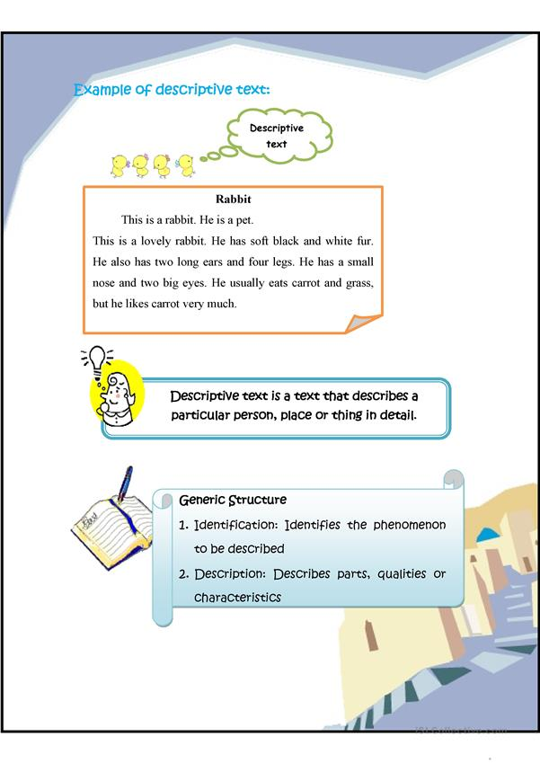
- What does the rabbit usually eat ?
- What is the title of the text ?
- What are the colours of the rabbit’s fur ?
- How many legs does the rabbit have?
- Does the rabbit have a big nose ?
- What does the rabbit like very much ?



Lampiran 2
LEMBAR KERJA MANDIRI TP 7.4.2
(Paket Level 1)
NAMA : ……………………………………..
KELAS : VII / ……………

Petunjuk
      - Bacalah teks dengan cermat dan teliti
      - Bacalah pertanyaan yang tersedia
      - Jawablah pertanyaan sesuai dengan informasi yang terdapat pada teks.



I have a favorite phone and it’s black. I bought it last year at an official shop in my city. This is very sophisticated and reliable because it has 3 GB RAM and 32 GB Internal Memory. This phone also has a strong battery. The size is not too big, I can hold it using one hand. It has two cameras located on the back side and on the front side.

Artinya :
Saya punya telepon favorit dan warnanya hitam. Saya membelinya tahun lalu di toko resmi di kota saya. Ini sangat canggih dan dapat diandalkan karena memiliki 3 GB RAM dan 32 GB Memori Internal. Ponsel ini juga memiliki baterai yang kuat. Ukurannya tidak terlalu besar, saya bisa memegangnya dengan satu tangan. Ini memiliki dua kamera yang terletak di sisi belakang dan di sisi depan.

Answer the questions based on the text.
- What is the suitable title for the text ?
- Does the phone have a strong battery ?
- Is the phone big ?
- How many cameras does the phone have ? Where are they located ?
- Why is the camera very sophisticated and reliable ?

LEMBAR KERJA MANDIRI TP 7.3.3
(Paket level 2

NAMA : ……………………………………..
KELAS : VII / ……………
Tujuan Pembelajaran
7.3.3 Peserta didik mampu memhami teks deskripsi dan menemukan informasi tersurat yang terdapat pada teks yang disajikan.
Petunjuk
- Bacalah teks dengan cermat dan teliti
- Bacalah pertanyaan yang tersedia
Jawablah pertanyaan sesuai dengan informasi yang terdapat pada teks.


Lake Toba

Lake Toba is one of the most famous tourist attractions in Indonesia. Lake Toba is located in North Sumatra, this lake is also the largest lake in Indonesia. Because this lake has a length of 100 KM or 62 miles with a width of 30 KM or 9 miles and the depth of this lake is 505 meters. Around Lake Toba has a very amazing view, because around it are a lot of shady trees. So that makes us feel calm and comfortable while on vacation in this place.
Artinya :
Danau Toba merupakan salah satu tempat wisata yang sangat terkenal di Indonesia. Danau Toba terletak di Sumatera Utara, danau ini juga merupakan danau terbesar yang ada di Indonesia. Karena danau ini memiliki ukuran panjang 100 KM atau 62 mil dengan lebar sebesar 30 KM atau 9 mil dan kedalaman danau ini yaitu 505 meter.
Disekitar Danau Toba memiliki pemandangan yang sangat menakjubkan, karena disekelilingnya banyak sekali pepohonan yang rindang. Sehingga membuat kita merasa tenang dan nyaman ketika berlibur ditempat ini.
Answer the questions based on the text.
- Do you think you can swim in Lake Toba ? Why ?
- Is lake Toba one of the most famous tourist attractions in the world ?
- Why does lake Toba have a very amazing view ?
- Where is Lake Toba located ? Is it at the east or west part of Indonesia ?
- Does the amazing view make us feel calm and comfortable ?
Lampiran 3

LEMBAR OBSERVASI KEGIATAN PEMBELAJARAN

Nama Siswa : ………………………………………
Kelas : ………………………………………
Pertemuan Ke-: ………………………………………
Hari/Tanggal Pelaksanaan : …………………………………………

Berilah penilaian terhadap aspek pengamatan yang diamati dengan membubuhkan tanda ceklis (√) pada berbagai nilai sesuai indikator.
NO | ASPEK YANG DIAMATI | SKOR PENILAIAN
NO | ASPEK YANG DIAMATI | kurang | cukup | Baik | Sangat baik
1 | Pendahuluan
 | Melakukan do’a sebelum belajar
 | Mencermati penjelasan guru berkaitan dengan materi yang akan dibahas
2 | Kegiatan Inti
 | Keaktifan siswa dalam pembelajaran
 | Kerjasama dalam diskusi kelompok
 | Mengajukan pertanyaan
 | Menyampaikan pendapat
 | Menghargai pendapat orang lain
 | Menggunakan alat peraga pembelajaran
3 | Penutup
 | Menyampaikan refleksi pembelajaran
 | Mengerjakan latihan soal secara mandiri
 | Memperhatikan arahan guru berkaitan materi selanjutnya

Keterangan Pernskoran :
Skor 1 = Kurang Garut, 30 November 2022
Skor 2 = Cukup Guru Mata Pelajaran
Skor 3 = Baik
Skor 4 = Sangat Baik

Eulis Siti Hajar,S.Pd
NIP. 19750120 200701 2 006

Lampiran 4
LEMBAR REFLEKSI DIRI
KEGIATAN PEMBELAJARAN

Nama Siswa : ………………………………………
Kelas : ………………………………………
Pertemuan Ke-: 25
Hari/Tanggal Pelaksanaan : …………………………………………

Pilihlah asesmen diri terhadap kompetensi Menyelesaikan perbandingan senilai dengan membubuhkan tanda ceklis (√) pada berbagai nilai sesuai indikator.
Asesmen | Jawab
Materi apa yang sudah kamu pelajari pada pembelajaran hari ini ?

Apakah materi yang disampaikan, didiskusikan, dan dipresentasikan dalam pembelajaran dapat kamu pahami?

Jika belum, Bagian apa yang belum dipahami?

Kesulitan apa yang kamu alami dalam pembelajaran?

Bubuhkanlah tanda centang (√) pada salah satu gambar yang dapat mewakili perasaan kalian setelah mempelajari materi ini!
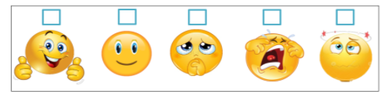

Garut, 30 November 2022
Guru Mata Pelajaran

Eulis Siti Hajar, S.Pd

NIP. 19750120 200701 2 006

Lampiran 5
BAHAN BACAAN
BAHAN AJAR
TP 7.3.2
DESCRIPTIVE TEXT

Descriptive text is is a text which says what a person or a thing is like. Its purpose is to describe and reveal a particular person, place, or thing."
(Teks yang menjelaskan gambaran seseorang atau benda. Tujuannya adalah mengambarkan atau mengungkapkan orang, tempat atau benda tertentu).
Social Function
To describe a particular person, place or thing.

Generic ( Schematic )Structure
- Identification : Identifies phenomenon to be described.
- Description : Describes quality and characteristics.

Language Features
- Focus on specific participants
- Use of Simple Present Tense
I. Pengertian Descriptive Text
- Descriptive berarti deskripsi (gambaran). Jika kamu diminta untuk mendeskripsikan sebuah benda, itu artinya kamu harus menggambarkan benda yang dimaksud baik dari ukuran, warna dan lain-lain.
- Descriptive text adalah: satu kaedah upaya pengolahan data menjadi sesuatu yang dapat diutarakan secara jelas dan tepat dengan tujuan agar dapat dimengerti oleh orang yang tidak langsung mengalaminya sendiri.
- Descriptive text adalah sebuah tulisan atau teks yang menggambarkan sifat-sifat yang melekat pada sesuatu, baik itu manusia, hewan, tumbuhan, atau pun benda mati seperti rumah, mobil computer, radio dan masih banyak lagi.

II. Tujuan Descriptive Text
Tujuan Descriptive Text adalah menggambarkan segala sesuatu baik itu manusia, hewan, tumbuhan atau benda mati dengan sifat yang melekat padanya seperti ukuran, jenis, warna, dan lain-lain, sehingga pembaca dapat mengetahui tentang seperti apa sesuatu itu dari gambaran yang kita sampaikan meskipun ia belum pernah melihatnya. Jadi seorang yang menerima informasi dari deskripsi itu dapat menggunakan imajinasi nya untuk menggambarkan tentang benda tersebut kedalam versi-nya masing-masing tetapi tetap dalam koridor informasi yang telah diberikan.
III. Generic Structure Descriptive TextDescriptive text mempunyai aturan dan etika tersendiri dalam penulisannya, termasuk dalam struktur atau susunan yang harus ditulis secara berurutan. Berikut adalah susunan di dalam membuat sebuah Descriptive Text:
1. Identification:
Paragraf pertama – adalah untuk mengidentifikasi sesuatu yang ingin dideskripsikan atau digambarkan. Indentification berfungsi untuk memperkenalkan kepada pembaca tentang objek atau sesuatu yang akan kita gambarkan sebelum kita beritahu tentang sifat-sifatnya. Saya akan menggambarkan mobil-mobilan/diecast baru yang saya beli kemarin , maka isi identification-nya adalah:
Aku kemarin membeli mobil-mobilan baru. Mobil-mobilan ini sebenarnya sudah lama aku idam-idamkan, tapi baru sekarang aku memilikinya.
(Berarti yang akan digambarkan adalah mobilku, bukan mobil orang lain).
2. Description:
paragraf kedua dan seterusnya – berisi tentang sifat-sifat yang melekat pada sesuatu yang sudah kamu perkenalkan sebelumnya kepada pembaca di paragraf pertama.
Misalnya (melanjutkan tentang mobil di atas)
Mobil-mobilan baru ku ini berskala 1/24 dan berwarna hitam. Mobil-mobilan ini merupakan mobil sport klasik keluaran tahun 1970 dari Ford. Mobil-mobilan ini disebut Mustang Boss American Muscle. Jumlah bangkunya hanya dua, satu untuk sopir dan satunya untuk penumpang, begitu juga dengan pintunya.
(My new diecast is 1/24 in scale and it is black. My new diecast is classic sports car type, it was built in 1970 by Ford. It is called Mustang Boss an American Muscle. It has two of seats in front, one for me and the last for my girl, that is also for the doors. It only has double doors in front.)
(Berarti kalimat-kalimat di atas menggambarkan secara spesifik tentang sebuah objek)

Lampiran 6
BAHAN AJAR
TP. 7.4.2
Descriptive text

Tujuan Pembelajaran

7.3.3 Peserta didik mampu memhami teks deskripsi dan menemukan informasi tersurat yang terdapat pada teks yang disajikan.

Pertanyaan Pemantik
- How do you like to read a teks, silently or loudly?
- How can it make you understand more of the text ?
- Do you think by answering questions based on the text we read can help us usderstanding the text ?
- What kind of topic do you like read ? Animals? People ? Things or places ?

Materi
Look at the picture and read the text carefully

Questions
Answer these questions based on the text above.
- What is the title of the text ?
- What are the colours of the rabbit’s fur ?
- How many legs does the rabbit have?
- Does the rabbit have a big nose ?
- What does the rabbit like very much ?
Question Words (Kata Tanya dalam Bahasa Inggris)
No | Question words | Meaning | Function
1. | What | Apa/apakah | Menanyakan sesuatu atau hal
2. | Who | Siapa | Menanyakan orang (Subjek)
3. | How many | Berapa banyak | Menanyakan jumlah
4. | Where | Dimana/kemana/  Darimana | Menanyakan tempat

Ditambah video pembelajaran yang dishare ke peserta didik.

MODUL AJAR BAHASA INGGRIS FASE D KELAS VII
(ABOUT ME)

INFORMASI UMUM
- Identitas Modul
Institusi : SMP IT Fitrah Insani
Tahun Aajaran : 2023/2024
Jenjang Sekolah : Sekolah Menengah Pertama (SMP)
Kelas/Fase : VII/ D
Alokasi Waktu : 2 JP (2x 35 menit)

- Capaian Pembelajaran Fase D
- Fase Capaian Pembelajaran
Pada akhir fase D, siswa menggunakan teks lisan, tulisan, dan visual dalam Bahasa Inggris untuk berinteraksi dan berkomunikasi dalam konteks yang lebih beragam dan dalam situasi formal dan informal, berbagai jenis teks seperti narasi, deskripsi, prosedur, teks khusus (pesan singkat, iklan) dan teks asli menjadi rujukan utama dalam mempelajari Bahasa Inggris di Fase ini. Siswa menggunakan Bahasa Inggris untuk berdiskusi dan menyampaikan keinginan/perasaan. Pemahaman mereka terhadap teks tulisan semakin berkembang dan keterampilan inferensi mulai tampak ketika memahami informasi tersirat. Mereka memproduksi teks tulisan dan visual dalam Bahasa Inggris yang terstruktur dengan kosa kata yang lebih beragam. Mereka memahami tujuan dan pemirsa ketika memproduksi teks tulisan dan visual dalam Bahasa Inggris.
- Elemen/Domain CP
Membaca-memirsa
Pada akhir fase D, siswa membaca dan merespon teks familiar dan tidak familiar yang mengandung struktur yang telah dipelajari dan kosakata yang familiar secara mandiri. Mereka mencari dan mengevaluasi ide utama dan informasi spesifik dalam berbagai jenis teks. Teks ini dapat berbentuk cetak atau digital, termasuk diantaranya teks visual, multimodal atau interaktif. Mereka mengidentifkasi tujuan teks dan mulai melakukan inferensi untuk memahami informasi tersirat dalam sebuah teks.
- Tujuan Pembelajaran (TP)
- Siswa dapat menyebutkan kosa kata terkait memperkenalkan diri. (C1)
- Siswa dapat memahami teks tulis dan visual tentang memperkenalkan diri. (C2)
- Siswa dapat menggunakan (mengungkapkan dan merespon) kosa kata terkait memperkenalkan diri dalam bentuk teks tulis, lisan maupun percakapan sederhana. (C3)
- Profil Pelajar Pancasila
- Beriman, bertaqwa kepada Tuhan Yang Maha Esa, dan berakhlaq mulia.
- Mandiri
- Bergotong royong
- Bernalar kritis
- Kreatif
- Sarana dan Prasarana
- Gadget (leptop/handphone)
- Jaringan internet
- Teks bergambar
- LKPD
- Target Peserta Didik
Peserta didik regular
- Model Pembelajaran yang Digunakan
Pembelajaran dilakukan secara tatap muka dengan model pembelajara:
- Model Pembelajaran
- Drill and practice
- Problem Based Leraning (PBL)
- Metode Pembelajaran
- Ceramah
- Diskusi
- Tanya jawab
- Kegiatan Pembelajaran
Kegiatan Pendahuluan
- Salam, sapa, presensi dan doa
- Membaca Al Quran sebanyak dua ayat
- Menyampaikan tujuan pembelajaran
- Mengelompokan siswa sesuai gaya belajarnya (Visual-audio)
Kegiatan Inti
- Orientasi siswa pada masalah
Siswa diberikan pertanyaan peamtik seperti:
- What do you do if you meet someone at the first time?
- What questions do you usually ask when you meet someone for the first time?
- Mengorganisasi siswa
Siswa mengamati video/cerita bergambar yang disajikan oleh guru. (diferensisi proses sesuai dengan gaya belajar)
Kelompok audio
- Siswa diberikan video tentang memperkenalkan diri sendiri
Kelompok Visual
- Siswa diberikan cerita bergambar tentang memperkenalkan diri sendiri
- Membimbing pengalaman individu/kelompok
- Siswa menyebutkan informasi yang mereka dapatkan dari video/cerita bergambar, seperti: name, address, age, hobby and siblings.
- Siswa dibimbing oleh guru mempelajari kosa kata terkait memperkenalkan diri dan oranglain.
(Dril and practice)
- Mengembangkan dan menyajikan hasil karya
- Siswa melakukan wawancara kepada minimal lima teman sekelasnya terkait identisas (jati diri) dengan menggunakan kosa kata memperkenalkan diri yang telah mereka pelajari
- Menganaalisis dan mengevaluasi proses pemecahan masalah
- Setiap siswa maju kedepan untuk membacakan hasil wawancara.
Kegiatan Penutup
- Siswa melakukan reflesi terhadap pembelajaran yang telah dilaksanakan
- Reflesi tentang perasaan mereka selama pembelajaran
- Reflesi tentang apa yang mereka pelajari pada pertemuan hari ini.
- Peserta didik dipandu guru mengambil kesimpulan terkait materi pembelajaran hari ini.
- Memberikan aprsiasi kepada siswa yang mebikuti pembelajaran dengan baik, disiplin dan aktif
- Siswa dan guru berdoa untuk mengakhiri pembelajaran.
- Assessment
Assesment formatif tulis dan lisan
- Reflesi secara lisan terkait persaan dan kesimpulan materi yang dipelajari pada hari ini
- Refleksi tulisan berupa angket yang diberikan kepada siswa
- Penilaian sikap dan spiritual
- Daftar Pustaka
- Damayanti, E.L., et al. (2022). English for nusantara untuk SMP/MTS kelas VII
- Glisten kids club. About my self-this is about me, diuanggah oleh pengunggah, 22 Desember2022, https://youtube.com/watch?v=41i0mq25_ro&features=share

Lampiran Materi
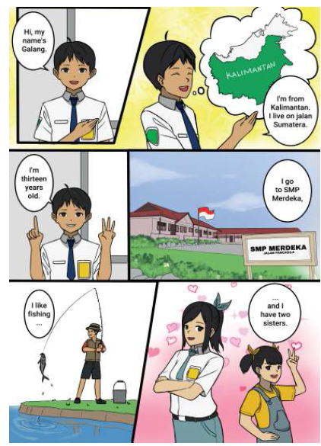

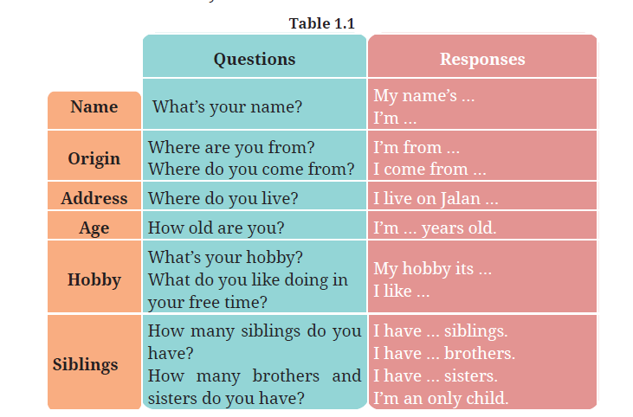
About my self-this is about me, diuanggah oleh pengunggah, 22 Desember 2022, https://youtube.com/watch?v=41i0mq25_ro&features=share

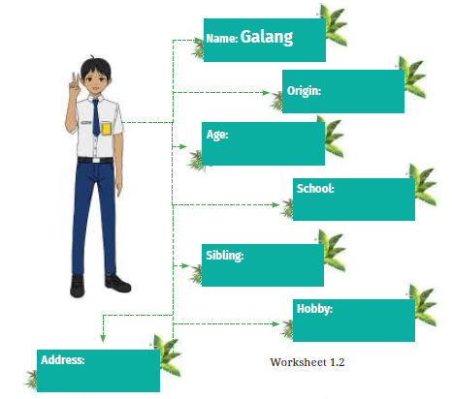
Lampiran Lembar Kerja Peserta didik (LKPD)
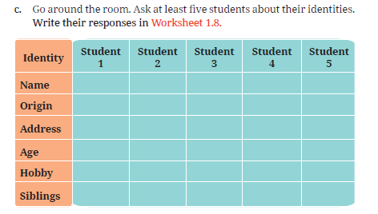
Lampiran Istrumen penilaian sikap – spiritual dan refleksi

LEMBAR OBSERVASI

Mata Pelajaran :
Kelas :
Semester :
Tahun Ajaran :
Periode pengamatan :
Butir Nilai : Sosial dan Spiritual
Indikator sikap
- Mengikuti tilawah Al Quran diawal pembelajaran
- Mengucapkan salam ketika masuk dan keluar kelas
- Meminta izin ketika memasuki atau meninggalkan ruangan kelas
- Tidak berkata-kata kotor,atau menyakitkan
- Sopan dan santun selama pembelajaran
- Aktif dan dapat bekerjasama selama pembelajaran

No | Nama Siswa | Skor Indikator Sikap |  |  |  |  |  | Jumlah perolehan skor | Skor akhir | Katagori
No | Nama Siswa | 1 | 2 | 3 | 4 | 5 | 6 | Jumlah perolehan skor | Skor akhir | Katagori
1
2
3
4
5
6
Catatan:
Petunjuk pengisian
1. Skor Indikator sikap diberi rentang 1-4, dengan ketentuan sebagai berikut;
4= siswa selalu melakukan hal yang diamati
3= siswa sering melakukan hal yang diamati
2= siswa kadang-kadang melakukan hal yang diamati
1= siswa jarang/tidak pernah melakukan hal yang diamati
Rumus skor akhir
Skor akhir = jumlah perolehan skor: 24 x 4
- Katagori
A (sangat baik) jika skor akhir = 3,6- 4
B (Baik) jika skor akhir = 2,6 - 3
C (Cukup) jika skor akhir = 1,6 – 2
D (Kurang) jika skor akhir =1,5 - 1

APPENDIX 3

RESEARCH TRANSCRIPT AND INFORMED CONSENT

Transcript 1st Participant
R | : | Apakah saat ini bapak/ibu menggunakan pembelajaran berdiferensiasi dikelas?
RYN | : | Iya
R | : | Apakah sebelumnya bapak/ibu sudah terbiasa menerapkan pembelajaran berdiferensiasi atau baru menerapkannya saat perpindahan kurikulum menjadi kurikulum merdeka?
RYN | : | Saya menggunakannya pada saat pergantian kurikulum sekarang ya
R | : | Menurut bapak/ibu pembelajaran berdiferensiasi itu sendiri seperti apa?
RYN | : | Yang pertama ada karakter murid dulu, muridnya itu bagaimana minatnya seperti apa gitu kan kita harus pahami dulu kebutuhan murid itu seperti apa. Kan disini ada maksudnya gaya belajarnya juga kan banyak ya ada tiga ya kalo ga salah, secara umum ada anak yang kinestetik, auditori, ada yang visual nah itu anak-anak yang seperti itu kan memiliki kebutuhan khusus jadi tidak bisa disama ratakan gitu kan tidak bisa disamaratakan terkait pembelajarannya gitu kan cenederungkan kita menggunakan metode ceramah saja nah itu merupakan kesalahan, ya oke untuk yang auditori itu bagus untuk dilakukan tapikan untuk yang kinestetik, kinestetik itu yang terkait dengan apa gitu harus mentreatmentnya itu dengan eh apa tindakan gitu ya degan tindakan dengan pengalaman gitu nah itu anak-anak kinestetik gitu kan lebih ke praktek. Terus anal-anak yang visual inikan harus ada visualisasinya, kita bisa mengecek anak-anak itu seperti apa gitu kan gaya belajarnya kita bisa lihat dari kecenderungan anak-anak itu di sekolahnya dikelas itu seperti apa, ada anak yang sering ketika ada gaduh dia suka marah-marah itu berarti anak-anak mungkin tergolong yang anak-anak auditori, terus ada anak yang terhalang oleh temannya gitu kan itu anak-anaknya takut eh apa suka marah juga tidak nyamanlah dikelas itu nah itu harus ada posisi duduk juga harus diatur.  Terus terkait masalah pembelajaran didalam kelas terkait konten tadi yaitu harus disesuaikan baik itu minat gitu kan minatnya seperti apa, adakan kalo sekarang disetiap sekolah itu ada asesmen diagnostik ya sebelum pembelajaran itu awal tahun pasti ada bagaimana ini kemampuan siswanya kita cek bahkan disetiap pertemuan juga kita harus mengecek kesiapan anak itu seperti apa misalkan didalam Bahasa inggris kana nak ini baru bisa di describing people saja atau describing things jangan dulu ke ini jangan dulu kita membahas memberikan materi yang lebih berbobot misalkan describing place nah jangan seperti itu, tapi minimal anak diberikan rangsangan dulu agar kita tahu kemampuan anak itu sampai dimana nah itu terkait dari segi kognitifnya gitu ya dari segi pemahaman ssswanya terkait materi yang akan kita sampaikan. Terkait masalah minat juga dalam konten ini kita bisa membuat nih ada anak yang minatnya ke olahraga ada anak yang minatnya ke memasak misalkan ada anak yang minatnya ke musik nah kita buat tema-tema seperti itu. Nah justru saya juga belajar dari pak asep itu tentang multimodal teks multimodal nah itu bisa diterapkan juga, jadi walaupun teksnya banyak berbeda-beda materi yaitu bisa kita gunakan kita terapkan dikelas dalam pembelajaran, memang kemarin itu menjadi masalah yaitu bagi guru yang pertama waktu menjadi lebih banyak, instrument bahan ajar yang hsrus guru siapkan itu lebih banyak makanya harus ada persiapan dari jauh-jauh hari kalo didifferensiasi makanya dari awal harus kita pahami dulu mungkin 7a sama 7b itu akan berbeda kita harus mengerti dulu kelas ini cenderungnya dimana gitu kan kita buat skala mayoritasnya mayoritas dikelas 7a ini gaya belajarnya minimal gaya belarnya dululah, karena setelah gaya belajarnya bis akita ketahui kita enak bahkan dari posisi duduk pun bisa kita atur oh ini cocoknya di ini gitu kan misalkan yang audio dan visual itu boasanya harus ada duduknya didepan kelas, anak-anak kinestetik biarkan mereka dibelakang untuk melakukan aktivitas dalam pembelajaran pun dalam konten gitu kan kita bagi juga saya lebih ke PJBL kemarin waktu ppl itu karena di PJBL itu aktivitas geraknya ada visualnya ada dan auditorinya ada itu kita hrarus membuat strategi pembelajaran yang memang bisa mengcover keseluruhan karena kita tidak bisa sebenarnya saya dulu sempat bertanya kepada ahli pak kenapa tidak dipisahkan saja kelasnya yang visual-visual saja kelasnya yang auditori auditori saja nah itu akan menjadi kendala ternyata anak tidak bisa beradptasi dengan kemampuan yang lain jadi anak akan terus seperti itu, kalo digabung minimal anak akan bisa belajar oh yang auditori belajarnya seperti ini apakah saya bisa seperti itu karena setelah diteliti lagi itu banyak ada anak anak yang memiliki kemampuan gaya belajarnya itu campur ada yang visual dengan audio ada yang audio dengan kinestetik nah itu menjadi hal yang luar biasa juga gitu kan yakan kita sering-sering menjustifikasi bahwa anak yang tidak bisa diam itu adalah anak yang bandel secara mayoritas nah itu saya kurang setuju gitukan bahkan diskripsi saya dituliskan juga seperti itu saya lebih menekankan kepada anak anak kinestetik karena problem yang menjadi masalah besar bagi sekolah itu adalah anak anak kinestetik yang tidak tercover, auditori bisa dengan ceramahnya gitukan guru-guru pasti sering menggunakan metode ceramah, visual sering guru-guru sering menggambarkan apalagi didalam deskripsi ada nih ini coba deskripsikan bend aini bentuknya seperti apa warnanya apa itu sudah bisa tergambarkan tercover tapi anak-anak kinestetik bagaimana solusinya nah itu yang menjadi permasalahan kwnapa harus adanya differensiasi karena adanya ketidakadilan sebenarnya ada yang nilainya rendah gitukan mungkin anak bisa dilihat juga minatnya bisa berbeda bahkan seperti kurikulum yang dulu gitu kan anak hanya dibatasi dengan tiga mata pelajaran sifatnya notulen ipa, ips, Bahasa Indonesia, matematika, nah itukan jadi permasalahan ketika tidak lulus itu sementara mereka di olahrga bagus di itu bagus tidak bisa lulus mungkin itu mrnjadi acuan dikurikulum sekarang itu seperti itu nah itu baru konten. Sekarang proses mungkin tadi sudah terbahas proses itu terkait pemetaan belajar seperti apa pengelompokan gaya bekajar dan minatnya juga seperti apa nah kalo saya kemarin lebih kepada minat walaupun gaya belajar hampir beragam satu kelompok itu digabungkan oleh minatnya dikelompokan oleh minatnya ada yang kemarin main bola suka olahraga ke bola saya buat konten-konten describing people materi tentang tokoh-tokoh misalkan tokoh sepak bola itu anak lebih familiar karena secara tidak langsung itu juga kan menyodorkan ketertarikan kalo kita ketahui gitu ya misalkan kita lebuh suka kepada kpop ada si ini ada si ini ada si ini gitu kan tapi kalo kita membahas tokoh nasuonal anak-anak belum paham gitu kan minimal kalo ada GBA ada Bkof background knowledgenya itukan sudah kalo anak yang sudah familiar dengan materi yang sudah kita sampaikan bkofnya sudah tidak perlu dibahas secara mendalam gitu karena sudah ada jadi memperingan lagi prosesnya dari pengelompokan dari posisi duduk harus sesuai memang tidak bisa dipisahkan lebh enakkan gitu ya yang kinestetik kinestetik saja 7a kita banyakin gerak itu akan lebih enak tapi tetep itu secara kemampuan emosionalnya mungkin tidak akan baik kalo dipisah seperti itu. Dari segi produk nah produknya bisa berbeda produkkan hasil-hasil dari pembelajaran yanah ini kebanyakan asesmen hanya satu rangkaian asesmen saja biasanya misalkan kalua asesmennya itu pasti tes tulis ada yang lisan, dalam satu bab itu sebenarnya bisa kalo pembelajaran berdiferensiasi itu bisa keseluruhannya ada jadi diberikan keleluasaan apalagi dikurikulum merdeka anak-anak itu diberikan keleluasaan untuk membuat sebuah produk yang memang hasil karya original misalkan seperti ini dari describing ada anak yang bisa menulis jago menulisnya biarkan mereka untuk menulis gitu, terus ada anak-anak kinestetik justru sebenarnya itu akan mendominasi ketika presentasi, anak auditori dengan penguatan katanya yang lebih banyak pasti bakalan lebih baik diberikan produk misalkan membuat vn ini saya ada contoh kemarin ini adalah anak-anak kinestetik sebenarnya ya yang biasa dianggap tidak bisa diam dan ternyata ketika diberikan treatment lebih dia jauh lebih pasih dari pada saya, jadi kadang kita tidak percaya kepada murid kita sendiri padahal ketika digali dan diberi kesempatan itu akan lebih kena biarkanlah mereka berekspresi di diferensiasi itu yang penting kita ada standar ada batasan ini sampe mana, dalam pembelajaran berdiferensiasi kemampuan yang lebih diatas rata-rata itu mereka bisa lebih lagi bisa diberikan materi yang lebih berat lagi, saya berikan keleluasan kasih ilmunya kepada oranglainada beberapa anak yang sudah mulai ikut bahkan mereka penggagas adakan English club memang ungkin kulturnya dari sekolah sd nya dari kota mungkin ada tapi itu jadi bahan juga buat guru ternyata ada yang berpotensi agar guru tidak terlalu rumit karena kan aga bingung kalo nanya sama guru ada ketakutan bahkan ketika didalam kelas anak-anak silahkan kerjakan aan-anak tidak mau mengerjakan kedepan tapi setelah ada temannya yang mengerjakan pak eta abi oge, nah itu berarti ada budaya yang tidak mendukung kesalahn murid padahal makanhya saya sering menerapkan disini dikelas saya silahkan anda buat kesalahan yang dapat dimaafkan kan manusia itu pada sejatinya belajar dari kesalahan gitu ya maka ketika ada kesalahan daam pembelajaran jangan meledek nah itu adalah salah satu budaya yang harus diterapkan.
R | : | Pada awal penerapan pembelajaran berdiferensiasi, apakah bapak/ibu melakukan asesmen diagnostik siswa terlebih dahulu?
RYN | : | Iya
R | : | Apakah bapak/ibu merasa pembelajaran berdiferensiasi ini menyita waktu pada saat melakukan persiapan dalam merancang pembelajaran?
RYN | : | Iya betul memakan waktu karenakan biasanya kita menggunakan materi satu setelah melihat kondisi kelas ada berapa minat dan gaya belajar kita melihat kebutuhan anak dulu berapa berarti bisa lebih dari tiga materi yang harus kita siapkan karena waktu kalo hanya satu buku ada di Nusantara dalam buku itu tapi itu enaknya buku Nusantara itu pake GBA cuma kelemahannya itu belum terdiferensiasi itu hanya pengelompokkan tetep materinya harus kita yang mencari.
R | : | Pada saat memetakan hasil asesmen diagnostik siswa, apakah bapak/ibu mengalamai kesulitan?
RYN | : | Untuk pemetaan sebenarnya gampang didalam untuk mengetahui anak yang paham dan tidak paham berikanlah pertanyaan pemantik seperti misalkan anak-anak ini apa coba jelaskan pakai Bahasa inggris ada anak yang bisa dan anak yang tidak bisa, coba masing-masing tuliskan satu benda yang bisa kamu deskripsikan baik menggunakan Bahasa Indonesia dulu lalu ke Bahasa inggris jangan-jangan menggunakan Bahasa Indonesia pun anak-anak kesulitan karena belum mengetahui sintaknya seperti apa mungkin sperti itu dipertanyaan-pertanyaan sederhana juga tidak bisa mengetahui oh ini anak sudah paham. Terkait asesmen gaya belajar juga itu diawal pembelajaran itu kita melakukan semacam quisioner diberikan kepada anak terkait itu pertanyaan yang kecenderungan anak ke arah kemana misalkan ketika kalian menjelaskan pake gamabar atau gerakan nah itu sudah tergambar anak ini visual auditori jadi ketika dalam pembelajaran pun sudah bisa dipetakan.
R | : | Apakah terdapat perbedaan pemilihan atau penggunaan media pembelajaran saat menerapkan pembelajaran berdiferensiasi serta apakah bapak/ibu mengalami kesulitan dalam pemilihannya?
RYN | : | Media pembelajaran itu sulit. Strategi dan media pembelajaran juga harus kita sesuaikan dengan tipe siswa. Kalau menggunakan alat elektronik, tidak semua sekolah ada bahkan sekolah negeri, hanya sedikit sekolah yang punya.
R | : | Karena kebutuhan dan kesenangan setiap siswa berbeda, apakah bapak/ibu merasa kesulitan ketika harus memenuhi kesenangan siswa? Apalagi siswa yang lebih suka bekerja sendiri?
RYN | : | Kembali lagi pada psikologis ya nah terkait masalah itu harus dirangsang ketika ada anak yang merasa sendiri nah ada apa kita cari dulu dasar dari anak itu makanya kita harus berada dikelas itu harus seperti itu misalkan ada anak yang sampe seekstrim itu bahkan anak tidak mau lagi masuk ke kelas justru kita panggil cari permasalahannya apa siapa tau makanya kita wajib harus ada komunikasi dengan orangtua juga bagaimana dirumahnya apakah seperti itu nah kita rangsangdengan biarkan mereka walaupun dia tidak bekerja dalam grupnya minimal dia sudah mau bergabung juga sudah lumayan gitu kan itu cikal bakal merangsang anak selanjutnya makanya hrus dalam pembelajaran kali inikan pe,belajaran yang diskusi kerjasama makanya di PJBL kemarin saya lebih di grup kita buat program grupnya seperti apa asesmen akhirnya harus individu inikan perancah ada scappoldingnya fokus di diskusijadi anak yang tidak bisa menjadi bisa dibantu oleh teman-temannya jadi walaupun dia tidak belajar juga tapi bergabung itu akan mengurangi, ada anak yang jangankan bergaul masuk ke klas pun harus diantar sama ibunya kenapa seperti itu begitu digabungkan seperti itu menemukan teman ngobrol proses pembelajaran teman sejawat itu penting ketika ada anak yang tidsk mau bergabung seperti itu ya kita tanya dulu hal yang mendasarnya itu apa nah ini orang-orang yang tidak mau bergabung adalah korban-korban buli kebanyakan ketika saya identifikasi ya ternyata anak belum bisa baca makanya tidak mau bergabung makanya saya mau mengemukakan budaya positif itu tapi kerennya nih dia tidak bisa baca tapi lagu-lagu Bahasa inggris dia pasih dengan pronounciationnya bagus oh ini bisa menjadi metode juga anak-anak harus dibiasakan mendengarkan.
R | : | Apakah penilaian siswa dibedakan sesuai dengan kebutuhan dan masing-masing kemampuan siswa? Jika iya apakah bapak/ibu mengalami kesulitan pada saat menilai hasil belajar siswa ketika penilaiannya dibedakan?
RYN | : | Kemarin juga memang sempat karena saya masih terlalu kaku menanggapi bahwa berdiferensiasi itu harus berbenhda-beda ternyata setelah dijalani disiklus pertama saya ppl sempat mendapat tidak frekuensi juga dari pak asep ini ini seperti apa? Saya bingung menjelaskan gitu kan, tapi ketika siklus kedua saya sudah punya jawabannya seperti apa, nah itu jadi jawabannya sama seperti tadi akan memberikan memberikan sebuah treatment memang permasalahan yang itu kan tadi instrumen harus beragam, assesmentnya seperti ini seperti ini seperti itu. Tapi ketika saya menjalani siklus kedua ini, saya paham. Oh berarti yang yang menjadi indicator utama dalam ketercapaian anak itu ya udah rubriknya aja. Masalah anak mau dia itu membuat video atau voice note misalkan karena malu-malu bisa jadi berbicara secara oral oh yaudah tinggal poin aja ini terjawab atau tidak gitu aja.
R | : | Dalam pembelajaran berdiferensiasi itu harus menyesuaikan pengajaran dengan kebutuhan siswa dan juga gaya belajar yang beragam, apakah bapak/ibu mengalami kendala dalam mengatasi keberagaman tersebut seta bagaimana bapak/ibu mengatasinya?
RYN | : | Ya kalau saya yang ngomong mungkin akan sulit. Karakter yang beragam dari background keluarga yang berbeda itu pasti sulit. Tapi ketika kita sudah membuat sebuah budaya positif itu akan lebih enak dan pada pemetaan siswa ketika kita sudah melakukan diagnosis awal itu akan lebih gampang.
R | : | Apakah bapak/ibu mengalami kesulitan saat menerapkan strategi pembelajaran diferensiasi ketika siswanya terlalu banyak?
RYN | : | Strategi tersebut harus dipelajari secara mendalam sebelum disampaikan kepada siswa agar kesulitan dapat teratasi. Salah satu contohnya adalah ketika anak-anak beragam dan kita membuat kelompok menjadi lebih kecil, kita dapat lebih mengontrolnya
R | : | Apakah ada dukungan dari sesama guru dalam mengimplementasikan pembelajaran berdiferensiasi?
RYN | : | Masih ada sebagian kecil guru yang kurang setuju dengan pembedaan, karena mungkin belum memahaminya, apalagi guru senior masih menggunakan metode lama.
R | : | Selain dukungan dari sesama guru, apakah dukungan dari orangtua siswa itu juga penting terhadap keberhasilan pembelajaran berdiferensiasi?
RYN | : | Banyak siswa yang berada di rumah sehingga harus ada keterlibatan orang tua. Harus ada komunikasi dan kontribusi yang besar dari orang tua siswa. Berkomunikasi dengan orang tua, kita ingin mengetahui karakter siswa dari orang tua siswa. Seorang wali kelas terlebih lagi harus memahami kondisi anak di rumah.
R | : | Apakah bapak/ibu merasa bahwa pembelajaran diferensiasi itu menjadi salah satu beban kerja bagi bapak/ibu?
RYN | : | Kalau beban kerjanya memang agak memberatkan. Namun setelah memahami dan merasakan hasilnya, kami tidak terlalu lelah. Ketika membedakan masalah kognitif seperti itu, ada siswa yang lebih unggul dan kelebihannya bagi guru adalah siswa tersebut dapat melakukannya.
R |  | Apakah bapak/ibu pernah mengikuti pelatihan implementasi pembelajaran berdiferensiasi dalam Kurikulum Merdeka?
RYN |  | Pembelajaran berdiferensiasi kebanyakan di guru penggerak, sambil mejadi guru penggerak dulu saya ikut dengan salah satu dosen jadi panitia workshop dulu ya saya justru lebih banyak dari sana. Jadi sebelum masuk jadi guru juga berdiferensiasi ini memang perlu saya sudah belajar makanya saya lebih banyak ke diferensiasi. Jadi pernah jadi panitia tapi tidak bersertifikat.
R |  | Apa saja yang bapak/ibu dapatkan setelah mengikuti pelatihan implementasi pembelajaran berdiferensiasi dalam kurikulum merdeka?
RYN |  | Yang pertama, kesadaran diri sayalebih meningkat bahwa anak yang nakal belum tentu nakal, anak yang tidak cerdas belum tentu tidak cerdas karena dalam pelatihan-pelatihan itu dibahas juga kan 18 kecerdasan anak dari 18 itu maksimal anak itu punya 4 dari 18. Makanya saya tidak memberikan atau menjustifikasi anak itu jelek atau anak itu pintar tapi kecerdasan yang lain yang lebih pintarnya. Yang kedua, terkait masalah manajemen diri saya, kelas, lebih terarah lagi terhadap diferensiasi pembelajarannya.

Transcript 2nd Participant
R | : | Apakah saat ini bapak/ibu menggunakan pembelajaran berdiferensiasi dikelas?
ESH | : | Iya
R | : | Apakah sebelumnya bapak/ibu sudah terbiasa menerapkan pembelajaran berdiferensiasi atau baru menerapkannya saat perpindahan kurikulum menjadi kurikulum merdeka?
ESH | : | Sebelumnya pernah coba tapi tidak se-spesifik di Kurikulum Merdeka, jadi itu kalo tuh gatau bahwa perlakuan itu adalah perlakuan berdiferensiasi jadi cuma pake beberapa kali aja tapi tidak spesifik nah ketika pergantian kurikulum baru paham oh ini namanya pembelajaran berdiferensiasi jadi pake sekarang pada saat Kurikulum Merdeka baru dipake.
R | : | Menurut bapak/ibu pembelajaran berdiferensiasi itu sendiri seperti apa?
ESH | : | Pembelajaran berdiferensiasi itu adalah pembelajaan mengutamakan keistimewaan, keunikan, perbedaan siswa masing-masing siswa didalam kelas. Jadi pembelajaran kita tidak disamaratakan untuk setiap siswa untuk setiap kelas, misal saya ngajar dienam kelas dengan cara yang sama persis kemudian bahan Pelajaran yang sama persis untuk setiap anak juga tidak. Jadi pembelajaran berdiferensiasi itu mengutamakan keistimewaan dan perbedaan setiap siswa.
R | : | Pada awal penerapan pembelajaran berdiferensiasi, apakah bapak/ibu melakukan asesmen diagnostik siswa terlebih dahulu?
ESH | : | Iya. Jadi diawal pembelajaran itu setiap tahun ada kita dibantu oleh BK dan mereka membagikan kuesioner tentang ases,em diagnostic nonkognitif jadi itu mencakup status sosial, status ekonomi, sikap, dsb. Kita sebagai guru mata pelajaran melaksanakan asesmen diagnostik kognitif jadi ada dua asesmen itu ada asesmen diagnostic kognitif dan nonkognitif.
R | : | Apakah bapak/ibu merasa pembelajaran berdiferensiasi ini menyita waktu pada saat melakukan persiapan dalam merancang pembelajaran?
ESH | : | Iya. Pembelajaran berdiferensiasi memerlukan banyak persiapan, mulai dari penyusunan modul pengajaran harus menentukan strategi, bahan ajar, dan alat peraga yang sesuai. Kalau kita ingin ideal, untuk satu pertemuan saja persiapannya memakan waktu lama. Jadi guru memerlukan waktu yang relatif lama untuk mempersiapkan pembelajaran yang berdiferensiasi sehingga memakan banyak waktu, materi dan tenaga.
R | : | Pada saat memetakan hasil asesmen diagnostik siswa, apakah bapak/ibu mengalamai kesulitan?
ESH | : | Ini sangat sulit. Ketika hasilnya sudah ada kadang kita bingung mengklasifikasikannya. Saya sudah pisahkan berdasarkan gaya belajar seperti audio dengan audio namun terkadang ada siswa yang memiliki ketiga gaya belajar tersebut dan ada pula yang tidak sesuai hasilnya. Akhirnya kami mengklasifikasikan mereka ke dalam tiga kelompok besar yaitu pembelajar cepat, pembelajar reguler, dan pembelajar lambat tetapi tanpa memberi tahu mereka.
R | : | Apakah terdapat perbedaan pemilihan atau penggunaan media pembelajaran saat menerapkan pembelajaran berdiferensiasi serta apakah bapak/ibu mengalami kesulitan dalam pemilihannya?
ESH | : | Media pembelajaran selama ini saya pake saya cari sendiri saya browsing ya saya cari worksheet yang breakable/breathable, kemudian cari worksheet yang cocok saya kombinasikan kenapa karena buku paket b. inggris yang dikeluarkan itu ditahun pertama untuk kelas 7 itu tidak cocok dengan ATP (alur tujuan pembelajaran) yang kita bikin disekolah jadikan gini kurikulum Merdeka itu memberi kebebasab pada guru untuk membuat tujuan pembelajaran sesuai dengan kemampuan siswanya disekolah masing-masing. jadi enggak sama media pembelajaran kita sekolah itu enggak sama nah itu pinter-pinternya kita ngasih materi ke anak-anak kita disekolah.
R | : | Karena kebutuhan dan kesenangan setiap siswa berbeda, apakah bapak/ibu merasa kesulitan ketika harus memenuhi kesenangan siswa? Apalagi siswa yang lebih suka bekerja sendiri?
ESH | : | Nah kalau yang introvert itu justru tidak susah, kenapa? Karena mereka akan mencari jalannya sendiri. Saya menemukan ada di kelas dia tuh enggak peduli anak yang lain sampai mana anak lain ngerjain atau tidak dia mah ya emang kerja gitu khusunya sendiri dan dia kan dia tahu kapan harus bertanya. Dia tahu kapan harus menyelesaikan itu karena dia penyendirinya yang positif. Kan ada penyendiri yang memang dia enggak mau ngapain gitu, tidak mengerjakan lalu ketika tugas diam ada yang begitu. Tapi kalau penyendiri tapi dia tahu bagaimana mengerjakan dan dia akan terganggu kalau disatuin temannya itu kan itu tidak masalah kalau menurut saya.
R | : | Apakah penilaian siswa dibedakan sesuai dengan kebutuhan dan masing-masing kemampuan siswa? Jika iya apakah bapak/ibu mengalami kesulitan pada saat menilai hasil belajar siswa ketika penilaiannya dibedakan?
ESH | : | Karena materinya berbeda karena jika disamakan belum tentu siswa yang mempunyai kemampuan di bawah bisa mengikuti. Sebenarnya bisa, tapi butuh waktu lama untuk keluar. Misal 2 jam pelajaran 90 menit dalam waktu 90 menit pembelajar cepat bisa selesai dan pembelajar tengah juga bisa mengikuti, tapi murid pembelajar lambat tidak bisa menyelesaikan, dia bisa tapi butuh waktu lebih lama.
R | : | Dalam pembelajaran berdiferensiasi itu harus menyesuaikan pengajaran dengan kebutuhan siswa dan juga gaya belajar yang beragam, apakah bapak/ibu mengalami kendala dalam mengatasi keberagaman tersebut seta bagaimana bapak/ibu mengatasinya?
ESH | : | Kami tidak punya banyak waktu untuk memperhatikan setiap siswa. Di sekolah negeri keberagamannya sangat kompleks, berbeda dengan sekolah luar biasa tidak terlalu sulit karena rata-rata berada pada tingkat ekonomi menengah ke atas dan yang dihadapi hanyalah permasalahan pribadi. Yang di sekolah saya adalah kalangan menengah ke bawah, mereka berkumpul dengan permasalahan ekonomi seperti seragam mereka robek dan berjalan kaki ke sekolah karena jarak yang jauh. Artinya sebelum mereka menghadapi pembelajaran mereka menghadapi permasalahan di rumah, menghadapi permasalahan dalam kehidupannya. Artinya, tuntutan kita terhadap pembelajaran mereka tidak bisa sama. Sulit sekali jika kita harus memahami setiap siswa.
R | : | Apakah bapak/ibu mengalami kesulitan saat menerapkan strategi pembelajaran diferensiasi ketika siswanya terlalu banyak?
ESH | : | Sulit sekali jika kita harus memahami setiap siswa, apalagi 180 siswa. Itu susahnya, bagaimana kita bisa maksimal menangani satu anak saja, itu tidak mungkin karena terlalu banyak yang harus kita perhatikan. Pada akhirnya, kita tidak punya banyak waktu untuk memberikan perhatian maksimal.
R | : | Apakah ada dukungan dari sesama guru dalam mengimplementasikan pembelajaran berdiferensiasi?
ESH | : | Saat itu memang diperlukan dan karena guru-guru di sekolah juga paham bahwa kita sekarang punya kurikulum mandiri. Kita diskusi kemudian kalau butuh observer, kita minta saja untuk membantu mengamati selama mereka bisa dan tanpa bentrok dengan jam mengajarnya.
R | : | Selain dukungan dari sesama guru, apakah dukungan dari orangtua siswa itu juga penting terhadap keberhasilan pembelajaran berdiferensiasi?
ESH | : | Iya. Sangat penting. Karena, Ini butuh kepahaman orang tua bahwa kurikulum kita berbeda dengan sebelumnya. Cuma mungkin di sini kita tidak banyak melibatkan mereka dalam pembelajaran berdiferensiasi. Kalau saya sendiri gitu ya. Tapi, Enggak tahu nih kalau mata pelajaran lain seperti yang butuh sarana prasarana misalnya seni budaya dan sebagainya gitu. Kalau saya sendiri sih Bahasa inggris tidak terlalu menuntut dalam segi ekonomi dari segi dukungan ekonomi atau materi. Jadi paling gitu ya saya minta dukungan mereka kalo ada tugas bersama sama, tolong misalnya dibolehkan kerja kelompok Makalah semacam itu kalau saya sendiri sih gitu bukan orang tua, yang penting mereka paham apa yang dikerjakan oleh anaknya. Nanti anaknya cerita apa yang sudah dialami dipelajar. Tapi insya allah mereka paham orang tua sudah tahu.
R | : | Apakah bapak/ibu merasa bahwa pembelajaran diferensiasi itu menjadi salah satu beban kerja bagi bapak/ibu?
ESH | : | Sebenarnya semuanya seolah menjadi beban. Sebab kemampuan setiap guru juga berbeda-beda. Daripada meninggalkan semuanya, kami hanya melakukan apa yang kami bisa sesuai dengan kemampuan saya.
R |  | Apakah bapak/ibu pernah mengikuti pelatihan implementasi pembelajaran berdiferensiasi dalam Kurikulum Merdeka?
ESH |  | Pernah disekolah. Jadi di sekolah itu ada komunitas MGMP Tingkat sekolah setiap mata pelajaran. Biasanya kita berkumpul setiap hari minggu. Nah kalau sekarang dijarakin jadi setiap bulan supaya tidak terlalu sering. Kurikulum SMP itu mengadakan tentang pembelajaran berdiferensiasi. Apa itu diferensiasi? Bagaimana cara melaksanakan diferensiasi? Difrensiasi itu meliputi beberapa hal bisa konten, bisa produk. Kita kita sudah kita sudah melaksanakan itu.
R |  | Apa saja yang bapak/ibu dapatkan setelah mengikuti pelatihan implementasi pembelajaran berdiferensiasi dalam kurikulum merdeka?
ESH |  | Iya jadi ternyata kita harus melihat siswa itu tidak homogen tapi heterogen itu satu, kita harus lebih membuka mata kepada siswa ketika ada yang kok beda ya gitu, kamu kok nggak ngerti gitu saya jelasin begini kamu kok nggak ngerti, ternyata kita tidak boleh sama. Kesatu bahwa anak-anak itu heterogen pembelajarannya pun tidak boleh sama. Kemudian yang kedua pembelajaran berdiferensiasi itu meliputi bisa diferensiasi konten, konten itu materi seperti saya jelaskan materi untuk kelompok tertentu bisa berbeda dengan materi kelompok yang lain, tapi dalam satu tema, tapi materinya berbeda, sesuaikan dengan kemampuan belajar dengan motivasi masing masing masing. Kemudian diferensiasi proses pada prosesnya anak tertentu bisa dengan cara khususnya kelompok tertentu bisa dengan cara kelompok C bisa dengan cara C, kelompok B dengan cara B kita cari informasi dengan cara diagnostik tadi. Setelah diagnostik baru kita tentukan oh kelompok ABC caranya bagaimana. Kemudian diferensiasi produk, hasilnya kita tidak bisa mengharapkan hasil yang sama seperti tadi kalo kelompok A hasilnya harus begini kurang lebih, untuk kelompok B hasilnya harus segitiga, kelompok C hasilnya harus bisa segiempat dengan begini anak ini produknya berbeda karena materi berbeda maka produk bisa berbeda atau yang sama, tapi hasilnya berbeda bisa juga. Dalam satu pembelajaran kita bisa menerapkan 3 diferensiasi ini. Diferensiasi konten, produk, dan proses tadi. Jadi selain itu juga pembelajaran berdiferensiasi juga berefek pada penilaian. Penilaian itu tidak hanya bergantung pada kognitif saja karena hanya satu sisi. Dari siswa yang kita nilai banyak sisi lain yang harus diperhatikan karena Allah memberi keistimewaan pada setiap anak berbeda. Kita harus berusaha seadil mungkin memberi nilai sesuai denga napa yang mereka tampilkan. Ketika anak itu dicap sebagai kelompok C belum tentu dia C terus gitu. Ketika dia mau berusaha, kita melihat usahanya melihat kehadiran bagus, melihat sikapnya bagus itu juga harus disesuaikan maka nilainya nanti dia tambah. Beda dengan yang tidak ada usaha. Itu mungkin jadi lebih ke bahwa pembelajaran berdiferensiasi ini kita ingin lebih memanusiakan manusia memanusiakan anak didik kita. Jadi kita tidak dianggap sebagai objek, tapi dianggap sebagai manusia yang butuh didewasakan butuh dimanusiakan. Ketika si a pencapaiannya baru B kita tingkatkan menjadi A, ketika pencapaiannya C kita tingkatkan menjadi B yang penting berubah. Jadi mau sekecil apapun dia berubah yang penting berubah, tujuan pembelajaran itu ada perubahan ketika pembelajaran hanya menyampaikan materi saja perubahan ada perubahan secara kognitif saja tapi tidak yang lainnya. Yang penting katanya bahwa di kurikulum Merdeka ini bahwa materi tidak jauh lebih penting dibanding perubahan karakter sikap, makanya munculah program Profil Pelajar Pancasila. Itulah yang diterapkan dan diusahakan supaya anak itu tidak hanya pinter tapi juga berkarakter, bagaimana membentuk anak yang berkarakter profil pelajar Pancasila itu melalui pembelajaran jadi bukan pembelajaran fokusnya tapi melalui pembelajaran anak menjadi berkarakter bagaimana caranya kita terapkan. Jadi pembelajaran Bahasa inggris, ipa, matematika itu hanya sarana membuat mereka lebih meningkat dari segi pengetahuan, sikap, dan segi lainnya. Itu artinya ada sisi yang kita cari dan ungkap sehingga mereka berubah itu mungkin yang sulit dan butuh untuk perjuangan kita sebagai guru juga itu yang sulit jadi sebelum mereka kitanya dulu harus punya profil Pancasila nah itulah yang dituntut oleh kurikulum Merdeka.
Transcript 3rd Participant
R | : | Apakah saat ini bapak/ibu menggunakan pembelajaran berdiferensiasi dikelas?
EKN | : | Iya. Saya menggunakan pembelajaran berdiferensiasi pada saat ini.
R | : | Apakah sebelumnya bapak/ibu sudah terbiasa menerapkan pembelajaran berdiferensiasi atau baru menerapkannya saat perpindahan kurikulum menjadi kurikulum merdeka?
EKN | : | Kalau untuk saya baru menggunakan pada saat perpindahan kurtilas ya ke kurikulum merdeka. Memang di kurikulum 13 juga ada yang dinamakan pembelajaran untuk anak yang condong pada daya tangkap menggunakan auditorial, visual, kinestetik dan juga menggunakan ketiganya. Jadi di kurtilas sudah diperkenalkan tetapi belum secara mendalam. Nah di kurikulum merdeka ini menjerumus ke iya pembelajaran menggunakan aspek itu juga. Ada yang dinamakan audit auditorial, visual dan kinestetik seperti itu.
R | : | Menurut bapak/ibu pembelajaran berdiferensiasi itu sendiri seperti apa?
EKN | : | Kalau menurut saya pembelajaran berdiferensiasi adalah pembelajaran yang memungkinkan guru untuk memenuhi kebutuhan setiap siswa dan siswi di kelas. Jadi guru harus memperhatikan cara belajar anak untuk melihat perkembangan anak tersebut entah itu dari segi kompetensi kognitif maupun karakter anak tersebut. Seperti itu kalau menurut saya.
R | : | Pada awal penerapan pembelajaran berdiferensiasi, apakah bapak/ibu melakukan asesmen diagnostik siswa terlebih dahulu?
EKN | : | Sebelum menggunakan pembelajaran ini, pembelajaran berprestasi ya. Iya, saya melakukan asesmen diagnostik terlebih dahulu.
R | : | Apakah bapak/ibu merasa pembelajaran berdiferensiasi ini menyita waktu pada saat melakukan persiapan dalam merancang pembelajaran?
EKN | : | Yah sangat menyita waktu karena untuk melakukan pembelajaran ini, guru condong memberikan pembelajaran menggunakan tiga gaya pembelajaran kepada anak yang berkebutuhan berbeda-beda. Jadi guru dituntut untuk memberikan pembelajaran yang sangat extra kepada anak tersebut.
R | : | Pada saat memetakan hasil asesmen diagnostik siswa, apakah bapak/ibu mengalamai kesulitan?
EKN | : | Kesulitan atau kendala yang saya hadapi ketika kevalidan jawaban anak, kemudian terbatasan waktu, hambatan dari anak tersebut dan hambatan fasilitas seperti itu.
R | : | Apakah terdapat perbedaan pemilihan atau penggunaan media pembelajaran saat menerapkan pembelajaran berdiferensiasi serta apakah bapak/ibu mengalami kesulitan dalam pemilihannya?
EKN | : | Ya. Saya mengalami kesulitan ketika anak yang lebih memahami pembelajaran yang harus dipraktikkan. Nah, bahkan anak-anak tersebut lebih condong ke melakukan pembelajarannya di luar kelas nih seperti itu.
R | : | Karena kebutuhan dan kesenangan setiap siswa berbeda, apakah bapak/ibu merasa kesulitan ketika harus memenuhi kesenangan siswa? Apalagi siswa yang lebih suka bekerja sendiri?
EKN | : | Iya terkadang. Tapi mereka bisa menyesuaikan
R | : | Apakah penilaian siswa dibedakan sesuai dengan kebutuhan dan masing-masing kemampuan siswa? Jika iya apakah bapak/ibu mengalami kesulitan pada saat menilai hasil belajar siswa ketika penilaiannya dibedakan?
EKN | : | Ya. Saya mengalami kesulitan ketika satu persatu anak harus dinilai dari bidang kognitifnya kemudian sampai ke karakter anaknya.
R | : | Dalam pembelajaran berdiferensiasi itu harus menyesuaikan pengajaran dengan kebutuhan siswa dan juga gaya belajar yang beragam, apakah bapak/ibu mengalami kendala dalam mengatasi keberagaman tersebut serta bagaimana bapak/ibu mengatasinya?
EKN | : | Ya saya mengalami kendala tersebut ketika anak meminta gurunya untuk melakukan pembelajaran di luar kelas. tetapi sebagiannya ingin pembelajaran di dalam kelas karena tidak fokus untuk belajar di luar kelas. Nah, cara untuk mengatasi hal tersebut saya membuat kesepakatan kelas dan membuat jadwal kapan kita belajar di luar kelas dan kapan kita belajar di dalam kelas. Dengan catatan harus bersangkutan dengan materi yang akan dibawakan seperti itu
R | : | Apakah bapak/ibu mengalami kesulitan saat menerapkan strategi pembelajaran diferensiasi ketika siswanya terlalu banyak?
EKN | : | Iya. Sangat kesulitan sekali
R | : | Apakah ada dukungan dari sesama guru dalam mengimplementasikan pembelajaran berdiferensiasi?
EKN | : | Iya. Dukungan dari sesama itu mungkin berpengaruh yak arena keterlibatan sesama guru itu untuk sharing atau bertukar cerita. Nah ketika tidak ada dukungan kita mau bertukar cerita kepada siapa kalau rekan gurunya tidak mendukung apa yang kita lakukan untuk menggunakan pembelajaran berdiferensiasi ini seperti itu.
R | : | Selain dukungan dari sesama guru, apakah dukungan dari orangtua siswa itu juga penting terhadap keberhasilan pembelajaran berdiferensiasi?
EKN | : | Dukungan dari orang tua itu sangat penting dan berpengaruh dalam pembelajaran berdiferensiasi ini. Karena ketika melihat anak-anaknya tumbuh berkembang dari bidang kognitifnya maupun karakteristiknya, otomatis orang tua akan memberikan dukungan penuh kepada guru guru tersebut seperti itu maupun sekolah tersebut.
R | : | Apakah bapak/ibu merasa bahwa pembelajaran diferensiasi itu menjadi salah satu beban kerja bagi bapak/ibu?
EKN | : | Beban sih ngga. Kalo beban menurut saya tidak. Karena zaman kan semakin ke sini semakin maju ya jadi saya akan melakukan penuh untuk perkembangan anak didik saya supaya maju ke depannya.
R |  | Apakah bapak/ibu pernah mengikuti pelatihan implementasi pembelajaran berdiferensiasi dalam Kurikulum Merdeka?
EKN |  | Pelatihan ya kalau seminar pelatihan tidak pernah ya, tetapi di sekolah saya kepala sekolah saya khususnya terutama adalah guru penggerak ya. Nah, oernah ada pada saat itu kepala sekolah ada tugas untuk menyampaikan pembelajaran berdiferensiasi itu seperti apa. Jadi itu yang saya alami ketika mendengar pembelajaran berdiferensiasi tersebut.
R |  | Apa saja yang bapak/ibu dapatkan setelah mengikuti pelatihan implementasi pembelajaran berdiferensiasi dalam kurikulum merdeka?
EKN |  | Ya tentu saja ilmu. Kemudian yang saya dapatkan juga pengalaman pembelajaran berdiferensiasi itu seperti apa, kemudian itu menerapkan pembelajaran berdiferensiasi ini kepada siswa dan siswi.

Transcript 4th Participant
R | : | Apakah saat ini bapak/ibu menggunakan pembelajaran berdiferensiasi dikelas?
INY | : | Iya. Saat ini saya menggunakan pembelajaran berdiferensiasi karena sekolah saya merupakan sekolah penggerak, jadi hampir semua guru di sana sudah memberlakukan pembelajaran berdiferensiasi.
R | : | Apakah sebelumnya bapak/ibu sudah terbiasa menerapkan pembelajaran berdiferensiasi atau baru menerapkannya saat perpindahan kurikulum menjadi kurikulum merdeka?
INY | : | Saaya baru menggunakannya sekarang pada kurikulum Merdeka.
R | : | Menurut bapak/ibu pembelajaran berdiferensiasi itu sendiri seperti apa?
INY | : | Iya jadi pembelajaran berdiferensiasi yaitu proses pembelajaran di mana dalam pembelajarannya kita harus menyiapkan seperti bahan ajar materi, lembar kerja jadi disesuaikan dengan kemampuan-kemampuan siswa ya, jadi ada kemampuan mereka yang memiliki kemampuan rendah, kemampuan sedang ataupun kemampuan tinggi dan disesuaikan juga dengan gaya belajar siswa.
R | : | Pada awal penerapan pembelajaran berdiferensiasi, apakah bapak/ibu melakukan asesmen diagnostik siswa terlebih dahulu?
INY | : | Ya. Dari dulu lakukan assesmentnya jadi itu dilakukan pada awal-awal pembelajarankan ya sekitar satu bulan. Asesmen diagnostik itu kemampuan siswa, apakah kemampuan lemah sedang atau tinggi gitu ya dilihat juga gaya belajar mereka seperti apa itu.
R | : | Apakah bapak/ibu merasa pembelajaran berdiferensiasi ini menyita waktu pada saat melakukan persiapan dalam merancang pembelajaran?
INY | : | Menyita waktu. Tapi kalau dalam proses pembelajaran kan kalau guru itu kan dikasih ya itu 40 menit ya tetap saja, tapi dalam persiapannya tentu saja lebih banyak harus banyak meluangkan waktu kita harus lebih banyak menyiapkan berbagai macam bahan ajarnya ya lembar kerjanya jadi jadi disiapkan ya mana yang bahan ajarnya atau apa latihan tempat kerjanya itu mana yang dipergunakan nantinya untuk siswa yang berkemampuan tinggi rendah atau sedang gitu kan ya jadi harus lebih banyak dibandingkan dengan yang dulu.
R | : | Pada saat memetakan hasil asesmen diagnostik siswa, apakah bapak/ibu mengalamai kesulitan?
INY | : | Ya. sesudah didapatkan hasil diagnostik awal ya tentu saja kesulitannya karena kita harus segera apa menerapkan, kita harus segera menyiapkan bagaimana cara untuk memenuhi kebutuhan belajar anak. Ya, jadi kesulitannya itu saya kan memiliki banyak siswa ya jadi saya harus pintar-pintar bagaimana untuk memenuhi kebutuhan siswa yang banyak tersebut itu.
R | : | Apakah terdapat perbedaan pemilihan atau penggunaan media pembelajaran saat menerapkan pembelajaran berdiferensiasi serta apakah bapak/ibu mengalami kesulitan dalam pemilihannya?
INY | : | Pemilihan media pembelajarannya kalau dalam pembelajaran bahasa Inggris kan kita tahu sendiri ya kalau pembelajaran bahasa Inggris itu kan ada pembelajaran speaking, writing, listening jadi ya selalu bervariatif ya gitu. Jadi tentu saja selalu menggunakan media ya. Ada media melalui buku teks ya kalau speaking atau listening menggunakan soeaker yang bisa di dengarkan oleh anak-anak itu atau ada juga yang kinestetik itu ada kegiatan anak-anak supaya bergerak di mana ada game yang kayak gitu. Media pembelajarannya ada kesulitannya biasanya kita ya dicari tapi solusinya bisa ditemukan kalo kita terus belajar.
R | : | Karena kebutuhan dan kesenangan setiap siswa berbeda, apakah bapak/ibu merasa kesulitan ketika harus memenuhi kesenangan siswa? Apalagi siswa yang lebih suka bekerja sendiri?
INY | : | Ya jadikan kebanyakan belajar kelompok ya dimana anak yang memiliki kemampuan rendah, sedang, tinggi itu dalam pembelajarannya itu dikelompokan. Jadi kan ada siswa yang mau belajarnya itu sendiri atau mau belajarnya itu mau sama kelompoknya aja nah saya minta untuk belajarnya itu berkelompok aja bersosialisasi kerjasama harus belajar berkolaborasi dan menerima berbagi ide dengan yang lainnya agar kita bisa mencapai tujuan pembelajaran. Jadi mereka diberi pemahaman akhirnya mereka bisa belajar berkelompok dan berkolaborasi dengan temannya disesuaikan dengan kemampuan anak.
R | : | Apakah penilaian siswa dibedakan sesuai dengan kebutuhan dan masing-masing kemampuan siswa? Jika iya apakah bapak/ibu mengalami kesulitan pada saat menilai hasil belajar siswa ketika penilaiannya dibedakan?
INY | : | Ya tentu saja nilainya dibedakan sesuai dengan kemampuan siswa, ada anak yang bekerja keras dan yang kemampuannya tinggi biasanya dibedakan dengan anak yang kemampuannya rendah. Tapi yang terpenting disini bukan nilainya tapi kita lihat dari prosesnya kita lihat mereka semuanya mau belajar.
R | : | Dalam pembelajaran berdiferensiasi itu harus menyesuaikan pengajaran dengan kebutuhan siswa dan juga gaya belajar yang beragam, apakah bapak/ibu mengalami kendala dalam mengatasi keberagaman tersebut seta bagaimana bapak/ibu mengatasinya?
INY | : | Ya kendalanya itu ketika kita ngajar itu siswanya itu terlalu banyak dan waktunya juga sedikit. Jadi itu kendalanya waktunya sedikit tidak sesuai dengan target y akita harus misalnya beres materinya. Ya jadi gitu karena terlalu banyak jadi kadang tidak memenuhi kebutuhan mereka secara menyeluruh dan merasa tidak maksimal karena siswanya yang terlalu banyak.
R | : | Apakah bapak/ibu mengalami kesulitan saat menerapkan strategi pembelajaran diferensiasi ketika siswanya terlalu banyak?
INY | : | Iya. Karena siwanya yang banyak sehingga saya sulit untuk memperhatikan satu persatu siswa.
R | : | Apakah ada dukungan dari sesama guru dalam mengimplementasikan pembelajaran berdiferensiasi?
INY | : | Ya kami sesama guru khususnya sesama guru pembelajaran bahasa inggris ya kami selalu saling mendukung, selalu bertukar ide, sharing materi dan selalu belajar bersama. Jadi kami selalu saling mendukung dalam hal positif dan terus berkolaborasi.
R | : | Selain dukungan dari sesama guru, apakah dukungan dari orangtua siswa itu juga penting terhadap keberhasilan pembelajaran berdiferensiasi?
INY | : | Ya tentu saja sangat berpengaruh karena jika hanya guru saja yang memberikan semangat pada siswa tapi kalo orantuanya tidak mengerti bahwa belajar itu penting ya jadi ga akan sama. Jadi kadang ada orangtua itu yang seperti itu tidak terlalu mendukung anaknya belajar jadi dikasih tahublangsung pada orangtua bahwa anaknya harus belajar, gimana mereka harus belajar memeiliki karakter anak yang soleh, ilmu pengetahuan yang banyak dan memenuhi tanggungjawab mereka dan tugas mereka sebagai pelajar ya jadi harus dilaksanakan saya beritahukan pembelajaran siswa.
R | : | Apakah bapak/ibu merasa bahwa pembelajaran diferensiasi itu menjadi salah satu beban kerja bagi bapak/ibu?
INY | : | Saya tidak merasa menjadi beban ya. Jadi kita sebagai guru itu harus menyesuaikan pembelajaran dengan perubahan zaman ya jadi zaman berubah jadi guru juga harus banyak belajar. Jadi inikan tantangan apalagi kalo ini merupakan efeknya nantinya bagus kenapa ngga kita juga hrus belajar terus gitu.
R |  | Apakah bapak/ibu pernah mengikuti pelatihan implementasi pembelajaran berdiferensiasi dalam Kurikulum Merdeka?
INY |  | Iya. Untuk menambah pengetahuan saya dan keprofesionalan saya sebgai guru apalagi saya mengajar disekolah penggerak saya mengikuti pelatihan-pelatihan webinar secara daring atau secara offline untuk menambah pengetahuan saya tentang kurikulum merdeka khususnya pembelajaran berdifrensiasi.
R |  | Apa saja yang bapak/ibu dapatkan setelah mengikuti pelatihan implementasi pembelajaran berdiferensiasi dalam kurikulum merdeka?
INY |  | Seperti saya mengikuti pelatihan tentang cara membuat modul ajar berdiferensiasi kemudian saya terapkan modul itu pada proses pembelajaran sehingga bisa sesuai dengan modul ajar. Dan juga saya mengikuti misalnya pelatihan tentang bagaimana cara agar siswa senang belajar terus diterapkan pada proses pembelajaran.

Informed Consent
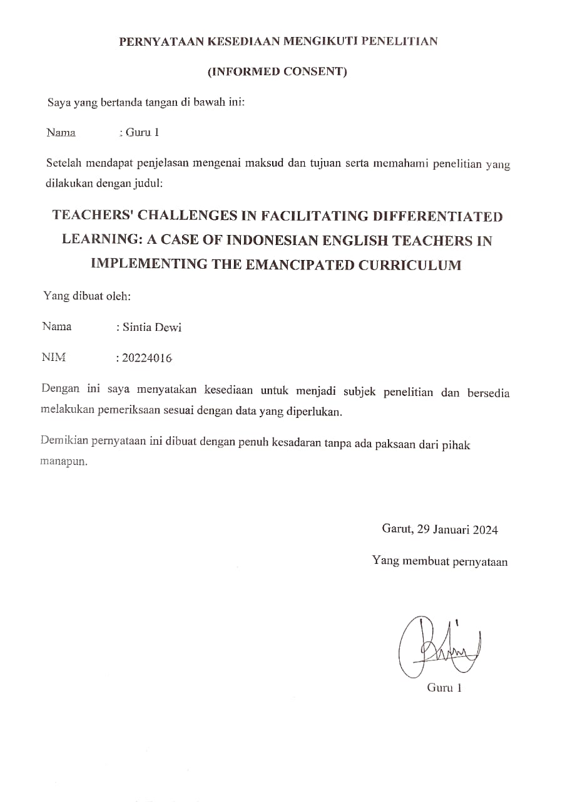
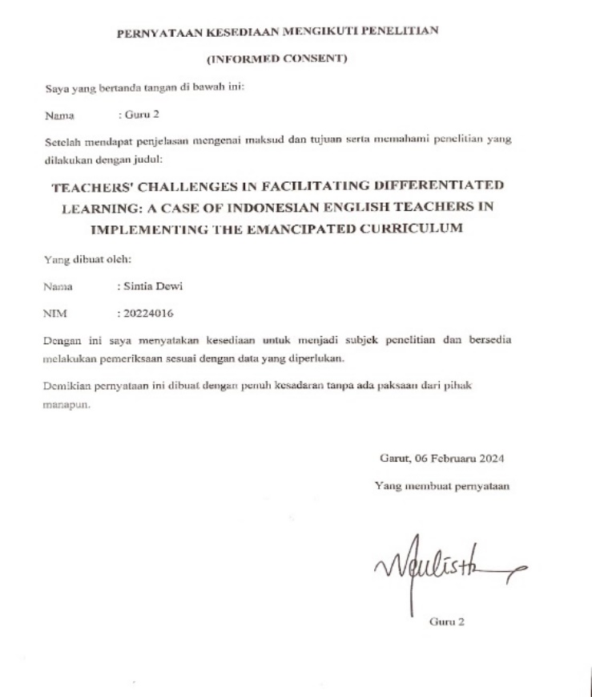

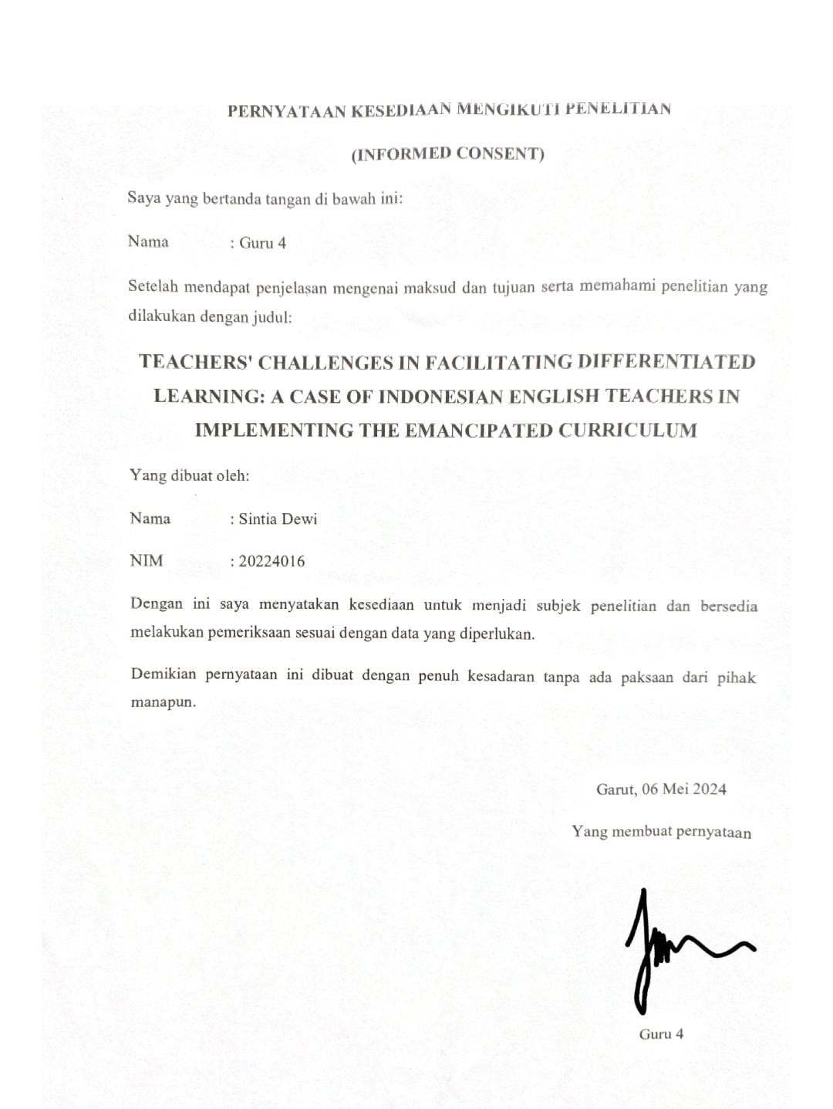
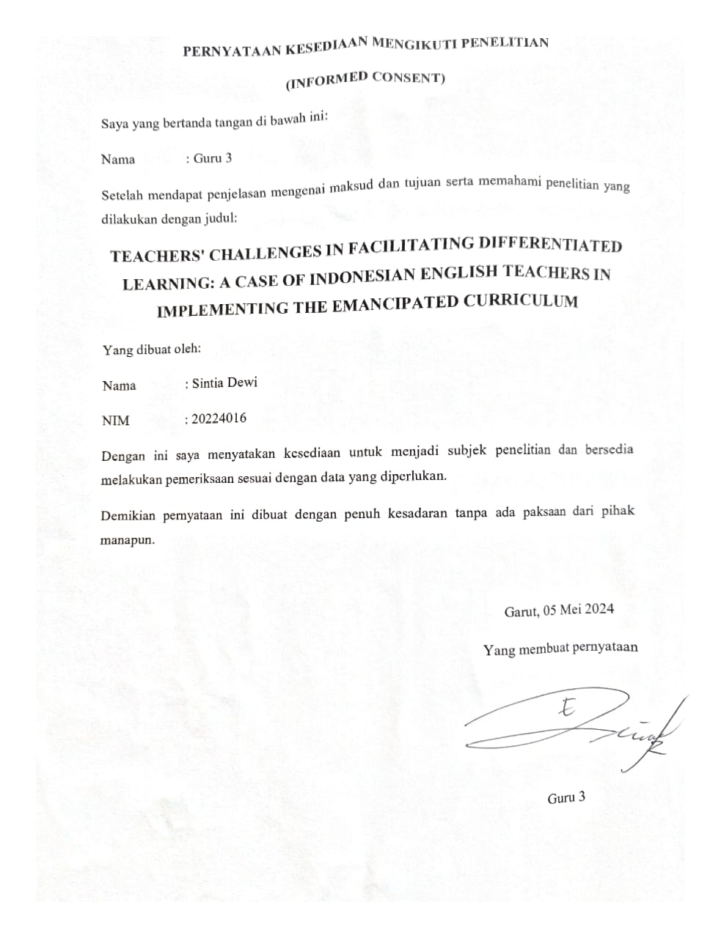

APPENDIX 4

LETTERS
Research Permit
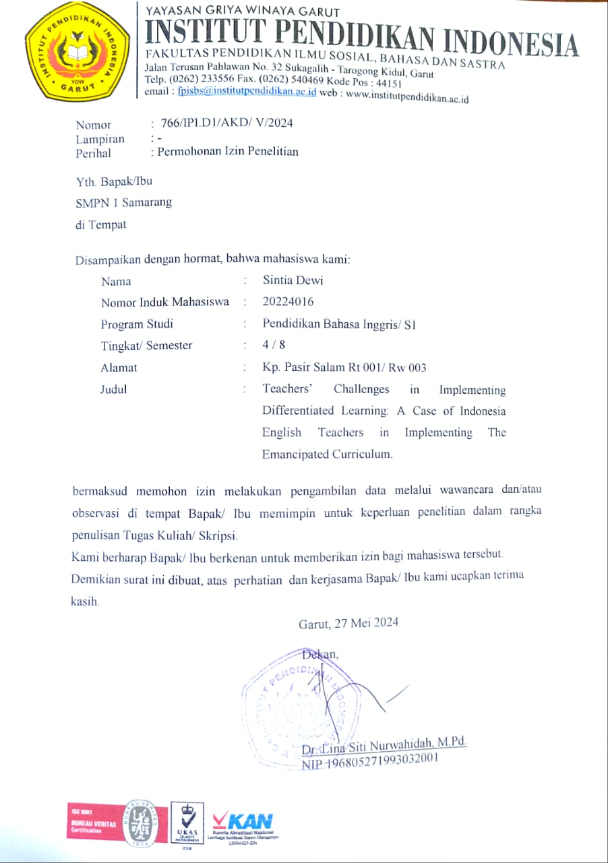
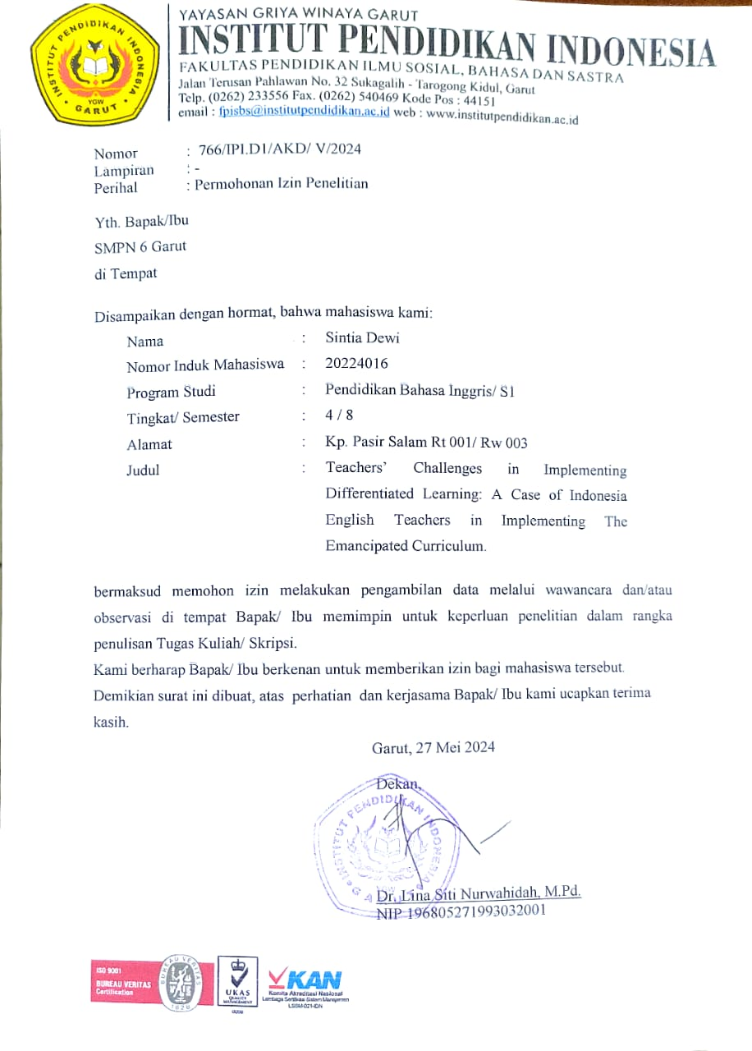
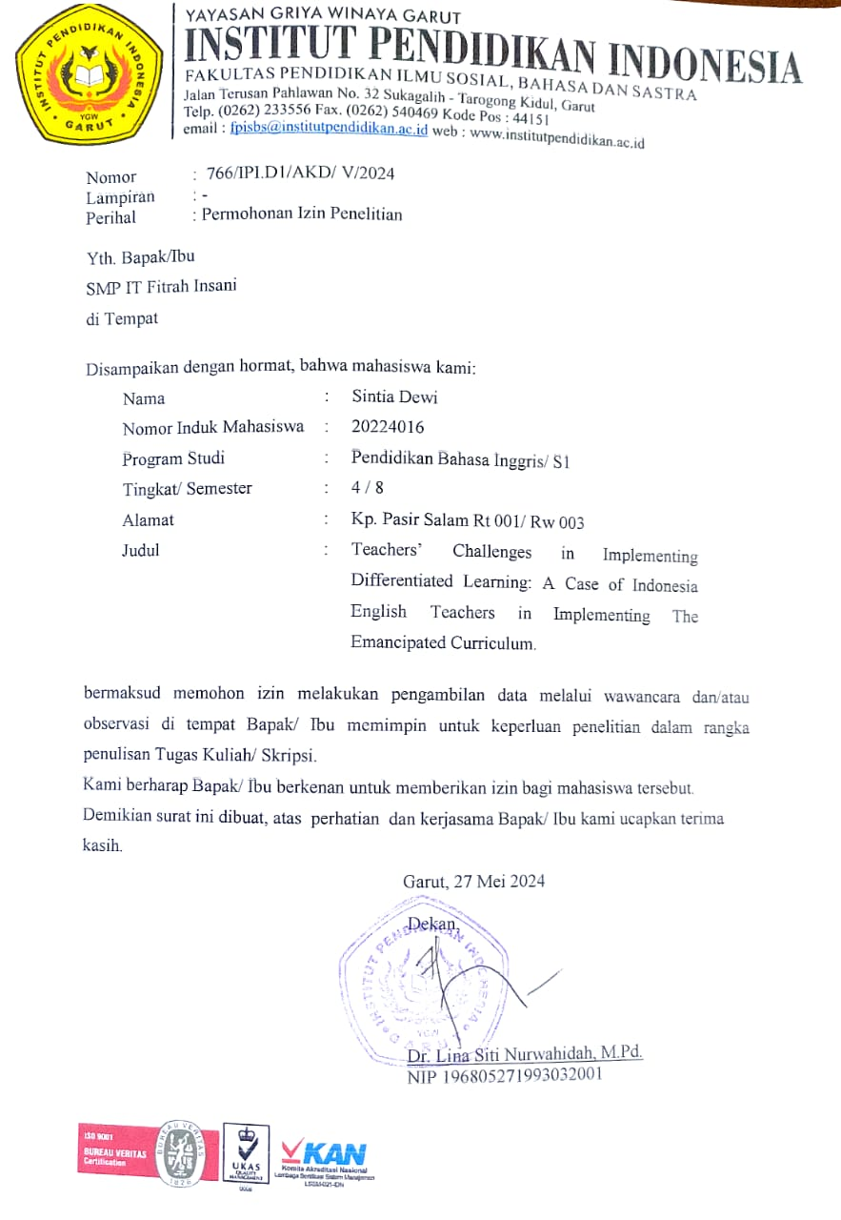
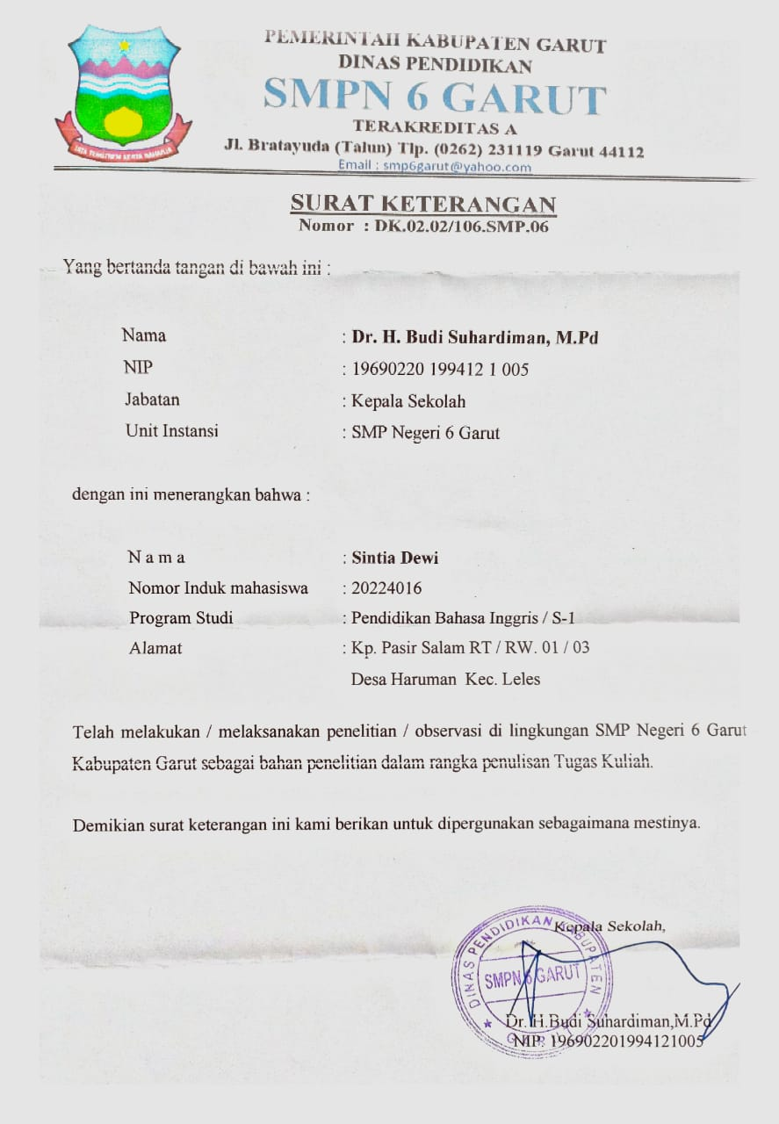
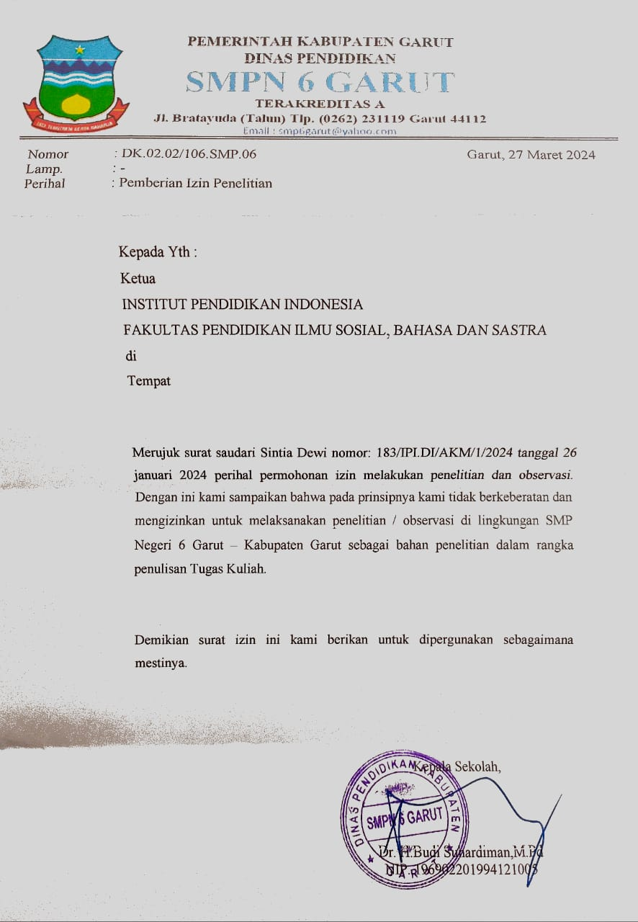

Dean’s Letter of Appointment of Supervisors

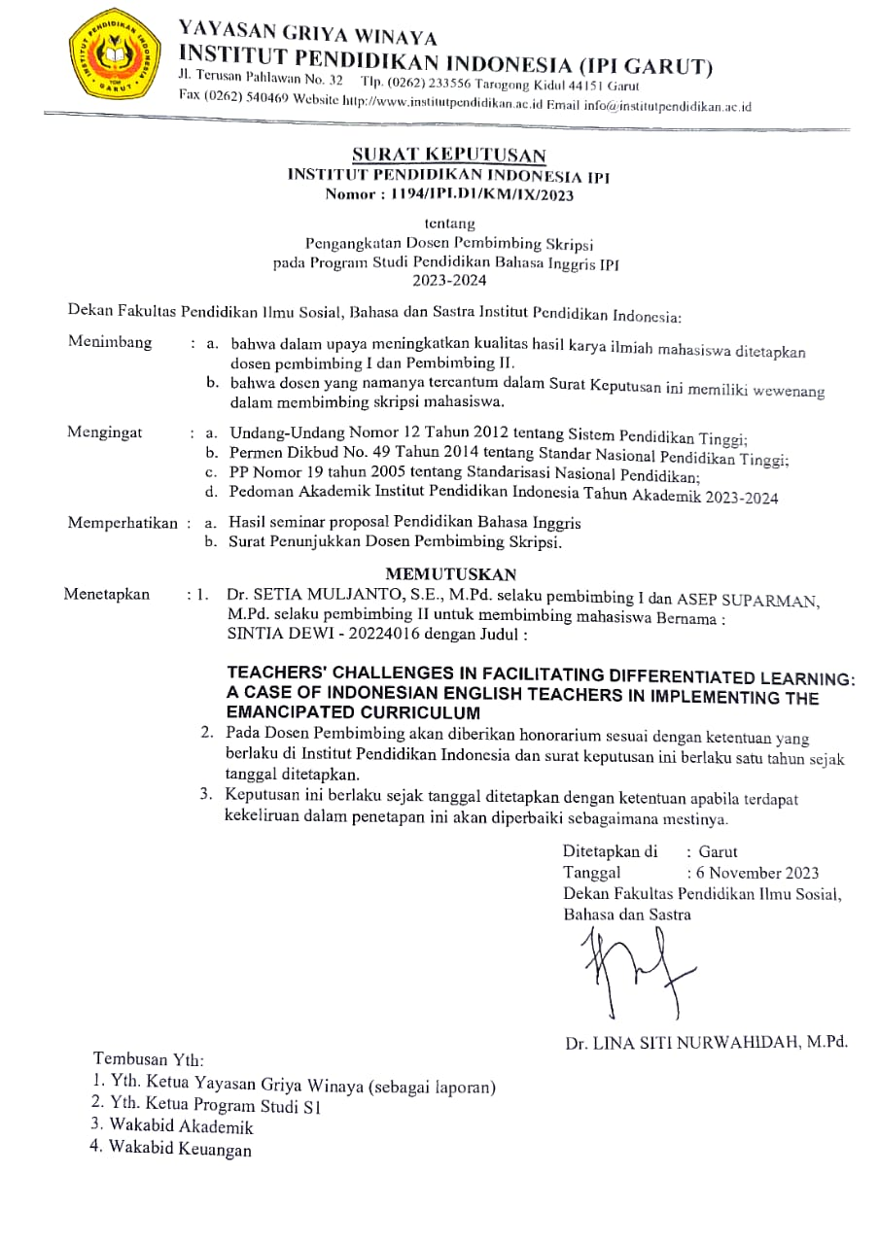

APPENDIX 5

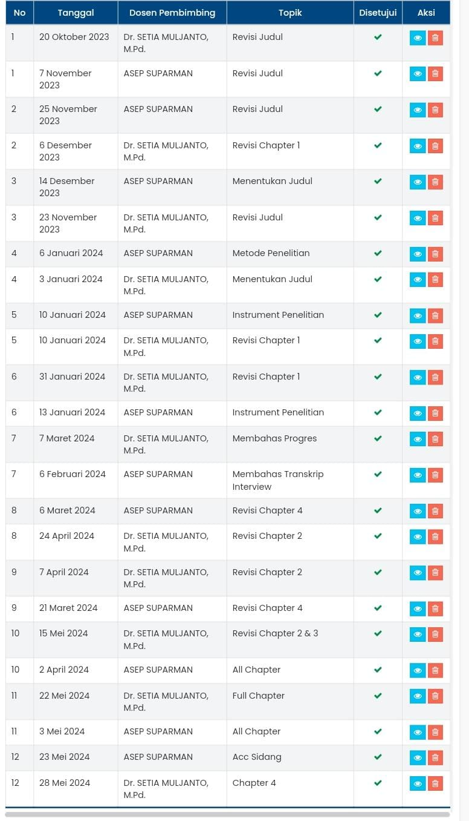
SUPERVISION CARD

APPENDIX 6

DOCUMENTATION OF THE INTERVIEW

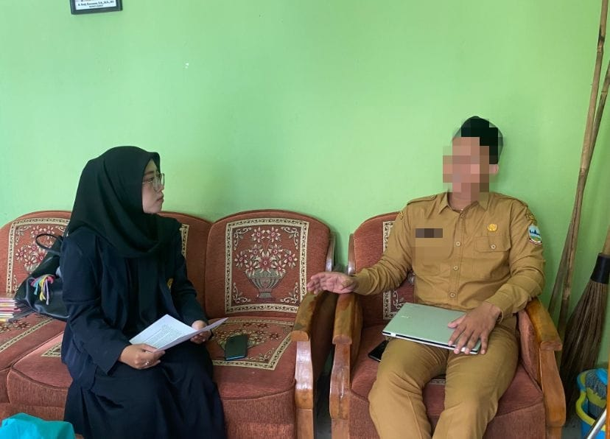
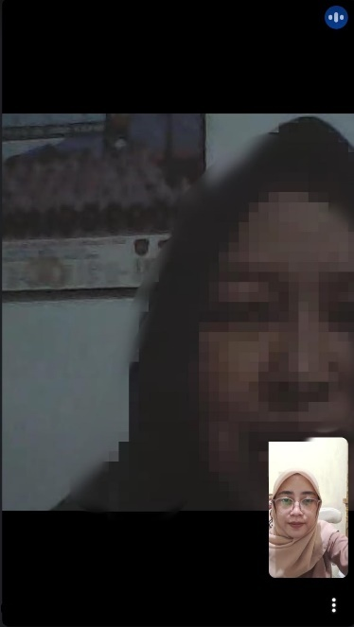
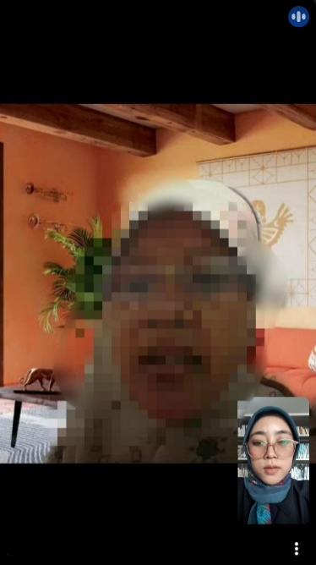
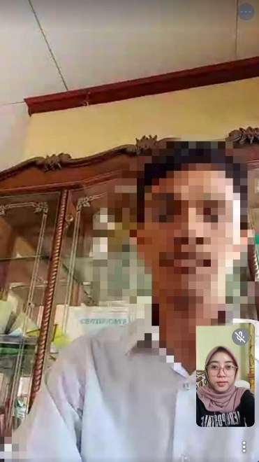

CURRICULUM VITAE

The author’s name is Sintia Dewi. She was born in Garut on April 17, 2001. She lives in Pasir Salam Leles, Garut. She graduated from SDN Haruman 2, in 2012. She continued her education in SMP Pasundan Leles, graduated in 2016. She joined Karawitan. In 2019, she graduated from SMA YKBBB Leles. She joined the school choir. Then she continued her study in Institut Pendidikan Indonesia (IPI) Garut, took English Education Program. During her study, there she joined HIMADIKSARIS (Himpunan Mahasiswa Pendidikan Bahasa Inggris) an intracampus organization as a member. In the following period, she became a member of the Regeneration division. Additionally, she also joined PAMMUS IPI (Paduan Suara Mahasiswa dan Musik) as a member. Then, she should graduate from Institut Pendidikan Indonesia in 2024 (S-1 Degree).

