TEACHERS’ PERCEPTION OF PROJECT BASED LEARNING (PJBL) MODEL IN EMANCIPATED CURRICULUM TO IMPROVE SENIOR HIGH SCHOOL STUDENTS’ SPEAKING SKILL

A PAPER
Submitted to the English Education Program of IPI Garut
as a Partial Fulfillment of the Requirements for the
Bachelor Education Degree

By
Salma Jihan Padila
20226017



ENGLISH EDUCATION PROGRAM
FACULTY OF SOCIAL SCIENCE LANGUAGE AND LITERATURE EDUCATION
INSTITUT PENDIDIKAN INDONESIA GARUT
2024

APPROVAL SHEET
TEACHERS’ PERCEPTION OF PROJECT BASED LEARNING (PJBL) MODEL IN EMANCIPATED CURRICULUM TO IMPROVE SENIOR HIGH SCHOOL STUDENTS’ SPEAKING SKILL

Written by:
Salma Jihan Padila
20226017

Approved by:
First Supervisor  Dr. Setia Muljanto, SE., M.Pd.  NIDN. 0419106705 | Second Supervisor  Drs. H. Surtiana H., M. A.  NIDN. 0010075102
Acknowledged by:
Head of English Education Program

Anne Ratna Suminar, M.Pd.
NIDN. 0415038601

LEGITIMATION OF EXAMINATION BOARD

TEACHERS’ PERCEPTION OF PROJECT BASED LEARNING (PJBL) MODEL IN EMANCIPATED CURRICULUM TO IMPROVE SENIOR HIGH SCHOOL STUDENTS’ SPEAKING SKILL

Written by:
Salma Jihan Padila
20226017

This paper was examined on August 31st, 2024
First Examiner  Dr. Rajji Koswara Adiredja, M.Pd.  NIDN. 0424086301 | Second Examiner  Drs. Ateng Kurnia, M.Pd  NIDN. 0023036301 | Third Examiner  Anne Ratna Suminar, M.Pd.  NIDN. 0415038601
Acknowledged by:

Dean of Faculty of Social Science,
Language, and Literature Education

Dr. Lina Siti Nurwahidah, M.Pd.
NIP. 196805271993032001

DECLARATION

I hereby declare that this paper entitled “Teachers’ Perception Of Project Based Learning (Pjbl) Model in Emancipated Curriculum To Improve Senior High School Students’ Speaking Skill” and all its content is fully my own work. I did not plagiarize or quote in ways that are on in accordance with the ethics of science prevailing in scientific societies. Therefore, I confirm that I will be ready to respond to any risks that can be imposed on me if any violations of educational research ethics are later found in this work.

Garut, August 01st, 2024
The Researcher,

Salma Jihan Padila
20226017

PERNYATAAN

Dengan ini saya menyatakan bahwa skripsi yang berjudul “Teachers’ Perception Of Project Based Learning (Pjbl) Model in Emancipated Curriculum to Improve Senior High School Students’ Speaking Skill” ini beserta seluruh isinya adalah benarbenar hasil karya sendiri. Saya tidak melakukan penjiplakan atau pengutipan dengan cara-cara yang tidak sesuai dengan etika keilmuan yang berlaku dalam masyarakat keilmuan. Oleh karena itu, saya menyatakan siap menanggung segala resiko yang dapat dijatuhkan kepada saya apabila kemudian hari ditemukan adanya pelanggaran terhadap etika penelitian pendidikan di dalam karya ini.

Garut, 01 Agustus, 2024
Peneliti,

Salma Jihan Padila
20226017

ABSTRACT

The purpose of this research is to see the teachers’ perception of the PjBL model in the independent curriculum. The research method used by researcher is qualitative, this study obtained data from the results of semi-structured interviews. The data sources of this research are high school teachers in Garut who are willing to conduct interviews. The results showed that PjBL increased student participation in class, students were able to be more involved in lectures, PjBL was able to face real contextual in learning English to improve speaking skills, and encourage student confidence. Therefore, the role of the government in providing training and the role of teachers in improving skills by thinking more critically are needed. Therefore, it can be concluded that the speaking skills of students taught using project-based learning improved.
Keywords: Emancipated Curriculum, Perception, PjBL.

ABSTRAK

Tujuan penelitian ini adalah melihat persepsi guru terhadap model PjBL pada kurikulum merdeka. Metode penelitian yang digunakan oleh peneliti adalah kualitatif, penelitian ini memperoleh data dari hasil wawancara semi-terstruktur. Sumber data penelitian ini adalah guru-guru SMA di Garut yang bersedia melakukan wawancara. Hasil penelitian menunjukkan bahwa PjBL meningkatkan partisipasi siswa di kelas, siswa mampu lebih terlibat dalam perkuliahan, PjBL mampu menghadapi kontekstual yang nyata dalam belajar bahasa Inggris untuk meningkatkan kemampuan berbicara, dan mendorong kepercayaan diri siswa. Oleh karena itu, peran pemerintah memberikan pelatihan dan peran guru meningkatkan kemampuan dengan cara berpikir lebih kritis sangat dibutuhkan. Oleh karena itu, dapat disimpulkan bahwa keterampilan berbicara siswa yang diajarkan menggunakan pembelajaran berbasis proyek meningkat.
Kata kunci: Kurikulm Merdeka, Persepsi, PjBL.

PREFACE

In the name of Allah and His permisson the writer has completed this thesis. He who has blessed the writer with every amazing thing. This paper entitled “Teachers’ Perception Of Project Based Learning (Pjbl) Model in Emancipated Curriculum to Improve Senior High School Students’ Speaking Skill” is submitted to fulfill the requirement to get the Education Bachelor Degree of the English Education Program of IPI Garut. This thesis is also dedicated to everybody who supports the process. The writer admits the imperfection in writing this paper it is still far from being perfect. Thus, any suggestion and critic will be received openly.

Garut, August 01st, 2024

ACKNOWLEDGEMENTS
Bsimillahirrahmanirrahiim ..
Alhamdulillah, all praise is due to Allah SWT, who has bestowed all His grace and guidance so that researchers can complete the thesis with the title “Teachers' Perception Of Project Based Learning (Pjbl) Model in Emancipated Curriculum To Improve Senior High School Students’ Speaking Skill” in order to fulfill some of the requirements for obtaining a Bachelor of Education degree in the English Language Education Study Program at the Indonesian Institute of Education (IPI) Garut. In writing this thesis, the author realizes that there are so many obstacles and difficulties that the author has experienced, but thank God thanks to the prayers and support of various parties the author can complete it. Therefore, the author would like to express his gratitude to all those who have provided assistance, direction, guidance and support so that this thesis can be completed on time. The author's special thanks go to:
- My beloved mothear Siti Rohimah who never stop praying for her daughter's success, always gave love, time and attention as well as guiding, educating, supporting, motivating until finally I could complete this thesis.
- My sister Siti Solihah who always supports, motivates and becomes a place to confide in the author when compiling this thesis.
- My younger sister Siti Nur Halimah, the enemy as well as the closest person who always prayed for encouragement so that I could complete this thesis.
- Mr. Asep Suparman, M.Pd., who has been the homeroom teacher of class C for these four years.
- Mr. Setia Muljanto, M.Pd., as the first supervisor and Mr. Drs. H. Surtiana H., M.A. as the second supervisor who have provided guidance, direction, advice, motivation and suggestions so that the process of preparing this thesis runs well.
- Prof. Dr., Dr., Nizar Alam Hamdani, SE., M.M., M.T., M.T., M.Si., M.Kom. as the Rector of Institut Pendidikan Indonesia (IPI) Garut.
- Dr. Hj. Lina Siti Nurwahidah, M.Pd. as the Dekan of Faculty of Social Science, Language and Literature Education of Institut Pendidikan Indonesia (IPI) Garut.
- Mrs. Anne Ratna Suminar, M.Pd., as the Head of English Education Program.
- The examiners of this thesis:
- The big family of HIMADIKSARIS, RWM IPI Garut, HIRMA Panawuan, dan IPM Panawuan which has become a place to develop themselves, find talents in themselves, and provide extraordinary experiences and memories.
- All my classmates in class C. Thanksfor the wonderful and adventurous journey with them for the past few years.
- The teachers who are willing to be participants so that this research runs smoothly.
- Who has NIM 20816001 one of the influential people in the speed of this thesis being made.
- Ryan Fadillah, Lilis Asma Darojah Luthfiah, Zeni Rubiani Kirana and Zihan Fauziah Meilani thank you very much for always being there when happy and sad, always willing to accept whatever my situation is.
- Hilsa, Asti, Mitha, Zeni, Zihan, Novia, Ainun and Sintia who have accompanied me for four years in college, hopefully our friendship will last forever.
- Imas, Aldi, Mega and Ima, thank you for always being with me.
- All parties involved in helping either directly or indirectly, and cannot be mentioned one by one, but does not reduce the author's respect.
- Last but not least I wanna thank to myself for surviving this far, let us continue this life struggle in order to get safa'at in the afterlife.

MOTTO

“The scary news is.. you're on your own now.
but the cool news is.. you're on your own now”
~Taylor Swift

This paper is dedicated to:
My beloved and strongest mother, Siti Rohimah
My beloved older sister, Siti Solihah
My beloved enemy and younger sister, Siti Nur Halimah
Myself, Salma Jihan Padila

TABLE OF CONTENTS
APPROVAL SHEET i
LEGITIMATION OF EXAMINATION BOARD ii
DECLARATION iii
PERNYATAAN iv
ABSTRACT v
ABSTRAK vi
PREFACE vii
ACKNOWLEDGEMENTS viii
MOTTO x
TABLE OF CONTENTS xi
CHAPTER I INTRODUCTION 1
1.1 Background of the Study 1
1.2 Reason for Choosing the Topic 4
1.3 Research Question 5
1.4 Research Objectives 5
1.5 Significances of the Study 5
1.6 Research Methodology 5
1.7 Definition of Terminologies 6
1.7.1 Emancipated Curriculum 6
1.7.2 Project Based Learning (PjBL) 6
1.7.3 Perception 6
CHAPTER II LITERATURE REVIEW 7
2.1 Perception 7
2.2 Emancipated Curriculum 8
2.2.1 The Concept of Emancipated Curriculum at the Senior High School Level 10
2.3 Project Based Learning (PjBL) 12
2.3.1 Definition of Project-Based Learning (PjBL) 12
2.3.2 Characteristics of Project Based Learning 13
2.3.3 Syntax of Project Based Learning Model 13
2.3.4 Principles of Project Based Learning 16
2.3.5 Advantages and Disadvantagesof Project Based Learning Model 17
2.4 Speaking Skill 18
2.5 Previous Studies 19
2.6 Chapter Summary 21
CHAPTER III RESEARCH METHODOLOGY 22
3.1 Research Method 22
3.2 Research Design 22
3.3 Research Site 23
3.4 Research Participant 23
3.5 Research Instrument 24
3.6 Data Collection 24
3.7 Data Analysis 25
3.8 Research Procedure 25
CHAPTER IV FINDINGS AND DISCUSSION 27
4.1 Research Findings 27
4.1.1 PjBL Promoted Students Participation in Class 27
4.1.2 Students are Capable of Being More Engaged with the Lecture 28
4.1.3 Pjbl was Able to Face a Real Contextual Setting in Learning English to Improve Speaking Skills. 29
4.1.4 Encouraging Confidence in Students 30
4.2 Data Analysis 31
4.3 Research Discussion 32
CHAPTER V CONCLUSION AND SUGGESTION 34
5.1 Conclusion 34
5.2 Limitations of the Study 35
5.3 Recommendations 35
5.3.1 For Teachers 35
5.3.2 For Educational Institutions 35
5.3.3 For Stakeholder 36
5.3.4 For Future Researchers 36
REFERENCES 37
APPENDICES 46
APPENDIX I: ADMINISTRATION LETTER 46
APPENDIX II: GUIDE QUESTIONS AND TRANSCRIPT 50
APPENDIX III: DOCUMENTATION 66
APPENDIX IV: CIRRICULUM VITAE 67

CHAPTER I

INTRODUCTION
This chapter presents the background of the study, reasoning for choosing the topic, research question, research objective, scope and limitation, significance of the study, and definition of terminologies. In detail, the discussion of the points above is explained in the following parts.

1.1 Background of the Study
A learning model is a plan or pattern that can be used to create a curriculum (long-term learning plan), design learning materials, and guide learning in classrooms and other environments. The learning model can be used as a selection pattern. This means that teachers can choose appropriate and efficient learning models to achieve their educational goals (Mirdad & Pd, 2020). Therefore, the learning model is a learning technique that used by teachers in teaching a particular subject (material) and in selecting a model it must be adjusted first to the subject matter. The level of students' cognitive development and the facilities or facilities available are in accordance with the learning objectives so that the expected learning model can be achieved (Samsiah et al., n.d.). Considering that in the current year the emancipated curriculum is being implemented in various schools, including senior high schools, then teachers are required to be creative by keeping up with the times, one of which is by choosing a learning model that is able to create a learning atmosphere that is interactive, fun, non-boring and of course can increase students' creativity and learning achievement.
One learning model that can be used to implement a merdeka curriculum is Project Based Learning (PjBL), which is an learning model that uses projects or activities as the main teaching tool. The learners engage in exploration, deduction, interpretation, synthesis, and information gathering to yield various learning outcomes. Learning on the basis of a project is a teaching approach that uses the assignment as a starting point for gathering and integrating new knowledge based on actual activities. According to Sulolipu et al., (2023) Project based learning is a learning model recommended for implementation because it is aimed at students.
With implementation of this learning model, students become more active in learning.
Teachers' understanding and application of project-based learning have been prioritized ever since the Emancipated Curriculum was implemented. According to Grossman et al., (2019), an examination of teachers' opinions regarding the use of project-based learning showed that they comprehend it well and are able to infer it from the roles. The other study found that the lesson plan and teaching and learning process did not reflect the approach, despite teachers' generally positive opinions of project-based learning—which is the key strategy in the emancipated curriculum (Rostika & Prihantini, 2019). Therefore, it can be concluded that teachers' opinions tended to be accurate and comprehensive for general curriculum topics based on their level of view and procedural knowledge.
One of the alternative methods provided by Emancipated Curriculum, project-based learning (PjBL), has been tested to determine its efficacy in fostering higher-order thinking skills (HOTS). This kind of instruction involves having students complete a project that the teacher has suggested in order to learn something. In comparison to traditional teaching methods, it offers an environment where learning is more engaging and has a stronger real-world focus (Lee et al., 2014). A collection of instructional strategies called project-based learning (PjBL) are used to create learning scenarios. It alludes to the problem- or project-based learning approach to education (Xiong, 2021). Drawing from a wealth of real-world experience, this creative teaching method dramatically boosts students' motivation to learn, encourages self-directed learning, enhances oral communication skills (Abu Bakar et al., 2019).
In additional, students are also encouraged to consider what they have learned through PjBL. Students can become more aware of their speaking strengths and areas for improvement through reflective discussions and self-assessments. Group reflection sessions encourage discussion and the exchange of personal insights, which improves speaking abilities even more (Judy et al., 2016).
There are two examples of teaching modules that apply the PjBL learning approach, the first is applied in one of the 11th grade high school level schools with the theme “Suggestions and Offers” this learning is carried out for a week twice a meeting with each meeting lasting 45 minutes. The activities carried out by teachers or educators when class learning begins are that the teacher is responsible for mastering the material so that the material to be taught looks more interesting and the teacher must at least be skilled at motivating students in working on projects, so students are expected to feel “ownership” of the project or on the project that is being carried out. In addition, students also play an important role in this PjBL learning model, they at least have several activities to carry out such as students writing various types of fictional and factual texts independently, showing students' awareness of the purpose and target audience. They plan, write, review and rewrite a variety of text types showing self-correction strategies, including punctuation, capitalization and grammar. They convey complex ideas and use a diverse range of vocabulary and grammar in their writing. They write the main sentences in their paragraphs and use time signatures for order, as well as conjunctions, conjunctions and third person pronouns to connect or contrast ideas between and within paragraphs. They present information using various presentation modes in front of other learners and take turns.
The next module example is in grade X at a different high school. With the theme “Descrptive text: Great Athletes” this lesson is also held twice a week with a duration of 45 minutes each meeting. There are several activities carried out by the teacher during the lesson, namely the teacher shows pictures of outstanding athletes in certain sports. In the Student Book, examples of pictures of athletes from the sports of Badminton, Wall Climbing, Weightlifting, and Football are given. Teachers are advised to provide pictures of different athletes and sports through learning media. Teachers can also show pictures of athletes and sports that are not very well known in Indonesia to provoke learners' curiosity and to broaden their horizons to new types of sports. The teacher asks some triggering questions that help learners prepare their background knowledge. The questions should be graded from close-ended to open-ended. If learners have difficulty, questions can be repeated, paraphrased or elaborated further. In addition, there are also several activities carried out by students such as students will be in groups sorting the important things that an athlete must have based on the words in the table then, students will present the results of their discussion using the English language they master.
Many previous study said about teachers’ perceptions regarding the use of PjBL. According to Cintang et al., (2017) It is clear from this that teachers' perspectives on the application of project-based learning in elementary schools have unique qualities that lead to various interpretations of the project-based learning carried out in the primary project pilot school. In addition Macmath et al., (2017) said The employment of multiple researcher, in-depth focus group interviews conducted both before and after the completion of multiple PjBL units, and the participation of teachers who have been using PjBL for a long time are the study's strong points. With these advantages, anyone wishing to work with or use PBL in their classrooms will find great value in the advantages and suggestions listed here. It is important to exercise caution because this study only included students in grade 9 (ages 14 to 15), and its findings might only apply in secondary school settings. Furthermore, it is imperative to restate that the educators who participated in this research exclusively utilized the PjBL model (Webster et al., 2022). In turn, suggestions might not translate to other PjBL models. In the end, gathering perceptions was the study's main objective. It would be very beneficial to have more hard data with which to compare these findings. Still, the above-mentioned results show that PjBL is an instructional model deserving of further study and application.
According to the previous studies, researcher found that various results from the implementation of Project-Based Learning from teachers’ opinions. In this particular research, researcher would like to investigate how is the impact of PjBL for senior high school students in improving speaking skill according to teachers’ perception.

1.2 Reason for Choosing the Topic
The researcher chose this topic because she wanted to know and there has not been much research that discusses the perspective or perception of teachers in implementing project-based learning to improve students' speaking skill at the high school level in Garut.

1.3 Research Question
After the researcher considering about background of the study and reasons for choosing the topic, here are the research question that has been constructed:
“What are teachers’ perception about the project based learning (pjbl) model in emancipated curriculum to improve senior high school students’ speaking skill?”

1.4 Research Objectives
According to the research question, this reasech attempt to find out the teacher perception about the project based learning (pjbl) model in emancipated curriculum to improve senior high school’s students speaking skill.

1.5 Significances of the Study
This study has significance that is expected to be practical benefits, which is explained in the following section:
- For teachers,
- Allows teachers to know more about their students,
- Provides teachers with many opportunities to conduct assessments,
- Helps teachers to communicate progressively and meaningfully with a student or group of students on a variety of issues.
- For students,
- Provides opportunities for students to demonstrate their ability to work independently.
- Can demonstrate students' ability to apply desired skills such as conducting research studies,
- Develops students' ability to work together with their peers.

1.6 Research Methodology
Qualitative design was used to understand teachers' perspectives of project-based learning implementation in high school. This research was conducted on two high school teachers who implemented project-based learning. The research subjects were spread across several districts in Garut Regency. The data was collected by using interview method, the interview was given to teachers with open-ended questions to describe the condition of teaching process and find out some problems related to the implementation of project-based learning.

1.7 Definition of Terminologies
Several important terms are used in this research, to understand the meaning of these terms they will be explained in the paragraph below:

1.7.1 Emancipated Curriculum
The Emancipated Curriculum based on the National Education Standards Agency or abbreviated as BSNP is a policy established by the Ministry of Education, Culture, Science and Technology (KEMENDIKBURISTEK) and provided to educational units as an additional recovery measure to be used in applications with learning in 2022-2024. As for according to A. E. R. Dewi, (2022) The emancipated curriculum is one of the existing curricula in Indonesia, this curriculum refers to national education standards. The aim of implementing the emancipated curriculum is to prepare people to have productive, creative and innovative personalities.

1.7.2 Project Based Learning (PjBL)
Project based learning, learning model recommended for implementation because it is aimed at students. With implementation of this learning model, students become more active in learning (Sulolipu et al., 2023).

1.7.3 Perception
Perception has the meaning of a person's perspective on something, or an understanding expressed from the processed results of thought. According to Ghavifekr et al., (2006) Perception is the process of receiving, selecting, organizing, interpreting, testing and reacting to sensory stimuli or data. Basically, perception is a process of assessing a person against certain phenomena or objects. Perception begins with a stimulus such as events that occur in the social environment, then a view arises and forms different perceptions in each individual (Vo & Tran, 2023).

CHAPTER II

LITERATURE REVIEW
The literature review is carried out to select problems that will be used as research topic, where the literature review will look for theories or concepts that will become the theoretical basis of the research to be carried out. The literature review in this study such as Perception, Emancipated Curriculum, Project Based Learning (PjBL), and Speaking Skills.

2.1 Perception
Perception has the meaning of a person's perspective on something, or an understanding expressed from the processed results of thought. According to Ghavifekr et al., (2006) Perception is the process of receiving, selecting, organizing, interpreting, testing and reacting to sensory stimuli or data. Basically, perception is a process of assessing a person against certain phenomena or objects. Perception begins with a stimulus such as events that occur in the social environment, then a view arises and forms different perceptions in each individual (Vo & Tran, 2023).
From the several definitions of perception that have been described above, it can be concluded that perception is a person's perspective or understanding of an object, symptom, event, or phenomenon that occurs so that it forms a diverse perception in each individual. The diversity of perceptions can occur because the emergence of a perception does not depend on the object alone but is influenced by the activities and position of each individual.
Teachers' perceptions play an important role in shaping emancipated curriculum, as they directly influence how educators understand and respond to their students' unique needs, abilities and interests. By being responsive and mindful of the diversity of backgrounds and learning styles present in their classrooms, teachers can adapt their instructional approaches to better align with the principles of an emancipated curriculum. This flexibility allows educators to transition from the 2013 curriculum to an emancipated curriculum to create a
dynamic learning environment that emphasizes student freedom, creativity and critical thinking.

2.2 Emancipated Curriculum
Etymologically, the curriculum comes from the Greek “curir”, which means runner and curare, which means a place to race. So the term curriculum comes from the world of sports in Ancient Roman times in Greece, which means the distance that must be traveled by the runner from the start line to the finish. It can be nderstood that the distance to be traveled here means a curriculum with content and subject matter that is used as a period of time that must be taken by students to obtain a diploma. taken by students to obtain a diploma Barlian et al, 2022 cited in (Ana, 2023).
The curriculum is a reference for educational institutions in carrying out the educational process education process to achieve certain goals (Setiadi, 2016). Curriculum is a learning plan that contains the objectives, content and organization of learning activities to achieve educational goals (Angelya et al., 2022).
According to S. Nasution in (Bahri, 2017), the curriculum is a plan that is prepared to launch the teaching and learning process under the guidance and responsibility of schools or educational institutions and teaching staff. guidance and responsibility of the school or educational institution and teaching staff. Furthermore, Nasution explained that a number of curriculum theorists argue that the curriculum not only includes all planned activities but events that occur under the supervision of the school. So in addition to formal curriculum activities which are often called co-curricular or extra-curricular activities.
Based on the above opinion, it can be concluded that the curriculum is a learning plan prepared by an educational institution to serve as a reference to achieve educational goals education agency to serve as a reference to achieve educational goals learning.
The emancipated curriculum is a new policy program of the Ministry of Education and Culture of the Republic of Indonesia, which was launched by the Minister of Education and and Culture of the Republic of Indonesia Mr. Nadiem Anwar Makarim. Emancipated curriculum itself can be interpreted as freedom of thought. The essence The main essence of freedom of thought comes from educators or teachers. If as an educator has not felt independent in teaching, it will result in the absence of independence felt by students (Naufal et al., 2020).
Teachers have the flexibility to choose various teaching tools so that learning can be tailored to the learning needs and interests of students. Projects to strengthen the achievement of the Pancasila learner profile are developed based on specific themes set by the government. The project is not directed to achieve specific learning outcome targets, so it is not tied to subject content Barlian et al, 2022 in (Ana, 2023).
The Emancipated curriculum has several advantages. Some of these advantages are that the curriculum is simpler and more in-depth. In the Emancipated curriculum, learning focuses on essential knowledge and developing students' abilities according to their phase. Learning is deeper, meaningful, unhurried and fun. The second advantage is that it is more independent. As at the high school level there is no longer a specialization program, students determine the subjects of interest, according to their talents and aspirations. For teachers in teaching activities can carry out teaching according to the assessment of the level of achievement and development of students. For schools in implementing this independent curriculum, they are given the authority to develop and manage the curriculum and teaching and learning process that is tailored to the character of the education unit and students. The third advantage is that it is more relevant, and interactive. In this case, learning is mostly done through project work and given the freedom to learners to actively explore, explore and describe actual issues such as environmental issues, circular economy, sanitation and so on to foster the ability of critical thinking, careness and complex problem solving as a form of character development and competence (Arisanti, 2022).
In this specific research, there are two learning module that researcher examine. In the first learning module, the students are expected to learn descriptive text that explain particular thing such as person or place. In this learning module, during the implamantation of learning module, both teatcher and students are using supportive facilities for instead, projector, learning materials, and internet. In this learning module the learning approach is using project based learning integrated differentiated learning based on Social Emotional Learning (SEL). Also in the first module, the learning activities in classroom has many several activities. For example, discussion regarding the particular learning, sharing section, and practice. In addition, the learning module by using emancipated curriculum, Pancasila Learner Profile (Profil Pelajar Pancasila (PPP) become obligation during the implementation learning module.
In the second learning module, the learning activities are more operative. This happened because in this second teaching module, students are required to create a dialog about suggestions and offers. Students are required to practice the dialog with their classmates. In this activity, the teacher also takes part in self-correction and improvement if a student makes a mistake. Teaching media needed in implementing this activity such as laptops, internet access, loud speakers, power point materials. In this activity, students are also expected to understand the grammar used when composing suggestion and offer dialogs. Vocabulary related to suggestions and offers are also expected to be known by students. The learning model in this learning module uses PjBL integrated with differentiated learning based on social emotional learning (SEL).

2.2.1 The Concept of Emancipated Curriculum at the Senior High School Level
According to Barlian at al 2022 in Ana (2023) there is a new policy of the Minister of Education and Culture related to independent learning, which is as follows.
- Curriculum Structure, Pancasila Learner Profile (Profil Pelajar Pancasila (PPP)) becomes a reference in the development of Content Standards, Process Standards, and Assessment Standards, or Curriculum Structure, Learning Outcomes (Capaian Pembelajaran (CP)), Learning Principles, and Learning Assessment. In general, the New Paradigm Curriculum Structure consists of intracurricular activities in the form of face-to-face learning with teachers and project activities. In addition, each school is also given the flexibility to develop additional work programs that can develop the competencies of their students and these programs can be adjusted to the vision and mission and resources available at the school.
- The interesting thing about the New Paradigm Curriculum is that if in the KTSP 2013 we recognize the terms KI (Kompetisi Inti) and KD (Kompetisi Dasar), namely the competencies that must be achieved by students after going through the learning process, then in the New Paradigm Curriculum we will be acquainted with a new term, namely Learning Outcomes (Capaian Pembelajaran (CP)) which is a series of knowledge, skills and attitudes as a continuous process that builds complete competence. Therefore, every learning assessment that will be developed by teachers must refer to the learning outcomes that have been determined.
- When viewed from the number of lesson hours, the New Paradigm Curriculum does not determine the number of lesson hours per week as has been the case in KTSP 2013, but the number of lesson hours in the New Paradigm Curriculum is determined per year. Therefore, each school has the convenience to organize the implementation of its learning activities. A subject may not be taught in the odd semester but will be taught in the even semester or vice versa, for example English class X is only taught in the odd semester. As long as the lesson hours per year are fulfilled, it is not a problem and can be justified.
- Schools are also given the flexibility to implement collaborative learning models between subjects and make cross-subject assessments, for example in the form of summative assessments in the form of projects or project-based assessments. In the Emancipated Curriculum, junior high school, high school / vocational school students can carry out at least three project assessments in one school year. This aims to strengthen the Pancasila Student Profile (Profil Pelajar Pancasila (PPP)).
- For science and social studies subjects at the high school level, specialization or majors in science, social studies, and language will be re-implemented in grades XI and XII. In implementing the New Paradigm Curriculum, the Ministry of Education and Culture provides a number of supports to schools. The Ministry of Education and Culture provides Teacher's Books, teaching modules, a variety of formative assessments, and examples of education unit curriculum development to assist and students in the implementation of learning. Modules are recommended to be prepared by the respective subject teachers. However, if at the initial stage teachers are not capable enough to prepare learning modules, then they can use modules that have been prepared by the Ministry of Education, Culture Research and Technology.
Based on the explanation above, a learning model that can support this is needed. Project-based learning model is a learning model where students work independently in order to develop the power of thought and overcome the problems they identify.

2.3 Project Based Learning (PjBL)
For the next step, we will discuss the definition and what components are in the project-based learning model.

2.3.1 Definition of Project-Based Learning (PjBL)
According to the Ministry of Education and Culture, project-based learning is a learning approach that requires a comprehensive learning where the student's learning environment is designed so that students can investigate authentic problems including deepening the material of a lesson, work independently and material, work independently and ultimately produce real work. real work. Project-based learning is learning designed for complex, product-oriented problems. In the project-based learning approach, students develop a project either individually or in groups to produce a individual or group to produce a product such as a portfolio.
Project-based learning is a learning model that gives teachers the opportunity to manage classroom learning by involving project performance. Based on these opinions, it can be said that in the project-based learning approach, the teacher acts as a facilitator for students to obtain answers to guiding questions. Through this project-based learning, students can explore a material by using various ways that are meaningful to them. Students are accustomed to working collaboratively, assessment is done by measuring, monitoring assessing all learning outcomes and learning resources can be highly developed.
Project based learning, learning model recommended for implementation because it is aimed at students. With implementation of this learning model, students become more active in learning (Sulolipu et al., 2023).
Referring to some of the above definitions, it can be understood that Project Based Learning is a learning strategy that uses projects/activities as a means of learning to achieve attitude, knowledge and skill competencies. In addition, project-based learning has great potential to provide interesting and meaningful learning experiences for students. Given that each student has a different learning style, Project Based Learning can provide opportunities for students to explore the material by using various ways that are meaningful to them and conduct experiments collaboratively.

2.3.2 Characteristics of Project Based Learning
There are several characteristics of project-based learning including:
- Students make decisions and frameworks.
- There is a problem whose solution is not predetermined.
- Students design the process to achieve the outcome.
- Responsible for obtaining and managing the information collected.
- Students conduct continuous evaluation.
- Regularly look back at what they are doing.
- The final product is evaluated for quality.
- The learning situation is very tolerant of mistakes and changes.
On the whole, Project-Based Learning facilitates deeper and more meaningful learning by motivating students to engage in active and collaborative learning, connecting theory with real practice, and developing essential skills for everyday life.

2.3.3 Syntax of Project Based Learning Model
Project-based learning model can make students think more critically and independently. Because when in the learning process students can do three stages. The three stages are, (1) students prepare the learning equipment needed, (2) when learning takes place students will make observations independently, (3) at the end of learning students conclude the activities that have been carried out. In the application of project-based learning model, the teacher acts not only as a learning resource but also as a guide and facilitator. Project-based learning has stages of learning, namely:
  - Describe the concept/material being studied. The teacher assigns students to describe the concept being studied. For example, if students are learning about natural disaster mitigation, they are assigned to describe the factors that influence natural disasters and how they occur.
  - Defining the problem. The teacher directs students to create a question by looking at the concept description that students have made. Then students are directed to identify small problems that concern a system as a whole.
  - Examining the problem. Using deeper thinking, students are invited to understand the problem as an effective first step. Students work cooperatively with their peers to find out what they need to know, not just what they know. The teacher acts as a facilitator by providing a variety of resources for students to use, refining questions, and connecting students who are experts on the subject.
  - Understand the parties involved. Students conduct discussions with experts on the subject. If that is not possible, they can use the web/internet.
  - Determine problem solving/solution. The solution taken must be based on a joint decision by considering aspects of limitations and convenience. The teacher explains to the students that the solution must be based on criteria, which is the result of summarizing several possible solutions based on who, what, where, when and how questions. It also considers positive and negative aspects, based on the opinions of the parties involved/relevant experts, and the level of difficulty of each solution.
  - Planning the project, students and teachers collaboratively develop a schedule of activities in completing the project which includes timeline, deadline, materials tools and ways of working.
  - Implementing the project, the project is carried out collaboratively between students in the group. At this stage the teacher facilitates students in every process.
  - Summarize, evaluate, and reflect. At this stage the teacher provides an assessment of the projects that students have made.
Teachers and students discuss with each other to conclude, evaluate and reflect on the learning activities that have been carried out. This last stage is useful for improving performance during the learning process, so that an effective way can be found in shaping a good project for the future.
The stages of PjBL in this study developed by the Education Foundation are as described below:
- Stage 1: Starting with questions
The questions should not be easy to answer and should lead students to work on the project. Such questions are generally divergent, provocative, challenging, require higher-order thinking, and relate to students' lives. The teacher should try to make the topic relevant to the students
- Stage 2: Designing the project
The purpose of planning is to prepare all activities that can complete and complete the project and determine the appropriate tools and materials
- Stage 3: Develop a schedule
Teachers and students collaboratively develop a schedule of activities in completing the project. Activities at this stage include: (1) making a schedule for completing a project, (2) determining the end time of project completion, (3) helping students plan new solutions, (4) guiding students when making solutions that are not related to the project, and (5) asking students to make explanations (reasons) about how to manage time. The schedule should be mutually agreed upon so that the teacher can monitor and work on the project outside of class.

- Stage 4: Monitoring students and project progress
During the process of completing the project, the teacher assists students and monitors the implementation of activities using a rubric.
- Stage 5: Assessing the results
Assessment is conducted to assist the teacher in measuring student achievement, play a role in evaluating each student's progress, provide feedback on the level of understanding students have achieved, and assist the teacher in developing further learning strategies.
- Stage 6: Evaluating the experience
At this stage, the teacher invites students to reflect on the project activities that have ended. In the reflection activity, students are asked to express their feelings and experiences during the project and when the project has been completed. The teacher and students discuss together to improve the results during the learning process so that in the end a new solution is found to answer the problems raised in the first stage of learning.
In this research using PjBL stages, namely fundamental questions, designing project planning, developing schedules, monitoring students, testing results evaluating experience.

2.3.4 Principles of Project Based Learning
There are four principles of project-based learning including:
- The Centralist Principle. The centralist principle asserts that project work is the essence of the curriculum.
- The principle of encouraging statements. This principle is an external motivation that is able to arouse independence in doing learning tasks.
- Autonomous Principle. It is the student's independence in carrying out the learning process.
- Realistic principle. This principle says that the project is something real, not like in school.
Overall, Project Based Learning provides a holistic educational experience that not only focuses on content knowledge but also develops important skills such as increasing independence. By engaging students in meaningful projects, PjBL prepares them for success in both academic and real- life environments.

2.3.5 Advantages and Disadvantagesof Project Based Learning Model
Following are some of the advantages and disadvantages of project based learning according to (M. R. Dewi, 2022).
2.3.5.1 Advantages of Project Based Learning
- Increase students' motivation to learn, encourage their ability to do important work, and they need to be rewarded.
- Improve problem solving skills.
- Makes students become more active and successfully solve complex problems.
- Enhances collaboration.
- Encourages students to develop and practice communication skills.
- Improve students' skills in managing resources.
- Provides students with learning and practical experience in organizing projects, and making allocations of time and other resources such as supplies to complete tasks.
- Provides learning experiences that engage students in complex ways and are designed to evolve with the real world.
- Engage students to learn to retrieve information and demonstrate their knowledge, then apply it to the real world.
- Make the learning setting fun, so that both students and educators enjoy the learning process.
On the whole, PjBL offers transformative educational experiences that engage students, develop essential skills, and prepare them for success in a rapidly changing world.
2.3.5.2 Disadvantages of Project Based Learning Model
Besides having advantages, project-based learning also has disadvantages, which are:

- Requires a lot of time to complete the project.
- Requires quite a lot of money.
- Many teachers feel comfortable with the traditional classroom, where the teacher plays the role in classroom learning.
- The amount of equipment required.
- Students with weaknesses in experimentation and information gathering will have difficulty.
- There is a possibility that students are not active in group work.
- When the topic given to each group is different, it is feared that students cannot understand the topic as a whole.
Although PjBL offers many benefits, there are some challenges that educators and institutions must face to ensure its successful implementation. By recognizing and mitigating these weaknesses, educators can create a more effective and balanced learning experience for students.
Project-based learning (PjBL) and speaking skills are closely related, as PjBL provides students with authentic opportunities to develop and practice their oral communication skills. In PjBL, students engage in collaborative projects that often require them to present their findings, ideas and solutions to an audience, whether classmates, teachers or community members. When students work in teams, they learn to communicate effectively, share responsibilities, and give and receive feedback, which are essential components of strong speaking skills.

2.4 Speaking Skill
One of the language skill that students learning English as a second language need to have is speaking. According to Richards, n.d. (2008), speaking is the primary medium through which communication occurs, and its development is a major goal in language learning. He emphasizes that speaking involves the production of spoken language and an interactive process of communication. Providing students with the skills to communicate in English correctly and successfully is the main goal of most English language teaching (Davies & Pearse 2000) cited in (Savignon, 2003).
However, in reality, one of the major problems hindering speaking learning in English as a foreign language classrooms is due to the lack of authentic learning situations, so students tend to only gain abstract knowledge which results in an imbalance of language input and output (Wang, 2015). In other words, students only understand linguistic competence (vocabulary, grammar, and pronunciation) without further understanding its use in communication. Thus, the language output process is hampered because with authentic learning situations, learners tend to be able to apply what they have learned. This is in line with what Thornbury (2005) cited in Kürüm (2016) found, namely that the problem of speaking a foreign language includes two main areas, namely the knowledge factor, meaning that students do not yet have the linguistic aspects that allow them to produce, and the second factor is the skill factor, meaning that the knowledge possessed by students is not yet fluent so it is difficult to apply or practice it. Therefore, after years of learning English, not all language learners can communicate fluently and accurately because they lack the necessary knowledge.
Therefore, it can be concluded that in learning English as a foreign language, in addition to paying attention to learning materials as language input, learning situations should also be considered to support the language output process. With authentic learning situations, students can have more opportunities to use and produce language by paying attention to the knowledge of when, why, and how a language is used so that they can communicate appropriately.

2.5 Previous Studies
In many studies that related to the particular this context, there are several opinion about PjBL. First one according to Sari, et al., (2021) shows that teachers have positive perception towards project-based learning. It can be concluded that project-based learning needs to be practiced by teachers in English classes as one of the models in the teaching and learning process because it focuses on students.
Cintang et al., (2017) through their research on elementary school teachers' perceptions of project based learning implementation, based on the results, it can be concluded that teacher's perception on the implementation of project based learning in primary school has special characteristics which derive different interpretations of project based learning conducted in the pilot project primary school.
(2023), based on their research on the implementation of the project-based learning model in the emancipated curriculum, it can be concluded that the emancipated curriculum is a solution to the rigid and overly theoretical curriculum in Indonesia. The emancipated curriculum is a curriculum that is flexible and can adjust the conditions around students. this curriculum is heterogeneous and learner-centered. To support this, an appropriate model is needed. Project-based learning is a type of teaching and learning that is in accordance with this, because it involves students working on real-world projects directly. it enables learners to be independent, creative and innovative and implement them into real-world projects.
Umi, (2020) in her research on the application of project-based learning to improve the writing skills of smk students, the results showed that after using a project-based learning model can improve students' ability to write descriptive texts. It is recommended that students work collaboratively and share with their friends in writing. Teachers can use the Project-Based Learning model in teaching writing. Because this model can allow students to work collaboratively and share with friends in learning to write so that it can improve their abilities.
Trisdiono, (2014) in his research on project-based learning planning experienced obstacles in determining teaching materials in accordance with the curriculum applied by using project-based learning. In its implementation, teachers experience difficulties in terms of time because project-based learning takes quite a long time, and others are worried about disrupting the learning process. In terms of assessment, teachers have difficulty in conducting authentic assessment in the learning process and learning outcomes, especially in the realm of attitudes and skills. Project-based learning can improve students' ability to integrate competency achievement in the domains of attitude, knowledge, and skills, but requires teacher readiness in planning and controlling time so that learning can be carried out well and students can achieve knowledge competencies.
Based on previous studies, few have examined Project Based Learning (PjBL) in an emancipated curriculum, specifically focusing on teachers' perceptions of improved speaking among high school students. This study is likely to explore how teachers perceive the effectiveness of PjBL, the challenges they face, and how this instructional approach affects students' ability to communicate effectively. The study might assess factors such as engagement, skill development and the overall impact on the learning environment. These findings will provide insights into how well PjBL aligns with the goals of the emancipated curriculum and the potential benefits for improving students' speaking ability based on teachers' perceptions.

2.6 Chapter Summary
The theoretical foundation described earlier explains that the implementation of PjBL in Indonesia has been widely done. In the emacipated curriculum, PjBL itself is one of the approaches to teaching. In the context of this study, the researcher wants to know how teachers perceive learning modules that use emancipated curriculum in an effort to improve speaking skills. According to the existing literature, there is a good response to learning modules that use emancipated curriculum.

CHAPTER III

RESEARCH METHODOLOGY
Reviewing the theoretical foundation in the previous chapter, this chapter presents the research methodology. The purpose of this chapter is to demonstrate a brief explanation of how the research will be conducted. This chapter includes the research design, research site, research subject, data collection, and data analysis.

3.1 Research Method
This research used qualitative research methods. Qualitative research methods were relevant to use because the purpose of this study was to understand the reasons for choosing this approach, based on the definition of qualitative research itself, which encouraged the researcher to make personal evaluations regarding descriptions that fit scenarios or themes capturing the main categories of information and focusing only on certain phenomena (Creswell & Creswell, 2018). This research was classified as qualitative research because it studied words and not statistics (Fossey et al., 2002). The researcher used this research design to explore how teachers perceived the project-based learning model in an effort to improve students' speaking skills at the senior high school level..

3.2 Research Design
This research used a case study research design to understand how the project-based learning model was implemented at the senior high school level. This research was categorized as a case study because the researcher interpreted data collected through English teacher interviews to determine the teachers' perceptions of student development, particularly in speaking skills. According to Hammersley (2018), a case study was a type of research that examined various examples in depth. To obtain data, interviews were conducted. This research examined interview transcripts derived from participants' responses to verify the data. Case studies provided a comprehensive picture of the research and participants in their natural environment and offered an in-depth understanding of processes rather than outcomes (Creswell et al., 2007). As this example differed from others due to the limited literature regarding teachers’ perceptions of the
project-based learning model, a case study was an appropriate research approach for this topic.

3.3 Research Site
This research was conducted in two senior high schools in Garut, West Java. The researcher chose these high schools because they represented the data needed for this study. These schools were selected for various reasons. First, these schools had implemented the emancipation curriculum, which, according to curriculum guidelines, recommended the use of PjBL. Secondly, these high schools were chosen because the use of PjBL in English language teaching had been suggested and implemented, as observed from preliminary research. Additionally, the researcher chose multiple high school to compare teachers' abilities to understand Project-Based Learning.

3.4 Research Participant
The subjects of this study involved 2 teachers from two different high schools in Garut, and both had more than 10 years of teaching experience.
First, a high school teacher from one of the schools in Garut, with the initials YR, had 22 years of experience teaching English. She started teaching in 2002. Given his extensive experience, before conducting an interview, the researcher first asked her about the curriculum being used in his school. According to her acknowledgment, the school had used the emancipated curriculum from 2022 onward. Therefore, the researcher chose this teacher because he was considered experienced in teaching English, particularly as she had experience with the emancipated curriculum and the application of the project-based learning model. This choice aimed to provide a better understanding of teaching perceptions during the learning process based on her experience.
The second high school teacher, who came from one of the school in Garut and had the initials AN, had 24 years of teaching experience and was one of the first teachers to use the emancipated curriculum from 2022 onward. Similar to the first teacher, the researcher chose this teacher because he met the necessary criteria, having used the emancipated curriculum and applied the project-based learning model. The researcher believed that selecting this teacher would support the success of this research.
In this study, the researcher used interviews as a tool to collect data from two participants. The interview technique was employed to gather detailed responses from the participants. Cohen et al. (2005) stated that interviews allowed participants, both interviewers and interviewees, to discuss their own perspectives.

3.5 Research Instrument
The instrument used in this research was an open-ended interview to obtain data or information by selecting purposive sampling and understanding the teacher's perception of the project-based learning (PjBL) model. According to Creswell et al. (2007), in qualitative interviews, a researcher asked broad and open-ended questions to one or more participants and documented their responses. The researcher used open-ended questions to learn more about the interviewees and their thought processes, with no right or wrong answers to these questions. During the interview, the researcher only asked questions, and then the participant answered according to those questions. This study consisted of 13 questions, which could be adjusted according to the needs of the researcher. These questions were developed based on theories and research findings from Ana (2023), which discussed the meaning of project-based learning; Yuvita et al. (2023), which discussed student motivation in improving English speaking skills; and Setia Dewi (2020), which explained the Project-Based Learning technique as an alternative to teaching speaking and the advantages and disadvantages of PjBL in enhancing speaking skills.

3.6 Data Collection
The following procedures were used to collect data in this study.
- Semi-structured Interview
Data collection was conducted using semi-structured interviews. These interviews facilitated the assessment process by analyzing the research topic from the participants' points of view and conveying their thoughts, ideas, and opinions (Cohen et al., 2007). They were also chosen because they allowed any portion of the pre-planned questions to be added or removed. Only the researcher’s questions were asked of the participants, using a pre-prepared set of questions.
- Audio Record
During the interviews, audio recordings were useful for the researcher. The researcher used a smartphone voice recorder to capture participant comments, making the transcription process easier.

3.7 Data Analysis
There are three analysis techniques carried out in this study based on the data analysis procedure based on Milles and Huberman (1992) in Fona (2023) as follows.
- Data reduction
Data reduction was a form of analysis to sharpen, select focus, discard and organize data, towards conclusions.
- Display data
Data display was the process of presenting data in qualitative research in the form of summaries, charts, categories and patterns that are arranged systematically to make it easier for readers to understand the concepts presented.
- Conclusion and verification
The final step in the interactive method is drawing conclusions and verifying them. In qualitative research, the conclusions drawn are still temporary, so they can change if they are not supported by strong evidence, but if the conclusions drawn are supported by relevant and reliable evidence, then the conclusions drawn are flexible

3.8 Research Procedure
In this study, researchers used several steps to obtain the necessary data. These steps include:
- Researcher collected information about the school that became the research location by conducting interviews and observations with various parties, such as students and teachers who taught at the school starting from July 10-12th, 2024.
- The researcher visited the school concerned to request information and submit a research letter that had been prepared previously. The researcher sent a research permit from the campus to Schools A and B on July 15th, 2024 and determined the research implementation schedule.
- After obtaining permission, the researcher prepared some equipment to collect data.
- Then, the researcher met teachers A and B at different schools and at different hours on August 19th, 2024 to conduct interviews regarding teachers' perceptions of the project-based learning model in the independent curriculum in improving high school students' speaking skills.
- After all the data is collected, the researcher will start processing the data by selecting and sorting the data according to the rules.
- Finally, the researcher processes data and draws conclusions from the results of data collection.
.

CHAPTER IV

FINDINGS AND DISCUSSION
In this chapter, the researcher presented the findings from the analysis. The research findings were explained using the results of several interviews as an instrument to answer the following question: "What are teachers' perceptions about the project-based learning (PjBL) model in the emancipated curriculum to improve senior high school students' speaking skills?” Furthermore, the researcher findings were addressed in the discussion section.

4.1 Research Findings
This section highlighted the findings concerning teachers' perceptions of the project-based learning (PjBL) model in the emancipated curriculum to improve senior high school students' speaking skills. There were two English teachers from senior high schools, during the course of the interview, the researcher used a voice recorder to record the conversation directly with the participants. The researcher presented the data after collecting it through interviews. A semi-structured interview with 13 questions was given to all participants. An interview was conducted to verify the accuracy of the answers and to determine the teachers' perceptions of the project-based learning (PjBL) model in the emancipated curriculum to improve senior high school students' speaking skills. The two English teachers were identified with the codes YR and AN.
After the interview, the teachers' perceptions of the project-based learning (PjBL) model in the emancipated curriculum to improve senior high school students' speaking skill were identified. The researcher found that PjBL promoted students' participation in class, allowed students to be more engaged with the lecture, provided a real context for learning English to improve speaking skills, and encouraged confidence in students.

4.1.1 PjBL Promoted Students Participation in Class
In this particular research, most of the teachers' responses were positive about PjBL for improving students' speaking skills. One of their responses was that PjBL promoted students' participation in class. Teachers mentioned that, due
to the implementation of PjBL, the students became more active in the classroom. Some of the teachers' statements were:
YR: “...Pjbl, which is related to improve speaking, I use it with presentations by forming a class group, but students are given material individually so that they are responsible and each student does their job, which leads to everyone being communicative” (Recorded on August 19th 2024, Q3)
AN: “We held a project by using pjbl to increase students' enthusiasm for learning because it is practical and allows them to discuss with one another; in comparison, if students are only given material in class, particularly in English, most students will get bored” (Recorded on August 19th 2024, Q12)
In conclusion, the use of PjBL significantly helped students promote their participation in class, according to teachers. Students were given a platform and freedom to learn, discuss, and present what they had already learned. Teachers reported that since the implementation of PjBL, students became more enthusiastic about the classroom.

4.1.2 Students are Capable of Being More Engaged with the Lecture
According to teachers, by using PjBL, students were able to follow the lecture in the classroom. Through PjBL, students engaged in the lecture creatively and always had room for innovation. All students also had opportunities to express themselves and be vocal in the classroom. Some of the teachers' statements were:
YR: “PjBL is very useful when I build a teaching project that requires student participation... when they are working on a group project, I also encourage the students to practice speaking English with their friends based on their abilities. As a result, there is always room for innovation in the process between individuals or groups in the classroom” (Recorded on August 19th 2024, Q11)
AN: “Students' abilities have improved; they can write, speak well, listen well, and less make mistakes when asked to say and write it back because they exercise frequently practice in class...the gain is that many students have improved their speaking skills because the learning English” (Recorded on August 19th 2024, Q14)
As stated by teachers, using PjBL allowed learners to pay attention to the lecture in the classroom. Through PjBL, students became acquainted with the lecture in a creative way and always had opportunities to pursue creativity. All students had the possibility to express themselves and be outspoken in the learning environment.

4.1.3 Pjbl was Able to Face a Real Contextual Setting in Learning English to Improve Speaking Skills.
In PjBL, students had used projects to learn something new in the classroom. Some teachers had created projects for students based on group or individual work. Teachers had provided real contexts for English conversation through these projects. In this particular research, students had been able to understand real English conversations related to specific situations. As a result, students had tended to become more comfortable using English. Here were some teachers' statements:
YR: “Students are taken out of the school environment to learn contextual learning in a natural setting, such as how to communicate with strangers… the greeting is in English. Then we are given an example, I usually like to use English in class, which may be asked of the children. Not every child speaks English, but I do. Teaching speaks English and asks students, "Do you understand?" in English” (Recorded on August 19th 2024, Q2)
AN: “For example, in class, students may play telephone receivers in hotels or shopkeepers, or when groups are assigned a project to create a dialogue. Yes, they exercise as if they were in a role play. And they see each other, so they are motivated” (Recorded on August 19th 2024, Q3)
AN: “…because students who go into without the assistance of learning media are frequently bored, whereas when learning media is used, many students become enthusiastic. For example, implementing PjBL on the material "Bank customer service" could have used home phones to capture the children's interest while practicing” (Recorded on August 19th 2024, Q5).
In this study, students were fortunate enough to relate to real English conversations connected to a specific situation. As a result, students became more familiar with English. In PjBL, students applied projects to master new skills in the classroom. Some teachers established projects for students, either as a group or individually. Teachers provided a real situation for English conversation through the use of projects. In conclusion, according to the teachers, learning through PjBL was useful for introducing students to the real context of English conversations.

4.1.4 Encouraging Confidence in Students
In the implementation of PjBL, teachers typically gave projects individually or divided students into groups to work on a class project. Since the projects were completed in groups, students often felt more confident because they were learning alongside their friends, which made them more confident and less afraid when studying in class. Here are some teachers' statements:
YR: “Students are confident; they indirectly practice becoming confident before discovering how to listen and speak English well. Therefore, the child is encouraged to speak more in class” (Recorded on August 19th 2024, Q4)
AN: “Every Monday, students make speeches in front of the ceremony (upacara). So the students become increasingly able to speak in English, there is some progress and they get used to it” (Recorded on August 19th, Q6)
In conclusion, the use of PjBL increased the students' confidence. Students frequently felt inclined to learn because they were acquiring knowledge alongside their friends, which resulted in them feeling more positive instead of reluctant to study in class.

4.2 Data Analysis
The study discovered numerous results regarding the teachers' perceptions of the project-based learning (PjBL) model in the emancipated curriculum to improve senior high school students' speaking skills. The teachers' perceptions found were that PjBL promoted students' participation in class, students were capable of being more engaged with the lecture, PjBL was able to provide a real context in learning English to improve speaking skills, and it encouraged confidence in students.
According to teachers, one of the benefits of using PjBL was that it promoted students' participation in the classroom. Sulolipu et al. (2023) stated that the project-based learning model was recommended for implementation because it was aimed at students. After implementing this learning model, students became more active in learning. In this research, the majority of teachers responded positively to PjBL in order to improve their students' speaking skills. One of the outcomes was that PjBL encouraged students' participation in class. Teachers reported that since the implementation of PjBL, students had been more engaged in the classroom. Finally, teachers believed that using PjBL helped students participate more in class. Students were given an environment and independence to study, speak about, and share what they had already learned.
Students were capable of being more engaged with the lecture, which was also one of the advantages of using PjBL according to the teachers. Mailok et al. (2016) stated that PjBL was clearly a promising strategy for increasing student engagement. In line with the results of this research, as stated by teachers, using PjBL allowed students to follow the discussion in the classroom. Using PjBL, students could engage with the lecture through innovative techniques and always had room for the pursuit of creativity. PjBL promoted an active environment in the classroom, making students excited to follow the lecture.

Within PjBL, students implemented projects to experience new things in the classroom. Certain educators established projects for students, either as a group or individually. Teachers provided a real setting for English conversation through the application of projects. According to Astri et al. (2023), the project-based learning model combined with the role-playing method was highly effective. Students were able to not only solve problems better but also explain concepts more clearly through role play. In this research, students were able to relate to real English conversations connected to a particular context. As a result, students became more familiar with English.
Encouraging confidence in students was also one of the benefits of using PjBL, according to the teachers. Rambe and Suganda (2023) stated that students were motivated, energetic, and thought critically about their projects. Teachers, on the other hand, were actively and eagerly participating as facilitators in the project-based learning implementation process. In addition, according to Susanti et al. (2020), the students expressed satisfaction with their English learning experience. They found project-based learning to be an effective method for learning English. In summary, the use of PjBL boosted student confidence. Students were frequently motivated to learn because they gained understanding together with their friends, which made them feel more positive rather than unwilling to participate in class.

4.3 Research Discussion
In this study, the researcher took into account certain factors as weaknesses. Due to limitations in time, the researcher did not inquire about students' perceptions of the process of studying with the project-based learning (PjBL) model in the emancipated curriculum to improve speaking skills. In this study, the researcher concentrated solely on the teachers' perceptions.
However, there were some highlights and unique aspects in this study. This study was still in its early stages. The Emancipated Curriculum was a new topic in Indonesian education, as well as for researchers. The unique aspect of this research was that the topic of using an Emancipated Curriculum to improve students' speaking skills by using PjBL was not frequently explored by researchers. In past research related to this study, others had only examined the Emancipated Curriculum in more general terms, without considering any specific skills or learning models that students needed to perform.
In addition, unlike previous studies, the researcher was willing to learn about teachers' perceptions of the project-based learning (PjBL) model in the emancipated curriculum to improve senior high school students' speaking skills.

CHAPTER V

CONCLUSION AND SUGGESTION
Based on the results of the research and discussion above. Furthermore, in this chapter there are three parts that will be discussed, namely conclusions, research limitations and recommendations for further research. These sections summarize the information, research findings, and discussion from the previous chapter.

5.1 Conclusion
As was explained in the statement of the problems in the previous chapter, this research was made with the aim of knowing the teacher's perception of project-based learning in the emacipated curriculum model to improve the speaking skills of high school students. According to the findings and discussion, there are four factors: PjBL promotes students' participation in class, students are capable of being more engaged with the lecture, PjBL is able to face a real context in learning English in order to improve speaking skills, and encouraging confidence in students.
Based on the findings, the study concludes that teachers perceive the project-based learning (PjBL) model within the emancipated curriculum as an effective approach for improving senior high school students' speaking skills. The key benefits highlighted by teachers include enhanced student participation and engagement in the classroom, the ability of PjBL to provide a more contextual and practical approach to learning English, and increased student confidence. Overall, the positive response from teachers suggests that PjBL fosters an interactive and supportive learning environment, which promotes active learning and better speaking skills among students.
The study concludes that the project-based learning (PjBL) model is highly effective in increasing student engagement, fostering creativity, and boosting confidence in learning English. Teachers observed that PjBL promotes an active classroom environment where students are more eager to participate and engage with lectures innovatively. The model allows students to connect with
real-life English conversations, making them more familiar and comfortable with the language. Additionally, PjBL encourages students to think critically and work collaboratively, which enhances their motivation and confidence in using English. Overall, PJBL is seen as an effective method for improving both the engagement and speaking skills of students in an English learning context.

5.2 Limitations of the Study
The researcher discovered some limitations while conducting this research. Some of the limitations are:
- The first reason is due to time constraints, the researcher did not ask students' perceptions of the learning process with the project-based learning (pjbl) model in the emancipation curriculum to improve speaking skills.
- The researcher did not observe in depth how the conditions in the classroom regarding learning took place while using project-based learning, especially in students' speaking skills.

5.3 Recommendations
There are several recommendations for teachers, educational institutions, stakeholders, and future researchers. The recommendations from this research may lead to the consideration of taking decisions and policies. Here ae some recommendations:

5.3.1 For Teachers
Teachers should make new innovations in learning, both lesson plans, learning media, methods and learning models. With these innovations, it is expected to improve the quality of education by applying project-based learning models to students, as an alternative in classroom learning, especially English language learning.

5.3.2 For Educational Institutions
The researcher would like to suggest that before implementing the new curriculum or the Emancipation curriculum, it is important to provide the necessary facilities and infrastructure. According to the teachers in this study, the most influential obstacle is the lack of supporting facilities and infrastructure. This can also affect teachers' teaching outcomes and performance. The provision of supporting facilities and infrastructure can be indicated and coordinated with the government.

5.3.3 For Stakeholder
Teachers need to receive comprehensive training on how to implement PjBL effectively. This includes project design techniques, how to facilitate productive discussions, and strategies for evaluating student learning outcomes.

5.3.4 For Future Researchers
It is hoped that in future studies researchers in applying the project-based learning model can make the best use of time, so that the planned learning can run as expected.

REFERENCES
Abu Bakar, N. I., Noordin, N., & Razali, A. B. (2019). Improving Oral Communicative Competence in English Using Project-Based Learning Activities. English Language Teaching, 12(4), 73. https://doi.org/10.5539/elt.v12n4p73
Ana, N. (2023). Implementasi Manajemen Kurikulum Merdeka Dalam Meningkatkan Mutu Pendidikan Di Smpn 2 Pekalongan. Prosiding SEMAI 2, 84–97. http://proceeding.uingusdur.ac.id/index.php/semai
Angelya, A. A., Nurmalasari, Enggin Rios Saputra, Naziha Amani, Sukatin, & Mashudi Hariyanto. (2022). Pengorganisasian Dalam Manajemen Pendidikan. Jurnal Riset Manajemen Dan Akuntansi, 2(3), 97–105. https://doi.org/10.55606/jurima.v2i3.85 6
Arisanti, D. A. K. (2022). Analisis Kurikulum Merdeka Dan Platform Merdeka Belajar Untuk Mewujudkan Pendidikan Yang Berkualitas. Jurnal Penjaminan Mutu, 8(02), 243–250. https://doi.org/10.25078/jpm.v8i02.1386
Astri, A. R., Bawani, A., & Cipta, D. A. S. (2023). Penerapan Project Based Learning dengan Metode Role Playing dalam Mengatasi Kesulitan Belajar Siswa pada Persamaan Linier Satu Variabel. Cakrawala Jurnal Ilmiah Bidang Sains, 2(2), 25. https://doi.org/10.28989/cakrawala.v2i2.1974
Bahri, S. (2017). Pengembangan Kurikulum Dasar Dan Tujuannya. Jurnal Ilmiah Islam Futura, 11(1), 15. https://doi.org/10.22373/jiif.v11i1.61
Cintang, N., Setyowati, D. L., Sularti, S., & Handayani, D. (2017). Perception of Primary School Teachers towards the Implementation of Project Based Learning. 6(24).
Cohen, L., Manion, L., & Morrison, K. (1928). A guide to teaching practice. In A guide to teaching practice. https://doi.org/10.4324/9780203282632
Creswell, J. W., & Creswell, J. D. (2018). Mixed Methods Procedures. In Research Defign: Qualitative, Quantitative, and Mixed M ethods Approaches.
Creswell, J. W., Hanson, W. E., Clark Plano, V. L., & Morales, A. (2007). Qualitative Research Designs: Selection and Implementation. The Counseling Psychologist, 35(2), 236–264. https://doi.org/10.1177/0011000006287390

Dewi, A. E. R. (2022). Implementasi Strategi Penguatan Kurikulum Merdeka Belajar. Of Learning Education and Counseling, 5(1), 81–89.
Dewi, M. R. (2022). Kelebihan dan kekurangan Project-based Learning untuk penguatan Profil Pelajar Pancasila Kurikulum Merdeka. Inovasi Kurikulum, 19(2), 213–226. https://doi.org/10.17509/jik.v19i2.44226
Fona, C. (2023). Qualitative data analysis: Using thematic analysis. Researching and Analysing Business: Research Methods in Practice, 130–145. https://doi.org/10.4324/9781003107774-11
Fossey, E., Harvey, C., Mcdermott, F., & Davidson, L. (2002). Understanding and evaluating qualitative research Australian and New Zealand Journal of Psychiatry. Journal of Psychiatry, 717–732.
Ghavifekr, S., Kunjappan, T., Ramasamy, L., Anthony, A., & My, E. (2006). Teaching and Learning with ICT Tools: Issues and Challenges from Teachers’ Perceptions. 4(2), 38–57. www.mojet.net
Grossman, P., Dean, C. G. P., Kavanagh, S. S., & Herrmann, Z. (2019). Preparing teachers for project-based teaching. Phi Delta Kappan, 100(7), 43–48. https://doi.org/10.1177/0031721719841338
Hammersley, M. (2018). Case study and generalisation. January.
Judy, B., Helm, H., Katz, L., Helm, J. H., & Ed, D. (2016). Book Study Ideas for Young Investigators : The Project Approach in the Early Years.
Kürüm, E. Y. (2016). Teaching Speaking Skills. Annals of the University of Oradea: Economic Science, 25(1), 264–273.
Lee, J. S., Blackwell, S., Drake, J., & Moran, K. A. (2014). Taking a Leap of Faith: Redefining Teaching and Learning in Higher Education Through Project-Based Learning. Interdisciplinary Journal of Problem-Based Learning, 8(2), 3–13. https://doi.org/10.7771/1541-5015.1426
Macmath, S., Sivia, A., & Britton, V. (2017). Teacher Perceptions of Project Based Learning in the Secondary Classroom. 63, 175–192.
Mailok, M., Hasbiah, U. N., Salam, F., Mailok, R., Ubaidullah, N., & Ahmad, U. (2016). The Effect of Project-Based Learning Against Students’ Engagement. Article in International Journal of Development Research, 6(2), 6891–6895.
Mirdad, J., & Pd, M. I. (2020). MODEL-MODEL PEMBELAJARAN ( EMPAT RUMPUN MODEL PEMBELAJARAN ). 2(1), 14–23.
Naufal, H., Irkhamni, I., & Yuliyani, M. (2020). Penelitian Penerapan Program Sistem Kredit Semester Menunjang Terealisasinya Merdeka Belajar di SMA Negeri 1 Pekalongan. Jurnal Konferensi Ilmiah Pendidikan, 1(1), 141–148. https://proceeding.unikal.ac.id/index.php/kip/article/view/493
Rambe, L. N., & Suganda, S. P. (2023). Implementation of project-based learning in English Classroom of Merdeka Curriculum: Student and Teacher Perception. Lingua Didaktika: Jurnal Bahasa Dan Pembelajaran Bahasa, 17(2), 196. https://doi.org/10.24036/ld.v17i2.126166
Richards, J. C. (n.d.). Teaching Listening and Speaking : From Theory to Practice. 1–37.
Rostika, D., & Prihantini, P. (2019). Pemahaman Guru Tentang Pendekatan Saintifik Dan Implikasinya Dalam Penerapan Pembelajaran Di Sekolah Dasar. EduHumaniora | Jurnal Pendidikan Dasar Kampus Cibiru, 11(1), 86. https://doi.org/10.17509/eh.v11i1.14443
Sadia, & Retnasari, D. (2023). Implementasi Model Project Based Learning Dalam Kurikulum Merdeka. Prosiding Pendidikan Teknik Boga Busana FT Universitas Negeri Yogyakarta, 18(1), 1–6.
Samsiah, C., Surana, D., & Afrianti, N. (n.d.). Implementasi Model Pembelajaran Project Based Learning ( PjBL ) untuk Meningkatkan Kreativitas Siswa Kelas VI SDN Pasirkelewih Cianjur. 521–528.
Sari, dkk, 2021. (2021). Persepsi Guru terhadap Pembelajaran Berbasis Proyek di Sekolah Menengah Kejuruan Teachers ’ Perception on Project -Based Learning in Vocational High School. 21(2), 1–11.
Savignon, S. J. (2003). Teaching english as communication: A global perspective. World Englishes, 22(1), 55–66. https://doi.org/10.1111/1467-971X.00272
Setia Dewi, K. M. (2020). The Effect of Project Based Learning and Learner Autonomy on Students’ Speaking Skills. Journal of Education Research and Evaluation, 4(1), 82. https://doi.org/10.23887/jere.v4i1.21251
Setiadi, H. (2016). Pelaksanaan penilaian pada Kurikulum 2013. Jurnal Penelitian Dan Evaluasi Pendidikan, 20(2), 166–178. https://doi.org/10.21831/pep.v20i2.7173
Sulolipu, A. A., Yahya, M., Rismawanti, E., & Anas, M. (2023). Model Pembelajaran Dalam Implementasi Kurikulum Merdeka. Jurnal Pengabdian Kolaborasi Dan Inovasi IPTEKS, 1(5), 730–737. https://doi.org/10.59407/jpki2.v1i5.118
Susanti, A., Retnaningdyah, P., & Trisusana, A. (2020). Students’ Perception Toward the Implementation of Project Based Learning for EFL Vocational High School. 390(Icracos 2019), 115–119. https://doi.org/10.2991/icracos-19.2020.24
Trisdiono, H. (2014). Project Based- Learning in Teachers ’ Perspectives. 2(5).
Umi, I. (2020). PENERAPAN PROJECT BASED LEARNING UNTUK MENINGKATKAN KETERAMPILAN MENULIS SISWA SMK Umi. Ejournal.Unkhair.Ac.Id, 10(July), 1–23. https://ejournal.unkhair.ac.id/index.php/pedagigk/article/viewFile/5551/3498
Vo, T. L. H., & Tran, Q. N. T. (2023). EFL high school teachers’ perceptions and practices of Project-based Learning in teaching speaking skill. Journal of Inquiry into Language and Culture, 7(3), 346–360.
Wang, W. (2015). Teaching English as an international language in China: Investigating university teachers’ and students’ attitudes towards China English. System, 53, 60–72. https://doi.org/10.1016/j.system.2015.06.008
Webster, A., Metcalf, A., Kelly, L., Bisesi, A., Marnik-Said, M., Colbeck, C., Marine, R., Vinces, M., Campbell, A., & Allen, T. (2022). Undergraduates’ lived experience of project-/problem-based learning in introductory biology. Advances in Physiology Education, 46(1), 162–178. https://doi.org/10.1152/ADVAN.00042.2021
Xiong, Y. (2021). The Development of the Project-based-learning Teaching Method. Proceedings of the 2021 5th International Seminar on Education, Management and Social Sciences (ISEMSS 2021), 571(Isemss), 886–890. https://doi.org/10.2991/assehr.k.210806.168
Yuvita, Y., Hartono, R., Fitriati, S. W., & Saleh, M. (2023). Tren Model Project Based Learning dalam Pembelajaran Bahasa Inggris (Systematic Literature Review). Prosiding Seminar Nasional Pascasarjana Universitas Negeri Semarang, 967–974. http://pps.unnes.ac.id/pps2/prodi/prosiding-pascasarjana-unnes
Abu Bakar, N. I., Noordin, N., & Razali, A. B. (2019). Improving Oral Communicative Competence in English Using Project-Based Learning Activities. English Language Teaching, 12(4), 73. https://doi.org/10.5539/elt.v12n4p73
Ana, N. (2023). Implementasi Manajemen Kurikulum Merdeka Dalam Meningkatkan Mutu Pendidikan Di Smpn 2 Pekalongan. Prosiding SEMAI 2, 84–97. http://proceeding.uingusdur.ac.id/index.php/semai
Angelya, A. A., Nurmalasari, Enggin Rios Saputra, Naziha Amani, Sukatin, & Mashudi Hariyanto. (2022). Pengorganisasian Dalam Manajemen Pendidikan. Jurnal Riset Manajemen Dan Akuntansi, 2(3), 97–105. https://doi.org/10.55606/jurima.v2i3.856
Arisanti, D. A. K. (2022). Analisis Kurikulum Merdeka Dan Platform Merdeka Belajar Untuk Mewujudkan Pendidikan Yang Berkualitas. Jurnal Penjaminan Mutu, 8(02), 243–250. https://doi.org/10.25078/jpm.v8i02.1386
Astri, A. R., Bawani, A., & Cipta, D. A. S. (2023). Penerapan Project Based Learning dengan Metode Role Playing dalam Mengatasi Kesulitan Belajar Siswa pada Persamaan Linier Satu Variabel. Cakrawala Jurnal Ilmiah Bidang Sains, 2(2), 25. https://doi.org/10.28989/cakrawala.v2i2.1974
Bahri, S. (2017). Pengembangan Kurikulum Dasar Dan Tujuannya. Jurnal Ilmiah Islam Futura, 11(1), 15. https://doi.org/10.22373/jiif.v11i1.61
Cintang, N., Setyowati, D. L., Sularti, S., & Handayani, D. (2017). Perception of Primary School Teachers towards the Implementation of Project Based Learning. 6(24).
Cohen, L., Manion, L., & Morrison, K. (1928). A guide to teaching practice. In A guide to teaching practice. https://doi.org/10.4324/9780203282632
Creswell, J. W., & Creswell, J. D. (2018). Mixed Methods Procedures. In Research Defign: Qualitative, Quantitative, and Mixed M ethods Approaches.
Creswell, J. W., Hanson, W. E., Clark Plano, V. L., & Morales, A. (2007). Qualitative Research Designs: Selection and Implementation. The Counseling Psychologist, 35(2), 236–264. https://doi.org/10.1177/0011000006287390
Dewi, A. E. R. (2022). Implementasi Strategi Penguatan Kurikulum Merdeka Belajar. Of Learning Education and Counseling, 5(1), 81–89.
Dewi, M. R. (2022). Kelebihan dan kekurangan Project-based Learning untuk penguatan Profil Pelajar Pancasila Kurikulum Merdeka. Inovasi Kurikulum, 19(2), 213–226. https://doi.org/10.17509/jik.v19i2.44226
Fona, C. (2023). Qualitative data analysis: Using thematic analysis. Researching and Analysing Business: Research Methods in Practice, 130–145. https://doi.org/10.4324/9781003107774-11
Fossey, E., Harvey, C., Mcdermott, F., & Davidson, L. (2002). Understanding and evaluating qualitative research Australian and New Zealand Journal of Psychiatry. Journal of Psychiatry, 717–732.
Ghavifekr, S., Kunjappan, T., Ramasamy, L., Anthony, A., & My, E. (2006). Teaching and Learning with ICT Tools: Issues and Challenges from Teachers’ Perceptions. 4(2), 38–57. www.mojet.net
Grossman, P., Dean, C. G. P., Kavanagh, S. S., & Herrmann, Z. (2019). Preparing teachers for project-based teaching. Phi Delta Kappan, 100(7), 43–48. https://doi.org/10.1177/0031721719841338
Hammersley, M. (2018). Case study and generalisation. January.
Judy, B., Helm, H., Katz, L., Helm, J. H., & Ed, D. (2016). Book Study Ideas for Young Investigators : The Project Approach in the Early Years.
Kürüm, E. Y. (2016). Teaching Speaking Skills. Annals of the University of Oradea: Economic Science, 25(1), 264–273.
Lee, J. S., Blackwell, S., Drake, J., & Moran, K. A. (2014). Taking a Leap of Faith: Redefining Teaching and Learning in Higher Education Through Project-Based Learning. Interdisciplinary Journal of Problem-Based Learning, 8(2), 3–13. https://doi.org/10.7771/1541-5015.1426
Macmath, S., Sivia, A., & Britton, V. (2017). Teacher Perceptions of Project Based Learning in the Secondary Classroom. 63, 175–192.
Mailok, M., Hasbiah, U. N., Salam, F., Mailok, R., Ubaidullah, N., & Ahmad, U. (2016). The Effect of Project-Based Learning Against Students’ Engagement. Article in International Journal of Development Research, 6(2), 6891–6895.
Mirdad, J., & Pd, M. I. (2020). Model-Model Pembelajaran ( Empat Rumpun Model Pembelajaran ). 2(1), 14–23.
Naufal, H., Irkhamni, I., & Yuliyani, M. (2020). Penelitian Penerapan Program Sistem Kredit Semester Menunjang Terealisasinya Merdeka Belajar di SMA Negeri 1 Pekalongan. Jurnal Konferensi Ilmiah Pendidikan, 1(1), 141–148. https://proceeding.unikal.ac.id/index.php/kip/article/view/493
Rambe, L. N., & Suganda, S. P. (2023). Implementation of project-based learning in English Classroom of Merdeka Curriculum: Student and Teacher Perception. Lingua Didaktika: Jurnal Bahasa Dan Pembelajaran Bahasa, 17(2), 196. https://doi.org/10.24036/ld.v17i2.126166
Richards, J. C. (n.d.). Teaching Listening and Speaking : From Theory to Practice. 1–37.
Rostika, D., & Prihantini, P. (2019). Pemahaman Guru Tentang Pendekatan Saintifik Dan Implikasinya Dalam Penerapan Pembelajaran Di Sekolah Dasar. EduHumaniora | Jurnal Pendidikan Dasar Kampus Cibiru, 11(1), 86. https://doi.org/10.17509/eh.v11i1.14443
Sadia, & Retnasari, D. (2023). Implementasi Model Project Based Learning Dalam Kurikulum Merdeka. Prosiding Pendidikan Teknik Boga Busana FT Universitas Negeri Yogyakarta, 18(1), 1–6.
Samsiah, C., Surana, D., & Afrianti, N. (n.d.). Implementasi Model Pembelajaran Project Based Learning ( PjBL ) untuk Meningkatkan Kreativitas Siswa Kelas VI SDN Pasirkelewih Cianjur. 521–528.
Sari, dkk, 2021. (2021). Persepsi Guru terhadap Pembelajaran Berbasis Proyek di Sekolah Menengah Kejuruan Teachers ’ Perception on Project -Based Learning in Vocational High School. 21(2), 1–11.
Savignon, S. J. (2003). Teaching english as communication: A global perspective. World Englishes, 22(1), 55–66. https://doi.org/10.1111/1467-971X.00272
Setia Dewi, K. M. (2020). The Effect of Project Based Learning and Learner Autonomy on Students’ Speaking Skills. Journal of Education Research and Evaluation, 4(1), 82. https://doi.org/10.23887/jere.v4i1.21251
Setiadi, H. (2016). Pelaksanaan penilaian pada Kurikulum 2013. Jurnal Penelitian Dan Evaluasi Pendidikan, 20(2), 166–178. https://doi.org/10.21831/pep.v20i2.7173
Sulolipu, A. A., Yahya, M., Rismawanti, E., & Anas, M. (2023). Model Pembelajaran Dalam Implementasi Kurikulum Merdeka. Jurnal Pengabdian Kolaborasi Dan Inovasi IPTEKS, 1(5), 730–737. https://doi.org/10.59407/jpki2.v1i5.118
Susanti, A., Retnaningdyah, P., & Trisusana, A. (2020). Students’ Perception Toward the Implementation of Project Based Learning for EFL Vocational High School. 390(Icracos 2019), 115–119. https://doi.org/10.2991/icracos-19.2020.24
Trisdiono, H. (2014). Project Based- Learning in Teachers ’ Perspectives. 2(5).
Umi, I. (2020). PENERAPAN PROJECT BASED LEARNING UNTUK MENINGKATKAN KETERAMPILAN MENULIS SISWA SMK Umi. Ejournal.Unkhair.Ac.Id, 10(July), 1–23. https://ejournal.unkhair.ac.id/index.php/pedagigk/article/viewFile/5551/3498
Vo, T. L. H., & Tran, Q. N. T. (2023). EFL high school teachers’ perceptions and practices of Project-based Learning in teaching speaking skill. Journal of Inquiry into Language and Culture, 7(3), 346–360.
Wang, W. (2015). Teaching English as an international language in China: Investigating university teachers’ and students’ attitudes towards China English. System, 53, 60–72. https://doi.org/10.1016/j.system.2015.06.008
Webster, A., Metcalf, A., Kelly, L., Bisesi, A., Marnik-Said, M., Colbeck, C., Marine, R., Vinces, M., Campbell, A., & Allen, T. (2022). Undergraduates’ lived experience of project-/problem-based learning in introductory biology. Advances in Physiology Education, 46(1), 162–178. https://doi.org/10.1152/ADVAN.00042.2021
Xiong, Y. (2021). The Development of the Project-based-learning Teaching Method. Proceedings of the 2021 5th International Seminar on Education, Management and Social Sciences (ISEMSS 2021), 571(Isemss), 886–890. https://doi.org/10.2991/assehr.k.210806.168
Yuvita, Y., Hartono, R., Fitriati, S. W., & Saleh, M. (2023). Tren Model Project Based Learning dalam Pembelajaran Bahasa Inggris (Systematic Literature Review). Prosiding Seminar Nasional Pascasarjana Universitas Negeri Semarang, 967–974. http://pps.unnes.ac.id/pps2/prodi/prosiding-pascasarjana-unnes

APPENDICES

APPENDIX I: ADMINISTRATION LETTER

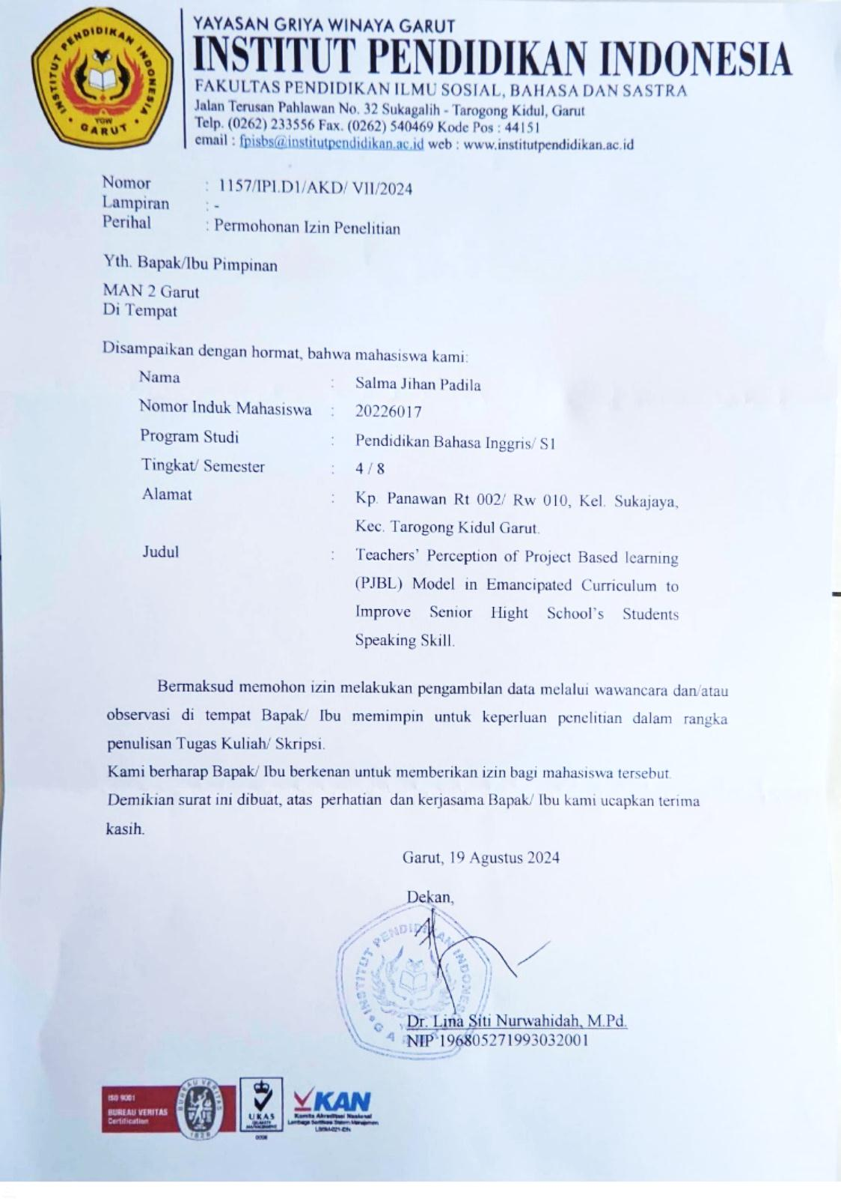

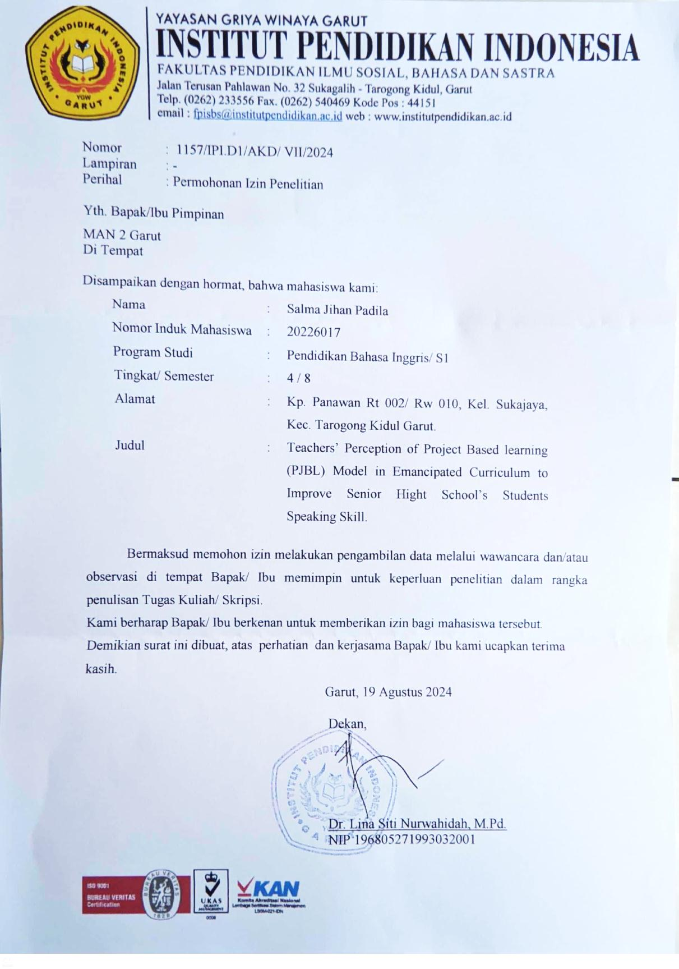

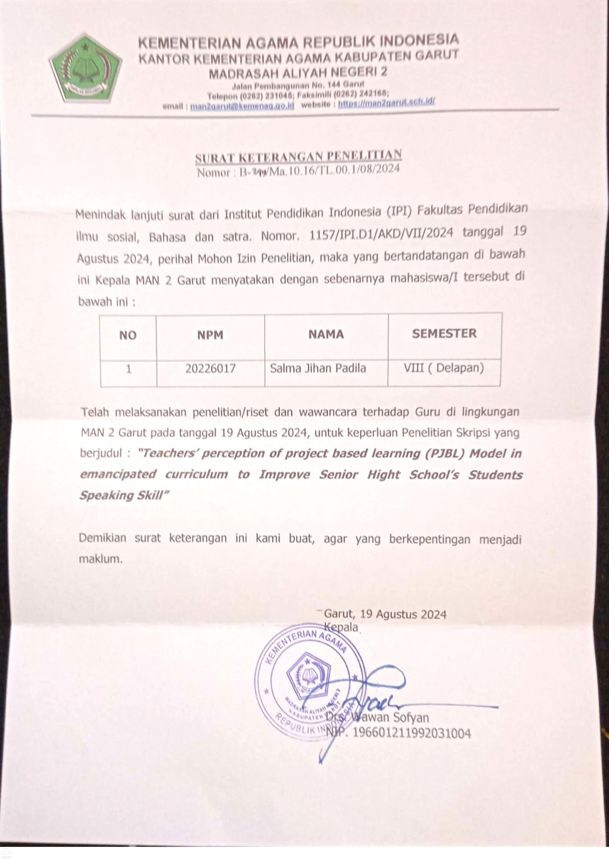

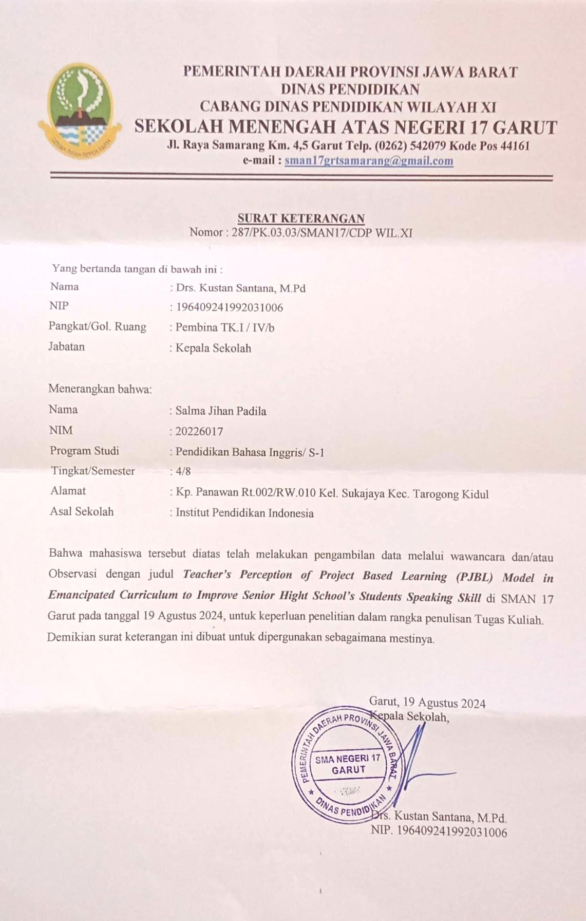

APPENDIX II: GUIDE QUESTIONS AND TRANSCRIPT
Guided Questions
Theoris | Variable | Questions
Project based learning, learning model recommended for implementation because it is aimed at students. With implementation of this learning model, students become more active in learning(Sulolipu et al., 2023) | Understanding | 1. Apa yang sebelumnya Bapak/Ibu mengetahui apa itu Project Based Learning (PjBL)?  2. Bagaimana model pembelajaran PjBL ini dapat diterapkan pada pembelajaran bahasa asing?
Yuvita et al., (2023) revealed that student motivation in learning English in speaking skills has increased effectively. | Implementation | 3, Apakah Bapak/Ibu percaya /mengetahui bahwa penerapan PjBL dapat meningkatkan keterampilan siswa dalam berbicara bahasa Inggris? Bagaimana itu bisa terjadi?  4. Media project pembelajaran seperti apa yang paling membantu dalam mengimplementasikan pembelajaran berbasis proyek secara efektif di kelas terutama dalam meningkatkan keterampilan berbicara?
Setia Dewi, (2020) decided to try the Project Based Learning technique as an alternative to teaching speaking because many research results state that this technique is effective for teaching speaking. | Perception | 5. Manfaat apa yang Bapak/Ibu rasakan saat menerapkan PjBL dalam meningkatkan keterampilan berbicara bahasa Inggris siswa?  6. Adakah contoh yang telah dirasakan dalam kehidupan nyata dikelas?  7. Apakah Bapak/Ibu mengamati adanya peningkatan dalam kefasihan pengucapan/kosakata siswa ketika setelah menggunakan model pembelajaran PjBL?
According to (Setia Dewi, 2020) said that speaking remains the most difficult skill to master for most English Language Learners, and they are still incompetent in communicating orally in English. There are several factors that lead to speaking difficulties such as inhibitions (students are worried about making mistakes, afraid or being criticized, or simply embarrassed), nothing to say (students have no motive to express themselves), low or uneven participation (only one participant can speak at a time due to large classes and the tendency of some learners to dominate, while others speak very little or not at all), use of mother tongue (learners who share the same mother tongue tend to use it because it is easier and because learners feel less exposed if they speak their mother tongue). | Perception | 8. Tantangan apa yang Bapak/Ibu temui ketika menerapkan model pembelajaran PjBL dalam pengajaran keterampilan berbicara (bahasa Inggris)? Bagaimana anda mengatasi tantangan-tantangan tersebut?  9. Apakah ada aspek tertentu dari keterampilan berbicara yang Anda rasa sulit untuk diatasi melalui PjBL?  10. Apakah Anda menemukan bahwa PBL mendorong lebih banyak kolaborasi dan komunikasi di antara para siswa? Mengapa demikian?
Dewi, (2022) said that more specific studies are needed to study the advantages and disadvantages of implementing the PjBL learning model. This is very important to be able to become input and reference in making learning development strategies both in terms of process and expected results | Perception | 11. Apa saja kekurangan dan kelebihan yang Bapak/Ibu rasakan setelah menerapkan model pembelaran PjBL? Dan lebih condong kemana?  12. Bagaimana Anda menilai keefektifan pembelajaran berbasis proyek dalam meningkatkan keterampilan berbicara siswa?  13. Umpan balik apa yang Anda terima dari siswa mengenai pengalaman mereka dengan pembelajaran berbasis proyek dalam kaitannya dengan keterampilan berbicara mereka?

List Interview
A. Project Based Learning (PjBL)
- Apa yang Bapak/Ibu ketahui mengenai Project Based Learning (PjBL)?
- Bagaimana model pembelajaran PjBL ini dapat diterapkan pada pembelajaran bahasa asing?
B. Speaking Skill
- Apakah Bapak/Ibu percaya /mengetahui bahwa penerapan PjBL dapat meningkatkan keterampilan siswa dalam berbicara bahasa Inggris? Bagaimana itu bisa terjadi?
- Media project pembelajaran seperti apa yang paling membantu dalam mengimplementasikan pembelajaran berbasis proyek secara efektif di kelas terutama dalam meningkatkan keterampilan berbicara?
- Manfaat apa yang Bapak/Ibu rasakan saat menerapkan PjBL dalam meningkatkan keterampilan berbicara bahasa Inggris siswa?
- Adakah contoh yang telah dirasakan dalam kehidupan nyata dikelas?
- Apakah Bapak/Ibu mengamati adanya peningkatan dalam kefasihan pengucapan/kosakata siswa ketika setelah menggunakan model pembelajaran PjBL?
- Tantangan apa yang Bapak/Ibu temui ketika menerapkan model pembelajaran PjBL dalam pengajaran keterampilan berbicara (bahasa Inggris)? Bagaimana anda mengatasi tantangan-tantangan tersebut?
- Apakah ada aspek tertentu dari keterampilan berbicara yang Anda rasa sulit untuk diatasi melalui PjBL?
- Apakah Anda menemukan bahwa PjBL mendorong lebih banyak kolaborasi dan komunikasi di antara para siswa? Mengapa demikian?
- Apa saja kekurangan dan kelebihan yang Bapak/Ibu rasakan setelah menerapkan model pembelaran PjBL? Dan lebih condong kemana?
- Bagaimana Anda menilai keefektifan pembelajaran berbasis proyek dalam meningkatkan keterampilan berbicara siswa?
- Umpan balik apa yang Anda terima dari siswa mengenai pengalaman mereka dengan pembelajaran berbasis proyek dalam kaitannya dengan keterampilan berbicara mereka?

TRANSCRIPT
Transcript 1st Interview
- Teacher Interview
Date: 19th August 2024
Informant: English Teacher 1 (YR)
Interviewer: Researcher (R)
- Transcript

R | : | Menurut Ibu apasih Project Based Learning itu?
YR | : | Eee.. kalau project based learning itukan ada 4 point ya? Ynag dikaitkan dengan element pembelajaran atau konsep pembelajaran dikelas itu ada yang sistemnya kuesioner, ada yang sistemnya inovatif, ada yang sistemnya eee actual learning nah itu mungkin tidak semua elemen untuk project based learning dipakai tapi mungkin disesuaikan dengan kondisi pembelajaran. Kalau seandainya kebetulan untuk tahun ini materi kurikulum merdeka itu bab pertama itu tentang narrative dikelas 11 itu, nah ibu terapkan itu memacu dengan based learningnya itu kuesioner. Jadi berkaitan dengan materi yang akan disampaikan.
R | : | Bagaimana menurut ibu model pembelajaran PjBL ini bisa dikaitkan dengan pelajaran bahasa Inggris gitu?
YR | : | Semuanya bisa kalau yang tadi 4 pont itu, project based learning itu ada 4 ponit kan tadi yah yang mungkin salah satunya untuk eee.. untuk actual mungkin bisa kita anak-anak dibawa keluar lingkungan sekolah untuk mempelajari contextual learning ya dengan suasana alam atau apa mungkin bisa dengan komunikasi dengan eee... orang asing atau apa itu dengan contextual learning yah. Mungkin diluar kelas yah kalau contextual learning. Kalau yang semacam untuk bab pertama ini mungkin disesuaikan dengan kondisi dan pembelajaranya itu dikelas yaitu lebih baik mungkin untuk elemen materinya itu atau proses pembelajarannya itu dengan memacu ke siswa dengan proses kuesioner. Nah jadi sesuai dengan pengalaman anak yang telah belajar mungkin tahun lalu bisa diulang bertanya untuk acknowledgenya mungkin apa tujuanya, apa mungkin masih diingat, atau apa eee.. semacam kalau jenis teks ini seperti apa. Pokoknya semua dipacu untuk kuesioner dulu sampai sejauh mana acknowledge anak atau kemampuan anak itu tahu tentang jenis teks narrative.
R | : | Karna itukan saya penelitiannya menjurus ke speaking skill, jadi ee.. menurut Ibu sendiri apakah PjBL ini dapat meningkatkan kterampilan siswa gitu bu dalam speaking skillnya?
YR | : | Ohh bisa! Bisa dan dituntut harus itu kalau ibu biasanya penglaman mengajar bahasa Inggris itu dari mulai awal masuk kelas juga apalagi guru pertama jam mengajar itu harus ee... greeting itu menggunakan bahasa Inggris gitu yah. Kemudian kita dikasih contoh untuk ibu biasanya suka menggunakan bahasa Inggris itu dikelas, mungkin ditanya ke anak ga setiap anak tapi ibu speak English. Mengajarnya speak English and questoin with students “do you understand?” atau “What I explain” nah gitu. Nah setelah itu mungkin anak ada masukan atau mungkin bisa melihat anak meresponnya sampai sejauh mana gitu kemampuan acknowledge speak Englishnya nah gitu. Apalagi untuk project based learning yang berkaitan dengan speaking itu bisa ibu menerapkannya dengan presentasi dengan membuatkan sebuah grup kelas tapi anaknya semua dikasih materi per individu bair dia responsible gitu ya jadi tidak each other student do their job, jadi komunikatif semuanya is do it nah gtiu. Kemudian dipresentasikan kedepan dengan menggunakan conversition in English presentasinya.
R | : | Lalu ibu bagaimana tanggapan siswanya secara umum terhadap kegiatan yang mengaharuskan siswa gitu ikut andil dalam berbicara bahasa Inggris itu seperti apa? Apakah mereka lebih aktif gitu atau apa?
YR | : | Aktif! Ya aktif pasti dia confident dan itu berlatih ya secara tidak langsung dia berlatih untuk merasa confident kemudian ya belajar step by step untuk listen and speaking in Englsih nah gitu. Jadi, anak itu dipacu harus gitu. Biasanya gitu kalau untuk project based learning menerapkannya melalui conversition jadi dugunakannya adalah presentasi.
R | : | Selain presentasi ada tidak media khusus pembelajaran seperti apasih yang paling membantu ibu dalam mengimplementasikan pembelajaran?
YR | : | Boleh dengan power point, atau dengan infocus bisa dengan mendengarkan atau meriview, summarize dan conclusion in speak English. Jadi siswa bisa listening kemudia bisa conversition. Jadi menyampaikannya nanti memlalui kesimpulannya itu menggunakan bahasa Inggri.
R | : | Lalu bu manfaat apa saja yang ibu rasakan saat menerapkan PjBL dalam meningkatkan keterampilan berbicara siswa?
YR | : | Banyak sekali ya lebih bisa melihat/menganalisis sejauh mana anak mampu conversition dan mungkin komunikatif.
R | : | Apakah ada contoh nyatanya tidak bu seperti dikelas mungkin?
YR | : | Contohnya seperti kalau lomba kan seperti perlombaan speech contest dan kalau disinikan setiap hari senin upacara saat siswa mejadi protokol itu menggunakan bahasa Indonesia kemudia bahasa Inggris jadi dari situ terlihat bahwa anak terbiasa dalam pronounciation dan kuminikasi dengan menggunakan bahasa Inggris.
R | : | Lalu apakah ibu juga mengamati adanya peningkatan kafasihan pengucapan dalam kosakata gitu?
YR | : | Pasti ya kalo megamati dan itu wajib ya agar ibu bisa menilai sejauh mana nih bahasa Inggrisnya. Jangan sampai “oh bahasa Inggris di SMA 17 itu sangat rendah sekali” jangan sampai seperi itu. Ibu juga selalu memotivasi memberikan support banyak mungkin alumni yang dari sini yang sudah berhasil membawa nama baik sekolah atau melanjutkan perguruan tinggi ke yang lebih bagus dengan basic bahasa Inggrisnya juga bagus gitu.
R | : | Selanjutnya tantangan apasih yang ibu temui ketika menerapka model pembelajaran PjBL meningkatkan keterampilan berbicara bahasa Inggris siswa?
YR | : | Eamngsih ya agak rumit sulit ya tantangannya harus lebih sabar ya namanya proses ya dalam mendidik apalagi ibu pengajar bahasa asing itu banyak sekali tantangannya. Jadi sejauh mananih anak harus bisa. Dan solusinya ibu selalu menganalisis seperti baru masuk kelas aja dilihat satu kelas ada berapa anak nih yang mampu berkomunikasi menggunakan bahasa Inggris. Dan dari situlah PjBL itu sangan membantu seperti ibu membuat sebuh proyek pengajaran yang pastinya harus melibatkan siswa.
R | : | Dan ibu apakah ada gitu aspek tertetu dari keterampilan berbicara yang ibu rasa sulit gitu untuk mengatasinya?
YR | : | Emm.. kalau selama ini ibu rasa tidak terlalu sulit ya karena mungkin ibu sudah berpengalaman mengajar jadi dapat menggunakan trik-trik. Cuman ya memang setiap kelas dan siswa itu kan beda-beda ya IQ, kemampuan dalam pemahaman bahasa Inggris itu berbeda. Jadi ibu tidak mengaitkan sejauh mana kesulitan itu ya dituntun saja pelan-pelan.
R | : | Selanjutnya bu, apakah ibu menemukan bahwa PjBL dapat mendorong lebih banyak kolaborasi dan komunikasi diantara para siswanya sendiri/
YR | : | Selain tadikan ibu menerapkannya dengan presentasi ya untuk diterapkan supaya siswa itu bisa lebih percaya diri dengan penampilannya menggunakan bahasa Inggris. Karenakan mereka dituntut untuk bisa berbicara didepan yang lain. Saat mereka sedang mengerjakan suatu tugas proyek yang berkelompok jugakan ibu suka meminta anak-anak membiasakan berbicara bahasa Inggris dengan teman-temannya sesuai dengan kemampuan mereka. Jadi lebih inovatif dalam proses antara individu atau pergrup dalam lingkungan kelas itu selalu ada.
R | : | Lalu apa saja sih kekuramgan dan kelebihan yang ibu rasakan gitu setelah menerapkan model pembelajaran berbasis proyek ini khususnya dalam keterampilan berbicara siswanya? Dan lebih condong kemana bu apakah lebih banyak manfaatnya atau malah lebih banyak kekurangannya?
YR | : | Lebih bnnyak manfaatnya ya kalau yang ibu rasakan. Jadi manfaatnya setelah diterapkan itu anak juga asalnya yang tidak tahu jadi tahu, yang tidak pernah dengan jadi terbiasa dan banyak juga masukan dari siswa yang tadinya pakem ya jadi komunikatif.
R | : | Pertanyaan terakhir nih bu, umpan balik apsih yang ibu terima gitu dari siswa mengenai pengalaman mereka dengan pembelajaran berbasis proyek ini dan kaitannya dengan keterampilan berbicara mereka itu ada tidak bu?
YR | : | Responnya ya? Baik ya dari siswa. Melihat mereka ada perkembangan setiap pertemuannya saja itu sudah merupakan timbal balik yang sangat luar biasa menurut ibu. Jadi ya secara jelas ibu sudah berhasil gitu dan ikut andil dalam keberhasilan mereka.
Transcript 2nd Interview
- Teacher Interview
Date: 19th August 2024
Informant: English Teacher 2 (AN)
Interviewer: Researcher (R)
- Transcript

R | : | Apa yang bapak ketahui mengenai project based learning di kurikulum merdeka?
AN | : | Kurikulum merdeka itu sebenarnya memberikan kemerdekaan pilihan kurikulum yang dibuat oleh negara. Jadi kita tetap punya dasar-dasar pengajaran itu yang disediakan oleh kurikulum merdeka supaya ketika menyampaikan ada beberapa teknik ya seperti yang disebutkan teknik pembelajaran berbasis proyek yaitu metode belajar yang menggunakan masalah sebagai langkah awal dalam mengumpulkan dan mengintegrasikan pengetahuan baru berdasarkan pengalamannya dalam beraktifitas secara nyata. Disekolah ini siswa disedia fasilitas buku dan bisa pinjam diperpustakaan siswa dianjurkan untuk mencari dulu materi apa yang dia sukai biasanyakan dalam buku itu setiap bab sudah ditentukan materi-materinya tetapi tidak misal karna yang dia sukai bab 3 disemester ini ya saya akan memfasilitasi pembelajajran pada bab itu. Lalu dia harus melakukan 4 skill yang ada pada bahasa Inggris seperti mendengar, berbicara. Membaca dan menulis. Dan kita sebagai guru juga harus memotivasi dan mendapatkan hasil ajar memahami materi.
R | : | Seperti students center gitu ya pak?
AN | : | Iyaaa jadi siswa yang memutuskan, sesuai dengan kemampuan dan keinginan. Harus senang dulu dianya.
R | : | Lalu bagaimana sih pak model pembelajaran berbasis proyek ini dapat diterapka khususnya dalam pembelajaran bahasa Inggris gtiu?
AN | : | Ya sebenarnya banyak model-model yang sudah kita laksnakan. Dan karena kurikulum ini anjuran dari pemerintah gitu ya jadi ada keharusan gitu diterapkannya dalam pelajaran bahasa Inggris. Kalau kebetulan materinya misalnya tentang “memberikan layanan/pertolangan” tergantung model ajarnya apaka mau dibaut seperti permainan atau dibuat role play misal ya bikin naskah atau dialog.
R | : | Kalau bapa percaya tidak bahwa penerapan PjBL itu dapat meningkatkan keterampilan siswa gitu khususnya dalam keterampilan berbicara?
AN | : | Iya karena model seperti project based learning itu memang seperti yang saya katakan tadi. Jadi siswa harus mengerti dulu materinya gitu bahwa misal kita akan belajar jadi maksud saya pada contoh dikelas siswa menjadi penerima telfon dihotel misal atau penjaga toko, atau misal saat berkelompok diberi proyek membuat dialog. Kemudia ya gitu dilatih seperti dibuat role play. Dan mereka melihat satu sama lain gitu jadi ikut termotivasi juga.
R | : | Bagaimana tanggapan siswanya gitu pak secara umum terhadap kegiatan speaking itu dalam pembelajran berbasis proyek/
AN | : | Kalau ini saya malu, disekolah ini kan tahun kemarin saya orang pertama gitu yang menjalankan kurikulum merdeka karena saya ngajar dikelas X. Dan mereka sangat antusias gitu dengan pembelajrannya karena diperbanyak prakteknya seperti penampilan dipanggung dengan speech, debat semua menggunakan bahasa Inggris. Akhirnya saat dia naik kelas XI dan berganti guru mereka sedikit kecewa gitu. Saat pembawaan mengajar kita menarik jadi anak-anakpun senang. Kemampuannya meningkat, menulisnya bisa, berbicaranya hebat, mendengarkannya juga dia tidak salah ketika diminta untuk mengucapkan dan menuliskannya kembali karena terlatih dan kita dikelas juga sering practice misal “Good morning (british accent)” Saya melatihnya seperti itu tidak “Good morning (aksen sunda)” itu tidak salah, namun yang mana cara pengucapannya yang lebih baik. Karena siswa mengahfalnya dalam bentuk tulisan bukan dari ekspresinya. Orang mengerti karena konteks.
R | : | Selanjutnaya media pembelajaran seperti apa yang paling membantu bapak dalam mengimplementasikan pembelajaran berbasis proyek tersebut khususnya dalam keterampilan berbicara (bahasa Inggris)?
AN | : | Media itu sebenarnya semua juga penting, ya tergantung juga apa yang mau kita sampaikan. Tapi misalnya untuk mempraktikan native speaker ya media yang diperlukan tayang video atau menonton film gitu. Jadi berbagai macam sudah disediakan disekolah ini tinggal anak-anaknya sih yang mau. Karena anak-anak begitu kita masuk tanpa bantuan media pembelajaran kadang sering merasa bosan tapi ketika digunakan media pembelajaran membuat banyak siswa yang antusias gitu. Misalnya menerapkan PjBL itu mengenai materi “Customer service bank” bisa saja digunakan telpon rumah untuk membuat anak-anak tertarik saat mempraktikannya.
R | : | Apakah ada gitu pak manfaat yang bapak rasakan setelah menerapkan model pembelajaran berbasis proyek ini khususnya dibidang keterampilan berbicara?
AN | : | Ya manfaatnya banyak siswa yang kemampuan berbicaranya meningkat karena tujuan pembelajaran bahasa Inggris itu dikhususkan dalam 4 skills. Tapi kebanyakan orang percaya bahwa orang yang lancar berbicara bahasa Inggris disebut jago Inggris. Maka disitulah peran speaking yang paling penting ketimbang 3 skills lainnya. Setiap hari senin saya tampilkan anak-anak tampil speech didepan saat upacara. Jadi siswa yang saya ajar yang mampu atau tidak mampu dalam berbicara bahasa Inggris harus tampil kuncinya yaitu berani. Bebas mau speech apapun yang penting mereka berani kadang tentang peraturan-peraturan di sekolah, masalah-masalah remaja saya bebaskan. Kalau dia ngeluh segala macam saya tawarkan untuk membuatkan dia teksnya. Itulah poin saya “keberanian” percuma pintar tapi tidak mau tampil tetap saja tidak akan dilirik orang. Maka speakinglah yang saya tampilkan tiap hari senin bisa 2-3 orang dan itu juga salah proyek yang saya dan anak-anak kerjakan untuk meningkatkan keterampilan berbicara mereka. Jadi alhamdulillah manfaatnya target-target yang saya inginkan tercapai walaupun masih banyak anak-anak yang tidak mampu karena tidak biasa. Karena bahasa Inggris itu bahasa. Coba anda bahasa sunda apakah belajar dulu bahasa sunda? Nggakan, terus bahasa Indonesia apakah belajar dulu bahasa Indonesia? Tapikan kalo ngomong ngerti. Sebenarnya bahasa Inggris juga begitu.
R | : | Yang penting practice ya ?
AN | : | Iya practice dulu, dengan siapa? Itulah mencari partner nya yang susah.
R | : | Lalu pak apakah bapak juga mengamati adanya peningkatan dalam kefasihan pengucapan/kosakata siswa tersebut setelah menggunakan model pembelajaran berbasis proyek ini?
AN | : | Iya sangat terlihat, ya seperti saya praktikan tadi. Kalau dulu “good morning, how are you? (aksen sunda)” itu tidak salah cuman logatnya sunda, kemudian kita belajar belajar ya namanya juga project based learning ya dasar-dasar jadi ya harus sabar gurunya. Kadang-kadang 2 jam pelajaran terus aja materi “greeting” sampai dia paham tapi ngga apa-apa. Besok dia misal ketemu di jalan ditanya dapat menjawab dengan aksen Inggris (British accent) sudah bagus itu ada pengingkatan yang penting berani.
R | : | Selanjutnya pak ada ga tantangan yang bapak temui saat menerapkan pembelajaran berbasis proyek khususnya dalam bidang keterampilan berbicara siswa?
AN | : | Sebenarnya tantangannya mah satulah kadang anak-anak suka malas, da palalinter anak-anaknya mah ketika berbicara waah mereka rame tapi ketika berbahasa Inggris dia malas. Kenapa dia begitu ketemu “ah.. bahaha Inggris mah lieur pak” padahal bahasa, bukan matematika bukan fisika atau kimia gitu. Karena ketidak biasaan, jadi kita sebagai guru harus sabar dulu. Jadi untuk menjawab pertanyaan itu tantangannya atau hambatannya itu kemalasan. Maka disini juga ada dua club bahasa Inggris, tapi dua club tersebut mempunyai kegunaan yang berbeda yang satu diajarkan seperi “bagaimana dia mendapatkan nilai dari teofl dan semacam test yang lainnya” dan yang satunyanya lagi club khusus berbicara “bagaimana siswa belajar berbicara bahasa inggris dari bawah sampai mahir”.
R | : | Lalu apakah ada aspek tertentu dari keterampilan berbicara yang bapak rasa sulit untuk diatasi dalam pengajaran berbasis proyek ini/
AN | : | Yang sulit sejauh ini ada pada mother tongue atau bahasa ibu ya, karena kitakan lidah-lidah orang sunda jadi ketika berbicarapun kadang anak-anak masih menggunakan aksen sunda itu karena pengaruh mother tongue. Tapi masih mendingsih orang sunda masih ada beberapa yang bisa mengikuti british accent beda lagi saya pernah ke jawa tengah kesalah satu sekolah smp yang ada disana mother tongue jawa gitu ya medok. Jadi kalau D belkangnya itu pasti jadi T, dan kesulitannya itu. Disini juga sama cuman lebih ke intonasinya anak-anak kalu bisa bahasa Inggris tapi intonasinya masih seperti sedang membaca. Padahal itu juga tidak salah karena berbeda negara pasti mempunyai aksen yang berbeda-beda juga. Kalau saya karena senang menggunakan British accent jadi ya kadang saya ajarkan juga pada anak-anak. Setidaknya gitu mereka sudah tahu bahwa intonasi begitu tuh salah.
R | : | Lalu pak apakah bapak menemukan bahwa PjBL itu mendorong lebih banyak kolabirasi dan komunikasi diantara para siswa gitu khususny dalam keterampilan berbicara gitu?
AN | : | Ya sangat terlihat sekali lah, palagi dikelas gitukan mereka sering berinteraksi satu sama lain. Seperti yang sudah saya sampaikan sebelumnya gitu saat belajar suatu proyek seperti tadi role play dalam sebuah hotel gitu, bapa juga suka menyuruh mereka untuk berdiskusi dalam bahasa Inggris ya itu juga melatih mereka agar lebih terbiasa.
R | : | Apa saja sih pak kekurangan dan kelebihan yang Bapak rasakan setlah menerapkan model pembelajaran berbasis proyek khususnya dalam bidanng keterampilan berbicara siswa? Dan bapak sendiri lebih condong kemana apakah lebih banyak manfaatnya atau kekurangannya?
AN | : | Lebih banyak manfaatnya sih ya, seperti karena diaadakannya suatu proyek gitu siswa jadi lebih semnagat belajarnaya karean inikan bersifat praktik dan diberi kebabasan saat berdiskusi satu sama lain gitu ya, beda lagi kalau dikelas siswa hanya diberi materi saja apalagi ini bahasa Inggris kebanyakan siswa akan merasa bosan saat didalam kelas.
R | : | Ya terakhir pak umpan balik apa yang bapak terima dari siswa mengenai pengalaman mereka dalam pembelajaran berbasis proyek khususnya pada bidang speaking skill?
AN | : | Umpan baliknya itu adalah kita jadi lebiih bisa mempersiapkan pembelajaran yang tingkat levelnya lebih tinggi. Dan ada kepuasaan tersendiri gitu bapak sebagai guru terlibat dalam proses berkembangnya keterampilan anak-anak.

APPENDIX III: DOCUMENTATION

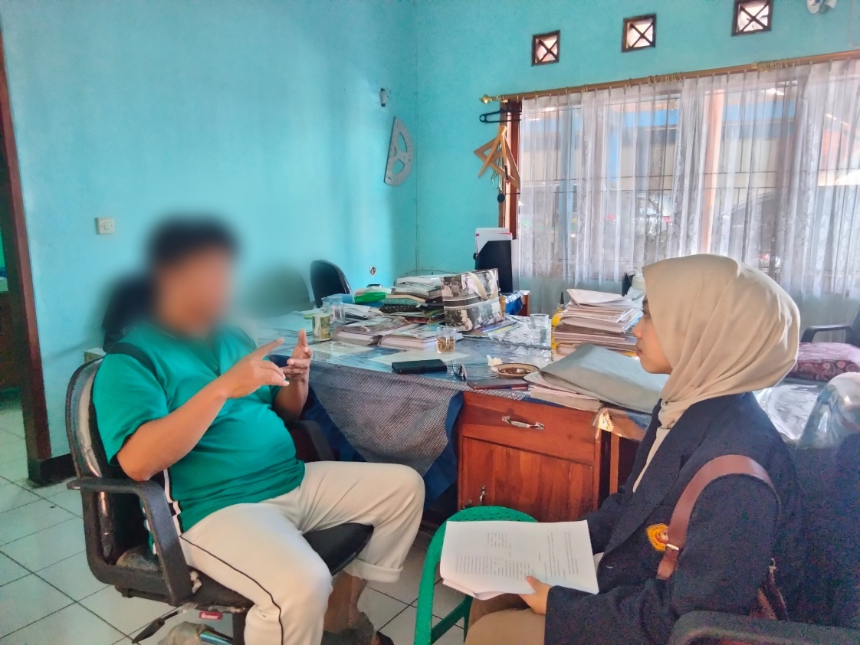

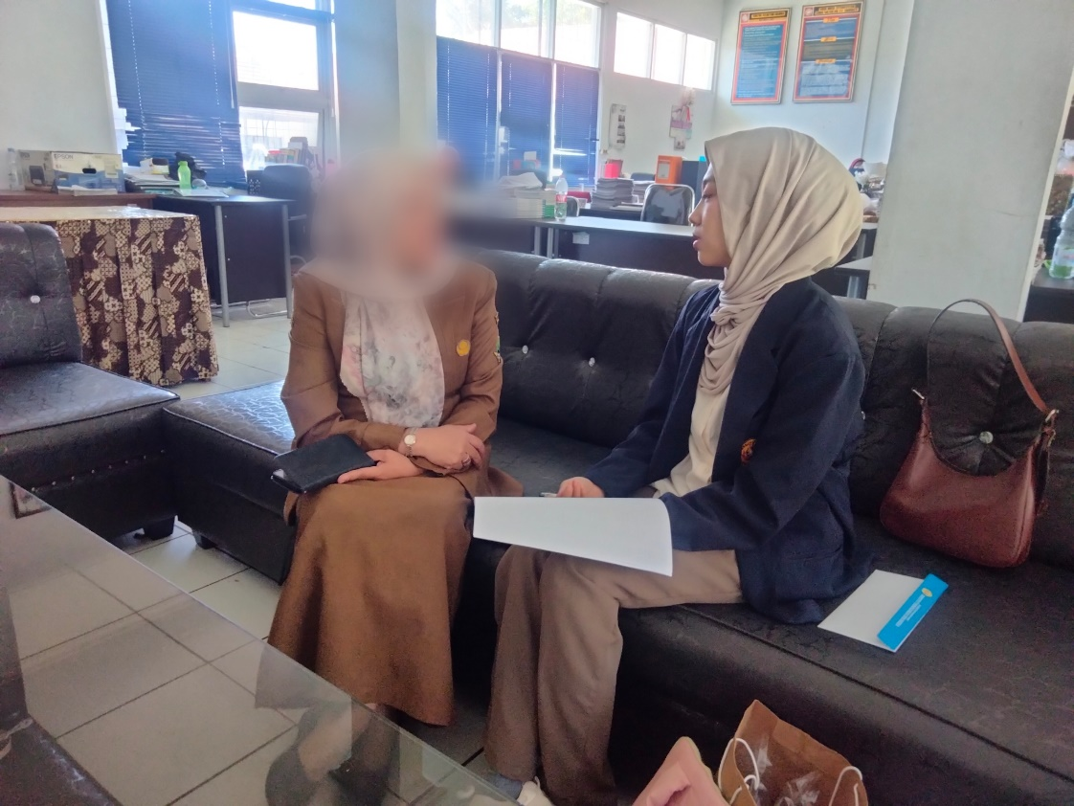

APPENDIX IV: CIRRICULUM VITAE

The author of this thesis is Salma Jihan Padila. A woman who was born in Garut but grew up in Bandung for 17 years and chose to return to live in her hometown of Garut until now, born on October 21, 2001. The 4th child of 5 siblings, is the baby of Mrs. Siti Rohimah. The author received her first education at MI AL-Barokah Bandung (2007-2013), then continued to MTs AL-Islam Bandung (2014-2017). Three years later the author completed his education at SMK Muhammadiyah Garut (2018-2020). In 2020 the author was enrolled in one of the universities in Garut with a major in English Education at the Indonesian Institute of Education (IPI) Garut.
The author also participates in several internal and external campus organizations. In the internal campus organization, the author plays an active role in HIMADIKSARIS (Himpunan Mahasiswa Pnedidikan Bahasa Inggris) and has also been active in the autonomous organization on campus, namely RWM (Racana Wiyata Mandala). The external organization that the author participated in was IPM (Ikatan Pelajar Muhammadiyah).
Thanks to the guidance and help of Allah SWT, your efforts and prayers in undergoing academic activities at the Indonesian Institute of Education (IPI) Garut, Alhamdulillah the author can complete the final project with a thesis entitled: “Teachers' Perception of Project Based Learning (Pjbl) Model in Emancipated Curriculum to Improve Senior High School's Students Speaking Skill”.

APPENDICES

