INVESTIGATING TEACHERS STRATEGIES IN TEACHING LISTENING IN BOARDING SCHOOL

A PAPER
Submitted to the English Education Program of IPI Garut as a Partial Fulfillment of the Requirements for the Bachelor Degree in Education



Written by:
Nadia Nurazmi
20223020

ENGLISH EDUCATION PROGRAM
FACULTY OF SOCIAL SCIENCE LANGUAGE AND LITERATURE EDUCATION
INSTITUT PENDIDIKAN INDONESIA GARUT
2024

APPROVAL SHEET

INVESTIGATING TEACHERS STRATEGIES IN TEACHING LISTENING IN BOARDING SCHOOL

By:
Nadia Nurazmi
(20223020)

Approved by:

First Supervisor  Dr. Setia Muljanto. SE., M.Pd.  NIDN. 0419106705 | Second Supervisor  Iyus Rustandi, M.Pd.  NIDN. 0424056402

Acknowledged by :
Head of English Education Program

Anne Ratna Suminar, M.Pd.
NIDN. 0415038602

LEGITIMATION OF EXAMINERS BOARD

INVESTIGATING TEACHERS STRATEGIES IN TEACHING LISTENING IN BOARDING SCHOOL

By:
Nadia Nurazmi
(20223020)

This paper has ben examined on 16th of August 2024

First Examiner,  Drs. H. Surtiana H., M. A.  NIDN. 0010075102 | Second Examiner,  Dr. Yustika Nur F, M.Pd.  NIDN. 0412069004 | Third Examiner,  Anne Ratna Suminar, M.Pd.  NIDN. 0415038602

Acknowledged by:
Dean of Faculty of social science,
Language and Literature Education

Dr. Lina Siti Nurwahidah, M.Pd.
NIP. 196805271993032001

PERNYATAAN

Yang bertanda tangan di bawah ini
Nama : Nadia Nurazmi
NIM : 20223020
Tempat/tanggal lahir : Garut 13 Agustus 2001
Alamat : kp. Cipaniis, Garut, Jawa Barat

Saya menyatakan dengan sesungguhnya bahwa tesis saya berjudul:

“Investigating Teachers Strategies In Teaching Listening In Boarding School”

Benar-benar karya saya, kecuali semua kutipan dan referensi yang disebutkan sumbernya. Jika ada kekeliruan atau kekeliruan di dalamnya, sepenuhnya menjadi tanggung jawab saya. Demikianlah surat pernyataan ini saya buat dengan sesungguhnya.

Garut, 13 Agustus 2024
Penulis,

Nadia Nurazmi
NIM, 20223020

DECLARATION OF ORIGINALITY

The undersigned below
Name : Nadia Nurazmi
NIM : 20223020
Place/date of birth : Garut, 13 August 2001
Address : kp. Cipaniis, Garut, West Java

I truly declare that my thesis is entitled:

“Investigating Teachers Strategies In Teaching Listening In Boarding School”

Is completely my work, except for all quotations and references where the source is stated. If there are any errors or mistakes in it, it will be entirely my responsibility. This is how I truly make this statement.
Garut, 13 Agustus 2024
Penulis,

Nadia Nurazmi
NIM, 20223020

MOTTO

"Waman yatawakkal 'alallahi fahuwa hasbuh"
"Barang siapa bertawakal kepada Allah, maka Allah akan mencukupkannya."
(QS. At-Talaq: 3)

"La yukallifullahu nafsan illa wus'aha"
"Allah tidak membebani seseorang melainkan sesuai dengan kesanggupannya."
(QS. Al-Baqarah: 286)

PREFACE
Praise be to Allah SWT, the Most Gracious and the Most Merciful. He has blessed me by completing this research paper. Furthermore, may Allah SWT bless our Prophet Muhammad SAW; peace and blessings be upon him and his family, friends, and followers forever. With Allah SWT's permission, the researcher was able to complete this paper with the title "Investigating Teachers Strategies in Teaching Listening in Boarding School". This article mainly discusses what strategies are used by teachers in boarding schools. This article aims to describe the strategies teachers use at the boarding school at Mts. Al-Qona'ah Cikajang Garut. The researchers acknowledge that there is still much work to be done on this publication. Both the language and content areas require much improvement. Therefore, researchers expect useful criticism and suggestions to improve current research and provide guidance for further research. The aim of this research is that this publication can be useful for other readers.

Garut, 13 Agustus 2024
Penulis,

Nadia Nurazmi
NIM, 20223020

ABSTRAK
Penelitian ini bertujuan untuk menginvestigasi strategi yang digunakan oleh guru dalam mengajar keterampilan mendengarkan bahasa Inggris di sekolah berasrama. Penelitian ini difokuskan pada satu pertanyaan penelitian utama: "Apa saja strategi guru dalam mengajar mendengarkan di sekolah berasrama?" Data diperoleh melalui wawancara dengan jumlah pertanyaan 13. Seluruh hasil penelitian disimpulkan kedalam tiga jenis strategi yang diidentifikasi oleh O'Malley dan Chamot, yaitu strategi metakognitif, kognitif, dan sosial-afektif. Hasil penelitian mengungkapkan bahwa dalam mengajar mendengarkan, guru di sekolah berasrama menggunakan strategi yang beragam. Strategi metakognitif mencakup kegiatan yang dilakukan guru sebelum, selama, dan setelah aktivitas mendengarkan, yang dirancang untuk merangsang dan membantu siswa dalam memahami materi. Strategi kognitif yang ditemukan termasuk pendekatan bottom-up dan top-down, serta penggunaan lagu-lagu berbahasa Inggris dan menonton video atau audio asli. Strategi sosial-afektif yang diidentifikasi mencakup diskusi kelompok, yang terbukti efektif dalam meningkatkan keterampilan mendengarkan siswa melalui interaksi dan komunikasi antar siswa. Kekuatan dari penelitian ini terletak pada fokusnya yang spesifik pada strategi pengajaran di sekolah berasrama, yang memiliki lingkungan belajar dan dinamika yang berbeda dari sekolah umum. Namun, penelitian ini memiliki keterbatasan dalam hal konteks, karena hanya berfokus pada satu sekolah berasrama tanpa mempertimbangkan persepsi siswa atau variasi antar sekolah berasrama lainnya. Perbedaan utama penelitian ini dengan penelitian sebelumnya adalah fokusnya pada sekolah berasrama yang memiliki struktur dan jadwal unik yang mempengaruhi strategi pengajaran.Penelitian ini juga menemukan keunikan bahwa kurikulum sekolah selaras dengan kurikulum pondok pesantren, di mana semua kegiatan pembelajaran mengikuti arahan yayasan pondok pesantren, memungkinkan siswa untuk belajar di sekolah sambil mempelajari ilmu agama secara bersamaan.
Kata kunci: strategi pengajaran, keterampilan mendengarkan, sekolah berasrama, strategi metakognitif, strategi kognitif, strategi sosial-afektif

ABSTRACT

This study aims to investigate the strategies used by teachers in teaching English listening skills in boarding schools. This study focused on one main research question: "What are teachers' strategies for teaching listening in boarding schools?" Data was obtained through interviews with a total of 13 questions. All research results were summarized into three types of strategies identified by O'Malley and Chamot, namely metacognitive, cognitive, and social-affective strategies. The research results revealed that in teaching listening, teachers at boarding schools used various strategies. Metacognitive strategies include activities that teachers carry out before, during, and after listening activities, which are designed to stimulate and help students understand the material. Cognitive strategies found included bottom-up and top-down approaches, as well as the use of English songs and watching original videos or audio. The social-affective strategies identified included group discussions, which were shown to be effective in improving students' listening skills through interaction and communication between students. The strength of this research lies in its specific focus on teaching strategies in boarding schools, which have different learning environments and dynamics than public schools. However, this research has limitations in terms of context because it only focuses on one boarding school without considering student perceptions or variations between other boarding schools. The main difference between this research and previous research is its focus on boarding schools, which have unique structures and schedules that influence teaching strategies. This research also found the uniqueness that the school curriculum is aligned with the Islamic boarding school curriculum, where all learning activities follow the Islamic Boarding School Foundation's Directions, allowing students to study at school while studying religion at the same time.

Key Words: Teachers Strategies, Teaching Strategies, Listening Skills, Boarding Schoo.

ACKNOWLEDGEMENT
Praise be to the presence of Allah SWT, the King of Kings, who has bestowed His mercy and grace on all mankind so that the author can complete his research for this final assignment. Our Prophet Muhammad SAW, his family, friends, and followers are always the recipients of our prayers and greetings.
The author would like to thank the following esteemed parties for their support, encouragement, and countless contributions during this research:
- Prof. Dr. Nizar Alam Hamdani, SE., M.Μ., Μ.Τ., M.Si., M.Kom, as Chancellor of the Indonesian Education Institute (IPI) Garut.
- Dr. Hj. Lina Siti Nurwahidah, M.Pd, as dean of the Faculty of Social Sciences, Language, and Literature Education, Indonesian Education Institute (IPI) Garut.
- Anne Ratna Suminar, M.Pd, as head of the English Language Education Program.
- Mr. Dr. Setia Muljanto, M.Pd, as the first supervisor. Thank you for taking the time to provide advice, suggestions, and guidance while working on and compiling this paper.
- Mr. Drs. Iyus Rustandi, M.Pd, as the second supervisor. Thank you for taking the time to provide advice, suggestions, and guidance while working on and compiling this paper.
- My first love, my hero, Cecep and my beloved mother Yuyun Hasipah. Thank you for all the support, sacrifices, and advice given to the author so that he can complete his studies and obtain a bachelor's degree. It is an honor to have parents who always give me their full love and take good care of me. I dedicate this paper to my parents.
- Next, I want to thank myself for always remaining strong, remaining enthusiastic, remaining patient even though the storm was very big. don't give up !
- Thank you to your aunts, Alis Latipah, Tuti Alawiah, Apiah Soeganda, Heni Putriani, and uncles of all HJ. Dadan, Ao Nadin, Enan Santana, and Ujang Rosjana and Pudin who always support you in every process, both in providing time and materials. May Allah reward you for your kindness.

- Thank you very much to my friends (Ceriwis, especially Sari Safitri and Rai Tri Oktaviani) and my close friend Asri Andini, who always provided help and answered all my confusion during the process of writing this thesis. May Allah reward your kindness.
- I would also like to thank Andika M. Arif Nurdin, who always accompanied me and provided as much assistance as possible in carrying out every detail of the process of completing this thesis. And what is no less important, I would like to thank all my family and friends, whom I cannot mention one by one. May Allah make all your affairs easier and be pleased with all your deeds.
This thesis is far from perfect, but it is hoped that it will be useful not only for researchers but also for readers. Therefore, we highly expect constructive suggestions and criticism.

TABLE OF CONTENS

APPROVAL SHEET............................................................................................i
LEGITIMATION OF EXAMINATION BOARD............................................ii
PERNYATAAN..................................................................................................iii
DECLARATION OF ORIGINALITY.............................................................iv
MOTTO................................................................................................................v
PREFACE............................................................................................................vi
ABASTRAK ......................................................................................................vii
ABSTRACT TABLE OF CONTENS.............................................................viii
ACKNOWLEDGEMENT..................................................................................ix
TABLE OF CONTENS......................................................................................x
LIST OF DIAGRAM.........................................................................................xi
LIST OF FIGURE.............................................................................................xii
LIST OF APPENDICES .................................................................................xiii
CHAPTER I..........................................................................................................1
INTRODUCTION ...............................................................................................1
  - Background of The Study ................................................................................1
  - Research Questions .........................................................................................7
  - Research Objective ..........................................................................................7
  - Significance of The Study................................................................................7
1.4.1 Theoretical .........................................................................................7
1.4.2 Practical .............................................................................................7
1.5 Definition of Terminologies.............................................................................8
1.5.1 Definition of Teaching Strategies......................................................8
1.5.2 Teaching Listening............................................................................8
1.5.3 Boarding School................................................................................8
CHAPTER II…………………………………………………………………..10
LITELATURE REVIEW..................................................................................10
2.1 Listening.........................................................................................................10
2.1.2 Discriminatory Listening................................................................10
2.1.2 Evaluative Listening........................................................................11
2.1.3 Listen Apprecialtively.....................................................................11
2.1.4 Listen Sympathecally......................................................................11
2.1.5 Listening Relationship.....................................................................11
2.1.6 Selective Listening..........................................................................12
2.2 Listening Process............................................................................................12
2.3 Teachers Strategy in Teaching Listening.......................................................13
2.3.1 Top To Bottom Processing..............................................................13
2.3.2 Application of Bottom-up and Top-down Strategies
in the Listening Process............................................................................14
2.3.3 Application of Bottom-up and Top-down Strategirs
In Listening...............................................................................................15
2.4 Emancipated Curriculum and Curriculum 2013.............................................15
2.5 Previous Study...............................................................................................16
CHAPTER III....................................................................................................21
RESEARCH METHODOLOGY.....................................................................21
3.1 Research Method...........................................................................................21
3.2 Research Design.............................................................................................21
3.3 Research Setting and Partisipants...................................................................22
3.4 Research Instrument.......................................................................................22
3.5 Data Collecting...............................................................................................23
3.6 Technique of Data Analysis...........................................................................23
3.7 Research Prosedure........................................................................................25
CHAPTER IV.....................................................................................................29
FINDING, DATA ANALYSIS AND DISCUSSION.......................................29
4.1 The Research Findings...................................................................................29
4.2 Data Analysis.................................................................................................35
4.3 The Research Discussion...............................................................................36
CHAPTER V......................................................................................................39
CONCLUSIONS, LIMITATIONS AND RECOMMENDATIONS……….39
5.1 Conclusions....................................................................................................39
5.2 Limitations......................................................................................................39
5.3 Recommendations..........................................................................................40
5.3.1 To English Teachers........................................................................40
5.3.2 To Related Institutions....................................................................40
5.3.3 To Further Researchers...................................................................41
REFERENCES………………………………………………………………...42

LIST OF TABLE
3.1 Table The Research Prosedure.......................................................................25

LIST OF DIAGRAM
3.1 Diagram Image Technique Data Analysis .....................................................25

CHAPTER I

INTRODUCTION

Background of the Study
Speaking English is not required for all Indonesian nationals, as it is regarded as a foreign language. But as globalization advances, English is now a universal tongue. In the transportation industry, English is commonly acknowledged as the primary international language, accounting for over 80% of communication exchanges, according to (Welianto, 2020 ). As a result, English is a topic that is required to be taught in Indonesian schools from elementary school through university level and is highly valued. Teaching English starts in primary school. Hapsari (2012) reports that on February 25, 1993, the Minister of Education and Culture issued Decree No. 060/U/1993, which addressed the potential of an English language program as a local topic in elementary schools. The fourth grade is a suitable starting point for instruction in this language, according to the Ministry of National Education.
According to Zaim's (2016) concept of language acquisition, the four main English language learning modules taught in Indonesia are speaking, listening, reading, and writing. A language learner can achieve these four language competencies by developing language skills, such as mastery of vocabulary and grammar. According to Anggraeni (2019:35, listening skills are behaviors that involve active listening and are centered on the ability to collect data, record content, and communicate verbally. You can start by watching films, listening to music, and often speaking with native speakers to improve this ability. The four learning ideas listed above are essential to understanding and comprehending the English language and each other in relation to each other. Despite this, researchers found many problems in teaching English in boarding schools, especially in listening skills.
In the context of teaching English, listening is crucial. However, one of the challenges for students is that they are not allowed to carry cell phones, which are now a tool for quickly looking for things. Additionally, there are no audio speaker facilities, etc., and the only way that students are taught to listen in Islamic boarding schools is by having them read aloud what the teacher says in class. Their search consequently becomes quite focused. These abilities are frequently developed unintentionally through spoken language exercise, claim Vandergrift and Goh (2009). This gets less overlooked and forgiven over time. As Graham and Santos (2015) recently showed with a short-term, principles-based, and research- based approach, it is evident that listening pedagogy has to be improved. The aforementioned explanation makes it abundantly evident that new listening approaches must be updated in order to enhance listening learning.
The researcher emphasizes the value of teacher tactics in listening skills instruction for students in Islamic boarding schools based on the aforementioned issues. Muluk et al. (2020) state that in order to produce high-quality instruction, teachers need to be proficient in pedagogy, professionalism, individuality, and social interaction. Anything related to education, such as instructional techniques, is called pedagogy. A strategy can be described as an approach, a plan, or a flow. A strategy is a detailed plan comprising numerous tasks. He was intended to serve as a tool for reaching standards in schooling. Teachers thus have a significant impact on communication in general. Teachers' methods for teaching listening skills can be influenced by starting with the variances between students and classes, which are defined by variations in resources, class size, and educational philosophy.

This disparity may result in differences in the approaches taken to teaching listening skills, which may have an effect on students' capacity to successfully comprehend spoken language. In order to enhance teaching methods and eliminate educational disparities, educators, legislators, and researchers must have a thorough understanding of these possible differences. As a result, it is said that the technique uses teaching and learning activities to support a more active learning process. The curriculum, which serves as a learning reference, is the foundation of the appropriate approach. Teachers can choose the appropriate learning modules by using a curriculum. Becouse of that the writer aim to find out more about teachers strategies to teach listening in boarding school.
The word curriculum, which comes from the words curir (runner) and curere (place to race), was first employed in the context of sports. Back then, the course requirement was the total distance a runner needed to complete in order to get a medal or reward. After that, this knowledge is put to use in the field of education across a variety of subjects in order to get diplomas. We are aware that the curricula being utilized are from 2013. However, due to the pandemic in 2020, the Indonesian academic community released the most recent version of the curriculum the independent curriculum in order to accommodate lesson plans during pandemic scenarios. One approach to addressing the educational difficulties brought on by the post-endemic educational crisis is to create an independent curriculum. The independent curriculum developed a number of new policies that theoretically give institutions and students flexibility in how they carry out the educational process. It was created in response to the pervasive educational issues of the time. It is envisaged that this curriculum revision would lead to changes in the educational landscape that put more of an emphasis on competency-based soft skill development and character development.

The Emancipated Curriculum offers a variety of extracurricular learning opportunities with appropriate material to provide students ample opportunity to enhance their conceptual understanding and solidify their skills. Teachers are able to select different learning resources during the instructional process in order to customize instruction to the interests and needs of their pupils. A project to support the attainment of the Pancasila student profile is included in this curriculum. Next, it is formulated according to specific themes established by the government. This project is not related to the subject matter because it does not have a specific learning accomplishment target in mind. The freedom to learn is the cornerstone of our autonomous curriculum.
Three exceptions to the Emancipated Curriculum implementation process are offered by the government to schools: (1) freedom of learning (2) freedom of sharing; and (3) freedom of modification. This is designed to allow students to explore their individual passions and skills. Teachers and other educational personnel in schools have major consequences and changes as a result of implementing the independent curriculum. These changes begin in the areas of learning administration, learning tactics and approaches, learning methodologies, and even learning evaluation. Fundamentally, self-directed learning entails strengthening the capacity of educators and learners to create and improve self-directed learning experiences.
Suppressing innovation in learning, utilizing technology more, and requiring teachers to be ready to conduct instruction are ways to address these issues. But this is inextricably linked to organizing the curriculum's core components in line with the learning model. The central government responded to the issues of the day by releasing a policy on the independent learning curriculum, also known as the prototype curriculum, in an attempt to resurrect the sharp decrease in educational development. The curriculum is a crucial and required component of educational institution in the field of education.
The curriculum plays a significant role as a set of educational resources that include lesson plans for learning activities that take the shape of a process of gaining information and experience through a sequence of learning activities. It is advised that the Emancipated Curriculum be implemented gradually to accommodate the unique needs of each school. The Ministry of Education and Culture has developed a number of phases that allow educational institutions to set goals for executing the Independent Curriculum in their individual schools.
Nevertheless, not all educational establishments private schools, for instance have fully implemented this Emancipated Curriculum. My research location, one of the Islamic boarding schools in Garut, continues to employ the 2013 curriculum. Actually, there are benefits and drawbacks to both the 2013 curriculum and the Emancipated Curriculum. They both aim to provide lesson plans for students to follow in class, but how each is taught will depend on the instructor. Teachers should have succeeded fully in the teaching and learning process because of their freedom, but regardless of the curriculum, they are not familiar with the references used. This is because the Emancipated Curriculum and 2013 free up teachers to appreciate learning for students and the pros and cons of Islamic boarding schools. and you still won't get good learning outcomes if you don't apply instructional tactics appropriately.
In the first lesson plan for the English teacher staff at one of the Islamic boarding schools in Garut, class VII, there were three listening teaching meetings, namely on the text theme of interpersonal interaction, which involved the actions of greeting, saying goodbye, saying thank you, and apologizing. The competencies on the first and second days are the same, namely identifying the social function, text structure, and linguistic elements of spoken and written interpersonal interaction texts that involve the actions of greeting, saying goodbye, saying thank you, and apologizing, as well as responding to them according to the context of their use .
With indicators (1) Imitate texts related to expressions of greeting, saying goodbye, saying thank you, and apologizing. (2) Identify the social function and text structure of linguistic elements related to expressions of greeting, farewell, thank you, and apology. (3) Complete sentences with related expressions and responses. The learning media for the first day were textbooks, and the second day used in-focus and speakers. At the third meeting, students were given reflection questions on their basic competencies in composing very short and simple written and spoken interpersonal interaction texts that involved the actions of saying goodbye, saying thank you, and apologizing, and responding to them by paying attention to social functions, text structure, and correct linguistic elements. according to context and indicators (1) Composing random words or sentences related to expressions of greeting, farewell, thanks, and apology.(2) Writing greetings, farewells, thanks, and apologies based on certain situations. (3) Demonstrate the text that has been created.
Nex, the second lesson planned participants of the two English language teaching staff at one of the Islamic boarding schools in Garut class VIII. There were only two meetings in one semester that were used for teaching listening, namely on the theme Song Lyrics Related to the Life of Middle School/MTs Teenagers, which aimed at students being able to imitate song lyrics related to life. SMP/MTs teenagers orally, identifying social functions and linguistic elements in song lyrics related to the lives of SMP/MTs teenagers. Mentioning messages related to social functions and linguistic elements of lyrics related to songs related to the lives of SMP/MT teenagers. The media used are infocus and speakers. At the first meeting, students are given presentations according to the theme of the material, namely listening to songs and also discussing the material in depth. At the second meeting, students were given reflection by being given a sheet of paper containing song lyrics that had not been completely completed.

Reasons for choosing the topic
Based on those lesson plan, the writer will look into the strategies that boarding school teachers employe in teaching. In the end, our research aims to promote more effocient and fair language instruction for children in a range of educational setting especially for teaching listening in boarding school.

Research Questions
According to the problematical background that explained, the writer formulates questions of research " What are teacher’s strategies to teach listening in boarding school?

Research Objective
To investigates teacher’s strategies to teach listening in boarding school.

Significance of the Study
The importance of research, “ Investigating Teacher Strategies in Teaching Listening In Boarding School." lies in its potential to make a meaningful contribution to education and improved strategies in learning. Here are some key points that highlight the importance of this research:

Theoretical
The study can provide insights into effective teaching methodologies, contributing to the enhancement of educational practices within private schools. This, in turn, can elevate the overall quality of education and improve student learning outcomes.

Practical
Curriculum Development: Findings from the investigation can inform curriculum development in boarding school, helping educators and curriculum designers tailor listening skills components to align with the most effective and contemporary teaching methodologies.

Definition of Terminologies
    - Definition of Teaching Strategies
According to Richards, Jack C. & Rodgres (1986), teaching strategies are any scheme, approach, or set of exercises intended to accomplish specific learning objectives. Furthermore, according to Klein, M. Frances (1991), teaching techniques are the roles that educators play or the tools they use to support learning, such as computers, televisions, or preprogrammed texts. So, a teaching strategy is an endeavor or technique that educators employ to support themselves in carrying out the learning process based on the techniques, procedures, or methods that educators employ to impart knowledge to pupils.

Teaching Listening
The capacity to understand, interpret, and react to spoken language is included in listening skills. This entails deciphering spoken words, recognizing key concepts, picking out specifics, and extrapolating the intended meaning from audio data. The five stages of hearing are receiving, understanding, remembering, assessing, and responding, according to DeVito (2000).

Boarding School
In today's modern era, boarding schools not only teach about religion, but school lessons have also become a new system and are quickly recognized by the public, which are now known as boarding schools. Boarding school is a school under the auspices of an Islamic boarding school, which requires its students to live in dormitories. According to Kalaun, (Alternative Islamic Education: Building Character Through the Boarding School System, Yogyakarta, UNY Press, 2010, Boarding School) boarding school is a combination of living for students in a school institution far from their home and family with being taught religion and learning several subjects.

Boarding school is a word in English which consists of two words, namely boarding and school, boarding means boarding and school means school. From the statement above, it can be concluded that a private school or boarding school is a system of interconnected associations within an institution which not only provides teaching, but also unites residence and school.

CHAPTER II
LITERATURE REVIEW
In this chapter, the researcher will explain a literature review regarding the meaning of listening, types of listening, the listening process, teacher strategies in teaching listening, the curriculum used, and previous Study.
2.1 Listening
Listening is one of the primary language skills. Since listening is a communication tool, it is important to have it in English. Listening is the act of understanding what is being said, whether directly or through audio. In learning a second language, hearing entails comprehending what is being said, according to Richards (2008). Listeners can start to use the language more fluently if they can take in and comprehend the speaker's important points and information. The following is an alternative interpretation of Al-Khayyat's (2015) definition of listening skills: "Listening is more than just listening to words." Students actively participate in the listening process as they hear spoken orally or nonverbally, digest the information, and then respond. Hanapi Natasasmita (2010: 24) adds that listening means focusing attention and listening to something in particular. There are various forms of listening. Therefore, the message of listening is an integral part of the communication process and should not be separated from other language arts. Types of listening Bacon (2000:70) classifies six types of listening. That is:
2.1.1. Discriminatory Listening
Discriminative listening is the most basic type of listening, in which differences between sounds are identified. The most basic form of listening, used to differentiate between different sounds and to identify variations in pitch, volume, and pitch. If listeners cannot hear the differences, then they cannot understand the meaning expressed by the differences. Example: Identifying a friend's voice in a noisy room.

    - Evaluative Listening
When we listen critically or evaluatively, we pass judgment on other people's statements. We evaluate the veracity of the statements made. We also assess what people say as good or terrible, worthy or worthless, depending on our ideals. When someone tries to influence us, maybe to alter our conduct or even our beliefs, we should listen with evaluation. In this instance, we are also able to pick up on linguistic nuances and comprehend the genuine meaning of what is uttered. Usually, we also weigh an argument's advantages and disadvantages to see if it makes sense and if it will be helpful to us. Critical, interpretative, or judgmental listening are other terms for evaluative hearing.
    - Listen Appreciatively
When we practice appreciative listening, we search for information that will be valued, such as knowledge that advances our objectives and needs. When we hear beautiful poetry, music, or even the inspirational words of a great leader, we are using appreciative listening.
    - Listen Sympathetically
When we listen with empathy, we demonstrate our concern for the other person by paying close attention to them, expressing our sorrow for their disease and our excitement for them.
    - Listening Relationship
Sometimes building or sustaining a relationship is the most crucial aspect of listening. Active reflective listening is another name for relationship listening. To genuinely grasp the message's underlying meaning, listen intently and with empathy. Example: Have a thorough discussion in which both participants are totally present and cognizant of one another's viewpoints.
    - Selective Listening
Selective listening involves hearing certain things and ignoring others. So, we listen to what we want to hear and pay less attention to details we don't want to hear'. In order to successfully interpret what is heard, experts recognize and use this sort of listening to improve learning experiences, strengthen interpersonal relationships, and improve communication.
Of the six types of listening above, the researcher concludes that all types of listening are important to teach, but for beginners learning to listen to students at the MTs level, the researcher believes that there are three listening approaches that are considered important as the main and relevant way to be taught at the beginning of learning because of the method. It is considered easier for students to understand and relate to each other with other listening methods. These methods are: first, Selective listening; second, relationship listening; and third, appreciative listening.
2.2 Listening Process
Listening activity is a reflection of an understanding that has been understood after experiencing a complete listening activity or an activity that asks to recall information that has been previously received. According to Brown (1995: 10), there are eight processes in listening activities, namely: first, the image is stored in short-term memory after the listener has processed the unprocessed speech. From the series of conversations he heard, this graph contains sentences, sign clauses, word stress patterns, and intonation. Second, every speech event that is processed is classified by the listener. Third, by analyzing the structure, substance, and context of a speech, listeners try to ascertain the speaker's intentions. Fourth, based on the topic context, listeners use their schemas to retrieve prior knowledge. Fifth, when they want to hear a message, they look for the true meaning of the message. Semantic interpretation tasks are involved. Sixth, the intended meaning is ascertained by the listener. Seventh, the listener considers whether to retain or postpone the knowledge given to him. Eighth, the listener deletes the form of the message he receives. Basically 99% of accepted words, phrases and sentences will be lost and forgotten.
As per Macceca (2007:33), it's crucial to have a fundamental comprehension of listening in order to build a suitable method for teaching first language skills. There are two distinguishable forms of listening: the up-down process and the bottom-up approach. According to bottom-up processing, listening is a linear process of translating data. In order to fully comprehend the text, listeners attempt to comprehend spoken words starting with the phonemes, which are then combined to form sentences, which are further processed and linked to. In contrast, the top-down listening model employs an active listener who, using the situation, place, and context as a guide, forms hypotheses, draws conclusions, sets goals, and so forth. The listener reconstructs the speaker's meaning based on incoming sound instructions. A signal from language data is used to start this top-down procedure.
Based on the definition above, listening skills have two processes for receiving what is conveyed, namely a bottom-up process and a top-down process. The bottom-up process is the process of understanding the meaning of the message from individual linguistics such as intonation, pronunciation, stress, rhythm, etc. Meanwhile, the top-down process is processed to understand the meaning of the message from background knowledge.
2.3 Teachers Strategy in Teaching Listening
As previously mentioned, an approach or activity that might aid students in improving their listening skills is known as the teacher's listening strategy. As to J. Richard's (2008) theory, there exist multiple ways that can enhance students' listening proficiency. Specifically, as follows:
2.3.1 Top to bottom processing
According to Richard (2008), the top-down process describes how background information is used to interpret a message. Gebhard (2000), who states that the top-down process uses prior knowledge to understand the information received, is also in favor of this (Mandarani 2016, p. 192). Stated differently, top-down processing emphasizes the "big" picture, which refers to the overall significance of the material being processed. Topdown tactics depend on students having some background knowledge on the subject as well as understanding how specific exchanges function in particular social contexts. Top-down processing proceeds from meaning to linguistic meaning, whereas bottom-up processing proceeds from language to meaning. According to Richard (2008), the following activities call for the top-down process improvement of pupils' listening skills, namely : First, building a discourse framework using key terms. Second, recap the context of the text. Third, recap the roles and goals of the participants. Fourth, conclude cause and effect. Fifth, conclude situational data that is not mentioned. Sixth, prepare questions regarding the subject or situation.
2.3.2 Application of Bottom-up and Top-down Strategies in the Listening Process
Mandarani (2016, p.192) learning activities are divided into three parts, namely pre-listening, while listening, and post-listening. The pre-listening session serves as preparation for listening. Bottom-up strategy in the prelistening session, the teacher helps students to identify which vocabulary and grammar is the key to the conversation playing in the listening audio. Meanwhile from top to bottom strategies in pre-listening sessions, students use their knowledge as context and situation. While listening. Meanwhile, listening is directly related to text interaction. Bottom-up strategy In the listening process, the teacher directs students through the listening process, unite listening difficulties. Meanwhile, the top-down strategy is while listening. In the process, the teacher helps students predict and understand what they hear. Post listening with bottom-up and top-down strategies is an activity where The teacher asks several questions or evaluates students related to their topic has been discussed previously.
2.3.3 Application of Bottom-up and Top-down Strategies in Listening
According to Tarigan in Mandarani (2016, p. 184), there are a number of benefits to using bottom-up and top-down listening tactics, one of which is that they can assist students who struggle with listening in a productive way. knowledge in the context provided by audio listening, making it easier for pupils to decipher the message being given. As for the drawbacks of these two approaches, pupils will struggle if they are unable to comprehend the context of what they hear, including recognizing grammar and vocabulary and so on.

The three strategies above are very important to use because they cover various strategies that can be taught to students. The three strategies above should have been used by teachers in various school institutions, especially with facilities that support these three strategies, which can produce effective learning goals.

  - Emancipated Curriculum and Curriculum 2013

The word curriculum, which comes from the words curir (runner) and curere (place to race), was first employed in the context of sports. Back then, the course requirement was the total distance a runner needed to complete in order to get a medal or reward. After that, this knowledge is put to use in the field of education across a variety of subjects in order to get diplomas. We are aware that the curricula being utilized are from 2013. However, due to the pandemic in 2020, the Indonesian academic community released the most recent version of the curriculum the independent curriculum in order to accommodate lesson plans during pandemic scenarios. One approach to addressing the educational difficulties brought on by the post-endemic educational crisis is to create an independent curriculum. The independent curriculum developed a number of new policies that theoretically give institutions and students flexibility in how they carry out the educational process. It was created in response to the pervasive educational issues of the time. It is envisaged that this curriculum revision would lead to changes in the educational landscape that put more of an emphasis on competency-based soft skill development and character development.
However, this independent curriculum has not been used comprehensively in all educational institutions, for example, in private schools. One of the Islamic boarding schools in Garut, which will be the place for my research, still uses the 2013 curriculum. Actually, the Independent Curriculum and the 2013 Curriculum both have advantages and disadvantages; both have the same goal, namely making teaching plans and strategies in class to achieve a clear understanding. good for students and students. There are 12 classes in total, and each level consists of 4 classes with only 2 English teachers. Because at this boarding school the Koran and school time are divided, there are no additional classes for learning English, especially listening. All lessons are taught according to predetermined class hours only. Therefore, teachers must have relevant strategies to balance school and Koran reading so that students are able to compete and gain knowledge on a par with other schools.
However, it does not rule out the possibility that in boarding schools, there are still many that lack facilities and classrooms that are not good enough. Hendriyenti, Ta'dib, Vol. XIX, No. 02, November 2014, states that the boarding school that is implemented certainly has its pluses and minuses, or advantages and disadvantages. There are also several problems that must be found for solutions. Especially in teaching foreign languages, which requires good teacher strategies, good classrooms, and adequate school facilities,.

  - Previous Study

Annisatul Liza 2023, in her research entitled Strategy for Teaching English Listening Skills: A Case Study at an Islamic Asset School in Aceh Besar. From the research results, it was found that there were three types of strategies used by teachers in teaching English listening, according to O'Malley and Chamet (1990). The first type is metacognitive. The strategy is a before-and-after strategy. The second type is cognitive. The strategies are bottom-up and top-down, listening to songs, listening and watching original audio or video, watching movies, literacy, listening and ticking, dictation, and chain whispering. The final type is socio-affective. The strategy is group discussion and debate. This researcher also revealed that the strategy that teachers often use in teaching English listening is listening to songs. Listen to songs that are easily accessible to teachers and students. Apart from that, it also makes the class atmosphere fun so that it can improve students' abilities. listening skills. The background to the problem that underlies this title is that, according to him, further research needs to be done regarding the strategies used in teaching listening in Islamic boarding schools because no research has been conducted on this topic in Islamic boarding schools and especially in Aceh Besar.
This research focuses on the strategies used by English teachers in teaching listening in three Islamic boarding schools in Aceh Besar. In an investigation into listening teaching strategies in boarding schools, there are various approaches and techniques that can be implemented to improve students' listening skills. The use of technology, task-based approaches, metacognitive strategies, interactive teaching, and authentic materials all contribute to effective listening teaching. However, the large amount of study time that is divided up and inadequate facilities also create obstacles to teaching strategies that are not on target. Further research is needed to evaluate the long-term effectiveness of these strategies and how they can be implemented to achieve their goals.
Indrayeni (2010). "Teachers' Strategies for Reducing Student Anxiety in Litening Classes in the Second Grade Islamic Center Kampar Islamic Boarding School" The aim of this research is to find out what strategies are implemented by English teachers to reduce students' anxiety in listening classes and to find out the factors that influence students' anxiety in listening. Next, the research questions are formulated as follows: 1. What are teachers' strategies for reducing students' anxiety in listening classes? 2. What factors influence teachers' strategies for reducing students' anxiety in listening classes? The subject of this research is an English teacher who teaches in the second grade at the Islamic Boarding School Islamic Center Kampar. Meanwhile, the object of this research is the teacher's strategy for reducing students' anxiety when listening to class at the Kampar Islamic Center in the second year. And the data collected is used to conduct observations and interviews. To analyze the data, the author used the formula: P = F/N x 100% After analyzing the data using observation and interviews, the researcher concluded that the strategies for reducing students' anxiety in the listening class were categorized as "poor," and the total score was 54%. And the factors that influence teachers' strategies for reducing students' anxiety when listening to class are students, teachers, and facilities.
Oyedele, V., and Chikwature (2016), “Teachers' Perceptions of the Role of Strategic Planning in Educational Development in Secondary Boarding Three Mission Schools in the Province of” Manicaland. This study looks at what teachers gain from role-planning strategies in developmental education. This research is motivated by the importance of planning strategies and proposes providing an understanding of goals and direction that can guide implementers in making daily choices regarding what actions should be taken to produce the expected results in education. The population for this study consisted of teachers in three United Methodist secondary boarding schools, with two learning institutions in Mutasa district and one in Marange district, all in the educational province of Manicaland. A qualitative research design was used to ask for respondents' opinions. The researchers adopted a qualitative perspective because they were more concerned with understanding individual perceptions, in this case, teachers' perceptions of the role of planning strategies in educational development. The instruments used to collect data from the sample were observation, interviews, and questionnaires. The findings from this research indicate that teachers have not fully understood the concept of planning strategies and implemented them in educational development. The main recommendation given from this research is that organizations must recognize that their employees are their most valuable resource and therefore must make a commitment to providing continuous learning opportunities to staff, especially on key success factors such as strategic planning and expected educational development.
Suhartatik and Adi (2015), "The Effectiveness of the Project Work Model in Teaching English in Modern Islamic Boarding Schools in the Malang Area." "Project Work" is an English learning model that focuses on students completing assignments independently in the form of project work as the final learning product. This research aims to test the effectiveness of the "Project Work" model to improve the English language skills of Modern Islamic Boarding School students in Malang Raya. The design of this research is pure experimental research involving an experimental group and a control group with a pre-test and post-test control group design. The samples used were students from An Nur Putri High School, Bululawang, and Ar-Rohmah Putri High School, Dau, Malang Regency, using purposive sampling. The results of statistical tests explained using the independent t-test formula concluded that the use of the "project work" model was more effective for teaching English at modern Islamic boarding schools in Malang Raya. Plus, based on the results of the student response questionnaire, they responded positively to the use of the "project work" model.
Kasyfur Rahman (2023). "Exploring teachers' concepts of spirituality and perceptions about its integration into EFL classes in Islamic boarding school-based madrasahs". This research aims to describe English teachers' conceptions of spirituality and their perceptions of its integration into the classroom at one Islamic boarding school in Lombok, West Nusa Tenggara. This research involved four teachers from each of four educational units, namely junior high school (male and female) and senior high school (male and female). Data was obtained through semi-structured interviews with four teachers and through the analysis of teaching documents. These findings indicate that spirituality, as conceptualized by these teachers, is centered on divinity, thereby establishing a transcendental bond in which God's role is linked to everything, including their personal existence as well as physics with humans and the rest of nature. This seems to conflict with contemporary Western views discussing the role of religion in spirituality. In addition, through thematic analysis, four major themes were obtained regarding their perceptions of integrating spirituality into the classroom, namely the important role of spirituality in teaching English, the potential for integration in learning, challenges in integration, and integration models. All teachers assess that Islamic spirituality plays a central role, especially in teaching and learning activities, and can interact through classroom learning activities and teaching materials such as greetings and prayers, the use of media with Islamic nuances, and teaching texts themed on Islamic figures. This is supported by the core competency elements contained in the learning syllabus regarding the practice of religious teachings. However, teachers also expressed various challenges in implementing the intended integration, including student understanding, difficulties in modeling the relationship between spiritual values and existing teaching materials, and teacher qualifications.
In conclusion, there are similarities and differences between previous research studies. The similarity is that there is one research item listed at the top that is almost similar to what the author will research now, namely about listening strategies in Islamic boarding schools. However, previous researchers examined teachers' strategies in teaching listening in three Islamic boarding schools and then concluded from the three which strategies were most widely used. Other previous research has focused on teachers' strategies for dealing with students' anxiety about learning to listen, teachers' perceptions of strategic planning for learning development in Islamic boarding schools, the effectiveness of project work models in teaching English in Islamic boarding schools, and teachers' concepts of EFL classes in Islamic boarding schools. The difference with the current research is that the author focuses on teacher investigations regarding the strategies used in teaching listening at the boarding school.

CHAPTER III

RESEARCH METHODOLOGY

In this chapter, the researcher will explain the implementation of the research which includes research methodology, research design, research setting and participants, technique of data collection, and technique of data analysis. The explanation of each part is presented below.
3.1 Research Method
This research focuses on finding out how strategies are used in teaching listening in Islamic boarding schools. This research aims to understand in depth the teaching strategies used by teachers in teaching listening skills. Researchers examined teacher strategy steps in listening learning. The qualitative method was chosen as the research method because the aim of this research was to find out what strategies teachers use in teaching listening through interviews. The process in this research includes developing questions, collecting data from participants, analyzing the data, and then making an interpretation of the meaning of the data.
3.2 Research Design
A qualitative approach was employed in this investigation. The goal of the qualitative research methodology, according to Suryana (2010), is to analyze research objects or subjects and produce an accurate and methodical picture that is grounded in the object or subject under study. Qualitative research looks closely at an individual, a group, or an event in an effort to better define the issue under study. The results of this qualitative methodological research will be communicated verbally rather than numerically (Sugiyono, 2006). Cresswell (2018) defines qualitative research as an approach to study that looks into and comprehends the meaning that people or groups assign to a social problem or humanitarian issue.
In summary, research that incorporates in-depth verbal descriptions of features, situations, and context is referred to as qualitative research. This study describes the methods used to teach listening at the boarding school using a qualitative descriptive design.

Research Setting and Participants
This research took place at one of the Islamic boarding schools in Garut. The reason this school was chosen was because it belonged to the same foundation as the dormitory, and students both studied and lived in the dormitory. Although there were students from outside the dormitory, they only accepted local residents close to the area. This situation led the researcher to conduct the study at this school to explore the strategies used by teachers in teaching English listening skills.
Research Participants According to Yin (2014), a participant is someone who can provide data or study data directly and can provide direct information related to the data or information. According to Sugiyono (2020) purposive sampling is a data sampling technique with certain considerations. The use of purposive sampling aims to determine informants who truly represent the amount of information needed in the research (Ahmadi, 2020). The criteria used in this research were English teachers who taught English listening at boarding schools.
The number of participants in this research were two English teachers. The first participant was an English teacher with the initials AR, and the second participant had the initials RN. AR had been a permanent foundation teacher since 2005. She taught Sundanese before graduating in English education and started teaching English in 2010. She handled 7 classes: 5 in class IX and 2 in class VII. RN had been a permanent teacher since 2018 and taught 6 classes, 2 in class VII and 4 in class VIII.

Research Instrument

Data for this study was gathered through interviews, which were defined as follows: semi-structured interviews, structured interviews, and open interviews (Perry, 2005). This study used semi-structured interviews as its method. Kajornboon (2005) defined interviews as a way for participants to express their feelings and opinions and talk about how they saw and understood a particular problem. Semi-structured interviews, according to Sugiyono (2013), allowed research participants to give comprehensive and unfettered comments but also forbade deviating from preset themes. Depending on the informant's responses, semi-structured interviews facilitated researchers' ability to elicit further information regarding relevant subjects. The results of the study that was done could also be enhanced by this kind of interview.
In this study, interview questions were used as a tool for gathering data. The interview instrument was taken from two expert opinions, namely from Bacon (2000:70) about types of listening, which consisted of six types of listening, and about teacher strategies in teaching listening, according to J. Richard's (2008), which consisted of three strategies. From the opinions of these two experts, the researcher produced 12 questions, which were used as interview instruments in this research.

Data Collection
The researcher has prepared a number of steps to carry out this investigation. Initially, the researcher drafts an interview guide that incorporates expert comments on the subject of the study. In order to gather information about the methods employed in listening instruction in schools, the researchers asked 12 questions to 2 participants during in-depth interviews that lasted between 15 and 20 minutes. After that, the researcher used a video recorder to capture the entire interview in real time. In these interviews, note-taking was also utilized to draw attention to a few important points. To ensure accuracy in the transcription process, researchers recorded and took notes.

Technique of Data Analysis
According to Sugiyono (2020:131), data analysis was the methodical process of searching for and collecting information from field notes, interviews, and documentation. It involved categorizing the information, describing it in units, synthesizing it, and arranging it into patterns. Additionally, it involved determining which information was significant and would be studied, as well as drawing conclusions that were easily understood by both you and others.
According to Sugiyono (2020:133), interactive processes were used repeatedly in qualitative data analysis until the data was saturated.

    - Data Collection
In qualitative research, data was collected by observation, in-depth interviews, documentation, or a combination of the three (triangulation). Data collection was carried out over days, possibly months, resulting in a large amount of data. In the initial stage, the researcher conducted a general exploration of the social situation or object being studied—everything seen and heard. In this way, researchers obtained extensive and varied data.
    - Data Reduction
The longer the researcher stayed in the field, the more data they gathered, making it more complex. For this reason, data was immediately analyzed through data reduction. Reducing data meant summarizing, selecting, and focusing on the main things, identifying themes and patterns. This allowed for a clearer understanding and made it easier for future researchers to find. In this research, two experts were used as references to create interview texts based on the topics taken, specifically the listening type from Bacon (2000:70) and teacher strategies by J. Richards (2008).
    - Data Presentation (Data Display)
After the data had been reduced, the next step was to display the data. In qualitative research, data was presented in narrative text form. From the results of the data reduction, the researcher produced 12 questions, including Bacon's (2000:70) opinion about several types of listening, which produced 3 interview questions. From J. Richard's (2008) opinion about teacher strategies, 7 questions were produced, and the remaining 2 questions were developed by the researcher.
    - Drawing Conclusions and Verification
Conclusions in qualitative research were new finding that had not previously existed. Finding could be in the form of a description or picture of an object that had been previously dim or dark, so that, after examination, it became clear.

Diagram Image 3.1 Technique of Data Analysis
Data Collection
Data
Reduction
Conclusion Drawing/ verification
Data
Display

The picture above explains that after collecting data, the researcher summarizes the topics that will be used, prepares the interview text to be submitted, and finally concludes. These steps are performed simultaneously for each data provided.

Research Prosedure
In this section, the researcher writes about the process the researcher carried out to carry out research through the guidance of two supervisors.

3.1 Table The Research Prosedure

No | Date | Activities
1. | 29 February2024 | - The title has been changed to "Investigating the Differences in Teaching Methodologies in Teaching Listening in Private Schools and Public Schools." The new title now reads "Investigating Teachers Strategies in Teaching Listening in Boarding Schools".  - Spacing: 2 spaces  - The research question changed.  - Research Objective Changed  - Revise punctuation

- Right and left aligned
- Spacing should not be too close, it should be 1.5
2. | 23 May 2024 | - Right and left alignment is allowed.  - Right, left, and top margins. Lower.  - Change the research year.  - Additional paragraph, deepening about listening, about teacher strategies.  - Includes curriculum and teaching modules.  - Correction of punctuation  - Grammar correction  - Discusses what should be in Chapter 2, especially in the previous study section.
3. | 5 June 2024 | - The narrating module opens slightly.  - Must include the theme and activities of the module.  - Wrong writing of subtitles  - Writing revision.  - punctuation revision.  - Revise grammar
4. | 11 June 2024 | - Margin corrections must be on the page.  - There is a paragraph that has to be re-copied, and it becomes messy.  - Paragraphs are simplified; they must be summarized.  - Correction of the mention of the independent curriculum.  - The author's revised grammar is checked again.  - The author's revised punctuation is checked again
5. | 12 June 2024 | - ACC Chapter 1  - Discuss what should be in Chapter 2.  - Discusses the sub-themes in Chapter 2.  - Revising chapter 2 in the previous research section requires looking for previous research.  - Provide conclusions and gaps that differentiate the writing that the writer will do now.

6. | 26 June 2024 | - The research year is too long; it must be the latest research.  - Include a conclusion about the importance of the research based on what has been explained in the paragraph, and include the reasons.  - There is a typo in the sentence.  - Submit the interview instrument for research, whether the questions to be asked are approved or not.
7. | 9 July 2024 | - Must include a general remake at the beginning of the discussion.  - The subtitle of the discussion about Islamic boarding schools must be replaced by discussing the curriculum only.  - Correction: In Chapter 3, there is a typo.  - Fixed no subtitles and subtitles
8. | 16 July 2024 | - The subtitle of the curriculum must be clarified as emancipated curriculum and 2013 curriculum.  - In Chapter 3, you must add paragraph content to research participants by including participants' biographies.  - Added a subtitle about research procedures.
9. | 17 July 2024 | - Revise chapter 3 in the research procedures section  - Discuss the contents of chapter 4  - Target completion of chapter 4  - Grammar and writing revision
10. | 23 July 2024 | - Revise typos and punctuation  - Revise the table title point  - Revise the use of spaces in tables  - Discussion of research results will be written in chapter 4
11. | 6 August 2024 | - Revise writing numbers in tables and diagrams  - Must add coding to interview research results  - Added data analysis  - Placement of numbers in the table  - Discussion of trial preparations

12. | 8 August 2024 | - In the general remax section, a distance of  1.5 is given  - The interview table is moved to the appendix  - Discussion regarding trial readiness

CHAPTER IV
FINDING AND DISCUSSION
This chapter contains research findings and a research discussion. Researchers analyzed data from interviews. The researcher investigates the research findings and discusses whether the related literature is well connected to the obtained data.
4.1. Research Findings
These data findings are divided into three stages: findings, data analysis, and discussion. The first part is the findings, which discuss the results of the research that has been carried out. The results of this interview are to answer research questions. The results of this interview are to answer research questions. The participants interviewed in this study were distinguished using the initials AR and RN, totaling two teachers who taught English at one of the Islamic boarding schools in Garut. Based on the results of interviews with participants, researchers classified several strategies used by teachers in teaching English listening. There are 13 questions for the interview. These questions were created to obtain information that can answer this research question.
This section provides an explanation of the results of interviews and quotes from participants regarding the strategies used in teaching English listening. These strategies are also grouped based on the type of strategy used and the strategies that teachers often use in listening classes. Semi-structured interviews were used to collect data from interviews. After the interview data was obtained, the researcher made an interview transcript so that the interview results could be written and read easily. From the results of the interviews, researchers found several teacher strategies and also obstacles.
There were 4 main strategies and also 4 obstacles that caused problems in learning to listen, along with a description of each strategy related to the obstacles along with solutions to overcome the existing obstacles. The first strategy found was that the teacher prepared a song and its lyrics to listen to and understand how to read the lyrics; the second was that the teacher prepared a short film; the third was that the teacher prepared a conversation from a live speaker; and finally, it was
read directly by the teacher and then followed by the students. Then there are the obstacles found: firstly, children's learning time is only in class, because after that, they have more time to recite the Koran; secondly, there is a lack of school facilities to support the implementation of learning objectives; thirdly, cellphones can only be used in listening classes, so there can be no homework; and finally, perhaps in the regions, many students are embarrassed to start using English.
To mark each participant's answer, the researcher created a code based on the initials of the participant's name, date, month, and year of the interview, as well as the answer number from the interview, as follows: The first participant was given the code (AR, 15 July 2024, Qn), and the second participant was given the code (RN, 15 July 2024, Qn).
From the results of the AR and RN interviews regarding the strategies used, there are many similarities, perhaps because the theme in the lesson plans is also the same. The researcher concluded that there were 4 main strategies found: first, the teacher prepared a song and its lyrics to be listened to and understood. how to read the lyrics, the second teacher prepares a short film, the third teacher prepares a conversation or a story from a native speaker, and the final strategy according to T1 is read directly by the teacher and then followed by the students.
From the teacher strategy findings above, the researcher grouped teacher strategies based on the type of strategy used and the strategies that teachers often use in listening classes. based on J. Richard's (2008) opinion, namely conversion from top to bottom, application of bottom-up and top-down strategies in the listening process, application of bottom-up and top-down strategies in listening.
a. Top-down processing
A top-down delivery strategy, namely the teacher provides material that has been prepared beforehand, such as presenting video, audio, or an image; then a bottom-up strategy, namely the teacher helps students to identify vocabulary and grammar, which is the key to the conversation played in the video, audio broadcaster, or picture. This is the same as what is done by participants.
AR: Usually I use audio, for example, listening to stories, music, or conversations, and later I link it to the listening material.
RN: Yes, students are given audio through native speakers, listen to music, and I bring the speakers myself from home, or the child is given the freedom to use a cellphone.
From the statement above, both teachers are proven to be implementing a top-down delivery strategy.
b. Application of bottom-up and top-down strategies in the listening process
Mandarani (2016, p.192) learning activities are divided into three parts, namely pre-listening, while listening, and post-listening.
- Pre-listening
The pre-listening session serves as preparation for listening. Bottom-up strategy: in the prelistening session, the teacher helps students to identify vocabulary and grammar, which is the key to the conversation played in the listening audio. While top-down strategies in pre-listening sessions, students use their knowledge as a context and situation.
AR: "The preparation I did first was preparing materials such as conversations and stories, which would later be read directly by me and followed by the children. Or I prepare audio supported by infocus so that children can listen to it. Then I also prepare worksheets so that I can measure the extent to which the material I present is understood by the children."
RN: "Especially in listening subjects, I urge children to bring their own cellphones, so that children will be more enthusiastic. I prepare material to listen to, such as songs or films that are currently hits, then I link it to the learning material, then I prepare a link for them to listen to." access later.”
From the statement above, the two participants made preparations by preparing a video or film, music and lyrics, and audio from the native speakers, which will be shown during the lesson later.

- While listening
Meanwhile, listening is directly related to text interaction. Bottom-up strategy: in the listening process, the teacher directs students through the listening process, uniting listening difficulties. Meanwhile, the top-down strategy is in while listening. In the process, the teacher helps students predict and understand what they hear.
T1: "Yes, I brought the audio to listen to it later, because coincidentally it wasn't allowed to bring cellphones here, but there was also one day in the listening subject where the children were allowed to bring cellphones, and then I gave the material there, and that proved an improvement in the class situation and also in the child's abilities."
T2: "Yes, students are given audio through native speakers or listen to music, and I bring the speakers myself from home; for example, the child is given the freedom to use a cellphone. Then I'll link it to the material later."
From the statement above, both teachers gave the same directions by discussing difficulties and then relating them to learning.
- Post-listening
Post listening with bottom-up and top-down strategies is an activity where the teacher asks several questions or distributes students related to topics they have previously discussed.
AR: "I joined them by making groups of students who brought cellphones so they could share with each other, then I gave them worksheets to fill in."
RN: "Usually I divide into groups, where before dividing into groups, I already have to know the child's abilities. So that they can share with each other and put them together in one group to fill in the worksheet that I have given them."
In this section, AR and RN use the same strategy, namely creating groups for students and providing worksheets as questions for the final results of the evaluation material.

c. Application of bottom-up and top-down strategies in listening
According to Tarigan in Mandarani (2016, p. 194), there are several advantages to implementing bottom-up and top-down strategies in listening, namely that this strategy can help students who have difficulty listening by building knowledge in the context presented by audio. The implementation of bottom-up and top-down strategies in listening aids students in comprehending the meaning they hear. Researchers found several obstacles that hindered the implementation of teacher strategies as expressed by participants.
AR: "The first is the facilities or facilities that make it difficult for children to find out more about the material that has been presented; then the children's mastery of vocabulary is very minimal, which means we have to explain the translation a little more first and then introduce the vocabulary because it is pronounced directly. and in the writing it's different."
T2: "Firstly, because this is the area and the school also divides their time between reciting the Koran, and English is something that is taboo and rarely heard, so it is quite difficult for them to become proficient in English by listening. Second, because it is taboo, children are proud to use English even if it's just a greeting because they might be made fun of by English friends; therefore, I continue to encourage children to start being confident in using English and not be proud. even if it's just a greeting. For example, I encourage children to greet me wherever they go, even if it's just a greeting."
The conclusion from the participant's statement above is that there are several obstacles: firstly, the lack of school facilities or resources; secondly, the mastery of vocabulary is very minimal, which makes teachers have to explain more; and thirdly, the comprehensive time for reciting the Koran means that lessons can only be obtained during ongoing lessons. They can't do homework, let alone have to look for answers related to internet access because they don't bring a cellphone, and fourthly, because maybe they come from an area where they tend to be embarrassed to use English.
Of the challenges that have been mentioned, AR and RN also provide solutions so that listening learning strategies can be conveyed well as expressed by AR: "In terms of facilities, perhaps the focus is at the school, but for audio support such as a music box, I provide it myself."
Then, so that students have enthusiasm for learning, the teacher asks the school for leniency to allow students to bring cellphones during listening lessons, as expressed by RN: "Because you can't actually bring a cellphone here, but the school has made concessions, you can use it if it's intended for studying. So I usually ask the children to bring cellphones and headsets, or I myself bring a music box from home and then listen to it to the children."
Furthermore, to determine students' abilities in the material presented, the teacher provides audio worksheets so that students do not get bored, as stated by AR: "I usually make a worksheet, usually from audio that I play, then they fill in their worksheet, then assess whether they have achieved what I want or are still lacking. RN: "Usually I see that they have started to get used to interacting with friends using English; even if it's just simple greetings or utterances, for me that is already an improvement that has been achieved.
Finally, so that students have enthusiasm for learning and want to continue learning English, teachers give prizes to students who have succeeded in understanding the material well, as a spur also for other students who are still lacking in their learning. As expressed by
AR: "Usually I provide prizes so that they are more enthusiastic about learning because usually the child's enthusiasm is higher to do it because they want to get a prize." From the statements above, participants mentioned the obstacles and also solutions to the difficulties they faced.

4.2 Data Analysis
This research found several findings regarding teacher strategies in teaching listening in boarding schools. This research refers to theory. In this research, researchers refer to J. Richard's (2008) theory regarding teacher strategies, namely bottom-up and top-down strategies in learning to listen, and from the findings of teacher strategies above, researchers grouped teacher strategies based on the types of strategies used and strategies that teachers often use in listening classes. Based on Mandarani's (2016, p. 192) opinion, learning activities are divided into three parts, namely pre-listening, while listening, and post-listening.
From the results of the interviews, researchers found several strategies used, including using audio, listening to music, watching films, listening to dialogue from native speakers, and reading directly from the teacher. According to AR and RN, teaching strategies using audio music can make students more enthusiastic about learning and easier to learn. understood, Hidayat (2013) also states that the application of songs can significantly improve students' listening skills. Apart from that, AR and RN also agree that films can also build enthusiasm and help students quickly understand the material. As also expressed by Budiasih (2020), film media equipped with English subtitles can facilitate a person's level of understanding in their English listening.
However, from the strategies that have been found, researchers also found obstacles in the strategies that will be implemented. Among them are inadequate school facilities, which make it difficult for teachers and students to achieve satisfactory learning outcomes (Jumari, 2019), who says that "the availability or completeness of facilities and infrastructure in schools will help teachers in the process of teaching and learning activities and will influence the learning . process and results. Apart from that, students' study time is busy because it is divided into two by studying the Koran in the dormitory, meaning that students can only study during the learning process. Students in the dormitory are also not allowed to bring cellphones, which makes it difficult for teachers to give assignments when it comes to homework. Then the obstacle found is that their lack of knowledge of English makes them embarrassed to use English. Even though English is a foreign language that is commonly taught in every school, most Indonesian students do not feel confident communicating in English (Herlina, 2020).
From the existing challenges, researchers also found solutions used by participants to overcome the difficulties they faced, such as AR and RN doing it, namely that they brought their own supporting media to make it easier for students to learn to listen. They also asked the school for a policy so that students are given permission to bring cellphones during listening lessons so that students who bring cellphones can be formed into a group with boarding students who do not bring cellphones so that they can share the material and assignments given.
4.3 Research Discussion
This section is a discussion of the findings described above. There is one research question asked in this study. The research questions were answered by data obtained from interviews. The research question is "What are teachers' strategies for teaching listening in boarding schools?" From the research findings, it was revealed that there are three types of strategies used by teachers in teaching English listening, according to (O'Malley & Chamot, 1990). The three types are metacognitive, cognitive, and socio-affective.
The first type consists of strategies related to metacognitive strategies. The only strategies found in this study for this type were pre-, during-, and post-strategies. This type of strategy relates to the activities that teachers do with students before, during, and after listening. This is a kind of development and strategy to stimulate and help students with listening activities. According to Soto and Garcia (2021), teachers are advised to apply the PDP Framework using video, audio, and student texts because it requires well-developed activities that help them acquire content and improve their listening comprehension skills. This strategy is effective in listening classes because it makes it easier for teachers to prepare lesson plans in class.
The second type includes strategies related to cognitive strategies. The strategy starts from bottom-up and top-down. It is commonly used in language teaching. This is in line with research by Yaqin (2013), which states that English teachers tend to use bottom-up activities in listening activities and top-down process activities in teaching listening. The next strategy is to listen to songs. Listyaningsih (2017) agrees that listening to English songs can increase vocabulary, improve pronunciation, and improve listening skills, and there are ways to improve listening skills.
The next strategy is to listen to and watch original audio or video. Many researchers have proven that this strategy is effective for use in listening classes. Putri et al. (2023) found that the process of learning English language film lessons with English subtitles is recommended for the learning process of students' better listening comprehension in listening classes. Participants also used watching films in listening classes, and they found it effective.
The last type of strategy is a socio-affective strategy. There are only two strategies included in this type; the first is group discussion. In discussions, of course, there are those who talk and listen. This process is called listening through non-native speakers and is believed to be effective in improving students' listening skills.
The strength of this research is its focus on the strategies used by teachers in teaching listening skills in boarding schools. This provides a clear and relevant focus for the research. The selection of a research site or specific environment in a specific context, namely a boarding school, allows for in-depth exploration of how the environment influences teaching strategies. So why was listening skill chosen? Because listening skill is one of the critical aspects of language mastery, this research is very relevant in the field of language education.
The weakness of this research is the limited context; the researcher only focused on one boarding school, and there was no differentiation from other boarding schools. The researcher also did not reach students' perceptions when implementing teacher strategies. The difference between this research and the previous one is that this research focuses on boarding schools, which have different learning environments and dynamics than public schools. Previous research may have focused more on public or non-boarding schools, so the social and cultural context and interactions between teachers and students in boarding schools provide a new perspective. Most previous research was probably conducted in public schools with different structures and schedules, so it has not explored how boarding settings influence teaching strategies.
The unique thing that researchers found was that the school curriculum and Islamic boarding school curriculum must be aligned, and all learning activities or policies must follow the direction of the Islamic boarding school foundation. Also, students can go to school and study gamma science at the same time.

CHAPTER V

CONCLUSIONS, LIMITATIONS, AND RECOMMENDATIONS

In this section the researcher writes conclusions, limitations in the research and recommendations.

5.1 Conclusion

In this conclusion section, the researcher would like to state the conclusion of strategies in teaching English listening. The results show that there are three types of strategies used by teachers in teaching English listening, according to Mandarani (2016, p. 192), namely pre-listening, while listening, and post-listening. The researcher also drew conclusions from the overall interview findings regarding the strategies used by the two participants at MTs Al-Qona'ah Cikajang Garut. Using the theory of O'malley and Chamot (1990), the strategies were metacognitive, cognitive, and socio-affective. The first type is metacognitive, which is a pre-, during-, and post-strategy. The second strategy is cognitive, which consists of several strategies that are included in this type of strategy. The strategies are bottom-up and top-down, listening to songs, listening to speakers, watching films, and being read directly by the teacher. The last type is socio-affective, which only has two strategies included in it. The strategy is group discussion. In addition, the strategy that is often used by teachers in teaching listening is listening to songs, because the findings show that they use listening to songs the most in teaching English listening.

5.2 Limitation

Study Limitations During this research, the researcher discovered several limitations.
- Researchers did not reach students' perceptions about their experiences of learning to listen using songs, films, or native speakers.

- Researchers did not make in-depth observations in class regarding how teachers implemented listening teaching.
- This research is only based on the findings of two teachers at at one of the Islamic boarding schools in Garut

5.3 Recommedation

Based on the findings of this research, researchers would like to propose several recommendations.

5.3.1 To English Teachers

Because the curriculum that is currently widely used is the independent curriculum; therefore, the latest curriculum should be used so that there is no lagging behind in learning, and more often than not, the pedagogical approach to teaching English listening is applied in listening classes. This is because most strategies have been proven effective in improving student achievement in the area of listening. The second recommendation is addressed to other researchers. The researcher recommends that researchers who aspire to conduct research with analog subjects or delve deeper into the analysis of strategies used in English listening teaching can use this investigation as a reference point.

5.3.2 To Related Institutions

Based on the findings of previous research, researchers would like to suggest that it is important to provide the necessary facilities and infrastructure. According to the teachers in this study, the obstacle that most affected them was the lack of supporting facilities and infrastructure. This can also affect the output and teaching performance of teachers. The provision of supporting facilities and infrastructure can be indicated and coordinated with the government.

5.3.2 To Further Researchers

For future researchers who are interested in conducting this research, the researcher hopes that the results of this research can be used as an additional reference for further research related to teacher strategies in teaching listening in other boarding schools. Apart from that, researchers also hope that the findings of this research can be used as a starting point for further research that discusses similar problems.

REFERENCES

Abbas, S. (2006: 125). Meningkatkan kemampuan menulis siswa kelas x aphc smk negeri 1 singaraja melalui teknik guiding questions. NMY Situmoran ejournal.undiksha.ac.id.
Ahmadi. (2020). The use of purposive sampling aims to determine informants who truly represent the amount of information needed in the research .
Anggraeni. (2019 ). Listening Skills . 35.
Bacon. (2007:70). Types of listening classifies six types of listening.
Brown. (1995 : 10). There are eight processes in listening activities.
Budiasih. (2020). Film media equipped with English subtitles can facilitate a person's level of understanding in their English listening.
Chamot, O. &. (1990). Types of strategies used by teachers in teaching English listening,.
Cresswell. (2018). Health care robotics: qualitative exploration of key challenges and future directions.
Garcia, S. a. (2021). Teachers are advised to apply the PDP Framework using video, audio, and student texts because it requires well-developed activities that help them acquire content and improve their listening comprehension skills.
Gebhard. (2000). Second language acquisition and school restructuring: reconceptualizing classroom second language learning as an institutional phenomenon.
Goh, V. d. (2009). Teaching and testing listening comprehension. The handbook of language teaching.
Hapsari. (2012). Decree of the Minister of Education and Culture No. 060/U/1993 dated 25 February .
Hidayat, t. (2023). Menegnal skrpsib. garut: grammedia.
Hidayat. (2013 ). States that the application of songs can significantly improve students' listening skills.
Jumari. (2019). Evailability or completeness of facilities and infrastructure in schools .
Khayyat's, A. (2015 ). Definition of Listening Skill .
Klein, M. F. (n.d.). Effective Teaching Strategies (Lesson from Research and Practice). Australia: Social Science Press.
Listyaningsih. (2017). Listening to English songs can increase vocabulary, improve pronunciation, and improve listening skills, and there are ways to improve listening skills. .
Mandarani. (2016 ). Students' Motivation in Listening English Songs Comprehension at SMP Muhammadiyah 5 Tulangan. 192.
Mecceca. (2007:33). An Analysis of Reading Materials on the Quality of English Textbook “Headline English” Published by Sewu for Grade VII Students of Junior High School.
Muluk. (2020 ). Teacher tatctics in Listening Skills Instruction for student in Islamic Boarding School.
Natasasmitha, H. (2010:24). listening means focusing attention and listening to something in particular.
Quinn (in Anggraeni. (2019:35). Stimulasi keterampilan menyimak terhadap perkembangan anak usia din. Jurnal Pendidikan Islam Anak Usia Dini, 2019 - jurnal.radenfatah.ac.id.
Rahim, F. 2. (2008). Pelajaran membaca disekolah dasar . jakarta, bumi akasara.
Richards. (2008 ). Second language teacher education today.
Richard's, J. (2008 ). Teaching Listening and Speaking.
Richards, J. C. (1986). Approaches and methods in language teaching. JC Richards, TS Rodgers - 2014 - books.google.com.
Santos, G. (2015). Strategies for second language listening: Current scenarios and improved pedagogy. S Graham, D Santos - 2015 - books.google.com.
sugiyono. (2006 ). qualitative methodological research.
Suryana. (2010). The goal of the qualitative research methodology.
Tarigan, H. (1985). Menulis Sebagai Suatu Keterampilan Berbahasa, Bandung.
Welianto. (2020 ). Primary International Lnguage .
Yin, R. K. (2014). Case Study Research Design and Methods (5th ed.).
Zaim. (2016). Evaluasi Pembelajaran bahasa inggris . jakarta,kencana.
Zaim's. (2016 ). Concept of Language Acquisition .

APPENDICES

Appendices A.
Surat izin permohonan penelitian ke sekolah MTs Al-Qonaa’ah Cikajang Garut
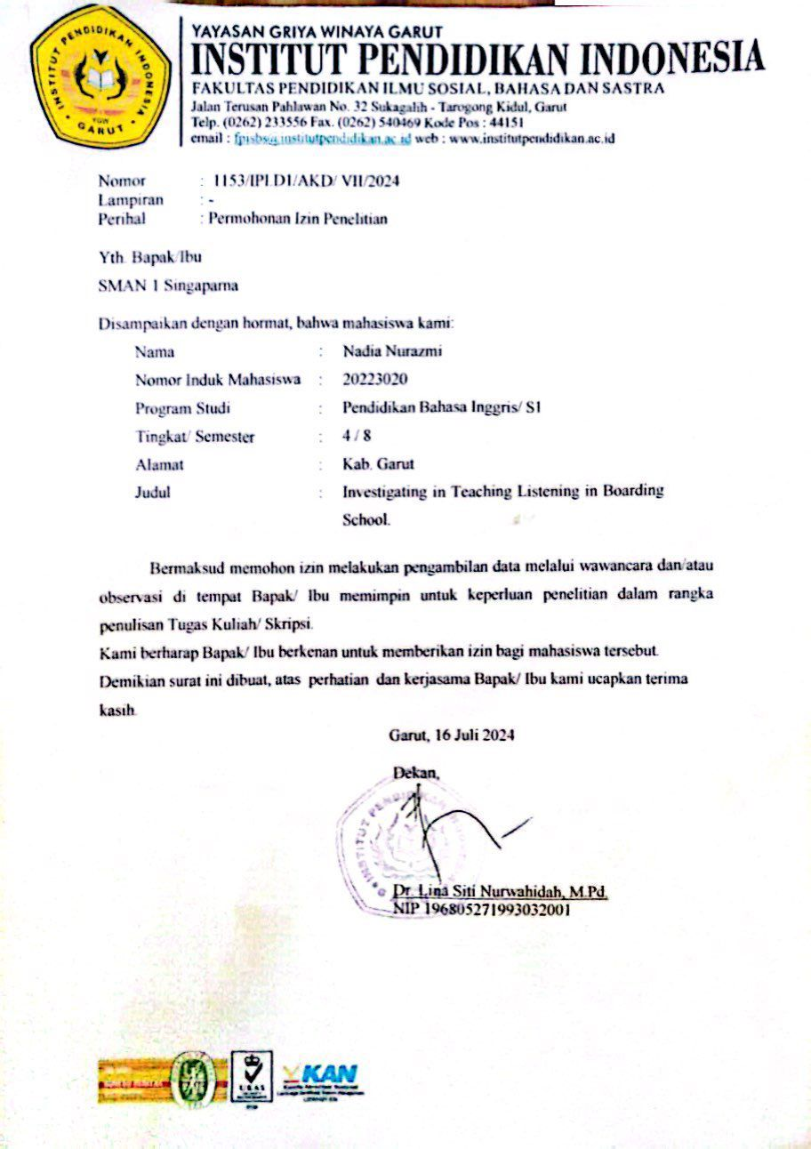

Appendices B.
Surat balasan selesai penelitian dari sekolah MTs Al-Qona’ah Cikajang Garut
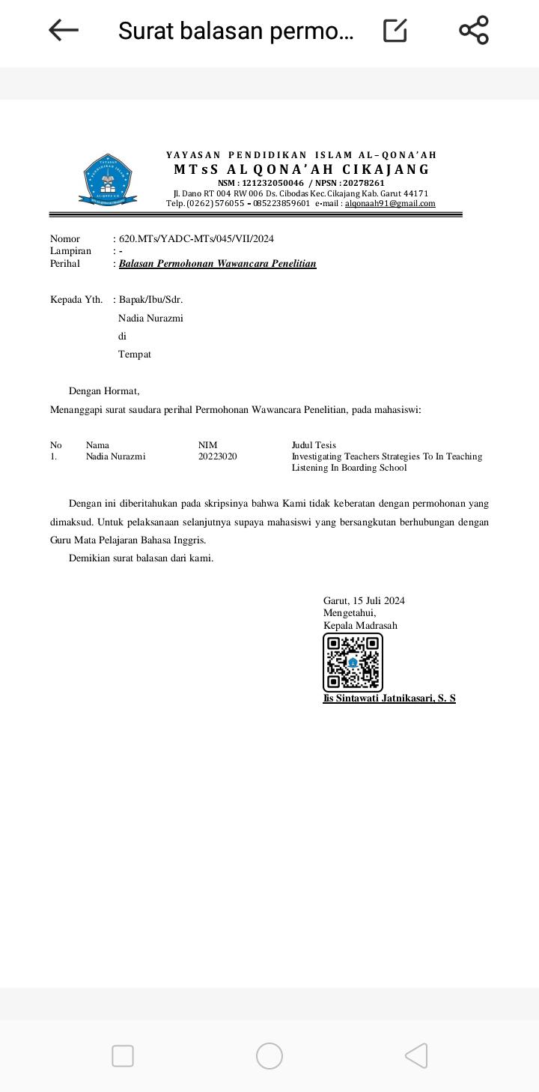

Appendices C
Surat persetujuan Wawancara
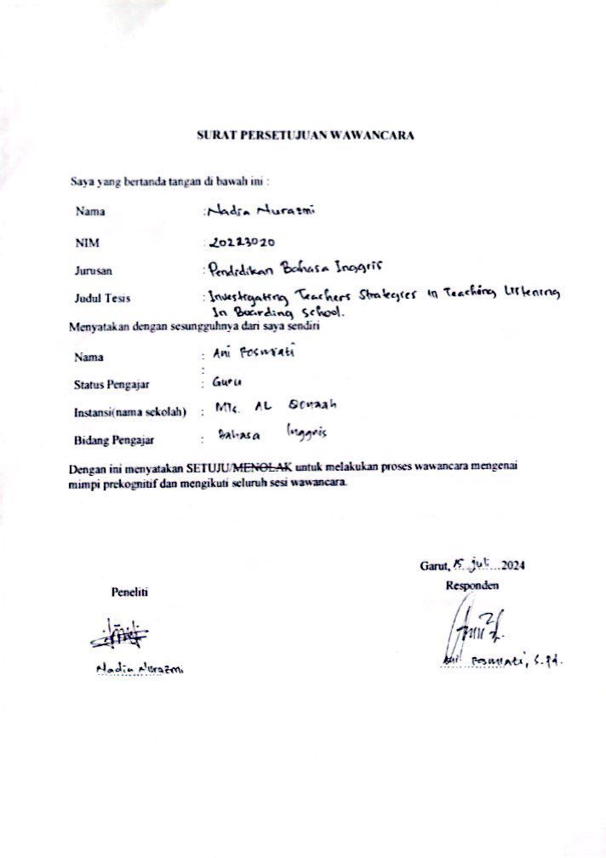

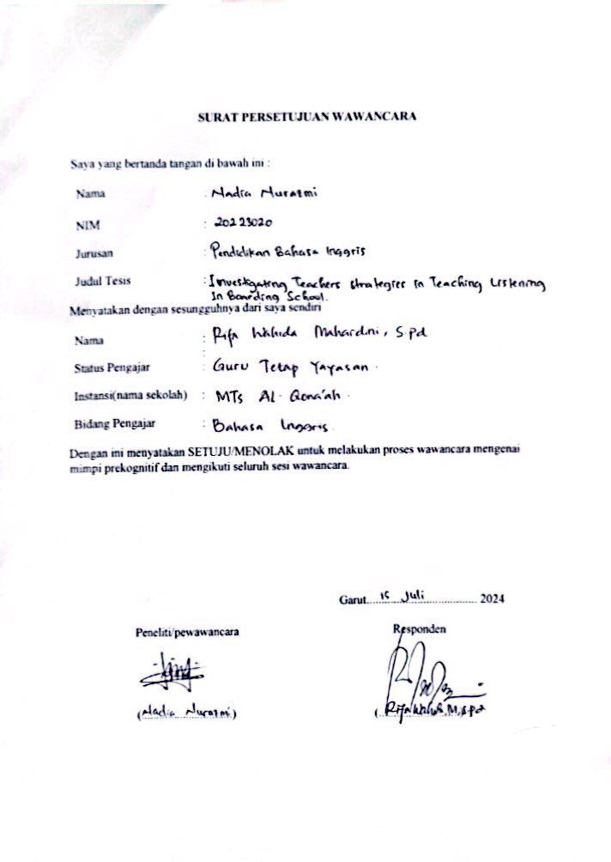

Appendices D
Instrumen Wawancara
Instrumen wawancara
Berdasarkan teori Bacon (2000 :70) tentang beberapa tipe listening, menghasilkan 3 pertanyaan sebagai berikut : | 1). Bagaimana Anda mempersiapkan diri untuk menghadapi kebutuhan belajar siswa yang beragam dalam keterampilan mendengarkan di lingkungan sekolah berasrama?  2.) Strategi apa saja yang anda gunakan dalam mengajar English listening?  3). Apa strategi utama yang Anda gunakan dalam mengajar keterampilan mendengarkan kepada siswa di sekolah berasrama?
Berdasarkan teori J. Richard (2008): tentang strategi yang dapat mengembangkan kemampuan siswa dalam keterampilan mendengarkan, menghasilkan 8 pertanyaan sebagai berikut | 1). Bagaimana cara anda mengimplementasikan strategi anda dalam mengajar English listening?  2). Bagaimana Anda menyesuaikan strategi mengajar Anda untuk memenuhi kebutuhan beragam siswa di lingkungan sekolah berasrama?  3). Apa kesulitan yang Anda hadapi dalam mengajar keterampilan mendengarkan di sekolah berasrama?  4). Apa yang anda lakukan untuk mengatasi kesulitan dalam mengimplementasikan strategi-strategi tersebut?  5). Apakah strategi-strategi yang sudah anda terapkan efektif bagi siswa dalam belajar English listening?  6). Peningkatan seperti apa yang dicapai siswa setelah anda menerapkan strategi tersebut ketika mengajar English listening?  7). Bagaimana Anda mengukur kemajuan siswa dalam kemampuan mendengarkan, terutama di lingkungan berasrama?  8). Bagaimana Anda memotivasi siswa untuk aktif dalam proses belajar mendengarkan?
Pertanyaan yang dikembangkan oleh penulis terdapat 2 pertanyaan. | 1). Apakah ada peran teknologi atau media dalam mendukung pengajaran dan pembelajaran keterampilan mendengarkan di sekolah berasrama?  2). Apakah media tersebut tersedia di sekolah atau guru mempersiapkannya secara mandiri?
Question | Answer  (AR,15july2024,Qn) = Teacher 1  (RN,15July2024.Qn) = Teacher 2
1. What strategies do you use in teaching English listening? | (AR,15july2024,Q1)  "Usually I use audio, for example, listening to stories, music, or conversations, and later I link it to the listening material."  (RN,15July2024.Q1)  "Usually prepare music, short films, and dialogue from native speakers, and bring your own music box from home so that children get used to listening, even if it's just greetings. So that children also know better what the pronunciation is and when the sentence can be used in everyday life."
2. What are the main strategies you use in teaching listening skills to students at boarding schools? | (AR,15july2024,Q2)  "In my opinion, by frequently listening to children, whether it's song lyrics, conversations, or stories, children will get used to it and be able to recognize new words."  (RN,15July2024.Q2)  "I took the most general one because children have diverse abilities and the theme for listening is listening to music, so I provide material for listening to hit songs so that they can learn more enthusiastically and enjoy it more."
3. How do you prepare to meet students' diverse learning needs for listening skills in a boarding school environment? | (AR,15july2024,Q3)  "The preparations I made first prepared materials such as conversations and stories, which would later be read directly by me and followed by the children. Or I prepare audio supported by infocus so that children can listen to it. "Then I also prepared worksheets so that I could measure to what extent the material I brought could be understood by the children."  (RN,15July2024.Q3)  "Especially in listening subjects, I urge children to bring their own cellphones. So that children will be more enthusiastic, I prepare material to listen to, such as songs or films that are currently hits, then I link it to the learning material, then I prepare a link so they can access it later.”
4. How do you implement your strategy in teaching English listening? | (AR,15july2024,Q4)  "Yes, I brought the audio to listen to it later, because coincidentally we weren't allowed to bring cell phones here, but there was also one day in the listening subject where the children were allowed to bring cell phones, and then I gave the material there, and that proved an improvement in the class situation and also in their abilities. child."  (RN,15July2024.Q4)  "Yes, students are given audio via native speakers, or listen to music, and I bring the speakers myself from home, or the child is given the freedom to use a cellphone. Then I will link it to the material later.”
5. How do you adapt your teaching strategies to meet the needs of diverse students in a boarding school environment? | (AR,15july2024,Q5)  "I asked or made an agreement with the school because, like it or not, children need cellphones as a tool to help students' understanding increase, considering that even at school the facilities are still inadequate to meet children's learning needs. So I asked for a day where they were allowed to bring cellphones. But because the children in the dormitory didn't bring cellphones, I combined them by making groups of students who brought cellphones so they could share with each other, then I gave them worksheets to fill in."  (RN,15July2024.Q5)  "Usually I divide into groups, and before dividing into groups, I already have to know the children's abilities. So that they can share with each other and put them together in one group to fill in the worksheet that I have given."

Appendices E
Dokumentasi di sekolah

