FACTORS CONTRIBUTING VOCATIONAL HIGH SCHOOL STUDENTS’ LESS-CONFIDENCE IN SPEAKING ENGLISH AND THE SOLUTIONS

A Paper
Submitted to the English Education Program of IPI Garut as partial fulfillment of the requirements for the Bachelor Education Degree

Written By:
M. Jihad Abdul Matin
NIM 20224006

ENGLISH EDUCATION PROGRAM
FACULTY OF SOCIAL SCIENCE LANGUAGE AND LITERATURE EDUCATION
INSTITUT PENDIDIKAN INDONESIA GARUT
2024

APPROVAL SHEET

FACTORS CONTRIBUTING VOCATIONAL HIGH SCHOOL STUDENTS’ LESS-CONFIDENCE IN SPEAKING ENGLISH AND THE SOLUTIONS

Written by:
M. Jihad Abdul Matin
NIM 20224006

Approved by:

  First Supervisor  Dr. Lucky Rahayu Nurjamin, M.Pd.  NIDN. 0410098901 | Second Supervisor    Dra. Rochmaniah, M.Pd.  NIDN. 0406065301

Acknowledged by:

Head of English Education Program
Anne Ratna Suminar, M.Pd.
NIDN. 0415038601

LEGITIMATION OF EXAMINATION BOARD

FACTORS CONTRIBUTING VOCATIONAL HIGH SCHOOL STUDENTS’ LESS-CONFIDENCE IN SPEAKING ENGLISH AND THE SOLUTIONS

by
M. Jihad Abdul Matin
NIM 20224006


This paper was examined on July 27th, 2024
First Examiner |   Second Examiner | Third Examiner
Dr. Yustika Nur F, M.Pd.  NIDN. 0412069004 | Irsyad Nugraha, M.Pd.  NIDN. 0408038304 | Anne Ratna Suminar, M.Pd.  NIDN. 0415038601

Acknowledged by:

Dean of Faculty of Social Science,
Language, and Literature Education
Dr. Hj. Lina Siti Nurwahidah, M.Pd.
NIP. 1968052719932001

MOTTO
“Finish it!”
This paper is dedicated to:
Me

DECLARATION OF AUTHENTICITY
I hereby declare that this thesis entitled “FACTORS CONTRIBUTING VOCATIONAL HIGH SCHOOL STUDENTS’ LESS-CONFIDENCE IN SPEAKING ENGLISH AND THE SOLUTIONS” and all its content is fully my own work. I did not plagiarize or quote in ways that are on in accordance with the ethics of science prevailing in scientific societies. Therefore, I confirm that I will be ready to respond to any risks that can be imposed on me if any violations of educational research ethics are later found in this work.

Garut, July 27th, 2024
My sincerely,

M. Jihad Abdul Matin
NIM. 20224006

ABSTRACT
Many students still struggle to speak the language confidently and fluently. This study aimed to identify the factors that contributed to students' less-confidence in speaking English at An-nida Vocational High School, Pasirwangi, Garut. The research uses qualitative approach also case study as the research design. The participants in this research are the 10th through 12th grade students. In data collection, this research is conducted in-depth interview as research instrument. The researcher’s conduct in-depth interviewing by semi-structured techniques. This study successfully identified factors that contributed to students’ less-confidence in speaking English and provided some solutions to minimize their less-confidence in speaking English. The results showed the factors that were found on this research were categorized in to two parts. The first is psychological factors such as anxiety, fear of making mistakes and feeling shyness. Then, linguistic factors such as pronouncing words incorrectly and improper sentence structure and lack of vocabulary. To minimize students' less-confidence in speaking English, some of the solutions found in this research. Students need to practice and evaluate more in speaking English. In addition, classroom learning techniques also need to be adjusted, teachers should pay more attention to how they appreciate students; provide constant encouragement and support as well ask questions that reveal the basis of a students’ problems. Communicating using English in class regularly can also minimize students' less-confidence in speaking English. This showed that the appropriate learning environment and methods can increase students' confidence in speaking English.
Keywords: Factors Contribute, Less-Confidence, Speaking English

ABSTRAK
Banyak siswa yang masih kesulitan untuk berbicara bahasa Inggris dengan percaya diri dan lancar. Penelitian ini bertujuan untuk mengidentifikasi faktor-faktor yang berkontribusi terhadap kurangnya kepercayaan diri siswa dalam berbicara bahasa Inggris di Sekolah Menengah Kejuruan An-nida, Pasirwangi, Garut. Penelitian ini menggunakan pendekatan kualitatif dan studi kasus sebagai desain penelitian. Partisipan dalam penelitian ini adalah siswa kelas 10 sampai 12. Dalam pengumpulan data, penelitian ini menggunakan wawancara mendalam sebagai instrumen penelitian. Peneliti melakukan wawancara mendalam dengan teknik semi-terstruktur. Penelitian ini berhasil mengidentifikasi faktor-faktor yang berkontribusi terhadap ketidakpercayaan diri siswa dalam berbicara bahasa Inggris dan memberikan beberapa solusi untuk meminimalisir ketidakpercayaan diri siswa dalam berbicara bahasa Inggris. Hasil penelitian menunjukkan faktor-faktor yang ditemukan pada penelitian ini dikategorikan menjadi dua bagian. Yang pertama adalah faktor psikologis seperti kecemasan, takut melakukan kesalahan dan perasaan malu. Kemudian, faktor linguistik seperti pengucapan kata yang salah dan struktur kalimat yang tidak tepat serta kurangnya kosakata. Untuk meminimalisir rasa kurang percaya diri siswa dalam berbicara bahasa Inggris, beberapa solusi yang ditemukan dalam penelitian ini. Siswa perlu lebih banyak berlatih dan melakukan evaluasi dalam berbicara bahasa Inggris. Selain itu, teknik pembelajaran di kelas juga perlu disesuaikan, guru harus lebih memperhatikan bagaimana cara mereka mengapresiasi siswa; memberikan dorongan dan dukungan yang konstan serta mengajukan pertanyaan yang mengungkap dasar dari masalah siswa. Berkomunikasi menggunakan bahasa Inggris di kelas secara teratur juga dapat meminimalisir rasa kurang percaya diri siswa dalam berbicara bahasa Inggris. Hal ini menunjukkan bahwa lingkungan dan metode pembelajaran yang tepat dapat meningkatkan kepercayaan diri siswa dalam berbicara bahasa Inggris.
Kata Kunci: Faktor-faktor yang Mempengaruhi, Kurang Percaya Diri, Berbicara Bahasa Inggris

PREFACE
Alhamdulillah, the research paper entitled “Factors Contributing Vocational High School Students’ Less-Confidence in Speaking English and The Solutions” is completed. This paper is submitted as a partial fulfillment of requirements for Bachelor of Education degree. Hence, the completion of this paper indicates that my study in English Education Department is finished.
This research paper is a part of the learning process. Any constructive suggestions and inputs are extremely welcomed for the improvements of this research paper and the related study. Hopefully, this research paper would give beneficial experience and contribution for the future researcher of the related study and for all the readers.

Garut, July 27th, 2024
My sincerely,

M. Jihad Abdul Matin
NIM. 20224006

AKNOWLEDGMENT

Alhamdulillahi Rabbil 'Alamin, with this sentence I express my gratitude to Allah SWT, because thanks to His love and mercy I can complete the thesis preparation as my final project. Furthermore, I do not forget to express my sholawat and salam to the great prophet Muhammad Saw.
Finally, I was able to complete this research that entitled “Factors Contributing Vocational High School Students' Less-Confidence In Speaking English And The Solutions” as one of the requirements to graduate from my beloved college, Institut Pendidikan Indonesia.
On this opportunity, the researcher acknowledges that there is no one who does not need other's assistance. Therefore, the researcher is very grateful to everyone who has contributed to the completion of this final project. Although researcher is not sure if researcher will be able to mention these people, researcher will try to mention them as a sign of gratitude.
- At first I would like to thank everyone in my home, especially my respected mother and father. Without their guidance and support, I would not have reached this point. The education given to me since I was a child has greatly impacted what I have achieved today.
- In addition, I also have a partner who supports and motivates me during accomplishing this final project. Of course, I would like to thank my partner Widya Intan Handayani who has been with me during my college studies and until the time I finished my final project. I fully admit that my writing skills are very poor, but with her guidance, support, and love, I was slowly able to complete this assignment.
- As the first supervisor, Mr. Lucky Rahayu Nurjamin, M.Pd. thank you for your consistent guidance, generosity, and support during the thesis writing. And always patiently guided me by giving insightful feedback on my thesis.
- Ms. Dra. Rohmaniah, M.Pd. As the second supervisor, thank you for your kindness and valuable guidance in completing this research by giving corrections, suggestions, and supervision.
- Prof. Dr., Dr., Nizar Alam Hamdani, SE., M.M., M.T., M.T., M.Si., M.Kom. as the Rector of Institut Pendidikan Indonesia (IPI) Garut
- Dr. Hj. Lina Siti Nurwahidah, M.Pd. as the Dekan of Faculty of Social Science, Language and Literature Education of Institut Pendidikan Indonesia (IPI) Garut
- Mrs. Anne Ratna Suminar, M.Pd., as the Head of English Education Program
- The examiners of this thesis
- The big family of HIMADIKSARIS which has become a place to develop myself, find talents in myself, and provide extraordinary experiences and memories.
- I would also like to express my gratitude to all the lecturers who spread knowledge to me. Hopefully what you have taught can be useful for me in particular, and for everyone

TABLE OF CONTENTS

APPROVAL SHEET i
LEGITIMATION OF EXAMINATION BOARD .............................................ii
MOTTO ................................................................................................................iii
DECLARATION OF AUTHENTICITY iv
ABSTRACT v
ABSTRAK vi
PREFACE vii
AKNOWLEDGMENT viii
TABLE OF CONTENTS x
CHAPTER I INTRODUCTION 1
1.1 Background of the study.....................................................................................1
1.2 Reason for choosing this topic............................................................................2
1.3 Research Question..............................................................................................2
1.4 Research Objective.............................................................................................3
1.5 Significance of the study.....................................................................................3
1.6 Definition of Terminology..................................................................................3
CHAPTER II LITERATURE REVIEW 5
2.1 The Concept of Speaking....................................................................................5
2.1.1 The Definition of Speaking 5
2.1.2 Types of Speaking 5
2.1.3 The Problems in Speaking English 6
2.2 Self-Confidence..................................................................................................7
2.2.1 The Definition of Self-Confidence 7
2.2.2 The Importance of Self-Confidence 7
2.2.3 Students’ Self-Confidence 8
2.2.4 The Factors Influencing Students’ Self-Confidence in Speaking English 10
2.3 Less-Confidence 11
2.3.1 The Definition of Less-Confidence 11
2.3.2 Students’ Less-Confidence 11
2.4 Previous studies................................................................................................12
CHAPTER III RESEARCH METHODOLOGY 14
3.1 Research Method..............................................................................................14
3.2 Research Design...............................................................................................14
3.3 Research Setting and Participants.....................................................................15
3.4 Data Collection Technique................................................................................15
3.5 Research Procedure..........................................................................................16
3.6 Data Analysis Technique..................................................................................16
CHAPTER IV FINDINGS AND DISCUSSION 18
4.1 Research Findings.............................................................................................18
4.1.1 Factors Contributing on Students’ Less-confidence in Speaking English 18
4.1.2 Students’ Solutions in Minimizing Their Less-Confidence in Speaking English 26
4.2 Research Discussion.........................................................................................31
CHAPTER V CONCLUSION AND SUGGESTIONS 34
5.1 Conclusion........................................................................................................34
5.2 Limitation of the Study.....................................................................................34
5.3 Suggestions.......................................................................................................35
5.3.1 For Teachers 35
5.3.2 For Students 35
5.3.3 For Institution 36
5.3.4 For the Further Researchers 36
REFERENCES 37
APPENDICES 40
APPENDIX A........................................................................................................41
APPENDIX B.........................................................................................................65
APPENDIX C.........................................................................................................69

CHAPTER I
INTRODUCTION

This chapter gives a brief description of the whole content of the study. The information that is included background of the study, reason for choosing this topic, research questions, research objectives, significance of the study, and definition of terminologies.

Background of the study
English is taught as the first foreign language in senior high schools after being implemented into the curriculum by the Indonesian government. Some schools even teach English to kindergarten or elementary school. This demonstrates how crucial English is to us. In other hand, speaking abilities are highly valued in Indonesia as it is heavily influenced by globalization and the necessity of communication in a variety of sectors. As stated in Konsep dan Implementasi Kurikulum 2013 (2014), speaking is one of the productive abilities that students need to acquire. The attitude, knowledge, and abilities that students have to show in a classroom setting are referred to as the standard competence of learning English. Regardless of the fact that English is taught in schools, many students still struggle to speak the language confidently and fluently. Many elements of Indonesia's social and cultural context, as well as its educational system, may contribute to this sense of less-confidence.
There are several factors that cause high school students’ less confident in speaking English. One of the primary causes of students' reluctance to speak in English in the classroom is their fear of making mistakes (Robby, 2010). Aftat (2008) notes that the fear of making mistakes is connected with worries of criticism and negative evaluation. Furthermore, this is also greatly impacted by the students' fear of receiving negative feedback from the teacher or being made jokes of by other students. Students tend to give up on the speaking activity as a result (Hieu, 2011). According to Baldwin (2011), one of the more common phobias that students face is speaking in front of others, and that feeling of shyness leads their minds to drift or makes them fearful that they will not know what to say. As they say, their shyness plays a big part in their inability to demonstrate their speaking abilities. The fear of making mistakes and shyness, coupled with fears about getting negative critiques and evaluations, significantly decrease high school students' confidence in speaking English.
Many studies examine factors that influence students' less confidence in speaking English. Study as conducted by Nguyen (2016) examine the influence of social and cultural factors on English language learning in secondary schools in Vietnam. This study examines how social and cultural factors influence students' self-confidence in speaking English. In addition, Lim (2017) examined the use of technology in English language learning in Malaysia. This study shows how the use of technology affects students' confidence in speaking English. Furthermore, research conducted by Phan in (2019), examined the role of intrinsic and extrinsic motivation, as well as teacher support, in increasing students' self-confidence in speaking English in Thailand. This research gives a better understanding of the psychological and social elements that affect students' self-confidence.
Regardless of the fact that many investigations have identified factors such as the impact of culture and the social environment and the role of technology in the classroom that affect students' confidence in speaking English, more research is required to find practical solutions that can be implemented in the various social and cultural contexts discovered in Indonesia. In order to find practical solutions which match Indonesia's current social and cultural context researcher wants to focuses to investigate case studies among students staying in rural area.

Reason for choosing this topic
In this study, researcher wants to learn more about factors that contribute vocational high school students’ less-confidence in speaking English and wants to find the solution.

Research Question
In regard to the background of study as previously described, the researcher creates a research questions to guide the research:
- What are contributing factors to students’ less-confidence in speaking English?
- What are the solutions that student do to minimize their less-confidence in speaking English?

Research Objective
In response to research questions above, the objectives of the study are divided into two types:
- To identify contributing factors to students’ less-confidence in speaking English.
- To explore the solutions implemented by students to minimize their less-confidence in speaking English.

Significance of the study
- Student
It is expected that students will get benefits from learning about the elements that affect their confidence when speaking English in a situation with others and this will reflect positively on their ability to speak. Student would become more confidence.
- Teacher
It is expected that the results of this study will assist teachers in recognizing what contributing factors to their students’ less-confidence so that they can provide students with the necessary feedback and corrections and appropriate techniques and approaches to help students improve their language abilities.
- Future Researcher
This study is expected to provide some knowledge about the factors that affect students' less-confidence in speaking English. This is also hoped that this research can serve as an inspiration for future researchers who are interested in conducting similar studies.

Definition of Terminology
To avoid misconceptions of crucial terms, the researcher needs to clarify the following terms:
- Speaking is described as using the voice to express ideas, emotions, and thoughts out loud. It involves oral interaction where participants negotiate the meaning of ideas, feelings, and information, requiring both language processing and knowledge of grammatical structures (Brown, 2008).
- Self-confidence is a key determinant of how people think, feel and act. Individuals with high self-confidence tend to be more motivated, more persistent, and more successful in achieving their goals (Bandura, 1977).
3. Less-confidence refers to a lower belief in one's abilities to speak or perform tasks effectively, often leading to feelings of anxiety, fear of making mistakes, and reluctance to participate in speaking activities (Bandura, 1986).

CHAPTER II
LITERATURE REVIEW

This chapter provides the relevant theories and previous research related to this study which covers the concept of speaking, self-confidence, less-confidence, and the previous studies.

The Concept of Speaking

The Definition of Speaking
A lot of individuals in this world express their thoughts on a daily basis, allowing us to listen, derive conclusions, and develop an attitude based on what they have to say. Through speaking engagements, individuals carry out the process of sharing their thoughts. It is in line to Santi (2020) that stated that speaking is the deliberate use of spoken language with the goal of understanding others by expressing things, ideas, emotions, and feelings to them in a clear, logical, deliberate, and methodical approach.
Another definition of speaking, according to Brown (2003) stated that speaking is oral interaction when participants need to negotiate meaning of ideas, feeling and information in this case, the speaker must see the relationship between ideas. Meanwhile, Harmer (2007) said speaking is the capacity to communicate effectively and requires both language processing and knowledge of grammatical structures. In our regular interactions, we communicate and interact frequently. Students can effectively process information and articulate words, thoughts, and feelings, according to this. Furthermore, speaking requires interaction because it takes the form of face-to-face discussion (Thornbury, 2005). According to the definitions given above, speaking is a fundamental daily action that allows people to communicate thoughts, feelings, and views to others through the use of words or audible cues.

Types of Speaking
There are five fundamental categories of speech. The first is imitative. This category consists of repeating a word, phrase, or sentence as well as practicing intonation and focusing on certain language form factors. Second is intensive in this speaking activity, the students are improving their phonological and grammatical abilities. Students typically do the assignment in pairs (group work). Third is responsive. This category is simple requests and states, brief conversations, interaction, test understanding, and similar activities are examples of responsive assessment tasks. Fourth is interactive. The length and sophistication of interactive speaking might occasionally involve several individuals and/or conversations. Responsive and interactive speaking differ in the length and complexity of the interaction, which can involve several participants and/or exchanges. The last is extensive Monologue. In oral reports, the teacher gives the students long presentations. Summarizes and stories (Brown, 2003). The study only looked at one kind of speech, which is long monologues. Students receive extensive monologues from their teachers in the form of oral presentations, storytelling, and fresh events. Based on the definition previously provided, the researcher determines that in order to become proficient speakers, students must be aware of the various types of speaking in order to speak in an appropriate manner.

The Problems in Speaking English
The student has a few issues in speaking as stated by Ur (2010), specifically;
- Students feel ashamed to talk in English and fear making mistakes. Students have difficulty in their English practice because of this.
- Nothing to say (The students lack confidence and limited vocabulary prevent them from being motivated to practice).
- The low participant (students speak with limited duration, or low speaking participation). The tendency of certain English students to dominate conversations in their native tongue causes this issue.
- Topic to be discussed (there are no topics to be discussed).
- Use of mother tongue.
From the statements above, it can be concluded that there are some problems in public speaking, such as; Inhibition, nothing to say, low of participants, topics to be discussed, and the use of mother tongue.

Self-Confidence

The Definition of Self-Confidence
Self-confidence as an attitude or belief in one's own abilities, so that one is not overly nervous when acting, feels free to take any action and takes responsibility for it, it is helpful when interacting with others, it drives to succeed, and it is able to identify their strengths and weaknesses (Lauster, 2003). Additionally, Sara (2015) defines that confidence is crucial for students studying a foreign language. Students will find it easier to learn and engage in their task without any obstacles that could hinder their performance when they have a strong belief in their abilities.
Another definition of self-confidence is stated by Brown (2001), that self-confidence as a student's trust that they are capable of completing a task to the best of their abilities. The two main components of self-confidence are self-efficacy and self-esteem. When students see themselves becoming proficient in the teaching-learning activity and reaching their objectives, they will develop a sense of self-efficacy. Students' sense of self-efficacy is shown when they believe they can finish a task. In other words, self-efficacy is the students' perception of their own ability to carry out and manage particular tasks. While self-esteem refers to the overall sense of self-worth or personal value that an individual holds. It is a more general evaluation of one self and is not tied to specific tasks or situations. The focus of self-esteem is on how much a person values themselves as a whole, regardless of specific abilities or competencies. It reflects how much a person respects, likes, and accepts themselves. However, not every student in Indonesia is confident in themselves. In order to assist students in overcoming their difficulty speaking English, it is crucial to build their confidence. The researcher concludes from the previous state that self-confidence is the capacity to act with optimism, objectivity, responsibility, reason, and realism along with self-ability beliefs.

The Importance of Self-Confidence
A significant challenge while learning a new language is self-confidence. A high level of confidence is frequently exhibited by successful students. As argued by Cole (2010) confidence is important as speaking and listening. Besides that, Abdallah (2015) pointed out here is a strong correlation between self-confidence and success, especially between oral communication and academic accomplishment, according to his earlier study on the impact of self-confidence in learning English. In addition to this, Kakepoto (2012) said that a successful performance requires self-confidence. Effective sharing and expression of thoughts are facilitated by it for the speaker. Since self-confidence has a significant impact on learning as well as everything they accomplish in general, students should understand how important it is. The essential component for a successful life is said to be confidence. Dornyei (2001) asserts that even with the most innovative motivational strategies, students will not progress academically if they continue to be less-confidence.

Students’ Self-Confidence
Students who exhibit self-confidence possess several distinct characteristics as outlined by Lauster (2006:15), including self-belief, independence, risk-taking, openness to criticism, and adaptability. Each of these traits contributes to their overall ability to succeed and thrive in various contexts. These characteristics can be understood with the explanation below:
1. Self-Belief
Students with self-confidence demonstrate a strong conviction in their own abilities and judgments. They approach challenges and new situations with assurance, believing that they are equipped to handle whatever comes their way. This inner confidence not only helps them navigate academic and social pressures but also fosters a proactive attitude towards problem-solving and goal achievement.
2. Independence
High self-confidence is often accompanied by a sense of autonomy in decision-making. These students are less likely to rely excessively on others for validation or guidance. Instead, they trust their own judgment and feel competent in making decisions that impact their academic and personal lives. This independence empowers them to take initiative and follow their own paths, enhancing their ability to manage responsibilities and pursue their goals effectively.
3. Risk-Taking
A key trait of self-confident students is their willingness to take calculated risks. They are not easily deterred by the prospect of failure; rather, they view potential setbacks as opportunities for growth. This willingness to step out of their comfort zones allows them to explore new possibilities, innovate, and push boundaries in their academic and extracurricular endeavors.
4. Openness to Criticism
Self-confident students possess the ability to receive and utilize constructive criticism without feeling threatened. They understand that feedback is a valuable tool for improvement and view it as a chance to refine their skills and knowledge. This openness not only helps them enhance their performance but also fosters a growth mindset, where they continuously seek ways to improve.
5. Adaptability
Self-confidence equips students with the ability to adapt to diverse situations and environments. They handle change with flexibility and resilience, navigating transitions and unexpected developments with ease. This adaptability enables them to thrive in various settings, whether it’s adjusting to new academic challenges or integrating into different social groups.
Based on the explanation above, students who have self-confidence show several key characteristics that include self-confidence, independence, courage to take risks, openness to criticism, and adaptability. These characteristics play an important role in influencing how they face new challenges and situations.

The Factors Influencing Students’ Self-Confidence in Speaking English
Students’ self-confidence in speaking is influenced by two factors. According to Shen (2019) these factors are physiological and linguistic factors. The first is psychological aspects include shyness, anxiety, and fear of making errors, While vocabulary, grammar, pronunciation, and fluency are examples of linguistic factors. As stated by (Gurler, 2015), speaking with confidence is realistically impacted by a variety of limitations, including mental, physical, physiological, and attitudinal. Lack of confidence may be used to describe psychological obstacles as well as attitudes that make it difficult for students to speak a foreign language.
- Psychological factor
Psychology is the scientific study of behavior and cognitive processes. The systematic, scientific study of behavior and mental processes is known as psychology. The material domain of mental forms consists of a wide range of complex mental processes such as thinking and visualizing. Psychological issues contribute to students’ ability to practice English language skills. The psychological components are related to one another. These include lack of motivation, insecurity, anxiety, and the fear of making errors (Juhana, 2012).
- Linguistic Factor
The study of language is known as linguistics. According to Spolsky (2021) Linguistic theory relies on the study and description of language, which is divided into three areas: phonology, grammar, and semantics. Grammar, which is considered a graphical science that demonstrates how words work, how sentences are put together, and how those things connect to one another, is one aspect of speaking English. While it is less than a theory of language in certain ways, educational linguistics is more than a theory of development. Students' English language ability is impacted by some aspects of their speaking ability. There are vocabulary, pronunciation, grammar, and fluency (Harmer, 2007).

2.3 Less-Confidence

The Definition of Less-Confidence
An individual that has no self-confidence is someone that doubts their own capabilities. Some students studying English as a second language may also experience this issue. Defined by Horwitz (1986), foreign language anxiety as discomfort, anxiety, or fear that an individual experiences when speaking a language besides their native tongue. In this case, the context of less-confidence may be related to an anxiety about making mistakes or facing criticism from others. Dorney (2001) provided additional explanation, stating that less-confidence can impact students' motivation to learn since they believe they are not capable of achieving the desired learning outcomes. According to Gilbert (2009), anxiety in social situations that is feeling scared and unsure when interacting with others is linked to less-confidence. This is brought on by feelings of unappreciation or negative feedback from others. As a result, anxiety or a fear of receiving negative feedback from others can contribute to a lack of confidence in speaking English.

Students’ Less-Confidence
Students who don't have confidence will face a variety of psychological challenges in the classroom, including feelings of insecurity, fear, anxiety, and social isolation. They might take a person's focus away from the process of learning. It would negatively impact the person's performance (Rubio, 2007). Furthermore, according to Habiburrahim (2020), experiencing anxiety is recognized as an emotional component that a person goes through while learning. It encourages an environment of high anxiety, which damages students' self-confidence and makes them shy away from interactions with classmates and teachers.
These are specific characteristics of students that do not have confidence in themselves according to Wright (2008), presents:
- Fear of change
The students are nervous and worried about what lies ahead. They seem to be reactive than proactive and have negative attitudes about their abilities as a result.

- Difficult in defining life goals
The aspirations and ambitions of the students in their lives are not well understood. When they speak, they consider difficult-to-understand generalities like being successful, wide, and attractive.
- Letting others’ needs ahead of his own
Students prioritize appealing others over being authentic. In addition, they prioritize happiness and fulfillment over helping people discover their potential and change their perspectives.
- Pessimistic and insecure
They think negatively and never strive for success in life or education. As faced with difficulties, they give up easily.

Previous studies
Before conducting this research, researcher already found out several research which have the similarities with this research. A research by Cadiz-Gabejaan (2021) about Enhancing Students’ Confidence in an English Language Classroom has found that for improving learners’ confidence, learners should encourage to collaborate with their colleagues. The participants of this study had some little knowledge and skill based on English grammar and passive to speak the English language. The views and perceptions of the students’ confidence development were obtain by using of quantitative analysis in line with the confidence questionnaire. The findings of this study revealed that incorporation of additional speaking activities classroom resulted to an increase in learner’s confidence.
There was also a research conducted by Hadi, M, I,. et al (2020) that investigate Factors Affecting Speaking Anxiety of Thai Students During Oral Presentation: Faculty of Education in TSAI found out that Thai students had anxiety during English oral presentation that affected their self-confidence. This study use a quantitative method with survey research by implementing the design of an online questionnaire. Based on the finding and discussion in this research concluded that the level of speaking anxiety experienced by 46 Thai participants was revealed that the average meant score of Thai students is high anxiety level and the obstacles in English speaking of the students were found that their less confidence to speak English is the main reason of the high anxiety.
The third research had been done by Hayeehasa, D,. et al (2022) about An Analysis of Thai Students problems in English Speaking Mathayom 3 at Darunsat Witaya Islamic School Pattani in Thailand. From the summary of data analysis the researcher found the several conclusions about students’ problem in learning speaking skill at at Darunsat Witaya Islamic School Pattani in Thailand were less of confidence because lack of vocabulary, pronunciation, and understanding of learning speaking English of problems faced by students.
Muklas, M., et al (2024) carried out An Analisys The Factors Affecting Students’ English Speaking Proficiency. The researcher found that there are quite a few students today whose ability to speak English is still not good. The results of this research were; affective factors (less confidence and motivation) and linguistic factors (grammar and vocabulary). The oral performance task result of 24 students currently explained that their oral performance were at the 5th-grade level or higher with total averages of 5.0. Many students focused on speaking skill and complained that English is a difficult to use and pronounce.
Another research was conducted by Kansil, V, E,. (2022) about Analysis of the Effect of Students’ Self Confidence on Speaking Skill. Based on the result that has been carried out it can be seen that the percentage of answer choices agree on the factors that can be affect students speaking skill have a high percentage of approval by the respondents, such as motivation to speak was approved by 100% of respondents. Then the factors that can affect students confidence get a high percentage result from the effect of self-confidence on speaking respondent answered “You speak well when you are confidence” approved by 93.30% of respondents. From the result of the students’ opinion it can be concluded that their speaking ability is influenced by self-confidence.
In conclusion, there are two things contribute to students' less confidence in speaking English. First, psychological factors, such as anxiety, shame, and lack of motivation, which have a big impact on students' self-confidence. Additionally, linguistic factors have the same impact on students' confidence. These elements include students' lack of understanding of English language learning, incorrect pronunciation, and lack in vocabulary.

CHAPTER III
RESEARCH METHODOLOGY

This chapter provided various methodologies that was used in gathering data and analysis which were relevant to the research. The methodologies included areas such as the research method, research design, research setting and participant, data collection technique, research procedure and data analysis.

Research Method
This research used qualitative approach because this study focused on examining factors contributing on Vocational High School Students’ less-confidence in speaking English and finding the solutions. This was supported by Moleong (2010), qualitative research is a research method that inform an understanding the phenomenon of the subject of research, behavior, perception, motivation, and the result of the research described by form of words and sentences.

Research Design
Case study design was used in this research. It allowed researcher to uncover the complex psychological and linguistic factors that may contribute to English speaking difficulties. Researcher discoverd a particular factor about a majority of the students at this school that they have no confidence in speaking English even when the teacher asks them to speak English in the context of questions and answers in class, they are not confident in doing so. Case study examined the interaction between self-confidence and language acquisition in a specific educational or cultural context. This focus can highlight how local factors influence learning outcomes, offering solutions that were highly relevant to that context but potentially applicable to similar settings. In order to make it obvious to identify cases that affect students at the school, researcher have to utilize case study. Yin (2009) defines case study as an empirical inquiry which investigates a phenomenon in its real-life context. A case study should provide an in-depth understanding of the case and data is collected through various means, including interviews (Coombs, H, 2022). This was in line with the purposes of this study which were investigating the factors contributing vocational high school students' less-confidence in speaking English and finding the solutions. In this case, the researcher examined the factors contributing vocational high school students' less confidence in speaking English in classroom setting. Based on the aim of this study which only focused on students’ less-confidence in speaking English at that school, this study used case study. Therefore, the results of this study cannot be generalized in other situations.

Research Setting and Participants
The research was conducted at Sekolah Menengah Kejuruan An-nida in Pasirwangi, Garut. In its determination, this school was chosen based on some reasons that is considered by researcher. First, the chosen school was one of the schools in small village far from the city, in line with the interest of researcher who want to investigate case studies among students staying in rural areas. Second, gathering the data required for the study was relatively easier due to accessibility. As the teacher of the school, the researcher considered that obtaining authorization and gaining access to conduct the research would be allowed.
The Participants in this research are 10 through 12 grades students in that school. The participants of this study consist of 11 students from total populations 35 students who acquired three languages. They used Sudanese as L1, Indonesian as L2 and English as foreign language (FL). While the only time they spoke English was in English classroom. Random sampling was used to select participants in this study because it provided every member of the population with an equal chance of being chosen as a sample. In this study, researcher hoped that students were able to speak honestly and freely during the research so that what is needed in this study can be fulfilled properly.

Data Collection Technique
In data collection, this research was conducted in-depth interview as research instrument. The researcher conducted of in-depth interviewing by semi-structured techniques was to get detailed information that sheds light on a students’ perspective, experiences, and feelings about the factors contributing vocational high school students' less-confidence in speaking English. Semi-structured interviews are those in-depth interviews where the respondents have to answer preset open-ended. This method, provided the opportunity of gathering rich data, and emerging new concepts. According to Moleong (2007) said that interview is a meeting of two person to exchange information and idea through question and responses.
An in-depth interview was a qualitative research technique that was used to conduct detailed interviews with a small number of participants (Rutledge, 2020). In contrast to other forms of qualitative research, researcher using an in-depth interviewing by semi-structured technique approach invested a significant amount of time with each participant employing a conversational format. Interview questions were primarily open-ended and lead to a discovery-oriented approach. In order to have the interview data captured more effectively, recording of the interview made it easier for the researcher to focus on the interview content and to generate transcript of the interview.

3.5 Research Procedure
To get the required data for this study, researcher had to take several steps. The steps were as below:
- Researcher first made an appointment with the students who would be participants in this research and discusses the researcher's purpose.
- Then, researcher visited the school where students studied and asked permission to conduct research.
- After obtaining permission, researcher collected data through interview while recordings.
- After all data was collected, researcher said goodbye and thanked to the participants because the researcher has finished collecting data.
- The researcher processed all data obtained.

Data Analysis Technique
The researcher conducted interviews with the participants to get detailed and in-depth data regarding the difficulties students had in speaking English and potential solutions. Before analyzing the data, researcher recorded and transcribed the data in the form of student utterances in the interview. This technique could help researcher to listen carefully to the speech produced by students during the interview. So that the data that was originally in oral form became written data so that it was easy to process into analysis data. Researcher investigated similarities among multiple classifications to find factors that contributed students’ less-confidence in speaking English and to find its solutions. Through the use of qualitative data analysis approaches, researcher were able to understand participant thinking, examine new patterns in the data, and examine the significance of the data.
Data analysis techniques provided a clear picture, explanation, and comprehension of the data in order to make the data easily accessible and understandable. Three stages of data analysis were identified by Miles & Huberman (1992) and were as follows:
- Data Reduction
The first step in analyzing qualitative data involved data reduction. Data reduction meant selecting, focusing, simplifying, abstracting, and altering the data found in the interview transcripts.
- Data Display
The second step was data display. At this step, the data collected from the interview transcripts was analyzed. After that, the interview material was reviewed and categorized to identify similarities in certain factors. The classified data was reviewed before being written and presented. So, the researcher can swiftly determine what conclusions can be drawn in this way.
- Drawing Conclusion or Verification
The last step of qualitative data analysis was conclusion drawing or verification. The researcher concluded from the data. Additionally, the researcher concluded from the collected data based on hypotheses and findings of the study.

CHAPTER IV
FINDINGS AND DISCUSSION

Researcher captured the results that were collected in this chapter. The finding and discussion sections made up the two main sections of this chapter. The results of the data analysis from the interviews were presented in the findings. Through discussion in the research, the study's findings were interpreted.

Research Findings
The research on the factors contributing vocational students’ less-confidence in speaking English and the solutions was presented in this section. Interviews were the instrument used in this study. Researcher interviewed eleven students in Sekolah Menengah Kejuruan An-nida. Face-to-face interviews were conducted, and the researcher used a voice recorder to capture the conversations. Following the interview process, the researcher processed the data right away.

Factors Contributing on Students’ Less-confidence in Speaking English
Each finding was supported by additional data obtained from interviews. The results could be read as follows:
- Psychological Factors
- Anxiety
From the results of interview with several students, they felt anxious in speaking English. Student 4 and 8 admitted that they felt anxious and blank or did not know what to say when they were suddenly required to speak English. They feel anxious because they are afraid of making mistakes in pronouncing words or mistakes in arranging language structures to be spoken.
S4: Apabila dalam kondisi sudah siap dengan apa yang akan disampaikan maka penyampaian nya akan lebih tenang dan akan lebih menguasai momen, tapi jika ditunjuk secara tiba-tiba saya justru lebih gugup dan seakan akan blank tidak bisa berbicara.
(S4: If I'm ready with what I'm going to say, I'll be calmer and more in control of the moment, but if I'm appointed suddenly, I'm more nervous and I feel like I can't speak).
S8: Terasa mudah jika berbicara dengan menyiapkan dialog terlebih dahulu, namun jika sebaliknya saya merasa gugup dan takut salah dalam penyebutan atau grammar nya.
(S8: It's easy to speak by preparing the dialog in advance, but otherwise I feel nervous and afraid of getting the pronunciation or grammar wrong).
Meanwhile, student 11 felt very anxious especially when she had to present in front of the teacher. Because according to her, in speaking English, she got the pressure generated from the surrounding situation for fear of making mistakes.
S11: kalo aku sih lebih ke gugup yah takut salah, apalagi kalo misalnya presentasi terus ada guru, emang bener bener apa yah, kalo ngobrol bahasa Inggris itu lebih banyak tekanannya, karena lebih banyak takutnya, kadang gak percaya diri juga sama temen temen lain, jadi ah takut salah takut salah, gitu.
(S11: If I'm more nervous, I'm afraid of making mistakes, especially if for example a presentation and then there is a teacher, really what is it, if you talk in English, there is more pressure, because there is more fear, sometimes you don't have confidence in other friends, so you're afraid of making mistakes).
In addition, despite feeling anxious, student 6 stated that he enjoyed speaking English because English was a subject that she liked even though she was still covered in anxiety.
S6: Saya senang ketika menggunakan bahasa inggris di depan kelas, tapi terkadang saya juga grogi.
(S6: I enjoy using English in front of the class, but sometimes I get anxious).
It is shown in the previous interviews that students experienced anxiety in speaking English. A few of them experienced anxiety if the students had not prepared what they would say. Six of the eleven students who participated in the interviews reported feeling less-confidence as a result of their anxiety. This showed that anxiety can hinder students' ability to speak English, although some students still try to enjoy it despite the anxiety they feel.
- Fear of Making Mistakes
Some students feel insecure because they were very worried when they have to speak English in class. Based on the data obtained, students 1 and 8 said that they felt less-confidence when they had to speak in class. They were afraid of making mistakes in pronouncing words and also in formulating sentences. Moreover, they were afraid of being ridiculed by their friends in class when they make mistakes.
S1: kadang saya tidak percaya diri karena takut menjadi bahan bercandaan teman teman kelas saya.
(S1: Sometimes I'm not confident because I'm afraid of being the butt of my classmates' jokes).
S8: sangat, karena saya malu ketika saya salah dalam mengucapkan kata atau dalam menyusun kalimat. saya juga takut menjadi bahan ejekan teman saya.
(S8: Very much, because I am embarrassed when I mispronounce words or construct sentences. I am also afraid of being ridiculed by my friends)
Although student 2 stated that he felt less-confidence in speaking English because he was afraid of making mistakes in pronouncing words and sentence construction. Unlike student 1 and 8, student 2 was not afraid of being ridiculed by his friends when he made some mistakes, he was just afraid that what he said could not be heard clearly and understood by others.
S2: Iya, saya merasa tidak percaya diri berbicara bahasa Inggris karena takut salah pelafalan dan juga takut bahwa apa yang saya katakan itu tidak jelas sehingga membuat lawan bicara saya tidak mengerti dengan apa yang saya katakan.
(S2: Yes, I don't feel confident speaking English because I am afraid of mispronunciation and also afraid that what I say is not clear so that the person I am speaking to doesn't understand what I am saying).
This showed that some students fear of speaking English incorrectly. Some students were afraid of mistakes because they believed their English was not good and they didn't want to look foolish. Some students even felt less-confidence because they worried about their peers making fun of them. In conclusion, students' less-confidence in speaking English was due to concerns about pronunciation and sentence construction errors, with some students also fearing ridicule from their peers, while others were more concerned about their interlocutor's clarity and understanding.
- Shyness
Based on the results of interview with students, some students felt less-confidence in speaking English because they felt shy. Student 1 admitted that he felt less-confidence when he had to speak English in class because he felt shy. Because he is not used to speaking in public, especially having to speak using English which was not his native language.
S1: karena saya tidak biasa berbicara didepan banyak orang, apalagi menggunakan bahasa yang bukan bahasa asli saya oleh karena itu saya merasa malu.
(S1: Because I am not used to speaking in front of many people, especially using a language that is not my native language, therefore I feel embarrassed).
In addition, student 7 also experienced the same, she felt shy to speak English in class. Because according to her, he needed someone who can initiate a conversation using English in class. It could reduce his insecurity.
S7: Saya merasa malu awal nya karena tidak ada murid lain yang mulai pembicaraan bahasa inggris dan saya yang memulai nya menggunakan Bahasa inggris jadi saya merasa agak malu di awal.
(S7: I felt shy at the beginning because none of the other students started talking in English and I was the one who started using English so I felt a bit shy at the beginning).
Based on the earlier interview, it can be inferred that shyness was another factor preventing students from improving their English-speaking abilities. This occured as a result of their unfamiliarity with the language as well as the lack of friends who initiate in making conversations in English. These insights highlighted the significant role that shyness and the need for supportive classroom dynamics played in students' confidence levels in speaking English.
- Linguistic Factors
- Lack of Vocabulary
The interview results showed that some students felt less-confidence when they have to speak in English because of the lack of vocabulary they mastered. As student 6 who found it difficult to speak English because of her lack of vocabulary. Lack of vocabulary can hinder students in pouring ideas into speech.
S6: Mungkin karena penggunaan kosakata yang kurang dan pelafalan yang kurang.
(S6: Maybe because of my lack of vocabulary and pronunciation).
Even so, student 9 really felt happy when he speaked in English, but he also felt less-confidence because he felt difficulty when speaking caused by poor vocabulary mastery. Poor vocabulary mastery can have an impact on students' confidence in speaking English.
S9: Sebetulnya saya sangat senang sekali ketika saya berbicara bahasa Inggris dengan percaya diri di depan kelas, tapi di satu sisi saya juga kadang merasa kesulitan bicara bahasa Inggris karena tidak menguasai vocab dengan baik, tidak menguasai banyak vocab.
(S9: Actually I am very happy when I speak English confidently in front of the class, but on the other hand I also sometimes find it difficult to speak English because I don't have a good vocab, I don't have many vocabularies).
S9: Sebetulnya bukan merasa malu, namun lebih ke adanya perasaan tidak percaya diri karena tidak menguasai vocab secara menyeluruh.
(S9: Actually, I don't feel embarrassed, but more like I don't feel confident because I don't master the vocab thoroughly).
As a result, it can be inferred from that interview that students' lack of vocabulary was also a contributing factor to their less-confidence in speaking English. In conclusion, lack of vocabulary was the main factor that hindered students' ability to speak in English confidently.
- Grammatical and Pronunciation Errors
Based on the findings from the student interviews, students often felt less-confidence when they have to speak English in class because they were worried about pronouncing words incorrectly or constructing sentences that are not grammatically correct. For example, student 2 said that he felt less-confidence in speaking English because he was worried about pronouncing words incorrectly and also inaccurate formulating sentences structure. This meant that pronouncing words correctly and constructing structured sentences can increase their confidence in speaking English.
S2: Bisa, karena saya sering merasa tidak percaya diri berbicara bahasa inggris juga takut karena pengucapan dan struktur bahasa nya tidak sesuai dengan apa yang seharusnya.
(S2: It can, because I often feel insecure about speaking English and afraid that the pronunciation and language structure are not what they should be).
Whereas students 6 and 9 stated that knowing good grammar and being accustomed to using good language structures greatly affected their confidence in speaking English. According to students 6 and 9, when they already had ideas to express and already know the vocabularies, they often felt difficulty concretizing their ideas because they felt hampered by sentence structure. Putting ideas together into a sentence that can be spoken with a good language structure can make students think many times. The students were not used to use the correct language structure, because if they were used to it, they would no longer think about the grammatically correct language structure in the dialog.
S6: Menurut saya ketika saya sudah mengetahui struktur bahasa iya sangat mempengaruhi rasa percaya diri saya, saya jadi berpikir berkali kali untuk mengucapkan bahasan inggris.
(S6: I think when I already know the structure of the language, it really affects my confidence, I think many times to pronounce English).
S9: terpaku pada tata bahasa, saya merasa kesulitan karena harus memikirkan pola, pola kalimat, selain itu apabila si pola kalimat itu sudah tertata dalam pikiran saya, justru kadang menjadi masalah itu ketika saya melafalkan kalimat tersebut, karena menurut saya itu adalah hal yang paling sulit.
(S9: fixated on grammar, I find it difficult because I have to think about patterns, sentence patterns, besides that if the sentence pattern is already organized in my mind, it sometimes becomes a problem when I pronounce the sentence, because I think it is the most difficult thing).
As can be seen from the above interview results, a number of students stated that their confidence may be impacted by their ability to pronounce words correctly. Some of them, though, feel limited by their knowledge of grammar. This made students constantly considered structures, which delayed their ability to articulate their ideas. Although they already had enough ideas and vocabularies, they often struggled to organize these ideas into grammatically correct sentences, which caused them to think repeatedly before speaking. They felt that if they were familiar with the correct language structure, they no longer needed to think deeply about grammar in their speaking.
Many factors could affect students' less-confidence in speaking English in class. It could be caused by psychological and linguistic factors as explained above. However, there were also some students who felt confident in speaking English. For example, student 3 said that he really felt happy and confident when he had to speak English. Because according to student 3, with the ability he had, he could improve to increase his potential in speaking English.
S3: saya merasa senang karena saya akan percaya diri dengan kemampuan yg saya dapat agar bisa terus berkembang.
(S3: I feel happy because I will be confident in my abilities so that I can continue to develop).
Likewise with student 10 who felt happy to speak English fluently. Because fluency in speaking will not be able to interfere to students' confidence.
S10: Perasaan saya sangat senang bisa berbicara bahasa inggris dengan lancar.
(S10: I feel very happy to be able to speak English fluently).
This showed that despite the barriers, there were also students who felt motivated and confident in their use of English, which could be an inspiration for other students. Although some students felt confident in speaking English, the majority of students who had been interviewed did not feel confident when it came to speaking English. Therefore, it can still be concluded that the factors found were still a problem that hinders most students.

4.1.2 Students’ Solutions in Minimizing Their Less-Confidence in Speaking English
Strategies for resolving students' less-confidence in speaking English could be implemented. Using interviews as references, there were several strategies that could be used to help students modified their less-confidence in speaking English. These strategies were offered as follows:
- Independent practice and self-evaluation
Based on the results of the interview with several students, independent practice and self-evaluation can be a solution for students in overcoming their less-confidence in speaking English. According to student 1, practicing to speak English frequently while being recorded can decrease students' less-confidence. This was because students could get used to speak English and knew what their mistakes were in speaking English, and also the results of the recording can be used by students as material to evaluate their mistakes.
S1: menurut saya bisa dengan belajar berbicara sendiri sambil direkam, kita bisa tahu kesalahan kita dimana dan nanti berlatih lebih lagi dari kesalahan.
(S1: I think we can learn to speak by ourselves while being recorded, we can know where our mistakes are and then practice more from the mistakes).
Moreover, according to student 9, speaking in front of a mirror can reduce students' less-confidence in speaking English. This would make students as if they were speaking in public. When students were used to speak English in public, they would not got anxious and shyness anymore.
S9: Saya rasa harus banyak banyak harus belajar berbicara di depan cermin, karena hal itu memang sangat membantu saya dalam proses pembelajaran di depan kelas, dan juga belajar untuk banyak menggali kosa kata baru sehingga bisa diimplementasikan dalam kehidupan sehari-hari.
(S9: I think I have to learn to speak in front of the mirror a lot, because it really helps me in the learning process in front of the class, and also learn to explore a lot of new vocabulary so that it can be implemented in everyday life).
From the interviews with several students, it was found that self-practice and self-evaluation can be a solution to overcome students' less-confidence in speaking English. When students got used to speak in English in public, they no longer felt anxious and shy. For example, the combination of self-recorded speaking practice and practice in front of a mirror can help students improve their confidence in speaking English.
- Improving linguistic proficiency
One way to overcome students' less-confidence in speaking English as a foreign language was improving students' proficiency in English. As student 2 suggested that students had to study English more diligently so that they were fluent in speaking English. When students were fluent in speaking English, students no longer need to be afraid of making mistakes in speaking English in class.
S2: Solusi yang bisa saya katakan mungkin saya perlu mempelajari bahasa Inggris lebih giat lagi agar saya fasih dalam berbicara bahasa inggris.
(S2: The solution I can say is maybe I need to study English more diligently so that I am fluent in speaking English).
Student 2 also added that students had to increase speaking practice using English. According to student 2, if activities such as communication in class often used English, it made students accustomed and more proficient in speaking English. This method can reduce students' less-confidence in speaking English.
S2: Mungkin harus diperbanyak latihan, jadi metode pembelajaran yang bisa membatu mengurangi rasa tidak percaya diri yaitu praktek berdialog. Menurut saya, jika berbicara bahasa inggris sering digunakan di kelas, itu akan membuat saya terbiasa dan mengurangi rasa gugup dan malu untuk berbicara bahasa Inggris di depan kelas.
(S2: Maybe there should be more practice, so the learning method that can help reduce insecurity is practicing dialog. In my opinion, if speaking English is often used in class, it will make me get used to it and reduce my nervousness and shyness to speak English in front of the class).
Meanwhile, student 5 stated that learning a lot about how to master vocabulary and pronounce and arrange words correctly could increase students' confidence in speaking English. This was because students no longer need to be hindered by mistakes in constructing sentences and pronunciation of words that were not appropriate and lack of vocabulary to express their ideas.
S5: Lebih banyak belajar pengucapan dan pengetahuan tentang vocabulary dalam bahasa inggris.
(S5: Learn more pronunciation and vocabulary in English).
The conclusion of the findings suggested that improving students' confidence in speaking English as a foreign language can be achieved through improving their English language skills. Thus, this approach can reduce barriers caused by sentence construction errors, improper pronunciation, and lack of vocabulary, so that students can be more confident in expressing their ideas in English.
- Techniques used in the classroom
There were various ways suggested by the students from the interview results as their solutions to reduce their less-confidence in speaking English. Student 5, 6 and 7 offered several ways such as appropriate classroom activities that can overcome students' lack of confidence in speaking English. These ways were used to use English as the main language in learning English. As using English in a question and answer activity in class. This activities could get students used to speak English so that they would be confident. Furthermore, group learning methods could also be a solution for students in overcoming their less-confidence when speaking English in class. With a smaller scale of discussion, students felt more confident when they had to speak English.
S5: Dengan membiasakan pembelajaran di kelas menggunakan bahasa inggris secara rutin
(S5: By getting used to learning in class using English regularly).
S6: Metode tanya jawab aja pake bahasa inggris mungkin bisa untuk menumbuhkan rasa percaya diri.
(S6: The question and answer method using English might be able to foster self-confidence).
S7: Biasa nya cukup efektif untuk membuat mulai percaya diri itu menggunakan metode pembelajaran kelompok.
(S7: Usually it is quite effective to make me start to be confident using group learning methods).
Student 9 also added that in addition students that should often practice and get used to speaking English, during learning, teachers had also to speak English. This did not mean that the teacher had to force the communication carried out in class to use English, but rather to motivate students to familiarize themselves with speaking English. Because the motivation given by the teacher could increase students' confidence in speaking English.
S9: guru di dalam kelas harus menggunakan bahasa Inggris bukan untuk menekan siswanya agar menggunakan bahasa Inggris juga, namun untuk mendorong motivasi siswanya untuk percaya diri saat berbicara bahasa Inggris.
(S9: Teachers in the classroom should use English not to pressure students to use English too, but to encourage students' motivation to be confident when speaking English).
In addition, student 1 emphasized that teachers should pay more attention and appreciation to students in class. When the teacher did so, it would make students felt more confident especially student 1 was one example of a student that was afraid of being ridiculed when making mistakes in speaking English.
S1: menurut saya, guru harus lebih memperhatikan bagaimana mereka memberi apresiasi pada siswa seperti saya, ketika guru memberi pujian yang baik maka saya sebagai siswa akan lebih percaya diri.
(S1: In my opinion, teachers should pay more attention to how they give appreciation to students like me, when teachers give good praise then I as a student will be more confident).
Based on the interview results, the students proposed several solutions to improve their confidence in speaking English. These included integrating English in classroom activities on a regular basis and using it extensively in question and answer sessions. Group learning methods were also highlighted as effective, as they provided a less intimidating environment for speaking in English. In addition, students emphasized the importance of teachers using English to motivate and encourage them, rather than as a form of pressure. Then, personal attention and positive reinforcement from teachers were also considered important in building students' confidence, especially for those who feared being ridiculed for their mistakes. Overall, this strategy reflected a multifaceted approach to increasing confidence in communicating in English among students.
Students can apply the strategies to increase their confidence based on their responses compared to the interview above. These strategies can be used in class by both students and teachers, alongside independent practice and appropriate language mastery.

Research Discussion
Based on the findings of this study, this study investigated factors that affected vocational high school students’ less-confidence in speaking English and found the solutions. Factors that were found on this research were anxiety, fear of making mistakes, shyness, grammatical and pronunciation errors and lack of vocabulary. These factors can be categorized in to two parts, first was physiological factor which include anxiety, shyness and fear of making mistakes. In addition, grammatical and pronunciation errors and lack of vocabulary were categorized as linguistic factor.
In this discussion, firstly, researcher discussed psychological factors such as anxiety, fear of making mistakes and feeling shyness. Anxiety was one of the main causes of students' less-confidence in speaking English. In this study, it was found that students often feel anxious for fear of making mistakes in pronunciation or sentence structure. This is in line with the findings of Darmaida (2017), which stated that Fear of not being able to communicate well or fear of making mistakes in speaking English caused anxiety. However, in this study, anxiety seemed to be more influenced by sudden unexpected situations, such as being appointed to speak without preparation. Fear of mistakes was another significant factor that reduced students' less-confidence. Students worried about being ridiculed by classmates if they make mistakes. Rahmawati (2023) also found that fear of negative evaluation by peers can reduce students' participation in speaking a foreign language. Students worried about being ridiculed or teased when trying to speak English, which makes them felt like an object of ridicule and reduced the motivation to speak English. But this study was focused on ridicule from peers as the dominant factor compared to the fear of evaluation by teachers. Shyness also contributed to students' less-confidence. Research by Maji (2022) showed that shyness can be a major inhibitor for students to participate in English speaking activities. Students who felt shy tend to be reluctant to speak in front of others for fear of making mistakes or being ridiculed. In the context of this study, shyness seemed to be more related to the lack of public speaking habits, especially in a language that is not their mother tongue.
After discussing psychological factors, the researcher also discussed some linguistic factors such as pronouncing words incorrectly and improper sentence structure and lack of vocabulary. Grammatical and pronunciation errors were also factors that affected students' less-confidence. Students felt less-confidence if they pronounced words incorrectly or created sentences that did not conform to grammar rules. This research confirmed the importance of good grammar and pronunciation skills, but also highlighted that the lack of habit of using correct language structures can be a major barrier. Research by Fitriani (2015) stated that accuracy in grammar and pronunciation were crucial to improve students' confidence in speaking. Lack of vocabulary was also major obstacle for students in speaking English. Students found it difficult to express their ideas due to limited vocabulary. In this study, although students showed interest in learning English, the lack of vocabulary prevented them from speaking confidently. This is in line with Research by Chema (2023) that showed an extensive vocabulary was essential for effective speaking skills. A lack of vocabulary can make it difficult for students to construct sentences or express ideas clearly and precisely in English. When students felt they did not have enough vocabulary, they might feel unsure in conveying their ideas well, which can reduce their confidence.
This research also investigated some solutions to minimize students' less-confidence in speaking English. Some of the solutions found in this research were independent practice and self-evaluation, improving linguistic proficiency and teaching used in the classroom. Students need to practice and evaluate more in speaking English in order to improve their self-confidence, and also students need to improve their skills in speaking English as in increasing vocabulary and increasing fluency in the pronunciation of words and honing language structures to make easier when they want to speak in English. In addition, classroom learning techniques also need to be adjusted. Teachers should pay more attention to how they appreciate students so that student felt more confident. As stated by Aftat (2008) suggested that to encourage students’ motivation, teachers should provide constant encouragement and support as well ask questions that reveal the basis of a students’ problems. Doing this becomes very important because encouragement also gave students a feeling of secure and welcome in their learning. Integrating the use of English into various classroom activities, so that students become accustomed to using English in different contexts. Communicating using English in class regularly can also minimize students' less-confidence in speaking English. Kubo (2009) added that to build students’ confidence to speak English, teachers can provide regular opportunities to practice proper pronunciation, intonation, and to converse freely. By doing this, students will experience a greater sense of ability to speak English. As research conducted by Cadiz-Gabejan (2021) which proved that how important students' confidence is in speaking English. This showed that the appropriate learning environment and methods can increase students' confidence in speaking English. The study suggested that self-confidence played a significant role in students' ability to speak English. Therefore, pedagogical practices should include strategies specifically aimed at boosting students' self-esteem and self-efficacy in language learning. Teachers might incorporate more positive reinforcement, set achievable speaking goals, and provided a supportive and non-judgmental classroom atmosphere to encourage hesitant speakers. Teachers could implement more one-on-one or small group activities that allowed students to practice speaking English in a less intimidating environment to improve their confidence. This research successfully identified factors that contributed to students’ less-confidence in speaking English and provided some solutions to minimize their less-confidence in speaking English.

CHAPTER V
CONCLUSION AND SUGGESTIONS

This chapter was broken down into three parts: the conclusion, the limitations of the study, and suggestions for additional research. The sections provided an overview of the findings and discussions from the previous chapter.

Conclusion
The study discovered that some of the primary factors to students’ less-confidence in speaking English were anxiety, shyness, and fear of making mistakes, grammatical and pronunciation errors and lack of vocabulary. The results of this study highlighted the significance of self-confidence in relation to students' speaking abilities, which was supported by earlier research. These results also showed that psychological and linguistic factors influenced students' less-confidence in speaking English. Nevertheless, linguistic factors that were not as much focused on in previous studies were also highlighted in this study, showing that linguistic factors could inhibit students' ability to speak fluently and confidently. Indicating the need for an expanded approach in learning, students should be able to speak more fluently and more confidently as a result to the solutions given. This study demonstrated how important it is for educators to utilize more integrated teaching and learning methods. These methods should help students become proficient in grammar, get over anxiety and the fear of making mistakes, expand their vocabulary, and improve their pronunciation. Students that received the appropriate kind of support could speak English more confidently and fluently. In the end, this would improve their proficiency level in Speaking English. Overall, the objective of this research that investigated factors contributing students’ less confidence in speaking English and find solutions to minimize it had been fully achieved.

Limitation of the Study
Although this research succeeded in finding factors that influenced students' less-confidence in speaking English and its solutions, the researcher also found limitations in this research. One of them, there were limited contexts found in this research. This research was only conducted in one school so that contextual factors from other schools or schools from different regions could not be fully represented. This meant that the findings from this research cannot be generalized. The focus of this study was students living in a particular location, which might have different educational and cultural context. Apart from that, the limitations of data collection in this research which only used in-depth interview technique as the main instrument can result in a tendency for subjectivity and bias from researcher and participants.

5uggestions
Regarding to the study's findings, the researcher obtained a number of suggestions for teachers, students, institution, and further researchers. The suggestions were as follows:

For Teachers
Researcher hoped that teachers had a better understanding of factors influencing students' less-confidence in speaking English. Teachers should know more about how students' less-confidence in speaking abilities are impacted by grammar, vocabulary, pronunciation, fear of making mistakes, shyness and anxiety. It was the responsibility as educators to assist students in acquiring the skills and knowledge learned. By developing a deeper comprehension, teachers could assist students in overcoming these obstacles and boosting their self-confidence in speaking English. In addition, teachers may create a positive learning environment, offer helpful feedback, and increase common speaking practice. Teachers can use this strategy to assist students in learning English.

For Students
The researcher hoped that students can get better understanding of the factors that influence their less-confidence in speaking English. By knowing how limitations in grammar, vocabulary, pronunciation, fear of making mistakes, shyness, and anxiety affect speaking ability, students can take steps to overcome these barriers and eventually feel more comfortable and confident in using English.

For Institution
Researcher hoped that through carrying out this research, especially on English language learning, institutions can be more aware in creating educational programs for future teachers. Educational institutions could develop more effective programs to overcome the challenges that students faced. This will provide teachers with the abilities and knowledge they need to deal with these challenges in the classroom. As a result, these institutions could enhance the high quality of English education and provide educators to overcome obstacles in teaching English.

For the Further Researchers
Researcher hoped for further researchers may find this study is useful in finding more references or information on the same topic or issue. To support the findings, the researcher advised for further researchers in considering larger and more varied sample sizes for strengthening the findings in future studies. Therefore, researcher hoped that the results will enrich the literature.

REFERENCES
Abdallah, S. (2015). The Impact of Self-confidence on EFL Sudanese Tertiary Level Students. International Journal of Information Research and Review.
Aftat, M. (2008). Motivation and Genuine learning. English Teacher.
Baldwin, C. (2011). How to Overcome Shyness during an Oral Presentation. Ehow.
Bandura, A. &. (1977). Social learning theory (Vol. 1). Englewood Cliffs.
Bandura, A. (1986). Social Foundations of Thought and Action: A Social Cognitive Theory. Englewood Cliffs.
Brown, H. (2008). Design Thinking (Vol. 6). Harvard Business Review.
Brown, H. D. (2001). Teaching by Principle and Interactive Approach to Language Pedagogy. Longman Inc.
Brown, H. D. (2003). Language Assessment Principle and Classroom Practice. Longman Inc.
Cadiz-Gabejan, A. (2021). Enhancing Students’ Confidence in an English Language Classroom. International Journal of English Language Studies.
Chema, M. S. (2023). Thai students’ difficulties in mastering English speaking at Mattayom 5 Darunsatwithaya School. Journal on Education.
Cole, D. E. (2010). Teaching Speaking and Listening: A Toolkit for Practitioners. Portishead Press.
Coombs, H. (2022). Case Study Research Defined. Southern Utah University.
Dornyei, Z. (2001). Motivational Strategies in The Language Classroom. Cambridge.
Fitriani, D. A. (2015). A study on student’s English speaking problems in speaking performance. Jurnal Pendidikan dan Pembelajaran Khatulistiwa (JPPK).
Gilbert, P. (2009). The Compassionate Mind: A New Approach to Life's Challanges. New Harbinger Publications.
Guiora, A. Z. (1972). Empathy and Second Language Learning. Language learning.
Gurler, I. (2015). Self-Confidence and Speaking Skill of English Language Teaching, and Literature Preparatory Students. Curres Science.
Habiburrahim, H. R. (2020). The Effect on Anxiety Toward Acehnese Students' English Speaking Ability . The Qualitative Report.
Hadi, M. I. (2020). Factors Affecting Speaking Anxiety of Thai Students During Oral Presentation: Faculty of Education in TSAI. English Language in Focus.
Harmer, J. (2007). The Practice of English Language Teaching.
Hayeehasa, D. B. (2022). An Analysis of Thai Students' Problem in English Speaking Mathayom 3 At Darunsat Witaya Islamic School Pattani in Thailand. Research in English Language Teaching.
Hieu, T. (2011). Students Lack Confidence to Use English. Vietnam News.
Horwitz, E. K. (1986). Foreign Language Classroom Anxiety. The Modern language Journal.
Juhana. (2012). Psychological Factors That Hinder Students from Speaking in English Class. Journal of Education and Practice.
Kakepoto, D. (2012). Factors that Influence Oral Presentations of Engineering Students of Pakistan for Work Place Environtment.
Kansil, V. E. (2022). Analysis Of The Effect Of Students’ Self-Confidence On Speaking. Journal of Teaching English, Linguistics, and Literature .
Kebudayaan, K. P. (2014). Konsep dan Implementasi. Jakarta: Kementrian Pendidikan dan Kebudayaan.
Krashen, S. D. (1985). The Input Hypothesis: Issues and Implications. Longman.
Kubo. (2009). Extensive Pair Taping for College Students in Japan: Action Research in Confidence and Fluency Building. Accents Asia Journal.
Lauster, P. (2006). Tes Pengembangan Diri. Jakarta: PPM.
Lim, S. H. (2017). The Role of Technology in Enhancing English Language Learning in Malaysian Secondary Schools. Malaysian Journal of Language Studies.
Maji, E. S. (2022). Students' Difficulties in Speaking English: (a case study in SMKN 3 Sorong).
Miles, M. B. (1994). Qualitative Data Analysis: An Expanded Sourcebook. Sage Publications.
Moleong, J. (2007). kualitatif, Metodologi penelitian. PT Remaja Rosdakarya.
Moleong, J. (2010). Metodologi penelitian kualitatif. PT Remaja Rosdakarya.
Muklas, M. Y. (2024). An Analysis of The Factor Affecting Students' English Speaking Proficiency. Wiralodra English Journal.
Nguyen, T. T. (2016). The Influence of Socio-Cultural Factors on English Language Learning in Secondary Schools in Vietnam. Journal of Southeast Asian Education.
Phan, H. Q. (2019). Motivation and Teacher Support in Developing English Speaking Confidence among High School Students in Thailand. Asian Journal of Education and Training.
Rahmawati, D. &. (2023). Anxiety Effects Of Self-Confidence In Efl Speaking Skill. Project (Professional Journal of English Education.
Robby, S. (2010). Conquer Your Fear of Making Mistakes when Speaking English. English Harmony.
Rubio, F. (2007). Self-esteem and foreign language learning. Scholar Publishing.
Rutledge, P. (2020). In-Depth Interviews. International Encyclopedia of Media Psycology.
Santi Adriani Putri, S. A. (2020). The Student' Difficulties Factors in Speaking. J-Shelves of Indragiri.
Sara, B. (2015). Investigating the effects of efl students’ self-confidence on their oral performance (Master’s Thesis). Biskara University.
Sari, D. (2017). Speaking Anxiety as a Factor in Studying EFL. English Education Journal.
Shen, M. (2019). EFL Learners' English Speaking Difficulties and Strategy Use. Education and Linguistics Research.
Spolsky. (2021). Educational Linguistics: A personal note. Research in Language and Educations. An International Journal.
Thornbury, S. (2005). How to Teach Speaking. Harlow. Pearson Education.
Ur, P. (2010). A Course in Language Teaching. Cambridge University.
Wright, J. H. (2008). Building Self-Confidence with Encoiraging Words. Total Recall Publications.
Yin, R. K. (2009). Case Study Research: Design And Methods (Vol. 5). Sage Publications.

APPENDICES

APPENDIX A

Sub variables | Theories | Questions
Pengalaman belajar bahasa inggris | Krashen (1985) distinguishes between language “acquisition” and “learning”. Acquisition is the natural and unconscious process by which one develops language skills through meaningful communication, similar to the way children learn their mother tongue. Meanwhile, learning is the conscious process by which one learns the rules of language. | 1. Apakah anda menyukai pembelajaran bahasa inggris?  2. Apakah anda sering praktek berbicara bahasa inggris di kelas?
Kepercayaan diri dalam berbicara bahasa inggris | Behavior, environment, and personal factors (such as cognition and affection) influence each other. This means that not only the environment affects individual behavior, but individual behavior also affects their environment Bandura (1977). | 1. Bagaimana perasaan anda ketika beribicara bahasa inggris di depan kelas (guru/’teman?  2. Apakah anda pernah merasa tidak percaya diri ketika berbicara bahasa inggris di depan kelas?  3. Bagaimana reaksi teman-teman atau guru ketika anda berbicara di depan kelas?
Faktor Penghambat dalam berbicara bahasa inggris | Guiora et al. (1972) suggest that the ability to empathize, or understand and feel what others feel, plays an important role in second language learning. High levels of empathy can help individuals more easily understand cultural and emotional nuances in a new language, thus reducing inhibitions. | 1. Menurut anda, apa faktor yang membuat anda tidak merasa percaya diri ketika berbicara bahasa inggris di depan kelas?  2. Apakah takut dan malu membuat kesalahan berpengaruh terhadap rasa percya diri anda ketika berbicara bahasa inggris?  3. Apakah ada faktor eksternal (seperti teman menterwakan) yang bisa mempengaruhi rasa percaya diri anda dalam berbicara bahasa inggris?
Solusi untuk miminimalisir rasa tidak percaya diri | The learning environment and the kind of feedback provide by teachers and peers greatly influence the level of inhibition. Negative or unconstructive feedback can increase inhibition, while positive and supportive feedback can reduce anxious and increase self-confidence (Guiora et al. 1972). | 1. Bagaimana cara anda mengatasi rasa tidak percaya diri ketika berbicara bahasa inggris?  2. Menurut anda, hal apa yang bisa mengurangi atau menghilangkan rasa tidak percaya diri dalam berbicara bahasa inggris?

Transcript 1
Date: 12 June 2024
Informant: Student 1
Interviewer: Researcher
R: Apakah anda menyukai pembelajaran bahasa inggris?
S1: Sangat menyukai, karena saya belajar bahasa inggris melalui game, musik dan film, dan tiga hal itu saya sangat suka
R: Apakah anda sering berbicara bahasa inggris di kelas? Dalam situasi seperti apa yang mengharuskan anda berbicara bahasa inggris di kelas?
S1: Tidak begitu sering, tapi saya selalu mengusahakan berbucara bahasa inggris
R: Ketika guru atau teman anda bertanya menggunakan bahasa inggris, apakah anda menjawabnya menggunakan bahasa inggris juga?
S1: Kalau di kelas bahasa inggris iya, kalau di luar kelas saya tidak pernah karena saya merasa malu
R: Bagaimana perasaan anda ketika anda berbicara bahasa Inggris di depan kelas?
S1: Kadang saya tidak percaya diri karena takut menjadi bahan bercandaan teman teman kelas saya
R: Menurut anda, mengapa anda merasakan hal demikian? Apakah anda merasa malu?
S1: Karena saya tidak biasa berbicara didepan banyak orang, apalagi menggunakan bahasa yang bukan bahasa asli saya oleh karena itu saya merasa malu
R: Apakah anda takut membuat kesalahan ketika berbicara bahasa inggris?
S1: Iya, saya malu takutnya bahasa inggris saya salah dihadapan orang orang
R: Selain itu, apakah ada hal hal lain yang membuat anda tidak percaya diri?
S1: Tidak ada, saya hanya tidak percaya diri karena takut salah dan malu
R: Menurut anda, apakah cara pengucapan dan struktur bahasa bisa mempengaruhi rasa percaya diri anda?
S1: Menurut saya bisa, ketika saya lancar berbahasa inggris nanti, mungkin saya tidak akan tidak percaya diri lagi ketika berbicara bahasa inggris di depan banyak orang
R: Menurut anda, apa solusi untuk mengatasi rasa tidak percaya diri saat berbicra bahasa Inggris?
S1: Menurut saya bisa dengan belajar berbicara sendiri sambil direkam, kita bisa tahu kesalahan kita dimana dan nanti berlatih lebih lagi dari kesalahan tersebut
R: Agar merasa percaya diri dalam berbicara bahasa Inggris, menurut anda metode pembelajaran seperti apa yang harus dilakukan di kelas?
S1: Menurut saya, guru harus lebih memperhatikan bagaimana mereka memberi apresiasi pada siswa seperti saya, ketika guru memberi pujian yang baik maka saya sebagai siswa akan lebih percaya diri

Transcript 2
Date: 12 June 2024
Informant: Student 2
Interviewer: Researcher
R: Apakah anda menyukai pembelajaran bahasa inggris?
S2: Ya, sangat suka, karena Bahasa Inggris merupakan bahasa internasional, jadi saya suka mempelajarinya agar bisa mempermudah dalam komunikasi dan juga menambah skill untuk membantu saya mendapatkan pekerjaan di kemudian hari
R: Apakah anda sering berbicara bahasa inggris di kelas? Dalam situasi seperti apa yang mengharuskan anda berbicara bahasa inggris di kelas?
S2: Lumayan sering, saya berbicara bahasa Inggris dikelas hanya pada saat pelajaran Bahasa Inggris saja. Saya tidak berbicara bahasa Inggris diluar jam pelajarannya
R: Ketika guru atau teman anda bertanya menggunakan bahasa inggris, apakah anda menjawabnya menggunakan bahasa inggris juga?
S2: Di beberapa situasi, saya menjawab dengan bahasa Inggris jika teman atau guru berbicara bahasa inggris kepada saya, namun apabila saya kurang mengerti arti dari pembicaraannya, saya sering kali menjawabnya dengan bahasa indonesia atau juga memilih untuk diam.
R: Bagaimana perasaan anda ketika anda berbicara bahasa Inggris di depan kelas?
S2: Saya seringkali merasa gugup dan malu
R: Menurut anda, mengapa anda merasakan hal demikian? Apakah anda merasa tidak percaya diri?
S2: Iya, saya merasa tidak percaya diri berbicara bahasa Inggris karena takut salah pelafalan dan juga takut bahwa apa yang saya katakan itu tidak jelas sehingga membuat lawan bicara saya tidak mengerti dengan apa yang saya katakan.
R: Menurut anda, apakah cara pengucapan dan struktur bahasa bisa mempengaruhi rasa percaya diri anda?
S2: Bisa, karena saya sering merasa tidak percaya diri berbicara bahasa inggris juga takut karena pengucapan dan struktur bahasa nya tidak sesuai dengan apa yang seharusnya.
R: Menurut anda, apa solusi untuk mengatasi rasa tidak percaya diri saat berbicra bahasa Inggris?
S2: Solusi yang bisa saya katakan mungkin saya perlu mempelajari bahasa Inggris lebih giat lagi agar saya fasih dalam berbicara bahasa inggris.
R: Apakah kemampuan bahasa inggris mempengaruhi rasa percaya diri dalam berbicara bahasa Inggris? Mengapa demikian?
S2: Menurut saya sangat berpengaruh, jika saya mempunyai kemampuan berbicara bahasa inggris yang fasih, itu akan membuat saya percaya diri dalam berbicara bahasa inggris di depan kelas maupun di luar kelas.
R: Agar merasa percaya diri dalam berbicara bahasa Inggris, menurut anda metode pembelajaran seperti apa yang harus dilakukan di kelas?
S2: Mungkin harus diperbanyak latihan, jadi metode pembelajaran yang bisa membatu mengurangi rasa tidak percaya diri yaitu praktek berdialog. Menurut saya, jika berbicara bahasa inggris sering digunakan di kelas, itu akan membuat saya terbiasa dan mengurangi rasa gugup dan malu untuk berbicara bahasa Inggris di depan kelas.

Transcript 3
Date: 12 June 2024
Informant: Student 3
Interviewer: Researcher
R: Apakah anda menyukai pembelajaran bahasa inggris? Mengapa?
S3: Saya sangat suka,karena bahasa inggris salah satu bahasa international.
R: Apakah anda sering berbicara bahasa inggris di kelas? Dalam situasi seperti apa yang mengharuskan anda berbicara bahasa inggris di kelas?
S3: Saya sering berbicara bahasa inggirs dikelas disaat saya ingin mengembangkan skill bahasa saya, mungkin salam situasi yang menyenangkan
R: Ketika guru atau teman anda bertanya menggunakan bahasa inggris, apakah anda menjawabnya menggunakan bahasa inggris juga?
S3: Saya menyesuaikan, karena saya masih belajar jadi terkadang saya jawab sebisa saya
R: Bagaimana perasaan anda ketika anda berbicara bahasa Inggris di depan kelas?
S3: Saya merasa senang karena saya akan percaya diri dengan kemampuan yg saya dapat agar bisa terus berkembang
R: Apakah anda merasa tidak percaya diri ketika berbicara bahasa inggris?
S3: Tentu tidak, saya justru senang
R: Menurut anda, apakah cara pengucapan dan struktur bahasa bisa mempengaruhi rasa percaya diri anda?
S3: Iya betul
R: Menurut anda, apa solusi untuk mengatasi rasa tidak percaya diri saat berbicra bahasa Inggris?
S3: Cara mengatasinya cukup bergaul dengan orang yang mau berkembang dan terus maju
R: Agar merasa percaya diri dalam berbicara bahasa Inggris, menurut anda metode pembelajaran seperti apa yang harus dilakukan di kelas?
S3: Metode yg paling bagus menurut saya itu dengan cara praktek

Transcript 4
Date: 12 June 2024
Informant: Student 4
Interviewer: Researcher
R: Sejak kapan anda belajar bahasa inggris?
S4: Sejak saya sekolah
R: Apakah anda menyukai pembelajaran bahasa inggris? Mengapa?
S4: Suka, karena harus adanya interaksi dengan pelajar yang lain
R: Apakah anda sering berbicara bahasa inggris di kelas? Dalam situasi seperti apa yang mengharuskan anda berbicara bahasa inggris di kelas?
S4: Sering, seperti dalam diskusi, berdebat dan bercerita
R: Ketika guru atau teman anda bertanya menggunakan bahasa inggris, apakah anda menjawabnya menggunakan bahasa inggris juga?
S4: Iya
R: Bagaimana perasaan anda ketika anda berbicara bahasa Inggris di depan kelas?
S4: Apabila dalam kondisi sudah siap dengan apa yang akan disampaikan maka penyampaian nya akan lebih tenang dan akan lebih menguasai momen, tapi jika ditunjuk secara tiba-tiba saya justru lebih gugup dan seakan akan blank tidak bisa berbicara
R: Apakah anda takut membuat kesalahan ketika berbicara bahasa inggris?
S4: Tidak, karena hal yang membuat saya lebih baik itu dengan membuat kesalahan terlebih dahulu dan memperbaikinya
R: Apakah ada hal hal lain yang membuat anda tidak percaya diri?
S4: Tidak, karena sudah berlatih untuk belajar percaya diri
R: Menurut anda, apakah cara pengucapan dan struktur bahasa bisa mempengaruhi rasa percaya diri anda?
S4: Iya, dengan pengucapan dan struktur bahasa yang baik bisa mempengaruhi rasa percaya diri saya
R: Menurut anda, apa solusi untuk mengatasi rasa tidak percaya diri saat berbicra bahasa Inggris?
S4: Menurut saya untuk mengatasinya dengan cara menyempurnakan ucapan dan struktur bahasa
R: Agar merasa percaya diri dalam berbicara bahasa Inggris, menurut anda metode pembelajaran seperti apa yang harus dilakukan di kelas?
S4: Agar merasa percaya diri kita harus mempersiapkan apa yg harus disampaikan dan diucapkan

Transcript 5
Date: 12 June 2024
Informant: Student 5
Interviewer: Researcher
R: Sejak kapan anda belajar bahasa inggris
S5: Dari sejak smp kelas 9 kang
R: Apakah anda menyukai pembelajaran bahasa inggris? Mengapa?
S5: Sangat menyukai, karena saya pribadi menyukai film film luar negeri yang mana membutuh kan pemahaman bahasa inggris untuk menikmati film tersebut
R: Apakah anda sering berbicara bahasa inggris di kelas? Dalam situasi seperti apa yang mengharuskan anda berbicara bahasa inggris di kelas?
S5: Untuk berbicara di kelas saat ini masih jarang. Di saat guru saya mengajar bahasa inggris saja
R: Ketika guru atau teman anda bertanya menggunakan bahasa inggris, apakah anda menjawabnya menggunakan bahasa inggris juga?
S5: Iya, tentu
R: Bagaimana perasaan anda ketika anda berbicara bahasa Inggris di depan kelas?
S5 P: Biasa saja kang
R: Apakah anda merasa tidak percaya diri ketika berbicara di depan kelas?
S5: Tidak juga
R: Menurut anda, apakah cara pengucapan dan struktur bahasa bisa mempengaruhi rasa percaya diri anda?
S5: Iya, tentu
R: Menurut anda, apa solusi untuk mengatasi rasa tidak percaya diri saat berbicra bahasa Inggris?
S5: Lebih banyak belajar pengucapan dan pengetahuan tentang vocabulary dalam bahasa inggris
R: Agar merasa percaya diri dalam berbicara bahasa Inggris, menurut anda metode pembelajaran seperti apa yang harus dilakukan di kelas?
S5: Dengan membiasakan pembelajaran di kelas menggunakan bahasa inggris secara rutin

Transcript 6
Date: 12 June 2024
Informant: Student 6
Interviewer: Researcher
R: Sejak kapan anda belajar bahasa inggris?
S6: Sejak SD
R: Apakah anda menyukai belajar bahasa inggris? Apa alasannya?
S6: Ya menyukai, karena bahasa inggris itu menyenangkan
R: Apakah anda sering berbicara bahasa inggris di kelas? Dalam situasi seperti apa yang mengharuskan anda berbicara bahasa inggris di kelas?
S6: Kadang-kadang, tidak terlalu sering. Biasanya ketika pembelajaran bahasa inggris saja atau ketika mengobrol sama teman pake bahasa inggris yang ringan ringan saja
R: Ketika guru atau teman anda bertanya menggunakan bahasa inggris, apakah anda menjawabnya menggunakan bahasa inggris juga?
S6: Kadang kadang, ketika saya bisa menjawab pake bahasa inggris saya gunakan bahasa inggris, tpi kalo ada kosa kata yang kurang tau saya suka di campur
R: Bagaimana perasaan anda ketika anda berbicara bahasa Inggris di depan kelas?
S6: Saya senang ketika menggunakan bahasa inggris di depan kelas, tapi terkadang saya juga grogi
R: Menurut anda, mengapa anda merasakan hal demikian? Apakah anda terkadang merasa tidak percaya diri?
S6: Betul, saya terkadang merasa tidak percaya diri
R: Apakah anda takut membuat kesalahan ketika berbicara bahasa inggris?
S6: Ya , saya takut membuat kesalahan ketika berbicara di depan kelas
R: Selain itu, apakah ada hal hal lain yang membuat anda tidak percaya diri?
S6: Mungkin karena penggunaan kosakata yang kurang dan pelafalan yang kurang
R: Menurut anda, apakah cara pengucapan dan struktur bahasa bisa mempengaruhi rasa percaya diri anda?
S6: Menurut saya ketika saya sudah mengetahui struktur bahasa iya sangat mempengaruhi rasa percaya diri saya, saya jadi berpikir berkali kali untuk mengucapkan bahasan inggris
R: Menurut anda, apa solusi untuk mengatasi rasa tidak percaya diri saat berbicra bahasa Inggris?
S6: Dengan sering berlatih dan berada dilingkungan yang mendukung untuk menumbuhkan rasa percaya diri
R: Agar merasa percaya diri dalam berbicara bahasa Inggris, menurut anda metode pembelajaran seperti apa yang harus dilakukan di kelas?
S6: Metode tanya jawab aja pake bahasa inggris mungkin bisa untuk menumbuhkan rasa percaya diri

Transcript 7
Date: 12 June 2024
Informant: Student 7
Interviewer: Researcher
R: Sejak kapan anda belajar bahasa inggris?
S7: Sejak TK.
R: Apakah anda menyukai pembelajaran bahasa inggris? Kenapa?
S7: Saya suka pelajaran bahasa inggris. Karena saya suka bermain game, yang mana dalam game tersebut kebanyakan memakai bahasa inggris jadi untuk menamakan atau melewati level tertentu saya harus mengerti apa yang game tersebut ingin saya lakukan melalui bahasa inggris.
R: Apakah anda sering berbicara bahasa inggris di kelas? Dalam situasi seperti apa yang mengharuskan anda berbicara bahasa inggris di kelas?
S7: Ya saya terbilang cukup aktif di kelas saat pelajaran bahasa inggris
R: Ketika guru atau teman anda bertanya menggunakan bahasa inggris, apakah anda menjawabnya menggunakan bahasa inggris juga?
S7: Ya, tentu saja.
R: Bagaimana perasaan anda ketika anda berbicara bahasa Inggris di depan kelas?
S7: Awal nya tentu saja saya merasa malu tapi setelah mencoba sekali saja saya bisa mengatasi rasa malu tersebut.
R: Menurut anda, mengapa anda merasa malu?
S7: Saya merasa malu awal nya karena tidak ada murid lain yang mulai pembicaraan bahasa inggris dan saya yang memulai nya menggunakan Bahasa inggris jadi saya merasa agak malu di awal.
R: Apakah anda takut membuat kesalahan ketika berbicara bahasa inggris?
S7: Tentu tidak.
R: Menurut anda, apakah cara pengucapan dan struktur bahasa bisa mempengaruhi rasa percaya diri anda?
S7: Iya tentu saja cara pengucapan dan grammar berperan penting dalam menopang kepercayaan diri saya.
R: Menurut anda, apa solusi untuk mengatasi rasa tidak percaya diri saat berbicara bahasa Inggris?
S7: Menurut saya cara mengatasinya dengan banyak latihan berbicara menggunakan bahasa inggris.
R: Agar merasa percaya diri dalam berbicara bahasa Inggris, menurut anda metode pembelajaran seperti apa yang harus dilakukan di kelas?
S7: Biasa nya cukup efektif untuk membuat mulai percaya diri itu menggunakan metode pembelajaran kelompok

Transcript 8
Date: 12 June 2024
Informant: Student 8
Interviewer: Researcher
R: Sejak kapan anda belajar bahasa inggris?
S8: Kalau untuk belajar bahasa inggris dari sebelum masuk SD sudah belajar mengenal vocabulary.
R: Apakah anda menyukai pembelajaran bahasa inggris?
S8: Tidak terlalu.
R: Apakah anda sering berbicara bahasa inggris di kelas? Dalam situasi seperti apa yang mengharuskan anda berbicara bahasa inggris di kelas?
S8: Terkadang, jika memang harus melakukan praktek atau guru mengharuskan berbicara menggunakan bahasa inggris.
R: Ketika guru atau teman anda bertanya menggunakan bahasa inggris, apakah anda menjawabnya menggunakan bahasa inggris juga?
S8: Tidak selalu, terkadang secara spontan menjawab menggunakan bahasa indonesia atau bahasa daerah tapi dalam beberapa waktu menjawab dengan menggunakan bahasa inggris.
R: Bagaimana perasaan anda ketika anda berbicara bahasa Inggris di depan kelas?
S8: Terasa mudah jika berbicara dengan menyiapkan dialog terlebih dahulu, namun jika sebaliknya saya merasa gugup dan takut salah dalam penyebutan atau grammar nya.
R: Selain itu, apakah ada hal hal lain yang membuat anda tidak percaya diri?
S8: Ketika menjadi pusat perhatian, ketika berbicara di depan kelas otomatis saya akan menjadi pusat perhatian seisi kelas, saya merasa tidak percaya diri.
R: Menurut anda, apakah cara pengucapan dan struktur bahasa bisa mempengaruhi rasa percaya diri anda?
S8: Sangat, karena saya malu ketika saya salah dalam mengucapkan kata atau dalam menyusun kalimat. saya juga takut menjadi bahan ejekan teman saya.
R: Menurut anda, apa solusi untuk mengatasi rasa tidak percaya diri saat berbicara bahasa Inggris?
S8: Solusi yang bisa saya terapkan untuk mengatasi rasa tidak percaya diri adalah melatih penguasaan panggung ketika berbicara di hadapan orang banyak dengan menuliskan catatan, melatih artikulasi agar terbiasa dengan kata kata yang berbahasa inggris, dan mengatur tempo bicara.
R: Agar merasa percaya diri dalam berbicara bahasa Inggris, menurut anda metode pembelajaran seperti apa yang harus dilakukan di kelas?
S8: metode apapun bisa membantu meningkatkan rasa percaya diri, asal diberikan dulu konteks yang dimengerti

Transcript 9
Date: 12 June 2024
Informant: Student 9
Interviewer: Researcher
R: Apakah anda menyukai pembelajaran bahasa inggris?
S9: Sangat suka
R: Apa alasan Anda menyukai Bahasa Inggris?
S9: Karena sedari kecil saya sudah mengenal atau dikenali dengan kosa kata Bahasa Inggris melalui lagu lagu bahasa Inggris
R: Apakah anda sering berbicara bahasa inggris di kelas? Dalam situasi seperti apa yang mengharuskan anda berbicara bahasa inggris di kelas?
S9: Kalo untuk berbicara bahasa Inggris sehari sehari di dalam kelas sih terhitung jarang sekali, biasanya saya berbicara bahasa Inggris di dalam kelas hanya pada saat presentasi bahasa Inggris atau saat pembelajaran bahasa Inggris.
R: Ketika guru atau teman anda bertanya menggunakan bahasa inggris, apakah anda menjawabnya menggunakan bahasa inggris juga?
S9: Kadang kadang menggunakan bahasa Inggris, kadang kadang tidak. Karena, sering merasa kesulitan untuk menjawab atau dalam memilih vocab atau kosa kata.
R: Bagaimana perasaan anda ketika anda berbicara bahasa Inggris di depan kelas?
S9: Sebetulnya saya sangat senang sekali ketika saya berbicara bahasa Inggris dengan percaya diri di depan kelas, tapi di satu sisi saya juga kadang merasa kesulitan bicara bahasa Inggris karena tidak menguasai vocab dengan baik, tidak menguasai banyak vocab.
R: Menurut anda, mengapa anda merasakan hal demikian? Apakah anda merasa malu?
S9: Sebetulnya bukan merasa malu, namun lebih ke adanya perasaan tidak percaya diri karena tidak menguasai vocab secara menyeluruh.
R: Apakah anda takut membuat kesalahan ketika berbicara bahasa inggris?
S9: Betul sekali, saya kadang merasa takut untuk berbicara karena tidak menguasai vocab kemudian rasa ketidak percayaan diri itu muncul bersamaan.
R: Selain itu, apakah ada hal hal lain yang membuat anda tidak percaya diri?
S9: Tidak, hanya karena itu deh saya merasa takut berbicara bahasa Inggris.
R: Menurut anda, apakah cara pengucapan dan struktur bahasa bisa mempengaruhi rasa percaya diri anda?
S9: Terpaku pada tata bahasa, saya merasa kesulitan karena harus memikirkan pola, pola kalimat, selain itu apabila si pola kalimat itu sudah tertata dalam pikiran saya, justru kadang menjadi masalah itu ketika saya melafalkan kalimat tersebut, karena menurut saya itu adalah hal yang paling sulit.
R: Menurut anda, apa solusi untuk mengatasi rasa tidak percaya diri saat berbicara bahasa Inggris?
S9: Saya rasa harus banyak banyak harus belajar berbicara di depan cermin, karena hal itu memang sangat membantu saya dalam proses pembelajaran di depan kelas, dan juga belajar untuk banyak menggali kosa kata baru sehingga bisa diimplementasikan dalam kehidupan sehari-hari.
R: Agar merasa percaya diri dalam berbicara bahasa Inggris, menurut anda metode pembelajaran seperti apa yang harus dilakukan guru di kelas?
S9: Guru di dalam kelas harus menggunakan bahasa Inggris bukan untuk menekan siswanya agar menggunakan bahasa Inggris juga, namun untuk mendorong motivasi siswanya untuk percaya diri saat berbicara bahasa Inggris.
Transcript 10
Date: 12 June 2024
Informant: Student 10
Interviewer: Researcher
R: Apakah anda menyukai pembelajaran bahasa inggris?
S10: Iya saya suka dengan pembelajaran bahasa inggris, karena dengan belajar bahasa inggris saya bisa berbicara di negara manapun dikarenakan bahasa inggris adalah bahasa dunia. Selain itu, belajar bahasa inggris menjadi tantangan tersendiri buat saya.
R: Apakah anda sering berbicara bahasa inggris di kelas? Dalam situasi seperti apa yang mengharuskan anda berbicara bahasa inggris di kelas?
S10: Sering, karena membuat saya jadi terbiasa berbahasa inggris dan tidak mudah lupa
Dalam pelajaran bahasa inggris seperti face to face dengan guru bahasa Inggris
R: Ketika guru atau teman anda bertanya menggunakan bahasa inggris, apakah anda menjawabnya menggunakan bahasa inggris juga?
S10: Iya saya suka menggunakan bahasa inggris supaya melatih saya berbicara dengan lancar.
R: Bagaimana perasaan anda ketika anda berbicara bahasa Inggris di depan kelas?
S10: Perasaan saya sangat senang bisa berbicara bahasa inggris dengan lancar
R: Apakah anda merasa tidak percaya diri ketika berbicara bahasa inggris?
S10: Tidak. Saya lebih percaya diri dengan berbicara bahasa inggris
R: Apakah anda takut membuat kesalahan ketika berbicara bahasa inggris?
S10: Tidak. Ketika saya membuat kesalahan berbicara bahasa Inggris menjadi poin penting bagi saya, karena dapat dikoreksi oleh teman saya dan bisa lebih baik lagi.
R: Selain takut membuat kesalahan, apakah ada hal hal lain yang dapat membuat anda tidak percaya diri?
S10: Tidak ada. Karena saya terus belajar untuk tidak melakukan kesalahan yang berdampak pada percaya diri sendiri.
R: Menurut anda, apakah cara pengucapan dan struktur bahasa bisa mempengaruhi rasa percaya diri anda?
S10: Bisa mempengaruhi, tetapi saya terus belajar untuk percaya diri dan nanti juga akan terbiasa
R: Menurut anda, apa solusi untuk mengatasi rasa tidak percaya diri saat berbicara bahasa Inggris?
S10: Caranya dengan terus belajar dengan teman atau yang lainnya dengan begitu jika ada kesalahan langsung dikoreksi.
R: Agar merasa percaya diri dalam berbicara bahasa Inggris, menurut anda metode pembelajaran seperti apa yang harus dilakukan di kelas?
S10: Metode ceramah dan diskusi kelompok dapat membantu pendekatan dalam belajar berbicara bahasa inggris.

Transcript 11
Date: 12 June 2024
Informant: Student 11
Interviewer: Researcher
R: Apakah anda menyukai pembelajaran bahasa inggris?
S11: Iyah, saya suka belajar Bahasa Inggris.
R: Apa alasan Anda menyukai Bahasa Inggris?
S11: kalo awalnya sih suka dengerin lagu Bahasa Inggris, terus kalo dengerin orang ngobrol gitu pake bahasa Inggris juga kan dulu sering dengerin radio juga pake bahasa Inggris gitu terus keren, jadi pengen juga bisa Bahasa inggris
R: Apakah anda sering berbicara bahasa inggris di kelas? Dalam situasi seperti apa yang mengharuskan anda berbicara bahasa inggris di kelas?
S11: Kalo sering sih enggak yah, paling di situasi situasi kayak presentasi gitu yang emang guru nya ngewajibin pake Bahasa Inggris jadi harus pake Bahasa Inggris, tapi kadang kadang juga buat latihan gitu sama temen ngobrol juga pake Bahasa Inggris, cuman beberapa kata doang gitu gak full satu kalimat gitu, jarang di kelas juga.
R: Ketika guru atau teman anda bertanya menggunakan bahasa inggris, apakah anda menjawabnya menggunakan bahasa inggris juga?
S11: Kadang pake Bahasa Inggris, kadang enggak sih. Kalo sama guru mah diusahain pake Bahasa Inggris tapi kadang karena susah juga ya kurang vocabnya, jadi pake bahasa Indonesia. Jadi kadang pake Bahasa Inggris, kadang enggak.
R: Bagaimana perasaan anda ketika anda berbicara bahasa Inggris di depan kelas?
S11: kalo aku sih lebih ke gugup yah takut salah, apalagi kalo misalnya presentasi terus ada guru, emang bener bener apa yah, kalo ngobrol bahasa Inggris itu lebih banyak tekanannya, karena lebih banyak takutnya, kadang gak percaya diri juga sama temen temen lain, jadi ah takut salah takut salah, gitu.
R: Menurut anda, mengapa anda merasakan hal demikian? Apakah anda merasa malu?
S11: kalo menurut aku sih yang aku rasain yah masih kurang di vocabnya, terus grammarnya juga masih salah salah, tapi itu sih yang bikin aku malu atau nervous gitu pake bahasa Inggris apalagi di depan guru gitu, presentasi, jadi takut gitu, nervous gitu.
R: Apakah anda takut membuat kesalahan ketika berbicara bahasa inggris?
S11: Iyah betul sekali.
R: Selain itu, apakah ada hal hal lain yang membuat anda tidak percaya diri?
S11: Kayaknya udah sih, lebih ke ya karena tadi takut salah, terus vocabnya masih kurang, jadi kemampuan akunya gitu menurut aku tuh masih kurang gitu, jadi yah kurangnya vocab aku itutuh jadi bikin aku gak percaya diri buat ngomong pake bahasa Inggris.
R: Menurut anda, apakah cara pengucapan dan struktur bahasa bisa mempengaruhi rasa percaya diri anda?
S11: Oh iya bisa, bisa banget. Struktur bahasa tuh grammarnya kan nah takut salah grammar dan takut cara pengucapannya salah dan itu bikin jadi gak PD buat bicara bahasa Inggris di depan kelas.
R: Menurut anda, apa solusi untuk mengatasi rasa tidak percaya diri saat berbicara bahasa Inggris?
S11: Nah menurut saya yang penting itu kalo tipe seperti aku tuh pelajari dulu tata bahasanya, tambah lagi kosa katanya, kalo merasa udah cukup, yuk kamu harus percaya diri gitu buat latihan sama orang lain karena bahasa itu tujuannya buat komunikasi gitu, kayak gitu.
R: Agar merasa percaya diri dalam berbicara bahasa Inggris, menurut anda metode pembelajaran seperti apa yang harus dilakukan guru di kelas?
S11: Em kalo menurut aku sih dalam belajar bahasa yah, harus lebih banyak latihan. Karena ternyata kalo kita sering pake, kita jadi PD, jadi makin percaya diri banget. Sebetulnya kita takut reaksi orang lain pas kita ngomong pake bahasa Inggris, jadi dengan banyaknya praktek menurut aku metode ini tuh cocok diterapkan di pelajaran bahasa gitu.

APPENDIX B

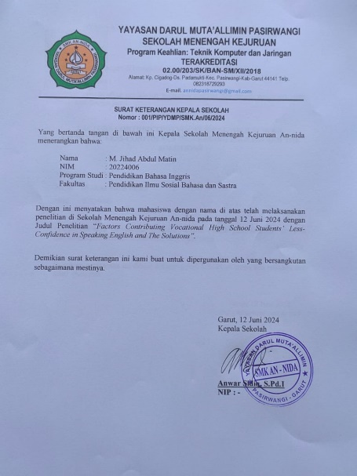 | 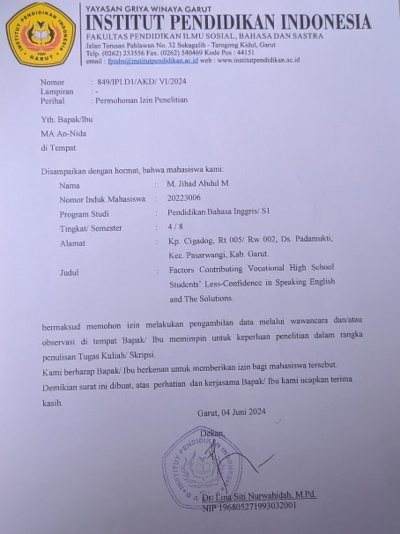
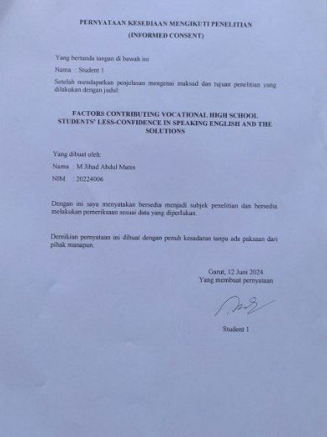 | 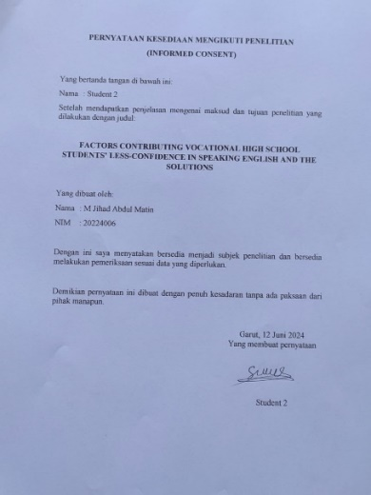
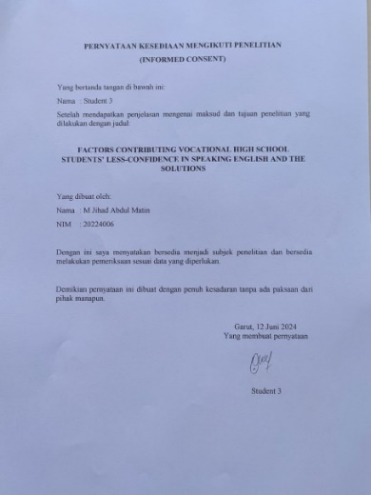 | 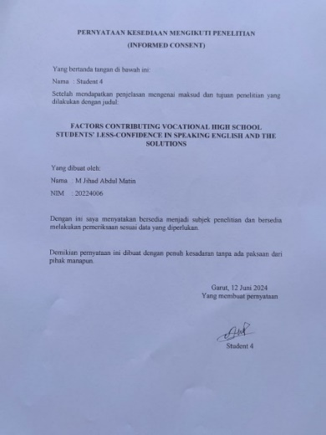
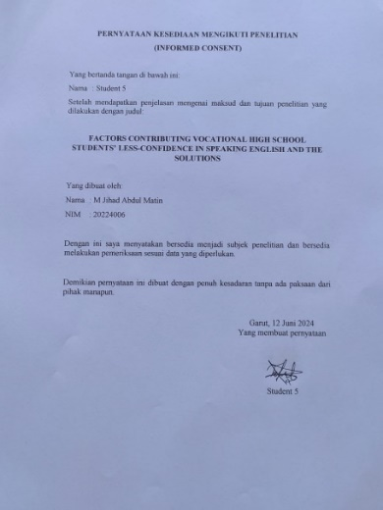 | 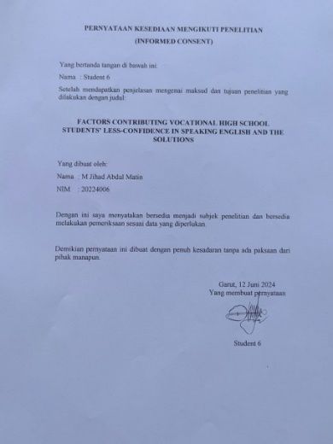
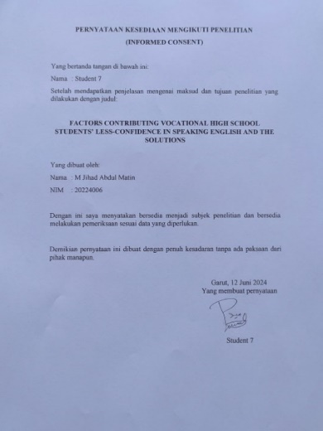 | 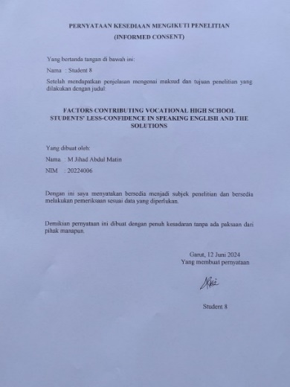

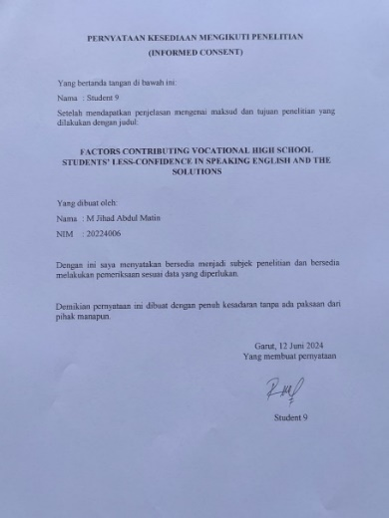 | 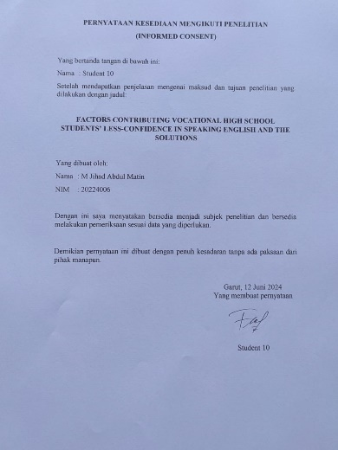 | 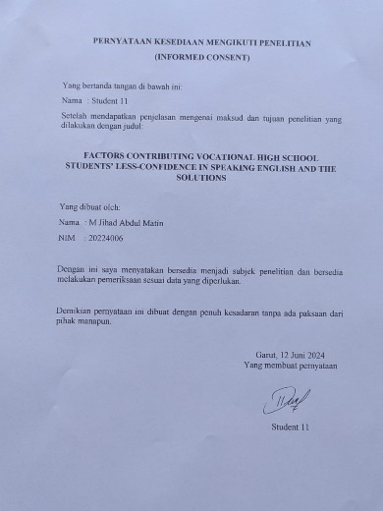

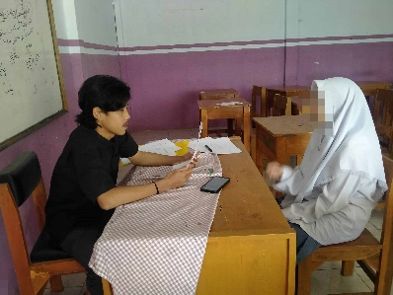 | 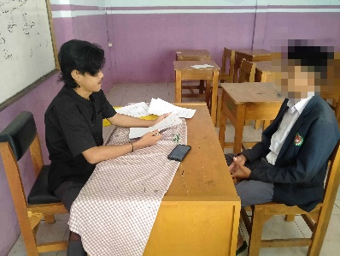 | 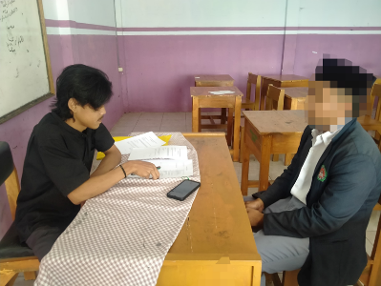
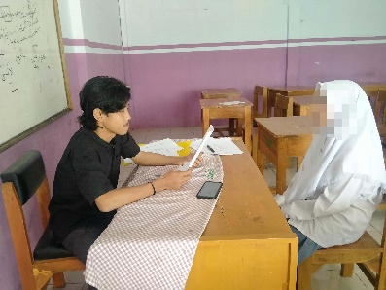 |  | 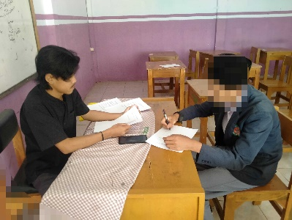
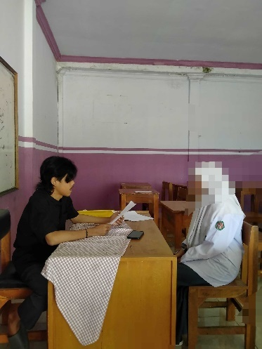 | 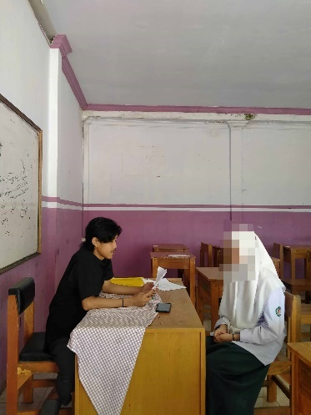 | 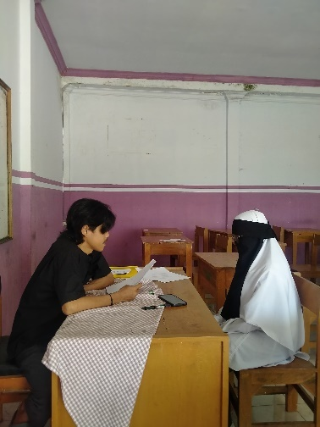
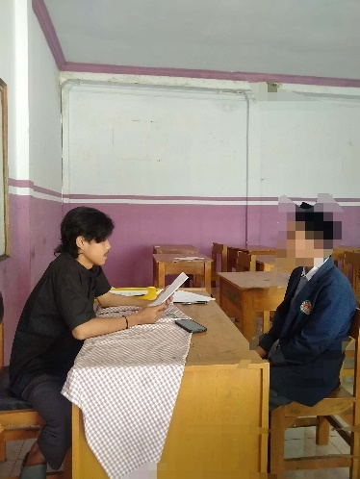 | 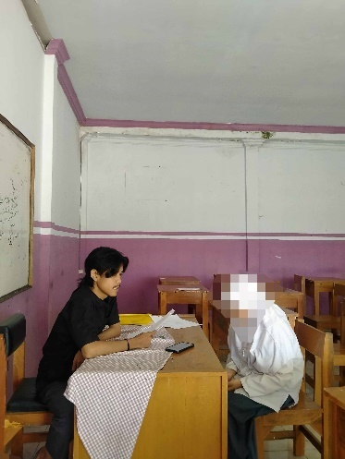 | 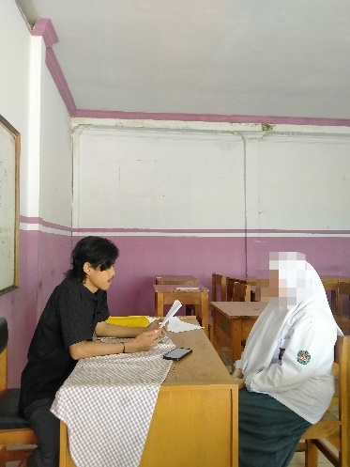

APPENDIX C
CURRICULUM VITAE
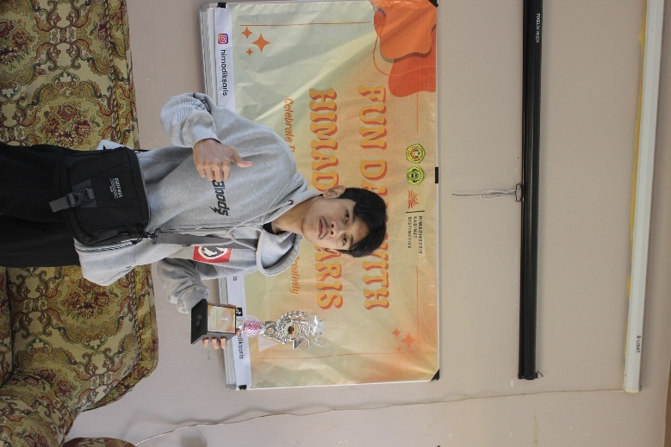 |  | M. Jihad Abdul Matin
ADDRESS |  | Kp. Cigadog, Ds. Padamukti, Kec. Pasirwangi, Kab. Garut, Prov. Jawa Barat 44161
E-MAIL |  | jhoneot@gmail.com
SUMMARY |  | My name is M Jihad Abdul Matin. I was born in 2000 Desember 30th. My Hobby is playing futsal. I want to be a billionaire.
EDUCATION |  | MI Ciwahangan (2013)
EDUCATION |  | MTs Ma’arif Daarut Taqwa Cibatu (2016)
EDUCATION |  | SMA Terpadu Darul Muta’allimin (2019)
EDUCATION |  | Institut Pendidikan Indonesia (2024)

