STUDENTS’ PERCEPTION ON TEACHER’S CORRECTIVE FEEDBACK IN LEARNING WRITING

A PAPER
Submitted to the English Education Program of IPI Garut as a Partial Fulfilment of the Requirements for the Sarjana Pendidikan Degree

Written by:
Luthfie Mubarok
20222013

ENGLISH EDUCATION PROGRAM
FACULTY OF SOCIAL SCIENCE, LANGUAGE, AND LITERATURE EDUCATION
INSTITUT PENDIDIKAN INDONESIA
2024

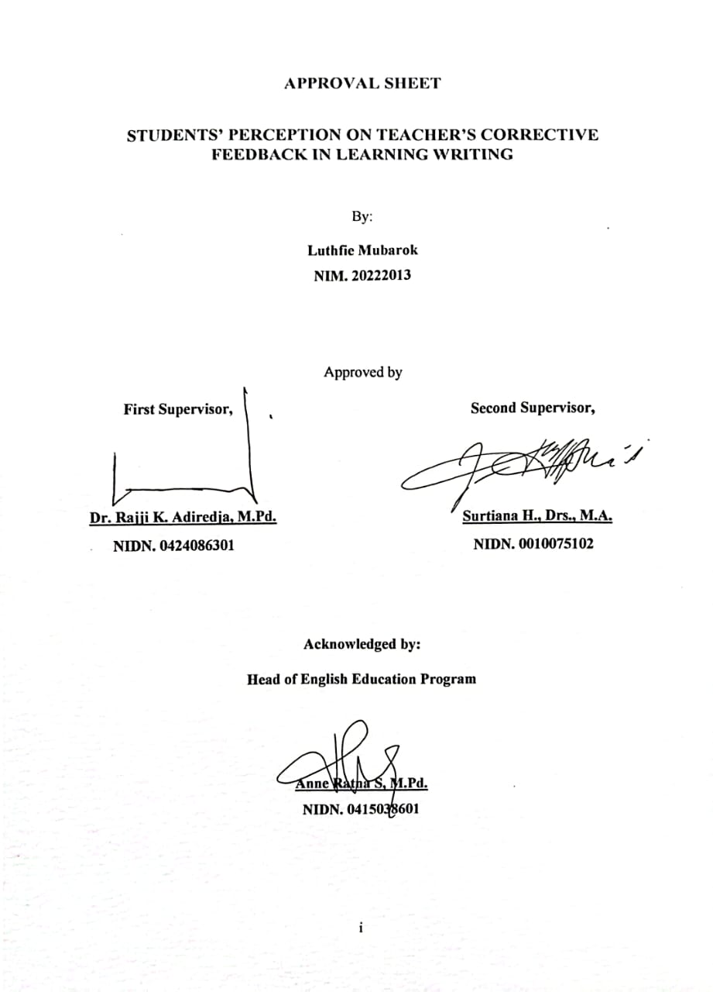
APPROVAL SHEET

STUDENTS’ PERCEPTION ON TEACHER’S CORRECTIVE FEEDBACK IN LEARNING WRITING

By:
Luthfie Mubarok
NIM. 20222013

Approved by
First Supervisor, Second Supervisor,

Dr. Rajji K. Adiredja, M.Pd. Surtiana H., Drs., M.A.
NIDN. 0424086301 NIDN. 0010075102

Acknowledged by:
Head of English Education Program

Anne Ratna S, M.Pd.
NIDN. 0415038601

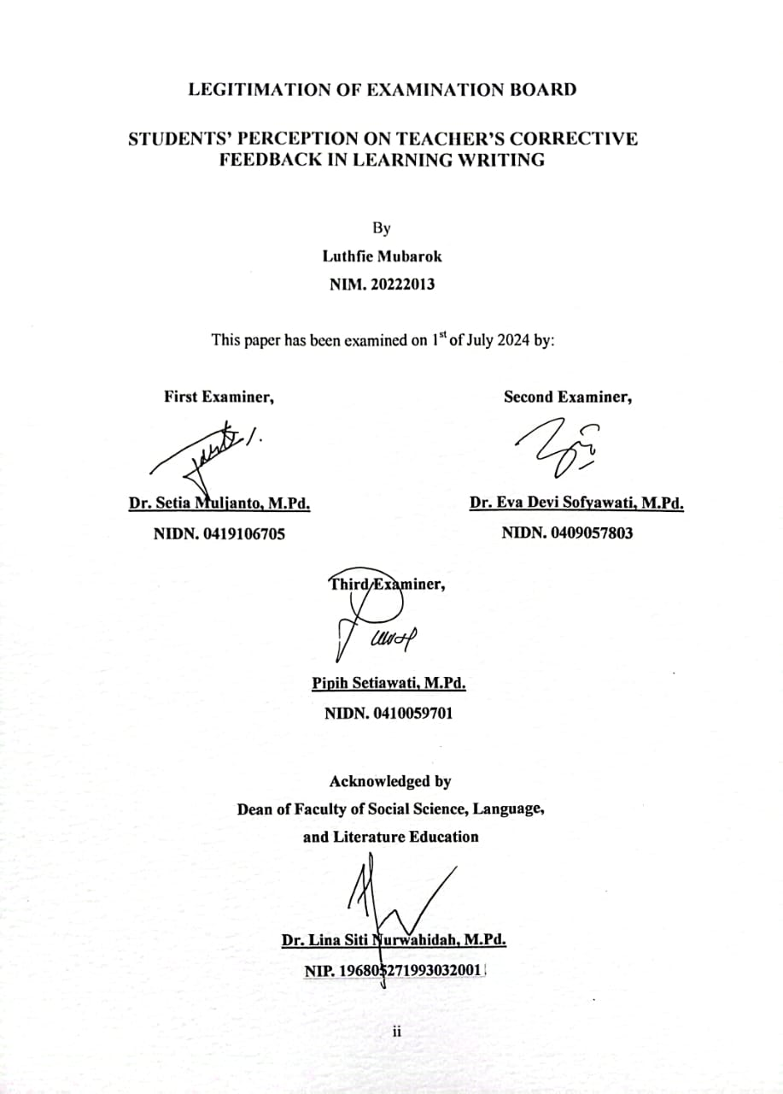
LEGITIMATION OF EXAMINATION BOARD

STUDENTS’ PERCEPTION ON TEACHER’S CORRECTIVE FEEDBACK IN LEARNING WRITING

By
Luthfie Mubarok
NIM. 20222013

This paper has been examined on 1st of July 2024 by:

First Examiner, Second Examiner,

Dr. Setia Muljanto, M.Pd. Dr. Eva Devi Sofyawati, M.Pd.
NIDN. 0419106705 NIDN. 0409057803

Third Examiner,

Pipih Setiawati
NIDN. 0410059701

Acknowledged by
Dean of Faculty of Social Science, Language,
and Literature Education

Dr. Lina Siti Nurwahidah, M.Pd.
NIP. 1968052719930322001

MOTTO
“Believe in yourself, do everything that make yourself better than before, and don’t be scared to make your dream come true”

This paper is dedicated to:
My beloved parents
My dear sister and brothers
My dear friends
My dear cousins

STATEMENT
The researcher hereby declares that this paper entitled “Students’ Perception on Teacher’s Corrective Feedback in Learning Writing” was really written by the researcher. Quotation from other sources have been carried out based on citation rules in accordance with applicable scientific ethics. Therefore, the content of this paper and all its completeness are original works of the researcher. In this case, if things are found that are not suitable, the researcher will be responsible and willing to accept any risk and sanctions.

Garut, June 20^{th,} 2024
The researcher,

Luthfie Mubarok
NIM. 20222013

PERNYATAAN
Dengan ini, peneliti menyatakan bahwa skripsi yang berjudul “Students’ Perception on Teacher’s Corrective Feedback in Learning Writing” benar-benar ditulis oleh peneliti. Kutipan dari sumber lain telah dilakukan berdasarkan aturan kutipan sesuai dengan etika ilmiah yang berlaku. Oleh karena itu, isi beserta segala kelengkapannya merupakan karya asli peneliti. Dalam hal ini, jika ditemukan hal-hal yang tidak sesuai, peneliti bertanggung jawab dan bersedia menerima segala resiko dan sanksi apapun.

Garut, 20 Juni 2024
Peneliti,

Luthfie Mubarok
NIM. 20222013

PREFACE
In the name of Allah, the Most Gracious and Most Merciful, praise and Gratitude to Allah Subhanahu Wata'ala. Thank God for all His help, grace, and love so the researcher can complete his thesis entitled "Students’ Perception on Teacher’s Corrective Feedback in Learning Writing”. Shalawat and salam to Rasulullah Shallallahu Alaihi Wasallam who has always been a source of inspiration and the best example for mankind.
The researcher thanks all parties who cannot be mentioned one by one, for helping the researcher in completing this thesis.
The researcher realizes that nothing is perfect, and the researcher still makes mistakes in preparing their thesis. Therefore, the researcher apologizes profusely for the mistakes made by the researcher.
The researcher hopes that this thesis can be useful for readers and can be used as a reference and provide insight into giving input by teachers. Apart from that, the researcher also hopes that this thesis can contribute to the development of writing learning.

Garut, June 20^{th,} 2024

The researcher

ACKNOWLEDGEMENT
First of all, I would like to say Allhamdulillahirabbil’alamin. Finally, this paper has been accomplished. In the name of Allah, the most gracious and the most merciful, the lord of the universe. Thanks to Allah for blessing, kindness, and inspiration in leading me to accomplish this paper. Blessing is upon for our prophet Muhammad SAW, to his family, his friends, and his followers.
I would like to express my sincere, gratitude to the following personnel, for giving advice, guidance, comments, critics, correction, help, prayer, and support, they are;
- Dr. H. Nizar Alam Hamdani, M.M., MT., M.Si., the Rector of Institut Pendidikan Indonesia (IPI) Garut.
- Dr. Hj. Lina Siti N, M.Pd., the Dean of the Faculty of Social Science, Language, and Literature Education of Institut Pendidikan Indonesia (IPI) Garut.
- Anne Ratna Suminar, M.Pd., the Head of the English Education Program.
- Dr. Rajji K. Adiredja, M. Pd., as the first supervisor who has guided me with his worthy, corrections and suggestion to improve the quality of this research paper.
- Surtiana H., Drs., M.A., as the second supervisor who has guided me with his worthy, correction and suggestion to improve the quality of this research paper.
- All lectures of the English Education Program of IPI Garut who have taught me useful knowledge and skills.
- My beloved father, Abdul Kodir, thank you for not giving up to support my education. Thank you for always praying for me, giving me love, giving me valuable advices and inspiring me. You are one of my reasons to keep fighting.
- My beloved mother, Elva Latipah, thank you for always pray for me, giving me love, and supporting me. I want to thank you for not only being a mother figure to me, but also being a friend, a good listener, and a motivator. You are always encouraging me to support my education and giving me hope for a better future life. Then, I want to say thank you for always being with me in any condition.
- My beloved brother namely Azis Jaelani, my beloved sister namely Ula Nurkhalisa, and my brother-in-law namely Rizal Gunawan, thank you for your help, support, and motivation.
- I also want to thank my grandmother, Oom Romyati, for always praying the best for me.
- To all PBI friends from classes 4A, 4B and 4C thank you for being my good friends for me for all this time.
- To all my cousins, thank you for being friends to me, comforting me, and always kind to me.
- Last but not least, I want to thank myself for not stopping dreaming, keeping trying, and not giving up. I want to thank myself for continuing to fight and persisting even in the worst conditions.

Garut, June 20th, 2024

The researcher

ABSTRAK
Siswa EFL seringkali mengalami kesulitan dalam menulis bahasa Inggris, sehingga kesalahan tidak dapat dihindari dalam proses belajar menulis mereka. Oleh karena itu, umpan balik korektif guru penting untuk meningkatkan keterampilan menulis mereka. Oleh karena itu, penelitian ini bertujuan untuk menyelidiki persepsi siswa tentang pentingnya umpan balik korektif yang diberikan guru dalam pembelajaran menulis dan untuk mengetahui jenis umpan balik korektif yang terbaik dalam pembelajaran menulis. Penelitian ini menggunakan pendekatan kualitatif dengan bentuk desain studi kasus. Data dikumpulkan dengan menggunakan angket tertutup terhadap 33 siswa kelas writing di salah satu universitas di Garut. Hasilnya, ditemukan bahwa umpan balik guru penting untuk digunakan dalam pembelajaran menulis. Selain itu, ditemukan juga bahwa umpan balik langsung dan tidak langsung efektif dalam pembelajaran menulis dengan berbagai cara.
Kata Kunci: Umpan Balik Korektif, Umpan Balik Langsung, Umpan Balik Tidak Langsung

ABSTRACT
EFL students often have difficulties in writing English, so errors cannot be avoided in their learning writing process. Therefore, teacher’s corrective feedback is important to improve their writing skills. Thus, this study aims to investigate the students’ perception of the importance of teacher’s corrective feedback in learning writing and to find out the best type of corrective feedback in learning writing. This research employed a qualitative approach in the form of a case study design. Data were collected using a close-ended questionnaire with 33 writing class students at one university in Garut. the results found that teacher feedback is important to be used in learning writing. in addition, it is also found that both direct and indirect feedback are effective in learning writing in different ways.
Keywords: Corrective Feedback, Direct Feedback, Indirect Feedback

TABLE OF CONTENTS

APPROVAL SHEET i
LEGITIMATION OF EXAMINATION BOARD ii
MOTTO iii
STATEMENT iv
PERNYATAAN v
PREFACE vi
ACKNOWLEDGEMENT vii
ABSTRAK ix
ABSTRACT x
TABLE OF CONTENTS xi
CHAPTER I INTRODUCTION 1
1.1 The Background of the Study 1
1.2 Reasons for Choosing the Topic 3
1.3 Research Questions 3
1.4 Research Objectives 3
1.5 Significance of the Study 3
1.6 Definitions of Terms 4
CHAPTER II LITERATURE REVIEW 5
2.1 Writing 5
2.2 Learning Writing 6
2.3 Teaching writing 7
2.4 The Importance of Feedback 9
2.5 Corrective Feedback in Writing 11
2.6 Types of Corrective Feedback 11
2.7 Characteristics of Effective Feedback 13
2.8 Previous Studies 16
CHAPTER III RESEARCH METHODOLOGY 17
3.1 Research Method 17
3.2 Research Design 17
3.3 Research Setting and Participants 17
3.4 Data Collection 18
3.5 Data Analysis 18
3.6 Research Procedure 19
CHAPTER IV DATA ANALYSIS, FINDINGS AND DISCUSSIONS 20
4.1 Data Analysis and Finding 20
4.2 Discussion 33
CHAPTER 5 CONCLUSIONS AND SUGGESTIONS 40
5.1. Conclusions 40
5.2 Suggestions 41
REFERENCES 43
APPENDICES 47
RUBRIC OF QUESTIONNAIRE 48
LINK OF GOOGLE FORM (QUESTIONNAIRE) 54
QUESTIONNAIRE 55
QUESTIONNAIRE RESULTS 62
SAMPLE OF DIRECT FEEDBACK 73
SAMPLE OF INDIRECT FEEDBACK 80
INSTRUMENT VALIDATION REQUEST LETTER 84
EXPERT JUDGEMENT SHEET 85
RESEARCH PERMIT LETTER 86
TURNITIN CHECK RESULTS 87
CURRICULUM VITAE 99

CHAPTER I
INTRODUCTION

The Background of the Study
Writing is one of the English skills that is essential in many aspects, especially in education. It is in line with Wondim et al. (2024) that it is a skill that enables people to create perspective, unquestionable records of their ideas, thoughts, and spirits. As a result, writing ability is now valued as both a social and intellectual advantage in modern society. In the learning context, almost all courses contain writing elements and require the students to master the skill. It is shown that the skill is essential. However, students who are considered English as foreign language often have difficulties in writing English. It is proved by Sukha & Listyani (2022) that the differences in English sentence structures, syntax, and spelling with the first language make EFL (English as Foreign Language) students feel complicated in delivering their concepts in writing English. In that, errors are unavoidable in their progress of learning writing. Therefore, to create good writing, a teacher’s corrective feedback is needed to make the students easier to revise their work.
Corrective feedback in writing is an essential action to be done by educators to enhance students’ writing proficiency. It is supported by (Rosdiana (2016) that corrective feedback is proposed to improve students’ writing skills to the point where they can produce work with minimal error and maximum clarity. There are numerous types of corrective feedback utilized in evaluating writing, one of which is, direct and indirect corrective feedback. Direct and indirect corrective feedback have significant differences in characteristics and procedure. According to Ahmadi et al. (2012), direct feedback is a feedback strategy when the teacher identifies an error and corrects them. Conversely, it is mentioned that indirect feedback is a situation when the teacher points out errors made by students without offering any correction.
Research focused on teacher’s corrective feedback in learning writing has been studied by many researchers. For example, Hosseiny (2014) that examines how direct and indirect written corrective feedback impacts the improvement of EFL students’ writing skills. Based on the study, it is found that compared to the control group (students who are not receiving corrective feedback), the student group who received written corrective feedback showed higher gains in the development of grammar knowledge. In addition, another research is focused by Gholaminia et al. (2014) that is investigate the effect of meta-linguistic error feedback in enhancing paragraph writing skills and identifying the most useful type of error feedback. The result of their experiment shows that the experimental group (students which received implementing meta-linguistic code-correction) outperformed the control group (students who taught with traditional method). Therefore, it can be concluded that the studies focused on the influence of corrective feedback on the students’ writing skills and performance.
However, this study is focused on the students’ Perception of the Importance of Teacher’s corrective feedback in learning writing. Research that is significantly studied about the students’ perception of the Importance of Teacher’s corrective feedback and the best type of corrective feedback in learning writing is still limited. Hence, this research aimed to investigate the students’ perception of the Importance of corrective feedback in learning writing that is given by the teacher and to find out the best type of corrective feedback they can use in learning writing. Students’ perceptions are important to be highlighted because as the object of learning, students need to get suitable feedback in their learning process. On the other hand, the importance of corrective feedback needs to be investigated to provide information for the teacher in applying it. Additionally, the best type of corrective feedback is required to be found to help the teacher in finding appropriate feedback for the students. If the best type of feedback is found, the teacher can provide feedback with maximum quality. Thus, it can improve the development of students’ writing skills.

Reasons for Choosing the Topic
The topic was chosen because in learning writing, EFL students may experience difficulties. Therefore, the students often made errors in their writing learning process. To deal with that, it is requisite for the students to receive corrective feedback from the teacher. The reason why the researcher investigated students’ perceptions in the research is because the students are the object of the learning itself. Thus, their perception needs to be investigated to gain a better insight into giving corrective feedback in learning writing.

Research Questions
This research aimed to address the following questions:
- What are students’ perceptions of the importance of a teacher’s corrective feedback in learning writing?
- According to the students, what is the best corrective feedback in learning writing?

1.4 Research Objectives
This research would be aimed at finding out:
- To find out students’ perceptions of the importance of teacher’s corrective feedback in learning writing.
- To find out the best corrective feedback in learning writing based on the students.

1.5 Significance of the Study
This study is proposed to provide information about the importance of corrective feedback in learning writing from students’ points of view. It is also designated to inform readers about the best corrective feedback the students prefer in their learning process. Since the objective of the study is to investigate the students’ perception of the Importance of corrective feedback in learning writing and to find out the best type of corrective feedback, it is hoped that teachers and students can attain a better quality of the appliance of corrective feedback in writing class. Additionally, it is also hoped that this study can become a reference for the next researchers so they can develop studies regarding the impact of feedback in writing and challenges faced by teacher and students in applying corrective feedback. Therefore, it is hoped that the study can require some advantages for teachers, students, and further researchers, especially in improving students’ writing proficiency.

1.6 Definitions of Terms
Definition of writing
Writing is an activity of using symbols, letters, and words to express ideas or information through written words in a structured and coherent manner. Based on Sary (2019), it is the skill of communicating thoughts, feelings, and ideas to others clearly and concisely.
Definition of corrective feedback
Corrective feedback is a teacher's action to correct students’ work, to minimize mistakes and errors in that work. It is in line with Bitchener & Storch (2016) as cited in Liu (2024) that Teacher’s written corrective feedback is defined as written responses intended to correct incorrect usage or include details on error locations, causes, and remediation strategies.
Definition of direct and indirect feedback
Direct feedback is a type of feedback that occurs when the teacher corrects students’ errors and provides the correct answer for them. Besides, the significant difference with indirect feedback is that in indirect feedback, the teacher corrects students’ errors but doesn’t provide them with the correct answer. It is supported by Eslami (2014) that in indirect feedback, the teacher indicates that the error is made by the students without giving them the correct answer and lets students find it by themselves.

CHAPTER II
LITERATURE REVIEW
This chapter provides theoretical frameworks related to the study. It focuses on the theory of writing, learning, and teaching writing, the importance of feedback, corrective feedback in writing, types of corrective feedback, and characteristics of effective feedback. This chapter aims to provide a foundation for understanding current knowledge and identifying gaps that this research will address.

2.1 Writing
Writing is an act of conveying ideas or information in a written form. According to Sary (2019) writing is the ability to express concepts, emotions, and notions to others in a way that is clear and concise. Writing is one of the important skills that is required in many sectors, especially, in the academic and education sector. In terms of education, writing skills are needed at almost every level of education. Since writing is a skill that is gained through practice and education, learning to write is essential for recording information in writing, transcribing spoken thoughts, and overall writing expression Alemneh & Gebrie (2024). Thus, students need to master the writing skill.
Based on Oshima and Hogue (1999) as cited in Sary (2019)The writing process consists of six stages. The first stage is prewriting which involves narrowing down the topic and brainstorming ideas. The second stage is planning which involves determining what will be written. The third step is writing. In this step, the writer improves the ideas formulated during the planning stage. The fourth stage of writing is revising. In this stage, the writer corrects mistakes made in their writing by re-reading the text and fixing errors in spelling, sentence structure, and semantics. In addition, in the fifth stage, after correcting the errors, the writer continues toward the final version. This process is called rewriting. Furthermore, the last step is final writing. In this last step, the writer must follow these steps to achieve a good quality of writing.
However, writing is one of the most challenging skills in learning English. Struggles and difficulties are often experienced by learners in learning writing. It is in line with Fareed & Bilal (2016) that students in learning writing face several problems. They found that students lack information on suitable vocabulary. Additionally, they often made grammar errors such as in pronouns, tenses, articles, prepositions, and basic structures. Furthermore, their writing also had errors in syntax as it lacked coherence, knowledge consolidation, and the formal transitional and cohesive techniques that are needed. Those problems occurred due to several factors, such as undeveloped writing and reading culture, learners’ anxiety in writing, lack of critical thinking, and it is least liked skill in society (Fareed & Bilal, 2016).

2.2 Learning Writing
Writing skill is one of the crucial skills to be possessed by students. It not only enhances their language proficiency but also supports academic and professional growth. Since writing skills can allow students to express ideas clearly, it can help them to succeed in exams, pursue higher education opportunities, and navigate the demands of the modern workplace. It is in line with Hidayati (2017) which explains that writing is crucial for English as a Foreign Language (EFL) learning, and being able to write well is an essential goal in today’s education and society. In addition, writing proficiency plays an important role in the student’s academic achievement. This statement is relevant to the study of Adedin et al. (2013) who found that there is a significant connection between EFL students’ degree of content scores of EFL students and their writing skills.
According to Hidayati (2017), writing is not only transcribing spoken language on paper; it is a unique form of communication that involves distinct sociocultural norms and cognitive processes. Hence, there are some challenges faced by students in learning writing skills. According to Manggolo et al. (2024), students often face significant struggles in their learning writing, such as uncertainties about their progress, issues with self-confidence, and difficulties in generating ideas. These challenges may lead to students’ lack of motivation, pressure, and perfectionism. On the other hand, according to Prasetyaningrum et al. (2021), many students experience writing anxiety. This student’s writing anxiety is triggered by a combination of frequent writing assignments, low self-esteem regarding their abilities, and time constraints. These factors can cause students overwhelmed, lack confidence, and have a high risk of stress.
Therefore, there are some learning strategies to enhance students’ writing skills. According to Junianti et al. (2020), there are three types of learning language strategies that can be used in learning writing, such as meta-cognitive, cognitive, and social strategies. First, the meta-cognitive strategy, also known as the mental process, aids learners in managing their learning by planning, selecting their learning methods, and assessing their progress. Second, the cognitive strategy involves mental processes related to selecting appropriate information or sources. the last one is the social strategy focuses on how students interact with others, aiming to enhance their cultural understanding.

2.3 Teaching writing
Teaching writing is a process that involves the engagement between a teacher and students, leading to the creation of written work. According to Norhidayah et al. (2021), eight approaches can be used in teaching writing.
- Product approach: The product approach is characterized by imitating a model text, prioritizing the organization's ideas over the content, producing a single draft, highlighting and practicing specific features in a controlled manner, working individually, and focusing on the final product.
- Process approach: the characteristic of process approach is the text serves as a reference for comparison and a source of ideas, requiring multiple drafts to refine the focus on purpose, theme, text type, and audience. Additionally, this approach also stressed the students’ creativity and collaboration with peers.
- Strategic approach: in the strategic approach, writing is guided by a coach with partners engaging in think-aloud discussion. Students conversed with their partners about writing, which encouraged them to apply specific strategies to enhance their writing process.
- Cognitive approach: in the cognitive approach, students are instructed to consider their intended audience before writing. This process is guided by the teacher’s suggestions and revision with the instruction centered on setting and achieving goals.
- Genre approach: Genre approach is an approach that employs the product approach (understanding of the language) while emphasizing the social purpose.
- Pragmatic approach: Pragmatic approach is based on the process view, focusing on how people use language meaningfully, while also emphasizing the social aspects of writing.
- Process genre approach: Process genre approach employs a model for replication, emphasizing knowledge of language structure. It concentrates on the writing's social objectives and enables learners to learn the writing process.
- Concept model approach: The concept model approach demonstrated that writing occurs in three stages: input, process, and output.
However, there are several challenges found by the teacher in the process of teaching writing. The challenges can emerge from the students or the circumstances. An example of challenges from the students is teachers sometimes face difficulties in teaching students who have not mastered English vocabulary and grammar. It is relevant to Adam et al. (2021) that one of the teacher challenges in teaching writing is students’ obstacles in write that are caused by the lack of vocabulary and grammar. In addition, it is also mentioned that students lack enthusiasm to learn, search for the information they need in writing, and participate in writing projects. Besides, the challenges can also appear from the circumstances. For example, teachers often struggle with the lack of resources and material for writing instruction. Additionally, they also struggled with the limited time for teaching writing and providing feedback and assessment for students’ writing. It is in line with Endarwati et al. (2023) that teachers often found challenges in teaching writing, such as students’ disinterest, insufficient writing time, differences in skill levels, challenges in organization, lack of resources, difficulties in assessment, and a range of genres.
Related to the process of teaching writing, feedback is considered a crucial action. Feedback given by the teacher can help students to fix mistakes they made in the writing process. Additionally, it also can increase their knowledge and their critical thinking skill. This is supported by Aridah (2003) which found that hints and clues provided in the feedback can improve students’ writing accuracy and stimulate their logical reasoning. Therefore, teacher feedback is very useful for the improvement of students’ writing ability.

2.4 The Importance of Feedback
Feedback is data that a student gets regarding their language learning. It usually relates to data regarding the student’s language production (speaking and writing). However, it also addresses other topic like reading and listening, study techniques, effort, attitudes, etc. According to Kerr (2020), there are three fundamental and interrelated purposes of feedback. First, feedback is purposed to improve students’ fluency, accuracy, and complexity in writing and speaking. Second, feedback is also aimed at motivating learners. Furthermore, the third purpose of feedback is to develop students’ autonomy. Therefore, feedback plays a crucial role in students’ learning progress to improve students’ English skills, especially in learning writing.
The first feedback fundamental is to improve students’ fluency, accuracy, and complexity in writing and speaking. In learning writing, the teacher’s feedback is utilized in correcting linguistic errors made by the students. Therefore, it could develop students’ writing skills and help them to avoid mistakes in writing. It is supported by Aridah (2016) that written feedback can increase students’ writing performance in many aspects, such as verbal reasoning, error recognition, and grammatical accuracy. As a result, students will be helped by the feedback given by the teachers in their learning process. It is proved by Aziz & Jayaputri (2023) that students feel that feedback is beneficial for them in determining the correct linguistic form. Hence, feedback is required as it is helpful for students and improves their writing performance.
Additionally, the second fundamental and interrelated purpose of feedback is to motivate learners. In EFL classrooms, students often have difficulties in learning writing which causes them to be unmotivated in learning it. It is in line with Tehrani (2018) that writing is one of the trickiest skills in English Language teaching classes. Students struggled for many years due to excessive levels of anxiety and low self-confidence. Therefore, feedback is needed to keep students motivated in learning writing. Based on Asnawi & Wariyati (2021), feedback that is given by the teacher could increase students’ motivation such as increase their enthusiasm in interacting in the lesson. Additionally, Aziz & Jayaputri (2023) also mention that feedback can lead to students’ positive attitudes. It improves students’ motivation and encourages their desire to learn. Thus, feedback is really important in enhancing students’ learning motivation.
The last fundamental purpose of feedback is to develop students’ autonomy. According to Aprianti & Winarto (2021), students’ autonomy can be defined as the student’s skill to take responsibility and make decisions about various learning aspects, including active engagement in planning, monitoring, and evaluating their learning activities. Teacher feedback could increase learners’ autonomy if it is done in appropriate ways. Therefore, to assist students in achieving students’ autonomy, various ways can be done by the teacher in giving feedback to the students. One of which is, Asnawi & Wariyati (2021) mention that to achieve students’ independence, educators can define, communicate, and elucidate learning goals and criteria for success. Teachers should provide constructive feedback and not discourage students. As a result, receiving it from the teacher acts as a catalyst for students’ motivation. It is also suggested for the teacher to give feedback that includes helpful recommendations for students because it would be beneficial for them. On the other hand, Wulandari (2022) also stated that teachers are expected to provide feedback not excessively because it can make students less motivated to rewrite their writing. In contrast, teachers can provide feedback for the students but the teacher still gives them opportunities, support, and encouragement to make their own final decision.

2.5 Corrective Feedback in Writing
Corrective feedback in language learning is given by the teacher when students make a mistake or error in their learning process. According to Chen et al. (2016), corrective feedback is a method teachers employ to rectify errors or grammatical mistakes made by students during language learning. Corrective feedback can be applied in language learning both written and spoken. It is explained by Sukha & Listyani (2022) that feedback that is used to correct errors in linguistic forms of speaking is named oral corrective feedback. Meanwhile, feedback that is used to identify errors in writing is called written corrective feedback.
In the writing class context, written corrective feedback is the most appropriate to be utilized. There is a significant correlation between written corrective feedback and the accuracy of writing. It is supported by Eslami (2014) that this corrective feedback is beneficial because it can keep students’ attention on their area of difficulty. Hence, they can release their mind to process the language content.
In applying written corrective feedback, it is recommended for the teacher to involve students in that process. It would be beneficial for both teacher and students’ error evaluation. It is explained by Marzban & Arabahmadi (2013) that involving students in the corrective feedback process can provide information to the teacher as to which linguistic features they may find more problematic. For the students, when the teacher conveys the aim of providing feedback on particular error types, students could focus on those types of errors.

2.6 Types of Corrective Feedback
According to Hosseiny (2014) there are two types of written corrective feedback namely direct corrective feedback and indirect corrective feedback. However, both types of feedback are valuable for students’ learning improvement. Each type of feedback offers distinct advantages in different contexts. It is in line with Wondim et al. (2024) who found that both direct and indirect feedback are important to enhance students’ writing skills. Nevertheless, there are different characteristics between both of the corrective feedback types.
- Direct feedback
Direct feedback involves the educator identifying errors and providing the correct answer to the students. Wondim et al. (2024) explain that direct feedback is a strategy that directly presents the right linguistic form immediately following an error, serving as an input-providing approach. In correcting linguistic errors, this feedback may contain the crossing out of unnecessary words/phrases/morphemes, implying the missing words/phrases/morphemes, or providing the right form or structure (Gholaminia et al., 2014). They also explain that type of feedback can be given by using written meta-linguistic explanation or spoken meta-linguistic explanation.
The written meta-linguistic explanation means that the educator gives the correct grammar rules or structures and samples at the end of the student’s work. Furthermore, the teacher adds the reference back to places where the errors took place in that text. Meanwhile, the spoken meta-linguistic explanation occurs when the teacher corrects students’ errors by delivering a mini-lesson. There, the grammar rules or structures and the examples are presented by the teacher. In that lesson, conference, practice, and discussion occur between the teacher and the student group. It is in line with Hosseiny (2014) that the essence of direct feedback is a type of feedback when the educator identifies that the mistake exists in writing and gives the right linguistic form to the students. Therefore, it is understandable because it provides explicit information for students (Bitchener and Knoch, 2010 as cited in Hosseiny, 2014).
In learning writing, direct corrective feedback is appropriate to be used for beginner-level students who still lack English writing proficiency. It is in line Eslami (2014) that it is beneficial for students with low proficiency levels who struggle to correct errors made in writing by themselves and are unsure of the correct form. The appropriateness to be used for beginner-level students is supported by the explicit information provided by direct feedback. This statement aligns with previous studies which imply that direct feedback can be understood easily by the students (Sahmadan & Hasan, 2023).

- Indirect feedback
Indirect feedback is a type of feedback that occurs when the teacher identifies that the error exists but the teacher does not provide the proper linguistic form. Instead, the students will discover the correct answer for the errors by themselves. This type of feedback could be applied in many ways. For example, it is mentioned in Gholaminia et al. (2014) that indirect feedback signals errors by underlining or circling them, noting the number of errors in the margin per line, or employing codes to indicate the type of error to the students. However, instead of giving the pupils the correct answer, students are allowed to solve the problems and correct the errors by themselves. Therefore, students must have the ability to independently correct their writing errors. This is relevant to Eslami (2014) that in applying indirect feedback, students must exhibit sufficient language skills to be able to self-correct the errors.
Since it requires students to participate in guided learning and problem-solving, indirect feedback is beneficial because it encourages the kind of introspection, noticing, and attention that is more likely to support long-term acquisition. Therefore, this type of feedback is suitable for students who have previous knowledge of writing English. this is supported by Eslami (2014) that this kind of feedback is preferable for student writers. It is because it can engage them in “guided learning and problem-solving”. Besides, Wulandari (2022) states that effective feedback is the feedback that is given wisely. She stated that giving excessive feedback to students can make them more reluctant to revise their work. Thus, it is relevant to the characteristic indirect feedback that allows students to participate in the process of correcting errors in their work. Hence, it can help students enhance their writing skills (Ahmadi et al., 2012).

2.7 Characteristics of Effective Feedback
Effective feedback is fundamental to learning writing and catalyzing growth and improvement. It provides students with valuable insight into their strengths and areas for development, guiding them in increasing their abilities. According to Kerr (2020), there are several characteristics of effective feedback:

- Effective feedback is about learning tasks
Teacher’s written feedback is supposed to not only concentrate on students’ writing performance but also focus on students’ process in achieving the learning task. It explained by Wulandari (2022) that the organization of thoughts in written language and forms is what constitutes writing, therefore grammar and content are not the only things to be concerned with. It is also important to additionally discuss writing as a process (the way students achieve learning tasks) and as a product (students’ writing performance), and how teachers might help students with their learning. Thus, educators should encourage the learners to engage in discussing and evaluating the feedback given. It is in line with Barkaoui (2007) that teachers can help learners communicate, assess, and examine feedback they have received and talk about the reason for the feedback delivery and its implication for their writing. This helps students to be aware of what they are supposed to do to relate to their writing process.
- Effective feedback is specific and related to learning goals
When students have well-defined and precise learning goals, they are more likely to learn successfully. Feedback that offers guidance on how to accomplish these goals, works better than generic feedback. Thus, the teacher is expected to give feedback on students’ work as detailed as possible. According to Austen & Malone (2018), students prefer to receive clear and error-free feedback that includes an explanation of the error. In addition, effective feedback is also should be related to the learning goal. It is supported by Pan et al. (2022) that to improve students’ learning, the teacher’s feedback should be detailed enough and be able to accompany them to understand the learning objectives. Therefore, it could help students to understand the feedback more easily and avoid them from confusion and misunderstanding.
- Effective feedback is appropriately challenging
Effective feedback focuses on areas where progress can be made (Kerr, 2020). This is more likely to occur when a student has some control or comprehension of a particular learning process as opposed to a total lack of either. Effective feedback therefore usually concentrates on topics that the students have recently studied or have already received feedback on. It is less concerned with what a learner must achieve right and more focused on what the learner might be able to accomplish better. Wulandari (2022) explains that good feedback focuses on enhancing learning in a way that is feasible given their most recent learning. It is advised for teachers to highlight the areas that still require improvement.
- Effective feedback entails the active involvement of the learner
A crucial function of effective feedback is to encourage students to take on more independence. To make feedback from a teacher to be helpful, it must cause a learner to alter their knowledge, language production, or learning practices. Therefore, active participation from the student is required (Kerr, 2020). As a result, the teacher’s position will probably shift over time as the student becomes less “center-stage”. It is mentioned by Pan et al. (2022) that effective feedback enhances the psychological process of leadership. In terms of leadership, rather than constantly needing assistance from others, leaders would be better served by developing into self-directed learners who can progressively recognize and address their failings in every situation. Therefore, to increase students’ independence, teachers ought to avoid examining too much of their students’ writing. Although the teacher may offer suggestions on the structure, content, and mechanics, the students have the last decision.
- Effective feedback is a combination of the positive and the negative
Effective feedback should contain a balance of positive and negative. It means that the feedback includes praise and constructive criticism. In giving feedback, teachers could mention both the students’ achievements and their weaknesses. Based on Md. Mamoon-Al-Bashir et al. (2016), positive feedback involves motivating students to utilize the given feedback. Additionally, teachers should ensure that the feedback does not demotivate students in any manner. However, since the objective of the feedback is to correct students’ errors, the teacher should provide students with feedback that includes constructive criticism. It is in line with Kazemipour (2014) that corrective feedback is supposed to give the students the correct forms of their errors or make them aware that the errors exist and ask them to self-correct the errors. Therefore, the teacher needs to give a balanced combination of positive and negative feedback.

2.8 Previous Studies
Numerous studies have been conducted to analyze teacher’s corrective feedback in learning writing. One of which is, Hosseiny (2014) that investigate the role of direct and indirect written corrective feedback in enhancing EFL students’ writing skills. This study is conducted at the “Iranian” Institute in Ardabil. This research is focused on investigating the differences between the three student groups who receive direct corrective feedback, indirect corrective feedback, and the students who do not receive any corrective feedback. Based on the study, it is found that compared to the control group (students who are not receiving corrective feedback), the student group who received written corrective feedback showed higher gains in the development of grammar knowledge.
Another study is conducted by Gholaminia et al. (2014) that investigated the effect of meta-linguistic error feedback on the improvement of paragraph writing ability. Additionally, this research also aimed to find out the most useful type of error feedback. The research was done in the Department of English Language at an Iranian university. The result of their experiment shows that the experimental group (students who received implementing meta-linguistic code correction) outperformed the control group (students who taught with the traditional method).
The similarity of the current study with previous research is similar in analyzing the corrective feedback in learning writing. But there are also differences from previous researchers. This previous research focused on investigating the influence of corrective feedback on the student’s writing skills and performance. However, this study is focused on students’ perception of the importance of teacher’s corrective feedback in learning writing and to find out the best type of corrective feedback they preferred in learning writing.

CHAPTER III
RESEARCH METHODOLOGY
This chapter explains the research methodology utilized in this research. This chapter consists of several points such as research method, research design, research setting and participants, technique of data collection and analysis, and research timeline.

3.1 Research Method
This research used a qualitative research method. The qualitative research method is a research method that aims to investigate and offer an in-depth understanding of phenomena (Oranga & Matere, 2023). This method was used to comprehend fundamental beliefs, viewpoints, and motivations. Through this qualitative method, attitudes, perceptions, and beliefs regarding written corrective feedback in writing classrooms are also investigated.

3.2 Research Design
This study used a descriptive qualitative design as a design of the research. This research design was chosen because the research objectives taken the researcher are to investigate students’ perspectives on the importance of teachers’ corrective feedback in learning writing and gain insight into the best corrective feedback for learning writing. This design could offer an accurate comprehensive view of the phenomena being investigated. It is in line with Furidha (2023) that descriptive qualitative research aims to provide a systematic, precise, and factual overview of the facts, characteristics, and relationships among the phenomena being studied.

3.3 Research Setting and Participants
This research was conducted at one of the institutes in Garut. The choice of location aligns with the research focus since it can yield sufficient data that is relevant to the research objectives. This university consists of a lot of majors, one of which is the English Education Program. One of the subjects studied in that major is writing which is compatible with this research requisite. The population of the research was the 8th-semester students of the English Education Program. Thirty-three students who took the writing subject became the sample of this research.

3.4 Data Collection
The instrument used to collect data in this research was a close-ended questionnaire. Two sections of the questionnaire were used in this research including a 4-point Likert-scale questionnaire and a two-point multiple-choice questionnaire. A close-ended questionnaire was used in this study so that respondents could answer the questions more easily because it is provided with a set of specific answers. It is in line with Taherdoost (2022) that in the close-ended questionnaire, multiple choice, rating scales, checklists, and other schemes are used. These are the best kinds of questions in the self-administered surveys because responding to them rarely represents problems and is less likely to necessitate help. Thus, the researcher chooses this instrument due to the limited time and the large number of students. In addition, this instrument is used to provide data required in the research. It is supported by Mirhosseini (2020) that in qualitative study on language instruction, descriptive statistical data and census-like information can be utilized as marginal data. Additionally, tables of numerical data can also be utilized for a deeper comprehension of a study topic issue in its context.

3.5 Data Analysis
A descriptive study methodology was used to analyze the data. It is proposed to examine students’ perceptions of corrective feedback given by the teacher in learning writing. The data analysis was adapted from Andini & Arianto (2023). There are several steps in analyzing the data. For the Likert-scale questionnaire, firstly, the researcher chose, to narrow down, and classify the information found in the questionnaire. Second, the frequency of each alternate response was calculated to provide a data tabulation. Third, the researcher determined the percentage of the questionnaire answer. Fourth, the average value of the positive statement was calculated to determine the score of students’ perception with interval score. Lastly, the information gained is presented using descriptive text.
For the two-point questionnaire, the first step was similar to the first section which is choosing, narrowing down, and classifying the information found in the questionnaire. Second, the researcher calculated the frequency of each answer to provide a data tabulation. Third, the percentage of each answer is determined. After that, the percentage of each answer was used as a reference to determine the type of feedback that was more dominant. Last, the researcher elaborated on findings obtained using descriptive text.

3.6 Research Procedure
- On 17-20 February, the researcher wrote the research background, research questions, research objectives, and significance of the study.
- On 20-25 February, the researcher looks for theories and write the literature review.
- From 26 February to 30 March 2024, the researcher determined the research method, design, and instrument that will be utilized in this study.
- On 16-30 April 2024, the researcher developed the research instrument in the form of a Likert-scale questionnaire.
- On 1-16 May 2024, the researcher validated the instrument to one of the writing lecturers.
- On 22-29 May 2024, the researcher shared the Likert-scale questionnaire to the participants via WhatsApp group chat.
- From 30 May to 11 June 2024, the researcher analyzed the questionnaire data and wrote the research findings and discussion.
- On 12-16 June, the researcher wrote the research conclusion and suggestions.
- On 16-20 June, the researcher reviewed the whole chapter and completed the full paper.

CHAPTER IV
DATA ANALYSIS, FINDINGS AND DISCUSSIONS
The data was collected through a closed-ended questionnaire with 33 English Education Program learners who have completed writing subjects. The first section questionnaire contains 9 statements on a 4-point Likert scale. It was conducted to acquire information about students’ perception of the importance of teacher’s feedback. The questionnaire was divided into three sections based on the function of the teacher’s corrective feedback, such as motivating learners, improving writing fluency, accuracy and complexity, and developing students’ autonomy.
The second section questionnaire contains 12 questions with two points of multiple choice. The questionnaire was conducted to acquire the best corrective feedback between direct and indirect feedback in learning writing. It was divided into five sections: general questions, specific, appropriately challenging, active involvement, and the combination of positive and negative.

4.1 Data Analysis and Finding
- The Importance of Teacher’s Feedback
The data were analysed qualitatively in this study. To find out the students’ perceptions of the importance of teacher’s feedback, the researcher qualitatively interpret data scored in the table. The data analysis is adapted from Andini & Arianto (2023). Each option of the questionnaire statement has different score (strongly disagree: 1, disagree: 2, agree: 3, strongly agree: 4). The following table is the interval used to score the data.
Perception | Mean
Very positive | 3.26-4
Positive | 2.51-3.25
Negative | 1.76-2.50
Very negative | 1-1.75
Table 1. Data interval

- Motivate Learners
No | Statements | N (%) |  |  |  | Mean | Category
No | Statements | SD | D | A | SA | Mean | Category
1 | Providing feedback from lecturers can increase student motivation to correct mistakes in writing according to the feedback given.  (Pemberian feedback dari dosen dapat meningkatkan motivasi mahasiswa untuk memperbaiki kesalahan dalam writing sesuai feedback yang diberikan.) | 0  (0%) | 1  (3.0%) | 14  (42.4%) | 18  (54.5%) | 3.51 | Very positive
2 | Providing feedback from lecturers can increase students’ enthusiasm to interact in learning in writing classes.  (Pemberian feedback dari dosen dapat meningkatkan antusiasme mahasiswa dalam berinteraksi di pembelajaran di kelas writing.) | 0  (0%) | 2  (6.1%) | 16  (48.5%) | 15  (45.5%) | 3.39 | Very positive
3 | Feedback given in learning writing can increase students’ motivation to learn and dig deeper into the information or material needed.  (Feedback yang diberikan dalam pembelajaran writing dapat meningkatkan motivasi mahasiswa untuk belajar serta menggali lebih dalam informasi atau materi yang diperlukan.) | 0  (0%) | 2  (6.1%) | 17  (51.5%) | 14  (42.4%) | 3.36 | Very positive
Average |  | 0  (0%) | 1.6  (5.1%) | 15.6  (47.5%) | 15.6  (47.5%) | 3.42 | Very Positive
Table 2. Questionnaire result of students’ perception of the importance of teacher’s feedback to motivate learners in learning writing.
Table 2. presents the descriptive statistics of the students’ responses on the importance of teacher’s feedback to motivate learners in learning writing. The first statement aimed to find out students’ perceptions about the teacher’s feedback in motivating them to correct mistakes in writing according to the feedback given. In the first statement, most of the students have a very positive perception. It is in line with the data that shows that 54.5% of students strongly agree and 14.42 students agree with the statement. There are only 3.0% of students who disagree with the statement. Therefore, the first statement gained a mean score of 3.51. Based on the interval, it is included in the very positive category. It shows that most of the students strongly agree that the teacher’s feedback can enhance their motivation to learn writing. Especially in correcting mistakes in writing according to the feedback given by the teacher.
The second statement aimed to find out students’ perception of the teacher’s feedback in increasing their enthusiasm to interact in learning in writing classes. The second statement also got a positive response from the students. Data shows that 45,5% of students strongly agree and 48.5% of students agree with the statement. There are only 6.1% of students who disagree with the statement. Thus, the statement achieved a mean score of 3.39 which is included in the very positive category. The data gives an insight into students’ positive attitude to the importance of teacher feedback to their enthusiasm. According to their responses, most of them strongly agree that their enthusiasm to interact in writing classes increased when they received feedback from the teacher.
The purpose of the third question is to find out students’ perceptions about the teacher’s feedback in increasing their motivation to learn and dig deeper into the information or material needed. A positive response has also been achieved by the third statement, that 42.5% of students strongly agree and 51.5% of students agree with the statement. There are only 6.1% of students who disagree with the statement. The third statement gets a mean score of 3.36. It is similar to the previous questions in that it is included in the very positive category. The data shows that the majority of students agree that feedback given by the teacher in learning writing can improve their motivation to learn. Moreover, it also shows their willingness to find out more about the necessary information or material for their writing.
According to the table above, the average of all the statements showed a very positive score of 3.42. Based on the data, students strongly agree that teacher’s feedback in learning writing can motivate learners. It is supported by all the statements in this section which received very positive scores. Therefore, the data shows that teacher feedback is important to improve students’ motivation variously.
- Improve Students’ Writing Fluency, Accuracy and Complexity in Learning Writing
No | Statements | N (%) |  |  |  | Mean | Category
No | Statements | SD | D | A | SA | Mean | Category
1 | Providing feedback from lecturers in learning writing can help students correct errors such as errors in grammar and sentence and paragraph structure  (Pemberian feedback dari dosen dalam belajar writing dapat membantu mahasiswa mengkoreksi error/kesalahan penulisan seperti kesalahan dalam grammar serta struktur kalimat dan paragraph.) | 0  (0%) | 0  (0%) | 15  (45.5%) | 18  (54.5%) | 3.54 | Very positive
2 | Feedback given by lecturers in writing can improve students’ grammatical accuracy and writing fluency.  (Feedback yang diberikan oleh dosen dalam writing dapat meningkatkan keakuratan grammar serta kelancaran penulisan mahasiswa.) | 0  (0%) | 3  (9.1%) | 19  (57.6%) | 11  (33.3%) | 3.24 | Positive
3 | Feedback given by lecturers in writing can improve overall writing abilities.  (Feedback yang diberikan oleh dosen dalam writing dapat meningkatkan kemampuan writing secara keseluruhan.) | 0  (0%) | 5  (15.2%) | 21  (63.6%) | 7  (21.2%) | 3.06 | Positive
4 | Feedback given by lecturers can help students be more careful and avoid mistakes in writing.  (Feedback yang diberikan oleh dosen dapat membantu mahasiswa menjadi lebih berhati-hati dan menghindari kesalahan dalam menulis.) | 0  (0%) | 1  (3.0%) | 20  (60.6%) | 12  (36.4%) | 3.33 | Very positive
Average |  |  | 2.25 | 18.75 | 12 | 3.29 | Very positive
Table 3. Questionnaire result of students’ perception of the importance of teacher’s feedback to improve students’ writing fluency, accuracy, and complexity in learning writing.
Table 3. presents the descriptive statistics of the students’ responses on the importance of teacher’s feedback to improve students’ writing fluency, accuracy, and complexity in learning writing. The purpose of the first statement in this section is to find out students’ perceptions about the teacher’s feedback in helping them to correct errors in writing. This statement received positive responses from the students. Data showed that 50% of students strongly agree and 50% of students agree with the statement. No student disagrees or strongly disagrees with the statement. This statement achieves a mean score of 3.54. The score is included in the very positive category. From the result of the statement, it can be seen that students strongly agree that teacher’s feedback can help them to correct errors in writing including errors in grammar and sentence and paragraph structure.
The second statement proposed to determine students' perception of the teacher’s feedback in improving their grammatical accuracy and writing fluency. This statement received positive responses from the students. Data revealed that 33.3% of students strongly agree and 57.1% of students agree with the statement. There are only 10.7% of students who are disagree with the statement. This statement gained a mean score of 3.24. According to the interval, the score is included in the positive category. Thus, the data shows positive responses from the students. Most of the students agree that in learning writing, teacher feedback can help them to increase their grammatical accuracy and writing fluency.
The third statement aimed to find out students’ perceptions about the teacher’s feedback in improving their overall writing abilities. In the third question, students also give positive perceptions. It is proved by the data that show that 21.2% of students strongly agree and 63.6% of students agree with the statement. There are only 15.2% of students who are disagree with the statement. The third statement achieved a mean score of 3.06. The score gained by the statement is included in the positive category. Thus, it can be seen that the data shows students' positive responses. Based on the data, the majority of students agree that feedback given by the teachers can improve their overall writing skills.
The fourth statement proposed to find out students’ perception of the teacher’s feedback in helping them to be more careful and avoid mistakes in writing. Similarly, the fourth statement also receives positive responses from the students. Data shows that 36.4% of students strongly agree and 60.6% of students agree with the statement. There are only 3.1% of students who are disagree with the statement. The last statement of this section got a mean score of 3.33. Based on the interval, the score is included in the very positive category. From the data, it can be seen that most of the students agree that the teacher’s feedback can help them to be more careful in writing. Furthermore, it helps them to avoid mistakes in writing.
According to the table above, the average of all the statements shows a very positive score of 3.29. Based on the score achieved, students strongly agree that teacher’s feedback in learning writing can improve students’ writing fluency, accuracy, and complexity in learning writing. Even though some statements received a positive score such as statement 2 and statement 3, the average score of the data shows a very positive score. Therefore, teacher feedback in learning writing is important to improve students’ writing fluency, accuracy, and complexity in learning writing.
- Develop Students’ Autonomy
No | Statements | N (%) |  |  |  | Mean | Category
No | Statements | SD | D | A | SA | Mean | Category
1 | Providing feedback on writing assignments can increase student independence, such as taking responsibility for work and decision-making.  (Pemberian feedback pada tugas writing dapat meningkatkan kemandirian mahasiswa, seperti bertanggung jawab pada pekerjaan dan pengambilan keputusan.) | 0  (0%) | 1  (3.0%) | 24  (72.7%) | 8  (24.2%) | 3.21 | Positive
2 | Providing feedback on writing assignments can increase student independence in planning and evaluating writing learning activities.  (Pemberian feedback pada tugas writing dapat meningkatkan kemandirian mahasiswa dalam merencanakan serta mengevaluasi aktivitas pembelajaran writing.) | 0  (0%) | 1  (3.0%) | 23  (69.7%) | 9  (27.3%) | 3.24 | Positive
Average |  | 0  (0%) | 1  (3.0%) | 23.5  (71.2%) | 8.5  (25.8%) | 3.22 | Positive
Table 4. Questionnaire result of students’ perception of the importance of teacher’s feedback to develop students’ autonomy in learning writing.
Table 4. presents the descriptive statistics of the students’ responses on the importance of teacher feedback to develop students’ autonomy in learning writing. The first statement aimed to find out students’ perception of the teacher’s feedback in increasing their independence, such as taking responsibility for work and decision-making. From the first statement, it can be seen that most of the students agree with the statement. Based on the data, 24.2% of students strongly agree and 72.7% of students agree with the statement. There are only 3.1% of students who are disagree with the statement. The first statement achieves a mean score of 3.21. Based on the interval, the data is included in the positive category. It means that most of the students agree that feedback given by the teacher on writing assignments can increase their independence such as taking responsibility for their work and decision making.
The second statement aimed to determine students' perception of the teacher’s feedback in increasing their independence in planning and evaluating writing learning activities. In this last question of this section, 27.3% of students strongly agree and 69.3% of students agree with the statement. There are only 3.1% of students who are disagree with the statement. The second statement gained a mean score of 3.24. The data is included in the positive category. Based on the data, students strongly agree that teacher’s feedback given in their writing assignments can increase their independence in planning and evaluating writing learning activities.
According to the table above, the average of all the statements shows a positive score of 3.22. Based on the data, students agree that teacher’s feedback in learning writing can develop students’ autonomy. It is supported by all the statements in this section which received positive scores. Therefore, the data shows that teacher feedback is important to develop students’ autonomy in learning writing.
- The Best Corrective Feedback
The data were analyzed qualitatively in this study. There are two types of teacher feedback received by the students in the writing classes, namely direct feedback and indirect feedback. To find out the students’ perceptions of the best type of teacher feedback, the researcher interpreted data obtained from the percentage of the questionnaire answers.
- General Questions
No | Questions | Direct feedback | Indirect feedback
1 | When receiving feedback in writing, which type of feedback do you receive more often?  (Saat menerima feedback dalam writing, jenis feedback mana yang sering anda terima?) | 19  (57.6%) | 14  (42.4%)
2 | In general, which type of feedback do you prefer?  (Secara umum, jenis feedback mana yang lebih anda sukai?) | 33  (100%) | 0  (0%)
Table 5. questionnaire result of general questions of students’ perception of the best type of corrective feedback type in learning writing
Table 5. presents the descriptive statistics of the student’s responses to the general questions of students’ perception of the best type of corrective feedback type in learning writing—the first question aimed to find out the type of corrective feedback that students received more often. Based on the data, 57.6% of students receive direct feedback more often than indirect feedback. It means that more than half of the students more often received direct feedback. The second question proposed to find out the type of corrective feedback that the students prefer. Based on the data, 100% students which means that students prefer direct feedback. Overall, the data shows that direct feedback is a type of feedback that is received more often and preferred by the students.
- Specific
No | Questions | Direct feedback | Indirect feedback
1 | In your opinion, which type of feedback is more detailed?  (Menurut anda, feedback jenis mana yang lebih detail?) | 32  (97%) | 1  (3%)
2 | In your opinion, which type of feedback is easier to understand and does not cause any confusion?  (Menurut anda, feedback jenis mana yang lebih mudah dimengerti dan tidak menimbulkan kebingungan?) | 33  (100%) | 0  (0%)
Table 6. Questionnaire result of students’ perception of the most specific corrective feedback type in learning writing
Table 6. presents the descriptive statistics of the student’s responses on most specific corrective feedback types in learning writing. The first question aimed to find out the most detailed type of corrective feedback in learning writing. According to the data, direct feedback achieved a score of 97%. It means that almost all students agree that direct feedback is the most detailed corrective than indirect feedback.
The second question aimed to find out the type of feedback that is easier to understand and does not cause confusion. Based on the table, direct feedback achieved a score of 100%. It means that all of the students agree that compared to indirect feedback, direct feedback is the type of feedback that is easier to understand and does not cause any confusion.
Based on the data obtained, direct feedback is the most specific type of feedback in learning writing. This is proved by the high score of direct feedback in both of the questions in this section.
- Appropriately Challenging
No | Questions | Direct feedback | Indirect feedback
1 | In your opinion, which type of feedback can focus more on things that need to be improved in writing?  (Menurut anda, feedback jenis mana yang bisa lebih memfokuskan pada hal-hal yang perlu ditingkatkan dalam writing.) | 30  (90.9 %) | 3  (9.1%)
2 | In your opinion, which type of feedback is more effective to improve writing skills?  (Menurut anda, feedback jenis mana yang lebih efektif, untuk meningkatkan kemampuan writing? | 26  (78.8%) | 7  (21.2%)
3 | In your opinion, which type of feedback can trigger students to make progress in learning writing?  (Menurut anda, feedback jenis mana yang dapat memicu mahasiswa untuk mencapai kemajuan dalam belajar writing?) | 17  (51.5%) | 16  (48.5%)
Table 7. Questionnaire result of students’ perception of the most appropriately challenging corrective feedback type in learning writing
Table 7. presents the descriptive statistics of the students’ responses on the most appropriately challenging corrective feedback type in learning writing. The first question aimed to find out the type of feedback that can focus more on things that need to be improved in writing. Based on the data, direct feedback gained a score of 90.9%. It means that almost all students agree that compared to indirect feedback, direct feedback is a type of feedback that can focus more on things that need to be improved in writing.
The second question aimed to find out the most effective feedback to improve students’ writing skills. In this question, direct feedback achieved a mean score of 78.8%. As a result, most of the students agree that direct feedback is more effective in improving students’ writing skills than indirect feedback.
The last question of this section aimed to find out the type of feedback that can trigger students the most to make progress in learning writing. According to the data, direct feedback gained a 51.5% score. The data shows that more than half of students agree that direct feedback can trigger students the most to make progress in learning writing.
Based on the data obtained, direct feedback is the most appropriately challenging corrective feedback type in learning writing. It is supported by the results of all the questions in this section which show the dominance of direct feedback.

- Active Involvement
No | Questions | Direct feedback | Indirect feedback
1 | In your opinion, which type of feedback focuses more on students’ involvement in the work?  (Menurut anda, feedback jenis mana yang lebih memfokuskan keterlibatan mahasiswa dalam pengerjaannya?) | 11  (33.3%) | 22  (66.7%)
2 | In your opinion, which type of feedback can provide support and freedom for students to determine the final results of their work independently?  (Menurut anda, feedback jenis mana yang bisa memberi dukungan serta kebebasan pada mahasiswa untuk menentukan hasil akhir pekerjaan secara mandiri?) | 7  (21.2%) | 26  (78.8%)
3 | In your opinion, which type of feedback is more effective in increasing students’ discipline and independence in learning writing?  (Menurut anda, feedback jenis mana yang lebih efektif untuk meningkatkan kedisiplinan dan kemandiririan mahasiswa dalam belajar writing) | 10  (30.3%) | 23  (69.7%)
Table 8. Questionnaire results of student’s perception about the type of feedback that contains students’ active involvement the most.
Table 8. presents the descriptive statistics of the student’s responses on the type of feedback that contains students’ active involvement the most. The first question aimed to find out the type of feedback that focuses more on students’ involvement in the progress. Based on the data, indirect feedback gained a score of 66.7%. It means that more than half of students consider indirect feedback as a type of feedback that contains students’ active involvement the most.
The purpose of the second question is to find out the type of feedback that can provide support and freedom for students in their work. According to the table, indirect feedback achieved a 78.8% score. It means that the majority of students consider indirect feedback as a type of feedback that can give the students support and freedom in their writing, such as determining the final results of their work independently.
The third question proposed to find out the most effective to increase students’ discipline and independence in learning writing. Based on the data, indirect feedback achieved a score of 69.7%. the data shows that most of the students concur that indirect feedback is more effective than direct feedback to enhance students’ discipline and independence in learning writing.
Based on the data obtained, indirect feedback is the type of feedback that contains students’ active involvement the most. It is supported by indirect feedback that achieves a high score in all of the questions in this section.
- Combination Of Positive and Negative
No | Questions | Direct feedback | Indirect feedback
1 | In your opinion, which type of feedback is more likely to provide criticism of errors in students’ writing?  (Menurut anda, feedback jenis mana yang lebih memungkinkan dosen untuk memberikan kritik terhadap kesalahan dalam tulisan mahasiswa?) | 19  (57.6%) | 14  (42.4%)
2 | In your opinion, which type of feedback is more likely to enable lecturers to give appreciation to students’ writing achievement?  (Menurut anda, feedback jenis mana yang lebih memungkinkan dosen untuk memberikan apresiasi terhadap pencapaian dalam tulisan mahasiswa?) | 16  (48.5%) | 17  (51.5%)
Table 9. Questionnaire results of student's perception about the type of feedback that contains the combination of positive and negative the most
Table 9. presents the descriptive statistics of the student’s responses on the type of feedback that contains a combination of positive and negative the most. The first question aimed to find out the type of feedback that is more likely to provide criticism of errors in students’ writing. Based on the data, direct feedback achieved a score of 57.6 %. The data shows that the students believe that direct feedback is the possible type of feedback that can provide criticism of errors in their writing.
The second question proposed to find out the type of feedback that is more likely to enable lecturers to give appreciation to students’ writing achievement. Conversely, indirect feedback achieved a high score of 51, 5% on this question. From the result, more than half of students agree that indirect is the possible type of feedback that can provide appreciation for students’ writing achievement.
Overall, based on the data obtained, there is no dominant type of feedback that contains a combination of positive and negative the most. It is supported by the result of the first question which shows the dominance of direct feedback. In contrast, indirect feedback gained a higher score in the second question. As a result, direct feedback is the type of feedback that is possible to provide criticism of errors in their writing. Additionally, indirect feedback is the type of feedback that can provide appreciation for students’ writing achievement.

Discussion
- The Importance of Teacher’s Feedback
- Motivate learners
The Likert-scale questionnaire data gathered from the students provides information about their perceptions of the importance of teacher feedback. The first section of the questionnaire revealed that students strongly agree that teacher feedback is important in learning writing to motivate learners. The result of the first statement in this section showed that most of the students strongly agree that the teacher’s feedback can enhance their motivation to correct mistakes in writing according to the feedback given by the teacher. It is in line with the notion that one of the aims of teacher feedback is to motivate learners (Kerr, 2020).
The second statement’s result implied that most of the students gave positive responses that the teacher’s feedback can enhance their enthusiasm to interact in writing classes. This finding is consistent with Asnawi & Wariyati (2021) that teacher feedback can improve students’ motivation to learn, such as improve their enthusiasm in interacting with the lesson. From the third question, it can be found that the majority of students agree that feedback given by the teacher in learning writing can improve their motivation to learn. Additionally, students are also agreeing that the feedback can improve their willingness to find out more about the necessary information or material for their writing. This aligns with the previous research that explains that teacher feedback can enhance students’ motivation and encourage their desire to learn (Aziz & Jayaputri, 2023).
The analysis of the first section questionnaire gives insight into the student's perception that teacher feedback is important in learning writing to motivate learners. It is supported by the positive response given by most of the students regarding the importance of feedback to motivate them to correct mistakes in writing according to the feedback given by the teacher, to enhance their enthusiasm to interact in writing classes, and to motivate them to learn and dig deeper into the information or material needed. These findings are consistent with Kerr (2020) who explained the fundamentals of teacher feedback to motivate learners.
- Improve Students’ Writing Fluency, Accuracy and Complexity in Learning Writing
The result of the second section questionnaire implied students’ perception of the importance of teacher feedback in improving their writing fluency, accuracy, and complexity in learning writing. The result of the first statement showed that students strongly agree that teacher’s feedback can help them to correct errors in writing including errors in grammar and sentence and paragraph structure. It is relevant to the previous studies that imply the benefit of teacher feedback for students to correct linguistic forms in learning writing (Aziz & Jayaputri, 2023).
Students also agree with the second statement that in learning writing, teacher feedback can help them to increase their grammatical accuracy and writing fluency. This finding is related to the previous study that explains that in learning writing, feedback can enhance students’ writing performance such as in verbal reasoning, error recognition, and grammatical accuracy Aridah (2016). From the result of the third statement, it can be seen that the majority of students agree that feedback given by the teachers can improve their overall writing skills. This result is relevant to the concept that teacher feedback is required to improve students’ writing performance (Aziz & Jayaputri, 2023). Students’ responses to the last statement of this section showed that teacher feedback can help them to be more careful in writing and avoid mistakes in writing. This is also in line with the notion that feedback can enhance students’ writing performance (Aridah, 2016).
From the analysis of this questionnaire section, it can be found that students suggest that teacher feedback is important in learning writing to improve students’ writing fluency, accuracy, and complexity in learning writing. This finding is reinforced by the agreement of students regarding the importance of teacher feedback in correcting errors in grammar and structure, increasing grammatical accuracy and writing fluency, improving their writing skills, and avoiding mistakes in writing. This is in line with the theory of one of the foundations of feedback to enhance student's writing fluency, accuracy, and complexity in learning writing (Kerr, 2020).
- Develop Students’ Autonomy
In this section, the data shows students’ perception of the importance of teacher feedback in developing students’ autonomy. In the first statement, it is found that most of the students agree that feedback given by the teacher on writing assignments can increase their independence such as taking responsibility for their work and decision-making. In addition, the result of the second statement also revealed that students agree that teacher feedback given in their writing assignments can increase their independence in planning and evaluating writing learning activities. Those findings are relevant to the theory of the feedback fundamental and the purpose is to develop students’ autonomy (Kerr, 2020).
Overall, the Likert-scale questionnaire data obtained become evidence of the importance of teacher feedback for students in learning writing. This finding is proved by the positive perception of the students regarding the importance of teacher feedback in motivating learners, improving their writing fluency, accuracy, and complexity in learning writing, and developing students’ autonomy. This is in line with the importance of feedback to motivate students, improve students’ writing fluency, accuracy, and complexity, and develop students’ autonomy (Kerr, 2020).
- The Best Corrective Feedback
- General questions
This section provides insight into the general information regarding students’ perception of the best type of corrective feedback type in learning writing. Based on the data, it is found from the answer to the first question that most of the students receive direct feedback more often than indirect feedback. The second question result showed that all of the students agreed that they prefer direct feedback to indirect feedback. It is relevant to Austen & Malone (2018) that learners would rather have precise feedback, error-free, and include a description of the mistake. Then, it is in line with the essence of direct feedback which is a type of feedback when the teacher indicates that there is a mistake in writing and giving the correct linguistic form to the students (Hosseiny, 2014). Therefore, based on the data analysis, it is found that direct feedback is the type of feedback most often received and most liked by students.
- Specific
This section describes the questionnaire results regarding students’ perception of the most specific corrective feedback type in learning writing. The result revealed that in the first question, students agree that direct feedback is the most detailed corrective feedback than indirect feedback. In addition, the result of the second question showed that all of the students agreed that compared to indirect feedback, direct feedback is the type of feedback that is easier to understand and does not cause any confusion. This is related to the previous research that implies that direct feedback provides explicit information for students (Bitchener and Knoch, 2010 as cited in Hosseiny, 2014).
Therefore, the data provides insight that direct feedback is the most specific corrective feedback type in learning writing. It is in line with the findings that revealed that students suggest direct feedback as the type of feedback that is detailed, easier to understand, and does not cause any confusion. This finding is relevant to the previous study which implies that direct feedback can be understood easily by the students (Sahmadan & Hasan, 2023).
- Appropriately Challenging
The questionnaire result presented in this section shows students’ perception of the most appropriately challenging corrective feedback type in learning writing. According to the data, the first question result shows that almost all students agree that compared to indirect feedback, direct feedback is a type of feedback that can focus more on things that need to be improved in writing. Additionally, in the second question, students perceive that direct feedback is more effective in improving students’ writing skills than indirect feedback. Data also shows that students agree that direct feedback can trigger students the most to make progress in learning writing. These findings are aligned with the explanation that direct feedback contains a metalinguistic description and it is a successful method to enhance students’ writing skills (Wondim et al., 2024).
Thus, according to the data obtained, direct feedback is the most appropriately challenging corrective feedback type in learning writing. It can be proved by the majority of students who agree that direct feedback is a type of feedback that can focus more on things that need to be improved in writing. Additionally, students also agree that direct feedback can improve students’ writing skills and trigger students to make progress in learning writing. This is in line with the notion of direct feedback as an effective strategy to increase students’ writing skills (Wondim et al., 2024).
- Active Involvement
According to the questionnaire result, this section describes the students’ perception of the type of feedback that contains students’ active involvement the most. From the result of the first question, it is found that more than half of students consider indirect feedback as a type of feedback that contains students’ active involvement the most in the progress. It is relevant to Eslami (2014) that in applying indirect feedback, students must exhibit sufficient language skills to be able to self-correct the errors.
The second question result showed that the majority of students consider indirect feedback as a type of feedback that can give the students support and freedom in their writing, such as determining the final results of their work independently. This is relevant to the method of indirect feedback that allows students to find out the correct answer for the errors by themselves Gholaminia et al. (2014). This is also in line with Wulandari (2022) that giving excessive feedback to students can make them more reluctant to revise their work.
Then, the next result showed that students concur that indirect feedback is more effective than direct feedback to enhance students’ discipline and independence in learning writing. It is in line with the notion explained that in using indirect feedback, students must get used to self-correct and self-edit their writing (Eslami, 2014)
The data analysis revealed that indirect feedback is the type of feedback that contains students’ active involvement the most. This claim is supported by the students’ positive response that indirect feedback can contain students’ active involvement in the progress, can give the students support and freedom in their writing, and enhance students’ discipline and independence in learning writing. These findings are relevant to the statement that indirect feedback can engage students in “guided learning and problem-solving” (Eslami, 2014)
- Combination Of Positive and Negative
The questionnaire result of this section provides insight into the students’ perception of the type of feedback that contains a combination of positive and negative the most. The data of the first question result shows that the students believe that direct feedback is the possible type of feedback that can provide criticism of errors in their writing. This finding is relevant to the statement that states the availability of metalinguistic explanations of the corrected mistakes in direct feedback (Wondim et al., 2024). The result of the second question shows that the students agree that indirect is the possible type of feedback that can provide appreciation for students’ writing achievement. This is related to the effectiveness of indirect feedback to help students enhance their writing skills (Ahmadi et al., 2012)
As a result, the data obtained revealed that there is no dominant type of feedback that contains a combination of positive and negative the most. This finding is strengthened by the results which show that direct feedback is effective in providing criticism of errors in students’ writing, and indirect feedback is effective in providing appreciation to students’ writing achievement. Therefore, these findings imply that both feedback types are effective in different ways. It is in line with the notion which explains that both direct and indirect feedback is important to enhance students’ writing skills (Wondim et al., 2024).
Overall, the result of the questionnaire received gives insight that there is no more dominant type of feedback to be used in learning writing. This is supported by the findings which show that direct feedback is the type of feedback that is most often received and most liked by students. additionally, the result found that direct feedback is the type of feedback that is specific, appropriately challenging, and able to provide criticism of errors in students’ writing. In contrast, it is found that indirect is the type of feedback that contains students’ active involvement and is able to provide appreciation for students’ writing achievement. Therefore, these findings revealed that both direct and indirect feedback are effective to be used in learning writing in different ways. This finding is relevant to previous research which states that although direct feedback is more dominant, both direct and indirect feedback are important in enhancing students’ writing skills (Wondim et al., 2024).

CHAPTER 5
CONCLUSIONS AND SUGGESTIONS
This chapter provides a summary of the research findings and offers conclusions based on analysis. It also provides actionable suggestions for teachers, students, and further researchers.

5.1. Conclusions
This study aimed to investigate the students’ perception of the importance of teacher’s corrective feedback in learning writing and to find out the best type of corrective feedback in learning writing. This research underscores the importance of teacher feedback in the writing-learning process. First, teacher feedback serves as a significant motivational tool, encouraging learners to engage more deeply with writing tasks. This motivational aspect is crucial in fostering their will to revise their work, seek the material or information, and raise their enthusiasm for learning writing. Second, feedback is important in enhancing students' writing fluency, accuracy, and complexity. By receiving constructive comments, students can refine their errors, improve their grammar accuracy, avoid making mistakes, and develop their writing performance. Third, feedback contributes to the development of student autonomy in learning writing. As learners become more adept at recognizing and correcting their mistakes, they will be more responsible for their work and their decisions. Additionally, they will gain greater independence in planning and evaluating writing learning activities.
Furthermore, the research reveals that there is no definitive superiority between direct and indirect feedback; both types are essential and effective in different contexts. Direct feedback is particularly valuable because it is specific, appropriately challenging, and provides clear criticism, helping students understand precisely where they need to improve. This type of feedback is beneficial for addressing specific issues and offering straightforward guidance. On the other hand, indirect feedback promotes active involvement from students and offers appreciation for their achievements, which can enhance their motivation and engagement. Indirect feedback encourages learners to critically evaluate their work, fostering a deeper understanding and long-term retention of writing skills. Therefore, both direct and indirect feedback play crucial roles in the writing-learning process. A balanced approach that incorporates both types can maximize their respective benefits, leading to more comprehensive and effective writing instruction. In the learning context, a combination of direct and indirect feedback strategies can be used to enhance students' writing performance.

5.2 Suggestions
Based on the topic of corrective feedback in learning writing, there are several suggestions as follows:
- For teacher
Teachers should prioritize providing feedback as it plays a crucial role in the writing-learning process. Consistently offering timely and constructive feedback helps create a supportive learning environment, motivating students to engage more deeply with their writing tasks and encouraging them to improve their skills. Additionally, it is recommended for teachers to apply a combination of direct and indirect feedback in their writing instruction. Direct feedback is essential for addressing specific issues and providing clear, actionable guidance that helps students understand exactly where they need to improve. Conversely, indirect feedback encourages students to actively engage with their work, promoting critical thinking and long-term retention of writing skills. By integrating both types of feedback, teachers can maximize the benefits of each approach, fostering students' development as competent and autonomous writers.
- For students
Students are expected to maximize the benefits of feedback given by the teacher in learning writing. The teacher's feedback can be utilized by them to enhance their motivation, their writing accuracy, and their independence in learning writing. In addition, students should actively engage in the process of correcting mistakes in their writing. Therefore, it can maximize the feedback given by the teacher in developing their overall writing skills.

- For the next researcher
Future researchers are encouraged to focus their studies on the impact of teacher feedback in learning writing. The research could highlight how different types of feedback—both direct and indirect—affect various aspects of students' writing skills. Additionally, it is suggested that researchers investigate the challenges associated with giving feedback from both the students' and teachers' perspectives. Understanding these problems can help in developing more effective feedback strategies and addressing any obstacles that hinder the feedback process, ultimately contributing to improved writing instruction and learning outcomes.

REFERENCES

Adam, N., Abid, & Bantulu, Y. (2021). Challenges in teaching English writing skills : Lessons learnt from Indonesian high school English language teachers. Jambura Journal of English Teaching and Literature, 2(April), 12–21.
Adedin, M. J. Z., Taghizadeh, M. E., Hosseini, M., & Naseri, E. (2013). In the Importance of EFL Learners ’ Writing Skill : Is there any Relation between Writing Skill and Content Score of English Essay Test ? International Letters of Social and Humanistic Sciences, 6, 0–12. https://doi.org/10.18052/www.scipress.com/ILSHS.6.1
Ahmadi, D., Maftoon, P., & Gholami, A. (2012). Investigating the effects of two types of feedback on EFL students ’ writing. Procedia Social and Behavioral Sciences, 46, 2590–2595. https://doi.org/10.1016/j.sbspro.2012.05.529
Alemneh, S., & Gebrie, G. (2024). Social Sciences & Humanities Open The role of project-based learning in improving the writing ability and sub- writing abilities of 10th grade Amharic speaking students . Social Sciences & Humanities Open, 9(February), 100843. https://doi.org/10.1016/j.ssaho.2024.100843
Andini, Z. A., & Arianto, M. A. (2023). Students ’ Perceptions on Using Whatsapp and Youtube Applications in English Online Learning. Journal of Lamguage Teaching, 12(1), 12–30. https://doi.org/10.24036/jelt.v12i1.121069
Aprianti, F., & Winarto, E. R. (2021). Developing Learner Autonomy in Writing Through The Use of E-Portfolio. Journal of English Education, 10(1), 49–60. https://doi.org/https://doi.org/10.25134/erjee.v10i1.5354 Received:
Aridah. (2003). The Role of Feedback inThe Teaching and Learning of writing. A Journal of Culture, English Language Teaching and Literature (Celt), 3(2).
Aridah. (2016). The Effectiveness of Direct and Indirect Written Corrective Feedback in EFL Writing Performance. Proceedings of the Fourth International Seminar on English Language and Teaching, 2013, 105–115.
Asnawi, & Wariyati. (2021). The impact of using feedback to increase students ’ motivation at the University of Muslim Nusantara Al Washliyah Medan. Research, Society and Development, 10(1), 1–8. https://doi.org/http://dx.doi.org/10.33448/rsd-v10i1.11784 The
Austen, L., & Malone, C. (2018). What students’ want in written feedback: praise, clarity and precise individual commentary. Practitioner Research in Higher Education, 11(1), 47–58.
Aziz, M. F., & Jayaputri, H. E. (2023). EFL Learners ’ Perspective on Corrective Feedback. Journal of English Language Teaching, 07(02), 219–225. https://doi.org/http://dx.doi.org/10.30998/scope.v7i2.14806
Barkaoui, K. (2007). Rating scale impact on EFL essay marking : A mixed-method study. Elsevier, 12(March 2003), 86–107. https://doi.org/10.1016/j.asw.2007.07.001
Chen, J., Lin, J., Jiang, L., & Studies, F. (2016). Corrective Feedback in SLA : Theoretical Relevance and Empirical Research. English Language Teaching, 9(11), 85–94. https://doi.org/10.5539/elt.v9n11p85
Endarwati, Anwar, K., & Maruf, N. (2023). Exploring The Challenges Faced by Teachers in Teaching Writing Skills and How Anchor Charts Can Address Them. ENGLISH REVIEW: Journal of English Education, 11(3), 629–640. https://doi.org/https://doi.org/10.25134/erjee.v11i3.8421
Eslami, E. (2014). The Effects of Direct and Indirect Corrective Feedback Techniques on EFL Students ’ Writing. Procedia - Social and Behavioral Sciences, 98, 445–452. https://doi.org/10.1016/j.sbspro.2014.03.438
Fareed, M., & Bilal, M. (2016). ESL Learners ’ Writing Skills : Problems , Factors and Suggestions. Journal of Education and Social Sciences, 4(2), 81–92.
Furidha, B. W. (2023). Comprehension of the Descriptive Qualitative Research Method : A Critical Assessment of the Literature. ACITYA WISESA (Journal of Multidisciplinary Research), 2(4). https://doi.org/doi.org/10.56943/jmr.v2i4.443
Gholaminia, I., Gholaminia, A., & Marzban, A. (2014). An investigation of meta-linguistic corrective feedback in writing performance. Procedia - Social and Behavioral Sciences, 116, 316–320. https://doi.org/10.1016/j.sbspro.2014.01.214
Hidayati, U. N. (2017). The Implementation of Process Approach in Paragraph Writing for Student in University. MIYAH: Jurnal Studi Islam, 13(01), 194–210.
Hosseiny, M. (2014). The Role of Direct and Indirect Written Corrective Feedback in Improving Iranian EFL Students ’ Writing Skill. Procedia - Social and Behavioral Sciences, 98, 668–674. https://doi.org/10.1016/j.sbspro.2014.03.466
Junianti, R., Pratolo, B. W., & Wulandari, A. T. (2020). The Strategies of Learning Writing Used by EFL Learners at a Higher Education Institution. Ethical Lingua, 7(1), 64–73. https://doi.org/10.30605/25409190.131
Kazemipour, S. (2014). Comparing the Outcomes of Two Types of Corrective Feedback on EFL Classes ’ Final Exam. Procedia - Social and Behavioral Sciences, 98, 876–881. https://doi.org/10.1016/j.sbspro.2014.03.495
Kerr, P. (2020). Giving feedback to language learners. Part of the Cambridge papers in ELT series. [pdf]. Cambridge University Press.
Liu, X. (2024). Understanding the development and implementation of teachers ’ beliefs of written corrective feedback : A study of two novice transborder teachers in mainland China. Teaching and Teacher Education, 142(January), 104519. https://doi.org/10.1016/j.tate.2024.104519
Manggolo, N. S. K. H., Arifin, M. F., Indriani, L., & Khusniyati, N. N. (2024). Analysis of EFL Learners ’ Writing Challenges in the Digital Era. Eternal: English Teaching Journal, 15(1), 130–143.
Marzban, A., & Arabahmadi, S. (2013). The effect of written corrective feedback on Iranian EFL students ’ writing. Procedia - Social and Behavioral Sciences, 83(2007), 1000–1005. https://doi.org/10.1016/j.sbspro.2013.06.186
Md. Mamoon-Al-Bashir, A., Md. Rezaul kabir, A., & Rahman, I. (2016). The Value and Effectiveness of Feedback in Improving Students ’ Learning and Professionalizing Teaching in Higher Education. Journal of Education and Practice, 7(16), 38–41.
Mirhosseini, S. (2020). Doing Qualitative Research in Language Education. Palgrave Macmillan. https://doi.org/https://doi.org/10.1007/978-3-030-56492-6
Norhidayah, Amelia, R., & Hidayat, F. (2021). Approaches of Teaching Writing; How It Facilitates Students’ Writing. Proceeding of International Conference on Linguistics and Literature (InColl).
Oranga, J., & Matere, A. (2023). Qualitative Research : Essence , Types and Advantages. Open Access Library Journal, 10, 1–9. https://doi.org/10.4236/oalib.1111001
Pan, Z., Zhou, J., & B, S. Z. (2022). From Educational Field to Work Place : The Impact of Effective Feedback on Leadership Development (Vol. 3). Atlantis Press SARL. https://doi.org/10.2991/978-2-494069-31-2
Prasetyaningrum, A., Nazri, A., Asrobi, M., Lecturer, E., Lecturer, E., & Lecturer, E. (2021). A Study of Learners’ Writing Anxiety in EFL Context. Jo-ELT (Journal of English Language Teaching), 8(1), 19–31. https://doi.org/10.33394/jo-elt.v8i1.3707
Rosdiana. (2016). Students’ Perception Toward Written Corrective Feedback in Writing Classroom. Getsempena English Education Journal, 3.
Sahmadan, S., & Hasan, I. (2023). Direct and indirect written corrective feedback in learning writing : The students ’ perception. Journal of Research in Instructional, 3(2), 139–146. https://doi.org/https://doi.org/10.30862/jri.v3i2.250
Sary, H. A. (2021). Direct and Indirect Corrective Feedback and Students’ Development i Paragraph Writing at The Second Semester of English Education Study Program of Muhammadiyah University of Kotabumi Academic year 2018/2019. Jurnal Griya Cendikia, 6(2).
Sukha, prema G., & Listyani. (2022). Students’ Perspectives on The Teachers’ Written Corrrective Feedback in Online Professional Narrative Writing Class. LLT Journal: A Journal on Language and Language Learning, 25(2), 582–595. https://doi.org/https://doi.org/10.24071/llt.v25i2.4659
Taherdoost, H. (2022). Designing a Questionnaire for a Research Paper : A Comprehensive Guide to Design and Develop an Effective Questionnaire. Asian Journal of Managerial Science, 11(1), 8–16. https://doi.org/https://doi.org/10.51983/ajms-2022.11.1.3087
Tehrani, F. A. (2018). Feedback for writing or writing for feedback? Journal of Language and Linguistic Studies, 14(4), 162–178.
Wondim, B. M., Bishaw, K. S., & Zeleke, Y. T. (2024). Effectiveness of teachers ’ direct and indirect written corrective feedback provision strategies on enhancing students ’ writing achievement : Ethiopian university entrants in focus. Heliyon, 10(2), e24279. https://doi.org/10.1016/j.heliyon.2024.e24279
Wulandari, Y. (2022). Effective Feedback to Improve Students ’ Writing Skills. Wulandari, Y. English Education, Linguistics, and Literature Journal, 1(1), 10–17.

APPENDICES

RUBRIC OF QUESTIONNAIRE
Instrument: Likert Scale Questionnaire
Total: 21 statements
- THE IMPORTANCE OF FEEDBACK

CATEGORY: MOTIVATE LEARNERS
No | Statements | Expected Information
1 | Pemberian feedback dari dosen dapat meningkatkan motivasi mahasiswa untuk memperbaiki kesalahan dalam writing sesuai feedback yang diberikan. | To understand if providing feedback to students on their writing mistakes motivates them to revise and improve their work, self-correct, and learn in the context of writing. It is in line with Kerr (2020) that one of the purposes of feedback is to motivate students.
2 | Pemberian feedback dari dosen dapat meningkatkan antusiasme mahasiswa dalam berinteraksi di pembelajaran di kelas writing. | To evaluate the impact of feedback on students' level of interest and active participation in classroom activities and discussions. It is supported by Asnawi and Wariyati (2021) that teacher feedback could increase learners’ enthusiasm in interacting with the lesson.
3 | Feedback yang diberikan dalam pembelajaran writing dapat meningkatkan motivasi mahasiswa untuk belajar serta menggali lebih dalam informasi atau materi yang diperlukan. | To explore students’ perspectives on whether feedback plays a role in fostering students' interest and curiosity in acquiring knowledge and skills beyond classroom requirements. It is in line with Aziz and Jayaputri (2023) that feedback can lead to students’ positive attitudes and encourage their desire to learn.
CATEGORY: IMPROVE WRITING FLUENCY, ACCURACY, AND COMPLEXITY
No | Statements | Expected Information
1 | Pemberian feedback dari dosen dalam belajar writing dapat membantu mahasiswa mengkoreksi error/kesalahan penulisan seperti kesalahan dalam grammar serta struktur kalimat dan paragraph. | To assess the perceived effectiveness of feedback in correcting writing errors. According to Kerr (2020), the fundamental feedback is to improve students’ fluency, accuracy, and complexity in writing and speaking.
2 | Feedback yang diberikan oleh dosen dalam writing dapat meningkatkan keakuratan grammar serta kelancaran penulisan mahasiswa. | To explore perceptions regarding the impact of feedback on grammatical accuracy in writing. It is supported by Aziz & Jayaputri (2023) that students feel that feedback is beneficial for them in determining the correct linguistic form.
3 | Feedback yang diberikan oleh dosen dalam writing dapat meningkatkan kemampuan writing secara keseluruhan. | To assess the individual's belief in the efficacy of feedback in enhancing writing proficiency. It is supported by Aridah (2016) that written feedback can increase students’ writing performance in many aspects, such as verbal reasoning, error recognition, and grammatical accuracy.
4 | Feedback yang diberikan oleh dosen dapat membantu mahasiswa menjadi lebih berhati-hati dan menghindari kesalahan dalam menulis. | To understand if students believe that the feedback they receive from lecturers helps them to be more meticulous and reduces their writing errors. According to Aridah (2016), written feedback can increase students’ writing performance in many aspects, such as verbal reasoning, error recognition, and grammatical accuracy.
CATEGORY: DEVELOP STUDENTS’ AUTONOMY
No | Statements | Expected Information
1 | Pemberian feedback pada tugas writing dapat meningkatkan kemandirian mahasiswa, seperti bertanggung jawab pada pekerjaan dan pengambilan keputusan. | To measure whether students think that receiving feedback on their writing assignments encourages them to be more self-reliant, particularly in terms of taking responsibility for their work and making decisions independently. Based on Aprianti and Winarto (2021), students’ autonomy can be defined as the ability of students to take responsibility and make decisions about various learning aspects, including active engagement in planning, monitoring, and evaluating their learning activities.
2 | Pemberian feedback pada tugas writing dapat meningkatkan kemandirian mahasiswa dalam merencanakan serta mengevaluasi aktivitas pembelajaran writing. | To evaluate if students feel that feedback from lecturers enhances their ability to independently plan and assess their writing learning activities. Based on Aprianti and Winarto (2021), students’ autonomy can be defined as the ability of students to take responsibility and make decisions about various learning aspects, including active engagement in planning, monitoring, and evaluating their learning activities.

- THE BEST CORRECTIVE FEEDBACK
No | Questions | Expected Information
1 | Saat menerima feedback dalam writing, jenis feedback mana yang sering anda terima? | To understand the types of feedback typically received, whether it is direct or indirect.
2 | Secara umum, jenis feedback mana yang lebih anda sukai? | To determine students’ overall preference for feedback style in the context of learning writing.
CATEGORY: SPECIFIC
1 | Menurut anda, feedback jenis mana yang lebih detail? | To assess students’ perception of the level of detail provided by different types of feedback. It is supported by Pan et al. (2022) that to improve students’ learning, the teacher’s feedback should be detailed enough and be able to accompany them to understand the learning objectives.
2 | Menurut anda, feedback jenis mana yang lebih mudah dimengerti dan tidak menimbulkan kebingungan? | to determine which type of feedback that students find clearer and more straightforward, minimizing misunderstanding. According to Austen & Malone (2018) that students prefer to receive clear and error-free feedback that is including an explanation of the error.
CATEGORY: APPROPRIATELY CHALLENGING
1 | Menurut anda, feedback yang mana yang bisa lebih memfokuskan pada hal-hal yang perlu ditingkatkan dalam writing. | To determine which type of feedback that the students believe is better at identifying specific areas for improvement in their writing. According to Kerr (2020), effective feedback focuses on areas where progress can be made.
2 | Menurut anda, untuk meningkatkan kemampuan writing, cara mana yang lebih efektif? | To determine students’ perception of the effectiveness of different feedback approaches in improving writing proficiency. According to Kerr (2020), the fundamental feedback is to improve students’ fluency, accuracy, and complexity in writing and speaking.
3 | Menurut anda, jenis feedback mana yang dapat memicu mahasiswa untuk mencapai kemajuan dalam belajar writing? | To determine which type of feedback that students believe is more motivating and encouraging for making progress in writing. Based on Wulandari (2022), good feedback focuses on enhancing learning in a way that is feasible given their most recent learning.
CATEGORY: ACTIVE INVOLVEMENT
1 | Menurut anda, feedback jenis mana yang lebih memfokuskan keterlibatan mahasiswa dalam pengerjaannya? | To find out which type of feedback students believe encourages their active participation and engagement in the writing process. Based on Kerr (2020), active participation from the students is required to alter their knowledge, language production, or learning practices.
2 | Menurut anda, feedback jenis mana yang bisa memberi dukungan serta kebebasan pada mahasiswa untuk menentukan hasil akhir pekerjaan secara mandiri? | Understanding which type of feedback students feel offers both guidance and the autonomy to make decisions about their work's final outcome. According to Wulandari (2022), effective feedback is feedback that is not excessive because it can make students more reluctant to revise their work.
3 | Menurut anda, cara mana yang lebih efektif untuk meningkatkan kedisiplinan dan kemandiririan mahasiswa dalam belajar writing? | To assess which type of feedback students believe better promotes discipline and self-reliance in their writing practice. According to Kerr (2020), a crucial function of effective feedback is to encourage students to take on more independence.
CATEGORY: COMBINATION OF POSITIVE AND NEGATIVE
1 | Menurut anda, feedback mana yang lebih memungkinkan dosen untuk memberikan kritik terhadap kesalahan dalam tulisan mahasiswa? | To understand which type of feedback that students believe is more focused on identifying and pointing out mistakes in their writing. It is in line with Kerr (2020) that effective feedback should contain a balance of positive and negative. It means that the feedback includes praise and constructive criticism.
2 | Menurut anda, feedback mana yang lebih memungkinkan dosen untuk memberikan apresiasi terhadap pencapaian dalam tulisan mahasiswa? | To determine which type of feedback students feel better facilitates lecturers in expressing appreciation for their writing accomplishments. It is also in line with Kerr (2020) that effective feedback should contain a balance of positive and negative. It means that the feedback includes praise and constructive criticism.

LINK OF GOOGLE FORM (QUESTIONNAIRE)

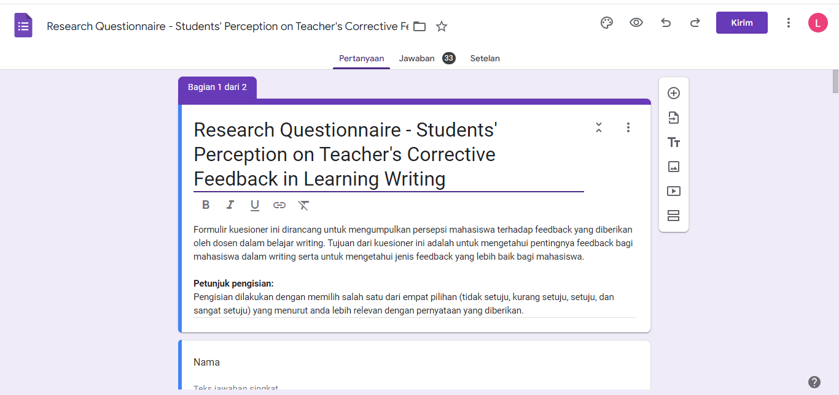

Link:
https://docs.google.com/forms/d/e/1FAIpQLSdxeIz1ldknfi8Vwts71KlxmGJ3UVdLzB4NJH6xp76ChOGOSQ/viewform?usp=sf_link

QUESTIONNAIRE
Instrument: Likert Scale Questionnaire
Total: 21 statements
- THE IMPORTANCE OF FEEDBACK
Petunjuk Pengisian:
Pengisian dilakukan dengan cara memilih salah satu dari empat pilihan (tidak setuju, kurang setuju, setuju, sangat setuju).

CATEGORY: MOTIVATE LEARNERS
No | Pernyataan | Tidak setuju | Kurang setuju | Setuju | Sangat setuju
1 | Pemberian feedback dari dosen dapat meningkatkan motivasi mahasiswa untuk memperbaiki kesalahan dalam writing sesuai feedback yang diberikan.
2 | Pemberian feedback dari dosen dapat meningkatkan antusiasme mahasiswa dalam berinteraksi di pembelajaran di kelas writing.
3 | Feedback yang diberikan dalam pembelajaran writing dapat meningkatkan motivasi mahasiswa untuk belajar serta menggali lebih dalam informasi atau materi yang diperlukan.
CATEGORY: IMPROVE WRITING FLUENCY, ACCURACY, AND COMPLEXITY
No | Pernyataan | Tidak setuju | Kurang setuju | Setuju | Sangat setuju
1 | Pemberian feedback dari dosen dalam belajar writing dapat membantu mahasiswa mengkoreksi error/kesalahan penulisan seperti kesalahan dalam grammar serta struktur kalimat dan paragraph.
2 | Feedback yang diberikan oleh dosen dalam writing dapat meningkatkan keakuratan grammar serta kelancaran penulisan mahasiswa.
3 | Feedback yang diberikan oleh dosen dalam writing dapat meningkatkan kemampuan writing secara keseluruhan.
4 | Feedback yang diberikan oleh dosen dapat membantu mahasiswa menjadi lebih berhati-hati dan menghindari kesalahan dalam menulis.
CATEGORY: DEVELOP STUDENTS’ AUTONOMY
No | Pernyataan | Tidak setuju | Kurang setuju | Setuju | Sangat setuju
1 | Pemberian feedback pada tugas writing dapat meningkatkan kemandirian mahasiswa, seperti bertanggung jawab pada pekerjaan dan pengambilan keputusan.
2 | Pemberian feedback pada tugas writing dapat meningkatkan kemandirian mahasiswa dalam merencanakan serta mengevaluasi aktivitas pembelajaran writing.

- DIRECT FEEDBACK OR INDIRECT FEEDBACK
Petunjuk pengisian:
- Bacalah penjelasan terlebih dahulu untuk memahami pertanyaan-pertanyaan yang diberikan.
- Pengisian dilakukan dengan memilih salah satu dari dua jenis feedback yang menurut anda lebih relevan dengan pertanyaan yang diberikan.
Penjelasan:
Menurut Hosseiny (2014), terdapat dua jenis written corrective feedback (umpan balik korektif tertulis) yaitu direct feedback (umpan balik secara langsung) dan indirect feedback (umpan balik secara tidak langsung).
- Direct feedback adalah jenis feedback dimana dosen memberitahu kesalahan yang dibuat dalam writing serta mencantumkan jawaban yang benar.
Contoh:
“My father read the newspaper.” (Feedback: harusnya “reads”)
(Saat memberi feedback, dosen memberitahu bahwa terdapat kesalahan grammar lalu memberitahu struktur grammar yang benar.)
- Indirect feedback adalah jenis feedback dimana Dosen memberitahu kesalahan yang dibuat dalam writing tanpa mencantumkan jawaban yang benar (membiarkan siswa mencari jawaban yang benar secara mandiri.)
Contoh:
“My father read the newspaper.”
(Saat memberi feedback, dosen hanya melingkari, menggaris bawahi, atau memberi kode bahwa terdapat kesalahan dalam penulisan tanpa mencantumkan jawaban yang benar.)

No | Pertanyaan | Direct feedback (Dosen memberitahu kesalahan yang dibuat dalam writing serta mencantumkan jawaban yang benar.) | Indirect feedback (Dosen memberitahu kesalahan yang dibuat dalam writing tanpa mencantumkan jawaban yang benar (membiarkan siswa mencari jawaban yang benar secara mandiri))
1 | Saat menerima feedback dalam writing, jenis feedback mana yang sering anda terima?
2 | Secara umum, jenis feedback mana yang lebih anda sukai?
CATEGORY: SPECIFIC
1 | Menurut anda, feedback jenis mana yang lebih detail?
2 | Menurut anda, feedback jenis mana yang lebih mudah dimengerti dan tidak menimbulkan kebingungan?
CATEGORY: APPROPRIATELY CHALLENGING
1 | Menurut anda, feedback yang mana yang bisa lebih memfokuskan pada hal-hal yang perlu ditingkatkan dalam writing.
2 | Menurut anda, untuk meningkatkan kemampuan writing, cara mana yang lebih efektif?
3 | Menurut anda, jenis feedback mana yang dapat memicu mahasiswa untuk mencapai kemajuan dalam belajar writing?
CATEGORY: ACTIVE INVOLVEMENT
1 | Menurut anda, feedback jenis mana yang lebih memfokuskan keterlibatan mahasiswa dalam pengerjaannya?
2 | Menurut anda, feedback jenis mana yang bisa memberi dukungan serta kebebasan pada mahasiswa untuk menentukan hasil akhir pekerjaan secara mandiri?
3 | Menurut anda, cara mana yang lebih efektif untuk meningkatkan kedisiplinan dan kemandiririan mahasiswa dalam belajar writing?
CATEGORY: COMBINATION OF POSITIVE AND NEGATIVE
1 | Menurut anda, feedback mana yang lebih memungkinkan dosen untuk memberikan kritik terhadap kesalahan dalam tulisan mahasiswa?
2 | Menurut anda, feedback mana yang lebih memungkinkan dosen untuk memberikan apresiasi terhadap pencapaian dalam tulisan mahasiswa?

QUESTIONNAIRE RESULTS
- THE IMPORTANCE OF FEEDBACK

- THE BEST CORRECTIVE FEEDBACK

SAMPLE OF DIRECT FEEDBACK
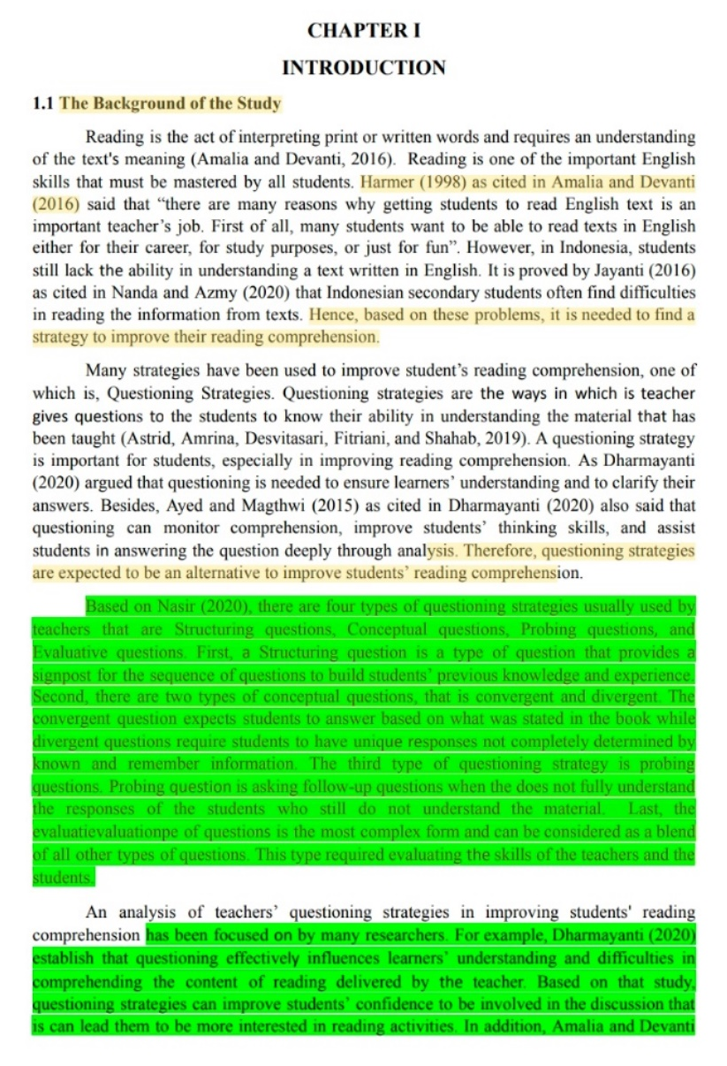
In the following feedback example, the lecturer marks the mistakes made by student by highlighting them in yellow. In the last section, the lecturer gives the explanation of the mistakes the students have made.

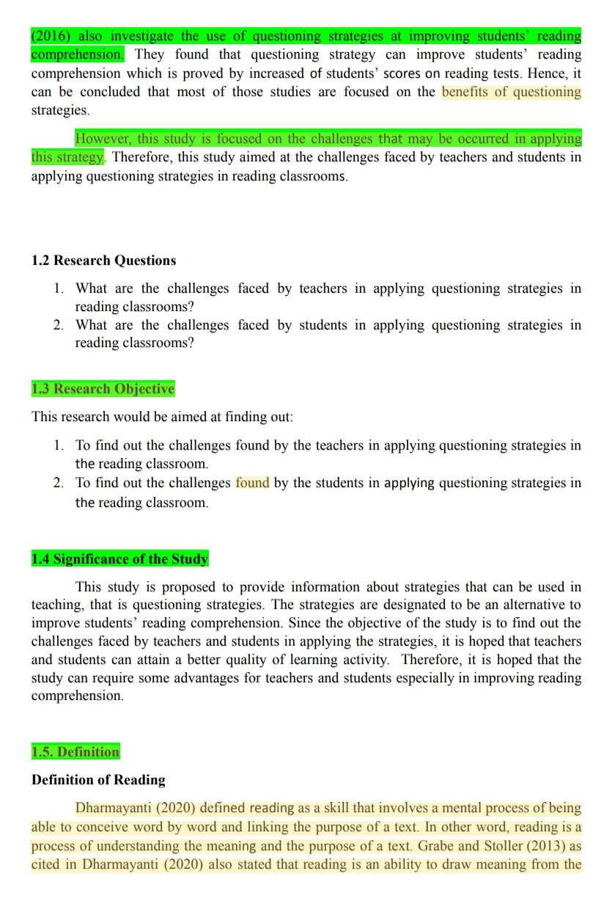
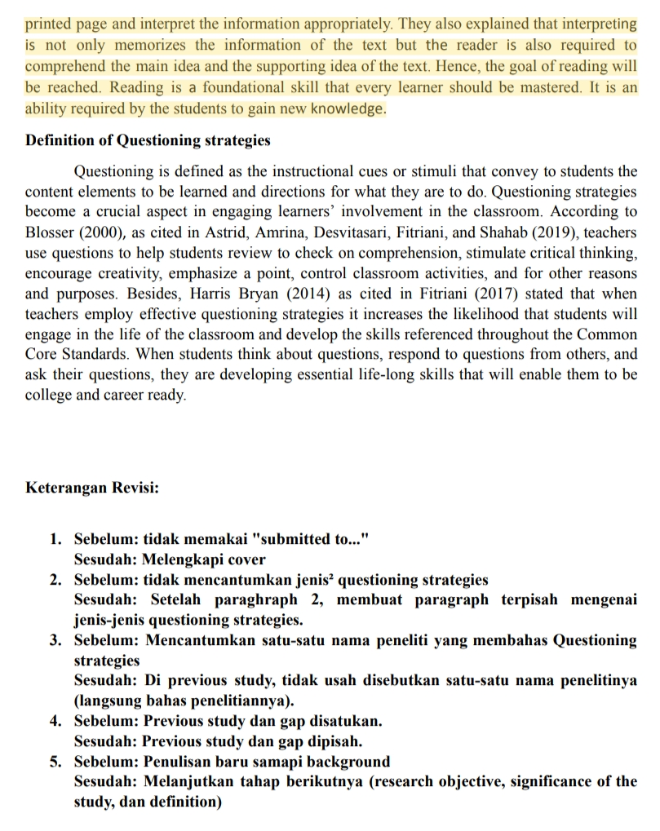
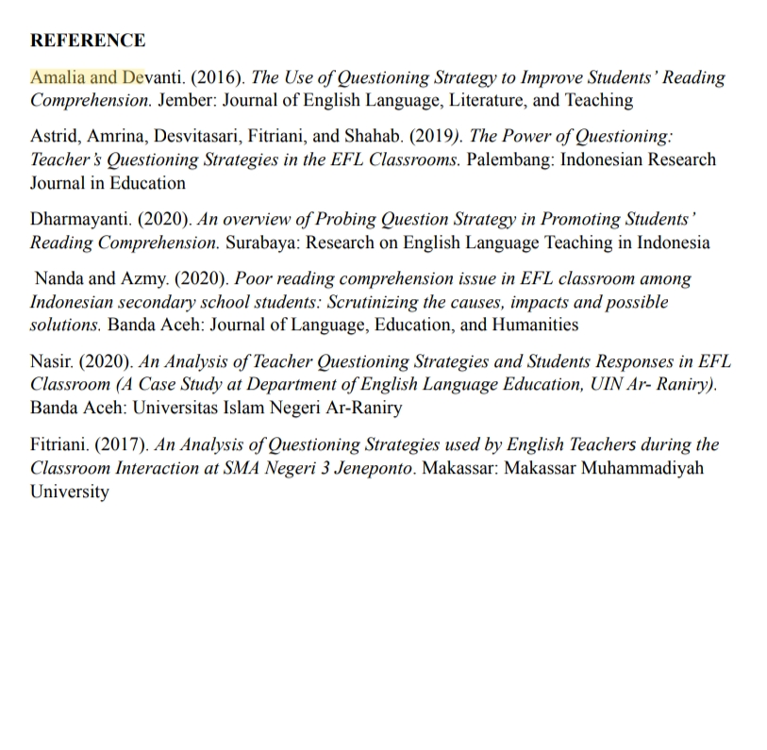
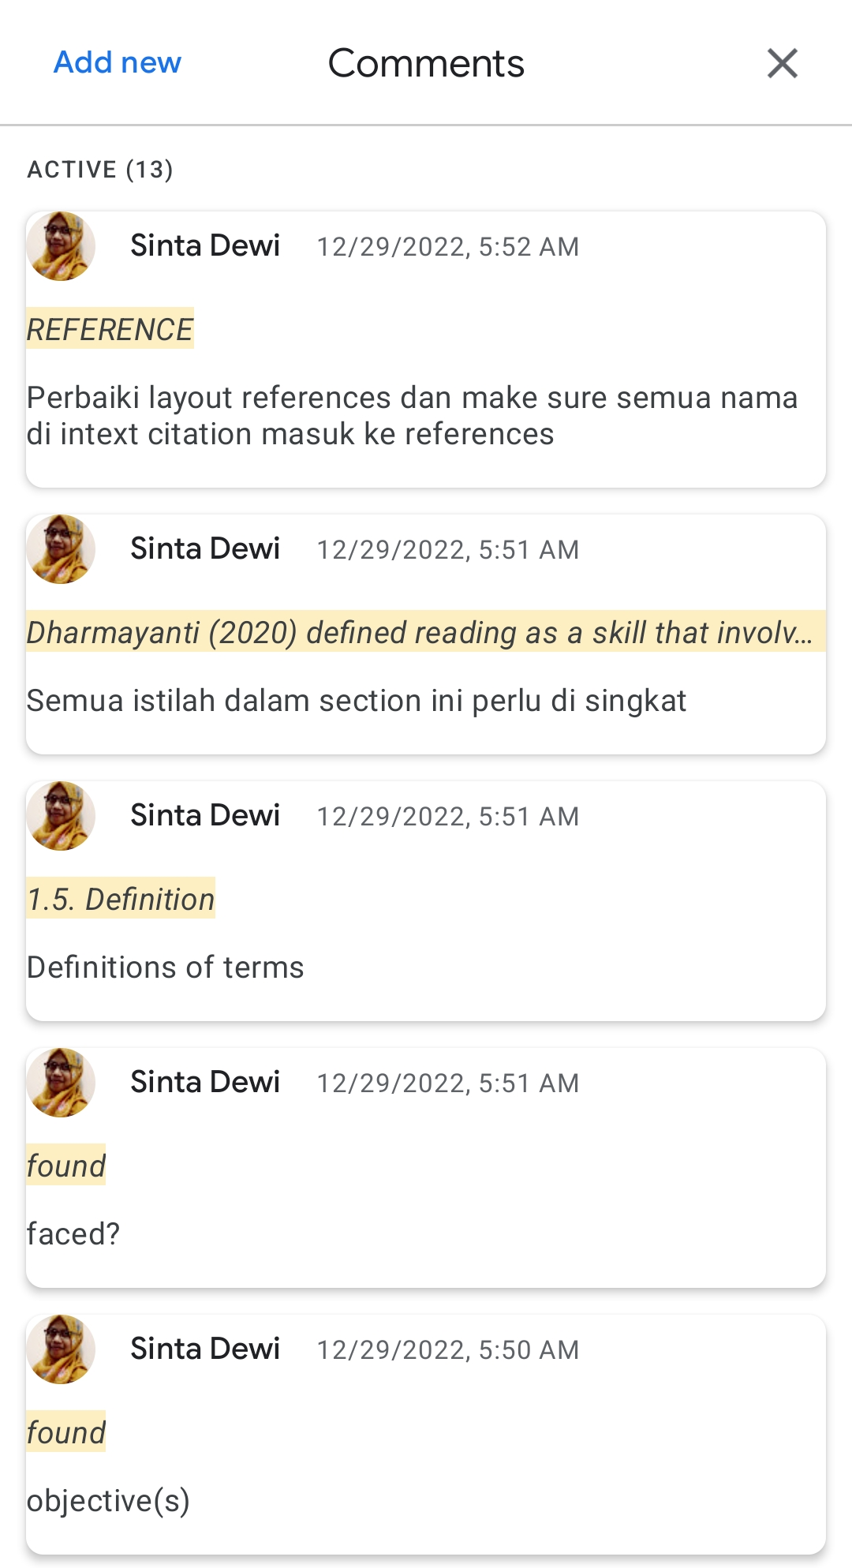
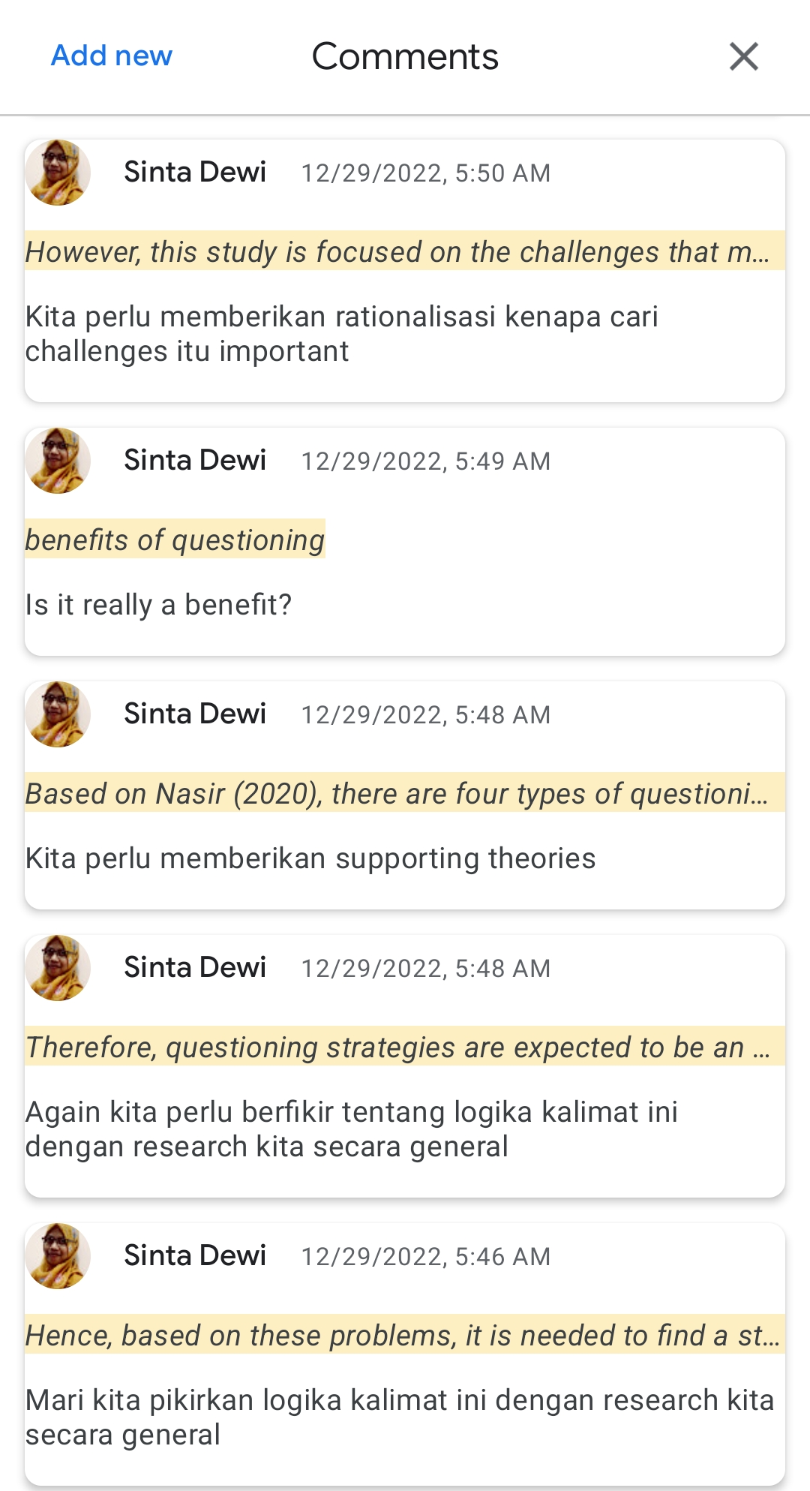


SAMPLE OF INDIRECT FEEDBACK
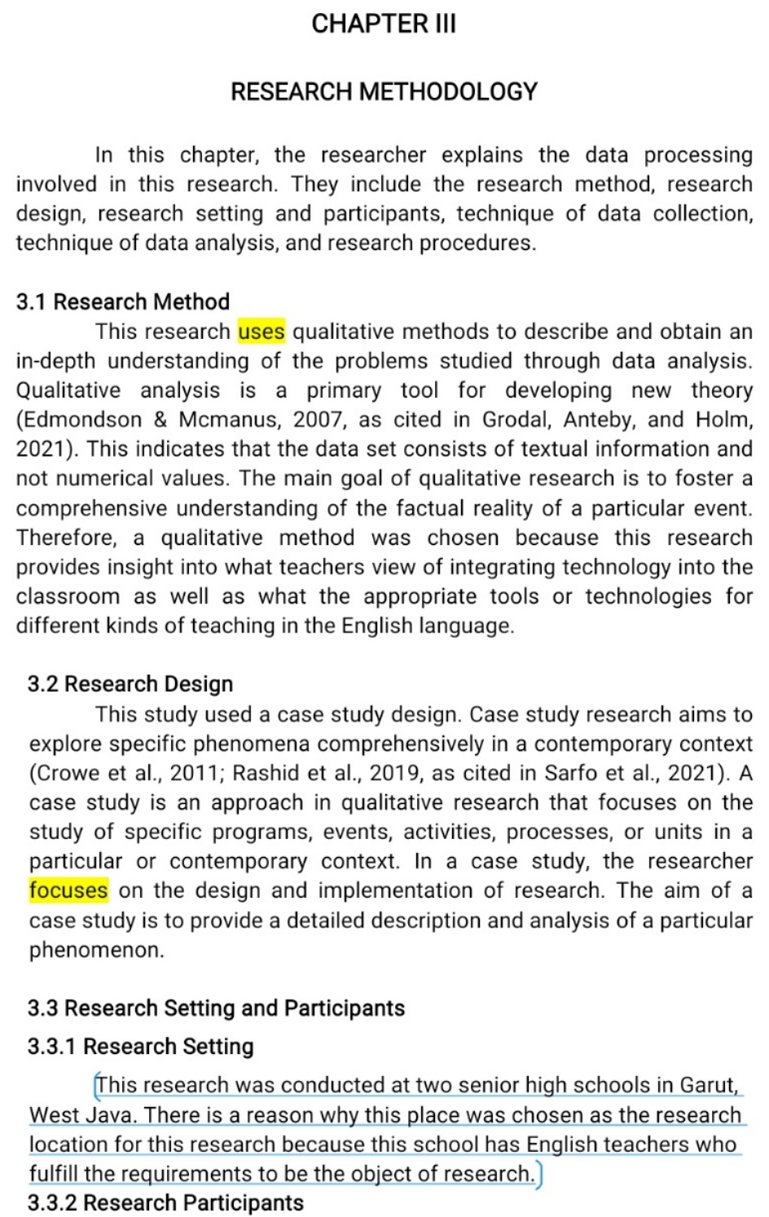
In the following feedback example, the lecturer marks the mistakes made by student by highlighting them in yellow. In this feedback type, the lecturer only marks the mistakes made by the students without providing any explanation.
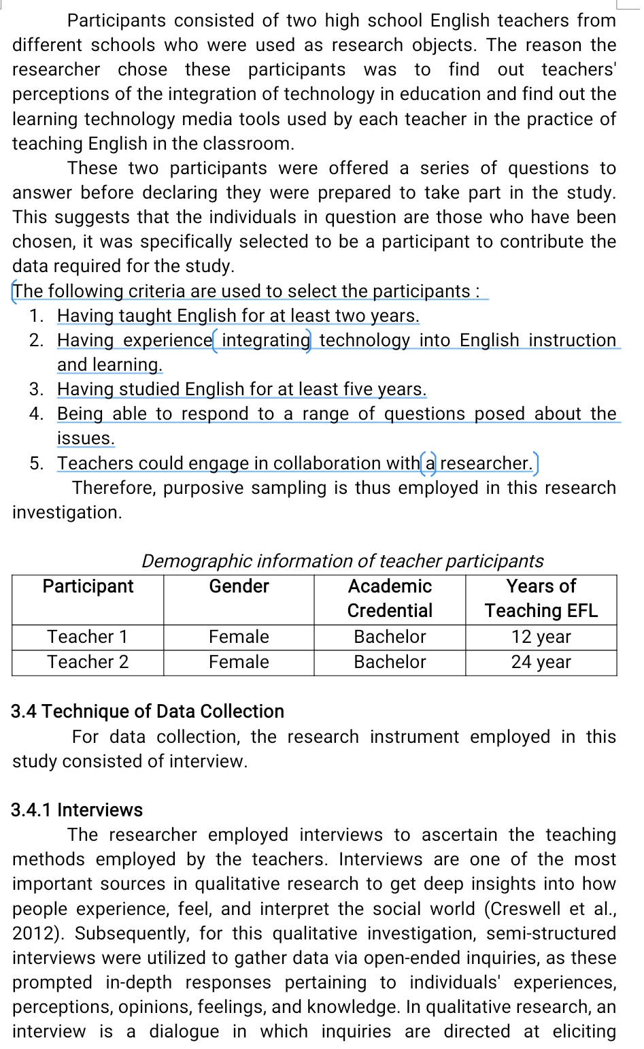
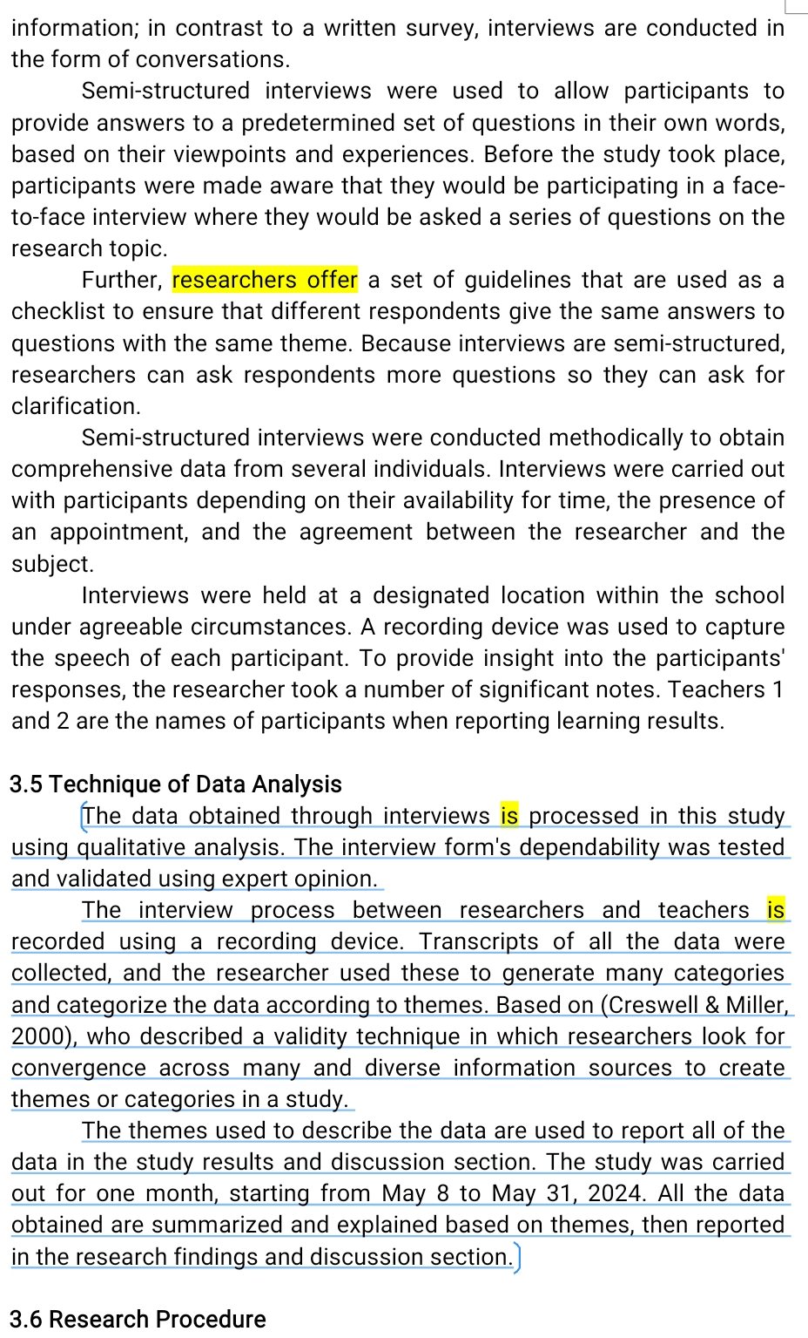
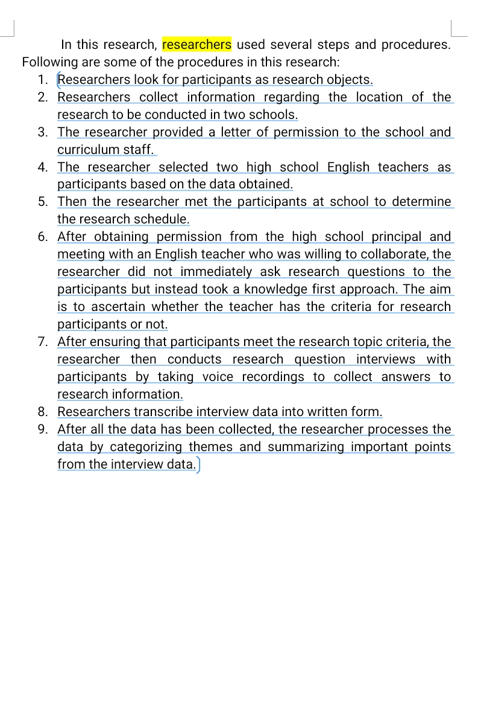

INSTRUMENT VALIDATION REQUEST LETTER
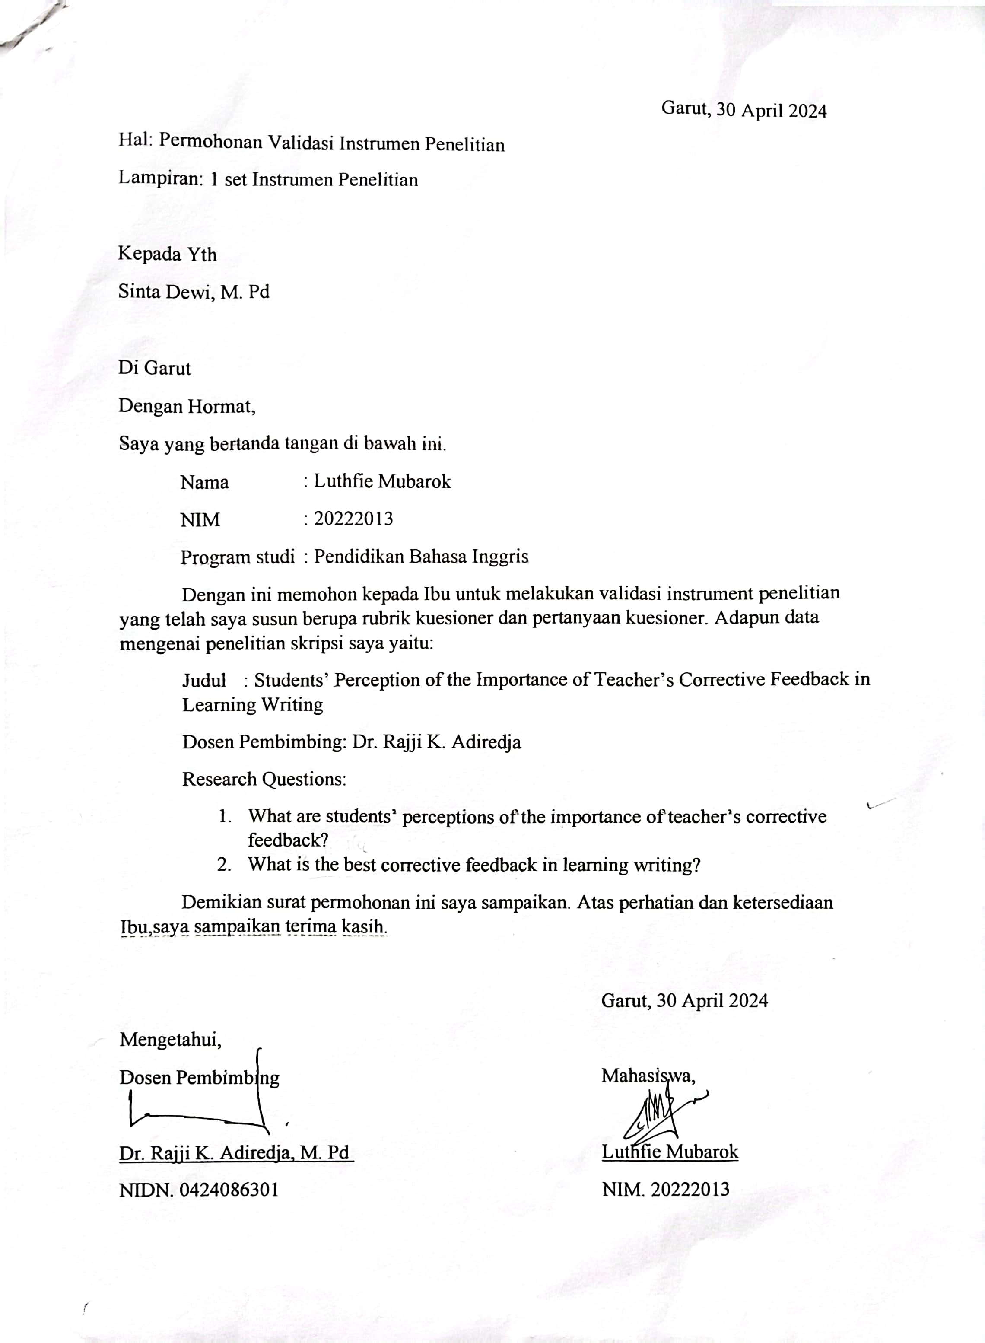

EXPERT JUDGEMENT SHEET

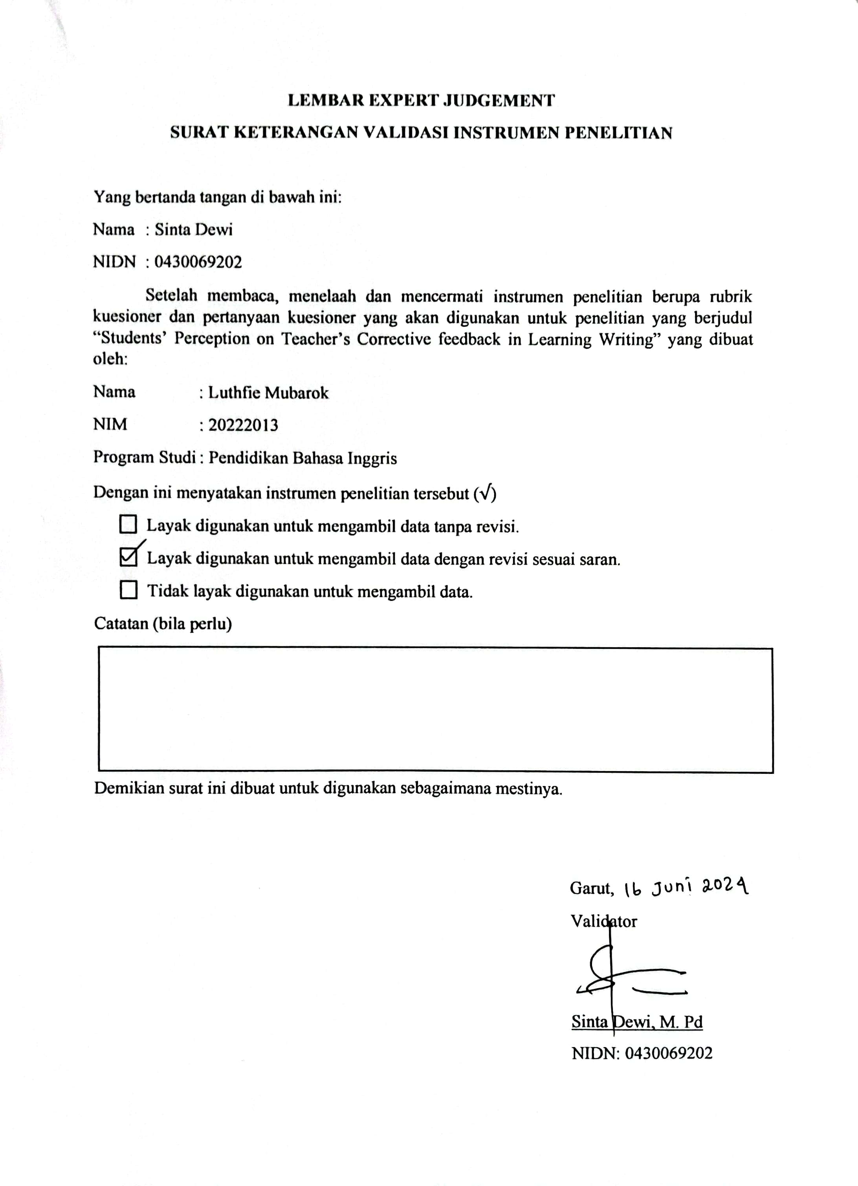

RESEARCH PERMIT LETTER

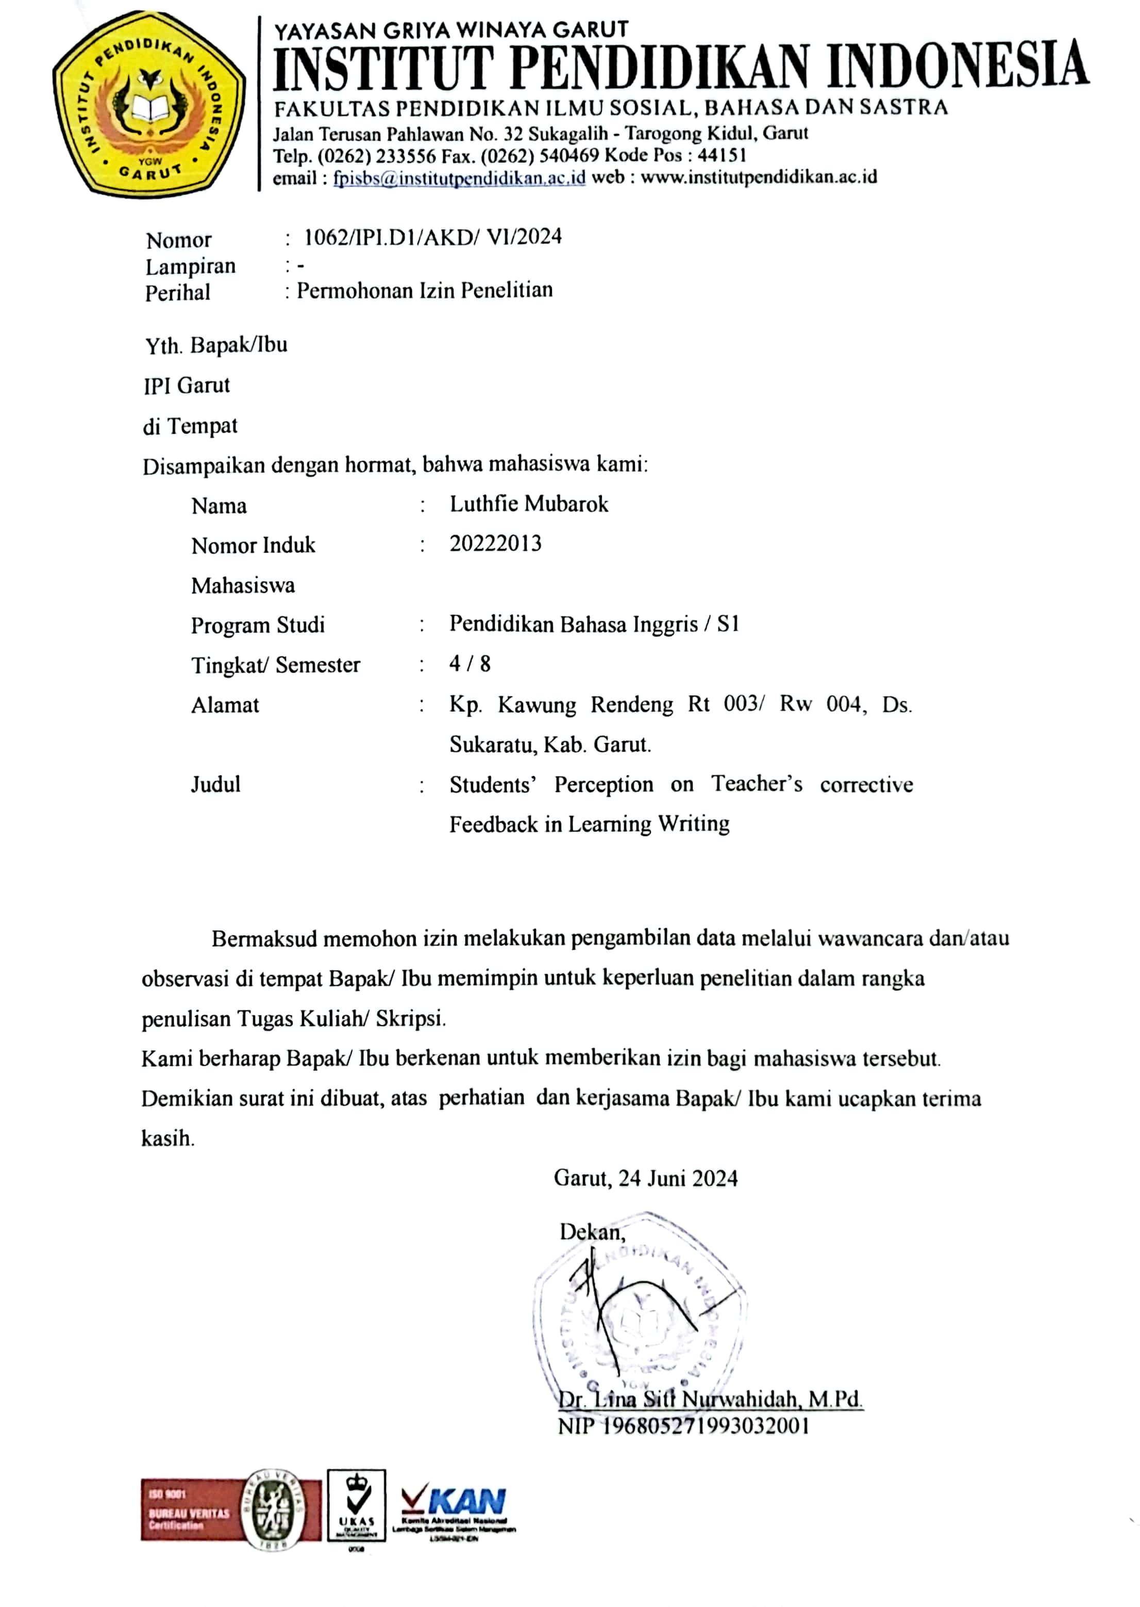

TURNITIN CHECK RESULTS
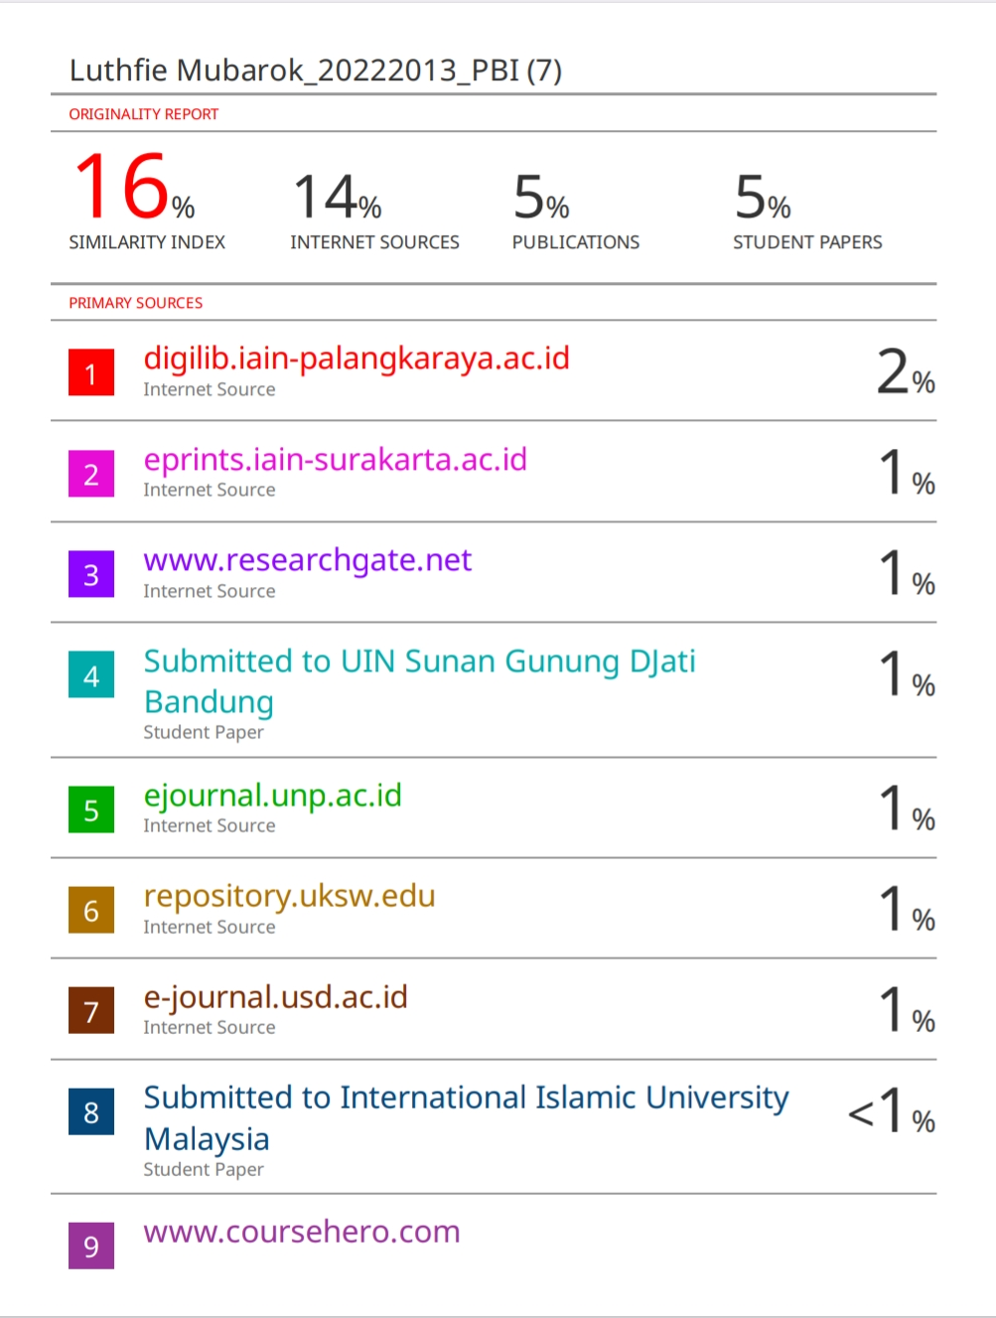

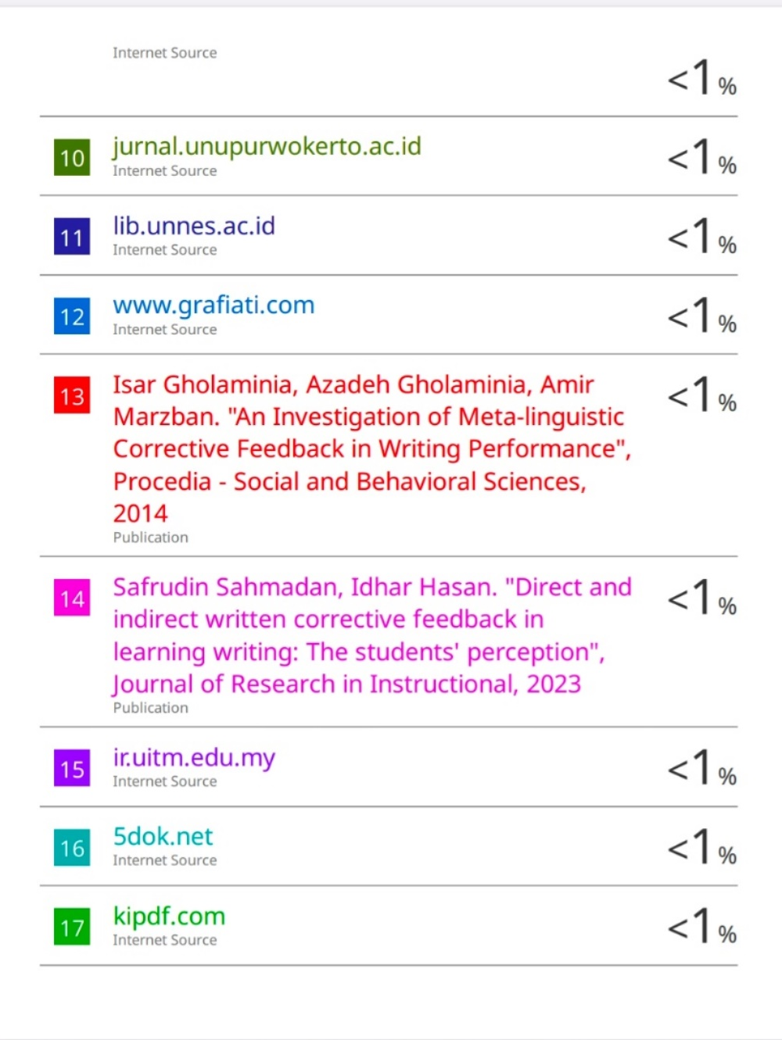

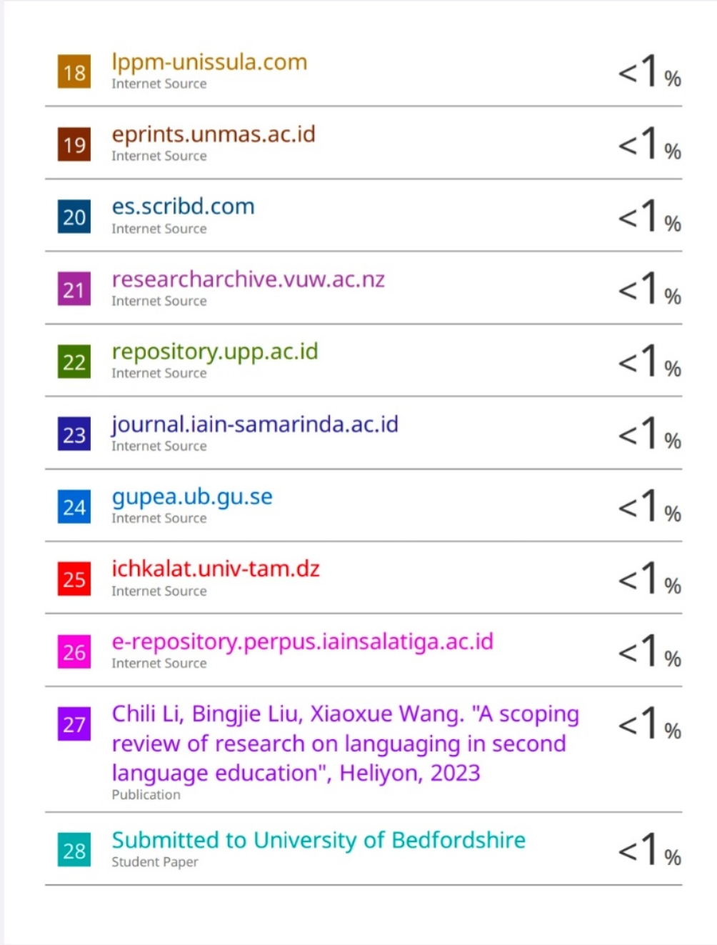

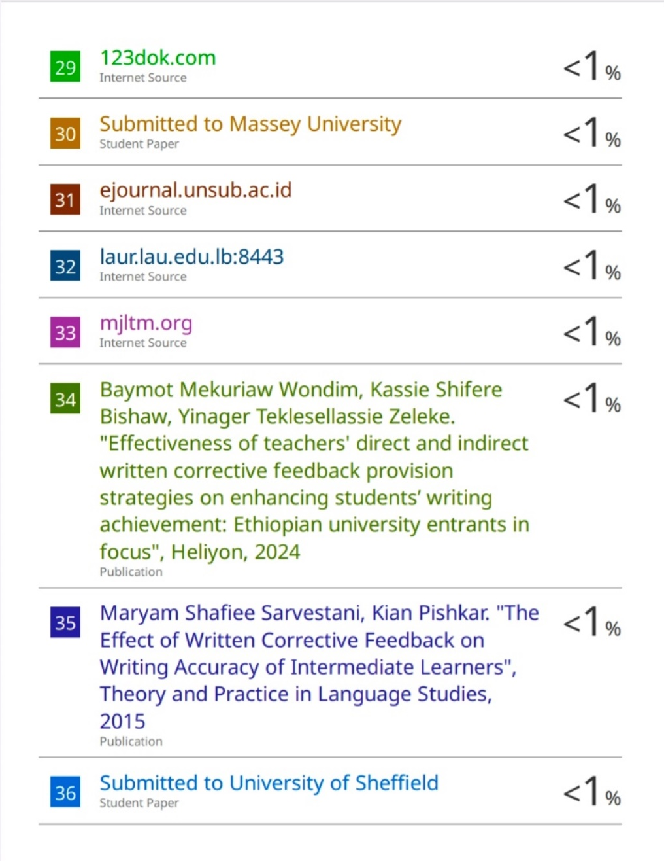

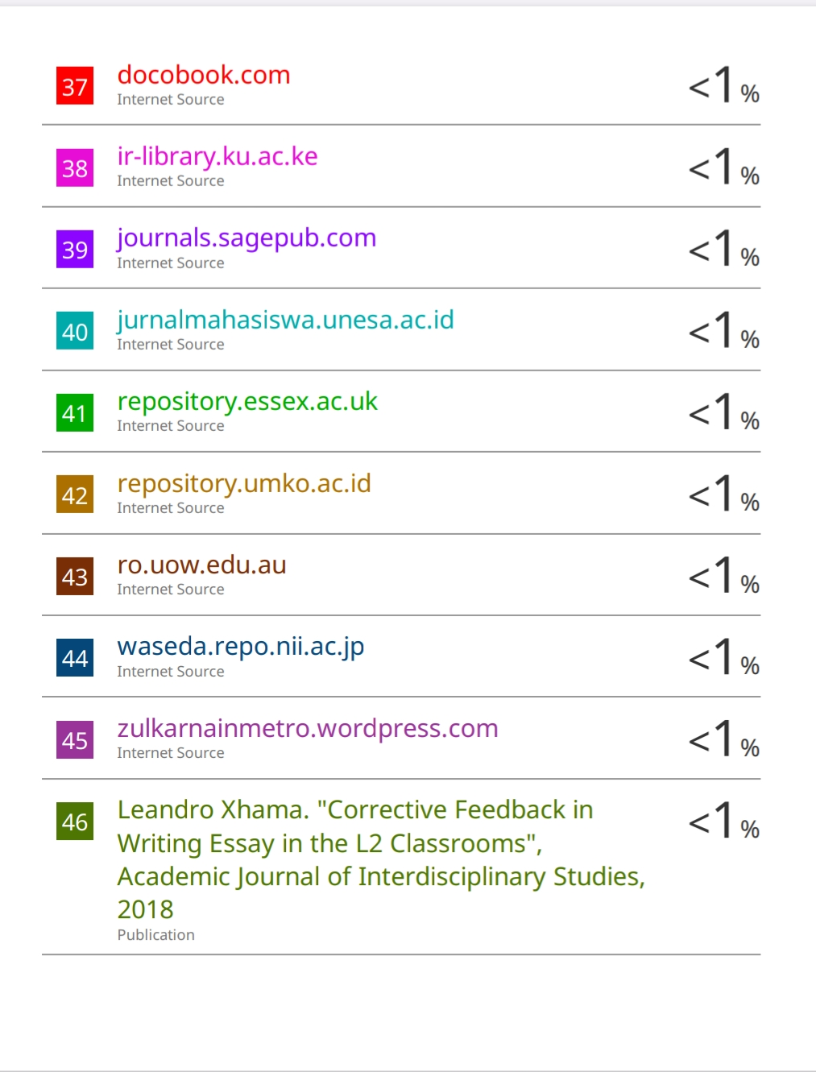
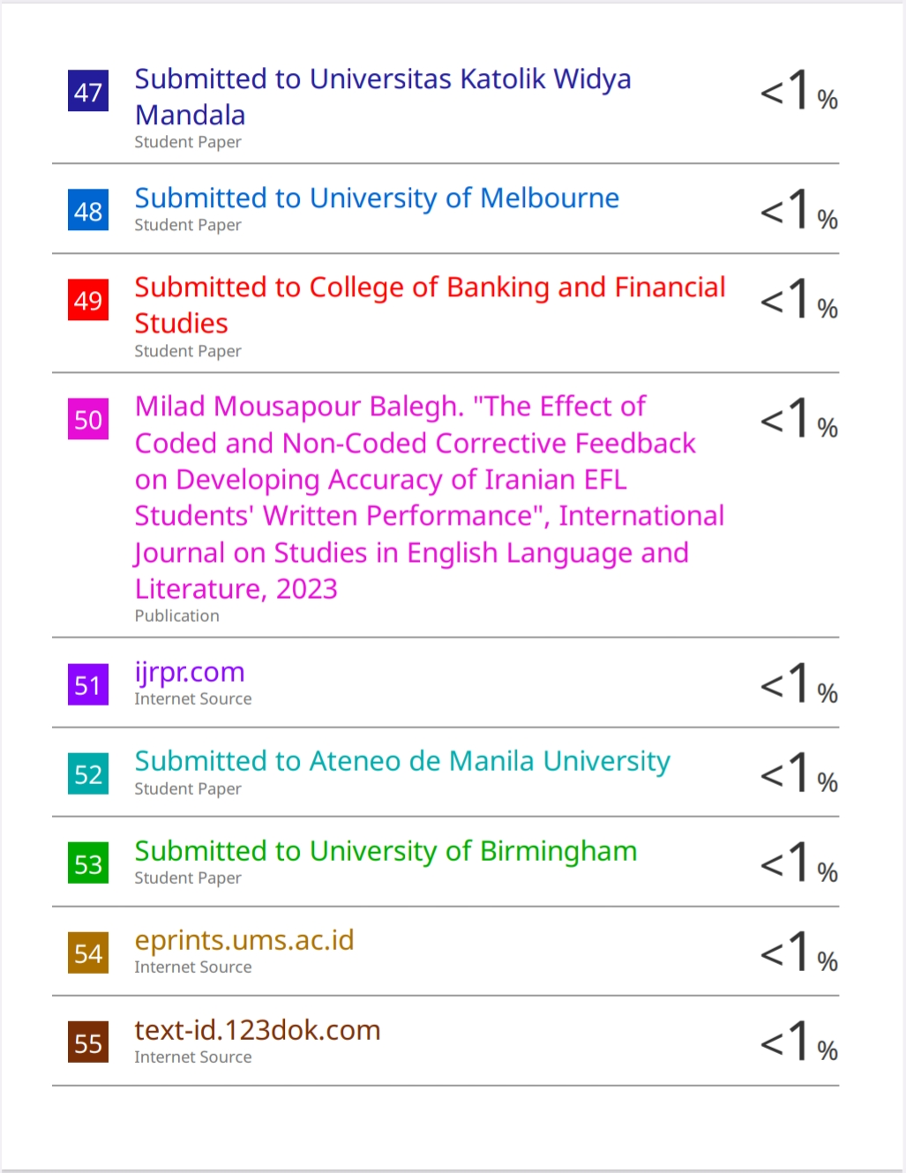

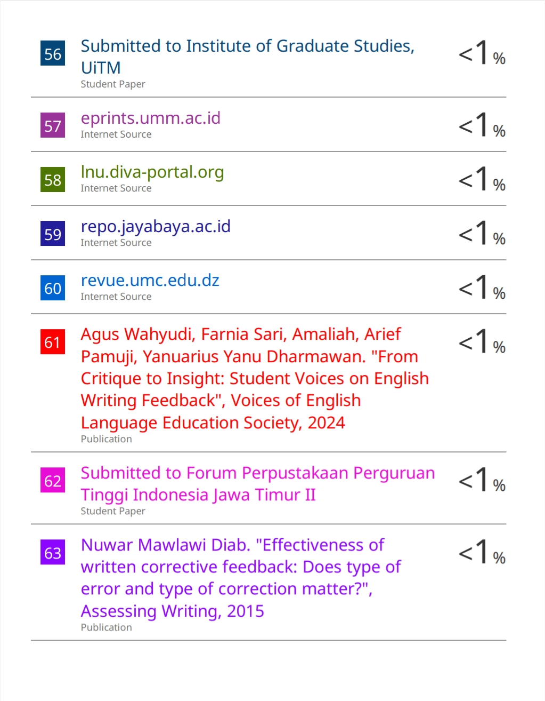

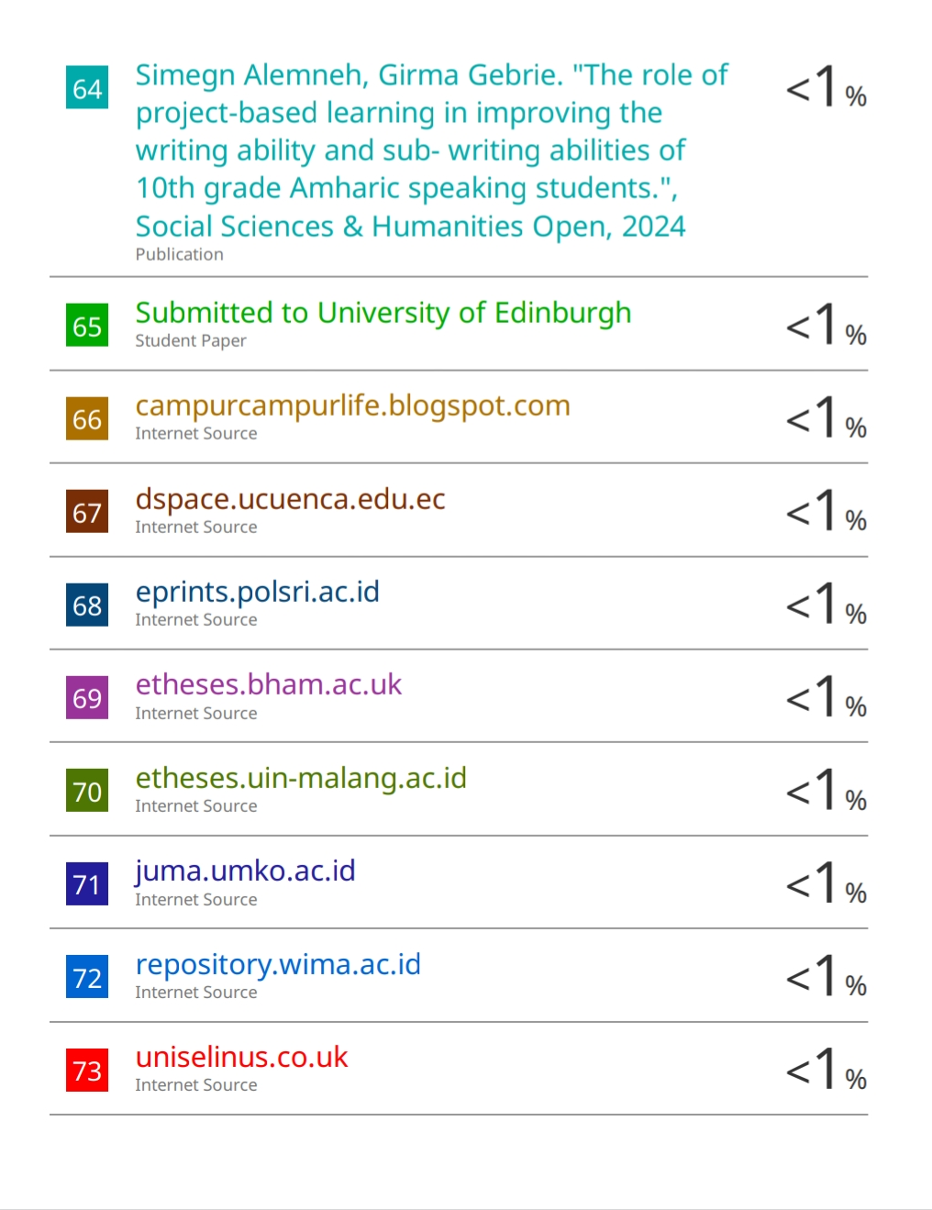
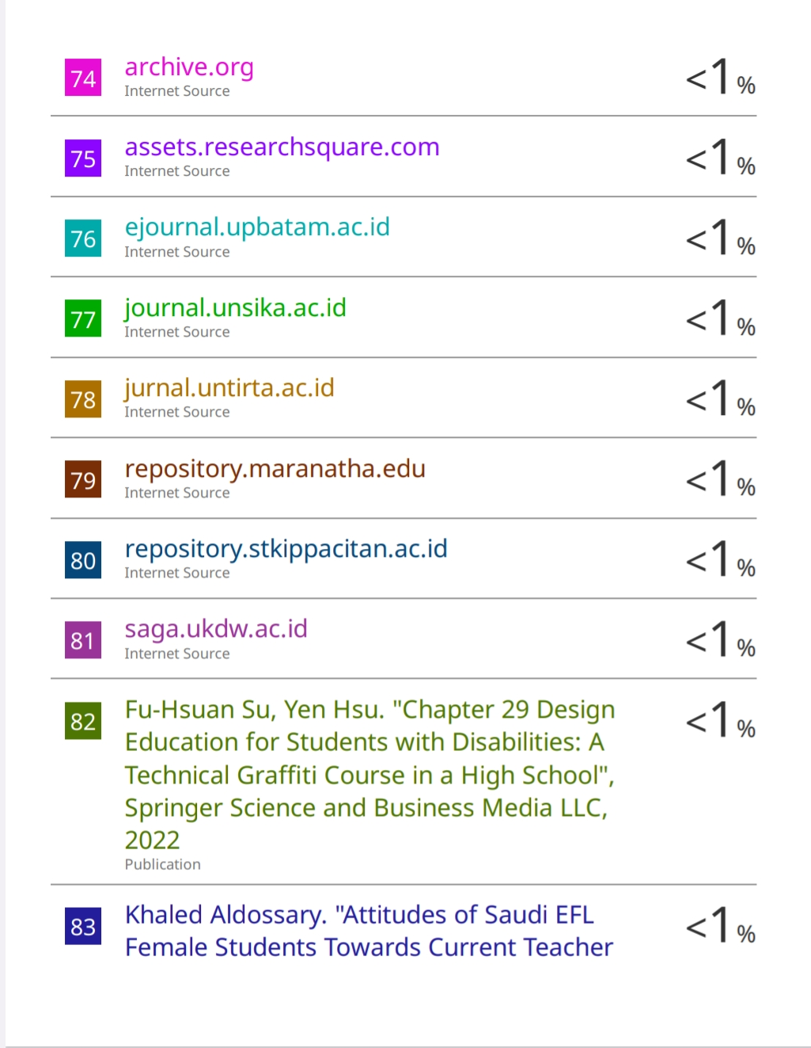
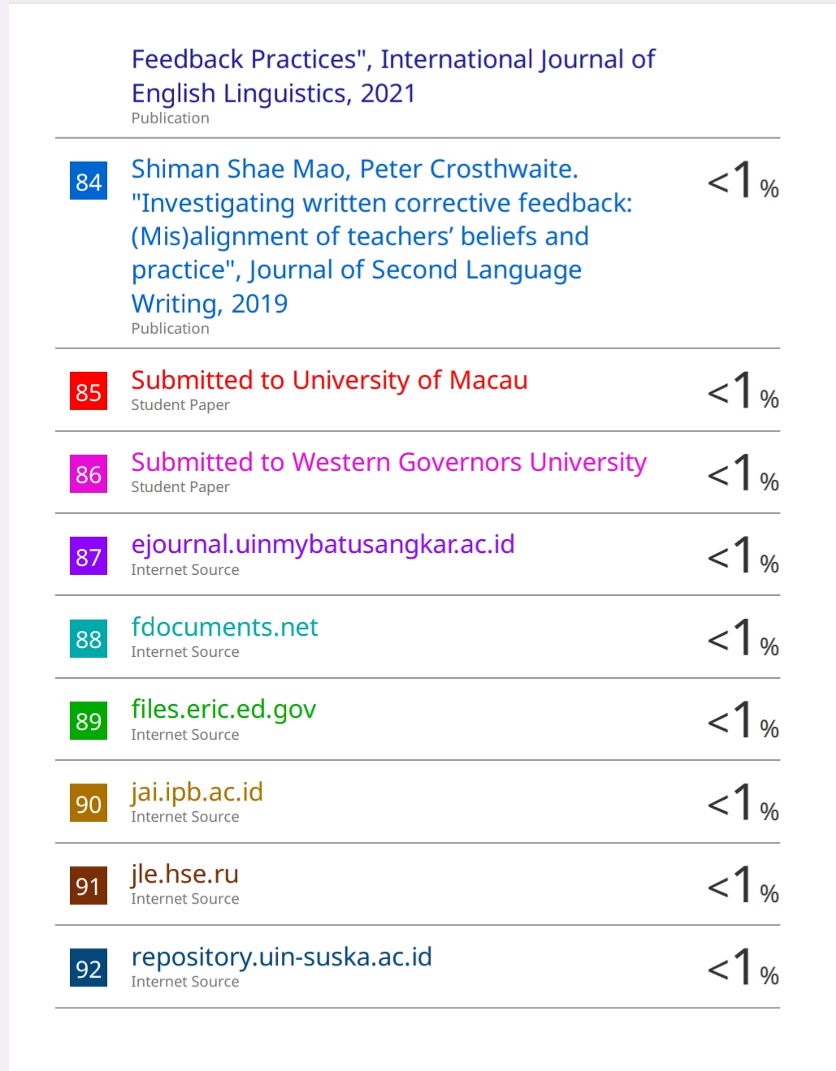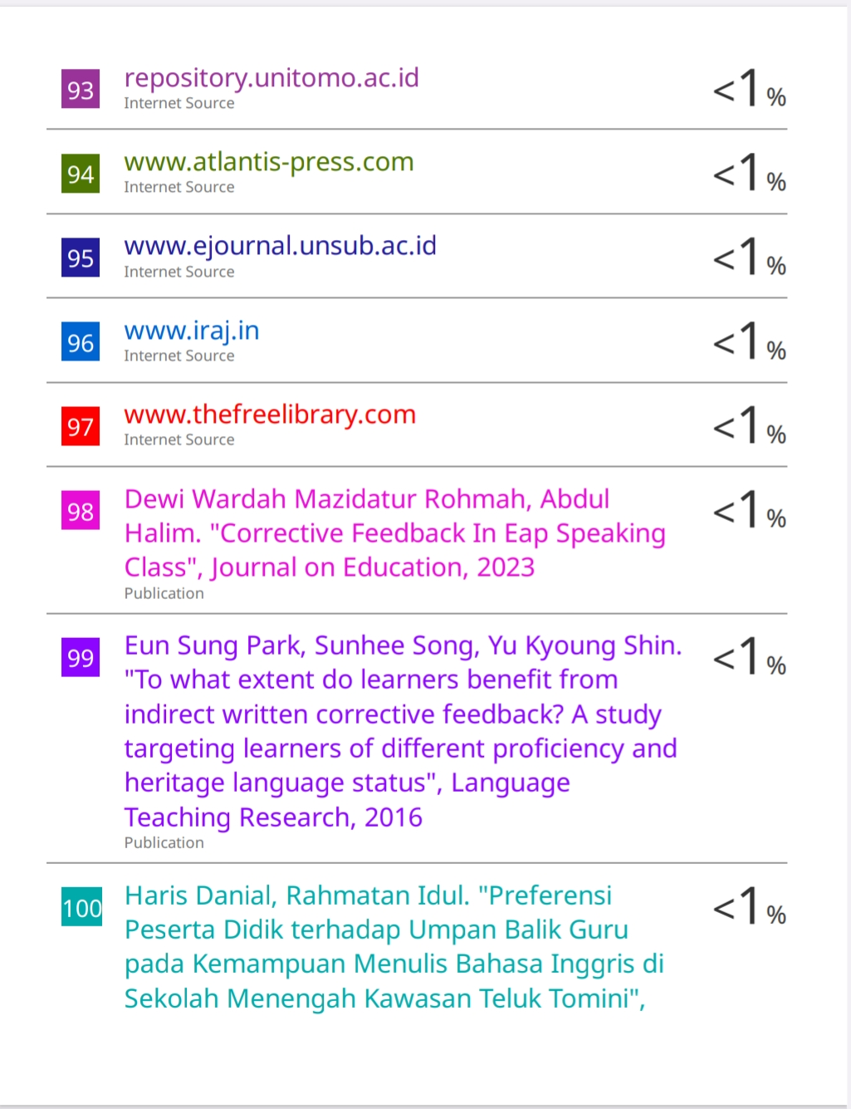

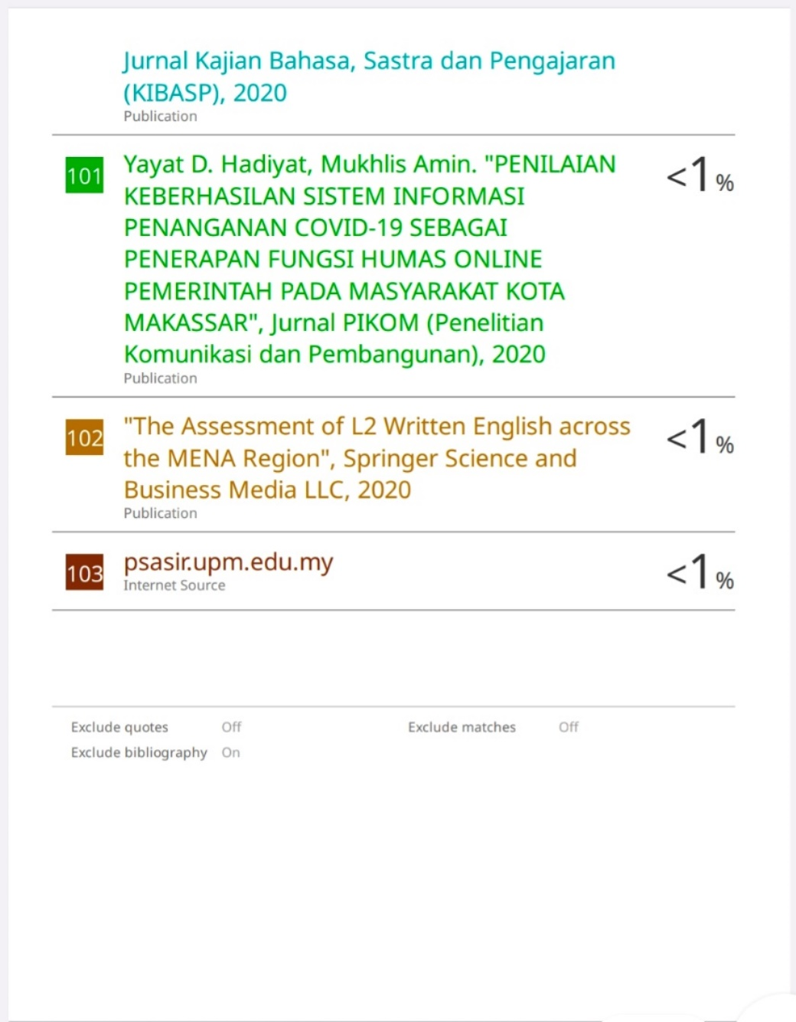

CURRICULUM VITAE
