ENGLISH TEACHERS’ PERCEPTION OF MERDEKA CURRICULUM AT JUNIOR HIGH SCHOOL

A Paper
Submitted to the English Education Program of IPI Garut as a Partial Fulfillment of the Requirements for the Sarjana Pendidikan Degree
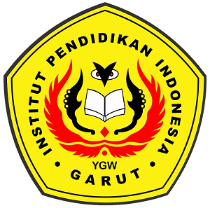

Written by:
Lestaringgi Alya Mahayapada
20222015

ENGLISH EDUCATION PROGRAM
FACULTY OF SOCIAL STUDIES, LANGUAGE, AND LITERATURE
INDONESIA INSTITUTE OF EDUCATION
2024

APPROVAL SHEET

ENGLISH TEACHERS’ PERCEPTION OF MERDEKA CURRICULUM AT JUNIOR HIGH SCHOOL

By:
Lestaringgi Alya Mahayapada
NIM. 20222015

Approved by:
First Supervisor, Second Supervisor,

H. Surtiana H, Drs., M.A. Jumli Alam Mapgun, M.Pd., M.Hum.
NIDN. 0010075102 NIDN. 0908017104

Acknowledged by:
Head of English Education Program

Anne Ratna Suminar, M.Pd.
NIDN. 0415038601

LEGITIMATION OF EXAMINATION BOARD

ENGLISH TEACHERS’ PERCEPTION OF MERDEKA CURRICULUM AT JUNIOR HIGH SCHOOL

By:
Lestaringgi Alya Mahayapada
NIM 20222015

This paper has been examined on July 1st 2024

First examiner, Second examiner, Third examiner,

Dr. Setia Muljanto, S.E., M.Pd. Wahid Hasyim, M.Pd. Sinta Dewi, M.Pd.
NIDN. 0419106705. NIDN. 0428078403. NIDN. 0430069202

Acknowledge by:
Dean of Faculty of Social Science, Language, and Literature Education

Dr. Lina Siti Nurwahidah, M.Pd.
NIP. 196805271993032001

DECLARATION

The researcher declares that this paper entitled 'ENGLISH TEACHERS’ PERCEPTION OF MERDEKA CURRICULUM AT JUNIOR HIGH SCHOOL' is written by the researcher and acknowledged as her intellectual properly. The following references, quotations, and literature citations were conducted using proper, legal, and scientific techniques. Therefore, the content of this paper is the original work of the researcher.

Garut, June 2024
The researcher,

Lestaringgi Alya Mahayapada
NIM. 20222015

PERNYATAAN

Dengan ini peneliti menyatakan bahwa skripsi ini yang berjudul "ENGLISH TEACHERS’ PERCEPTION OF MERDEKA CURRICULUM AT JUNIOR HIGH SCHOOL" merupakan karya peneliti berdasarkan pengetahuannya sendiri. Penggunaan referensi, kutipan, dan pengutipan dari sumber lain telah peneliti lakukan berdasarkan prosedur yang benar, legal, dan ilmiah. Oleh karena itu, isi skripsi ini merupakan karya asli peneliti

Garut, Juni 2024
The researcher,

Lestaringgi Alya Mahayapada
NIM. 20222015

PREFACE

All praise be to Allah SWT, the Most Gracious and the Most Merciful. Who has been giving me the blessing to complete this research paper. Then, may Allah SWT bless our prophet Muhammad saw, peace be upon him and his family, friends, and his forever followers. With blessing of Allah, the researcher has completed this paper entitled "ENGLISH TEACHERS’ PERCEPTION OF MERDEKA CURRICULUM AT JUNIOR HIGH SCHOOL". This paper essentially discusses English Teachers' perceptions regarding the challenges in implementing the Independent Curriculum. The purpose of writing this paper is to fulfill a requirement for the Sarjana Pendidikan Degree at IPI Garut.
The researcher hopes this paper will be helpful to others, especially the researcher herself. However, the researcher realizes that this paper is still far from perfect. Thus, corrections and suggestions are greatly appreciated, either in content or linguistic aspects.

The researcher,

ACKNOWLEDGMENT

First of all, In the name of Allah, who is most gracious and merciful, sholawat to the messenger of Allah, Prophet Muhammad SAW. Alhamdulillah, all praise belongs to Allah SWT. Finally, after all of the hard work, the researcher could finish the report in the form of paper entitled "ENGLISH TEACHERS’ PERCEPTION OF MERDEKA CURRICULUM AT JUNIOR HIGH SCHOOL” is a partial requirement for graduating from the English Education Program at Institut Pendidikan Indonesia (IPI) Garut.
The Researcher fully believed that success would not be achieved without many people's help, support, motivation, and encouragement while searching for the topic and writing the research paper. Therefore, I would like to thank:
- Dr. H. Nizar Alam Hamdani, M.M., M.T., M.Si., M.Kom., as Rector of Institut Pendidikan Indonesia (IPI) Garut,
- Dr. Hj. Lina Nurwahidah, M.Pd., as Dean of Faculty of Social Science, Language and Literature Education of Institut Pendidikan Indonesia,
- Anne Ratna Suminar, M.Pd., as the head of English Education Program in Institut Pendidikan Indonesia (IPI) Garut,
- H. Sutrtiana Hardjadidjaja, Drs., M.A., as the first supervisor in completing this thesis,
- Jumli Alam Mapgun, M.Pd., M.Hum., as the second supervisor in completing this thesis,
- My bloved mother (Yanti Sukmayanti), I love her so much, she played an important role in completing this thesis. Thank you very much for the prayers, support, and motivation that she always gave,
- My bloved father (Alm Sudarwan), my beloved person. Althrough he could not accompany to complete this thesis but thank him very much. The researcher would like to express his infinite gratitude and this article was written with great longing for him,
- My beloved siblings (Dirgan, Jiwa, Lanara, and Tasyaura) thank you for the help and support thay they have given every day,
- My beloved nieces (Ares Dzulfi and Putri Aameera) thank you for making laughter and spreading love and affection in the family,
- My grandmothers and almarhum grandfathers, my uncles and aunts, thank you for all your guidance and motivation,
- My special friends (Putri Nirwana, Vera Agustin, and Nisi Bunga), thank you for helping, supporting, and motivating. Thank you also for the laughter you give,I hope your warm smile will always be a good deed and may you always be protected by Allah SWT, I wish you all success,
- My all Class B (English Bee), thank you for the happiness and support you always give,
- My friends (Salma, Rosi, Marisa, Rena, Gita, Helen, Syifa), thank you for all support,
- All lecturers, thank you for your knowledge and experience,
- For my bf (Rio), thank you for your support and time,
- Lastly, to my self, thank you for fighting very far and trying hard. Those who are able to rise from feeling lazy and not take their thesis lightly, this is an achievement to be proud of.

The researcher,

ABSTRACT

This research purposes to find out the teachers perceptions regarding the experiences when implementation the Merdeka Curriculum at Junior High School. This research used qualitative research by conducting interviews to obtain in-depth information and observation. The participants in this research were two seventh-grade teachers. The results of this research indicated that the perception of the two English teachers towards the Merdeka Curriculum at SMP Negeri in Garut is in the fairly good category. With this Merdeka Curriculum, students are more active and enthusiastic and they can develop their natural interests and talents. In addition, teachers also face several obstacles or challenges, namely designing learning methods and media, as well as significant differences in students' ability to speak English and there are still students who are technologically illiterate.
Keyword: Merdeka Curriculum, English Teachers, Perception

ABSTRAK

Penelitian ini bertujuan untuk mengetahui persepsi guru mengenai pengalaman penerapan Kurikulum Merdeka di SMP. Penelitian ini menggunakan penelitian kualitatif dengan melakukan wawancara untuk memperoleh informasi mendalam dan observasi. Partisipan dalam penelitian ini adalah dua orang guru kelas 7. Hasil dari penelitian ini menunjukkan bahwa persepsi kedua guru bahasa Inggris terhadap Kurikulum Merdeka di SMP Negeri Garut berada pada kategori cukup baik. Dengan adanya Kurikulum Merdeka ini, siswa menjadi lebih aktif dan bersemangat serta dapat mengembangkan minat dan bakat alamiahnya. Selain itu, guru juga menghadapi beberapa kendala atau tantangan yaitu merancang metode dan media pembelajaran, serta perbedaan kemampuan siswa dalam berbahasa Inggris yang signifikan dan masih terdapat siswa yang buta teknologi.
Kata Kunci: Kurikulum Merdeka, Guru Bahasa Inggris, Persepsi

TABLE OF CONTENTS

APPROVAL SHEET i
LEGITIMATION OF EXAMINATION BOARD ii
DECLARATION iii
PERNYATAAN iv
PREFACE v
ACKNOWLEDGMENT vi
ABSTRACT viii
ABSTRAK ix
TABLE OF CONTENTS x
CHAPTER I INTRODUCTION 1
1.1 Background of the Study 1
1.2 Reason for Choosing the Topic 4
1.3 Research Question 4
1.4 Research Objectives 4
1.5 Significance of Study 4
1.6 Definition of Terminologies 5
CHAPTER II LITERATURE REVIEW 6
2.1 The Definition of Perception 6
2.2 The Definition of 2013 Curriculum 7
2.3 Merdeka Curriculum 7
2.3.1 The Definition of Merdeka Curriculum 7
2.3.2 The Principles of Merdeka Curriculum 7
2.3.3 The Purpose of Merdeka Curriculum 8
2.3.4 The Characteristics of Merdeka Curriculum 9
2.3.5 The Program of Implementing the Merdeka Curriculum 10
2.3.6 The Challenges of Merdeka Curriculum 10
2.3.7 Advantages of Merdeka Curriculum 11
2.3.8 Disadvantages of Merdeka Curriculum 12
2.4 Previous Studies 12
CHAPTER III RESEARCH METHODOLOGY 14
3.1 Research Methods 14
3.2 Research Design 14
3.3 Research Setting and Participants 14
3.4 Technique of Data Collection 15
3.5 Technique of Data Analysis 15
3.6 Research Procedure 16
CHAPTER IV FINDINGS AND DISCUSSIONS 17
4.1 Research Findings 17
4.2 Research Discussions 21
CHAPTER V CONCLUSIONS AND SUGGESTIONS 23
5.1 Conclusions 23
5.2 Suggestions 23
REFERENCES 25
APPENDICES 30
Appendix 1 31
Appendix 2 45
Appendix 3 66
CURRICULUM VITAE 71

CHAPTER I INTRODUCTION

In this chapter the researcher will present: Background of the Study, Reason for Choosing the Topic, Research Question, Research Objectives, Significance of the Study, and Definition of Terminologies.

1.1 Background of the Study
The curriculum is a vital tool for educational success. Without a proper curriculum, it will be difficult to attain the required educational goals and objectives (Zebua, 2024). According to Habiburrahim (2021) a curriculum is a collection of rules used to achieve an educational goal, and it consists of at least four important components: objective, material, method, and assessment. Telaumbanua (2024) states that the curriculum is an essential component in implementing the learning process at all levels of school. Another tool for accomplishing educational objectives is the curriculum. Essentially, the curriculum is a set of standards for structuring teaching and learning activities, together with planning and arrangements for learning resources and content (Gulo, 2024). The conclusion is that the curriculum is an important tool used in education.
There are several shortcomings in the 2013 curriculum. A lack of balance between soft and hard skills resulted in the design of a new curriculum, which was believed to increase teachers' performance and students' English language skills (Anaktototy, 2021). Moreover, Rufiandri (2023) states that many teachers are unable to comprehend or are unaware of how to implement learning with the 2013 Curriculum because the guidelines are neither ideal nor effective. Last but not least, a lot of educators engage in Teaching and Learning Activities (KBM) with their pupils without considering or acknowledging the 2013 Curriculum's mission and ideas. Instruction is carried out by teachers in accordance with their preferences; some even partially apply the KTSP Curriculum. Teachers find it extremely challenging to adopt the 2013 Curriculum in their classrooms since it is integrative.
The government produces a fresh breakthrough after realizing the challenges instructors have in implementing the 2013 curriculum. This new curriculum becomes the Merdeka Curriculum by either replacing or optimizing it. The Merdeka Curriculum is an initiative to improve education in Indonesia with the goal of creating a better learning environment (Lestari, Nyoman, 2023). The Curriculum Merdeka is made to be more adjustable and flexible to meet the requirements of individual students, with a stronger focus on student-centered learning and the use of technology (Qamariah, 2023). This curriculum is a varied intracurricular learning programme with better material to give every student the opportunity to hone skills and explore topics (Ndari & Suyatno & Sukirman & Mahmudah, 2023). Kusumawati (2024) states that the Merdeka curriculum is designed to give diverse learning experiences while focusing on vital topics, allowing students to improve their understanding and acquire competency. The Merdeka learning curriculum includes a Pancasila student profile principle that was not present in the previous curriculum (K-13). The Pancasila learning profile comprises six dimensions. Achieve a Pancasila student profile can be accomplished through four learning approaches/activities: intracurricular, extracurricular, school culture, and projects to improve Pancasila profiles. Learning outcomes provide the foundation for intracurricular learning activities.
A number of studies have been identified to examine English teachers perceptions of the Merdeka Curriculum. In this regard, the following are previous studies relating curriculum research: First, research is conducted by Fatma and Ratmanida (2023) under the title “ English Teachers’ Perception toward Merdeka Curriculum at Junior High Schools in Koto Tengah, Padang”. The purpose of this research is to investigate the English teachers’ perception toward the implementation of Merdeka curriculum. This analysis is based on the quantitative analyses analyses were employed in this research using liker scale approach to measure the questionnaire and calculated the average score. The results showed that the majority of the English teachers had a positive or good perception toward the implementation of Merdeka curriculum with average score 3,1. The teachers agree that it is easy to design the teaching module and they feel convenient using the assessment from Merdeka curriculum. Also, the teachers agree that the implementation of differentiated learning Project based learning link with Pancasila profile and can give a good impact to the students.
Second, research by Waruwu Defriani (2024) with the title “English Teachers’ Perception of Merdeka Curriculum Implementation”. This study aims to understand English teachers' opinions on the Merdeka curriculum. This study conducted a qualitative methods with structured data collection through measurement instruments, namely questionnaires. The survey results describe English teachers have diverse views on the learner-centered Merdeka curriculum. While some educators faced challenges due to limited resources and the curriculum's recent introduction, they acknowledged its potential benefits, including student autonomy and joyful learning. They highlighted the importance of infrastructure, facilities, and educators' competency, abilities, and mindset. Despite these challenges, educators saw opportunities for support from parents, curriculum teams, and principals, as well as the effective use of technology in the classroom. Overall, the Merdeka curriculum presents both opportunities for growth and obstacles.
Third, Research by Safitri Intan and Kusumaningtyas Etika (2023) with the title “English Teachers’ Perception on the Implementation of Merdeka Curriculum at Private Vocational High School”. The purpose of this research is to to ascertain English teachers’ perception of the implementation of the Merdeka curriculum in one of the vocational high schools, called Centers of Excellence (SMK PK). a descriptive qualitative method as a research design, and data obtained through observation and interview. This study conducted a descriptive qualitative method as a research design, and data obtained through observation and interview. This study examines the implementation of the Merdeka curriculum at a vocational high school. Despite its introduction, teachers face significant challenges in adapting to the new curriculum. They struggle to manage time efficiently and lack sufficient resources. The diverse student population requires teachers to adapt their evaluation methods, leading to less engaged students who view the teacher as a facilitator rather than a guide. Furthermore, teachers rarely utilize the Merdeka curriculum's assessment methods. However, English teachers have developed strategies to overcome these obstacles and ensure the Merdeka curriculum's success.
Based on the explanation above, it is interesting and important for researchers to conduct research on the same topic but with different participants and focus. This research focuses on English teachers' perceptions of implementing the Merdeka Curriculum. The results of this study are expected to be a consideration for students and lecturers in improving their skills in learning English. Based on this description, the researcher raises the title: “ENGLISH TEACHERS’ PERCEPTIONS OF MERDEKA CURRICULUM AT JUNIOR HIGH SCHOOL”.

1.2 Reason for Choosing the Topic
The reason for choosing this topic is to find out the teachers perceptions regarding the experiences while implementation the Merdeka Curriculum at Junior High School.

1.3 Research Question
What are the perceptions of Junior High School English teachers regarding the experiences of implementing the Merdeka Curriculum?

1.4 Research Objectives
The purpose of this research is to determine the perceptions of teachers at Junior High Schools that implement the Merdeka Curriculum.

1.5 Significance of Study
This study contributes to the understanding of English teachers' perceptions of the implementing the Merdeka Curriculum in SMP. The findings can help educators and policymakers develop strategies to support teachers in overcoming these challenges, ultimately enhancing the quality of education in Indonesia. It is hoped that this research can add new insight regarding the implementation of the Merdeka Curriculum in English language Learning.

1.6 Definition of Terminologies
The definition of terminologies there are two part perception and merdeka curriculum.
1.6.1 Perception
Perception is the process of interpreting what happens in a specific surrounding environment from one's point of view. People have the ability to think and comprehend events that occur around them based on their understanding (Nurlisa & Sada & Ikhsanudin, 2019).
1.6.2 Merdeka Curriculum
The "Merdeka Curriculum" is an educational effort developed in Indonesia to provide a more comprehensive and holistic approach to education, concentrating on skills, attitudes, and personality (Halawa, 2024).

CHAPTER II LITERATURE REVIEW

In this chapter the researcher will present: The Definition of Perception, The Definition of 2013 Curriculum, Merdeka Curriculum, The Definition of Merdeka Curriculum, The Principles of Merdeka Curriculum, The Purpose of Merdeka Curriculum, The Characteristics of Merdeka Curriculum, The Program of Implementing the Merdeka Curriculum, The Challenges of Merdeka Curriculum, The The Advantages of Merdeka Curriculum, The Disadvantages of Merdeka Curriculum, and Previous Studies.

2.1 The Definition of Perception
Perception is a term intimately related to human psychology (Latar & Rummahlewang, 2020). Dwinata (2017) states that perception is defined as the perception and interpretation of sensory information. Perception also includes our reactions to the information. Perception can be defined as the process by which we gather sensory information from our surroundings and use it to interact with them. Perception enables us to process sensory information and turn it into something meaningful. Perception is a series of behaviors that entail becoming aware of and understanding information about one's environment. It refers to how humans use their five sense organs to interpret the world around them (Lindawati, Jabu & Baa, 2022).
According to Derman (2021) perception can be defined as the process of understanding and conceptualizing stimuli received by sensory organs, as well as renaming the data gathered by those organs. Perception is the entire physical, neurological, and cognitive processes that begin with sensory impulses reaching sensory receptors and pass through the recognition, realization, grasp, perception, and characterization of the perceived feeling. Perception refers to people's responses to stimuli or events in their environment that affect their senses. It is the act of receiving, selecting, organizing, interpreting, verifying, and responding to stimuli (Fauzanah & Fatimah, 2019).

2.2 The Definition of 2013 Curriculum
The 2013 curriculum emphasizes values and focuses on character development (Ekawati, 2018). According to Nainggolan (2018) the 2013 Curriculum is a curriculum that introduces the concept of teaching and learning transformation, which is believed to increase effectiveness compared to the previous curriculum (KTSP). The 2013 Curriculum is a national educational framework launched in Indonesia in 2013. Its goal is to promote the comprehensive development of students, addressing cognitive, emotional, and psychomotor dimensions. Kurikulum 2013 focuses on a contextual learning approach, values student acknowledgment, and is centered on competency-based education (Rahimah & Widiatuty, 2023).

2.3 Merdeka Curriculum

2.3.1 The Definition of Merdeka Curriculum
The Merdeka Curriculum is a new curriculum implemented in education. According to Kamila & RM, Agus (2023), the merdeka curriculum emphasises differentiated learning, thus the teacher employs a system in which pupils are divided into two groups based on their skills. The Merdeka Curriculum is a curriculum designed to overcome learning gaps and meet the needs of the twenty-first century (Hazyimara, 2023). Damayanti & Muhroji (2022) state that the Merdeka Belajar Curriculum, often known as the Merdeka Curriculum, is a curriculum framework that evolves into a more flexible curriculum that focuses on fundamental materials and the development of students' character and competencies. This curriculum develops students' character and competencies. Therefore, a Merdeka curriculum makes students think critically and develops their character and competencies.

2.3.2 The Principles of Merdeka Curriculum
The learning principles found in the independent curriculum align with those identified by Ki Hajar Dewantara as necessary. These principles include those of independence, the principle of nationality, the principle of culture, the principle of natural nature, the principle of humanity (Wafa, 2023). According to Anggaira (2023), the "Merdeka Curriculum" has six primary principles: 1) Be straightforward, simple to comprehend, and easy to apply; 2) Concentrate on the character and competence of all learners; 3) Be flexible; 4) Aligned; 5) Cooperate; and 6) Pay attention to research findings and feedback.
In the first year of the Merdeka Curriculum, all learning materials are still taught to all students, but in smaller and/or compressed chunks, with the target achievement of learners who do not need to become specialists in all disciplines (Syahida & Siminto, 2023). One of the pillars of this curriculum is the establishment of spaces set aside for regional authorities to integrate local material based on regional features and knowledge. This curriculum education is grounded in the nation's culture. Local wisdom, as illustrated above, is tied to one of Pancasila's features, global diversity. The purpose is to elevate Indonesian localities to international competitiveness levels. This means that all cultural factors and geographical features have a significant presence in the curriculum. As a result, the textbook based on this curriculum includes Indonesian cultural references (Jayanti & Mustofa, 2023).

2.3.3 The Purpose of Merdeka Curriculum
The Merdeka Curriculum has several objectives. The purpose of the Merdeka curriculum, specifically: 1) Enhancing the standards of Indonesia's human resources, which offer benefits and competitiveness in relation to other nations. 2) Students with high levels of reasoning, particularly in reading and numeracy, and good character are the best and most competitive human resources (Risniyanti & Setiawan, 2022). It aims to make the Indonesian nation more advanced. According to Hazyimara (2023), the Merdeka curriculum is a concept that combines technological proficiency with literacy skills, knowledge, skills, and attitudes. Learners can think freely so they can use cutting-edge technology to learn as much as possible. Students must be independent learners in both formal and informal education settings, according to the idea of the 21st-century curriculum.
According to Lestari & Qamariah (2023), the present curriculum, known as "Kurikulum Merdeka" or the notion of independent learning, is consistent with the goals of the national education figure, Ki Hajar Dewantara, and emphasizes the freedom to learn independently and creatively. This finally helps students build independent personalities. Students learn to think critically.

2.3.4 The Characteristics of Merdeka Curriculum
The Merdeka Curriculum contains key elements that aid in learning recovery following the COVID-19 pandemic in Indonesia. First, Project-based learning helps Pancasila students build a variety of soft skills and character traits. The Merdeka Curriculum's use of project-based learning is anticipated to give students the chance to learn through an experiential process, integrate a variety of essential competencies with a range of disciplines, and provide a more flexible learning structure in accordance with their respective schools' needs. Second, focus on Essential Material. The use of this context is intended to establish a comprehensive learning process according to the subject matter that students are currently studying. Deepening can take several forms, such as debate, group projects, and the utilization of challenges and projects to look into and resolve specific issues. The last is flexibility in Curriculum Design in Schools. One intriguing aspect of the Merdeka Curriculum is its adaptability, which allows it to be tailored to the specific requirements and features of the educational setting. If learning objectives in the 2013 curriculum must be completed in a year, then in the Merdeka curriculum, the term "phase" refers to a period of two to three years (Rizaldi & Fatimah, 2022). The following are the primary characteristics of this curriculum that promote the recovery of learning, according to the government: Three items are prioritized: (1) project-based learning to strengthen soft skills and character; (2) subject-specific concentration; and (3) emphasis on critical thinking development. It is critical that students have adequate time to study fundamental competencies like literacy and numeracy in depth, and that teachers can differentiate instruction based on student achievement (Zidan & Qamariah, 2023).

2.3.5 The Program of Implementing the Merdeka Curriculum
Sekolah Penggerak is one of the Kurikulum Merdeka implementation programmes. The Sekolah Penggerak programme evolved from a school development programme launched by the Indonesian Ministry of Education, Culture, Research, and Technology. The Sekolah Penggerak programme accelerates existing schools in Indonesia, both public and private, to improve the quality of education (Cantika & Khaerunnisa & Yustikarini, 2022). According to Fitra & Tiarina (2023) the Indonesian Minister of Education, Culture, Research, and Technology introduced the Merdeka Curriculum, comprising four key components: a comprehensive USBN assessment, the replacement of national exams with assessments, condensed lesson plans, and more flexible PPDB zoning.

2.3.6 The Challenges of Merdeka Curriculum
There are many difficulties that teachers face when implementing the Merdeka Curriculum in junior high school. The challenge of implementing an independent curriculum for teachers is the nadequate socialization and training for the Merdeka Curriculum. Socialization and training for the Merdeka Curriculum are still insufficient. This leaves teachers feeling perplexed and unable to grasp the new topics in the curriculum. A lack of necessary resources. Resources needed to apply the Merdeka Curriculum, like as textbooks, learning modules, and teaching aids, are not easily accessible (Halawa, 2024). These challenges include difficulties in selecting suitable learning models, time management, and teacher preparedness, as well as insufficient teaching resources, segregation of children with impairments, and poor instructor competency (Yunitasari & Suastra & Lasmawan, 2023). According to Lestari (2023) One of the most significant challenges is that instructors must go through a time of adaptation and familiarization, particularly if they have previously employed the 2013 curriculum. Merdeka's curriculum introduces an adaptive framework. It will take time for teachers to appreciate the intricacies and change their teaching and learning methods. Furthermore, the Merdeka curriculum focuses on character development rather than just intellectual accomplishment. Teachers may face additional challenges in effectively integrating these two components.

2.3.7 Advantages of Merdeka Curriculum
The Merdeka Curriculum has the benefit of being project-based learning (PJBL), which makes it engaging and relevant. According to Ashari and Santoso (2023), the prototype curriculum or Merdeka Curriculum is a simplified form of the 2013 curriculum with a project-based learning system (Project Based Learning), allowing the Merdeka Curriculum to be more flexible and focus on essential material and character development. The learning system is also more interactive with project-based learning (Project Based Learning), which is supposed to make learning more enjoyable for pupils. The advantages of this curriculum are project-based learning, which assists students in developing their soft skills and personalities in accordance with the Pancasila Profil Pelajar (Pancasila profile students), a greater emphasis on core subjects like literacy and numeracy, and the freedom for teachers to modify their lesson plans in accordance with the needs of specific students (Fitra & Triarina, 2024).
There are various benefits associated with the Merdeka Curriculum. First, simplicity: although the Merdeka Curriculum is less complicated, it still offers a thorough comprehension of the material. Second, emphasis on fundamental knowledge and student growth: the Merdeka Curriculum places a strong emphasis on fundamental knowledge as well as students' growth according to phases and procedures. Third, meaningful learning: completing the Merdeka Curriculum is not the only goal of learning; learning is not hurried. It strives to produce a joyful learning environment. Fourth, student autonomy: the Merdeka Curriculum, for instance, does away with specialized programs in senior high school. Students can now select courses more freely in accordance with their interests and goals. Fifth, subject choices of students: students are free to select subjects that interest them based on their goals and abilities. Sixth, benefits for educators: The Merdeka Curriculum gives educators the ability to plan lessons based on evaluations of the growth and accomplishment of their students (Rahimah & Widiastuty, 2023).

2.3.8 Disadvantages of Merdeka Curriculum
Merdeka Curriculum has several advantages. Gea (2024) states several disadvantages of the Merdeka Curriculum. First, teachers still require a great deal of socialization and training to execute it. Second, clearly defined standards for graduation competency are still required. Last, not every school is prepared to put it into practice. Numerous challenges with the Merdeka Curriculum resulted in issues with its implementation for both instructors and pupils. One of the challenges encountered during the implementation of the Merdeka Curriculum is the lack of complete textbooks or other learning resources, with the exception of teacher guidebooks. Furthermore, there are difficulties in putting the Merdeka Curriculum into practice, particularly with regard to developing students' soft skills through a variety of coursework and school activities (Lestari, 2022).
According to Kamiliyah & Faruk (2023), teachers have challenges in implementing the Merdeka curriculum as facilitators. These include a lack of experience with learning freedom, restricted resources and access to education, time management, and adequate abilities. The constraints of contacts, which are nothing more than textbooks, are deemed insufficient to facilitate the required learning independence. The challenges of implementing the Merdeka curriculum for instructors include figuring out which modules to utilize and creating appropriate assessments. The Merdeka curriculum presents a challenge in differentiation learning due to the zoning era and the presence of pupils with various capacities (Kamila & RM, Abu, 2023).

2.4 Previous Studies
Related to this research, several research ideas can be found, but this research cannot be separated from other supporting research that has been conducted previously. First, Marthawati and Adi (2024) with the tittle “Learning Implementation of the Merdeka Curriculum”. The results of this study show that the Merdeka Curriculum makes a significant contribution to improving the quality of learning. Wahdani and Sahayu (2024) results indicated that the classroom activities carried out by the teacher while implementing the Merdeka Curriculum aligned with the principles of progressivism. This alignment is evident in the core activities of each session, which incorporated the five stages of the scientific approach: observing, questioning, implementing, associating, and presenting. Second, according to Zamista & Deswita (2023) with the title “Perceptions of Indonesian Teachers on the Implementation of Merdeka Curriculum”. The results of the literature review show that teachers hold a favorable view of the Merdeka Curriculum, as they recognize its potential to enhance the quality of education. In the context of assessment, Hidayat and Mahmudah (2023) the research show that teachers generally have a negative perception of assessment implementation under the Merdeka Curriculum framework, as they continue to face challenges in practice. (Azah, Sholeh, Sahri, Wahrudin, Muzakki, 2024) researching Teachers' Challenges in Implementing the Merdeka Curriculum. Research findings show that the implementation of the Merdeka Curriculum faces challenges related to technology access and teacher readiness. This research is in line with Akbar and Nugroho (2024) that teachers still face obstacles in implementing the Merdeka Curriculum.

CHAPTER III RESEARCH METHODOLOGY

In this chapter the researcher will present the Research Methods, Research Design, Research Setting and Participants, Technique of Data Collection, Technique of Data Analysis, and Research Procedure.

3.1 Research Methods
The research methodology used in this study is qualitative method. According to Nassaji (2020) a general definition of qualitative research is any naturalistic type of investigation that works with non-numerical data. This qualitative method was chosen because the researcher wanted to find out the teacher's understanding face-to-face and directly examine what the teacher said. Apart from that, this research used qualitative research by conducting interviews to obtain in-depth information and observation.

3.2 Research Design
This study used a qualitative research. Interviews, observations, diaries, and focus groups are common qualitative research methods used in academic and psychological studies (Alamri, 2019). This was a descriptive qualitative research, meaning that the information acquired was conveyed in words, images, and other non-numerical forms. In accordance with these problems, the research was conducted to find out how teachers understand the Merdeka Curriculum. This research plan used a frame of reference to better understand the research based on participant responses in interviews.

3.3 Research Setting and Participants
This research was conducted in one of the Junior High Schools in Garut. The selected school represented the research data needed for this study. The school was a school that implemented the Merdeka Curriculum.
The participants in this research were two 7th grade English teachers at a junior high school in Garut. The first teacher was a female who had taught for 16 years. She was chosen because she had 16 years of teaching experience and had implemented the Merdeka Curriculum for only one year. The second teacher was also a female, but she had only taught for one year and had used the Merdeka Curriculum for the same duration. Participants were selected because they had implemented the Merdeka Curriculum in their classes. Participants were selected because they had implemented the Merdeka Curriculum in the classroom.

3.4 Technique of Data Collection
In the case of collecting the data for the research, the researcher needed the instruments. The researcher used observation instruments and semi-structured interviews. Observation was used in this research to examine how teachers taught in the class. Observation was a method-systematic, purposeful, and unobtrusive used to perceive the examined objects in their natural environment (Dzwigol & Barosz, 2020). Semi-structured interviews were used in this research to obtain information about English teachers' perspectives on the Merdeka Curriculum. According to Alamri (2019), the semi-structured interview method allowed the researcher to include or exclude any component of the pre-planned questions. This semi-structured interview consisted of five questions for both teachers. The data collection plan for this study was carried out in one of the junior high schools in Garut. The researcher conducted interviews with two teachers. The interviews took place one by one on different days. First, the researcher asked permission from the teachers to record the conversations using a handphone. Second, the researcher asked the teachers questions, and they answered the questions provided by the researcher. Finally, the researcher conducted observations in the classrooms.

3.5 Technique of Data Analysis
As described above , the descriptive qualitative approach was used in this study. In the qualitative approach, the researcher did a descriptive analysis of the data. The researcher analyzed the data into a description of English teachers' perceptions of the Merdeka Curriculum.

3.6 Research Procedure
The research procedure in this study consisted of several steps, The steps were as follows:
- Prepared questions for the interview from May 20 to 22, 2024. Create some questions for teacher interviews regarding the Merdeka Curriculum.
- Asked for a permission letter to conduct research on May 30, 2024. Request a research permit letter from the Faculty by filling in the name, NIM, and research title.
- Asked for permission in the research site on June 3, 2024. Request research permission from the relevant teachers.
- Selected the teachers who had experience implementing the Merdeka Curriculum on June 3, 2024. There are two grade 7 teachers who implement the Merdeka Curriculum.
- Collected the data. The interview and observation were conducted on June 6 and 7, 2024. Conducting interviews and observations with two teachers on different days.
- Transcribed the data on June 10, 2024. Copy the interview data from two teachers.
- Analyzed the data on June 12 to 15, 2024. Conducted analysis of teachers’ interview data.
- Presented the findings on June 20, 2024.

CHAPTER IV FINDINGS AND DISCUSSIONS

In this chapter the researcher will present: the explanation of the findings intended to answer of the research question. This chapter contains two subheadings: research findings and discussions of the interview.

4.1 Research Findings
In this research findings the researcher discusses observation and interviews.
4.1.1 Observation
First teacher, When the teacher entered the class, she said, "Assalamualaikum." Before starting the lesson, she read "Basmallah." After that, she asked how all the students were and took attendance. During the observation, the teacher prepared material about descriptive text. Before explaining the learning material, she first asked all the students what they knew about descriptive text. The students then shared their knowledge about it, and the teacher explained descriptive text in more detail. After explaining the material, she provided an example of a descriptive text, read it aloud, and the students paid attention. Then, she appointed students to read the text. Next, she instructed the students to form groups of four and assigned each group a task. The teacher then gave the groups time to work on their assignments, and those who finished first sent representatives to present their group's results one by one. After all groups had completed their presentations, the teacher closed the lesson by reading "Hamdallah" and left the class.
Second teacher, the first thing the teacher did was read Basmallah to open the lesson. After that, the teacher took attendance and greeted all the students. During the observation, the teacher prepared material about descriptive text. Before explaining the learning material, the teacher first asked all the students what they knew about descriptive text. After the students shared their knowledge, the teacher explained descriptive text in more detail. Following this explanation, the teacher instructed the students to form groups of four and assigned tasks to each group. The teacher then gave the groups time to work on their assignment, and those who finished first sent their representatives to present the group’s results one by one. After all the groups had completed their presentations the teacher closed the lesson by reading Hamdallah and leaving the class.
4.1.2 Interview
4.1.2.1 Teachers Understanding of Merdeka Curriculum
Based on the interview data obtained, both teachers understand the Merdeka Curriculum. The teachers said:
T1: “The Merdeka Curriculum is a more flexible curriculum, while focusing on essential material and developing students' character and competencies”.

T2: “The Merdeka Curriculum is a curriculum that focuses on character development as well as students' needs, interests and talents”.

According to the first teacher, the Merdeka Curriculum is more flexible than the previous curriculum. The Merdeka Curriculum also focuses more on character development and student competencies. The second teacher also agreed that the Merdeka Curriculum focuses more on character development and student talents.
4.1.2.2 Experience of Teachers Teaching Merdeka Curriculum
Based on the interview data, there are differences in teachers' opinions regarding their experiences when implementing the Independent Curriculum.
T1: “Students are more enthusiastic because they use technology and digital media more, thereby increasing competency in the four language skills and encouraging students to be more active and communicative”.

T2: “During English learning using the Merdeka Curriculum, I had quite a hard time designing learning methods that could meet the needs and learning styles of diverse students, so that learning still felt less than optimal, especially since English is a foreign language for students”.

The first teacher noted that students were more engaged during lessons when using digital media, which enhanced their competencies. In contrast, the second teacher expressed difficulty in developing effective teaching methods under the Merdeka Curriculum.
4.1.2.3 Challenges for Teachers Implementing the Merdeka Curriculum
Based on interview data, even though the teachers feel supported by implementing the Merdeka Curriculum, they said they experienced several challenges in implementing the Merdeka Curriculum.
T1: “The challenge faced is the difference in students' abilities in English language is quite significant and there are still students who are still technologically illiterate”.
T2: “The challenge I face is when I have to design innovative and differentiated learning methods and media to meet the needs of diverse students”.
The first teacher reported that her challenge in implementing the Merdeka Curriculum was the varying levels of students' English proficiency, along with a significant number of students lacking technological skills. On the other hand, the second teacher indicated that her challenge lay in the difficulty of designing effective teaching methods and selecting appropriate media.
4.1.2.4 Advantages and Disadvantages of the Merdeka Curriculum
Based on the interview data, the teachers feel there are advantages and disadvantages to following the new curriculum.
T1: “The advantage is that learning is tailored to students' needs and learning methods, teachers can choose the right method, increasing students' creativity. The disadvantages are that it reduces the standardization of education, requires an active role from students in learning, teachers must be more active in developing learning”.
T2: “The advantages of the Merdeka Curriculum include that students can freely develop their interests and natural talents so that they can find their own passions, as well as developing students' positive character in accordance with the Pancasila values that are needed along with the times. The weaknesses are the lack of comprehensive socialization regarding the implementation of the independent curriculum, the lack of teacher readiness to spearhead curriculum changes and support from relevant teaching resources”.
According to the first teacher, the benefits of the Merdeka Curriculum include the ability of teachers to select suitable learning methods for their students; however, this also means that they must be more proactive in developing these lessons. Conversely, the second teacher highlighted that one advantage is allowing students to freely explore their interests and talents. However, she noted two significant disadvantages: the lack of readiness among teachers to pioneer curriculum changes and insufficient support for relevant educational resources.
4.1.2.5 Teachers' Opinions Regarding Things that Need to be Improved in Implementing the Merdeka Curriculum
Based on the interview data, the teachers’ provide their opinions regarding things that need to be improved in implementing of Merdeka Curriculum
T1: “More massive curriculum socialization, so that every teacher can understand the curriculum well. More complete facilities to support curriculum implementation”.
T2: “It is hoped that the Merdeka Curriculum will be more focused not only on students but also on teachers as one of the determinants of curriculum success. The focus is not only on character development but also on developing students' soft skills and hard skills”.
The first teacher stated that one area for improvement in the implementation of the Merdeka Curriculum is enhancing the supporting facilities necessary for its execution. Meanwhile, the second teacher emphasized that the Merdeka Curriculum should place greater emphasis on both teachers and students, as well as on developing students' soft and hard skills, rather than solely focusing on character development.

4.2 Research Discussions
Based on the observation results, the similarities between the two teachers are teaching according to the existing module. The material taught by the teacher revolves around descriptive text. Before delivering the material, both teachers involve students by asking questions about the descriptive text. After the students respond, the teacher provides an explanation or additional material related to the text. After the students understand the concept, the teacher gives group assignments. After completing the assignment, group representatives present their work in front of the class. However, there is a slight difference, namely that the first teacher first reads the correct reading of the example of a descriptive text while the second teacher immediately forms groups. The observation results show that the teachers teach with enthusiasm, which is contagious, because some students also feel enthusiastic. In addition, teachers prepare the material to be taught before the lesson, which shows their commitment to effective teaching practices.
Teachers must understand the meaning of the Merdeka Curriculum, this must be done first so that its implementation can run smoothly and respond to curriculum changes professionally and is part of the teacher's pedagogical abilities. The interview results show that teachers have positive perceptions, good appreciation for the implementation of the Merdeka Curriculum, and also have negative perceptions. There is an experience that teachers gain when implementing the Merdeka Curriculum in Class 7. The first teacher experiences is that students feel more enthusiastic about this new curriculum, because it uses more technology and digital media. By incorporating activities such as online discussions, multimedia presentations, and digital storytelling, curriculum designers can leverage technology to provide students with opportunities to develop and enhance these skills (Tasya & Siminto, 2023). Meanwhile, the second teacher felt that when implementing the Merdeka Curriculum, it was difficult to design learning methods. According to Tiarina & Fitra (2023) the five challenges in implementing the Merdeka Curriculum include lesson plan design, lesson execution, media utilization, classroom management, and learning assessment. There are also challenges when implementing this curriculum. The first teacher agreed that the challenge he faced was that there were quite significant differences in students' abilities in English and there were still students who were still technologically illiterate. Meanwhile, the challenges faced by the second teacher were still finding it difficult to design learning methods and media. There are advantages and disadvantages when teachers implement this curriculum. According to the first teacher, the advantages of this new curriculum are that learning is tailored to students' needs and learning methods, teachers can choose the right method, and can increase students' creativity. The disadvantages are that it can reduce the standardization of education, requires an active role from students in learning, and teachers must be more active in developing learning. Meanwhile, according to the second teacher, the advantages of this merdeka curriculum is that students can freely develop their natural interests and talents, as well as develop students' positive character in accordance with the Pancasila values that are needed along with the development of the times. According to Nurzen (2022) The Merdeka Curriculum emphasizes the development of students' diverse skills and character, while also offering them the chance to select their learning topics based on their interests, talents, and needs.The disadvantages are the lack of comprehensive socialization regarding the implementation of the independent curriculum, the lack of teacher readiness to spearhead curriculum changes and support from relevant teaching resources.

CHAPTER V CONCLUSIONS AND SUGGESTIONS

In this chapter the researcher will present the Conclusions and Suggestions.

5.1 Conclusions
Based on the findings and discussions presented in the previous chapter, the researcher concluded that the perceptions of the two English teachers towards the Merdeka Curriculum in Junior High Schools in Garut were in the fairly good category. Both teachers knew about the Merdeka Curriculum and had implemented the Merdeka Curriculum for approximately one year. Both teachers had taught according to the learning module. However, in the experience of the two teachers in implementing the Merdeka Curriculum in Junior High Schools, the two teachers faced several obstacles or challenges, namely designing innovative and different learning methods and media to meet the diverse needs of students and differences in student abilities in English which were quite significant, and there were still students who were technologically illiterate. When making the learning module, the two teachers felt a little confused because they had just implemented the Merdeka Curriculum. Both teachers assessed that there were students who were active and inactive during the learning process. There were students who were already good at English and descriptive texts, but there were also students who could not speak English. There were also students who still had minimal technology or could not use technology.

5.2 Suggestions
Following the research on teachers' perceptions of the Merdeka Curriculum, several recommendations based on the study's findings. The suggestions are outlined below:
- For teachers,
The researcher suggests that both teachers conduct Merdeka Curriculum training, such as designing learning methods and media so that it is easier to create teaching modules or media for learning. The researcher also suggests that teachers pay more attention to students who are less able to speak English and also students who are less familiar with technology so that students feel cared for and can speak English.
- For the next researchers,
Future researchers interested in exploring English teachers' perceptions of the Merdeka Curriculum can build on this study by investigating different aspects addressed by previous researchers and discovering unique elements that could contribute to further research.

REFERENCES

Akbar, Mauliyah & Nugroho, Arya. (2024). “Analysis of Elementary School Teachers Perceptions Regarding the Implementation of the Independent Curriculum”. Jurnal Pendidikan Guru Sekolah Dasar.
Alamri, Wafaa. (2019). “Effectiveness of Qualitative Research Methods: Interviews and Diaries”. International Journal of English and Cultural Studies, 2 (1).
Anaktototy, Karolis. (2021). “Potraying English Teachers Obstacles in Applying Curriculum 2013 for High School Level in Indonesia”. Eralingua: Jurnal Pendidikan Bahasa Asing dan Sastra, 5 (2).
Anggaira, Aria Septi. (2023). “Perceptions of English Teachers in Metro-Lampung on the Implementation of the “Kurikulum Merdeka”. Jurnal Al-Qiyam, 4 (1).
Azah, N & Sholeh, M & Sahri & Wahrudin, B & Muzzaki, H. (2024). “Management Challenges in Implementing the Merdeka Curriculum”. Al-Hayat: Journal of Islamic Education (AJIE), 8 (30).
Budiyanto, Dr. (2020). “Curriculum as a Dynamic System”. NOVATEUR PUBLICATIONS JournalNX- A Multidisciplinary Peer Reviewed Journal, 6 (8).
Cantika, V. M., Khaerunnisa, L., & Yustikarini R. (2022). “Merdeka Curriculum implementation at Wonoayu 1 Junior High School as Sekolah Penggerak”. Curricula: Journal of Curriculum Development, 1 (2).
Derman, Girnay Saynur. (2021). “Perception Management in the Media”. International Journal of Social and Economic Sciences, 11, (1).
Dwigol, H & Barosz, P. (2020). “Observation as a Research Method in Social Science”. Scientific Papers of Silesian University of Technology.
Dwinata, Erna. (2017). “Language and Perception”. Journal of English Language Teaching, Linguistics and Literature, 1 (1).
Ekawati, Yulia. (2018). “The Implementation of Curriculum 2013: a Case Study of English Teachers’ Experience at SMA Lab School in Indonesia”. BELTIC Journal, 1 (2).
Fatma & Ratmanida. (2023). “English Teachers’ Perception toward Merdeka Curriculum at Junior High Schools in Koto Tengah, Padang”. Journal of English Language Teaching, 12 (4).
Fauzanah, D., & Fatimah, Siti. (2019). “UNP Chemistry Students’ Perception of Using References Written in English”. Journal of English Language Teaching, 8 (3).
Fitra, Septrida & Tiarina, Yuli. (2024). “An Analysis of English Teachers’ Challenges in Implementing Merdeka Curriculum at Sman 3 Solok Selatan”. Journal of English Language Teaching, 12 (3).
Gulo, Yofita. (2024). “What are Teachers’ Perceptions of Curriculum Changes”. Jurnal Motivasi Pendidikan dan Bahasa, 2 (1).
Habiburrahim, Habiburrahim. (2021). “Exploring Curriculum Approaches and Issues: A Descriptive Analysis”. Journal of Language, Education, and Humanities, 9 (1).
Halawa, Merlina. (2024). “English Teachers’ Perceptions of Challenges and Responsibilities in Schools Related to the Implementation of the Merdeka Curriculum”. Jurnal Kajian dan Penelitian Umum, 2 (1).
Hazyimara, Karunia. (2023). “A New Paradigm of Madrasah Learning in the Implementation of Merdeka Curriculum”. Jurnal Penelitian Pendidikan Islam, 11 (2).
Hidayat, M & Mahmudah, U. (2023). “Teacher’s Perceptions of Assessment of the Independent Curriculum at SD Plus Al Burhan”. Annual International Conference on Islamic Education and Language (AICIEL).
Jayanti, Lukitaning Nur & Mustofa, Ali. (2023). “Cultural Content Evaluation in Indonesian Interactive English Textbook for Merdeka Curriculum”. ELite Journal : International Journal of Education, Language, and Literature, 3 (2).
Kamila, S., N., & RM, Agus Abu Hasan. (2023). “Implementation of Merdeka Curriculum in Improving the Quality of Senior High School”. Jurnal Educatio, 9 (1).
Kamiliyah, Z & Faruk, R. (2023). “Merdeka Curriculum Better than K13 Curriculum? (Comparative Analysis of Merdeka Curriculum Mathematics Textbooks with the K23 Curriculum)”. Noumerico: Journal of Technology in Mathematics Education,1 (2).
Kusumaati, Erna. (2024). “The Need Analysis of Elementary School Teacher for Merdeka Curriculum-Based E Module on Natural and Social Sciences”. Muallimuna: Jurnal Madrasah Ibtidaiyah, 9 (2).
Latar, M., I., & Rummahlewang, Ema. (2020). “Analysis Perception of Teacher's Physical Education Model Based on Creativity and Independency”. International Journal of Education, Information Technology and Others (IJEIT), 3 (2).
Lestari, Indah. (2023). “The English Teacher’s Perspective and Challenge on Implementing Merdeka Curriculum”. RETORIKA: Jurnal Ilmu Bahasa, 9 (3).
Lestari, Mirna & Qamariah, Zaitun. (2023). “Major Steps in Curriculum Merdeka Design for Lesrning English”. JURNAL JUKIM, 4 (2).
Lestari, Nyoman Ayu Putri. (2023). “Analysis of 2013 Curriculum Problems so it is Changed into a Merdeka Curriculum”. Jurnal Pendidikan Dasar Nusantara, 8 (2).
Lindawati, N., Jabu, B., & Baa, Sultan. (2022). “Students' Perception on the Use of WhatsApp in Learning EFL during Covid 19 at Remote Area”. Journal of Excellence in English Language Education, 1 (4).
Marthawati, C & Adi, B. (2024). “Learning Implementation of the Merdeka Curriculum”. Jurnal Penelitian Pendidikan IPA (JPPIPA), 10 (7).
Nainggolan, Elsa. (2018). “The Teaching of Reading Comprehension Based on 2013 Curriculum at Senior High School”. Getsempena English Education Journal (GEEJ), 5 (1).
Ndari, Wulan., Suyatno., Sukirman., & Mahmudah, Fitri Nur. (2023). “Implementation of the Merdeka Curriculum and its Challenges”. European Journal of Education and Pedagogy, 4 (3).
Nurfadila, Aqila, Mahyuni Mahyuni, I. Made Sujana, and Arifuddin Arifuddin. (2023). “Problems in the Implementation of Independent Curriculum (IC) A Case Study at SMAN 1 Masbagik in Academic Year 2022/2023.” Jurnal Ilmiah Profesi Pendidikan, 8 (3):1620–30.
Nurlisa, N., Sada, C., & Ikhsanudin, Ikhsanudin. (2019). “The English Teachers’ Perceptions and Problem in Implementing Curriculum 2013 in Senior High School”. Proceedings International Conference on Teaching and Education (ICoTE), 2.
Nurzen, M. (2022). “Teacher Readiness in Implementing the Merdeka Curriculum in Kerinci Regency”. Edunesia: Jurnal Ilmiah Pendidikan, 3 (3).
Rahimah, Siti & Widiastuty, Hesty. (2023). “2013 Curriculum and Merdeka Curriculum in English Learning”. Jurnal Pendidikan : SEROJA, 2 (2).
Risniyanti, Indah Dwi & Setiawan, Sifa Arif. (2022). “The Implementation of the Kurikulum Merdeka (Independent Curriculum) in Facing the Era of Society 5.0”. International Conference on Islam, Law, and Society (INCOILS).
Rizaldi, D., R., & Fatimah, Ziadatul. (2022). “Merdeka Curriculum: Characteristics and Potential in Education Recovery after the COVID-19 Pandemic”. International Journal of Curriculum and Instruction, 15 (1).
Rufiandri, Dyah. (2023). “A Comparison of Implementation Curriculum 13 and Merdeka Policies in Inclusive Early Childhood Education”. The Southeast Asian Journal of Early Childhood Care Education and Parenting, 4 (2).
Safitri, Intan & Kusumaningtyas, Etika Dwi. (2023). “English Teachers’ Perception on the Implementation of Merdeka Curriculum at Private Vocational High School”. English Education Department Journalistics (Journal of English Language Teaching and Applied Linguistics), 3 (1).
Syahida, Wafa Qaulan & Siminto, Siminto. (2023). “A Review of English for Vocational High School in Curriculum Merdeka”. Atmosfer: Jurnal Pendidikan, Bahasa, Sastra, Seni, Budaya, dan Sosial Humaniora, 1 (3).
Tasya, Devi & Siminto. (2023). “The Role of Technology in English Curriculum Design”. Pustaka: Jurnal Bahasa dan Pendidikan, 3 (4).
Telaumbanua, Desna Yarlina. (2024). “Teacher Perceptions in Implementing the Curriculum Merdeka”. Sintaksis: Publikasi Para ahli Bahasa dan Sastra Inggris, 2 (1).
Wafa, Ali. (2023). “The Relevance of the Educational Concept of Ki Hajar Dewantara to the Merdeka Curriculum”. Proceeding of International Conference on Education, Society and Humanity, 1 (1).
Wardani, U & Sahayu, W. (2024). “Implementation of Merdeka Curriculum in Vacational Schoo: Progressivism Perspective Analysis”. ELTN Journal: Journal of English Language Teaching, 12 (1).l
Waruwu, Defriani. (2024). “English Teachers’ Perception of Merdeka Curriculum Implementation”. Jurnal Pendidikan dan Kebudayaan, 4 (1).
Yunitasari, D., Suastra, W., & Lasmawan, W. “Implementation Challenges of Merdeka Curriculum in Primary Schools”. Prisma Sains: Jurnal Pengkajian Ilmu dan Pembelajaran Matematika dan IPA IKIP Mataram, 11 (4).
Zamista, A & Deswita, P. (2023). “Perceptions of Indonesia Teachers on the Impelementation of Merdeka Curriculum”. Wiyata Dharma: Jurnal Penelitian dan Evaluasi Pendidikan, 11 (1).
Zidan, Muhammad Rafi & Qamariah, Zaitun. (2023). “A Literature Study on the Implementation of Merdeka Curriculum”. Jurnal Riset Rumpun Ilmu Bahasa (JURRIBAH), 2 (2).
Zebua, Dwi. (2024). “English Teachers' Perceptions Of The Development Of An Independent Curriculum”. Jurnal Motivasi Pendidikan dan Bahasa Vol.2, No.1.

APPENDICES

Appendix 1
- Instrument Grid
Topic: ENGLISH TEACHERS’ PERCEPTION OF MERDEKA CURRICULUM AT JUNIOR HIGH SCHOOL
Topic | Sub-variable | Indicator | Data Collection | Data Source | Refences
ENGLISH TEACHERS’ PERCEPTION OF MERDEKA CURRICULUM AT JUNIOR HIGH SCHOOL | The perceptions of the Merdeka Curriculum | Explain the Merdeka Curriculum | Interview | The teachers | Ndruru, Anjelina. (2024). “Teachers' perceptions of Merdeka curriculum development in Nias”. Bhinneka: Jurnal Bintang Pendidikan danBahasa, 2 (2).
 | The experiences of the Merdeka Curriculum | Explain the experiences of Merdeka Curriculum | Interview | The teachers | Hazyimara, Karunia. (2023). “A New Paradigm of Madrasah Learning in the Implementation of Merdeka Curriculum”. Jurnal Penelitian Pendidikan Islam, 11 (2).
 | The perceptions about improvements to the independent curriculum |  | Interview | The teachers | Telaumbanua, Desna Yarlina. (2024). “Teacher Perceptions in Implementing the Curriculum Merdeka”. Sintaksis: Publikasi Para ahli Bahasa dan Sastra Inggris, 2 (1).

- Interview List Guided Question
No | Theories | Sub-Variable | Question
1. | Merdeka Curriculum promotes a holistic approach to education and strives to develop students' critical thinking abilities, creativity, and character development (Ndruru, 2024). | The perception of Merdeka Curriculum | What do you know about the Merdeka Curriculum?
2. | According to Hazyimara (2023), the Merdeka Curriculum implementation aims to teach children how to think critically, develop creativity, and discover things on their own. | The experiences of implementing the Merdeka Curriculum | How was your experience during the learning process using the Merdeka Curriculum in English classes?
 | One of the main problems is how to create and manage this curriculum in the different setting of Indonesian education (Fajri & Andarwulan, 2023). | The challenges of implementing the Merdeka Curriculum | What challenges do you face while implementing the Merdeka Curriculum in English classes?
 | The Merdeka Curriculum concentrates more on core subjects, giving students more time to study fundamental skills like reading and numeracy in-depth (Lestari, 2023). Students only concentrate on broad knowledge and attitude training. It is best suited for public schools but not for vocational institutions because skill capabilities cannot be observed. Furthermore, this discourages students from studying and finishing the assignments that the teacher assigns (Muhson, 2022). | The Strengths and Weaknesses of implementing the Merdeka Curriculum | What are the advantages and disadvantages of the Merdeka Curriculum, according to you?
 | A teacher's role as a driver of independent learning requires them to be active and enthusiastic, creative, imaginative, and skilled in order to facilitate changes at school. Teachers that promote autonomous learning must not only master it and teach successfully in the classroom, but also be able to create a positive environment by fostering close relationships with students (Telaumbanua, 2024). | The opinion of implementation the Merdeka CurriculumThe advantages and disadvantages of implementing the Merdeka Curriculum | In your opinion, what can be improved in the implementation of the Merdeka Curriculum to have a more positive impact on student learning and development?

- Interview Transcript
First Teacher (T1), and Second Teacher (T2).
No | Interview Question | Participants | Answer | Analysis
1. | What do you know about the Merdeka Curriculum? | T1 | The Merdeka Curriculum is a more flexible curriculum, while focusing on essential material and developing students' character and competencies. | The teacher knows about the merdeka curriculum.
1. | What do you know about the Merdeka Curriculum? | T2 | The Merdeka Curriculum is a curriculum that focuses on character development as well as students' needs, interests and talents. | The teacher knows about the merdeka curriculum.
2. | How was your experience during the learning process using the Merdeka Curriculum in English classes? | T1 | Students are more enthusiastic because they use technology and digital media more, thereby increasing competency in the four language skills and encouraging students to be more active and communicative. | Teachers feel that students are more enthusiastic when using the independent curriculum because they use more technology and digital media.
2. |  | T2 | While learning English using the Merdeka Curriculum, I had quite difficulty in designing learning methods that could meet the needs and learning styles of the students, so that learning was still not optimal, especially considering the position of English as a foreign language for students. | Teacher has difficulty designing learning methods
3. | What challenges do you face while implementing the Merdeka Curriculum in English classes? | T1 | The challenge faced is the difference in students' abilities in English language is quite significant and there are still students who are still technologically illiterate. | Teacher feels that students' ability in English looks quite significant.
3. |  | T2 | The challenge I face is when I have to design innovative and differentiated learning methods and media to meet the needs of diverse students | Teacher finds it difficult when they have to design learning methods and media
4. | What are the advantages and disadvantages of the Merdeka Curriculum, according to you? | T1 | The advantage is that learning is tailored to students' needs and learning methods, teachers can choose the right method, increasing students' creativity. The disadvantages are that it reduces the standardization of education, requires an active role from students in learning, teachers must be more active in developing learning. | Teacher feels that in the merdeka curriculum learning is adapted to students' needs and learning methods, but teachers must be more active in developing learning
4. |  | T2 | The advantages of the Merdeka Curriculum include that students can freely develop their interests and natural talents so that they can find their own passions, as well as developing students' positive character in accordance with the Pancasila values that are needed along with the times. The weaknesses are the lack of comprehensive socialization regarding the implementation of the Merdeka Curriculum, the lack of teacher readiness to spearhead curriculum changes and support from relevant teaching resources. | Teachers believe that students can freely develop their natural interests and talents, but there is a lack of teacher readiness as the spearhead of curriculum change.
 | In your opinion, what can be improved in the implementation of the Merdeka Curriculum to have a more positive impact on student learning and development? | T1 | More massive curriculum socialization, so that every teacher can understand the curriculum well. More complete facilities to support curriculum implementation. | Teacher believes that more complete facilities can support curriculum implementation and have a positive impact on learning.
 |  | T2 | It is hoped that the Merdeka Curriculum will be more focused not only on students but also on teachers as one of the determinants of curriculum success. The focus is not only on character development but also on developing students' soft skills and hard skills. | Teacher believes that this Curriculum is expected to be more focused not only on students but also on teachers.

The researcher (R), First Teacher (T1), and Second Teacher (T2).
- The results of interview with first teacher
R: What do you know about the Merdeka Curriculum?
T1: The Merdeka Curriculum is a more flexible curriculum, while focusing on essential material and developing students' character and competencies.
R: How was your experience during the learning process using the Merdeka Curriculum in English classes?
T1: Students are more enthusiastic because they use technology and digital media more, thereby increasing competency in the four language skills and encouraging students to be more active and communicative.
R: What challenges do you face while implementing the Merdeka Curriculum in English classes?
T1: The challenge faced is the difference in students' abilities in English language is quite significant and there are still students who are still technologically illiterate.
R: What are the advantages and disadvantages of the Merdeka Curriculum, according to you?
T1: The advantage is that learning is tailored to students' needs and learning methods, teachers can choose the right method, increasing students' creativity. The disadvantages are that it reduces the standardization of education, requires an active role from students in learning, teachers must be more active in developing learning.
R: In your opinion, what can be improved in the implementation of the Merdeka Curriculum to have a more positive impact on student learning and development?
T1: More massive curriculum socialization, so that every teacher can understand the curriculum well. More complete facilities to support curriculum implementation.l
- The results of interviews with the second teacher
R: What do you know about the Merdeka Curriculum?
T2: The Merdeka Curriculum is a curriculum that focuses on character development as well as students' needs, interests and talents.
R: How was your experience during the learning process using the Merdeka Curriculum in English classes?
T2: While learning English using the Merdeka Curriculum, I had quite difficulty in designing learning methods that could meet the needs and learning styles of the students, so that learning was still not optimal, especially considering the position of English as a foreign language for students.
R: What challenges do you face while implementing the Merdeka Curriculum in English classes?
T2: The challenge I face is when I have to design innovative and differentiated learning methods and media to meet the needs of diverse students
R: What are the advantages and disadvantages of the Merdeka Curriculum, according to you?
T2: The advantages of the Merdeka Curriculum include that students can freely develop their interests and natural talents so that they can find their own passions, as well as developing students' positive character in accordance with the Pancasila values that are needed along with the times. The weaknesses are the lack of comprehensive socialization regarding the implementation of the Merdeka Curriculum, the lack of teacher readiness to spearhead curriculum changes and support from relevant teaching resources.
R: In your opinion, what can be improved in the implementation of the Merdeka Curriculum to have a more positive impact on student learning and development?
T2: It is hoped that the Merdeka Curriculum will be more focused not only on students but also on teachers as one of the determinants of curriculum success. The focus is not only on character development but also on developing students' soft skills and hard skills.

- Observation Checklist
      - First Teacher
No | Activity | Checklist
No | Activity | Yes | No
1. | Take attendance of students | ✔
2. | Ask students before explaining the materials | ✔
3. | Explaining the materials | ✔
4. | Give examples to students of reading the text correctly | ✔
5. | Tell students to read the text | ✔
6. | Create multiple groups | ✔
7. | The teacher uses instructional material as teaching aid to support learning | ✔
8. | The teacher uses school based curriculum | ✔
9. | The teacher gives students assignments | ✔
10. | The teacher asks students to present the results of their assignments | ✔

      - Second Teacher,
No | Activity | Checklist
No | Activity | Yes | No.
1. | Take attendance of students | ✔
2. | Ask students before explaining the materials | ✔
3. | Explaining the materials | ✔
4. | Give examples to students of reading the text correctly
5. | Tell students to read the text
6. | Create multiple groups | ✔
7. | The teacher uses instructional material as teaching aid to support learning | ✔
8. | The teacher uses school based curriculum | ✔
9. | The teacher gives students assignments | ✔
10. | The teacher asks students to present the results of their assignments | ✔

Appendix 2

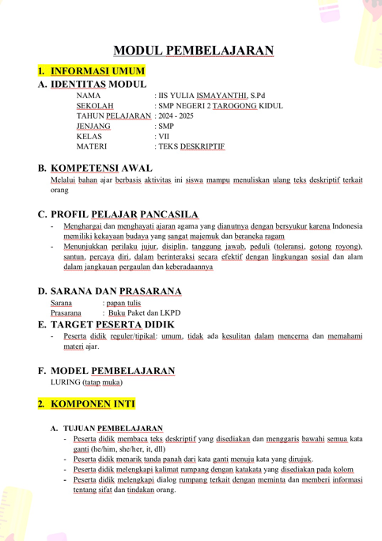
- Modul Ajar

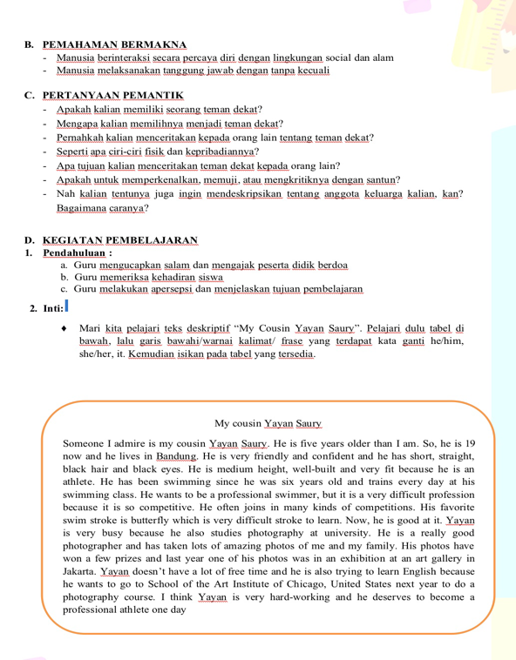
l
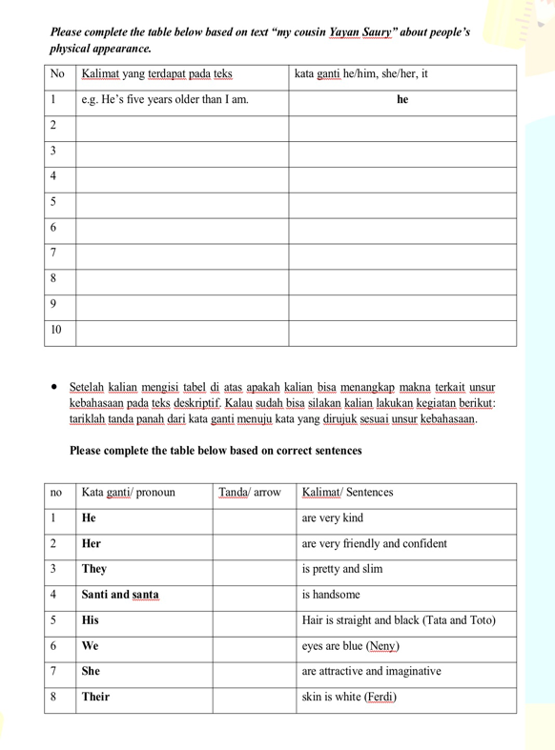

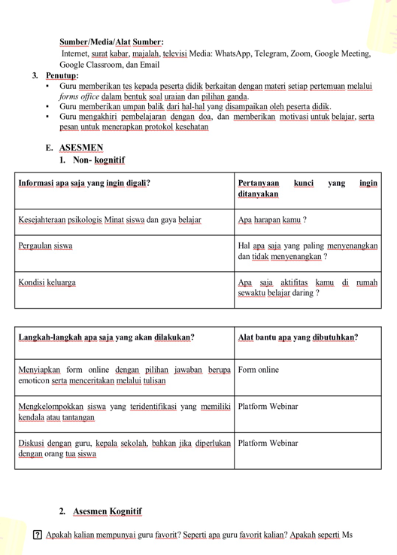
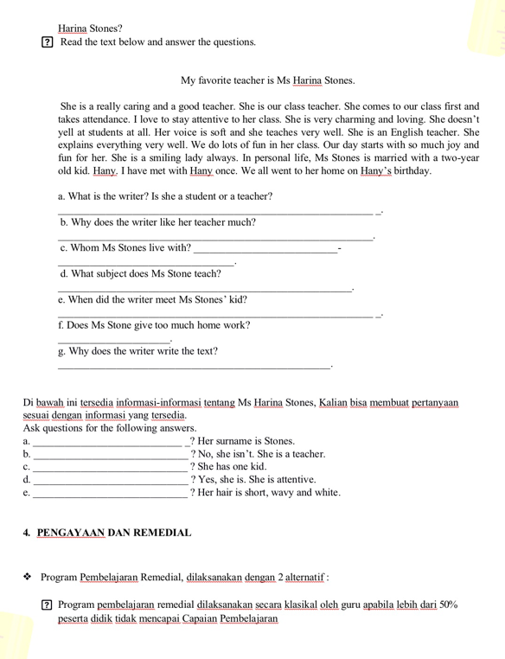
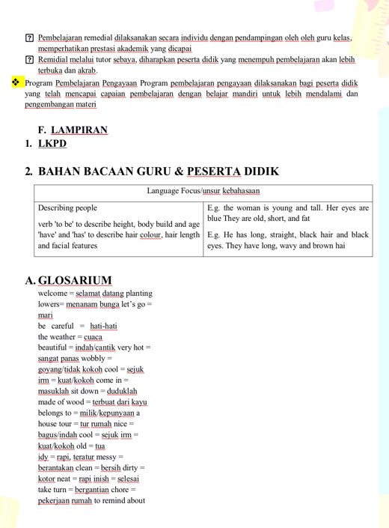

- SYLLABUS
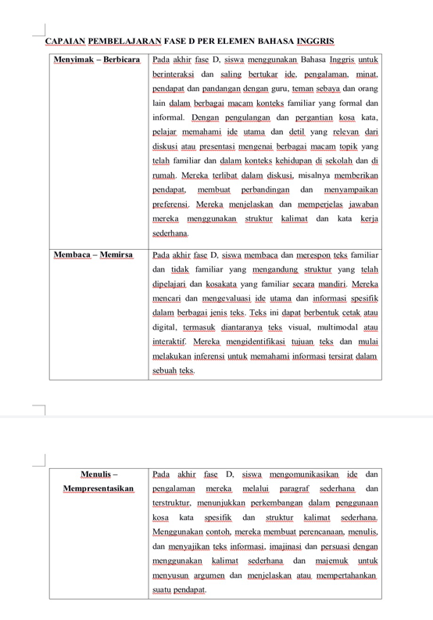

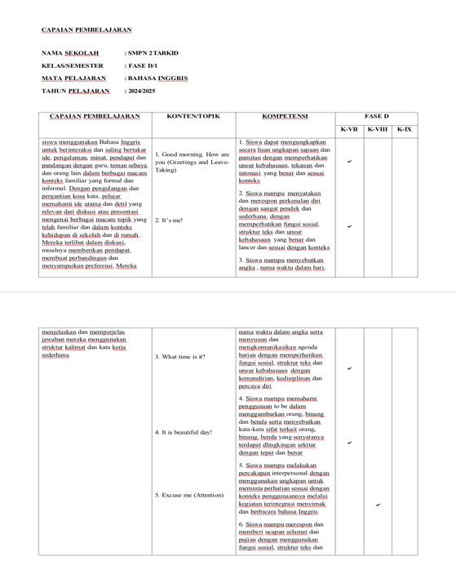
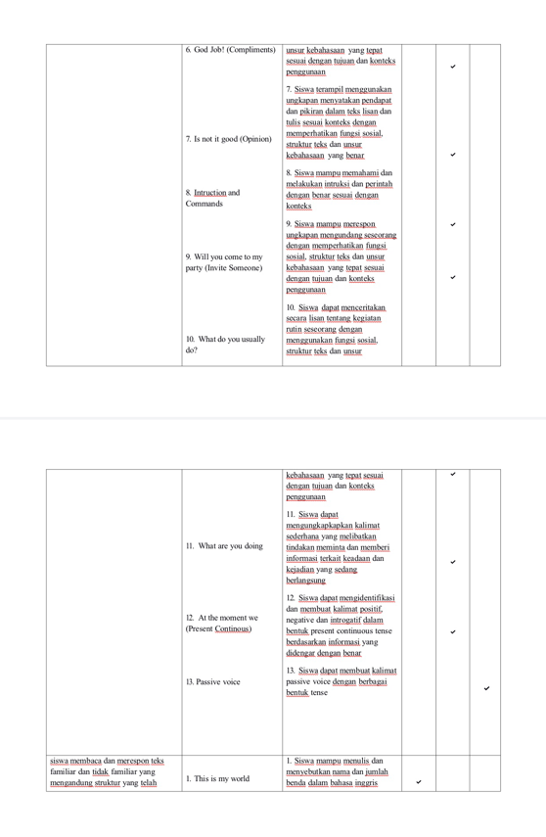

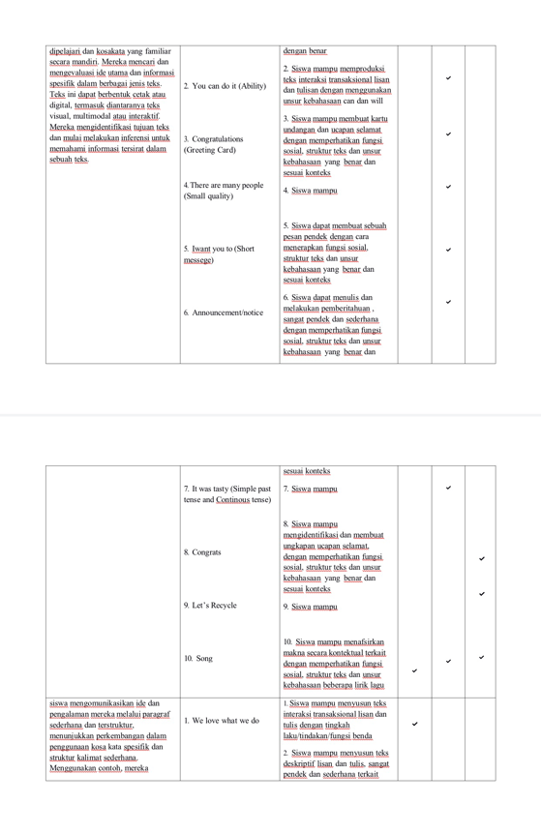

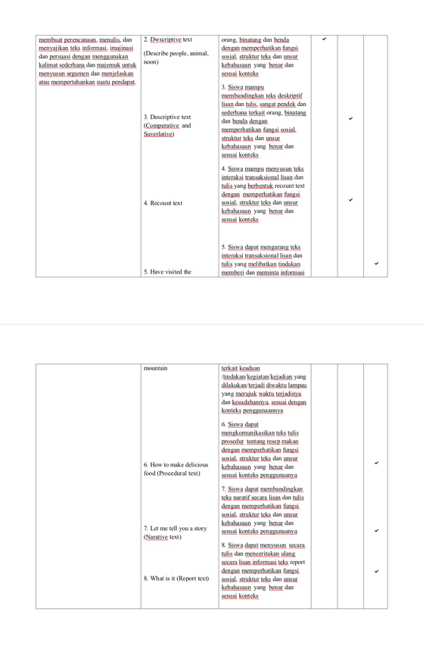

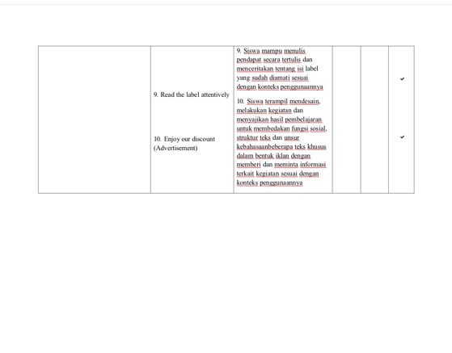

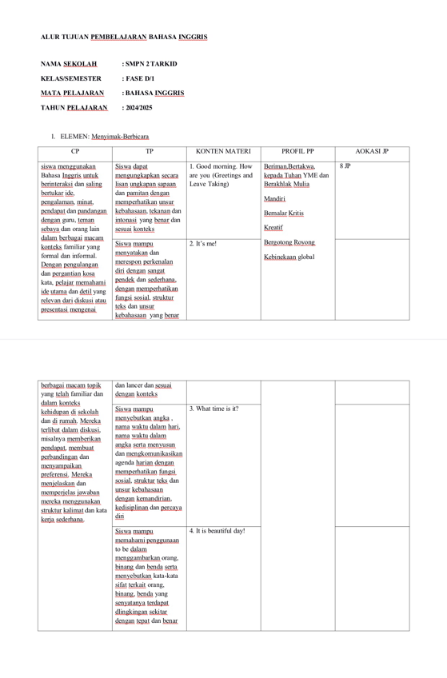

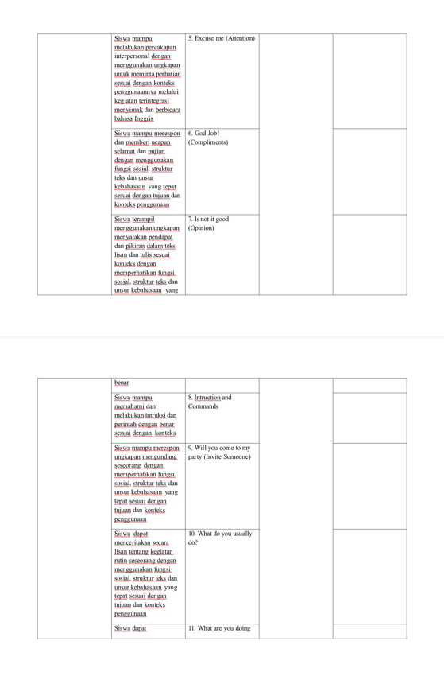
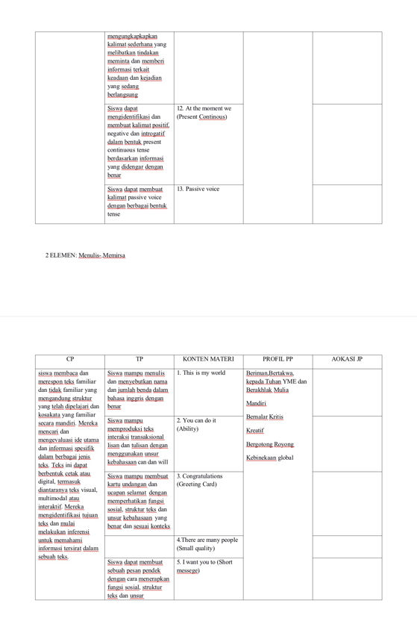
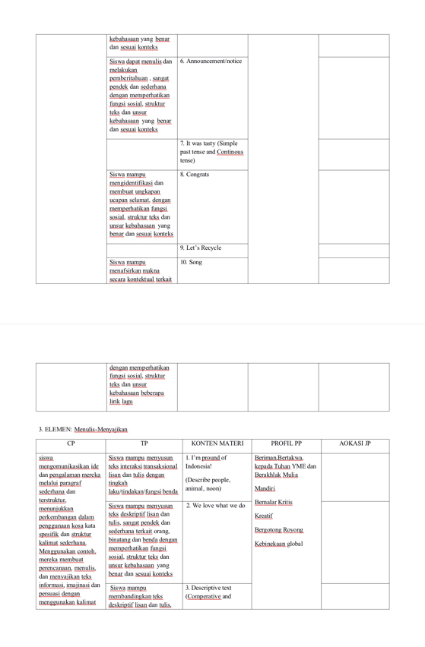
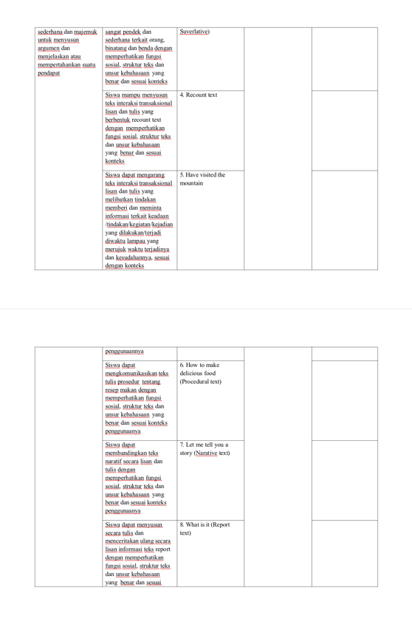
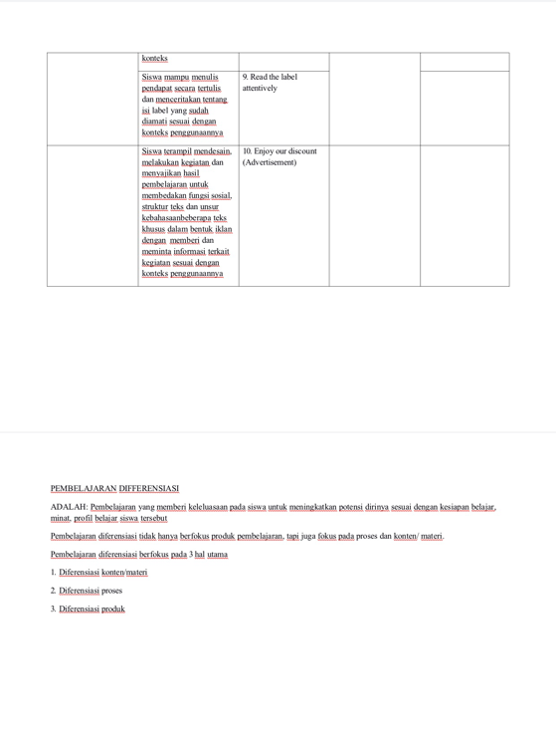
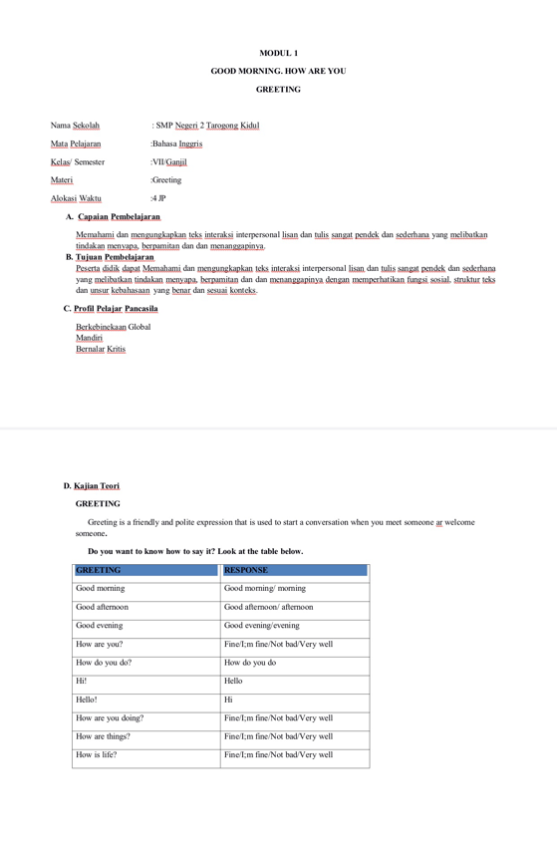
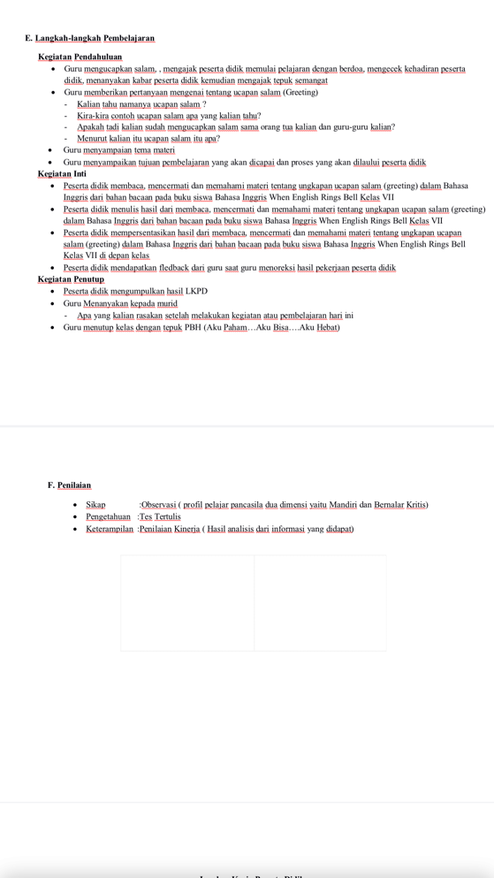
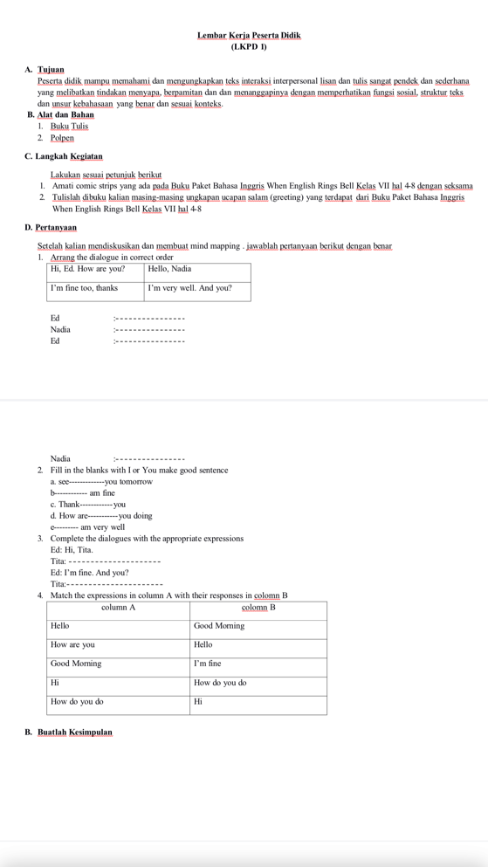

Appendix 3

Research Permit Application and Documentation
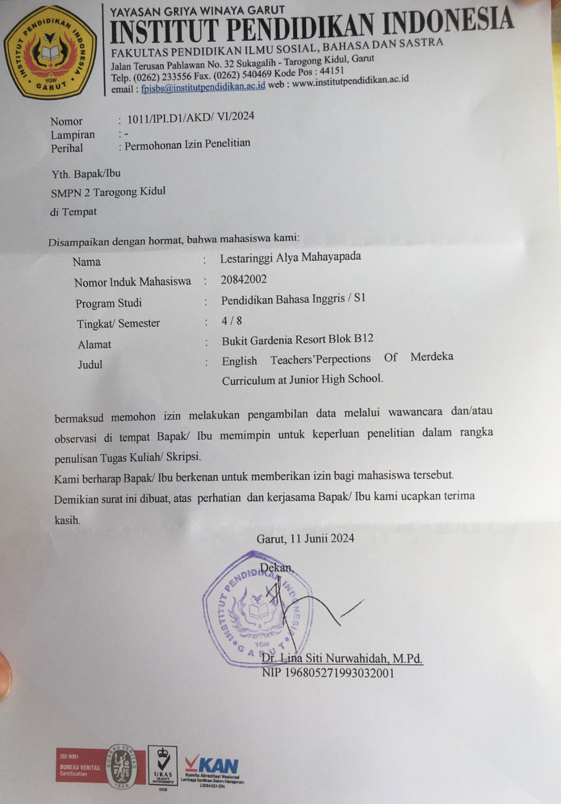
- Research Permit Application

- Documentation
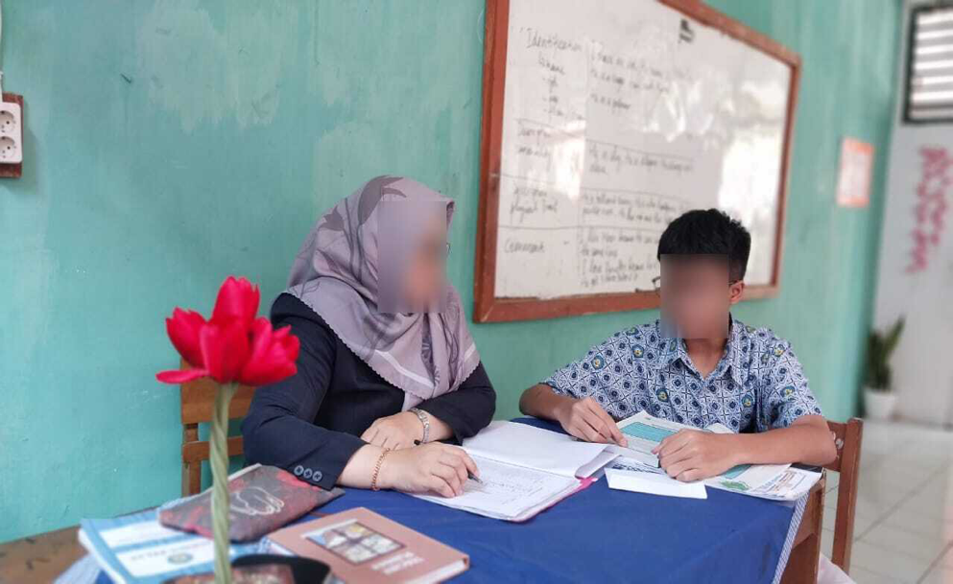

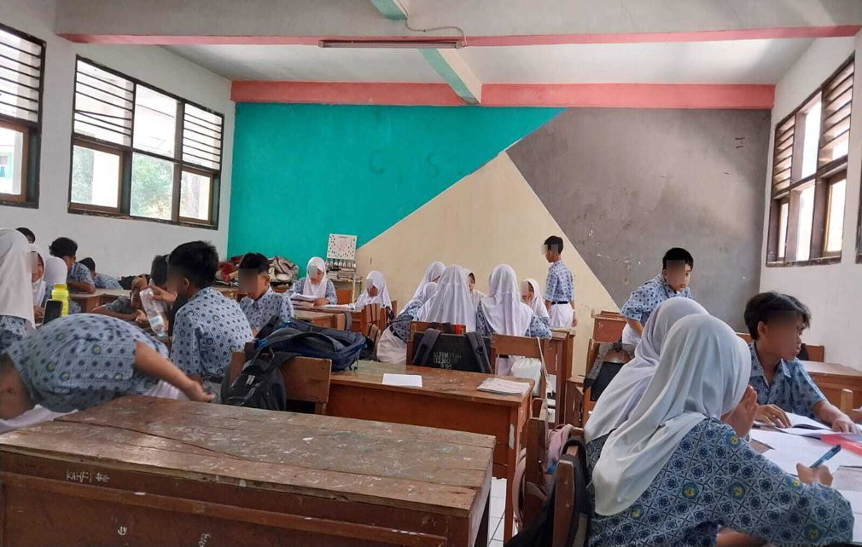
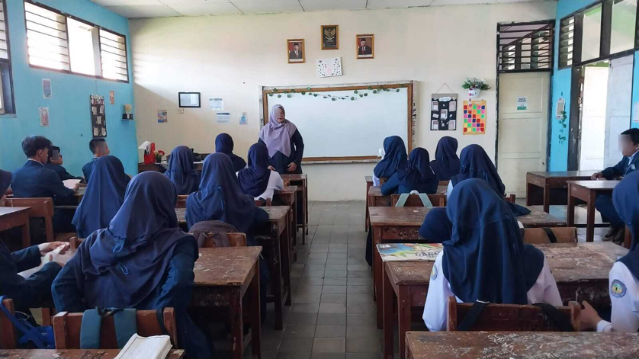
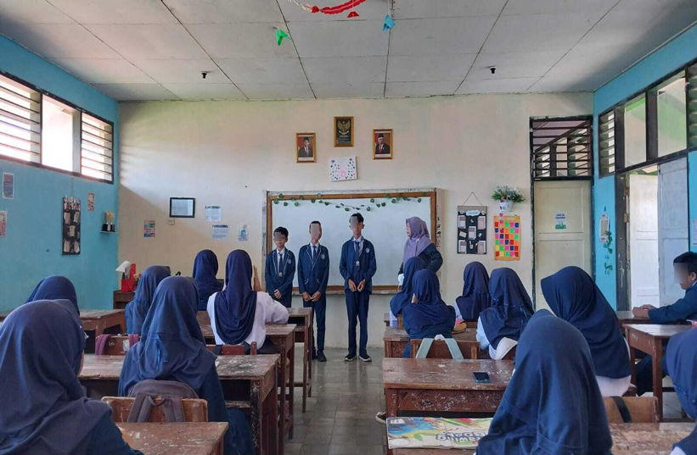
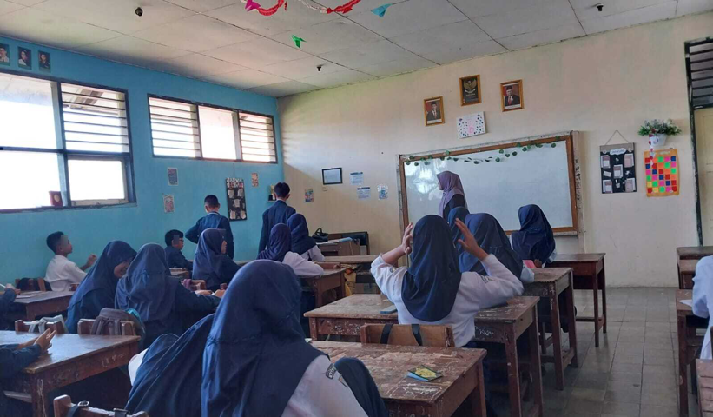
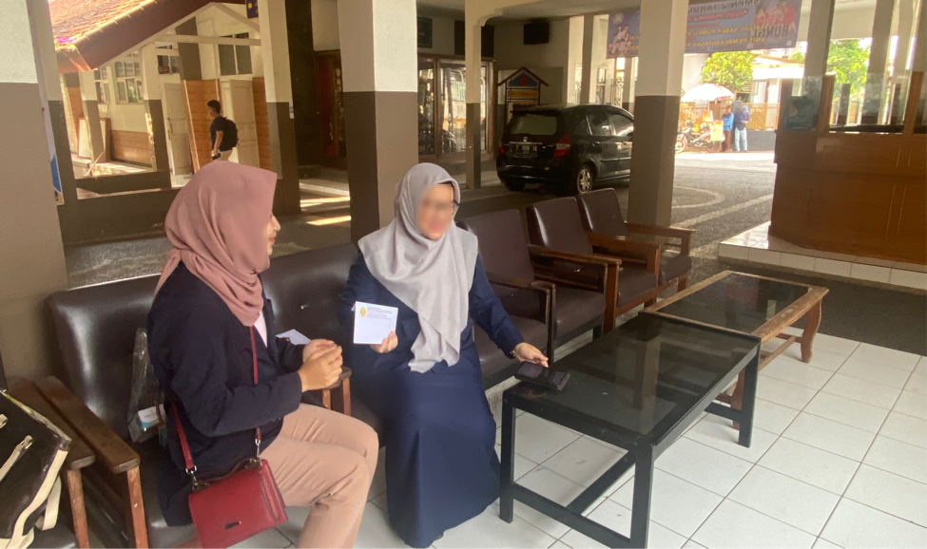
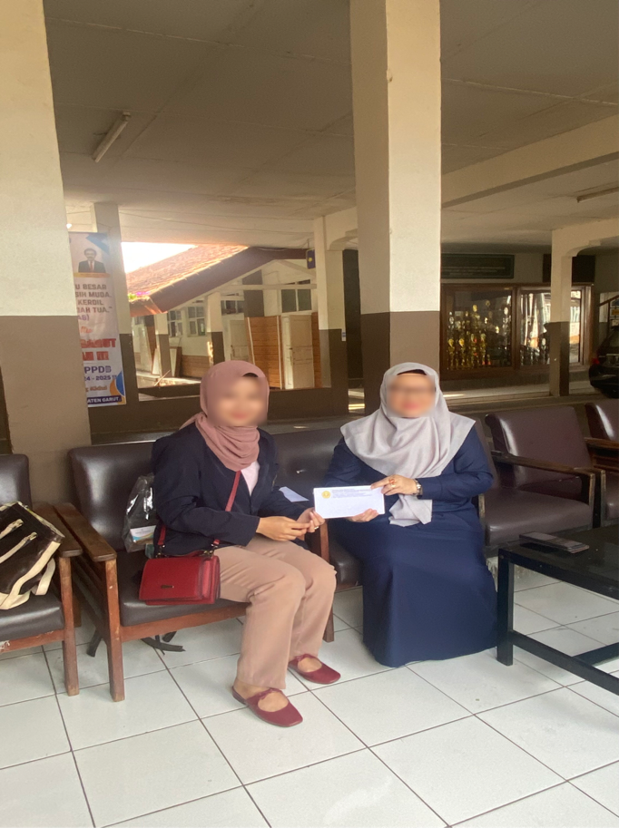

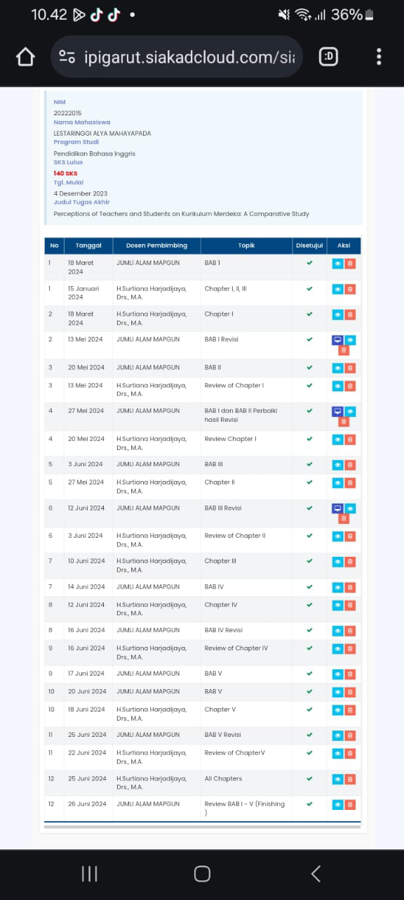

CURRICULUM VITAE

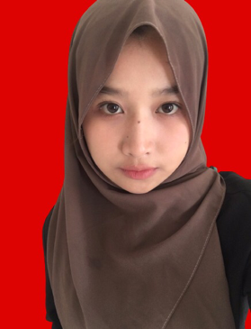
The researcher names is Lestaringgi Alya Mahayapada. She was born in Garut, 05 Januari 2001. She is originally from Garut. She was girl who studied at SDN Sukagalih 3, continued her education at SMPN 1 Tarogong Kaler, then continued her education at SMKN 1 Garut. Then continued her studied at Institut Pendidikan Indonesia (IPI) Garut, and took the English Language Education program. Then, she must graduate from the Insitut Pendidikan Indonesia in 2024 (S-1 Degree).

