TEACHERS’ PERCEPTIONS ON THE TECHNOLOGY INTEGRATION IN ENGLISH LANGUAGE TEACHING

A PAPER

Submitted to the English Education Program of IPI Garut as a Partial Fulfillment of the Requirements for the Sarjana Pendidikan Degree



Written by:
Hesti Nursahidah
20222010

ENGLISH EDUCATION PROGRAM FACULTY OF SOCIAL SCIENCE LANGUAGE AND LITERATURE EDUCATION
INSTITUT PENDIDIKAN INDONESIA GARUT
2024

APPROVAL SHEET

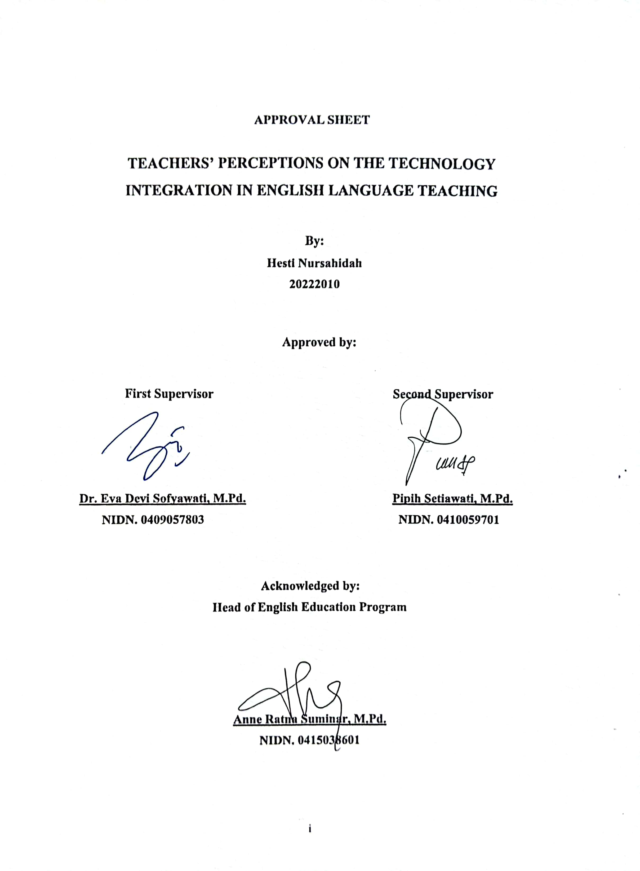

LEGITIMITATION OF EXAMINATION BOARD

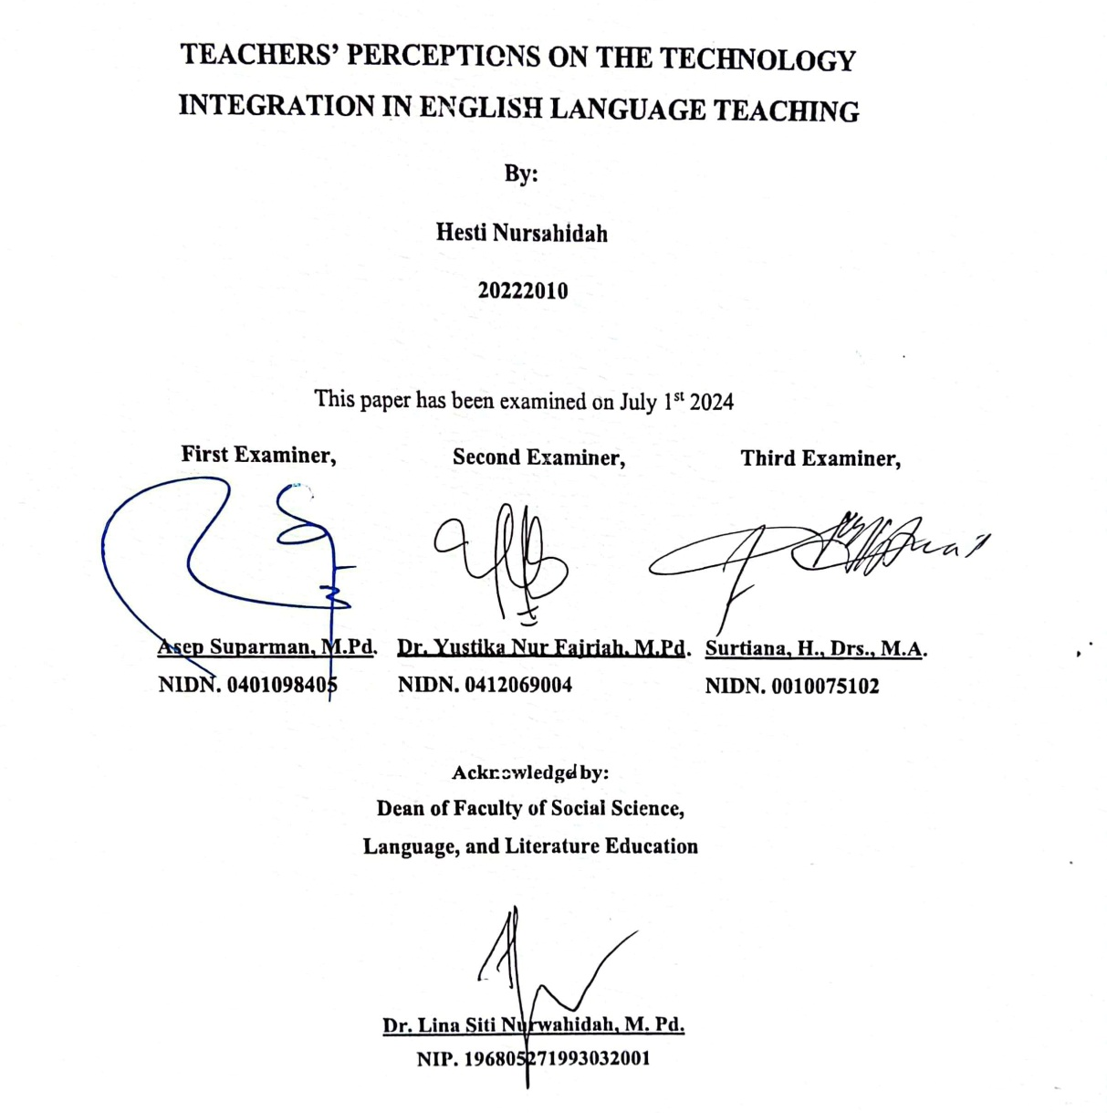

MOTTO
"Great success starts with small steps."
"Kesuksesan besar dimulai dari langkah yang kecil.”
"The secret of happiness lies in 3 things: patience, gratitude, and sincerity."
“Rahasia kebahagiaan terletak pada 3 hal: sabar, bersyukur, dan ikhlas.”
(HR. Ahmad)

-alhamdullilah-

This paper is dedicated to:
My beloved parents
My dear brothers and sisters
My dear friends
My dear distant friend

PERNYATAAN
Dengan ini, peneliti menyatakan bahwa skripsi yang berjudul “Teachers’ Perceptions On The Technology Integration In English Language Teaching” benar-benar ditulis oleh peneliti. Kutipan dari sumber lain telah dilakukan berdasarkan aturan kutipan sesuai dengan etika ilmiah yang berlaku. Oleh karena itu, isi beserta segala kelengkapannya merupakan karya asli peneliti. Dalam hal ini, jika ditemukan hal-hal yang tidak sesuai, peneliti bertanggung jawab dan bersedia menerima segala resiko dan sanksi apapun.

Garut, 25 Juni 2024
Yang membuat pernyataan,

Hesti Nursahidah
NIM. 20222010

STATEMENT
The researcher hereby declares that this paper entitled “Teachers’ Perceptions On The Technology Integration In English Language Teaching” was really written by the researcher. Quotation from other sources have been carried out based on citation rules in accordance with applicable scientific ethics. Therefore, the content of this paper and all its completeness are original works of the researcher. In this case, if things are found that are not suitable, the researcher will be responsible and willing to accept any risk and sanctions.

Garut, 25th June 2024
The Researcher,


Hesti Nursahidah
NIM. 20222010

ABSTRAK
Penelitian ini bertujuan untuk menganalisis persepsi guru bahasa Inggris dalam mengintegrasikan teknologi media pembelajaran di dalam kelas Bahasa inggris. Data dikumpulkan melalui wawancara semi terstruktur dengan dua guru bahasa Inggris disekolah yang berbeda. Temuan ini mengungkapkan bahwa kedua guru bahasa Inggris tersebut memandang penggunaan media teknologi belajar di kelas dengan sangat positif. Mereka menyadari bahwa teknologi membawa banyak manfaat, khususnya dalam mendorong pembelajaran yang berpusat pada siswa yang komunikatif, interaktif, dan kondusif terhadap pemikiran kritis. Guru telah mengembangkan strategi dan menerapkan berbagai media teknologi dalam pengajarannya, termasuk YouTube, TV digital, kuis, proyektor, laptop, dan audio/speaker. Alat-alat ini terbukti efektif dalam meningkatkan kemampuan bahasa Inggris siswa, khususnya dalam berbicara dan mendengarkan. Namun, penelitian ini juga mengidentifikasi beberapa keterbatasan dalam mengintegrasikan teknologi ke dalam ruang kelas, terutama karena kompleksitas penggunaan media teknologi yang belum dikenal. Mengingat meningkatnya tantangan yang ditimbulkan oleh globalisasi, penelitian ini menggarisbawahi pentingnya memberikan pelatihan yang lebih ekstensif kepada guru bahasa Inggris. Pelatihan semacam ini akan memungkinkan para guru untuk memanfaatkan teknologi secara efektif, sehingga meningkatkan kualitas pengajaran dan pendidikan.
Kata Kunci: Media Belajar, Teknologi Integrasi, Persepsi Guru, Pengajaran Bahasa Inggris

ABSTRACT
This research aims to analyze teachers’ perceptions on the technology integration in English language teaching. Data was collected through semi-structured interviews with two English teachers at different schools. These findings reveal that the two English teachers view the use of learning technology media in the classroom very positively. They realize that technology brings many benefits, especially in encouraging student-centered learning that is communicative, interactive, and conducive to critical thinking. Teachers have developed strategies and implemented various technological media in their teaching, including YouTube, digital TV, quizzez, projectors, laptops, and audio/speakers. These tools have proven effective in improving students' English skills, especially in speaking and listening. However, this research also identified several limitations in integrating technology into the classroom, mainly due to the unknown complexity of using technological media. Given the increasing challenges posed by globalization, this research underscores the importance of providing more extensive training to English teachers. This kind of training will enable teachers to utilize technology effectively, thereby improving the quality of teaching and education.
Keywords: Technology Integration, Learning Media, Teacher Perceptions, English Language Teaching.

PREFACE
In the name of Allah SWT, most gracious and most merciful, the praise to be Allah, the lord of the world, who has given mercy and blessing to the writer in finishing this paper entitled “Teachers’ Perceptions On The Technology Integration In English Language Teaching” Blessing and salutation be upon to the prophet Muhammad SAW, his family, his companion and his adherent.
This paper is submitted to the English Education Program of IPI Garut as a partial fulfillment of the requirements for the Sarjana Pendidikan Degree.
The writer realizes that this paper is still far from being perfect. Therefore, the writer will greatly appreciate to all comments and criticism.
Finally, the writer hopes this paper can give valuable contribution in teaching and learning to writer and readers.

Garut, 25th June 2024

The Researcher

ACKNOWLEDGMENT
First of all, I would like to say Allhamdulillahirabbil’alamin. Finally, this paper has been accomplished. In the name of Allah, the most gracious and the most merciful, the lord of the universe. Thanks to Allah for blessing, kindness, and inspirations in leading me accomplishing this paper. Blessing is upon for our prophet Muhammad SAW, to his family, his friends, and his followers.
I would like to express my sincere, gratitude to the following personal, for giving advice, guidance, comments, critics, correction, help, prayer, and support, they are;
- Dr. H. Nizar Alam Hamdani, M.M., MT., M.Si., the Rector of Institut Pendidikan Indonesia (IPI) Garut.
- Dr. Hj. Lina Siti N, M.Pd., the Dean of the Faculty of Social Science, Language, and Literature Education of Institut Pendidikan Indonesia (IPI) Garut.
- Anne Ratna Suminar, M.Pd., the Head of English Education Program.
- Dr. Eva Devi Sofyawati, M.Pd., as the first supervisor who has guided me with her worthy, correction and suggestion to improve the quality of this research paper.
- Pipih Setiawati, M.Pd., as the second supervisor who has guided me with her worthy, correction and suggestion to improve the quality of this research paper.
- All lectures of English Education Program of IPI Garut who have taught me useful knowledge and skill.
- My beloved parents, my father Saripin and my mother Yeti Nurhaeni, thank you for everything, especially thank you for all your love, attention, pray, motivation, and advice. And other, I can’t put my feeling about you into words.
- My beloved sisters and brothers, Yogi Harpani and Nenden Suryati who have given their support, pray, motivation, and always beside me in any condition.
- To all PBI friends from classes 4A, 4B and 4C who cannot be mentioned
one by one. Thank you for your support and prayers.
- I also want to thank my distant friend (Mr.Intelligent) for always accompanying me and providing advice and suggestions in working on this thesis.
- Last but no least, I wanna thank me, I wanna thank me for believing me, I wanna thank me for doing all this hard work. I wanna thank me for having no days off, for never quitting, for just being me at all times.

Garut, 25th June 2024

The Researcher

TABLE OF CONTENTS

APPROVAL SHEET i
LEGITIMITATION OF EXAMINATION BOARD ii
MOTTO iii
PERNYATAAN iv
STATEMENT v
ABSTRAK vi
ABSTRACT vii
PREFACE viii
ACKNOWLEDGMENT ix
TABLE OF CONTENTS xi
CHAPTER I 1
INTRODUCTION 1
1.1 Background of Study 1
1.2 Reasons for Choosing the Topic 5
1.3 Research Question 5
1.4 Research Objective 5
1.5 Significance of the Study 5
1.6 Definition of Terminologies 6
CHAPTER II 8
LITERATURE REVIEW 8
2.1 Definition of Technology Integration 8
2.2 The Role of Teachers’ on The Technology Integration in ELT 9
2.3 Teacher Perceptions of Media technology in ELT 10
2.4 Type of Media Technology used in ELT 11
2.5 Advantages and Disadvantages 14
2.6 Previous Studies 17
CHAPTER III 19
RESEARCH METHODOLOGY 19
3.1 Research Method 19
3.2 Research Design 19
3.3 Research Setting , Participants and Instruments 20
3.3.1 Research Setting 20
3.3.2 Research Participants 20
3.3.3 Research Instrument 20
3.4 Technique of Data Collection 21
3.5 Technique of Data Analysis 21
3.6 Research Procedure 22
CHAPTER IV 23
FINDINGS & DISCUSSION 23
4.1 FINDINGS 23
4.1.1 Teacher’s Perceptions of Media Technology in ELT 23
4.1.2 Type of Media Technology used in English Teaching 26
4.1.3 Supporting and Inhibiting Factors for Media Technology Integration 27
4.1.4 The Influence of Media Technology on Student Learning Outcomes 29
4.2 DISCUSSION 31
4.2.1 Teacher’s Perceptions of Media Technology in ELT 31
4.2.2 Type of Media Technology used in ELT 32
4.2.3 Supporting and Inhibiting Factors for Media Technology Integration 33
4.2.4 The Influence of Media Technology on Student Learning Outcomes 35
CHAPTER V 38
CONCLUSION AND SUGGESTIONS 38
5.1 Conclusion 38
5.2 Suggestions 38
REFERENCES 40
APPENDIXS TRANSCRIPT INTERVIEWS 43
SUVERVISION CARDS 58
RESEARCH PERMIT LETTERS 59
TURNITIN CHECK RESULTS 61
CURRICULUM VITAE 64

CHAPTER I

INTRODUCTION

1.1 Background of Study
The introduction of new technology-assisted learning tools and media, such as laptops, tablets, smartphones, smartboards, dynamic visualizations, and virtual laboratories, has altered education in schools and other institutions. Academic and professional education are increasingly using technology-enhanced instruction. In addition to allowing students to take charge of their own education, technology gives them instant access to a wealth of knowledge that teachers cannot direct or regulate. In a lot of schools, teachers are viewed as active participants in the process of making changes and putting new ideas into practice since their attitudes and views may be beneficial or detrimental to any educational reform, like implementing an advanced technological program (Abdulwahed et al., 2010).
Now days, in an era globalization characterized by rapid technological progress where everyone uses technology for social activities, many teachers and students use at least some new tools, resources, and behaviors that may be useful in language teaching. However, in this case, according to Akram et al., (2022b), many teachers still face difficulties in making the best use of technology in their teaching practices due to inadequate technological facilities and competencies, but the transition phase also improves their digital skills. This is also supported by Wang, (2023), over the last 10 years, there has been a push for higher education institutions to incorporate innovation to overcome global problems and increase the value of their study programs. In addition, intense competition in the higher education sector forces academic institutions to “think creatively." If schools want to remain competitive, they must take advantage of technological advances to improve learning outcomes and increase the effectiveness of their teachers.
Based on Rintaningrum, (2023) the extent to which teachers completely incorporate technology into their teaching techniques is largely determined by their opinions about how beneficial technology is for students' learning. The literature has extensively acknowledged the potential benefits of digital technology for teaching and learning in educational settings. Digital technologies have two positive effects that can be distinguished: (i) improving student performance, which encompasses things like ICT competency development and academic performance in foundational subjects; and (ii) improving and introducing new processes of teaching and learning.
Therefore, research regarding the integration of technology with teaching, especially in English classes, is important to examine in research because it has an influence on English teachers' perceptions and on what technological tools are used to improvise existing skills in English.
Based on Herdina et al., (2023), because every teacher has a different learning style, how successfully they integrate media technology into their lessons can be influenced by their perceptions of how it should be done. This is particularly relevant when it involves learning the language of English. In order to facilitate successful language learning improved by technology, English language teaching in the classroom also employs a blended learning approach. While on the other hand, recognizing the transformative potential of technology, educators are increasingly exploring its integration into language teaching to meet the needs of diverse learners (Levy, 1991). Teaching is related to classroom instruction that is also connected with advanced technology, claims Khan, (2022). The target learners have an easier time since they believe they are in a welcoming atmosphere where they may learn by playing or engaging in certain activities. Furthermore, as per Raman & Yamat (n.d.), the introduction of "ICT for all students" in Malaysia in 2012 has led to an increasing need for educators to include ICT in their teaching methods to give students a meaningful education.
The English language teaching profession has been around for a long time, and the Internet's influence has contributed to its growing importance. The transformative potential of technology is especially evident in the field of
language education, where educators are looking for innovative ways to engage students and increase proficiency in English as a second language, as supported by Akram et al., (2022), technology also benefits students in terms of increased motivation, personal development, and efficient information and knowledge development. Introduction technology integration in language learning offers great opportunities for learners as well as teachers to gain new knowledge and experiences, (Rintaningrum, 2023).
Teaching that makes use of multimedia technology not only the role that students play but also the significance of "interaction" between teachers and students. Previous studies also emphasized this, indicating that multimedia-based instruction undermines the "teacher-centered" teaching paradigm, increases class efficiency fundamentally, and enhances the curriculum (Suhardiana, 2019). Based on Wang, (2023), the results demonstrate how educators used technology to support a range of educational objectives, such as learner- and teacher-centered activities. The sociocultural environment, beliefs, resource accessibility, and technological competence and confidence are the other four critical aspects that this study found to be crucial in determining how instructors use technology.
The above discussions on teacher perceptions, and knowledge about integrating technology have proven highly valuable, but they are complicated by the blurred distinctions between teacher knowledge and teacher beliefs. Historically, knowledge has been dichotomized with beliefs, with knowledge being viewed as objective and based in fact, while beliefs were viewed to be more subjective and personal (Kuiken & Vedder, 2008). However, others have refuted this dichotomy in both general education and language teacher education noting that drawing a clear distinction between the two concepts seems impossible. Others have challenged this dichotomy, pointing out that it is hard to distinguish clearly between the two conceptions in both general education and language teacher education. It is difficult to study teachers' mental, and many scholars agree that teachers' knowledge bases frequently interact with their attitudes, beliefs, and other states ((Woods & Çakir, 2011).
Given that teachers' ideas and knowledge are commonly utilized although
not identical research has concentrated on analyzing many facets of teachers' beliefs because of their importance. Researchers have examined educators' perspectives on teaching and acquiring language skills, the origins of the teacher's beliefs (Ellis, 2004), the relationship (or lack of one) between educators' beliefs and their methods of teaching (Basturkmen, 2012), and the potential of teacher preparation plans to influence or modify the teacher's beliefs (Faez & Karas, 2020). As a result, although discussing teacher competence and knowledge bases is still crucial in the field of English language teaching, it is also entwined with teachers' personal values. By investigating teachers' perceptions on excellent practices in ELT classes based on their experiences, this case study contributes to the body of this research.
Based on the limitations of previous research conducted by Ammade et al. (2018) and Wang (2023), the integration of technology in education is crucial, but its immediate improvement is not guaranteed. Teachers' perceptions of technology can impact their teaching methods and student learning. Based on several studies, and the integration of technology has importance in the educational environment. According to Wang, (2023), research on the use of technology in the teaching and learning process has become increasingly popular recently. However, it cannot be guaranteed that the use of technology will immediately improve language teaching and acquisition. The way educators view technology can impact the way they teach. This, in turn, affects how well students learn. Thus, it is important to understand teachers' perceptions of technology.
The same researchers study by Ammade et al., (2018) states that there are now more obstacles for teacher professional development because of the possible usage of ICT integration in teaching and learning. The elements that affect how technology is used to teach English must be taken into account in order to improve education and achieve the aforementioned goal. Therefore, based on previous research has essentially investigated the variables that affect technology integration and the difficulties that colleges, universities, government agencies, and teacher educators have faced. However, there hasn't been much study conducted on what teachers perceive of media technology.
As a result, the main emphasis of this study is on teachers' perceptions in integrating learning media technology and finding the best media technology that is appropriate for various English language teaching objectives.

1.2 Reasons for Choosing the Topic
The reason for choosing a research topic about the perceptions of teachers and learning media technology in English classes is because educational technology currently exists in the majority of modern classrooms, particularly in view of the rising requirement for teacher education and in-service training, particularly for e-teaching. So that influencing teachers' perceptions of learning media technology may influence the way of teaching in English classes. Based on the objectives of this research, it is important to analyze and explore teachers' perceptions about learning media technology and its implementation in English classes.

1.3 Research Question
- What are teachers’ perceptions on the technology integration in English language teaching?

1.4 Research Objective
This research would be aimed at finding out:
- To analyze and explore the English teachers’ perceptions towards the technology integration in their teaching English.

1.5 Significance of the Study
Integrating media technology into English language teaching offers numerous real benefits for both teachers and students :
- Teacher competence and training
Integrating media technology into English language teaching encourages continuous professional development for teachers. Teachers can explore new teaching methods, and online resources to enhance their teaching and stay updated with the latest trends in language education.
- Enhanced Language Skills Practice
Digital tools offer diverse opportunities for practicing and developing language skills, including listening, speaking, reading, and writing. Teachers
can integrate multimedia resources, language learning apps, and communication tools to reinforce language learning both inside and outside the classroom.
- Innovative practices, with technology : Teachers can tailor learning materials and activities to meet the individual needs and interests of students
- Preparation for the Digital Age
Integrating media technology into English language teaching equips students with essential digital literacy skills necessary for success in the 21st-century workforce. Teachers perceive of media technology as a means to prepare students for the demands of the digital age, empowering them to navigate, evaluate, and utilize digital resources effectively in English language contexts.
Therefore, based on the real benefits and expectations that have been mentioned, this research is expected to provide relevant information about what teachers perceive of technology media use and its implementation in English classes for readers.

1.6 Definition of Terminologies
To avoid misunderstanding, there are several terms that will be clarified, does are:
- Teacher Perceptions
Teacher Perceptions refer to the attitudes, beliefs, and perspectives that educators hold regarding the incorporation of technology tools and resources in the teaching and learning of English language and literature. This encompasses how teachers perceive and employ computer-based technologies in their teaching is heavily influenced by their attitudes, particularly ideas about their own effectiveness and their understanding of the potential benefits and challenges associated with technology integration in the English classroom.in integrating technology into education, (Hutchison & Reinking, 2009)
- Integration
Integration often refers to the process of combining or coordinating
different elements, components, or systems to work together as a unified whole. This can apply to various fields, such as technology, business, and learning.
- Technologies
Technologies are the practical application of scientific knowledge in industries and engineering, encompassing tools, machinery, devices, and processes designed to solve problems, enhance productivity, and fulfill human needs. They can be tangible or intangible, and their rapid advancement has significantly impacted various aspects of society, including communication, education, healthcare, transportation, and entertainment.
- ELT (English Language Teaching)
Refers to the practice and study of teaching the English language to non-native speakers. This term encompasses a wide range of activities and methodologies aimed at helping learners acquire proficiency in English for various purposes, including communication, education, and professional development.
- Media
The term "media," which is the plural of "medium," refers to all forms of communication, including digital data and printed paper. Media includes magazines, newspapers, the internet, television, radio, and any other material that might reach or affect people. It also includes art, news, and educational content.

CHAPTER II

LITERATURE REVIEW

2.1 Definition of Technology Integration
In the context of education, "technology integration" refers to the efficient combination and use of diverse technical instruments, resources, and methodologies to support and improve the process of teaching and learning. Technology integration, according to the same research, is "the extent to which technology is used to facilitate teaching and learning" (Wang, 2023). It takes more than merely implementing technology in the classroom to increase student accomplishment; it also calls for thoughtful planning, curriculum integration, and purposeful use. As mentioned by Bui (2022), since a large portion of students' language use occurs outside of the classroom, digital technologies have a significant impact on language instruction. Thus, it is important for teachers to be able to use digital media technologies to support their social practices through language learning processes.
Moreover, Bui (2022) defined digital technology integration as the use of digital technology to enhance educational activities by enabling students to easily complete assignments online rather than on paper. This concept supported the potential of digital technology to generate a variety of learning outcomes. Therefore, digital technology may help students express themselves and participate in class, among other things, beyond merely helping them finish their assignments. Based on Nurhidayat et al. (2020), advances in information and communication technology in education can facilitate authentic interaction and communication between English language learners. In other words, the teacher only uses technological tools in the classroom as a complement to the material to be delivered so that students can think more actively and creatively during the English learning process. Thus, the integration of technology in teaching in English classes emphasizes that the use of technology is only for educational purposes.

2.2 The Role of Teachers’ on The Technology Integration in ELT
The rapid growth of technology has changed teaching methods. Although the use of technology in the classroom is common, there are differences in the type and level of integration. According to Nurhidayat et al. (2020), teachers play an important role in implementing technology integration in the classroom. Therefore, teaching strategies are expected to reflect the standards held by teachers as educators for higher-quality teaching.
Suhardiana (2019) proved that the use of multimedia and technology in the classroom highlights the significance of "interaction" between teachers and students as well as the responsibility of the student. The primary goal of multimedia-based teaching is to enhance students' communicative competence by training and enhancing their speaking and listening skills. The teacher's function as a facilitator is crucial throughout this process. It is approved by Bui (2022) that even though teacher-directed student technology use typically occurs outside of the classroom, because the guidance or recommendation is given within the classroom, it is seen as a component of technology integration. Therefore, students should be able to use digital technologies to support their social practices through English language learning processes.
Learning English is a process of teaching a second language that is not easy. According to research by Herdina et al. (2023), the difficulties teachers experience when imparting the four English language skills—listening, speaking, reading, and writing—while utilizing technology have a real impact on the way students engage in learning activities. Teaching English requires the instructor to be technologically proficient. Thus, in this case, teachers are required to have experience using technology or have attended webinars or training on the use of technology as teaching practice.
Teachers need to find ways to utilize technology as a learning tool for their students, even if they are not technology experts. According to Suhardiana (2019), the concept of improving writing skills can be implemented by encouraging
students to create online blogs. Blogging platforms such as Blogger or WordPress can give students the opportunity to create an online blog for free. Sometimes, students find blogging interesting and encouraging because they can write about anything they find interesting.
However, the fact that not only teachers can read their virtual writing, but basically anyone with internet access, makes them put more effort into writing. Getting feedback from a wider audience may also have a positive influence on one's skill development. Therefore, technology provides many options, such as making teaching interesting and also making teaching more productive in terms of improving students' ability to use English.

2.3 Teacher Perceptions of Media technology in ELT
Without a clear connection between technology and teaching objectives or subject matter, teachers will hesitate to integrate technology into classroom teaching practices. Achieving the maximum potential of technology in education depends on the beliefs and perceptions held by educators regarding the efficacy and benefits of applying technology in their teaching practices. Hence, teachers' beliefs and perceptions are needed to influence the impact of technology integration in their teaching practices. This is supported by Yunus et al., (2010), educators' beliefs about the learning process are also influenced by sociocultural origins, previous knowledge, and educational experiences.
Teachers' perceptions of educational benefits are a significant determining factor in how technology is integrated into the classroom. In accordance with Badia et al. (2014), "the belief that student learning is enhanced with the help of digital media" Therefore, students' beliefs about technology have an influence on teachers' perceptions when integrating technology into teaching practice, especially in English classes.
According to Wang, (2023), there are two main reasons why teachers use technology in their learning: first, to meet their own professional demands; and second, to meet the needs of its students. First, technology can support teachers' professional needs by enhancing their ability to create personalized learning plans
and manage the classroom more effectively. Teachers also see technology as a tool that helps them develop professionally because it gives them access to fresh teaching ideas and materials and gives them the ability to interact and communicate more widely. Therefore, technology has a very important role in education, so many teachers are required to use technology for teaching needs.
Technology adoption can also help students become more motivated and engaged while improving their technology skills, higher-order thinking, and understanding. Students will ultimately benefit by meeting teachers' professional needs and improving their classroom teaching practices. Supported by the same research, Wang, (2023) results show how educators use technology to support various educational goals, such as student- and teacher-centered activities. Therefore, the extent to which teachers fully incorporate technology into their teaching practices is largely determined by their perceptions of how beneficial technology is to student learning.
However, according to Abbasi et al., (2022), a positive teacher attitude alone is not enough for the successful implementation of technology. There are other factors also responsible for the use of technology, besides teacher attitude, training, knowledge, and the availability of digital tools. These are some of the factors that scholars say are necessary to incorporate technology into English language teaching and learning.
Therefore, based on the current studies, this research aims to determine perceptions about attitudes and teachers' use of technology integration and to determine the types and tools used by teachers to integrate technology in teaching and learning English in the context of ESL education.

2.4 Type of Media Technology used in ELT
Technological developments in the world, especially in Indonesia, are currently growing rapidly. So, it cannot be denied that the role of technology has an impact on education, especially on the development of teachers in teaching English language material. Therefore, there are many types of technology that can be used for teaching and instruction.
This is also supported by Ammade et al., (2018) several studies regarding the use of various technologies for educational purposes will be described below to show how various technologies influence educational practices throughout the world, especially in Indonesia.
One example taken from Gunuç & Babacan, (2017) is that the use of technology in the classroom—such as interactive whiteboards, laptops, projectors, and tablet PCs—as well as outside the classroom—such as smart phones, PDAs, and the internet—gives students learning opportunities that are sustainable. Therefore, technology can provide more learning opportunities for students and make it easier for teachers to deliver English-language material. Also supported by the results of previous research, students said that the use of this kind of technology would provide benefits from the direct feedback they received.
Furthermore, another finding by Altun & Ahmad (2021) is that students learn vocabulary, spell, and create sentences, which can improve their reading and writing skills. Thus, teachers will take advantage of the educational benefits of multimedia content as a complement to teaching, especially in English classes, which will require the use of technological instruments such as interactive whiteboards, tablet computers, and mobile phones (video, images, sound, and animation). According to Haleem et al., (2022) a digital classroom is when teachers use electronic tools such as social media, multimedia, and cell phones to teach students. This approach has transformed the educational environment, allowing students to learn quickly and easily. Students use computers, tablets, and Chromebooks for learning, and most of the curriculum is delivered online. The internet has expanded communication channels, facilitating learning through virtual places and media. Apart from that, previous research results by Suhardiana, (2019) stated that because the number of English language learners is increasing, fortunately, more and more modern tools and technological devices are being implemented into the teaching process. So currently, teachers tend to use tools such as videos, podcasts, e-learning, applications, and websites, which can be accessed via electronic devices such as personal computers or cell phones.
Therefore, this invention facilitates the classroom environment and the
diversification of learning activities. According to Ding et al., (2019), EFL teachers employ three distinct practice kinds—skill-based, rule-based, and function-based practices—while utilizing PowerPoint as a digital resource. These three types of practices may be indicative of distinct underlying pedagogies. The use of digital technology by participants for language practice and pronunciation acquisition is referred to in this study as "skill-based practice" (e.g., utilizing red to highlight pronunciation elements and visual aids to enhance vocabulary learning). Repetition of the target language is viewed by educators who favor skill-based practice as a key factor in language formation. Rule-based practice, which is a powerful indication of grammar-focused pedagogy, entails instructors employing digital technology to aid in grammar learning (e.g., presenting grammatical structures using PowerPoint). Last but not least, in order to implement function-based practice, teachers must leverage digital technology to develop context-based language activities for student engagement (such as utilizing YouTube videos as conversation starters). Teachers will therefore be more inclined to implement these strategies in order to highlight communicative skills as the primary objective of language learning.
Gunuç & Babacan, (2017) claims that Language Learning Websites try to make reading exercises as fun as they can and provide users the chance to engage with vocabulary development. With the use of English reading materials that incorporate narration or animation, students are now able to comprehend and relate topics. In addition, using interactive whiteboards enhances students' ability to memorize information, promotes effective and dynamic learning, and inspires students to review previously taught material. Teachers and kids have positive things to say about the interactive board. Language teachers said that the use of interactive whiteboards changed how they operated in the classroom and had a positive, sometimes significant effect on teaching language. Thus, It's important to keep in mind that students must use the interactive board for all in-class activities while incorporating this technology.
Herdina et al., (2023) also stated that learning can be carried out using a variety of learning methods so that it is not boring for both teachers and students.
This can enable students to further develop and integrate speaking, listening, reading, and writing skills in an authentic way. In line with Wang, (2023) the increasing affordability of computer technology helps English teaching and learning by offering multimedia resources, useful activities, and language practice. Therefore, technology has a very important role in the world of education and can be utilized optimally in learning English skill.
Based on a study by Levy, (1991), it was found that some types of technology and tools used for EFL, such as discrete-point vocabulary learning activities, such as Hot Potatoes software, offer flexibility in terms of content and format. These activities focus on vocabulary and grammar, with options for Flash audioplayers and audio-visual annotations. Another finding is that WordChamp, an online vocabulary-building tool, uses keyword hyperlinks to connect users to dictionary definitions, translations, and images. While it has limitations in providing accurate translations, it focuses on building content vocabulary when learners examine authentic websites designed for native speakers. Overall, these activities are effective for vocabulary practice.
According to review literature above, mentioned that types of technology used in teaching EFL are three types of practices may be indicative of distinct underlying pedagogies, such as skill-based, rule-based, and function-based practices. Teacher use language learning website/software (like, google translate or WordChamp for an online vocabulary-building tool), interactive whiteboards, tablet PCs, smart phones, and internet as skill based practice. In other, teacher use PPT or Hot Potatoes software for online quizzes as Rule based practice. Moreover, teacher sometimes use laptops, projectors for Youtube, Audio as implement function-based practice

2.5 Advantages and Disadvantages
Here some advantages and disadvantages of integrating technology into Teaching English :
- Advantages of integrating technology;
- Increased technology Engagement and Motivation:
According to Suhardiana, (2019) traditional teaching more or less hinders students' ability to understand certain languages and also understand the structure, meaning and function of language, as well as making students passive recipients of knowledge. So, it is more difficult for them to achieve communication targets. With teacher instructions directing thinking and motivating students, multimedia technology helps in the integration of teaching and learning and provides students with greater opportunities. Therefore, multimedia technology teaching uniquely inspires students' positive thinking and communication skills in practice social.
- Access to Original Resources:
Students can access original English-language materials such as news articles, podcasts, and videos, providing exposure to real-world use of the language. In addition, technology allows students to explore different cultures through virtual tours, documentaries, and online interactions with native speakers. According to Levy, (1991), the basic keyword hyperlink, which usually takes the user immediately to a dictionary definition, a translation, or a picture, is used by a lot of vocabulary learning applications. The curriculum does, however, include well-designed exercises that concentrate on expanding subject vocabulary when students browse real websites meant for native speakers. Because of this, the application continues to be a very useful tool for EFL.
- Personalized Learning:
When teachers use software programs or online English learning platforms that adapt to the level and pace of students, teachers can provide customized learning experiences and help students progress at their own pace. This is supported by Wang (2023), who says that teachers also see technology as a tool that helps them develop professionally because it gives them access to fresh teaching ideas and materials and gives them the ability to interact and communicate more widely. To this end, teachers can adapt content to meet each student's needs, addressing specific strengths and weaknesses.

- Disadvantages of integrating technology:
- Technical and Reliability Issues:
Using technology as a means of teaching English for teachers does have many advantages. But on the other hand, sometimes technology has connectivity problems; internet access is not always reliable or available, so it can disrupt learning time. It is supported by Nath (2019), who stated that teachers have additional obstacles due to a lack of confidence and technical abilities. Therefore, the solution is for teachers to prepare their teaching methods more thoroughly.
- Teacher Professional
Effective integration requires teachers to master the use of technology, which may require extensive training and ongoing professional development. The same researchers study by Ammade et al., (2018) states that there are now more obstacles for teacher professional development because of the possible usage of ICT integration in teaching and learning. The elements that affect how technology is used to teach English must be taken into account in order to improve education and achieve the aforementioned goals.
- Reduced Human Interaction:
The development of social skills and interpersonal communication skills between students and teachers can be hampered by excessive technology use, particularly if teachers utilize it excessively as a teaching tool in the classroom, particularly in English classrooms. According to Li et al., (2019), a drawback of digital technology that is not oriented toward the needs of students is that teachers are less likely to design engaging communicative language learning activities for their students. As a result, instructors should decide which English language learning resources require technology and which do not. For instance, technology should not be used in English-language resources that include debate forums or group discussions in the class.

2.6 Previous Studies
Numerous studies have been conducted to analyze teachers’s perceptions and practices in integrating technology for English language teaching. One of which, by Wang (2023), states that this study investigates university in-service English as a Foreign Language (EFL) teachers’ perceptions of technology integration and the relevant factors that may affect their technology integration in the classroom. This study was conducted at one private university in Southeast China and may not represent the situation in other parts of China. This research is focused on investigating in-service university EFL teachers’ perceptions of technology integration, the factors that may influence their technology integration, and the challenges they have encountered.
The second goal of this research is to determine how colleges and universities, government departments, and teacher educators can enhance the future technological integration of in-service teachers. Based on the study, it was found that (1) perceived usefulness and (2) teacher value beliefs are two important factors that influence in-service teachers’ technology integration. Additional factors are (3) subjective norms, (4) facilitating conditions of the environment, and (5) cultural values. Moreover, this study explored in-service teachers’ perceptions of what constitutes technology integration and the challenges or barriers they have encountered regarding technology integration in EFL classrooms. Therefore, teachers consider that effective technology integration must meet both their professional and student needs.
Another study is conducted by Hutchison (2009) collected data that was qualitative from 16 American high school science, social studies, and English teachers. This study investigates how teachers used technology and, ideas, and behaviors that went along with it. A researcher's notebook, focus group interviews, in-depth interviews, response data interviews, and systematic observations were among the sources of her data. Furthermore, Hutchison (2009) showed that teachers frequently used technology to adapt already-established reading practices rather than utilizing it in novel ways that drew on the special features and applications of ICTs. More detailed information on teachers' perceptions of ICTs
may be found in her study. However, only teachers of three distinct subjects in high school may participate.
In related research conducted by Katemba, (2020), this research investigates the challenges faced in the application of technology in language teaching and learning in Indonesia. Data was collected using a questionnaire and analyzed using mixed methods, namely quantitative and qualitative procedures. In addition, research participants were randomly selected, including 30 teachers from Bandung in rural areas. The results show that the use of technology in the classroom is very helpful. Apart from that, the more tools and facilities provided by schools, the better their ability to use technology. Even though the school has prepared facilities, there are several challenges in implementing technology in language learning classes. Therefore, based on the results of the research above, there are differences between this research and previous research. The results of previous research used questionnaires and mixed methods with a randomly selected sample of participants. Meanwhile, this research used qualitative methods with interviews two English teachers at two of the high schools in Garut.
The similarity between this research and previous research is that it is similar in its analysis of teachers’ perceptions of technology integration in teaching EFL. But there are also differences with previous researchers. This previous research focused on investigating the factors that may influence their technology integration and the challenges they have encountered in colleges and universities, government departments, and teacher educators. However, this research is focused on teachers' perceptions in integration learning media technology and finding the best types of learning media technology that are suitable for various English language teaching purposes has not been widely investigated. Therefore, the aimed of this research was to provide insight into teachers' views on integrating learning media technology in teaching in English classroom.

CHAPTER III

RESEARCH METHODOLOGY

In this chapter, the researcher explains the data processing involved in this research. They include the research method, research design, research setting, participants, and instruments, technique of data collection, technique of data analysis, and research procedures.

3.1 Research Method
This research used qualitative methods to describe and obtain an in-depth understanding of the problems studied through data analysis. Qualitative analysis is a primary tool for developing new theory (Edmondson & Mcmanus, 2007, as cited in Grodal, Anteby, and Holm, 2021). This indicates that the data set consists of textual information and not numerical values. The main goal of qualitative research is to foster a comprehensive understanding of the factual reality of a particular event.
Therefore, a qualitative method was chosen because the purpose of this research was to provide insight into teachers' perceptions in integrating learning media technology in the classroom of teaching in English.

3.2 Research Design
This study of the research employed a qualitative descriptive design. The aim of such a study is to capture and summarize the experiences of individuals or participants (Lambert, 2012). Specifically, this qualitative descriptive sought to offer a detailed account of teachers’ values, beliefs, and confidence as they began transitioning from a traditional learning environment to one that incorporates technology (Merriam, 2009; Yin, 2013, as cited in Hartman et al., 2019). In this type of study, the researcher emphasizes meticulous research design and implementation to ensure the phenomenon is thoroughly described and accurately reflects the participants' viewpoints and experiences.
Therefore, the aim of this research is to analyze and explore teachers' perceptions about learning media technology and its implementation in English classes.

3.3 Research Setting , Participants and Instruments

3.3.1 Research Setting
This research was conducted at two high schools in Garut, West Java. There is a reason why this place was chosen as the research location for this research: this school has an English teacher who meets the requirements to be the object of research. This includes the teacher's educational qualifications, teaching experience, and English language competencies required for this research.

3.3.2 Research Participants
Participants consisted of two class and two English teachers were used as research objects. The reason the researcher chose these participants was to find out teachers' perceptions of the integration learning media technology in teaching English classroom. These two participants were offered a series of questions to answer before declaring they were prepared to take part in the study. This suggests that the individuals in question are those who have been chosen, it was specifically selected to be a participant to contribute the data required for the study.

3.3.3 Research Instrument
The research instrument employed in this study consisted of interview. The researcher employed interviews to ascertain the teaching methods employed by the teachers. Interviews are one of the most important sources in qualitative research to get deep insights into how people experience, feel, and interpret the social world (Creswell et al., 2012). Subsequently, for this qualitative investigation, semi- structured interviews were utilized to gather data via open- ended inquiries, as these prompted in-depth responses pertaining to individuals, experiences, perceptions, opinions, feelings, and knowledge. Semi-structured interview were conducted methodically to obtain comprehensive data from several individuals. Interview were held at a designated location within the school under agreeable circumstances.

3.4 Technique of Data Collection
This research was carried out by conducting a preliminary observe/survey at two high schools in Garut, West Java, The researcher then asked permission from each school, so that the research it has two English teachers as research participants. Before the researcher conducted the interview, participants were made aware that they would be participating in a face-to-face interview in which they would be asked a series of questions about the research topic. After that, the researcher asked questions related to teachers' perceptions of the integration media technology in their teaching. A recording device was used to capture the speech of each participant.

3.5 Technique of Data Analysis
After collecting data, researcher analyzed the data. First, the researcher recorded teaching and learning activities in the class. After watching the video recording, the recording was transcribed, the aim was to see whether the teacher really used learning technology media when teaching English and to see the effect of student responses when the teacher integrated learning technology media in teaching English. On the other hand, data obtained from each teacher's responses were analyzed using content analysis. The interview recordings were then transcribed for further analysis. First, reading the data after the transcription process was complete, the researcher read the interview transcripts repeatedly to understand the context and identify initial themes that emerged from the data. Second, initial coding, at this stage the researcher codes relevant text segments. The third stage, creating categories, the codes that have been identified are then grouped into broader categories, based on Creswell & Miller, (2000) which describes a validity technique where researchers look for convergence across many and varied sources of information to create themes or categories in a study. Finally, reporting the results of the analysis shows that teachers have a positive perceptions on the technology integration in ELT. Teachers see the use of application media as an effective method for increasing student engagement and skills, so each school should need to hold special training on learning technology media tools with the aim of training the competency and information.
Although there are concerns regarding the implementation of these technological media tools, the data results show that the use of technological media tools when teaching is only adapted to certain English language materials. For example, material that cannot be accepted is only explained but needs to be illustrated, so the results of the data processing show that teachers use several learning support technology media tools such as projectors, digital TV or YouTube links, Duolinggo, Quizez, etc.

3.6 Research Procedure
This research procedure consists of several stages. The study was carried out for one month, starting from May 8 to May 31, 2024. Initially the researcher determines the research topic first, then the researcher determines the research method and creates observations checklist and a number of interview question instruments. After that the researcher looked for the theoretical source of the question as a validity instrument, then the researcher asked permission from each school to choose two English teachers from the two schools where the research took place, so that the research it has two English teachers as research participants, then the researcher recorded teaching and learning activities in the class. After, meet with the teacher’s concerned to approve the research. Next, the researcher conducted face-to-face interviews to collect data with two English teachers from the two schools at different times. Researcher interviewed two English teachers who have experience teaching English using technological media to improve data collection. After the data collection process was complete, the researcher thanked the two teachers and schools that had participated. Lastly, the collected data is analyzed and processed in written form based on themes.

CHAPTER IV

FINDINGS & DISCUSSION

4.1 FINDINGS
This chapter presents the findings from the study on teachers' perceptions and practices in integrating technology for English language teaching. Data were collected through interviews with English language teachers. The interviews were audio-recorded, transcribed, and the participants' responses were analyzed and categorized by themes. The following are the results presented in written form.

4.1.1 Teacher’s Perceptions of Media Technology in ELT
According to data from study interviews, Teacher 1 and Teacher 2 both have positive perceptions about the use of integration technology in the teaching of English. They believe that technology promotes education by increasing the range of instructional options, easing the delivery of difficult concepts, and supporting in the development of students' practical skills and requirements. They also pressure, though, how crucial it is to modify technology use in accordance with students' skill levels and the subject material.
It present the positive perceptions and benefits of integration technology in the teaching of English. Teacher 1 and Teacher 2 agree that technology expands the range of teaching methods. Teacher 1 states:
"In my view, technology in the world of education has a very positive impact because it can expand the language learning methods available." (Teacher 1)
Moreover, according to Teacher 2, technology must be used appropriately to match students' capabilities and the material's complexity:
"Yes, it has a lot of positive influences. So, I usually use technology to teach in English classes according to the level of difficulty of the subject matter to be delivered..." (Teacher 2)
Then, Teacher 2 highlights that integrating technology makes learning more dynamic and engaging, preventing boredom and maintaining students'
enthusiasm:
"Yes, we become more enthusiastic when we as teachers use more varied/mixed methods..." (Teacher 2)
Furthermore, Teacher 2 notes that technology integration enhances students' critical thinking, knowledge, and ability to differentiate cultural attitudes:
"...students can know more and compare behavior and culture which has a very big influence, in terms of thinking patterns it is more advanced..." (Teacher 2)
In addition, technology promotes a more student-centered learning environment, encouraging students to be innovative, active, and creative, it can be seen from the results:
"...The teaching method using technology is more student centered...we as teachers are only facilitators/directors of the learning process..." (Teacher 2)
Later, Both teachers find that technology facilitates quicker and more effective feedback, enhancing the learning process, it can be seen from the results:
"...there is continuity between technological media and direct feedback from me as a teacher." (Teacher 1)
Despite the benefits, the integration of technology also presents several challenges, it present Teacher 1 points out that not all students are familiar with the necessary applications or media tools, particularly those from less supportive educational backgrounds:
"...students are not familiar with or do not know how to use applications or media to support the English learning process..." (Teacher 1)
Furthermore, Teacher 2 admits that sometimes students are more adept at using technological tools than the teacher, although this does not significantly inhibit the teaching process:
"...sometimes I don't understand how to entertain students when they want media/technology in the teaching process..." (Teacher 2)
Besides that, both teachers face issues with student discipline when using technology. Students may misuse devices instead of focusing on the assigned
tasks:
"...sometimes students actually use the cellphone instead of directly looking for English material via cellphone." (Teacher 1)
Sometimes, student preparation for integrating technology varies, with some pupils being more ready than others:
"...there are children who are ready, but there are children who have to be taught manually." (Teacher 2)
Therefore, both Teacher 1 and Teacher 2 perceive the integration of technology in English teaching positively, acknowledging its potential to enhance learning methods, increase engagement, and promote critical thinking and cultural awareness. However, successful integration requires addressing challenges such as varying levels of student familiarity with technology, ensuring teacher proficiency with technological tools, and maintaining student discipline during technology-enhanced lessons. Balancing these factors can lead to more effective and engaging English language education.
However, it also presents disadvantages, including technical obstacles and varied student responses. Based on the results of the data, it shows that, Teacher 1 points out that not all students are familiar with the necessary applications or media tools, particularly those from less supportive educational backgrounds:
"...students are not familiar with or do not know how to use applications or media to support the English learning process..." (Teacher 1)
Furthermore, Teacher 2 admits that sometimes students are more adept at using technological tools than the teacher, although this does not significantly impede the teaching process:
"...sometimes I don't understand how to entertain students when they want media/technology in the teaching process..." (Teacher 2)
Moreover, both teachers face issues with student discipline when using technology. Students may misuse devices instead of focusing on the assigned tasks:
"...sometimes students actually use the cellphone instead of directly looking for English material via cellphone." (Teacher 1)
Overall, both Teacher 1 and Teacher 2 perceive the integration of technology in English teaching positively, acknowledging its potential to enhance learning methods, increase engagement, and promote critical thinking and cultural awareness. However, successful integration requires addressing challenges such as varying levels of student familiarity with technology, ensuring teacher proficiency with technological tools, and maintaining student discipline during technology-enhanced lessons. Balancing these factors can lead to more effective and engaging English language education.

4.1.2 Type of Media Technology used in English Teaching
The results of this research data show that several technological media tools were found that were used by both Teacher 1 and Teacher 2 participants, including Projectors, PPT Speakers, Laptops, Computers, Google Translate, Mobile Phones, Youtube (Films/Short Films/Narrative Stories), Quizzez, Gform, TvDigital, Tablet PC. Based on the data results, Teacher 1 became familiar with technological media tools as teaching methods such as Zoom, Google Classroom, PPT, Grammarly, Duolinggo, and Quizlet during the COVID pandemic several years ago, which required online learning. After the pandemic ended and schools went offline again, Teacher 1 did not reuse the technology application media, only using some of them that are often used in teaching methods, such as projectors, audio, and laptops, as sources for transferring material in class.
Meanwhile, Teacher 2, when the pandemic ended, still used the technology application media, but what Teacher 2 used most often was TVDigital because it was provided in class. Apart from that, Teacher 2 more often used the YouTube link website, Quizzez because it had more visual elements and audio that can support English language skills (listening, speaking, reading, and writing), and Gform because at this school the exams are online but are still carried out face-to-face. This can be seen from the results of the interview data statement:
“In the past, during the corona pandemic, we were /ever/required to use learning application media such as Zoom, Google Classroom/Google Translate, PPT, internet, Quizez, Grammarly, Duolinggo, or sometimes also a complementary application like Google Translate (dictionary), but for
those who still and I often use it in class, usually I sometimes use a laptop, projector or speaker.”(Teacher 1)
“I usually use digital TV, PPT, or the regular YouTube website then the teacher here during the exam the teacher makes Gform (Google Form) so when the exam is no longer using paper here, apart from that I also use Quizzez as practice questions from text structure material / grammar but I still explained the material first.”(Teacher 2)

4.1.3 Supporting and Inhibiting Factors for Media Technology Integration
On this topic, based on the results of research data, it was found that Teacher 1 and Teacher 2 highlight several factors supporting and inhibiting this integration.
Based on the research data provided, It present supporting factors for technology integration, As a following, Teacher 1 and Teacher 2 have used technological media tools as a teaching method since the COVID-19 pandemic through individual study, Teachers 1 and 2 have both become accustomed to using technology resources like Zoom, Google Meet, Google Classroom, and quizzes. They may successfully continue teaching both during and after the epidemic because of their capacity to independently acquire and master these skills. This can be seen from the results of the interview data statement:
“since 2019 I have been studying by myself because of the demands of today's developments..”(Teacher 1)
Apart from that, the results of the research data also show that the pandemic has brought widespread awareness and use of various educational technology tools that support online learning. This can be seen from the results of
the statement data from Teacher 1:
“The current learning support media applications like Zoom, Google Meet, Google Classroom, Quizzes only became known during the Covid pandemic.” (Teacher 1) PPT. This can be seen from the results of participant statement data:
“Usually, I will prepare learning support application materials/media before entering class, such as making a PPT for example by displaying material points, but we are still obliged to explain the material ourselves as teachers.”(Teacher 1)
Meanwhile, Using technology in teaching, such as facilitating group discussions and research using the internet, helps engage students and enhance their learning experience. This can be seen from the results of participant statement data:
“Here, I usually instruct students to form a partnered discussion with a group of 3-4 people, then divide the tasks into who will be the scribe, who will open the website, one person, and who will conclude. There is only one technology/cellphone for each group so there won't be any problems with students being too focused on their cellphones...”(Teacher 2)
However, it also presents inhibiting Factors for Technology Integration, as a following, Teacher 1 and Teacher 2 have not received formal training from their schools on using technological tools for teaching, which can limit their effectiveness and confidence in using these tools. This can be seen from the results of participant statement data:
“Until now there has never been any direct training specifically on the use of websites or technology.” (Teacher 2)
“The school actually has not provided training regarding the integration of technology as a teaching tool in English classes.” (Teacher 1)
Moreover, despite autodidactic efforts, there is a recognized need for professional development and formal training to ensure teachers can effectively use technology in teaching and not only master teaching methods using technological media tools but also to be able to condition students in the teaching process. This can be seen from the results of statement data:
“Sometimes we don't understand how to use technological tools, so there should be guidance on how to use technology to support the learning process as technology and education develops.” (Teacher 2)
Later, Technology can be a source of distraction for students if not managed properly. Therefore, Teachers need to develop strategies to control and optimize the use of technology in the classroom. It can be seen from the results of Teacher 2 statement data:
“There is only one technology/cellphone for each group so there won't be any problems with students being too focused on their cellphones.” (Teacher 2)
Last, Teachers need to balance between using technological tools and traditional teaching methods to ensure students do not rely solely on technology and develop a holistic understanding of the subject. It can be seen from the results of Teacher 1 statement data:
“We are still obliged to explain the material ourselves as teachers.” (Teacher 1)

4.1.4 The Influence of Media Technology on Student Learning Outcomes
Based on the results of research data, it shows technology's impact on student learning outcomes paints a complex picture, especially when it comes to teaching English as a second language. Research indicates that the use of technology improves pupils' basic English language proficiency, particularly in speaking and listening. The effect on writing and reading, however, is not as strong, because according to Teacher 2, writing skills had different gradual feedback when the teacher was using narrative text material.
The research highlights that listening and speaking skills are significantly improved through technological integration. For instance, using audiovisual tools like YouTube to present narrative texts, such as short fairy tale films, provides students with visual and auditory stimuli. This method not only makes the content more engaging but also facilitates better comprehension and retention. It can be seen Teacher 2' insights of this statement:
“The impact on students' speaking and listening is better and mastery when I teach a lot using technology as a complement to the material because if the students listen a lot and imitate the pronunciation of native English speakers from the video, it will be accepted more quickly and easily...” (Teacher 2)
By using this method, students can practice their speech imitating the intonation and pronunciation of native speakers. Additionally, students who listen to native speakers are more used to normal speech patterns, which is important for improving their listening skills.
On the other hand, reading and writing skills are less influenced by technology. Teacher 2 notes that these skills require extensive direct guidance and iterative feedback, which are more effectively provided through traditional teaching methods. While technology can support these skills, its impact is not as profound:
“...for students' reading and writing it doesn't have much influence when I use technology to teach because reading and writing require a lot of direct guidance and feedback from the teacher.” (Teacher 2)
The integration of technology also boosts student enthusiasm and motivation. Tools such as games, quizzes, and digital media make learning more interactive and enjoyable. Teacher 1 observes that students become more eager to participate when technology is used to complement the lesson:
“Oh yes, it's clear, students become more enthusiastic, for example if I give a game/quiz that is related to English skills/material that has been presented previously by giving instructions 'who can do this?...'Come on'..” (Teacher 1)
In contrast, presenting narrative texts on digital platforms keeps students interested and improves their comprehension of the subject matter:
“...for example, if we are delivering narrative text material on the fairy tale theme, students would prefer it if we as teachers provided a link/website for the film on the fairy tale topic.” (Teacher 2)

4.2 DISCUSSION

4.2.1 Teacher’s Perceptions of Media Technology in ELT
Based on the results of the research data, the English teachers of participants 1 and 2 stated that teaching practices using technology had a lot of positive influences and benefits on teachers' perceived beliefs, both on the world of education and student achievement results (CP/RPP) in classes starting from the elementary level. in general, especially at the middle/senior class level. According to Wang, (2023) technology adoption by teachers is significantly influenced by perceived utility. Therefore, this research was conducted to explore English teachers' perceptions of technology integration.
The results of this research data show that participant Teacher 2 believes that technology can make it easier for teachers to prepare lesson plans and complete material that cannot be delivered manually, such as English listening material, so it cannot be denied that technology has an important role in this matter for teachers. This is also supported by Abbasi et al., (2022) that teachers' positive beliefs about computers can improve the way they use technology in their learning plans.
In addition, the perception results from participant Teacher 1 stated that the role of technology integration in teaching, especially English, can increase the effectiveness and efficiency of student management in the classroom, such as creating groups. The results of this statement are in line with Wang, (2023) teachers feel that integrating technology will increase their efficacy and efficiency as teachers. Therefore, this is evidence that teachers have a positive view of the integration of technology in teaching English in the classroom.
Also, it present both teachers appreciate the increased access to current and diverse information that technology provides, supporting Rahim et al., (2016), who highlight that technology facilitates better learning by providing a wealth of information and knowledge resources. Not only that, technology makes learning more engaging and interactive, which motivates students and enhances their ability to compete globally (Abbasi et al., 2022). Teacher 2 emphasizes the variety in teaching methods and student-centered learning facilitated by technology.

Moreover, Teacher 2 observes that technology encourages students to think critically and become more independent. This aligns with Hartman et al., (2019; Suhardiana, (2019), who suggest that technology fosters real-world learning opportunities and critical thinking, unlike traditional teaching methods.
However, it also presents disadvantages, including technical obstacles and varied student responses. Based on the results of the data, it shows that both teachers face challenges such as students' lack of familiarity with technology, discipline issues, and varied readiness to engage with technology-enhanced learning. This is consistent with Nath, (2019; Winter et al., (2021), who note that teachers often struggle with confidence and technical skills. Besides that, Teacher 1 faces difficulties with students who are less familiar with technology, which disrupts learning time. Teacher 2, however, experiences personal challenges with the latest media applications but manages these by seeking help from more knowledgeable students.
Therefore, the integration of technology in English teaching provides substantial benefits, such as facilitating lesson planning, improving classroom management, increasing access to information, and enhancing student engagement, motivation, and critical thinking. However, it also presents challenges, including technical obstacles and varied student responses. Teachers 1 and 2 face different benefits and drawbacks, reflecting the diverse abilities of their students. Despite these challenges, the overall perception of technology integration in English teaching is positive, highlighting its potential to transform the educational experience and improve learning outcomes.

4.2.2 Type of Media Technology used in ELT
Based on the results of research findings show that there is adaptation of English language material with several media, technological tools/applications needed by English teachers as stated by Ammade et al., (2018) several studies regarding the use of various technology for educational purposes. The aim is to achieve the material skills that must be delivered which have been designed through the CP/RPP. This is supported by According to Ding et al., (2019), EFL teachers apply three different types of practices—skill-based, rule-based, and function-based practices—while utilizing PowerPoint as a digital resource. These three types of practice may demonstrate different underlying pedagogies.
Participants' use of digital technology for language practice and pronunciation mastery in this study is referred to as “skills-based practice” (e.g., use of the color red to highlight pronunciation elements and visual aids to enhance vocabulary learning). Repetition of the target language is viewed by educators who favor skill-based practice as a key factor in language formation. Rule-based practices, which are strongly indicative of grammar-focused pedagogy, require instructors to use digital technology to aid grammar learning (e.g., presenting grammar structures using PowerPoint). Finally, to implement function-based practices, teachers must utilize digital technology to develop context-based language activities for student engagement (such as utilizing YouTube videos as conversation starters). Therefore, teachers will be more likely to apply this strategy to highlight communicative skills as the main goal of language learning.
Judging from the previous researcher's statement, namely Ding et al., (2019), the results of the research data show that Teacher 1 and Teacher 2 participants implemented 3 types of teaching media strategies but with several different technological media tools, including Teacher 1 more likely and often used Function Based Practice where Teacher 1 uses laptops, projectors and audio more often. Meanwhile, Teacher 2 is more effective and varied in using technology media strategies including YouTube, PPT, Quizzez, Smartphone, some of these media show that Teacher 2 uses media strategies for skill-based practice, rule-based practice, and function-based, the types are adapted to purpose of English material. Therefore, based on this research topic, each teacher has the best type of media technology to support English language material, each tailored to the students' abilities and the material they will convey.

4.2.3 Supporting and Inhibiting Factors for Media Technology Integration
In the results of this research topic, it was found that teacher 1 and teacher 2 had learned autodidactically using technology as a supporting tool for English learning material, but only on certain English material, thus creating a blended learning process because, according to data from teacher 1, the process of
transferring English language material using technology still requires explanation of the material from a teacher because the abilities of each student are different.
Meanwhile, the data results according to teacher 2 show that when a teacher decides to teach material using technology, she must have the ability to learn methods and control the conditions of student effectiveness so that when problems occur both in terms of students and teachers, who sometimes don't understand technology, media equipment technicians, So, to keep the teaching and learning process effective, teachers automatically have to have backup teaching methods.
According to Tuzahra et al., (2021) stating that in order to improve their methods of teaching, teachers needed to build up their skills in technology and knowledge. Therefore, according to participant Teacher 2, she stated that teachers and students must know how to utilize technology in the teaching and learning process, and she also stated that every school must provide facilities to teachers by holding special routine training on how to use media tools.
Supporting the teaching and learning process in the classroom, especially in English classes, the aim is for teachers to have better quality and guaranteed competence, not to miss out on the latest information, and to make students have unlimited knowledge amidst current developments. Technology continues to have an increasingly rapid impact in the world of education, especially because some English language materials are practical, so students need direct examples that contain sound and visuals in real contexts. According to Raman & Yamat, (n.d.), the introduction of “ICT for all students" in Malaysia in 2012 has led to an increase in the need for educators to include ICT in their teaching methods to provide students with meaningful education. Therefore, it is important for schools and teachers to hold and attend training to be able to select and determine media technology-supporting materials for teaching English.
This is supported by According to research by Herdina et al., (2023), the difficulties experienced by teachers when imparting four English skills—listening, speaking, reading, and writing—while utilizing technology have a real impact on the way students engage in learning activities. English requires
instructors to be technologically adept, and according to Rofi’i et al., (2023), there are occasional training sessions and workshops on technology integration where teachers can gain information, tricks, and practice.
Therefore, based on the results of this research and evidence from experts, it is important for every school and teacher to be required to have experience using technology or have attended webinars or training on the use of technology in improving the quality of teaching practices in English classes.

4.2.4 The Influence of Media Technology on Student Learning Outcomes
As explained in the previous point, from the results of this research data, teachers use technological media as a tool to support English language learning in accordance with the needs of the material objectives which cannot be conveyed just by explanation, but if there is English the material requires practice. Because English has 4 skills (Speaking, Listening, Reading, Writing) that every student must have, then as a teacher you should direct and prepare teaching strategies for students so that they can achieve these English language material skills. Based on the results of this research and several previous studies suggest that Integrating technology when teaching English can have an impact on some English language skills. As mentioned by Bui, (2022), because most of students' language use occurs outside the classroom, digital technology has a significant impact on language teaching. According to (Ghanizadeh et al., 2015, as referenced in Bui, 2022) Language teachers may can further assist the development of the four language skills—speaking, listening, reading, and writing—by utilizing digital tools to help them deliver timely and relevant feedback. However, the data from this research shows that in fact not all English language skills are influenced by teaching materials that use technology because there are writing skills that include direct feedback and guidance from the teacher. Therefore, effective teaching strategies must include a combination of technology and direct interaction, ensuring that all English language skills can be developed holistically.
Based on the results of research data from participant Teacher 2, it shows that the skills that are more impacted by technology when teaching are speaking and listening skills.
This is agreed by Suhardiana, (2019), the main characteristic of multimedia-based teaching is training and improving students' listening and speaking abilities and developing their communicative competence. Therefore, because English is a second language for students, if teachers use more technological media tools in the classroom, such as narrative text material supported by digital TV and short stories from YouTube media applications, students will hear more and imitate the pronunciation of existing native speakers, so that their speaking and listening skills can be improved. in the video, or when there is conversational text in the narrative short story video. This is supported according by (Gençlter (2015:24) as cited in (Suhardiana, 2019)), the use of multimedia described here uses printed texts, films and the internet to develop and improve English language skills and knowledge.
Therefore, students will automatically read the text so that their reading skills can be improved, although it doesn't have much of an effect because reading and writing involve complex cognitive processes that benefit from personalized feedback and gradual development, which technology alone cannot adequately provide.
Additionally noted by (Arifah, 2014, a referenced in Altun & Ahmad, (2021)), using multimedia texts in the classroom facilitates students' acquisition of vocabulary and linguistic structure. Using printed texts, movies, and the Internet, multimedia also improves students' language proficiency. Students can obtain knowledge and access a variety of resources for language analysis and interpretation, as well as settings, by using print, video, and the Internet. As well, Abbasi et al., (2022) stated that the respondents supported technology use since it motivated students to learn English and enhanced their abilities to compete globally.
Therefore, teacher 1 and teacher 2 use some media tools to support their teaching in the English class, not only because it makes it easier and can motivate students. Based on theoretical statements from previous researchers and the results of the data from this research show that the research indicates that technology, when integrated effectively into English language teaching, significantly enhances
students' listening and speaking skills while also increasing their overall engagement and motivation. However, for reading and writing, traditional teaching methods involving direct teacher intervention and feedback remain crucial. This balanced approach ensures that technology is used where it is most effective, while other skills continue to develop through more traditional means.

CHAPTER V

CONCLUSION AND SUGGESTIONS
In the previous chapter, the research were analyzed and discussed according to the research topic of teacher perceptions and practices in integrating technology for English language teaching. This chapter contains conclusions related to the analysis of research problem phenomena along with suggestions/recom for further researchers regarding this research.

5.1 Conclusion
This research aims to analyze the perceptions of English teachers in integrating learning media technology. This research uses data collected from semi-structured interviews with two English teachers. According to this research, English teachers perceive the use of technology in the classroom from an extremely positive perspective. This is because technology brings many positive benefits for teachers and students, one of the most important of which is that the integration of learning media technology makes student-centered learning communicative, interactive, and more inclined to think critically in the learning process. English teachers have developed strategies and implemented various technological media in their teaching, such as YouTube, digital TV, quizzez, projectors, laptops, and audio/speakers. The use of these tools has proven to be effective in improving students' English language skills, especially speaking and listening skills. Nevertheless, this study also discovered that there are a variety of limitations to integrating technology into classrooms, particularly those associated with the complexity of utilizing technological media that are unfamiliar to teachers. In consideration of the increasing obstacles raised by globalization, this research highlighted the significance of providing English language teachers with more extensive training so they can improve the use of technology to provide high-quality teachers and education.

5.2 Suggestions
The following are some recommendations in line with the research issue
of teacher perceptions in integrating learning media technology for English language learning:
- For Teacher.
To provide references to teachers, English teachers must first complete special training and periodic workshops on guidelines for the use of various application media devices and technologies that are often used to support English language teaching materials. This training should also include managing English teachers in digital classrooms and integrating other media tools. Teachers must also be encouraged to develop and share innovative and interactive technology-based English language teaching materials, then integrate the use of technology into the English language teaching curriculum more systematically.
- For EFL Students.
When a teacher uses technology or application media tools as a supporting resource in the English learning process, the students need to be more interested, prepared, and active. If the students follow the teacher's instructions, they will accept the teacher's material transfer process and produce the learning outcomes that the teacher has planned. Therefore, teachers must stimulate students to become more motivated and take responsibility for their studies.
- For The Next Researcher
Researchers in the future have to consider carrying out more extensive research to determine the kinds of technological media/tools/resource that have a more beneficial effect on the typical level of English teacher teaching and student learning outcomes, especially with regard to the outcomes of students' English language skills.

REFERENCES

Abbasi, W. T., Ibrahim, A. H., & Ali, F. B. (2022). Perceptions About English as Second Language Teachers’ Technology Based English Language Teaching in Pakistan: Attitudes, Uses of Technology and Challenges. Lecture Notes in Networks and Systems, 299(January), 314–325. https://doi.org/10.1007/978-3-030-82616-1_28
Abdulwahed, S., Ismail, A., Almekhlafi, A. G., & Al-mekhlafy, M. H. (2010). Teachers’ perceptions of the use of technology in teaching languages in United Arab Emirates’ schools. International Journal for Research in Educatiion, 27, 37–56.
Altun, M., & Ahmad, H. K. (2021). The Use of Technology in English Language Teaching : A Literature Review The Use of Technology in English Language Teaching : A Literature Review. March. https://doi.org/10.23918/ijsses.v8i1p226
Ammade, S., Mahmud, M., Jabu, B., & Tahmir, S. (2018). Integrating Technology in English Language Teaching : Global Experiences and Lessons for Indonesia. 8(6), 107–114. https://doi.org/10.5539/ijel.v8n6p107
Basturkmen, H. (2012). Review of research into the correspondence between language teachers’ stated beliefs and practices. System, 40(2), 282–295. https://doi.org/10.1016/j.system.2012.05.001
Bui, T. H. (2022). International Journal of Educational Research Open English teachers ’ integration of digital technologies in the classroom. International Journal of Educational Research Open, 3(August), 100204. https://doi.org/10.1016/j.ijedro.2022.100204
Creswell, J. W., Columbus, B., New, I., San, Y., Upper, F., River, S., Cape, A., Dubai, T., Madrid, L., Munich, M., Montreal, P., Delhi, T., Sao, M. C., Sydney, P., Kong, H., Singapore, S., & Tokyo, T. (2012). Planning, Conducting, and Eva I uati ng Quantitative and Qua I itative Research FIFTH EDITION. 10–12.
Creswell, J. W., & Miller, D. L. (2000). Determining validity in qualitative inquiry. Theory into Practice, 39(3), 124–130. https://doi.org/10.1207/s15430421tip3903_2
Ding, A. C. E., Ottenbreit-Leftwich, A., Lu, Y. H., & Glazewski, K. (2019). EFL Teachers’ Pedagogical Beliefs and Practices With Regard to Using Technology. Journal of Digital Learning in Teacher Education, 35(1), 20–39. https://doi.org/10.1080/21532974.2018.1537816
Ellis, E. M. (2004). The invisible multilingual teacher: The contribution of language background to australian esl teachers’ professional knowledge and beliefs. International Journal of Multilingualism, 1(2), 90–108. https://doi.org/10.1080/14790710408668181
Faez, F., & Karas, M. (2020). Teacher perceptions of best practices in English language teaching. Asian Journal of English Language Teaching, 29(February), 77–94.
GRODAL, S., ANTEBY, M., & HOLM, A. L. (2021). Achieving rigor in qualitative analysis: The role of active categorization in theory building. Academy of Management Review, 46(3), 591–612. https://doi.org/10.5465/amr.2018.0482
Gunuç, S., & Babacan, N. (2017). the Journal of Teaching English for Technology Integration in English Language Teaching and Learning  . Specific and Academic Purposes, 5, 349–358. https://doi.org/10.22190/JTESAP1702349G
Haleem, A., Javaid, M., Asim, M., & Suman, R. (2022). Understanding the role of digital technologies in education : A review. Sustainable Operations and Computers, 3(May), 275–285. https://doi.org/10.1016/j.susoc.2022.05.004
Hartman, R. J., Townsend, M. B., & Jackson, M. (2019). Educators’ perceptions of technology integration into the classroom: a descriptive case study. Journal of Research in Innovative Teaching and Learning, 12(3), 236–249. https://doi.org/10.1108/JRIT-03-2019-0044
Herdina, G. F., Setya, A., & Ningrum, B. (2023). Teachers ’ Perceptions and Challenges of Integrating Technology in English Reading Course : A Systematic Research Review. 8(1), 91–101.
Hutchison, A. C., & Reinking, D. (2009). A National Survey of Barriers to Integrating Information and Communication Technologies into Literacy Instruction. 230–243.
Katemba, C. V. (2020). Teachers’ Perceptions in Implementing Technologies In Language Teaching and Learning in Indonesia. Acuity: Journal of English Language Pedagogy, Literature and Culture, 5(2), 38–51. https://doi.org/10.35974/acuity.v5i2.2299
Kuiken, F., & Vedder, I. (2008). Noticing and the role of interaction in promoting language learning. Investigations in Instructed Second Language Acquisition, 55(April), 353–381. https://doi.org/10.1515/9783110197372
Lambert, V. A. L. C. E. (2012). Editorial: Qualitative Descriptive Research: An Acceptable Design. Scholarly Inquiry and the DNP Capstone, 4, 255–256.
Levy, M. (1991). Technologies in Use for Second Language Learning.
Li, G., Sun, Z., & Jee, Y. (2019). The more technology the better? A comparison of teacher-student interaction in high and low technology use elementary EFL classrooms in China. System, 84, 24–40. https://doi.org/10.1016/j.system.2019.05.003
Nath, S. (2019). ICT integration in Fiji schools: A case of in-service teachers. Education and Information Technologies, 24(2), 963–972. https://doi.org/10.1007/s10639-018-9803-6
Rahim, M. I., Salija, K., & Weda, S. (2016). The Implementation of Integrated Technology in Motivating Students of an Accelerated Program at Senior Secondary School Makassar, Indonesia. ELT Worldwide: Journal of English Language Teaching, 3(2), 122. https://doi.org/10.26858/eltww.v3i2.2253
Raman, K., & Yamat, H. (n.d.). Barriers Teachers Face in Int egrat ing ICT During English Lessons : A Case St udy. 2(3), 11–19.
Rintaningrum, R. (2023). Technology integration in English language teaching and learning : Benefits and challenges Technology integration in English language teaching and learning : Benefits and challenges. https://doi.org/10.1080/2331186X.2022.2164690

Rofi’i, A., Nurhidayat, E., & Firharmawan, H. (2023). Teachers’ Professional Competence in Integrating Technology: A Case Study at English Teacher Forum in Majalengka. Ijlecr - International Journal of Language Education and Culture Review, 9(1), 64–73. https://doi.org/10.21009/ijlecr.v9i1.37683
Suhardiana, I. P. A. (2019). No Title. April, 92–102.
Tuzahra, F., Sofendi, S., & Vianty, M. (2021). Technology Integration of the In-Service EFL Teachers: A Study at a Teacher Profession Education Program. Indonesian Journal of EFL and Linguistics, 6(1), 317. https://doi.org/10.21462/ijefl.v6i1.396
Wang, J. (2023). In-Service Teachers ’ Perceptions of Technology Integration in English as a Foreign Language Classrooms in China : A Multiple-Case Study. https://doi.org/10.1177/20965311231193692
Winter, E., Costello, A., O’Brien, M., & Hickey, G. (2021). Teachers’ use of technology and the impact of Covid-19. Irish Educational Studies, 40(2), 235–246. https://doi.org/10.1080/03323315.2021.1916559
Woods, D., & Çakir, H. (2011). Two dimensions of teacher knowledge: The case of communicative language teaching. System, 39(3), 381–390. https://doi.org/10.1016/j.system.2011.07.010
Yunus, M., Hashim, H., Embi, M. A., & Lubis, M. A. (2010). The utilization of ICT in the teaching and learning of English : ‘ Tell Me More .’ 9, 685–691. https://doi.org/10.1016/j.sbspro.2010.12.218

APPENDIXS TRANSCRIPT INTERVIEWS

Teacher 1 : Ms rika (SMA Darussalam Wanaraja)
Teacher 2 : Ms. Ida (SMA Ciledug Al- Musaddadiyah Garut)
Teachers' Perceptions in Integrating Learning Media Technology for English Language Teaching
KNOWLEDGE | - Apakah sebelumnya ibu pernah mendengar apa itu integrasi media teknologi belajar? | T1 : Pernah  T2 : Sudah pernah mendengar tetapi tidak sering.
KNOWLEDGE | - Dimana ibu mendengar atau mengetahui informasi mengenai integrasi media teknologi belajar tersebut? | T1 : Disaat sharing dengan teman teman guru lainnya dan ketika ada pelatihan IHT dan dari pelatihan pengawas ujian.  T2 : Pada saat rapat sekolah kemudian ada pengawas dari dinas pendidikan yang sering membicarakan integrasi teknologi.
KNOWLEDGE | - Menurut ibu, integrasi media teknologi belajar itu seperti apa ? dan apa saja yang akan menjadi dampak jika teknologi di implementasikan dalam mengajar dikelas bahasa inggris? | T1 : Menurut saya, integrasi teknologi itu ialah menggunakan berbagai sumber teknologi, ya seperti komputer, kemudian internet, aplikasi dan alat media yg mendukung proses pembelajaran didalam kelas bahasa inggris. Jadi saya akan menginstruksikan anak anak dikelas kalo untuk materi yg membutuhkan ada nya penggunakan teknologi/alat media aplikasi internet seperti contohnya pada hari ini saya menguntruksikan anak anak untuk membawa handphone ke sekolah besok, tidak hanya itu tentu nya juga kami disini sebagai guru bagian dari sekolah telah menyediakan media pendukung proses belajar seperti projektor/lcd/komputer/speakers.  T2 : Menurut saya, integrasi teknologi dalam pendidikan itu lebih banyak baik nya daripada buruk nya kemudian bagi saya kalo dalam proses pembelajaran penggunaan teknologi hanya sebagai pelengkap materi saja. kalo untuk dampak positive nya ya bagi saya pribadi menjadi lebih tahu banyak teknologi dan tidak cape/susah mengukur kemampuan siswa, berbeda dengan metode mengajar secara manual.
BELIEF | - Bagaimana pandangan ibu terhadap integrasi media teknologi belajar dalam mengajar bahasa inggris? | T1 : Kalo menurut pandangan saya, teknologi dalam dunia pendidikan itu membawa dampak yg sangat positive karena dapat memperluas metode pembelajaran bahasa yang tersedia  T2 : Kalo dalam pembelajaran bahasa inggris itu dipakai tetapi tidak terlalu sering karena kan bahasa inggris itu basic skill nya listening, writing, reading, speaking. Jadi, kalo yang ke 4 skill tersebut yg berhubungan dengan integrasi teknologi tidak terlalu banyak yg dipakai mungkin ada hal hal tertentu yang tidak bisa disampaikan secara manual dengan jelas baru disampaikan menggunakan teknologi, jadi kalo ibu sendiri biasa nya menggunakan teknologi untuk mengajar dikelas bahasa inggris itu disesuaikan dengan tingkat kesulitan dari materi pelajaran yang akan disampaikan, dan itu semua berlaku bagi semua tingkatan kelas menengah atas karena harus mengacu pada silabus/CP (Capaian Kemampuan) sehingga baik siswa dan guru semua nya harus tahu bagaimana intergrasi teknologi didalam kelas tersebut.
BELIEF | - Menurut ibu, apakah penting integrasi media teknologi belajar terhadap pembelajaran di zaman sekarang yang semakin pesat? Jika iya, sebutkan alasan nya! | T1 : Menurut saya penting, karena penggunaan teknologi sebagai media pembelajaran, jelas akan lebih efektif dan efisien, contoh nya dalam menyampaikan materi pelajaran akan mempermudah kita sebagai guru, dan akan mempercepat penerimaan materi yang di terima oleh siswa.  T2 : Sangat penting, karena teknologi dalam pendidikan sangat membantu kita sebagai guru, apalagi guru bahasa inggris, kebayang misal nya kalo kita sedang menyampaikan materi narrative text tema fairy tale. anak itu akan lebih suka kalo kita sebagai guru memberikan link/website film topik fairy tale tersebut maka siswa akan lebih senang, jadi di karenakan dikelas sudah tersedia TV digital anak menonton ramai ramai itu juga sama seperti membaca reading nah kan pada saat itu juga skill listening pun dilatih, kemudian diakhir penayangan film tersebut otomatis siswa juga akan bisa berpikir kritis sendiri bahwa oh film tersebut menceritakan tentang apa seperti itu, sehingga biasa saya ketika mengajar di kelas tidak perlu lagi menjelaskan lebih detail teks narative itu seperti apa kepada siswa karena siswa, cuman saya biasanya hanya memberikan pertanyaan saja seperti ide utama dari film narative itu apa otomatis jika siswa nya memperhatikan pasti akan tahu, dan pertanyaan lainnya seputar apa yang telah mereka pahami dari apa yang mereka lihat, sehingga hanya dengan watching menggunakan film saja materi
 |  | tersebut sudah terpenuhi dan siswa pun tidak hanya mendapat kan materi tetapi juga muncul nya rasa interest dari tampilan visual yang dapat bisa dimengerti hanya dengan gerak tingkah orang dalam film tersebut walaupun bahasa nya belum tentu semua tahu, dan membuat siswa tidak bosan terhadap materi tersebut beda dengan zaman dulu kan masih menggunakan buku kemudian siswa harus membaca teks narative bahasa inggris yang belum tentu semua bahasa nya dipahami.
 | - Menurut ibu, apakah media teknologi belajar memiliki pengaruh yang positive terhadap cara mengajar setelah mengimplentasikan media kedalam kelas bahasa inggris? | T1 : Tentu, penggunakan teknologi sebagai metode peningkatan proses belajar bahasa inggris banyak memiliki pengaruh positive karena dapat meningkatkan interaksi komunikasi antara guru dengan siswa, serta dapat memotivasi semangat belajar siswa selama pembelajaran.  T2 : Iya memiliki pengaruh positive banyak sekali, salahsatu nya sudah disebutkan tadi ya, pasti teknologi membuat kita menjadi lebih modern jadi kita tidak banyak tertinggal informasi dan membuat kita tidak cape karena dibantu oleh teknologi kan.
LANGUAGE LEARNING OUTCOMES | - Menurut ibu, apa saja pengaruh positive/negative media teknologi belajar terhadap hasil belajar/sikap anak setelah diimplentasikan kedalam mengajar bahasa inggris? | T1 : Kalo sebagai guru pribadi ialah disisi lain, penggunakan teknologi sebagai media mengajar bagi guru juga ternyata memiliki dampak negative nya, seperti dari segi perilaku/tingkah siswa nya sendiri yng terkadang dalam suatu waktu menjadi kurang disiplin terkadang ketika saya mengintruksikan seluruh siswa untuk mencari materi sebagai media pelengkap materi yang membutuhkan contoh gambaran masalah nya maka terkadang siswa justru menggunakan handphone tersebut bukan langsung untuk mencari materi bahasa inggris melalui handphone.  T2 : Kalo terhadap siswa negative nya integrasi teknologi itu ada anak yang siap tapi memang ada anak yang harus di didik secara manual jadi kita akan cape nya dua kali, tapi kalo metode manual seperti reading secara driling/bergantian dibacakan tiap siswa justru tidak akan cape dua kali ya karena semua anak di bimbing secara berbarengan oleh guru kan. Jadi sebenarnya kalo metode mengajar menggunakan teknologi itu tergantung dari siswa yang mau dan bisa akan terus maju dan anak yang tidak mau bisa akan teknologi harus dibimbing itu efek negative nya jadi dua kali kerja guru nya.
LANGUAGE LEARNING OUTCOMES | - Menurut ibu, kira kira adakah prestasi siswa dari kelas bahasa inggris yg ibu ajar yg berhubungan dengn media teknologi belajar yg telah ibu pergunakan didalam kelas ? | T1 : Belum ada  T2 : Kalo untuk prestasi siswa diluar kelas menggunakan teknologi itu belum ada, jadi belum menunjukan prestasi secara khusus tapi siswa nya hanya lebih unggul saja dalam menguasai materi atau skill bahasa inggris ketika proses pembelajaran dikelas, jadi teknologi itu hanya meringankan tugas guru saja. Kalo dilihat dari segi sikap siswa selama saya mengajar menggunakan metode penggunaan teknologi siswa bisa lebih tahu dan membandingkan antara prilaku dan budaya yang sangat besar pengaruh nya, dari segi pola pikir nya lebih maju
LANGUAGE LEARNING OUTCOMES | - Menurut ibu, kalo dengan adanya media teknologi belajar yg telah ibu pergunakan dalam pengajaran bahasa inggris itu lebih ke student center atau teacher center? | T2 : Kalo metode mengajar nya menggunakan teknologi itu lebih ke student center, tapi kalo metode mengajar secara manual/konvensional/ceramah itu lebih kepada teacher center, jadi kalo metode mengajar dengan teknologi itu kita sebagai guru hanya sebagai fasilitator/pengarah proses belajar saja, sehingga justru membuat siswa kooperatif, interaktif dan menciptakan komunikasi partner yang lebih baik dengan siswa yang lainnya, dan yang paling penting kalo bagi saya dengan ada nya metode mengajar menggunakan teknologi itu ialah critical thinking siswa jadi anak bisa berpikir lebih kritis tanpa harus kita bimbing. Karena teknologi itu kan berkembang dan banyak sumbernya sehingga membuat anak lebih mampu berpikir kritis kita hanya mengarahkan saja sebagai guru.
KINDS OF LEARNING MEDIA TECHNOLOGY USED IN ELT | - Kira kira software/media teknologi belajar terkini apa saja yang ibu ketahui dan pernah/biasa ibu gunakan ketika mengajar? | T1 : Kalo dulu ketika pandemi corona sering/pernah/ guru dituntut untuk menggunakan media aplikasi belajar seperti zoom, google classroom/ google translate, PPT, internet, quizez, Grammarly, duolinggo, atau juga terkadang sperti aplikasi pelengkap google translate (dictionary), tetapi setelah pandemi berakhir aplikasi tersebut tidak kembali saya pergunakan ketika mengajar, karena disesuaikan dengan kesiapan kemampuan akan materi yang akan di terima oleh siswa.  T2 : Kalo saya biasanya pakai TV digital, PPT, atau web youtube biasa kemudian guru disini pada saat ujian itu guru membuat Gform (google form) jadi ketika ujian itu tidak lagi menggunakan kertas kalo disini, selain itu juga saya menggunakan Quizzez sebagai latihan soal dari materi struktur teks / grammar tapi tetap materi nya itu dijelaskan dulu oleh saya.
KINDS OF LEARNING MEDIA TECHNOLOGY USED IN ELT | - Media teknologi belajar terkini apa yang paling ibu sering gunakan dalam mengajar bahasa inggris? | T1 : Kalo untuk yang masih dan sering saya gunakan dikelas biasa nya saya terkadang menggunakan laptop, projektor, atau speaker dengan menampilkan kalimat atau kata dari sebuah teks kemudian saya biasa nya mengintruksi kan beberapa siswa secara bergantian untuk membaca beberapa kalimat teks tersebut sekaligus mengartikan kalimat teks yang dibacakan nya sesuai dengan kosa kata yang diketahui oleh siswa tersebut, kemudian saya juga terkadang menguji kemampuan siswa dengan menanyakan rumus tenses dari kalimat teks yang dibacakan teks tersebut, jadi intinya tujuan saya mengajar dengan menampilkan media teknologi sebagai pelengkap belajar tersebut ialah adanya berkesinambungan antara media teknologi dengan ada nya feedback langsung dari saya sebagai guru, dan lebih menciptakan komunikasi aktif antara guru dengan siswa.  T2 : Kalo teknologi yang paling sering dipakai itu web/link youtube sama TV digital.
KINDS OF LEARNING MEDIA TECHNOLOGY USED IN ELT | - Bagaimana ibu mengajarkan 4 skill dalam bahasa inggris khususnya reading, writing, listening dan speaking sebagai dampak pengaruh mengajar bahasa inggris menggunakan bantuan media teknologi belajar? | T1 : Dampak nya kalo menurut pribadi pengalaman saya selama mengajar itu ialah kebanyakan ada yang positive dan negative nya. Untuk ke 4 skill ini metode nya itu saya coba bentuk grup kelompok siswa, kemudian siswa tersebut harus mempresentasikan nya kedepan, tetapi yang lebih saya biasa pergunakan ketika mengajar bahasa inggris di kelas, saya lebih mengimprove skill bahasa inggris anak dari metode skill readingnya kemudian skill listening nya, makanya saya lebih senang ketika jika ada contoh teks yang panjang dengan mengintruksikan siswa secara bergantian untuk membacakan teks tersebut sementara siswa yang lainnya saya intruksikan untuk mendengarkan teman nya yang sedang membaca.  T2 : Dampak untuk speaking dan listening siswa itu lebih bagus dan menguasai ketika saya banyak mengajar menggunakan teknologi sebagai pelengkap materi karena kan siswa itu jika banyak mendengar dan meniru dari pronounciation native speakers bahasa inggris dari video itu akan lebih cepat dan mudah diterima, tapi untuk reading dan writing siswa tidak terlalu banyak berpengaruh ketika saya menggunakan teknologi untuk mengajar karena kan kalo reading dan writing itu harus banyak dibimbing dan diberi feedback secara langsung oleh guru.
THE FUNCTION OF TECHNOLOGY | - Menurut ibu apakah fungsi dari media teknologi tersebut? | T1 :  - Mempermudah proses pembelajaran  - Mempercepat proses penyampaian materi pada siswa  - Mengenalkan teknologi pada siswa  - Mengefektifkn efisiensi dalam pembelajaran  - Mempermudah penyusunan RPP belajar supaya selaras semuanya.  T2 : Memperlancar proses pembelajaran, karena kan kita didunia pendidikan harus mengikuti perkembangan zaman, kan tadi juga sudah bilang teknologi itu untuk meringankan beban guru, sehingga guru tidak akan terlalu capek menjadi sumber informasi karena siswa dengan sendirinya mendapatkan informasi.
THE FUNCTION OF TECHNOLOGY | - Berdasarkan pengalaman ibu dikelas, apakah ketika mengajar menggunakan beberapa teknologi media belajar tersebut, siswa menjadi lebih semangat/interaktif dikelas? | T1 : Oh ya jelas, siswa menjadi lebih semangat contoh nya jika saya memberikan game/quiz yang berhubungan dengan skill bahasa inggris/ materi yang telah disampaikan sebelumnya dengan memberikan instruksi 'siapa yang bisa mengerjakan ini? Ayo kedepan' walaupun respon dari siswa nya sebagian ada yang kurang antusias tetapi setidaknya kan kita sebagai guru telah berusaha semaksimal mungkin ketika mengajar dikelas.  T2 : Iya menjadi lebih bersemangat ketika kita sebagai guru mengguanakan metode yang lebih variatif/campuran, bukan hanya dengan menggunakan dengan teknologi atau jika metode mengajar nya secara ceramah/ konvensional terus menerus atau metode cara mengajar guru nya hanya dengan memberikan tugas terus kepada siswa maka siswa pun akan merasa bosan dan tidak memiliki semangat dalam belajar. Metode mengajar dengan variatif nya teknologi misal siswa menonton short film/ short stories juga diakhir short film/stories saya selalu memberikan feedback secara langsung pada saat itu juga saya biasanya hanya memberikan pertanyaan saja seperti ide utama dari film narative itu apa otomatis jika siswa nya memperhatikan pasti akan tahu, dan pertanyaan lainnya seputar apa yang telah mereka pahami dari apa yang mereka lihat, sehingga hanya dengan watching menggunakan film saja materi tersebut sudah terpenuhi dan siswa pun tidak hanya mendapat kan materi tetapi juga muncul nya rasa interest dari tampilan visual (sehingga capaian materi dan kemampuan anak setiap hari nya akan terpenuhi)
TEACHER COMPETENCE | - Apakah sebelumnya ibu pernah mengikuti pelatihan/training cara mengakses website atau teknologi media belajar untuk di implemantasikan ketika mengajar di kelas bahasa inggris? | T1 : Pelatihan secara spesifik tentang integrasi teknologi seperti media aplikasi/teknologi pendukung belajar dalam mengajar bahasa inggris nya itu belum pernah, hanya saja pelatihan seperti IHT waktu itu dari guru bahasa inggris juga, waktu beliau S2 ia mensosialisasikan penggunakan teknologi dalam mengajar, seperti cara membuat soal HOTS dengan bantuan menggunakan teknologi.  T2 : Secara otodidak belum pernah langsung secara khusus tentang penggunaan website atau teknologi, kalo pelatihan kurikulum merdeka juga pernah tapi bukan membahas yang berhubungan dengan penggunaan teknologi hanya dikenalkan secara umum saja bahwa penggunaan teknologi dalam mengajar itu apa.
CHALLENGES AND BARRIERS | - Apakah ibu pernah mengalami kesulitan/kendala saat mengajar menggunakan teknologi media mengajar? | T1 : Iya jelas pasti pernah ada  T2 : Banyak, ya pasti nya kalo saya sebagai guru sudah 24 tahun tentu nya ya kadang kita banyak tidak tahu justru sekarang siswa menjadi lebih banyak tahu dan paham, jadi kalo hambatan bagi saya sendiri disini ialah dari teknis teknologi nya kadang kurang paham nya akan cara menggunakannya ketika murid menginginkan media/teknologi dalam proses mengajar sebagai pelengkap materi, tapi sejauh ini ketika saya mengajar menggunakan teknologi itu baik baik saja tidak memiliki hambatan yang besar karena hambatan nya bukan dari materi yang saya kuasai dan bukan hambatan dari siswa nya yang tidak bisa menggunakan teknologi sehingga proses pembelajaran tetap berjalan secara interaktif.
CHALLENGES AND BARRIERS | - Menurut ibu pribadi, kira kira apa saja hambatan / tantangan ketika mengimplementasikan teknologi media dalam mengajar bahasa inggris? | T1 : Ketika saya sebagai pendidik menggunakan teknologi media belajar contohnya ya aplikasi otomatis akan timbul beragam respon dari siswa, terlebih jika anak atau siswa yang masih sangat minim melek akan teknologi gitu ya. Seperti didaerah sini gitu ya yang anak anaknya masih belum seperti di kota kota gitu kan semangat belajar nya itu beda karena anak/siswa yg sekolah di Negeri itu mungkin kan banyak yang les/bimbel sehingga mereka lebih banyak bertemu dengan teknologi/aplikasi yang update. Jadi, hambatan saya sebagai guru di sekolah ini itu dari segi kesiapan siswa dan dari segi waktunya proses belajar nya gitu, karena rumitnya penggunaan teknologi bagi siswa yang belum sama sekali beradaptasi dengan teknologi.  T2 : Iya itu tadi kadang kurang paham menggunakan alat teknologi nya, sehingga memang seharusnya perlu ada nya bimbingan cara menggunakan teknologi dalam mendukung proses pembelajaran sebagai perkembangan teknologi dan pendidikan, jadi menurut saya kalo bisa sekolah itu menyediakan pelatihan rutin guru tentang bagaimana penggunaan teknologi sebagai media pendukung mengajar, khusus nya bahasa inggris sehingga kita sebagai guru akan update terus informasi jadi bukan cuman hanya pelatihan kurikulum saja karena teori kan sekarang sudah bisa di explore dimana mana.
EXPERIENCE | - Kira kira telah berapa lama ibu menggunakan beberapa media teknologi ini dan bagaimana ibu belajar penggunaan teknologi media tersebut ? | T1 : Kalau laptop/internet/projector sama mungkin komputer/Tv digital gitu yang disediakan disini ya udah dari 2019 juga udah ada gitu. Tapi kalo aplikasi media pendukung belajar yang seperti sekarang itu kaya Zoom, Google meet, Google classroom, Google translate, Grammaly, quizez itu baru tahu ketika pas pandemi covid saja, dan belum pernah di gunakan untuk mengajar kepada siswa. Saya sendiri sebenarnya belum pernah mengikuti pelatihan khusus teknologi/aplikasi media ajar sehingga saya belajar secara otodidak saja karena tuntutan perkembangan zaman sekarang juga karena sekolah juga sebenarnya belum menyediakan pelatihan/training mengenai integrasi teknologi sebagai media alat ajar di kelas bahasa inggris tersebut, tapi untuk pelatihan IHT mengenai soal ujian seperti itu baru saya pernah.  T2 : Sudah 3 tahun sejak pandemi tahun sebelumnya, tapi sampai saat ini saya disini masih mengajar menggunakan media teknologi sebagai pelengkap materi dikelas, karena mungkin sudah terbiasa sehingga menjadi keenakan karena teknologi meringankan beban guru dalam mengajar.
EXPERIENCE | - Bagaimana cara ibu mengajarkan materi menggunakan teknologi media tersebut ? | T1 : Kalau untuk cara menyampaikan materi ketika saya menggunakan alat media pendukung belajar seperti projector/ laptop/TV digital atau aplikasi pendukung belajar lainnya, saya biasanya akan menyiapkan materi/ media aplikasi pendukung belajar itu sebelum ke kelas seperti membuat PPT, misalnya dengan menampilkan poin poin materi tapi tetap penyampaiannya oleh diri kita sebagai guru sendiri juga wajib ada gitu. Jadi materi tidak hanya disampaikan secara point of view nya saja, tetapi guru juga harus memberi penjelasan yang singkat tetapi dapat dipahami dan diterima oleh siswa. Jadi siswa itu tidak hanya menerima materi dari video saja atau dari tampilan PPT saja karena siswa juga butuh penjelasan materi yang dapat mudah dimengerti. Dan terkadang materi yang perlu Siswa terima itu kadang ada yang harus dianalogikan terlebih dahulu, misalnya materi yang kita ajarkan tentang "form" artinya formulir, kata "form" tersebut yang dianalogika/ di sambungkan dengan kosa kata yang lebih mudah dapat dimengerti oleh siswa seperti kosa kata sehari hari yang sering mereka dengar.  T2 : Kalo saya disini biasa nya mengintruksikan siswa untuk membentuk diskusi berpartner dengan grup 3-4 orang, kemudian dibagi tugas nya siap yang akan menjadi juru tulis, siapa yang akan membuka web nya satu orang, dan siapa yang akan menyimpulkan jadi tiap orang anggota itu yang menggunakan teknologi/ handphone nya itu setiap grup hanya satu sehingga tidak akan ada masalah siswa nya terlalu fokus dengan handphone ketika saya menggunakan teknologi sebagai media pelengkap proses pembelajaran karena siswa nya telah dibentuk grup dan memiliki tugas nya masing masing. Jadi intinya guru sebagai fasilitator dikelas dan harus tetap mengawasi dan mengarahkan siswa walaupun cara metode mengajar dengan teknologi membuat anak/siswa lebih mandiri dalam belajar, tetap saya sebagai guru tidak boleh meninggalkan arena kelas sehingga tidak ada kesempatan bagi siswa untuk membuka website atau aplikasi media yang lain. Saya biasa nya menggunakan teknologi itu disesuaikan dengan materi yang di butuhkan di kelas tersebut. Contoh ketika saya ada materi debat tentang masuknya pengaruh budaya korea terhadap budaya di indonesia, maka hubungan nya pasti ada dengan teknologi misal nya pasti siswa membutuhkan informasi yang aktual terlebih dahulu bagaimana budaya korea pada saat ini, yang informasi nya ada dari luar negri itu pasti kebanyakan dari internet/Tv maka dari itu ketika dalam diskusi partner grup debat tersebut tiap 1 siswa diberi tugas untuk menggunakan teknologi kemudian setelah infomasi nya terkumpul maka biasa nya saya kan menyuruh 1-2 grup tiap hari nya untuk mempresentasikan hasil diskusi partner, sehingga intinya teknologi dengan guru dalam pendidikan itu harus berkesinambungan dan harus terus di update.

SUVERVISION CARDS
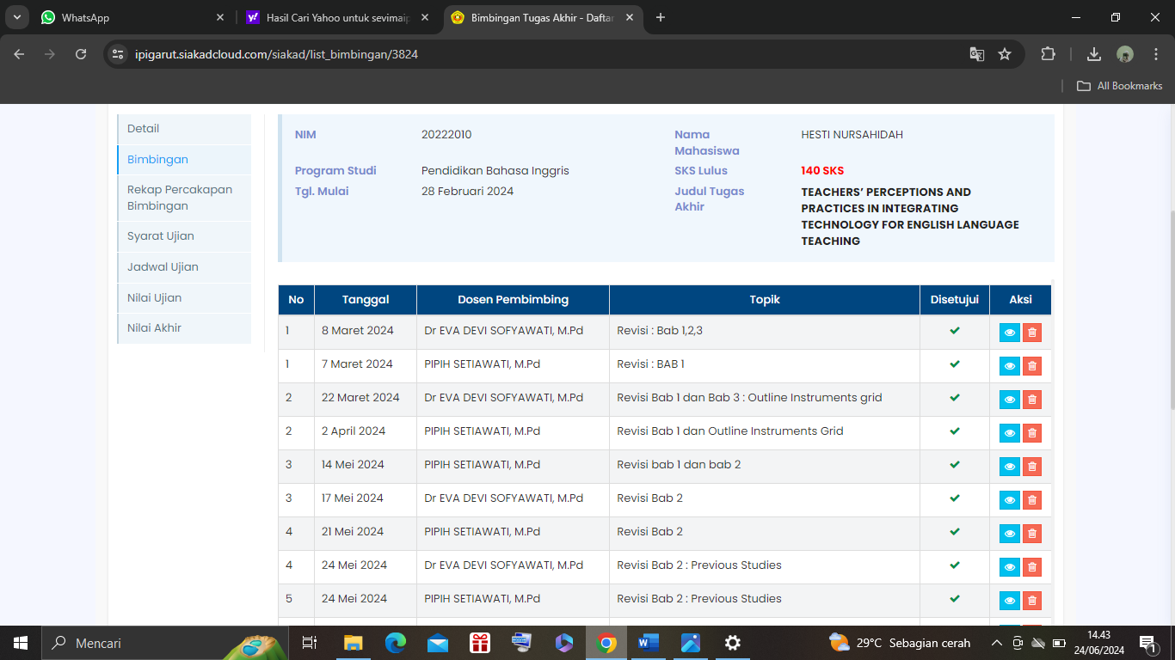
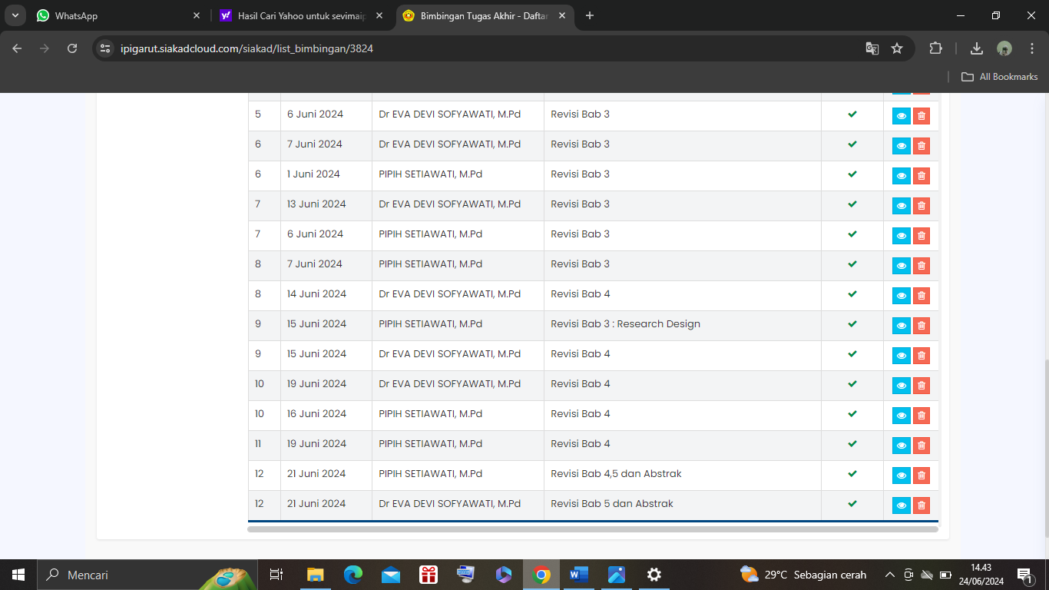

RESEARCH PERMIT LETTERS
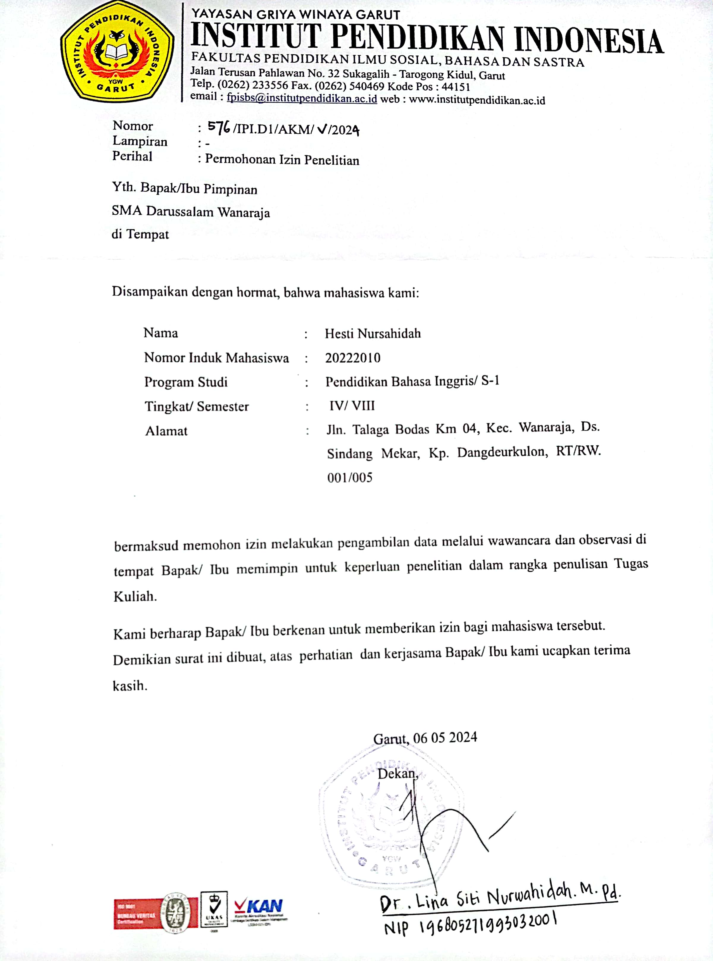

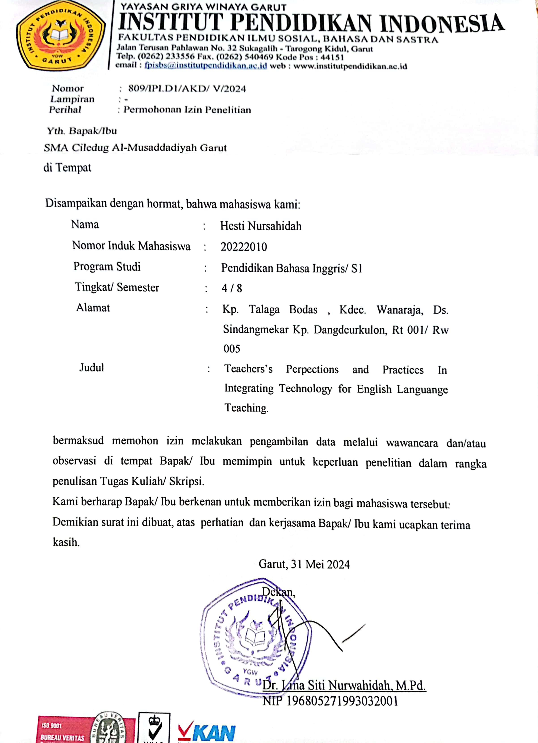

TURNITIN CHECK RESULTS
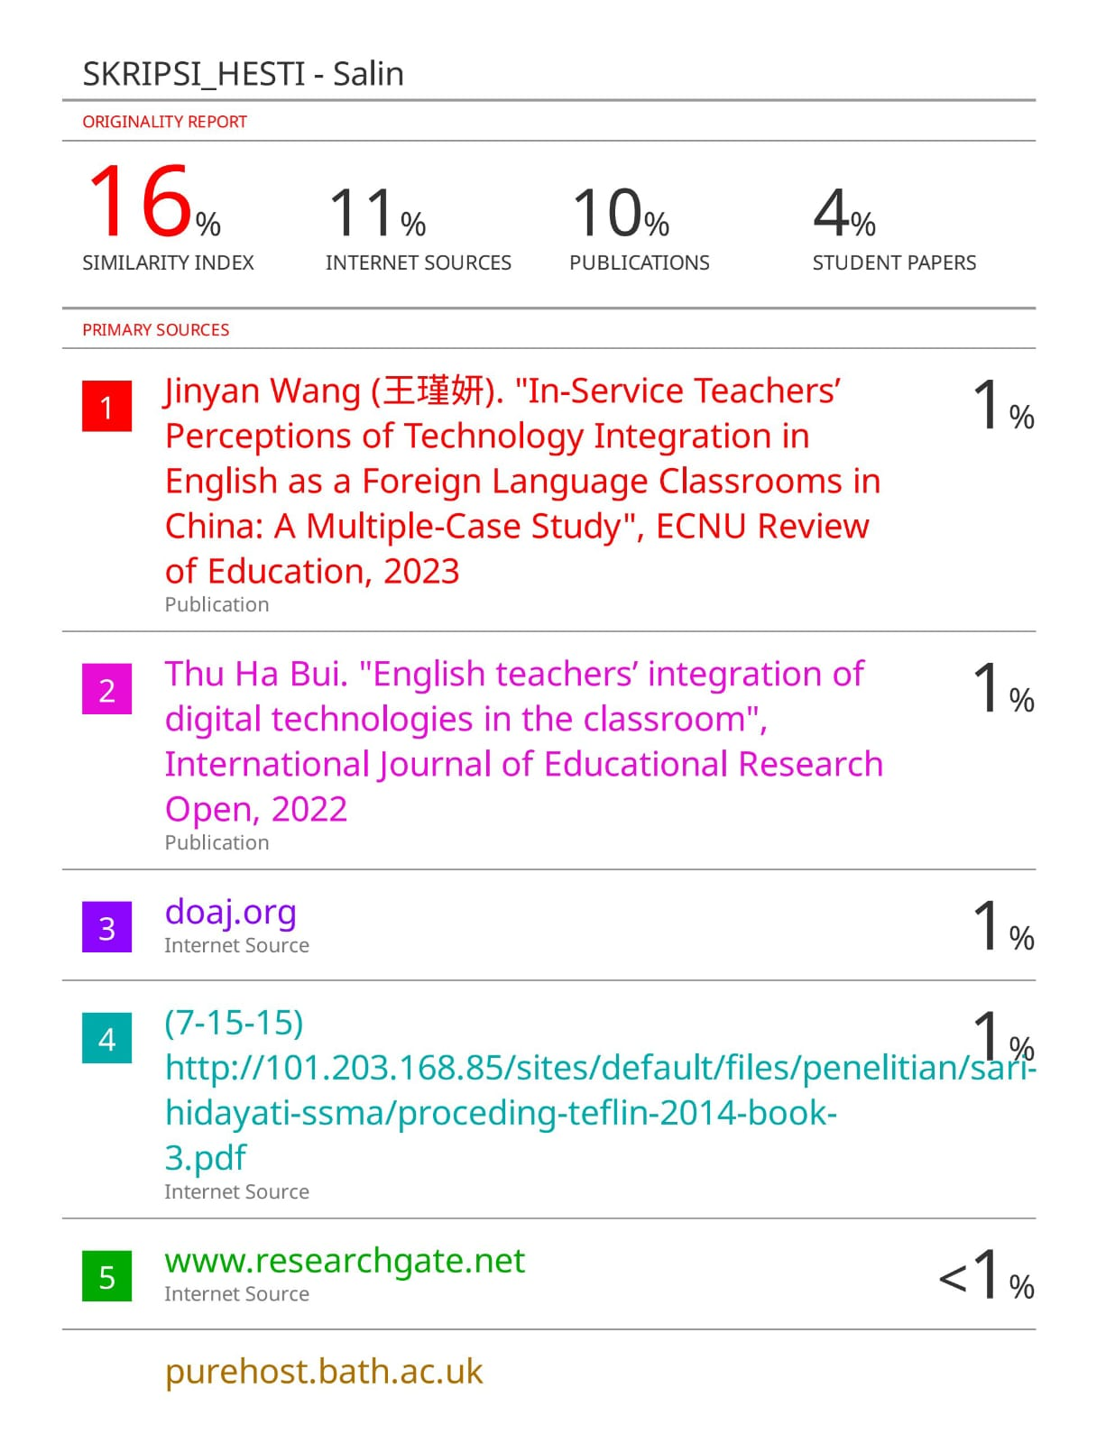

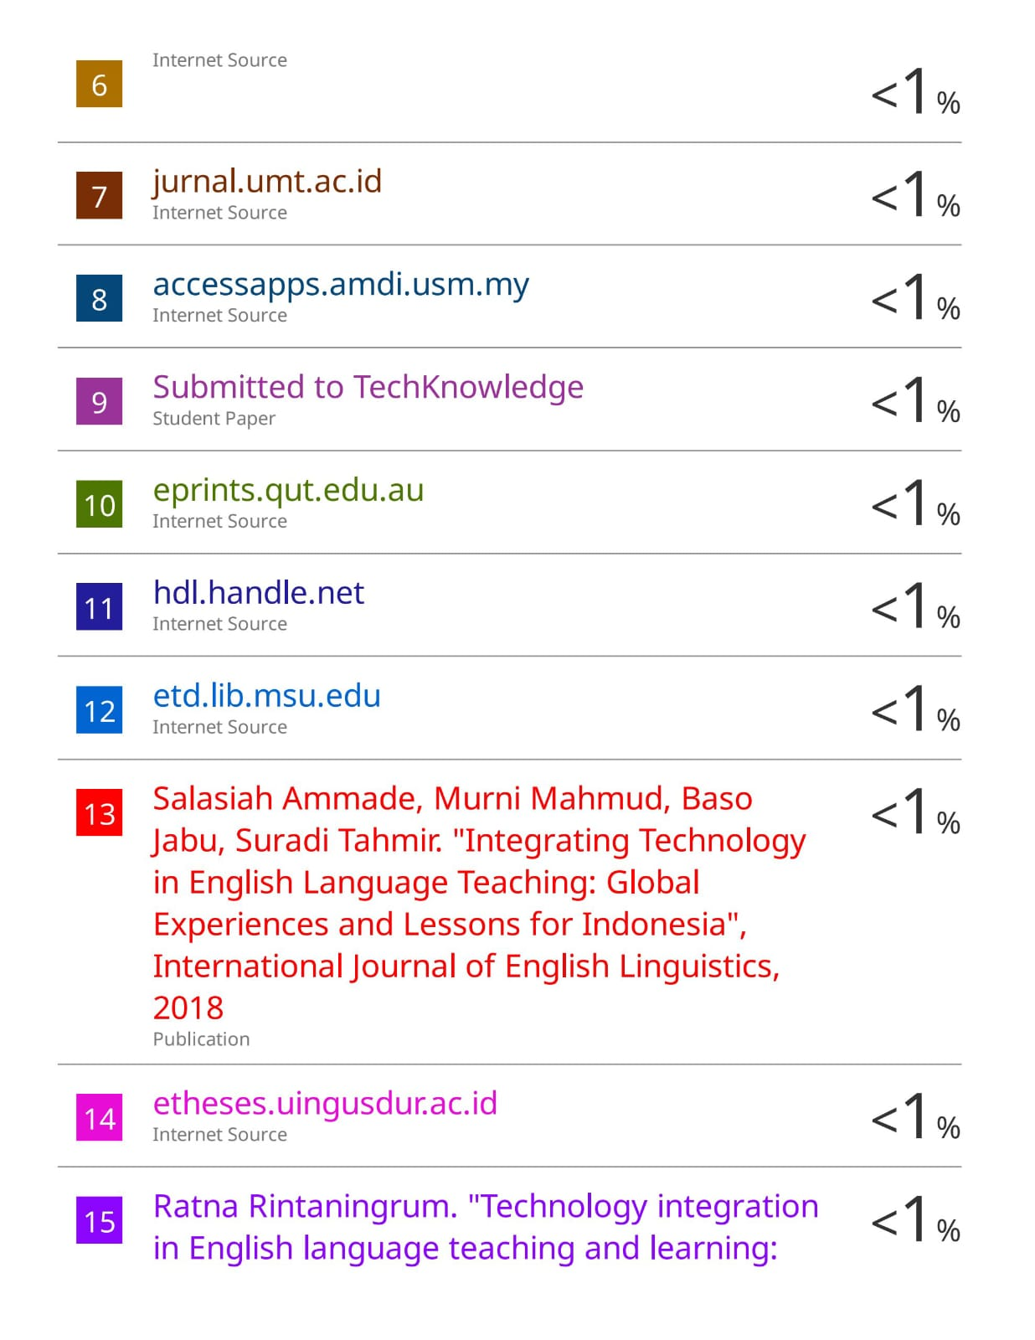



CURRICULUM VITAE

