GRAMMAR QUALITY BETWEEN ARTIFICIAL INTELLIGENCE TRANSLATION AND ENGLISH COLLEGE STUDENTS’ TRANSLATION: A COMPARATIVE STUDY
A PAPER
Submitted to the English Education Program of IPI Garut
as a Partial Fulfillment of the Requirements for the
Bachelor’s Degree

by
Henda Hendardi
20224007
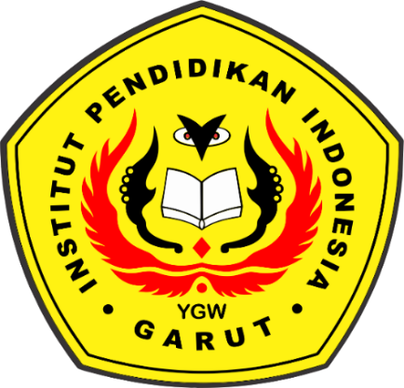

ENGLISH EDUCATION PROGRAM
FACULTY OF SOCIAL SCIENCE LANGUAGE AND
LITERATURE EDUCATION
INSTITUT PENDIDIKAN INDONESIA
GARUT
2024

APPROVAL SHEET
GRAMMAR QUALITY BETWEEN ARTIFICIAL INTELLIGENCE TRANSLATION AND ENGLISH COLLEGE STUDENTS’ TRANSLATION: A COMPARATIVE STUDY

Written By:
Henda Hendardi
20224007

First Supervisor Second Supervisor

Dr. Lucky Rahayu Nurjamin, M.Pd. Rochmaniah, M.Pd
NIDN. 0410098901 NIDN. 0406065301

Acknowledged by:
Head of English Education Program

Anne Ratna S, M.Pd.
NIDN. 0415038601

LEGIMATION OF EXAMINATION BOARD
GRAMMAR QUALITY BETWEEN ARTIFICIAL INTELLIGENCE TRANSLATION AND ENGLISH COLLEGE STUDENTS’ TRANSLATION: A COMPARATIVE STUDY

Written by:
Henda Hendardi
NIM. 20224007

This paper has been examined on July 27th, 2024

First Examiner Second Examiner Third Examiner

Dr. Yustika Nur F, M.Pd. Irsyad Nugraha, M.Pd. Anne Ratna Suminar, M.Pd.
NIDN. 0412069004 NIDN. 0408038304 NIDN. 0415038601

Certified by:
Dean of Faculty of Social Science,
Language, and Literature Education

Dr. Lina Siti Nurwahidah, M.Pd.
NIDN. 196805271993032001

MOTTO
“Allah Gives Me Eveything, Without Allah, we cannot do anything. Alhamdulillah for Everything.” –Khabib Nurmagomedov

PERNYATAAN

Dengan ini, peneliti menyatakan bahwa skripsi yang berjudul “KUALITAS GRAMMAR ANTARA HASIL PENERJEMAHAN ARTIFICIAL INTELLIGENCE DAN HASIL PENERJEMAHAN MAHASISWA: PENELITIAN KOMPARATIF” benar-benar ditulis oleh peneliti. Kutipan dan sumber lain telah dilakukan berdasarkan aturan kutipan sesuai dengan etika ilmiah yang berlaku. Oleh karena itu, isi beserta segala kelengkapannya merupakan karya asli peneliti. Dalam hal ini, jika ditemukan hal-hal yang tidak sesuai, peneliti bertanggung jawab dan bersedia menerima segala risiko dan sanksi apapun.

Garut, 27 Juli 2024
Yang membuat pernyataan,

Henda Hendardi
NIM. 20224007

DECLARATION
The researcher hereby declares that this paper entitled GRAMMAR QUALITY BETWEEN ARTIFICIAL INTELLIGENCE TRANSLATION AND ENGLISH COLLEGE STUDENTS’ TRANSLATION: A COMPARATIVE STUDY” was really written by the researcher. Quotation from other sources have been caried out based on citation rules in accordance with applicable scientific ethics. Therefore, the content of this paper and all its completeness are original works of the researcher. In this case, if things are found that are not suitable, the researcher will be responsible and willing to accept any risk and sanctions.

Garut, July 27, 2024
The Researcher,

Henda Hendardi
NIM. 20224007

PREFACE
In the name of Allah, the Most Beneficient, the Most Merciful. All the praises and thanks are due to Allah, who has been giving the writer His guidence, mercy, blessing, and health to finish this paper. Shalawat and salam also deliver to our prophet Muhammad S.A.W, who has led people from the darkness into the brighteness.
Alhamdulillah, the research paper entitled “Grammar Quality Between Artificial Intelligence Translation and College Students’ Translation: A Comparative Study” is completed. This paper is submitted as a partial fulfillment of requirements for Bachelor of Education degree. Hence, the completion of this paper indicates that my study in English Education Department is finished. It discusses about students grammar quality within translating narrative text and what are the translation procedures, methods and startegies that students used to produce a good translated text including a good quality of the grammar. The writer realizes that this paper is still far from being perfect. For that reason, the writer hopes for correction and suggestions, both in terms of content and linguistics aspects.

Garut, July 27, 2024
The Researcher,

Henda Hendardi
NIM. 20224007

ABSTRAK
Penelitian ini bertujuan untuk membandingkan kemampuan penerjemahan teks naratif antara AI dan mahasiswa. Mahasiswa Jurusan Bahasa Inggris di salah satu kampus pendidikan di Garut menjadi populasi dalam penelitian ini. Pengambilan sampel dilakukan secara purposive sampling, dengan tiga mahasiswa semester delapan tahun akademik 2023/2024 dipilih sebagai sampel. Penelitian ini menggunakan metode Perbandingan Kualitatif. Instrumen yang digunakan adalah analisis konten dalam bentuk hasil terjemahan mahasiswa dan AI. Hasil penelitian menunjukkan bahwa siswa memiliki prosedur, metode, dan strategi terjemahan yang bervariasi, sehingga setiap hasil terjemahan mereka memiliki cara yang berbeda dan mengacu pada empat aspek tata bahasa (omission, penambahan, misformation, misordering), yang mempengaruhi hasil terjemahan mereka. Dengan membandingkan dengan AI, tiga siswa tersebut tidak mencapai hasil terjemahan AI yang tidak memiliki kesalahan tata bahasa dengan tingkat akurasi yang tinggi. Siswa mungkin memerlukan peningkatan untuk meningkatkan kemampuan mereka dalam menerjemahkan teks dengan baik tanpa bantuan. Temuan ini menunjukkan bahwa terjemahan meskipun AI sering menunjukkan akurasi dan kefasihan yang lebih tinggi, siswa sering mengalami kesulitan dengan tata bahasa akibat pengaruh bahasa ibu mereka. Dengan membandingkan kedua metode penerjemahan ini, penelitian ini bertujuan untuk meningkatkan pemahaman tentang peran AI dalam pendidikan bahasa dan potensinya untuk mengatasi pemahaman pembelajaran yang berkelanjutan, serta pada akhirnya meningkatkan metode pengajaran terjemahan dan hasil pembelajaran bagi siswa.
Kata Kunci: Kecerdasan Buatan, Akurasi Terjemahan Tata Bahasa, Terjemahan Mahasiswa Perguruan Tinggi Bahasa Inggris, Terjemahan Kecerdasan Buatan.
ABSTRACT

This study aims to determine the comparison between AI and students ability at translating a narrative text. English Department students at one of the educational campuses in Garut are the population in this study. Purposive sampling was utilized in this study; three students in the eight semester of the 2023/2024 academic year were selected as samples in this study. This study used a Qualitative Comparative method. The instruments used were content analysis in the form of student and AI translation outcomes. The results showed that the students had variety translation procedure, methods, and strategy by the result each of them had different ways and it refered to the four grammatical aspects (omission, addition, misformation, misordering), thus influencing them in translating outcomes. By comparing them with AI, three students were not achieving the result of AI text, which there was no grammar error within the high accuracy of translation. The students might needed some enhancements to level up their own ability to translate the proper text without using any assistance. The findings suggest that while AI translations often demonstrate higher accuracy and fluency, students frequently struggle with grammar due to influences from their native language. By comparing these two translation methods, the study seeks to enhance the understanding of AI's role in language education and its potential to address persistent learning gaps, ultimately aiming to improve translation teaching methods and learning outcomes for students.
Keywords : Artificial Intelligence, grammar translation accuracy, English College Students’ translation, Artificial Intelligence Translation.

ACKNOWLEDGEMENTS
Alhamdulillahi Rabbil ‘Alamin, all of my gratitude and praise to Allah swt., the almighty for this merciful and beneficent, for blessing me with mercy and guidence to finish this thesis. The peace is upon our prophet Muhammad saw., with his family and followers. This paper entitled “Grammar Quality between Artificial Translation and English College Students’ Translation: A Comparative Study” is submitted as compulsory fulfillment of the requirements for sarjana pendidikan degree of English Education Program at Social Science, Language, and Literature Education faculty of Indonesia Institute of Education Garut.
Therefore, deepest appreciation and gratitude, expressed to:
- Dr. H. Nizar Alam Hamdani, M.T., M.M., M.Si, the rector of Indonesia Education Institution.
- Dr. Lina Siti Nurwahidah, M.Pd., the Dean of Social Science, Language, and Literature Education Faculty.
- Anne Ratna Suminar, M.Pd., the Head of English Education Program of IPI Garut for allowing the writer to cunduct the research at English Education Program.
- Dr. Lucky Rahayu Nurjamin, M.Pd., the first supervisor, for the support, advice, and allowing the writer to conduct the research in his classes.
- Rochmaniah, M.Pd., the second supervisor, for the support, guidence, and advice until this thesis finished.
- All lecturers of English Education Program in IPI Garut, who have taught all the knowledge to the writer since the first year of study.
- My beloved dad/Empah, Mr. Asep Deny for his support, prayer, and his love to the writer to finish this research.
- My beloved mom/emah, Mrs. Lilis Solihati for her endless love and support and everything in the writer’s entire life and cannot be replaced by anything for my love of my life mother.
- My beloved sisters Nur Aisyah, Hilda Daniar and Risana Dewi Saputri which all of them are my beloved older sisters who always support writer even they kept asking writer’s progression of dealing the thesis.
- My dearest friends of IPI Garut and the second home for writers, HIMADIKSARIS and BEM Nusantara whose people are being in the writers story and they gave everything in the entire four years of studying.
- My classmates, class C class of 2020 who always support and encourage each other, especially Jihad and Samsam who accompanied me as the one only men left in the class, but Samsam attended the most.
- All of writer’s participants, thank you in a billion for having time to do this research fulfillment and did your best in sincerely.
- Lastly, thanks thanks and thanks to myself, for dealing everything since the beginning of the problems appeared, for facing the failure, for solving everything, for keep praying, for not giving up, for keep trying, for keep fighting, for all of your decisions that decides this destiny and experienced all sadness and happiness, and absolutely for finishing this final task, thank you, it may not be easy to spare time to cleared this study at once, it may not be easy to handle all the problems you have, but look at you, you succeed it, you are the champ, you may have loosing and winning in your life, but still, you are the champ. Thank You.

LIST OF TABLES

Table 2.1 Vinay & Darbelnet’s Model of Translation Procedures. 11
Table 2.2 Newmark (1988)’s Translation Procedures 15
Table 2.3 Seguinot (1989)’s translation stratgeies. 20
Table 2.4 Newmark (1988)’s Translation Methods 22
Table 2.5 The Surface Strategy Taxonomy 26
Table 4.1 The Relation Between Translation Procedures and Methods 46
Table 4.2 Grammatical Error in Malin Kundang Text Translation 58
Table 3.1 Malin Kundang Text 77

TABLE OF CONTENTS
GRAMMAR QUALITY BETWEEN ARTIFICIAL INTELLIGENCE TRANSLATION AND ENGLISH COLLEGE STUDENTS’ TRANSLATION: A COMPARATIVE STUDY i
APPROVAL SHEET I
LEGIMATION OF EXAMINATION BOARD II
MOTTO iii
PERNYATAAN iv
DECLARATION v
PREFACE vi
ABSTRAK vii
ABSTRACT viii
ACKNOWLEDGEMENTS ix
LIST OF TABLES xi
TABLE OF CONTENTS xii
CHAPTER I INTRODUCTION 1
1.1 General Remarks 1
1.2 Background of the study 1
1.3 Reasons for Choosing the Topic 5
1.4 Research Question 5
1.5 Research Objective 5
1.6 Significance of the Study 6
1.7 Definition of Terminologies 6
CHAPTER II LITERATURE REVIEW 8
2.1 General Remarks 8
2.2 Definition of Translation 9
2.2.1 Translation Procedures 10
2.2.3 Translation Strategies 20
2.2.4 Translation Methods 21
2.3 Definition of Grammar 25
2.4 Definition of Artificial Intelligence 27
2.4.1 Artificial Intelligence in Learning 27
2.4.2 Artificial Intelligence Types. 29
2.5 Challenges in Language Learning 32
2.5.1 Common Difficulties in Grammatical and Translation Proficiency 32
2.6 Potential of Artificial Intelligence 33
2.6.1 Advantages of Artificial Intelligence 34
2.6.2 Disadvantages of Artificial Intelligence 34
2.7 Literature Review 35
CHAPTER III RESEARCH METHODOLOGY 37
3.1 General Remarks 37
3.2 Research Method 37
3.3 Research Design 38
3.4 Research Participant 39
3.5 Research Instrument 40
3.6 Technique of Data Analysis 40
3.7 Research Procedure 41
CHAPTER IV FINDINGS AND DISCUSSION 42
4.1 General Remarks 42
4.2 The Research Findings 42
4.2.1Translation Procedures 43
4.2.2 Translation Methods 45
4.2.3 Translation Strategies 49
4.2.4 Grammar Qualities 51
4.3 The Research Discussion 55
CHAPTER V CONCLUSIONS AND SUGGESTION 59
5.1 General Remarks 59
5.2 Conclusions 59
5.3 Limitations of The Study 60
5.4 Suggestions 61
References 63
APPENDICES 75
APPENDIX A 76
APPENDIX B 83
APPENDIX C 87
CURRICULUM VITAE 88

CHAPTER I
INTRODUCTION

General Remarks
This section provides a general introduction to the study including the background of the study, reasons for choosing the topic, research question, research objective, significance of the study, and definition of terminologies.

1.2 Background of the study
In the current globalized world, translation plays a crucial role in bridging linguistic and cultural gaps. Translation stands as a pivotal facilitator in the interconnected global landscape, where linguistic and cultural exchanges are commonplace. Besides, translation is an age-old process and has continually evolved throughout the years which there will always be an adaptation in each centuries. For instance, in this modern era, there are two major ways of translation: literary and machine translation (Sharma, 2001). In short, today’s translation is not purely human-translated which most of people called it as Artificial Intelligence (AI).Artficial Intelligence (AI) is currently being widely used in all aspects of society, including English Language Teaching (ELT). It is also mentioned by Bughinn & Manyika (2018), the progress of translation technologies based on application of AI in different aspects have been affected by industrialization, globalization, social media and technology (Altynbekova, 2020). Subsequently, Yang (2023), added that the application of these intelligence tutoring technologies can provide more flexible and personalized learning methods, helping students better understand and master English knowledge, and improve their learning outcomes and motivation. This demonstrates people’s tendency in believing AI as the assistance for translating. Including Facebook founder Mark Zuckerberg, believes that the development of AI will help people in many different areas (Ahmed Mohammed Moneus, Artificial intelligence and human translation: A contrastive study, 2024). On the other hand, there are many textbooks or even E-books for higher education that frequently uses English. Therefore, Adriyati (2023), experiences that language barriers can make it challenging for students to translate words from English Textbooks. Due to the widespread use of current technology, it is now easier to translate words or sentence which one of quick solution is using some AI tools such as “Google Translate”, “Chat-GPT”, “Quillbot” and so on. Indeed, these technologies set an automatic paradigm that people count on these machines ascribed to the accuracy of translating, as the result on Hendy, et.al. (2023) test, GPT models would enhance document-level translation, as they could exploit the context and coherence of the entire document to generate more accurate and fluent translations. Based on this outcome, it implies that AI is trusted enough to be a translate machine which is accurate in translating aspects including Grammatical which is the key of language, as Rofik (2020) notices in his findings that grammar is important in translation which is the most common concern among people.

On the contrary, several studies have demonstrated students’ translation abilities, primarily in Indonesian-English translation, including college students as the participants. The majority of the findings show some common error in four types of errors, namely omission, addition, misinformation, and misordering. In accordance with Siregar, et al., (2022) from 30 questions that have been given to 20 students who have answered many errors that have been found, omission 30,2%, addition 18,2%, misinformation 32%, and misoredering 19, 6%. As well as the finding of Damanik, et al., (2023) the grammatical error is subtition error 63%, omission error 27,8%, addition 7.28% misoredering 100%. These illustrate that the biggest issue in translating for students is the grammar itself. There is one common factor that the students have, as evidenced by Santika et al., (2021) the students often make a grammatical errors which is influenced by their native language Bahasa or interlanguage error. Therefore, the students might violate the four types of errors that can be concluded, grammar remains an important concern along with other aspects of translation.

Furthermore, there are also some previous studies that represent the quality of the student’s Indonesian-English translation. Based on the analysis of the Sukmawati et al., (2021) about the accuracy level of research abstract translation, some of the information within the source text was accurately rendered into the target text, while some of meaning within the translation were missed in the target language. In term of naturalness, most of the translation was possessing high level of naturalness which also referred that the translation was fully understandable for target readers. On the accuracy aspect, it didt merely affect the acceptability of the translation, because the familiarity of the language also determined the acceptability. Therefore, the translation had been in accordance with the rules, norms and culture within the target text that was easily understood and acceptable in the target language. In addition, Anwar et al., (2023) added, some various elements played a role in students’ difficulties. For instance lexical inaccuracies were often linked to vocabulary limitations and unfamiliarity with specific terms. Grammatical challenges, on the other hand, were associated with issues such as sentences structure, verb tense, and syntactical errors.
Based on the previous research above have shown promising results in the main issue of students translation that is grammar. Likewise the four types of errors mentioned above, there are also four major language systems that need to be analyzed by the translator that distinguished by linguist are the meaning of words (lexis), interrelation between words (grammar), the melody (phonology) and the usage in a particular situation (function). (Navickiene, 2018). In this case, students need to be alert on these aspects to decrease their translation issue. In line with Rofik (2020), Grammar was considered important in translation because of some reason. Larson (1998 in Rofik, 2020) stated that each language has its own division of lexicon into classes, such as nouns, verbs, adjectives, etc. Ultimately, the lexical resources are not the only factor, but also the grammatical systems of the language is the main factor that frequently be found in students Indonesian-English Translation. By building upon existing research, this study can contribute to the growing body of knowledge in this area and providing further insights into the students tendency of AI in language education. Further discussion is completely needed regarding to this research aspires to contribute to the advancement of knowledge in the field of language pedagogy and to catalyze a paradigm shift towards more effective, efficient, and inclusive approaches to addressing grammatical and translation learning gaps at the university level.
Based on the gaps identified in previous studies, there are several areas that can be further explored in this research. Firstly, most previous research has focused on grammatical and structural errors made by students, but there has been little comparison between the grammar quality through a translations produced by AI and those produced by students and the texts are mostly found in an essay or just a daily conversation text as the instrument. Secondly, although common errors in student translations have been identified, there has been little discussion on how translation teaching methods can be optimized to reduce these errors. Additionally, the influence of native language and interlanguage errors on the translation process requires more in-depth study to provide practical solutions for mitigating their negative impact. A qualitative approach to analyze translation errors could also offer new insights that quantitative methods cannot provide. Furthermore, the potential of AI technology in translation education has not been thoroughly explored, especially in terms of improving the accuracy and efficiency of student translations. Lastly, the evaluation of the acceptability and naturalness of student translations needs further research to understand how cultural factors and target language norms influence these assessments. By exploring these gaps, this research aims to make significant contributions to the understanding of students’ translation quality.

1.3 Reasons for Choosing the Topic
As one of the researcher’s concern, it is crucial to monitor the next generation’s English learners skill as a conservative estimate they could handle some basic grammar and translation skill and not contingent to the sophisticated tools notably “AI”. Thus, the justification behind selecting this particular topic are:
- Relevance and Timeliness: The topic of applying artificial intelligence (AI) to address grammatical and translation learning gaps at the university level is highly relevant. Due to the use of AI for working the task that attracts researcher to find out the students ability whether their skill is relevant to the AI.
- Persistent Learning Gaps: Despite conventional language teaching approaches, many university-level language learners continue to struggle with mastering grammar rules and translation skills. This issue highlights the need for innovative solutions that can provide targeted support and improve learning outcomes.
- Potential of AI Technology: AI technologies offer promising capabilities in personalizing learning experiences, providing immediate feedback, and adapting to individual learning needs. Exploring the application of AI in language education presents an opportunity to leverage these advancements to address longstanding challenges in language learning. Therefore, researcher wants to know

1.4 Research Question
This research concentrates on how the grammar quality between two different abilities are being compared. To this end, the following research question is:
- How is the grammar quality between AI translation and English college students’ translation?

Research Objective
The objective of this research is to compare the grammatical quality of translation produced by Artificial Intelligence (AI) systems and those created by English Education college students.

1.6 Significance of the Study
The applicated theoretical significance and practical significance in this research are expected to be as follow:

- Theoretical significance
The study deepens readers understanding of the role of AI in language education. By comparing the grammar quality of translation produced by Artificial Intelligence (AI) systems and those originally made by human translation, particularly English Education students, this study offers insights into the capabilities and limitations of AI translation technology.
- Practical significance
  - Students
English Education students are aspiring to become translators can utilize the findings of this research to identify common grammatical errors for improvement in their translation practice.
  - Lecturers
Ultimately, the study Aims to improve learning outcomes for students in language education programs. As the educators are aware of the problems in learning. The research empowers lecturers to facilitate more effective and efficient language learning experiences for their students. By integrating examples from AI-generated translations and human translations into coursework, lecturers can provide students with practical insight into grammatical structures, translation techniques, and quality assessment methods.

1.7 Definition of Terminologies
The definition of terminologies defines some key terms used in this research to avoid misunderstanding.
- Artificial Intelligence (AI) is the branch of computer science which deals with intelligence of machines where an intelligent agent is a system that takes actions which maximize its chances of success. As specified by Saini (2023), AI is the study of ideas which enable computers to do the things that make people seem intelligent, the central principles of AI included such as reasoning, knowledge, planning, learning, communication, perception and the ability to move and manipulate objects.
- According to Advantages and Disadvantages of Artificial Intelligence [AI] (simplilearn.com), there are two main categories of AI:
- Weak AI: Weak AI is a type of AI that can only perform specific tasks. For example, a weak AI might be able to play chess or translate languages.
- Strong AI: Strong AI is a type of AI that can perform any task that a human can.
- Grammar is the study of the classes of words, their inflections, functions and relations in the sentence of language. (ANUGRAHENI, 2016).
- Translation can be considered as a process and as a result. In the first case, it is an action that makes the translation text appear. Translation as a result, in turn, implies a ready-made translated text. (Kurganovna, et.al., 2023).

CHAPTER II
LITERATURE REVIEW

2.1 General Remarks
This chapter reviews the existing literature on translation quality, focusing on grammatical accuracy in translations produced by Artificial Intelligence (AI) systems and human translators, English college students precisely. The review focuses to provide a theoretical foundation for the study, highlight the gaps in this current study, and establish the relevance of comparing AI and human translations consisting the definition of translation, translation strategy, translation procedure, translate method, translation technique, translation, definition of AI, the AI roles in learning, types of AI, challenges in learning for English College students, advantages and disadvantages of AI, and literature review.
Translation course in general of knowledge universe is to elaborate principles that explain and predict the linguistic, cognitive, cultural, and ideological phenomena inherent in the process of transferring a written, oral or multimodal text from the source language to the target language in a specific sociocultural context including the good arranged grammar that could transfer the source and target language to be understood well by the reader or listener. Translation enables effective communication between people around the world. Indeed, this course is quite important to be learnt and practiced, particularly English College students. There are 3 common types of translations: Literary translation, technical translation, and administrative translation. The discussed type of translation in this study is Literary translation due to the target of English Education college must be pursued to translate novels, short stories, plays, poems, and essays. After all the decisions that researcher must take for the next step of collecting the data, the researcher takes the categorized short story a narrative text. In the end, the students are able to translate it without any specified words or meaning which they will require some assist such as library and browsing that will affect the purity of their translation. In other words, free translation is more suitable for literary text while literal translation generally suits scientific and technical texts. Moreover, Newmark (1988) firmly believes that literal translation is the best approach in both semantic and communicative translation (p. 39)

2.2 Definition of Translation
In modern linguistics, the study of the link between languages, as one of the main means of transmission of meaning and the socio-cultural reality, even the most common understanding of it is about the reduced to it is treatment as means of cross-language communication, it also becomes the challenge that must be faced to study the linguistics aspects of cross-language speech activity, which is called as ‘translation’. In accordance with Corina (2011), it is through the translations, people have access to the systems of meaning of other cultures, translation involves accurately and clearly communicating what is being communicated in one language through another. In this case, translation has it is own purpose in general, while as stated by Newmark (1988) in his book A textbook of Translation, there are five purposes of translation. The first purpose is to contribute to peace and understanding between people, groups and nations. The following purpose is to render knowledge in a simple, correct and accessible language. The next purpose is to explain and mediate between cultures taking into consideration the common humanity which he means that this does not mean each translation needs to find the cultural equivalent. The fourth purpose is to translate the universal human’s works that must be kept safe and lives such as: drama, poetry, fiction, philosophy, history, politics and sociology that should be retranslated for each genereations. Futhermore, translator has to avoid being overly specific, losing connotation, metaphor, symbolism, and meaning. Just like the original, translation has to be enchanted rather than just to instruct or inform.
Building on the definition, there are numerous definitions in different paradigms that have been explained by great experts. One such definition in linguistic paradigm comes from John. Cunnison Catford in his book A Linguistic Theory of Translation (1965) by whose paradigm is as same as Peter Newmark’s

definition of translation in linguistic paradigm, he proposes: “Translation is an operation performed on languages: a process of substituting a text in one language for a text in another. Clearly, then any theory of translation must draw upon a theory of language a general linguistic theory.” (Catford, 1965, p.1.). To conclude his work, translation is defined as replacing text in one language (SL) with equivalent text in another language (TL). Additionally, as cited in the preface of a book by Lefevere (1992), translation is, of course, a rewriting of an original text (p.xii)
After determining the definition and purposes of translation, it is crucial to investigate the strategies, procedure, and methods that could possibly support the translation process. In line with Corina (2011), when speaking of translation, there are a few important terms, that have tight connection, and we should be able to distinguish between them. These terms are translation procedure, translation strategy, and translation method. By investigating these aspects, both researcher and reader can acquire a better understanding of the complex process that allows for successful cross-linguistic communication.

2.2.1 Translation Procedures
Translation outlines information and reduces confusion which it makes people get any information easily. In order to make this statement true, it is obviously that the translation itself has to be created to be a good translation, translators have to apply appropriate procedures (Newmark, 1988; Newmark (1998;Larson, 1984; Vinay and Darbelnet, 1973) in translating the source texts into target texts creates suitable and meaningful messages. Therefore, the effectiveness of translation is dependent on translators applying appropriate procedures to ensure that the source text is accurately and meaningfully conveyed in the target text. This is also supported by Gibova (2012) who states that “when analyzing translation of any sort, be it literary or non-literary texts, there are certain categories that allow us to examine how the target text (TT) functions in relation to the source text (ST).
According to Vinay and Darbelnet (1995) there are two main translation strategies, direct and oblique translation which are the main seven procedures that most common be found in any translation majority.
Table 2.1 below presents a categorization of translation procedures as proposed by Vinay and Darbelnet
Table 2.1 Vinay & Darbelnet’s Model of Translation Procedures.
Direct translation  Procedures | Borrowing
Direct translation  Procedures | Calque
Direct translation  Procedures | Literal Translation
Oblique Translation  Procedures | Transposition
Oblique Translation  Procedures | Modulation
Oblique Translation  Procedures | Equivalence
Oblique Translation  Procedures | Adaptation

As detAIled in Table 2.1, Vinay & Darbelnet’s classification of translation procedures encompasses seven methods and it is divided into two main translation strategies direct and oblique translation, where the direct translation procedures refer to methods where the translation closely follows the form and content of the source text including:
- Borrowing: The source language word is transferred directly to the target language. There are numerous example of borrowing word, the simple one and most adapted one is the word “Computer” is borrowed directly from English as well:
Source Language (English): The word “Computer”
Target Language (Bahasa) : The word “Komputer”
In this example, “Computer” is adapted slightly in spelling to fit the phonetic and orthographic system of Bahasa Indonesia, becoming “Komputer”
- Calque: The source language expression is borrowed, where a phrase or expression is translated literally from one language to another thay may preserve the original structure but may not always conform to natural usage in the target language. For instance:
Source Language (Bahasa): “Hari Jumat”
Target Language (English) : “Friday day”
In this example, “Hari Jumat” in Bahasa directly translates to “Friday day” in English. This calque maintains the word-for-word correspondence between the source and target languages, which can sometimes result in a less natural expression in the target language. Therefore, this translation needs to be transferred in a literal translation.
- Literal Translation: a word-for-word translation. Now let’s take the previous sample to be literal translation,
Source Language (Bahasa): “Dia punya banyak uang”
Target Language (English): “He has much money”
In this literal translation, “Dia punya banyak uang” in Bahasa is translated literally to “He has much money” in English. The translation preserves the word-for-word correspondence, mAIntAIning the structre and the meaning of the original sentence. Another example:
Source Language (Bahasa): “Ini idak ada hubungannya!”
Target Language (English): “This has nothing to do!”
In this example. The English expression “Break a leg!” is translated literally into Bahasa as “patahkan kaki!” This literal translation preserves the words but does not convey the idiomatic meaning correctly in Bahasa, where the equivalent expression for wishing good luck would be different.
After discussing direct translation process, there is still any main translation strategies. According to Vinay and Darbelnet (1995), oblique translation means the more complex methods have to be used which at first may look unusual but which nevertheless can permit translators a strict control over the reliability of their work (P,31). Also, Lililanih (2020) added, “When the direct translation fails to assist translators to achieve natural suitable solution, it is better to use oblique (transposition, modulation, equivalence, and adaptation) “. In this case, oblique translation comprises:
- Transposition: Replacing one word class with another without changing the meaning of the message. For example:
Source Language (English): “A beautiful painting”
Target Language (Bahasa): “Lukisan yang indah”
In this example, the English noun phrase “A beautiful painting” has the adjective “beautiful” placed before the noun “painting”. In the Indonesian translation, the adjective “indah” comes after noun “lukisan”, changing the grammatical structure while maintaining the meaning.
- Modulation: A variation of the form of the message, obtained by a change in the point of view. For example:
Source Language (English): “I have no money”
Target Language (Bahasa) : “Saya tidak punya uang”
In this case of modulation, the English phrase “I have no money” is translated into Bahasa Indonesia as “Saya tidak punya uang,” which literally means “I don’t have money.” Instead of directly translating “no money” (which would be “tidak ada uang”), the phrase is modulated to a more natural expression in Bahasa Indonesia.
- Equivalence: Describing the same situation by using completely different stylic or structural methods for producing equivalents texts. As an illustration:
Source Language (Bahasa): “Selamat pagi”
Target Language (English): “Good morning”
In this illustration, the Indonesian greeting “Selamat pagi” is translated to the English equivalent “Good morning”, both phrases are used to greet someone in the morning, demonstrating the equivalence translation method by using a culturally appropriate and meaningful expression in the target language. It might be similar to idiom, indeed, equivalence translation is often used for idioms. It involves finding culturally and contextually appropriate expression in the target language that conveys the same meaning as the source language. For example:
Source Language (Bahasa): “Buah tangan”
Target Language (English): “Souvenir”
In this example, the Indonesian idiom “Buah tangan” (which literally translates to “hand fruit” but means “souvenir” or “gift” brought back from a trip”) is translated to the English equivalent “souvenir.” This is an example of equivalence translation spesifically involving idioms.
- Adaptation: It is used in those cases where the type of situation being referred to by the source language message is unknown in the target language culture. For example:
Source Language (Bahasa): “Selamat Tahun Baru”
Target Language (English): “Happy New Year”
In this example, the Indonesian phrase “Selamat Tahun Baru,” which is a common way to wish someone a good start to the new year, is translated into the English equivalent “Happy New Year,” This adaptation ensures that the sentiment is conveyed appropriately in the target culture, even though a literal translation is “Congratulations On the New Year” that would not sound natural in English.
Another relevant and mostly still as same as Vinay & Darbelnet’s procedures model was elaborated by Newmark (1988) that gives many translation procedures, it is apparent in the Table 2.2 below.

Table 2.2 Newmark (1988)’s Translation Procedures
Procedures | Definition | Example
Transference | Replacing one word class with another without changing the meaning of the message | Source Language (Bahasa): “Makanan khas Indonesia yaitu rendang sangat terkenal di seluruh dunia”  Target Language (English): “Indonesian specialty food known as “rendang” is famous worldwide”
Naturalization | It adapts the source language word first to the normal pronunciation, then to the normal | Source Language (Bahasa): “Ia memiliki kamera baru”  Target Language (English): “He has a new camera”
Cultural equivalence | The source language cultural word is translated by a target language cultural word. | Source Language (Bahasa):  “Orang Indonesia sering minum jamu untuk menjaga kesehatan”  Target Language (English):  “Indonesian people often drink herbal tea to maintain their health”  or retaining the original term with explanation;  Source Language (Bahasa):  “Orang Indonesia sering minum jamu untuk menjaga kesehatan”  Target Language (English):  “Indonesian people often drink jamu, a traditional herbal medicine, to maintain their health”
Descriptive Equivalence | Description has to be weighed against function. To be precise, descriptive equivalence describe the meaning or the expression in the target language. By using descriptive equivalence, translator can explain terms or concepts that have no direct equivalent in the target language, ensuring that the audience still understands the intended meaning and context. | Source language (Bahasa):  “Mereka menikmati sarapan nasi tumpeng, sebuah hidangan khas yang berbentuk kerucut”  Target Language (English):  “They enjoyed breakfast with nasi tumpeng, a traditional dish shaped like a cone”
Synonym | It is used for a source language word where there is no clear one-to-one equivalent, and the word is not important in the text. | Source language (Bahasa):  “Dia memiliki bakat yang luar biasa dalam seni lukis”  Target language (English):  “She has exceptional talent in painting”
Shifts/transpositions | A change in the grammar form from the source language to the target language, such as changing from passive to active voice, or rearranging word order (structural shift), changing grammatical class of word, such as noun to verb (Class shift), changing the level of the unit of translation, such as translating a phrase into word (Unit shifts), and changes within a grammatical system, like singular to plural or definite to indefinite articles (Intra-System shifts). | Example of shit or transposition:  Source language (Bahasa):  “Pohon itu sangat tinggi”  Target languae (English):  “The tree is very tall”  -The structure changes when translated to English, “pohon itu” (the tree) remains the subject, but the adjective “sangat tinggi” is transformed into a predicate adjective following the verb “is.”  Class shift:  Source Language (Bahasa):  “Dia seorang pelari cepat”  Target Language (English):  “He is a fast runner”  -Changes from a noun phrase (Indonesian) to an adjective-noun combination.  Unit Shift:  Source language (Bahasa):  “Dia terkenal karena kebaikannya”  “Dia memiliki kemampuan unntuk menulis dengan cepat”  Target Language (English):  “He is famous for his kindness”  “She can write quickly”  -“Kebaikan” is an adjective in Indonesian, and it becomes noun (kindness) in English.  -“Memiliki kemampuan untuk” (has the ability to) is shifted to a single word “can”.
Reduction and expansion | These are used to adjust the length and detail of the txt in the target language to ensure clarity, readability, and preservation of meaning. (Reduction) shortening the text, often by omitting or less important elements, to make the translation more concise while retaining the core meaning. (Expansion) lengthening the text, often by adding explanatory details or additional information, to ensure that the meaning is fully conveyed in the TL. | Source language (Bahasa):  *Baca manual dengan seksama sebelum mengoperasikan perangkat*  -Reduction: “Read the manual before using the device”  -Expansion: “Caredully read the user manual in its entirely before operating the device to ensure proper and safe use”
Paraphrase | An amplification or explanation of the meaning of a segment of the text by using different words and structures while retaining the original meaning. It is often used to simplify complex understandable for the Target language audience. | Source language *Bahasa):  “Meskipun cuaca buruk dan hujan deras, mereka tetap melanjutkan perjalanan menuju puncak gunung”  Target language (English):  -Original : “Despite the bad weather and heavy rain, they continued their journey to the top of the mountain”  -Paraphrased: “Even though the weather was bad and it was raining heavily, they kept going towards the mountain’s peak”  Or it could clarify the ambiguous phrase.  Source language (Bahasa):  “Dia adalah orang yang berhati emas”  Target language (English):  -Original: “He is a person with a heart of gold”  -Paraphrased: “He is a very kind and generous person”

Translation implies more than just converting words, it also requires conveying meaning, cultural nuances, and style. Transference, cultural equivalence, shifts, and modulation are examples of Peter Newmark’s procedures, which provide detailed strategies for specific challenges. Vinay and Darbelnet’s methods, which include borrowing, calque, transposition, and adaptation, provide more comprehensive framework for preserving the meaning of the source text. Integrating these frameworks ensure that translations are accurate, culturally appropriate, and stylistically appropriate. This combined approach provides translators with a variety of tools for improving cross-language communication and understanding by bridging linguistic and cultural gaps.

2.2.3 Translation Strategies
In the field of translation studies, effective translation strategies must be developed and implemented, because, these strategies will guide translator’s decision. Understanding and applying proper translation strategies is essential for achieving accuracy and equivalence between the source and target texts. According to Venuti (2001) conceptualizes translation strategy as a two level phenomenon, asserting that it encompasses the fundamental tasks of selecting the foreign text and devising an appropriate translation method (p, 240).
Talking about translation strategy, Seguinot (1989) differentiates between local strategies, which focus on specific segments of text, and global strategies, which address entire texts. He identifies at least three global strategies that translators can use:
Table 2.3 Seguinot (1989)’s translation stratgeies.
The strategies | Definition | Example
Translating without interruption for as long as possible: | This strategy involves working continuously on the translation of a text without pausing to make corrections or revisions which the goal of it is to keep translating continuously to ensure a smooth process and capture the original meaning of the source text without frequent stops. | A translator works on a chapter of a novel for an hour straight without pausing to review or edit, focusing solely on translating the text.
Correcting surface errors immediately: | It refers to the practice of fixing minor mistakes, such as typos and grammatical errors, as soon as they are noticed during the translation process. | While translating a document, the translator instantly corrects a typo or a misplaced comma as soon as it is spotted
Leaving the monitoring for qualitative or stylistic errors in the text to the revision stage: | This strategy means postponing the identification and correction of deeper issues related to the quality and style of the translation until the later revision phrase. | A translator completes a rough draft of speech text and then revisits it later to refine the tone and style to match the original speech’s intended impact.

On the other hand, Venuti (2001) identifies two global translation strategies: domestication and foreignization. Domestication adapts the source text to the target culture, meeting the expectations of target language readers but potentially reducing the original message. Foreignization, on the other hand, retains the source text’s cultural elements, making the translated text feel foreign to target readers and encouraging interest in other cultures. Domestication may simplify the source text’s message, foreignization should be preferred for preserving the original cultural context, even if it appears strange to some readers.
Assuming all the above definitions, global translation strategies may also be called as translation methods, while local translation strategies may also be called as translation procedures, translation techniques or translation transformation.

2.2.4 Translation Methods
In academic discussions, a translation method is an approach used to convert text from one language to another. There are much methods that can be applied and can vary widely depending on the translator’s objectives, the characteristics of the source and target languages, and the cultural contexts involved. Typical translation methods that mostly found in the realm of translation study encompass eight translation methods. According to Newmark (1988), translation methods are classified as word-for-word translation, literal translation, faithful translation, semantic translation, adaptation, free translation, idiomatic translation, and communicative translation. Based on these methods, the choice of translators depend on the specific requirements of the translation task, including the nature of the text, the expectations of the audience, and the desired impact of the translation. Along with this statement, Translators often combine the methods or choose one predominantly based on these considerations to achieve the best possible outcome in terms of fidelity, readability, and cultural appropriateness. To rephrase the use of these methods, translators should be able to recognize all the definition of these methods that can be expressed simply at the 2.4 Table.
Table 2.4 Newmark (1988)’s Translation Methods
Methods | Definition | Examples
word-for-word translation | This method is a translation in which the source language order is preserved, and the words are translated singly by their most common meanings, out of context. | Source text (Bahasa):  “Anak kecil itu seharusnya pergi bersama ibunya”  Word-for-word (English):  “Small child that should go together mother-his/her ”  Natural Translation (English):  “The little child should go with his/her mother”
literal translation | This method is a translation in which the source language grammatical constructions are converted to their nearest target language equivalence. It Aims for accuracy and clarity but may still result in slightly awkward phrasing in the target language. | Source text (Bahasa):  “ ”  Literal Translation (English):  “The small child should go together with his/her mother”  Natural Translation (English):  “The little child should go with his/her mother”
faithful translation | This method tries to reproduce the precise textual meaning of the original within the constraints of the target language grammatical structures. | Source text (Bahasa):  “Anak kecil itu seharusnya pergi bersama ibunya”  FAIthful translation (English):  “The little kid should go with his/her mother”  Natural Translation (English):  “The little child should go with his/her mother”
semantic translation | This method focuses on conveying the meaning of the original text. It differs from faithful translation only as far as it must take more account of the aesthetic values of the source language text or idiomatic expression. It Aims to preserve the original text’s meaning and tone but adapts it to be more readable and relevant in the target language. | Source text (Bahasa):  “Dia tahu jalan pintas agar dia datang tepat waktu bekerja”  Semantic translation (English):  “He knows the shortcut to come in time to work”
adaptation | This method is considered to be the freest form of translation. It involves altering the text to fit the cultural context and norms of the target language, often used for creative works like literature or drama. The goal is to ensure that the next resonates with the target audience. | Original sentence (Bahasa):  “Cerita ini menceritakan tentang bagAImana leluhur kami bertahan hidup”  Adaptation (English):  “This story is about the survive of our ancestors”
free translation | This translation produces the target language text without the style, for or content of the overall meaning and message of the original text rather than sticking closely to its exact words or structure. It involves more significant rephrasing to ensure clarity and naturalness. | Original text (Bahsasa):  “Motor ini sudah berumur sangat tua tetapi masih dapat digunakan”  Free Transaltion (English):  “The motorcycle is antique but still functional”
idiomatic translation | This method Aims to use natural expressions and idioms in the target language that convey the same meaning as the original text. | Original text (Bahasa):  “Ujian tadi sangat amat mudah”  Idiomatic translation (English):  “The test was a piece of cake”  Natural translation (Enlgish):  “The test was very very easy”
communicative translation | This methods prioritizes naturalness in conveying the message to the target audience, often adapting the text to ensure it is easily understandable. | Original text (Bahasa):  “Penemuan baru ini akan mengubah cara kita melihat teknologi”  Semantic translation (English):  “This new discovery will change the way we look at technology”

2.3 Definition of Grammar
In the aspect of writing, both grammar and translation are crucial in daily language which is a communication tool that is organized in the form of units, such as words, groups of words, clauses, and also sentences that are spoken either orally or in writing. Language is composed of various words and grammatical structures. Each language emphasizes different aspects of grammar, leading to distinctions among them. Some languages ​​feature a straightforward structure but compensate with intricate rules that allow for the seamless combination of words (Panjaitan, 2023). Grammar is a systematic framework that underpins the structure and function of language, governing the arrangement of words and phrases to convey meaning. Based on this definition, the use of proper structure in language matters, it is also stated by Siregar (2022) that, grammar refers to the basics and structure of language, including the construction of clear and correct sentences as well as the proper form of words. Grammar is a rule that must be adhered to because grammar has an important function in communication. Incorrect use of grammar can lead to miscommunication. In the scale of writing, there is also a strategy for analyzing the errors in a text which is called as a surface Strategy Taxonomy. Dulay et al., (1982) defines that there are four major grammar errors that is being analyzed in the surface strategy taxonomy; Omission, addition, selection, misordering. Here below is the detailed definitions of those four aspects:

Table 2.5 The Surface Strategy Taxonomy
Taxonomy | Definition | Example
Omission | Omission is a type of errors which are characterized by the absence of an item that must appear in a well-formed utterance. The missing part of to be/ Copular verb, article, -s as plural marker, -s as possessive, -s asthird singular person/present tense. | -I a student (I am a student)  -I have book ( I have a book)  -There are two car (two cars)  -Rian father (Rian’s Father)  -He see you (He sees you)
Addition | Addition is a type of errors which are characterized by the presence of item which must not appear in a well-formed utterance. There are also three kind of errors of addition; double markings, regularization, simple addition. | -She doesn’t knows ( double markings)  -Two mouses. It should be mice (reguralization)  -The fishes doesn’t eat. It should be fish and remove the –es (Simple addition)
Misformation (error of selection) | Misformation errors are those characterized by the use of the wrong form of the morpheme or structure. | - Goed instead of went  - That dogs are mine instead of Those dogs are mine  - Me don’t like it instead of I don’t like it
Misordering | Misordering is characterized by the incorrect placement of a morpheme or group of morpheme in an utterance. | -I don’t know who is she instead of I don’t know who she is

2.4 Definition of Artificial Intelligence
The Artificial Intelligence (AI) which it refers to the stimulation of human intelligence proceeded by computer systems. Quoted to Norvig (2010), Artificial Intelligence (AI) refers to the capability of machines to imitate intelligent human behavior, enabling them to learn from experience, adjust to new inputs, and perform tasks autonomously. AI encompasses a broad range of techniques, including machine learning, natural language processing, computer vision, and robotics, which aim to replicate human cognitive abilities. By analyzing large data sets, recognizing patterns, and making decisions based on probabilistic reasoning, AI systems can assist in solving complex problems and improving efficiency across various domains. Over and above that, the field of artificial intelligence (AI) has seen rapid advancements in recent years particularly with the introduction and adoption of large language models. With improved capabilities in areas like machine learning and natural language processing, AI has permeated diverse sectors including healthcare, business, and significantly – education (YEŞİLYURT, 2023). There are many different definitions of what exactly AI is. As Schmidt, et.al. (2022) mention that Artificial intelligence (AI) is a broad term used to describe a collection of technologies that can solve problems and perform tasks to achieve defined objectives without explicit human guidance.

2.4.1 Artificial Intelligence in Learning
At the present time, doing Task and even test in learning have become easier for students who are not really mastering the material, they tend to take advantage of Artificial Intelligence which is able to be reached every time and anytime. The use of Artificial Intelligence (AI) in learning, especially those who learn Foreign Language mainly English learning has emerged as a promising way to transform language education. AI technologies have a wide range of applications, from personalized language learning platforms to intelligent tutoring systems and virtual reality-based language immersion experiences, highlighting their advantages, challenges, and potential future directions. (Erna Iftanti, 2023). In pedagogical aspect, Artificial Intelligence (AI) enhances classroom pedagogy by personalizing learning, offering real-time feedback, and increasing engagement. AI-powered platforms adapt content to individual learning styles that the students may gain some benefits. First is in individualized instruction: AI can analyze student performance data and adjust the difficulty level and content to suit each student's learning pace and style. This way increases student engagement and motivation by providing content that is relevant and appropriately challenging. Second, Instant Feedback: AI can provide immediate feedback on assignments and quizzes, allowing students to learn from their mistakes and improve their understanding in real-time.Intelligent tutoring systems provide instant, precise feedback, helping student’s correct mistakes efficiently. Third, Chatbots and Virtual Assistants: AI-powered chatbots can answer students' questions and provide assistance outside classroom hours, enhancing accessibility to learning resources. The benefit gained is the increasing motivation by making learning more enjoyable and interactive. Fourth, Predictive Analytics: AI can predict student performance trends, allowing educators to intervene early and provide support to at-risk students. This could support teachers in refining their teaching strategies and curriculum design based on concrete data. AI tools like chatbots and gamified elements make learning interactive and enjoyable. Educators benefit from AI's data analytics, which inform instructional decisions and identify at-risk students for timely intervention. AI also supports collaborative learning by optimizing group dynamics and reducing teachers' administrative burden, allowing them to concentrate on student-centered activities. Overall, AI transforms education by tailoring learning experiences and improving outcomes for both students and educators.
Further evidence of AI in learning toward student’s motivation by earning a lot of benefits from AI. As stated in Moybeka, et.al. (2023), AI has significant implications for EFL students' motivation. While it offers numerous benefits such as personalization, immediate feedback, and gamification, it also raises concerns about overreliance, loss of intrinsic motivation, data privacy, and bias. Which this statement could be recognized that many students are utilizing AI in learning. No matter how, this impact could also bring the worried from the educator itself, as mentioned by Kyoungwon, et.al. (2021), Instructors worry that relying too much on AI systems might compromise the student’s ability to learn independently, solve problems creatively, and think critically.

2.4.2 Artificial Intelligence Types.
Artificial Intelligence (AI) encompasses a diverse array of technologies, each designed to perform tasks that typically require human intelligence. Broadly, AI can be categorized into three primary types: Narrow AI, General AI, and Super intelligent AI. Narrow AI, also known as Weak AI, is specialized in performing specific tasks, such as image recognition or language translation, and lacks generalization beyond its predefined functions. General AI, or Strong AI, Aims to replicate human cognitive abilities, enabling it to understand, learn, and apply knowledge across a wide range of tasks, much like a human being. The theoretical concept of Super intelligent AI envisions an intelligence that surpasses human capabilities in all aspects, including creativity, problem-solving, and social intelligence. While Narrow AI is prevalent and widely implemented in contemporary applications, General AI and Super intelligent AI remain largely aspirational, driving ongoing research and ethical discussions within the field of artificial intelligence.
- Chatbot: In terms of Artificial Intelligence, there are several types of the AI itself. Although, the most consumed types of AI, largely the students. The most common type that is genuinely common is the Narrow AI. Narrow AI has been has been created for specific tasks and it is designed to address limited, single tasks. A great part of the currently functioning systems of artificial intelligence are exactly this type of it, which performs clearly defined tasks. This is a technology, which allows high functioning systems to repeat, and even surpass human skills in terms of their assigned tasks. (Todorova, 2019). According to this statement, what people used to find in their daily life could be Google assistant, Siri or Alexa which are responsive to the human’s voice command, and the most highlighted is Chatbot whereas the most acquinted one is ChatGPT. This AI has become a favorite among students, because of the ChatGPT’s ability to learn from both structured and unstructured data makes it a highly flexible and versatile conversational AI tool (Tselikas, 2023). In addition, Tselikas, et.al. (2023), added that “The core advantages of such extensive language models are their ability to understand the context of a given input and produce the correct output”. As could be concluded, this chatbot is far more enough for the students to do their homework or assessment without even thinking or checking their errors. Once more, all solutions that are feasible today can be categorized as Narrow AI (Buxmann and Schmidt, 2019 in Schlegel, et.al. 2021).
- Neural machine: This type of AI is frequently used in all stages of human life. Machine Translation (MT) is an important task that aims to translate natural language sentences using computers. As well as in accordance with Tan, et.al. (2020), say that in recent years, end-to-end neural machine translation (NMT) has achieved great success and has become the new mainstream method in practical MT systems. Recent advances in neural machine translation (NMT) have led to astonishing translation quality of research systems in evaluation campAIgns as well as for commercial systems. These improvements even led to discussions whether automatic machine translation is already on par with human translation (Barrault et.al.., 2019 cited in Nieuheus, 2021). Regarding to the researches, this (NMT) type is also well-known as Google translate which cannot be denied that it has the equal functional as the Chatbot system, whereas it is true that Google translate was very useful specially for non-English Department. when they found some new words that they do not know the meaning of the words even if in Indonesian or English language. (Salasiah Ammade, 2023). On the other hand, Neural Machine Translation or NMT, is rapid and unpredictable, and it is almost impossible to predict common errors produced over time. (Masaru Yamada, 2019).
- Advanced Artificial Intelligence Tool: In this day and age, internet has made numerous tools to ease people’s daily life, including the online writing tools that provides almost complete all the students’ necessity. From spellcheckers to grammar-checkers, from writing prompts to plagiarism-checkers, there are a multitude of tools avAIlable online to help writers improve the quality and accuracy of their work. In line with Marzuki, et.al. (2023), state that the use of Artificial Intelligent (AI)-powered writing tools in English as a foreign language (EFL) classroom is increasing rapidly. These tools include grammar checks, writing AIds, and programs that can create written works like essays without human help. For instance, grammarly has become more helpful to assist some poor student’s grammatical ability, moreover Aprilia, et.al. (2022) refer to their finding that Grammarly is beneficial to improve the accuracy of writing, in particular, descriptive text. The implementation of Grammarly usage in descriptive text learning runs smoothly. The teacher gives assignments that are based on the lesson being studied. In accordance with reality, how to use this platform is indeed simple, once it is activated whether on Web site, Microsoft Word, Power point and so on. This tool relates to another tool which is absolutely complete for writing tools including Grammar-checker likewise translation auto correct. Quillbot can help students find writing errors such as punctuation and grammar and others. (Amanda, et.al. 2023). This kind of AI must be used frequently as well as ChatGPT, as according to (Dale, 2020 in Amanda, et.al., 2023), QuillBot is one of the most popular free paraphrasing tools. QuillBot offers a product that uses artificial intelligence (AI) to suggest paraphrases. AI methods combine several approaches to deep learning and natural language analysis. QuillBot also provides automatically delete, add, and change words to create new sentences which it makes the writing completely different even it was plagiarism. QuillBot has seven useful features, including 1) Standard Mode, which serves to balance changes to the text that you input by keeping it from changing the actual meaning of the text and making it look more original; 2) Fluency Mode, which is a feature that focuses on making text look natural and using correct and proper grammar in English. This feature makes only minor changes to the text, but it will retAIn the original meaning of the text well; 3) Creativity Mode, which focuses on changing as much as possible in the inputted text. However, this may result in the meaning or overall coherence of the results being altered. This mode can be useful if your text wants to look very different from the original text; 4) Creative+Mode, which is used to make changes that are more intuitive and more grammatical in-depth, such as common phrases or sayings; 5) Formal Mode, which is a mode that functions to change the text so that it sounds more appropriate for a formal audience. This mode is great if you are writing in an academic or business context; 6) Shorten Mode, serves to shorten the text as much as possible while maintaining the meaning in it. Shorten mode is especially useful if you are trying to reduce the word count or the overall size of the text; and 7) Expand Mode, serves to try to increase the length of the text by adding more words if possible. (Fitria, 2021). Come to an end, this tool provides an alternate option for students to write in English. Students recognize the tool's functions, which include paraphrasing, summarizing, grammar checking, and plagiarism checking. It is also user-friendly and accessible anytime.

2.5 Challenges in Language Learning
In the field of language learning, mainly English the language of education, business, and tourism and so on. As believed by Brown (2007), foreign language is a long and complex process to be learnt, because learners are required to cover all the aspects of a new language such as the structure and culture of the target language. There are a few problems that often be encountered by the learners, such as the cultural differences of course this is the most obvious difficulty, then accent as part of speaking proficiency include the pronunciation, and the mAIn trouble are grammar and translation. Looking at these issues, there should be a way to be solved for a better learning, eventually, in the finding of Mohammed (2018), learning English as a foreign language depends on methods, teacher’s role, students performance and environment, the learners must have a good plan and use the best techniques to overcome the difficulties of learning English such as practicing, making contacts with English native speakers, have a good attitude, reading a lot and etc.

2.5.1 Common Difficulties in Grammatical and Translation Proficiency
Teaching and learning English as second language, moreover a new language will not be as smooth as most people expect. Related to Farhana, et.al. (2018), found that most of the students were afraid and nervous to communicate in English. Therefore, educators must take the action to provide them by supporting their ability in many ways. Attached to this study, communicating in English must be involving the grammatical and translation as the language proficiency key. Yet, the common problems are still moving around among the higher education students. Translating is a complicated task as it involves two different languages with two different systems. (Yuliasri, 2016). Yuliasri (2016) also added, that Indonesian students find difficulties because they have to produce English writing which requires good mastery of English, including grammar. Additionally, based on the result of Refnita (2014), interviews show that the students‘grammatical problems were mostly caused by lack of grammatical competence and language awareness in English. Consequently, this may affect the student’s ability on writing grammatically correct sentences. In this case, it is reasonable to state that the students were academically lacking in grammatical competency.

2.6 Potential of Artificial Intelligence
Regarding to the issues that Univeristy-Level students have, it is impossible If there is no one of them that utilizes these smart and sophisticated tools as their problem solving. Students might get personalized learning through the adaptivity of using AI, which AI enables learning experiences to be customized to each student's specific needs, preferences, and learning styles. Besides, AI can be a toolset for improving the adaptivity of edtech (Technology, 2023). The potential of AI to fulfil the gaps of learning issues is highly demonstrated through Nuryadin, et.al. (2023), find that AI provides great potential to improve the quality and efficiency of the learning process. With the help of AI, the student learning experience becomes more personalized, assessments become more objective, and administrative processes become more efficient. As technology continues to evolve and infiltrate various aspects of human lives, of course with the potential of education, since AI has the power to transform the way human learn, teach, and interact with knowledge. In line with Ardiansah (2023), says that “One of the most significant advantages of incorporating AI in education is the potential to personalize learning experiences. Every student has unique learning preferences, strengths, and weaknesses”. Accordingly, the potential rate of AI in learning is quite high. However, it is undeniable that this potential could bring the advantage and even the disadvantage itself.

2.6.1 Advantages of Artificial Intelligence
There are numerous beneficial experiences through the Artificial Intelligence in developing students’ English proficiency. For instance, research by Zheng and Xing, (2020 in Rusmiyanto, et.al., 2023) investigated there is a pedagogical benefits of an AI-powered adaptive learning platform and found that it effectively personalized language instruction to meet learners' individual needs. Additionally, the study emphasized the importance of adaptive assessments and personalized feedback in promoting learners' progress and engagement. (Rusmiyanto, 2023). Based on the results of Kumala Dewi, et.al. (2021) study, it can be stated that AI's function in learning can have an impact on a .intelligence (AI) in the form of apps, websites, and other tools to help them interpret difficult words, construct a sentence, improve their writing and listening abilities, and learn other language skills. As connected to another statement which has been declared by Rahutomo et.al., (2019 cited in Iftiani,2023) Artificial Intelligence (AI) can provide the benefits of time efficiency and minimize human error compared to traditional methods.

2.6.2 Disadvantages of Artificial Intelligence
Behind all the goodness of AI have served to human, there is also a lack of perfection to assist every human’s life, in particular research finding in Ahmad et.al, (2023) show that AI significantly impacts the loss of human decision-making and makes humans lazy. The findings show that 68.9% of laziness in humans, 68.6% in personal privacy and security issues, and 27.7% in the loss of decision-making are due to the impact of artificial intelligence in Pakistani and Chinese society. This brings opinion about technology could destroy the human life by down creasing the inclination on learning, in accordance with the previous research by various scholars has also highlighted AI as a major reason for the gradual decline in people's decision-making capabilities. Alike the findings of Sabharwal et.al., (2023) study, further support the notion that the increasing reliance on AI can gradually diminish human decision-making abilities. The results confirm that AI is indeed a significant factor contributing to the erosion of human decision-making power. Along with the weakness of AI based on the above statement, it is possible that the user could get account hacked which contains the data of user security and privacy as mentioned on the finding of Sabharwal et.al., (2023), (AI) technology in the educational sector has the potential to cause security and privacy concerns among students, teachers, and institutions. It is critical to recognize that errors can occur, potentially posing significant security and privacy risks. Furthermore, inside educational organizations, contact between staff with varying degrees of competence increases the risk of hacking or unauthorized access to personal and institutional data.

2.7 Literature Review
There are several previous studies related to this research, the researcher Based on the most recent research time and the proximity of the topic to the current study, this section will only review a few studies related to Artificial Inletilligence in learning.
The first study was supervised by Li et al., (2019) under the title “HUMAN VS. AI: AN ASSESMENT OF THE TRANSLATION QUALITY BETWEEN TRANSLATORS AND MACHINE TRANSLATION.” This article made an assessment of translations of 4 selected major online machine translation platforms from perspectives of efficiency, operating mode and condition. The outputs of machine and human were compared by employing new “6-4” table and comprehensive error rate. Based on the research findings, the author predicts that machine translation cannot possibly replace human translation and the two will continue to coexist in the foreseeable future.
The second research was conducted by Moneus et al., (2024), with the title “Artificial intelligence and human translation: A contrastive study based on legal texts” This study thus aimed to examine any remaining contrasts between human and AI translation in the legal field to investigate the potential hypothesis that there is now no difference between human and AI translation. The paper thus also examined concerns about whether the need for human translators will decline in the face of AI development, as well as beginning to assess whether it will ever be possible for those in the legal field to depend only on machine translation. To achieve this, a collection of legal texts from various contracts was chosen, and these pieces were both allocated to legal translators and subjected to AI translation systems. Using a contrastive methodology, the study thus examined the differences between AI and human translation, examining the strengths and weaknesses of both approaches and discussing the situations in which each approach might be most effective.
The third related research was conducted by Kong (2022) along with the title “Artificial Intelligence-Based Translation Technology in Translation Teaching”. Which the aim of the study is to implement and compare the current mainstream deep neural network machine translation models, and due to the practical situation, this experiment uses a small-scale English-Chinese bilingual parallel corpus dataset as the experimental data; the translation task language direction selects the English to Chinese direction; the development framework selects the deep learning framework Tensor- Flow; the development experiment model selects several basic neural network translation models, which are recurrent neural network model, long short-term memory network model, and bidirectional recurrent neural network model, and adds attention mechanism to the above models, where transformer uses Tensor2tensor as its implementation framework. Other parameters are set to the same size. The result of this research shows that if a high-quality translation environment can be created with the help of AI technology, it is to create favorable conditions for our university students to improve their English translation skills.

CHAPTER III
RESEARCH METHODOLOGY

3.1 General Remarks
The most necessary part of a research is research methodology as a guideline to attain the research objectives. This chapter presents the procedures of the research. It consists of the research method and design, research setting and participants, research instrument or data collection, technique of data analysis, and research procedure.

3.2 Research Method
This study utilized a qualitative comparative approach methodology to investigate the grammatical quality of translations from Artificial Intelligence (AI) systems and English college students. According to Mello (2022) Qualitative Comparative Analysis (QCA) is a set-theoretic comparative method that treats cases as configurations of conditions. To be specified, Qualitative Comparative Analysis was a method for cross-case comparison that was used to understand which qualitative factors were likely to influence an outcome. Hence, the purposive sampling was involved in this study due to the related of this study design, as in consonance with Etikan (2017), purposive sampling techniques are used in qualitative research by selection of units from individuals, institutions base on a particular purpose that is associated with answering research analysis questions. Texts were selected for translation tasks, and participants generate translations used their own ability or manual translation methods. Data collection included the original texts, AI-generated translations, and students’ translations. Grammatical analysis focused on accuracy, complexity, and consistency, with errors categorized and quantified. Subjective evaluation methods such as expert judgement including one of grammar specialization lecturer to determine the grammar errors found, therefore the discussion ensued between the researcher in judging the participants results and user feedback, provide qualitative insights. Analysis involved thematic interpretation of findings to understand the strengths and limitations of AI and human translation.

3.3 Research Design
This study employed a descriptive qualitative research design to explore the grammatical quality of translation by Artificial Intelligence (AI) systems and English college students. As stated by Creswell (2014), qualitative research is a type of research that explores and understands the meaning in a number of individuals or a group of people who originate a problem social. Qualitative research could be generally be used for research about people’s lives, history, behavior, concepts or phenomena, social problems, etc. One of the main reasons to choose this approach was an experience of researcher whereas this method was able to discover and understood the problem behind this phenomena of AI in translation scope which was infrequently a difficult to do to be understood. In addition, based on Sugiyono (2010) who stated that qualitative research is descriptive. It means that collected data was in the form of words rather than number. To be precise, descriptive qualitative research is a study that explains to understand the phenomenon of the subject of research, behavior, perception, motivation, action, etc. Based on Punch’s (1998) explanation, qualitative research does not use numerical data. Additionally, he stated that the research question and method were more general at the start and become more focused as the study progresses.
In keeping with the previous explanation, the researcher used descriptive qualitative research in conducting this study due to the suitable method for this type of study to describe the AI in Indonesian –English translation to be a sample as compared to the students’ translation result. This study led to the accuracy between students’ translation and AI translation in any grammatical aspects. The text used was one of a local folklore in purely Indonesian text. The find out of this comparison would be visible at the end of the result that showed which one had accuracy translation in a cultural aspects even compared with the most used and trusted AI.

3.4 Research Participant
This research was conducted in a private university in one of the districts in West Java Garut. Involving the higher semester students as the sampling approach was one step that the researcher took due to some inducements that the first or new university students may needed times to learn more about either grammar or translation. The researcher took three students in this research. According to Sugiyono (2010), purposive sampling is collecting data from participants who have special qualifications or are considered representative based on previous evidence. In line with Kumayas (2023), the average of first semester student is significantly lacking in simple grammar, which they actually have to master when they were in junior high or high school; for example, there is very little understanding of parts of speech or tenses, so the lecturer must be more required to explain the material again after giving the test and the results are sometimes satisfying, sometimes not as expected. Overall, the researcher's ability to access the authorization, and preparation of knowledge regarding the essential competencies of students is the reason for the sampling is supported by these factors. Thus, researcher used purposive sampling by taking one non-human participant (ChatGPT) which it was one of the most used and trusted AI phenomenon due to the accuracy and smart and three students as the participants as each classes representatives, due to the limitation where the students’ scores were not balance between communicative grammar and translation grades. In line with creswell (2007), qualitative research recommends conducting three to five participants. There are also the students profiling for fulfilling this research by profiling the participants/students as well that match each other’s : the students had passed the translation and communicative grammar class along with their equal ability of translation which signified that there would be no either advanced or novice students level. In addition to this, there were also the result of communicative grammar and translation’s study of these three participants in initial A,B and C:

- A: Communicative Grammar: 85.00 (A)
Translation : 3.78 (A)
- B: Communicative Grammar: 85.00 (A)
Translation : 3.72 (A)
- C: Communicative Grammar: 85.00 (A)
Translation : 3.68 (A)

3.5 Research Instrument
The instrument of this research was using a test, precisely a direct test on site where the researcher would be able to see the progress of the participants translation without any assistance and it would take approximately thirty minute or one hour for the maximum time due to make the participants felt undisturbed and restful to do the translation. Then, content analysis was a technique that researcher used to collect the data through the narrative text that needed to be translated as visible as possible exists in Table 3.1 on (p, 72) and the story had been summarized by Kumparan on https://berita.99.co/cerita-rakyat-pendek-indonesia/. Therefore, it would be an amusement investigation which the text would have contained some cultural languages that could barely be translated well by translations machine.

3.6 Technique of Data Analysis
Content analysis had been considered as the main technique in this study. According to Zuchidi (1993), this technique earned an objective and systematic description regarding the content contained in communication media. In line with Shava et al., (2021) Qualitative content analysis involves a process designed to condense raw data into categories or themes based on valid inference and interpretations. As well as that, this technique was quite suitable due to examine qualitative data for the insights into participants’ translation strategies, challenges faced, and attitude towards AI translation tools. Creswell (2007) confirms that qualitative content analysis is a flexible method of analyzing qualitative data which uses inductive and deductive approaches or a combination of both approaches in data analysis Apart from this, there are three translation techniques that would become major aspects for the researcher to analysis the data by monitoring those three translation techniques: Literal, Cultural and artistic. As explained by Corina (2011), literal is a well-known technique, which meant that was quite easy to find sources on the topic and it would happen in numerous cases that the researcher faced in the future, while cultural translation focused on matching contexts, artistic translation focused on matching reactions. For instance, literal translation would be the closest thing we all had to the machines world which is match with this study that consists AI as the translation machine while artistic translation.

3.7 Research Procedure
In this study, the researcher had several steps to uncover the finding of this research. In the early stages of research procedure, the researcher set the title of this research on September 2023 and began to start it by finding the literature review on February 27th 2024 as well as formulating the research question and identifying research methodology until it went through the collecting data by generating the procedure of this study by deciding the genre and title of text that would have been translated by the future participants on June 24th, after this stage had been set, the researcher made a next move to demand three participants that qualified the requirements profile where researcher would observe the highest semester students per each classes in one university to translate the provided text and AI tools for translating as well and as the determiner of students translation and grammar quality and it would be a direct translation test, whereas the researcher took part by being situated with the participants while translating the text in order to avoid unexpected situation such as call a friend or cheating that fulfilled on June 26th-27th. The next movement of analyzing data was held on July 13rd through the finding and discussion on July 17th and conclusion plus suggestion on July 23^{rd.}

CHAPTER IV
FINDINGS AND DISCUSSION

4.1 General Remarks
This chapter presents the analysis and findings of the study, focusing on the grammatical quality of translation produced by Artificial Intelligence (AI) systems and English college students. The analysis involved a detailed examination of the translation procedures, translation methods, translation strategies and the accuracy and error patterns in the translation which had been held regarding the result of Students and AI translation. Therefore, the data were gathered by taking a test as the instrument that researcher took for this study. Additionally, qualitative insight from expert evaluations was discussed to provide a comprehensive understanding of the strengths and weakness of both AI and human translations.

4.2 The Research Findings
The concern of this section was discussing the findings of the research based on the data acquired. The data for this study were collected through translation tasks assigned to both AI systems and English college students. Three students and one of AI platform were conducted to translate one of Indonesian narrative text ‘Malin Kundang’. The test and the data collection was carried out from June 27, 2024 at once. During the test, the researcher watched and supervised the students to make sure that they did not use any assistant to translate the text to maintain the purity of their translation. To be sure, the test was conducted to obtain the information on the research question in this study. After collecting the data through the test, the researcher promptly continued on processing the data.
In this section, the researcher discussed the research findings and data analysis using theories that previously mentioned and defined in the Chapter II. Based on the research findings above discusses about which procedures, methods, strategies of translation that participants took, subsequently it would drive to their grammar quality by using this translation approach, then it would answer the research question and relate the, with the current theories. In order to find out the answer of the research question, in this chapter, researcher would define and summarize the result of participant’s translation in four divided aspecst:

4.2.1Translation Procedures
In analyzing the three human and AI translated texts of the story "Malin Kundang." researcher identified various translation procedures used in each text. Each sentence from the translated texts was analyzed based on the translation procedures listed in Table 2.1. by Vinay et al,. (1995) Precisely in Chapter II. These procedures reflect the specific approaches applied by the translators to maintain the meaning, structure, and nuances of the source text in the target text. Several common translation procedures were identified, including literal translation, modulation translation, transposition translation and shift (structure).

4.2.1.1 Students’ Translation Procedures
The First Text from student A shows a tendency to use the Literal translation procedure in almost every sentence. It means that the source language text is translated word for word into target language text. This procedure retains the structure and word order of the original text very strictly, often at the expense of fluency and readability in the target language. For example, the sentence "Once upon a Time there was a family who lived at a beach in Sumatra" is translated literally from the source text, maintaining the word order and sentence structure of the original. While this procedure ensures that the basic meaning of the original text is preserved, the resulting translation is less natural and sometimes confusing for the reader. Based on this find out it is related to the findings of Nurlaila (2017) that the student focuses on translating the form and structure without any addition or reduction into target text.
Meanwhile, student B in their second Text employs the word-for-word translation procedure, which is slightly more flexible than literal translation but still closely adheres to the original text. Sentences like "The pressure of the economic state makes the father go far to find a job" show how the translator retains most of the original structure while attempting to adjust some elements to better fit the target language. This procedure often results in a more understandable translation compared to literal translation, although it can still feel awkward. In selecting this procedure, student B might have several troubles in understanding some sentence, phrase, words or even forget some vocabularies within the text, because according to Umar et al., (2022) The main use of word-for-word translation is either to understand the mechanics of the source language or to construe a difficult text as a pre-translation process. Related to that, based on one of Peter Newmark’s procedures, shift procedures of student B are mostly dominating as well, due to the grammatical issue which needs fixing.
At last, the third text produced by the C student demonstrates the use of the combined modulation and transposition translation procedure which it is aiming to the free translation method, it is still related to the finding of Nurlaila (2017) “In transposition procedures, the translator translated each of the element in the source language’s words, then change the word order into the target language. She also stated that the student or translator who applies this procedure, there is a change of sequence of parts of speech with another without changing the meaning of the message. Those could happened by the change of sequence can also be followed by the change of word class. Back to the first issue, these procedures allow the translator more freedom to convey the meaning and nuances of the original text in a more natural way in the target language. For example, in the sentence "The increasing of economic demands affected the father's intention to try his luck" illustrates the translator's effort to adjust the text to be more fluent and easily understood by the target audience. Although this procedure could sometimes deviate from the original structure, it often produces a translation that is more readable and engaging.

4.2.1.2 AI’s Translation Procedure
Altogether, in translating the story of Malin Kundang, Chat-GPT absolutely had various procedures that could be employed to ensure clarity and naturalness in English. Literal translation was used to directly translate the meaning and structure of the original sentences with minimal adjustments, such as in the sentence, "Once upon a time, there lived a family on the coast of Sumatra." Transposition adjusted the sentence structure to fit English grammar while maintaining the original meaning, exemplified by the sentence, "The worsening economic conditions prompted the father of the family to seek his fortune elsewhere." Modulation changed the perspective to make the sentences sound more natural in English, as seen in "As he grew older, Malin Kundang decided to follow in his father's footsteps and set out to seek his fortune." Idiomatic might as well appeared in the AI translation’s result as shown in a phrase “her heart was filled with joy”. Adaptation adapted cultural references and specific details to make them relevant and understandable to the target audience, illustrated by the sentence, "Shortly after, Malin Kundang was turned into stone, which is now known as 'Batu Malin Kundang' located on Air Manis Beach, Padang, West Sumatra." These procedures ensure that the translated text was both accurate and easily comprehensible while preserving the cultural and emotional nuances of the original story.

4.2.2 Translation Methods
The analysis of the three different human translated result of the Malin Kundang story reveals the use V diagram as the way researcher analyze the outcome of the translation results that the V diagram is attributed to Newmark (1988), which it is a visual approach to translation that emphasizes a balance between the source text (ST) and the target text (TT). The "V" shape represents the process of moving from the ST to the TT while considering various translation strategies, levels of language, and contextual factors. Conversely, before descriptive the V diagram, Peter Newmark also states the relation between procedures and methods table which it helps translator to determine the use of procedure that connect to one of two methods by Newmark as the table provided:

SL EMPHASIS | TL EMPHASIS
Procedures | Procedures
- Borrowing  - Calque  - Description  - Standard Equivalence | - Adaptation  - Generalization  - Modulation  - Expansion/Reduction  - Transposition
SEMANTIC | COMMUNICATIVE
Table 4.1 The Relation Between Translation Procedures and Methods

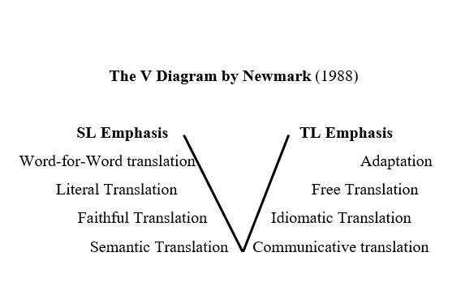
Based on the table 4.1 above, the relation between procedure and methods translation helps a lot the researcher to examine and consider on which procedures the translators used in their translation, it has the same procedure of direct and oblique translation by Vinay and Darbelnet on the table 2.1. There are four which is oriented in source language (SL emphasis) beside the Newmark table above has been provided : 1) word-for-word translation (the order in sentences is maintained and vocabulary translated one by one with the most general sense without considering the context), 2) literal translation (grammar construction is amended as close as possible with the equivalence in the TL, the vocabulary translated one by one without considering the context, 3) faithful translation (translation stays faithful retaining the content and form of SL, 4) semantic translation (translation is more flexible, adapted to his readers, did not fully follow/loyal to the source language text. While which is oriented to the target language (TL emphasis) also consists of four parts: 1) adaptation (a form of translation that comes closest to the target language), 2) free translation, 3) idiomatic translation (translation by producing messages in source language text, use more everyday languages and expressions that do not exist in the source language), and 4) communicative translation (translation by diverting the contextual meaning rightly of the source language text as well as observing the principles of communication that can be understood by the readers). Thus, it would drive to the next determination of considering methods that the translators applied. For instance, there are some sentences that translated by using Transposition procedure such as in the sentence “Growing up, Malin Kundang followed his father’s way to go.” Or even in Modulation procedure as in “"The demand of economical factor that worst arose the father's plan of that family to go." Based on these cases, it would make the reader thinks that translator A used the communicative method translation, as the matter of fact, student A has a tendency on using literal procedure and even dominating whole sentences in Literal method in their sentences. To sum up, student A was more inclined to the Semantic method. Now, to illustrate it in a clearer V diagram descriptive, here below is the illustration of V diagram:

|

4.2.2.1 Students’ Translation Methods
The First student predominantly uses a semantic translation method. This method focuses on preserving the meaning of the original text as close as possible, even if it results in a less natural expression in the target language. The reliance on literal translation throughout the text is a clear indication of this method. The translator's primary goal is to ensure that every detail and nuance of the source text is represented accurately in the target language, often prioritizing fidelity over readability.
The second student leans towards a mostly closed to the balanced approach between semantic and communicative translation. By employing word-for-word translation, the text attempts to stay faithful to the original meaning while making minor adjustments to improve readability. This method is evident in the way the translator tries to maintain the structure and content of the source text, while also considering the target language's syntax and grammar to some extent. On the whole, student B applied word-for-word in almost every sentences, which also approaches the end of semantic translation, that it could be concluded that student B utilizes the semantic translation method.
The Third student employs a communicative translation method. This method prioritizes the effectiveness of communication in the target language, aiming to produce a text that reads naturally and engages the reader. The free translation procedure used throughout the text reflects this approach. The translator's goal is to convey the intended meaning and emotional impact of the original story in a way that is both accessible and enjoyable for the target audience, even if it means making significant changes to the structure and wording of the source text.

4.2.2.2 AI’s Translation Method
In accordance with the V diagram translation theories above, the method part of translating the story of Malin Kundang by Chat-Gpt employed specific strategies to ensure the translated text was clear and natural in English. Communicative translation was prioritized throughout, focusing on conveying the traditional narrative effectively. This method ensures that each sentence, whether through literal translation maintaining the structure and meaning of the original, transposition adjusting for English grammar while preserving meaning, modulation changing perspective for natural English phrasing, or adapting modifying cultural references for relevance, maintained clarity and readability. Each method aligns with Newmark's (1988) approach to convey the story's emotional depth and cultural nuances while making it accessible to English-speaking readers, while preserving the essence of the original narrative in its translated form. Overall, this AI translation completely prioritizes clarity along with naturalness in English, moreover, it ensures the whole sentences are clear and natural in Target Language (English) also easy to be understood in English.

4.2.3 Translation Strategies
"In defining the strategy of translation utilized by all three participants, as Seguinot (1989) has described the three translation strategies, it becomes clear that all three participants adopt a method centered on the immediate correction of surface-level errors. This strategy involves efficiently identifying and rectifying errors in spelling, grammar, punctuation, it is shown by the strikethrough texts. By addressing these errors without delay, the participants aim to preserve the integrity and clarity of the text, ensuring that the final translation is both accurate and easily comprehensible but also facilitates smoother communication and a better understanding of the original content."

4.2.3.1 Student’s Translation Strategies
Misspelling might be one of the most strikethrough words in each three translation results, it is either to make the text becomes more natural or it makes it closer to the nearest meaning. It is illustrated by student A, in the sentence “The demand of the economical factor that worst arose the father’s decision plan of that family to go.” The decision here which is switched into “plan” is a right decision for student A, because when considering which term is closer to the source language "memunculkan niat" it is clear that "plan" is more appropriate than "decision." A plan refers to a detailed proposal for doing or achieving something, which aligns well with the idea of ​​having an intention or prompt. It involves outlining steps and strategies to accomplish a goal, reflecting the forward-looking nature of an intention. On the other hand, a decision refers to a conclusion or resolution reached after consideration. It is more about the outcome of a thought process rather than the initial intention or prompt behind it. Thus, a plan encapsulates the concept of intention more accurately than a decision does. Also, student A had a good vision on correcting a phrase structure, as in “all the staff of that ship was dead.” Determining the correct phrase between "the staff was dead" and "the staff dead," it is essential to consider grammatical structure and the rest of it are just misspelling.
Comparing the translation strategy within the three different participants but still in the same translation strategy, student B has more strikethrough texts compared to student A and C. B students might have a hesitation on choosing the right articles, as in “he was embarrassed to declare that the an old women is his mother" When choosing the correct phrase between "he was embarrassed to declare that the old woman was his mother" and "he was embarrassed to declare that the old woman was his mother," it is important to focus on the grammatical correctness. The correct sentence is "he was embarrassed to declare that the old woman was his mother." This is because "woman" should be singular to match the singular noun "mother," whereas "women" is the plural form. Additionally, using "the old woman" specifies a particular person, which is more appropriate in this context than "an old woman," which would imply any old woman. Therefore, the correct and clear way to express the sentence is "he was embarrassed to declare that the old woman was his mother." There is also one of the translation procedures in the strikethrough text, as in “makes the father complaining his life and go far from home to finding a job.” The expansion in this sentence was about to be proceed, but student B might stick to the literal procedure.
The least correction of the text is found in student C, there are just four immediate corrections found, there are just misspelling such as “Maling” instead of “Malin”, immediate correct of possessive pronoun as in “there was her his mother”, avoiding the word-for-word procedure as in “the ship anchored on one of in the coastlines” which the source text is “berlabuh di salah satu pesisir pantai.” Overall, student C is one step closer to the translating without interruption for as long as possible strategy. But, there is just one correct phrase that should not be corrected by the student in “"she asked God to give gave him a punishment" The unrevised one was correct by using the verb "give" in the infinitive form after "to" because it follows the structure of a standard English sentence where an action (asking) is followed by a request or desire (to give punishment).

4.2.3.2 AI’s Translation Strategy
ahmeIn contrast, AI translation that generated by Chat-GPT is certainly using Translating without interruption for as long as possible, there was no pause, or even a loading that it is in accordance with Seguinot (1989), it is translating continuously on the translation of a text without pausing to make corrections or revisions which the goal of it is to keep translating continuously to ensure a smooth process and capture the original meaning of the source text without frequent stops.

4.2.4 Grammar Qualities
At the conclusion of this session, which could be considered the core of this research, this part might be a part where the translators grammar quality revealed among the translation they did. This could be the core of translation as well, as Rofik (2020) states that, Grammar was considered important in translation because of some reason. In simple terms, this section is the consideration of grammar quality of the three participants alongside one AI platform. This section serves a dual purpose: it not only evaluates the grammatical competence demonstrated by the human participants and the AI ​​but also addresses the research question which has carefully formulated by researcher. Through detailed analysis and comparison, this part of the study Aims to shed light on the effectiveness and reliability of AI in handling grammatical structures compared to human performance. Consequently, it provides crucial insights and answers that support the overall objectives of this research.

4.2.4.1 Students’ Grammar Qualities
In the text provided by student A, several common grammatical errors were identified and corrected for clarity and accuracy. Firstly, the incorrect verb form and usage in the sentence "The demand of economical factors that worst arose the father's plans of that family to leave" can be revised to "The increasing economic demands prompted the father to leave." This correction ensures proper verb tense and eliminates awkward phrasing. Secondly, missing articles can affect the sentence's flow and meaning, as seen in "Once upon a time there was a family who lived at a beach in Sumatra." This should be corrected to "Once upon a time, there was a family who lived on a beach in Sumatra." Adding the article "a" before "beach" clarifies the location and improves readability. Thirdly, awkward phrasing can be addressed, such as in "After a long time, the father did not return home," which is clearer when corrected to "After a long time, the father did not return home." Lastly, incorrect prepositions can change the meaning, as seen in "Malin Kundang and his mother lived in a difficult situation," which should be revised to "Malin Kundang and his mother lived in a difficult situation." This change ensures the correct preposition "in" is used to describe their circumstances accurately. In conclusion, the first student demonstrates a basic understanding of English grammar, but there are several errors that affect its overall quality. Issues include incorrect verb forms, missing articles, and awkward sentence structures. A grammar quality is not as complicated as researcher thought, so it could be categorized as a mid-grammar quality.
In student B translation, several grammatical errors require correction to improve clarity and accuracy. Firstly, the sentence "The pressure of the economic situation made the father go far to find a job" should be corrected to "The pressure of the economic situation made the father leave to find a job." This adjustment ensures correct verb tense usage. Secondly, in the sentence “becoming adulting, Malin Kundang try to follow his dream” There are two errors found in this sentence, the use of verb phrase “becoming” is a present participle “to become” and "adult" is a noun used as a predicate nominative. In English, it's more common to use adjectives or descriptive phrases rather than nouns directly in this context then it should be “growing up” and add some information like “as an adult” instead. The following error occurs in a phrase “Malin Kundang try to follow his father’s path”. It is one of basic grammar error that probably most of beginners have, the subject verb agreement (s/es) or past tense inflection (d/ed), the phrase should be either “tries” or “Malin Kundang tried to follow his father’s path”, but according to the text is a narrative text, which the tense contained is past, it should be “tried” then it becomes like “Growing up as an adult, Malin Kundang tried to follow his dream”. One last basic grammar error was found in the phrase “the father was not go home.” This kind of error needs to be alleviated, mainly for college student level, it is a part of continues tense where the verb “go” after auxiliary verb and the context of this text is using past it would automatically be verb-ing, then it should go like “the father was not going home.” The overall grammar quality of student B still needs some clarifications and corrections, due to the errors of grammars are quite dominating in the whole text between two other participants that B grammar quality is low enough to be compared.
The third student demonstrates a better grasp of English grammar compared to the first two texts, although it still contains several errors. Firstly, "Growing up, Malin Kundang followed his father's footsteps to migrate." The phrase is complete correct but still it is an awkward phrase as same as the B student’s case. Next error that it is most regrettable that this occurred by student C who had been consistent on using past tense in this narrative text, there is one misplaced auxiliary verb, or it is also known as helping verb, in this case, "are" is used to form the passive voice of the verb "attack”, so the exact aux in this case should be either “were” or “was”, regarding to the context of this phrase on a sentence “the ship Malin Kundang was on are attacked by pirates”, the “attacked” here is the ship which it is a singular noun that should be “the ship Malin Kundang was on was attacked by pirates” and the phrase “it turns out” should have been “it turned out” .Lastly, the phrase "to gave" is incorrect because it mixes two different verb forms, in English, “to” is used as an infinitive verb or mostly known as to infinite, no matter what tense behind the “to” is, it still produces verb 1 after “to”, it should be “then she asked God to give him a punishment”. Based on the errors found in text B, the grammar quality of this student’s ability is quite good enough.

4.2.4.2 AI’s Grammar Quality
In contrast, the finding of the AI translation grammar is almost perfect, which this Chat-GPT is largely free of major grammatical errors, demonstrating a good command of English grammar. The identified issues primarily fall into the categories of omission and misordering errors, such as missing commas for clarity and natural flow, and the reordering of phrases for better readability. Specifically, several sentences benefit from the addition of commas to separate clauses and clarify meaning. The reordering of certain phrases enhances the text's clarity and coherence. There were no significant addition or misinformation errors detected, indicating accurate and relevant content throughout the narrative.
Overall, the grammatical quality of this text is high, with minimal errors. The sentences are clear, coherent, and grammatically correct, demonstrating a strong command of English grammar and sentence structure. the text is well-constructed with minor adjustments needed mainly for punctuation and sentence structure improvement. These refinements ensure the story is engaging and easy to follow for readers.

The Research Discussion
This section combines the findings from earlier sections, providing a clear analysis of the translation quality, methods, procedures, and strategies used by AI systems and English college students. By comparing human translators and AI, researcher can understand the strengths and weaknesses of each. This section explores what makes translations effective and points out areas that need improvement including this study that needs to be improved in any aspects.
The analysis shows different patterns in how students and AI translate texts. Both groups used literal translation, modulation, transposition, and free translation to varying degrees. Student A mostly used literal translation, keeping the original structure and word order but often resulting in awkward sentences. Student B used mostly word-for-word translation and produced somewhat rigid translations. Student C preferred free translation, which provided more flexibility and produced more readable and engaging translations, although sometimes deviating from the original structure that student C is worth almost completely successful level in translating. The AI ​​(Chat-GPT) combined several procedures, including literal translation, transposition, modulation, and adaptation, to ensure clarity and naturalness in English while keeping the original meaning and adapting cultural references and details for better understanding.
While analyzing the methods, researcher used the way Peter Newmark used to determine the methods of the translation is being used, as according to Newmark (1991), translation method is a way/translation process which is performed relating to the purpose of translation. Therefore, it is more simplified by establishing both the relation between translation procedure and method as displayed on table 4.1 and synchronizing the procedure with the methods that depend on the procedure used and which methods that is close to the either semantic or communicative as the V diagram below shows:

The V Diagram Translation Method involves the following key components:
Left side of the "V": Analyze the original text's language, culture, and purpose.
Bottom of the "V": Understand the core meaning and message.
Right side of the "V": Create the translated text, making sure it fits the new audience while staying true to the original meaning.
This V diagram helps translator move from the original text to the translated text while considering the meaning and context. The “V” shape represents the process of understanding the source text deeply and then creating target text in a balanced and accurate way. After utilizing the V diagram above, researcher focuses on the balance between semantic and communicative translation. Student A mainly used semantic translation, closely preserving the original text's meaning but often resulting in less natural expressions in English. Student B showed the loyalty to the original text with minor adjustments for readability. Student C used communicative translation, prioritizing effective communication in English, making significant changes to the original structure and wording as needed. The AI ​​(Chat-GPT) used a communicative translation method to ensure the translated text was clear, natural, and easily understood by English speakers. Based on the findings’ result, both semantic and communicative are worth to be applied. In line with Lijun et al., (2020), both semantic and communicative translation methods are really helpful in translation practice, mainly in translating long and difficult journalistic sentences from English to Chinese. Somehow, there is also a statement about Communicative translation and Semantic translation by Zu et a;l., (2015) there is one main differences between them as according to Newmark is that “where there is a conflict, the communicative must emphasize the ‘force’ rather than the content of message. He also added that in a word, any successful translation is a combination of the two methods. Only the flexible use of both is the most ideal translation method.
The grammatical quality of the translations was crucial to the study, providing insights into the effectiveness and reliability of AI compared to human performance. Student A had several common grammatical errors, including incorrect verb forms, missing articles, and awkward sentence structures. Student B also had grammatical issues, such as incorrect verb tense usage and subject-verb agreement errors. Student C showed a better grasp of English grammar with fewer errors, mainly involving awkward phrasing and subject-verb agreement. The AI ​​(Chat-GPT) demonstrated high grammatical quality with minimal errors within just two misformation that could still produce clear, coherent, and grammatically correct translations, primarily related to four types of error. Researcher adheres to one of the strategy which can be preferred to Surface Strategy Taxonomy . In this context, Dulay et al., (1982) elucidates that “A surface strategy taxonomy highlights the ways surface structures are altered: learners may omit necessary items or add unnecessary ones, they may deform items or misorder them.” Therefore, the surface strategy taxonomy is essential for second language instructors to identify their students' errors. Based on the location of these errors, the surface strategy taxonomy analyzes omission, addition, selection, and misordering. This translation maintains a formal tone and accurately conveys the meaning of the original text. Here below is the detailed grammatical errors within the participants’ translation.

Table 4.2 Grammatical Error in Malin Kundang Text Translation
NO | Students  Initial | Types of Grammatical Error
NO | Students  Initial | Omission | Addition |  |  | Misformation | Misordering | Total
1 | A | 7 | 1 |  |  | 7 | 0 | 15
2 | B | 5 | 2 |  |  | 25 | 0 | 31
3 | C | 3 | 0 |  |  | 9 | 0 | 10
4 | AI | 0 | 0 |  |  | 1 | 0 | 1
Total Errors |  | 16 |  | 3 | 38 |  | 0 | 57

The end of the result, there are approximately 57 errors found in the four different texts. Misformation is quite dominantly found in the text, while omission is in the low number of the total error found while addition is very lack in the text and misordering is the not found one. Student C might be good at choosing the procedure and method of translation but still needs to be evaluated on the structure of the text, whereas this students has 9 misformations mostly the inconsistency of using past tense in a narrative text and C should more pay attention to the missing article and possessive –es. A student is not probably good at translating in a free way as the C applied, but the accuracy of the text is still be tolerated by just need to be aware of placing a right article, the correct possessive of gender, and the verbs. The most highlighted number is found in student B, where there are a lot of problems were analyzed in changing the form of the grammatical structure, including incorrect verb, noun, preposition and more. Based on this case, student B needs more level up of grammar and understanding more about kind of texts.

CHAPTER V
CONCLUSIONS AND SUGGESTION

5.1 General Remarks
In this chapter, the results of this study has altogether been concluded by the researcher also the recommendation for the future research.

5.2 Conclusions
Based on the findings and discussions in the previous chapter, several key conclusions can be drawn regarding the grammatical quality and translation strategies of AI systems and English college students. There are also 5 levels of students accuracy translation as in the finding of imam et al., (2023), those are successful level indicates that the original message of SL has been almost completely conveyed to the TL reader without omissions and additions, then almost completely successful level indicates that there are some partial additions or omissions done by the students. Those problems are not categorized into a serious problem due to the little portion of additions and omissions found in the translation work, thirdly is adequate level where this level contains apparent omissions or additions that can be found due to the misunderstanding of the translator of some part from the original message, and lastly, inadequate level which there are numerous serious problems that make the TL reader hard to comprehend the original message of ST.
Based on the explanation above, it could be concluded that all participants are on the same level, it is related to the numerous four grammar errors that has been established on the previous chapter, all three students have each four errors: omission, addition, misformation, and misordering. To be concluded, student A and C are on almost successful level, maintaining their grammar errors are still found in the text and it is profoundly regrettable to classified B student in adequate level, due to the explosive numbers of omissions and misformation, but still, the meaning that student C delivered is understandable within misunderstanding of some part from the original message. The students' translation procedures also varied, with some leaning towards literal translations, resulting in grammatically awkward sentences, while others balanced between semantic and communicative methods. Student C demonstrated a better grasp of English grammar, producing more coherent and readable translations. The AI ​​system, Chat-GPT, effectively utilized a combination of literal translation, transposition, modulation, and adaptation, ensuring clarity, naturalness, and preservation of cultural nuances in the translated text.
The grammatical quality of the AI ​​translations was consistently high, with minimal errors, showcasing a strong command of English grammar and sentence structure. The AI ​​primarily employed communicative translation, making the text clear, natural, and accessible to English-speaking readers. In contrast, human translators showed varying degrees of grammatical accuracy, with some producing more readable texts while others struggled with grammatical issues. Overall, the AI ​​system demonstrated superior grammatical quality and consistency, highlighting its potential as a valuable tool for enhancing the efficiency and accuracy of translation tasks.

5.3 Limitations of The Study
Nevertheless, researcher still finds the limitation in this study, the researcher only took 3 samples from each classes. Therefore, the results of this research are biased and cannot be generalized to all students. Additionally, this research only uses folklore texts, and the researcher could have included several participants with translation experience, such as lecturers, teachers, tutors, and others with a solidified text as the part of the instrument of the stu

5.4 Suggestions
Based on the conclusions drawn from the research findings, the following recommendations are proposed:
- For Human Translator (Students):
There are three suggestions for the students or translators to follow related to this study, there are: Training and Practice: Enhance training programs for translators, focusing on balancing semantic and communicative translation methods to produce more natural and readable texts without losing the original meaning and avoiding the grammar errors. The Use of Technology: Encourage the use of AI-assisted translation tools to complement human efforts, ensuring higher accuracy and consistency in translations. Continuous Feedback: Implement regular feedback mechanisms where translators can receive constructive criticism on their work to continuously improve their skills, in this case, the students should take the advantage of technologies such as AI itself to level up the English skill ability mainly as an English Education Program students for a better performance.
- For Educators/Lecturers:
In teaching translation, it is crucial to evaluate and potentially revise learners’ translation teaching methods based on the findings of this study. Emphasizing a balanced approach that incorporates both semantic and communicative translation methods can help students produce more natural and readable texts. Educators should pay attention to the emphasis of translation methods that students really need to apply to get a better result of translation. This integration can enhance students' grammatical accuracy and consistency, providing immediate feedback and high-quality examples. Furthermore, lecturers should encourage students to critically analyze AI-generated translations, fostering their ability to evaluate and refine these outputs. By focusing on these areas, teachers can improve students' overall translation skills and better prepare them for the evolving landscape of translation work

.

- For Further Researchers:
For future researchers, there are several avenues to explore that could further illuminate the dynamics between human and AI translations. Conducting comparative studies across different languages ​​and text types will provide a broader understanding of the strengths and weaknesses inherent in both human and AI translation processes. Detailed error analysis of AI-generated translations could pinpoint specific areas for improvement, guiding the development of more sophisticated and accurate translation models. Additionally, investigating the user experience of translators working with AI tools can yield insights into best practices and highlight areas where AI can be better integrated into the translation workflow. By addressing these research areas, future studies can contribute to the ongoing enhancement of translation quality and the effective collaboration between human translators and AI system.

References
Adriyati,N (2023). Comparative Study Between Students Translation and Google Translate Translation on Parts of Speech (A Study of Third Year Students of SMAN 1 MAKASSAR). Translation Review, 2.
Abdullah Gharbavi, S. A. (2012, July 1). Do Language Proficiency Levels Correspond to Language Learning. English Language Teaching, 113. doi:10.5539/elt.v5n7p110
Adolfina M. S. Moybeka1*, N. S. (2023, October 01). Artificial Intelligence and English Classroom: The Implications of AI Toward EFL Students’ Motivation. EDUMASPUL Jurnal Pendidikan, 7(2), 2453. Retrieved from https://ummaspul.e-journal.id/maspuljr/article/view/6669/3182
Ahmed Mohammed Moneus, Y. S. (2024, March 14). Artificial intelligence and human translation: A contrastive study. Heliyon, 10, 2. doi:https://doi.org/10.1016/j.heliyon.2024.e28106
Ahmed Mohammed Moneus, Y. S. (2024, March 14). Artificial intelligence and human translation: A contrastive study based on legal texts. Heliyon 10. doi:https://doi.org/10.1016/j.heliyon.2024.e28106
Altynbekova, L. (2020, May). Artficial Intelligence and Translation Technology. Ministry of Education and Science of the Republic of Kazakhstan, 1.
Amanda, E. M. (2023, August). Quillbot As An AI-powered English Writing Assistant: An Alternative For. Jurnal Pendidikan dan Sastra Inggris (JUPENSI), 3(2), 188. doi:https://doi.org/10.55606/jupensi.v3i2.2026
et
ANDRIYATI, R. P. (2023, May 22). Comparative Study Between Students Translation and Google Translate Translation on Parts of Speech (A Study of Third Year Students of SMAN 1 MAKASSAR). Translation Review, 2.
Antra Roskoša, D. R. (2019). Problems Encountered in the Process of Translation and their Possible Solutions: The Point of View of Students of Technical Translation. VERTIMO STUDIJOS, 12, 148. doi:https://doi.org/10.15388/VertStud.2019.9
ANUGRAHENI, A. N. (2016). A STUDY ON STUDENTS’ GRAMMATICAL ERRORS IN WRITING INVITATION CARDS AT EIGHT GRADERS OF SMP NEGERI 2 PURWOKERTO IN ACADEMIC YEAR 2015/2016. repository.ump, 6. Retrieved from https://repository.ump.ac.id:80/id/eprint/1257
ANWAR, A. A. (2023, December 20). An Analysis of Students’ Problem in Translating Indonesian –. repository.uinjkt.ac.id, 34. Retrieved from https://repository.uinjkt.ac.id/dspace/bitstream/123456789/75857/1/ANDI%20AYU%20FIDDINI%20ANWAR_SKRIPSI_PBI.pdf
Aprilia Wismatul Fauziah Hadiat, W. T. (2022, July 1). THE USE OF GRAMMARLY TO ENHANCE STUDENTS' ACCURACY IN WRITING DESCRIPTIVE TEXT. Journal of English Education Program, 9(2), 137. Retrieved from https://jurnal.unigal.ac.id/index.php/jeep
Ardiansah, J. (2023). The Future of Education: Exploring the Potential of Artificial Intelligence in Learning. Pustakailmu.id, 3(3). Retrieved from http://pustakailmu.id/index.php/pustakailmu/article/view/352
Brown, H. D. (2007). Principlle of Language Learning and Teaching. San fransisco: Jungle publication. Retrieved from https://archive.org/details/PrinciplesOfLanguageLearningAndTeaching/page/n3/mode/1up
Catford, J. C. (1965). A Linguistic Theory of Translation. Oxford: Oxford University Press. Retrieved from https://ia801602.us.archive.org/13/items/J.C.CatfordALinguisticTheoryOfTranslationOxfordUniv.Press1965/j.%20c.%20catford-a%20linguistic%20theory%20of%20translation-oxford%20univ.%20press%20%281965%29.pdf
Corina, I. (2011). DEFINITION OF TRANSLATION, TRANSLATION STRATEGY, TRANSLATION PROCEDURE, TRANSLATION METHOD, TRANSLATION TECHNIQUE, TRANSLATION TRANSFORMATION. SCIENTIFIC COLLECTION, 473. doi:https://doi.org/10.51582/interconf.19-20.02.2021.049
Creswell, J. (2007). Qualitative Inquiry and Research Design: Choosing among Five Approaches. Thousand Oaks: Sage.
Creswell, J. W. (2007). Qualitative Inquiry & Research Design Choosing Among Five Approaches. Sage Publication.
Dagilienė, I. (2012). Translation as a Learning Method in English Language Teaching. STUDIES ABOUT LANGUAGES., 124.
Dennis Schlege, Y. U. (2021, December 7). A Perceived Risk P ed Risk Perspectiv erspective on Narr e on Narrow Artificial Intelligence. PACIFIC ASIA CONFERENCE ON INFORMATION SYSTEMS (PACIS), 2. Retrieved from https://aisel.aisnet.org/pacis2021/44?utm_source=aisel.aisnet.org%2Fpacis2021%2F44&utm_medium=PDF&utm_campaign=PDFCoverPages
Dr Dhruv Sabharwal, D. R. (2023, June). Artificial Intelligence (AI)-Powered Virtual Assistants and their Effect on HumanProductivity and Laziness: Study on Students of Delhi-NCR (India) & Fujairah (UAE). Journal of Content, Community & Communication, 17(9), 169. Retrieved from https://www.amity.edu/gwalior/jccc/pdf/june-2023-12.pdf
Dulay, H. (1982). Language Two. New York: Oxford University Press.
Erna Iftanti, A. S. (2023, October 24). THE USE OF ARTIFICIAL INTELLIGENCE AS THE POTENTIAL SUPPORTING LEARNING TOOLS FOR DOING LEARNING PROJECTS. ICOE, 455.
Fitria, T. N. (2021, November). QuillBot as an online tool: Students’ alternative in paraphrasing and rewriting of English writing. Englisia: Journal of Language, Education, and Humanities, 9(1), 187. doi:https://doi.org/10.22373/ej.v9i1.10233
Fuadi Imam, R. N. (2023, 03 16). An Analysis of f Accuracy in Translating News Item Text from Bahasa Indonesia to English Done by the Third Year English Department Students. Journal of English Language Teaching. Retrieved from http://ejournal.unp.ac.id/index.php/jelt
García-Vázquez, E., Vázquez, L. A., & López, I. C. (1997). LANGUAGE PROFICIENCY AND ACADEMIC SUCCESS: RELATIONSHIPS BETWEEN PROFICIENCY IN TWO LANGAUGES AND ACHIEVEMENT AMONG MEXICAN AMERICAN STUDENTS. Bilingual Research Journal, 21(4), 335.
Gibova, K. (2012). Translation Procedures in the Non-literary and Literary Text Compared. Presov. Retrieved from http://www.pulib.sk/elpub2/FF/Gibova1/
GN Shava, S. H. (2021). Qualitative Content Analysis, Utility, Usability and Processes in Educational Research. International Journal of Research and Innovation in Social Science (IJRISS), 5(7).
Godwin-Jones, R. .. (2023, February). Emerging spaces for language learning:. Language Learning & Technology, 27(2), 13. Retrieved from https://hdl.handle.net/10125/73501
Hanji Li, H. C. (2019). Human vs. AI: An Assessment of the Translation Quality Between translators and Machine Translation. International Journal of Translation, Interpretation, and Applied Linguistics, 1(1). doi:10.4018/IJTIAL.2019010104
Hemas Kumala Dewi, N. A. (2021). THE USE OF AI (ARTIFICIAL INTELLIGENCE) IN ENGLISH LEARNING AMONG UNIVERSITY STUDENT: CASE STUDY IN ENGLISH DEPARTMENT,UNIVERSITAS AIRLANGGA.
Henni Septina Panjaitan et al. (2023). AN ANALYSIS OF GRAMMATICAL ERRORS FROM INDONESIAN INTO ENGLISH IN TRANSLATING DESCRIPTIVE TEXTS. ejournal.unida, 4(1).
Henni Septina Panjaitan, K. T. (2023, June). AN ANALYSIS OF GRAMMATICAL ERRORS FROM INDONESIAN INTO ENGLISH IN TRANSLATING DESCRIPTIVE TEXTS. ejournal unida, 4(1), 38.
Hikmah, M. N. (2019, September 5). STUDENT'S PERCEPTION TOWARDS GRAMMAR IN ENGLISH CLASSROOM. Project, 2(5), 682. Retrieved from https://journal.ikipsiliwangi.ac.id/index.php/project/article/download/2892/pdf
I Dewa Ayu Devi Maharani Santika1, I. G. (2021). A GRAMMATICAL ERROR ANALYSISON THE TRANSLATION OF FOURTH SEMESTER STUDENTS OF FACULTY OF FOREIGN LANGUAGESMAHASARASWATI DENPASAR UNIVERSITY. e-journal.unmas.ac.id, 80. Retrieved from https://e-journal.unmas.ac.id/index.php/semnalisa/article/view/2337/1772
Ida Dian Sukmawati, R. H. (2021, March 15). Evaluating The Quality of The Indonesia-English Translation of Research Abstracts Written By The Students Of Harapan Bangsa University. English Education Journal, 94. doi:https://doi.org/10.15294/eej.v11i1.40857
Ilker Etikan, K. B. (2017). Combination of probability random sampling method with non probability random sampling method (sampling versus sampling methods). MedCrave, 5(6), 211.
Khawlah M. Al-Tkhayneh, E. M. (2023, July 5). The Advantages and Disadvantages of Using. Journal of Educational and Social Research, 13(4), 115. doi:https://doi.org/10.36941/jesr-2023-0094
Kong, L. (2022, June 29). Artificial Intelligence-Based Translation Technology in Translation Teaching. Computational Intelligence and Neuroscience. doi:https://doi.org/10.1155/2022/6016752
Kosimova Dilfuza Kurganovna, T. T. (2023). THE IMPORTANCE OF STUDY OF THE TRANSLATION OF SCIENTIFIC AND TECHNICAL. Eur. Chem. Bull., 12(4), 6577. Retrieved from https://www.eurchembull.com/uploads/paper/407d7f88dd6d761bf69ef5d870f5f2b1.pdf
Kumar, K. (2024). www.Simplilearn.com. Retrieved from https://www.simplilearn.com/tutorials/artificial-intelligence-tutorial/types-of-artificial-intelligence#:~:text=There%20are%20two%20main%20categories,task%20that%20a%20human%20can.
Kumayas, T. A. (2023, April 05). The Challenge of Teaching Grammar at The University Level: Learning From The Experience of English Lecturer. E-Clue: Journal of English, Culture, Language, Literature, and Education,, 11(1), 98.
Kyoungwon Seo, J. T. (2021). The impact of artificial intelligence. Seo et al. Int J Educ Technol High Educ, 18(54), 2. Retrieved from https://doi.org/10.1186/s41239-021-00292-9
Lefevere, A. (1992). Translation, Rewriting and the Manipulation of Literary Fame. Abingdon: Routledge Translation Classics. Retrieved from https://api.pageplace.de/preview/DT0400.9781315458489_A28539790/preview-9781315458489_A28539790.pdf
LILIANIH. (2020). OBLIQUE TRANSLATION AND ITS DEGREE OF EQUIVALENCE INDONESIAN SUBTITLE OF RALPH BREAKS THE INTERNET MOVIE. UINJKT repository, 43.
LUAN Lijun, G. Y. (2020). Translation Strategies of Long and Difficult Journalistic Sentences From the Perspective of Semantic Translation and Communicative Translation Theory. David Publishing, 17(12). doi:10.17265/1539-8072/2020.12.003
Marzuki, U. W. (2023, July 10). The impact of AI writing tools on the content and organization of students’ writing: EFL teachers’ perspective. Cogent Education, 10, 2. doi:https://doi.org/10.1080/2331186X.2023.2236469Page 2 of 17
Masaru Yamada. (2019, January). The impact of Google Neural Machine Translation on Post-editing by. The Journal of Specialised Translation(31), 87-88.
Mello, P. A. (2022). Qualitative Comparative Analysis. Routledge Handbook of Foreign Policy Analysis Methods.
Mingyue Zu, Y. D. (2015). A Brief Analysis of Communicative Translation and Semantic Translation. Atlantis Press.
Mohammed, M. H. (2018). CHALLENGES OF LEARNING ENGLISH AS A FOREIGN LANGUAGE (EFL) BY NON-NATIVE LEARNERS. International Journal of Social Science and Economic Research, 03(04). Retrieved from http://www.ijsser.org/
Mr. Sachin Bhbosale, M. V. (2020, February 29). Advantages And Disadvantages Of Artificial Intellegence. Aayushi International Interdisciplinary Research Journal, 227. Retrieved from https://www.researchgate.net/profile/Vinayak-Pujari-2/publication/344584269_Advantages_And_Disadvantages_Of_Artificial_Intellegence/links/5f81b70192851c14bcbc1d96/Advantages-And-Disadvantages-Of-Artificial-Intellegence.pdf
Navickiene, G. (2018). THE IMPORTANCE OF GRAMMAR FOR TRANSLATOR TRAINING. International Scientific Conference „Emerging Trends in Economics, Culture and Humanities (etECH2018), 36.
Newmark, P. (1981). Approaches to Translation. Oxford: Pergamon Press.
Newmark, P. (1988). A Textbook of Translation. Hemel Hempstead: Prentice HaH International vUIO Ltd. Retrieved from https://drive.google.com/file/d/0B2eyUs3kOlL0UTJQR0RBRTYwbFk/view?usp=sharing&resourcekey=0-qS2qbbqaiR_oKn2PCwEC2A
Newmark, P. (1991). About Translation. Clevedon: Multilingual matters.
Niehues, J. (2021, April 19-23). Continuous Learning in Neural Machine Translation using Bilingual. Association for Computational Linguistics, 830. Retrieved from https://aclanthology.org/2021.eacl-main.70.pdf
Nor Farhana Mardhiah Fissol, H. Y. (2018, February). Nor Farhana Mardhiah Fissol. Journal of Education and Social Sciences, 9(2), 89. Retrieved from https://www.jesoc.com/wp-content/uploads/2018/04/KC9.2_35.pdf
Norvig, S. J. (2010). Artificial Intelligence A Modern Approach Third Edition. San Fransisco: Prentince Hall.
Nunan, D. (1992). Research Method in Language Learning. Cambridge University Press, 41.
Nurlaila. (2017). TRANSLATION PROCEDURES APPLIED BY STUDENTS IN TRANSLATING INDONESIAN SPECIFIC TERMS INTO ENGLISH. Conference Proceedings – ARICIS I. Retrieved from https://jurnal.ar-raniry.ac.id/index.php/aricis/article/download/966/773
NZ, S. (2015). A guide to good survey design. wellington, New Zealand: Statistic New Zealand. Retrieved from http://www.stats.govt.nz/
Pornwiriyakit, P. (2022, June 19). Translation Problems Analysis and Application of the. Journal of Educational Issues, 8(1), 573.
Punch, K. F. (1998). Collecting qualitative data. 29.
Refnita, L. (2014, June). Students’ Grammatical Problems in Writing Simple Paragraphs:Lack of Grammatical Competency or Language Carelessness? SELT, 3(7), 299. Retrieved from https://ejournal.unp.ac.id/index.php/selt/article/download/6716/5257
Rika Yulia Siregar, A. Q. (2022, June). Grammatical Error Analysis in Translating Conditional Sentences from Indonesia into English. Jurnal Ilmiah Profesi Pendidikan,7(2),552.Retrievedfrom https://jipp.unram.ac.id/index.php/jipp/article/view/508/346
Riki Nuryadin, M. (2023, December 1). The Use of AI (Artificial Intelligence) in Education (Literature Review). Indonesian Journal of Primary Education, 7(2), 148. Retrieved from http://ejournal.upi.edu/index.php/IJPE/index
Rofik, A. (2020, December). GrammaticalaccuracyofIndonesian-Englishtranslation. Journal of Applied Studies in Language, 4(2), 329. Retrieved from http://ojs.pnb.ac.id/index.php/JASL
Rusmiyanto, N. H. (2023, December). The Role Of Artificial Intelligence (AI) In Developing English Language Learner's Communication Skills. Journal on Education, 6(1), 755. Retrieved from http://jonedu.org/index.php/joe
Saini, P. N. (2023). RESEARCH PAPER ON ARTIFICIAL INTELLIGENCE &. International Journal for Research Trends and Innovation, 356. Retrieved from https://www.ijrti.org/papers/IJRTI2304061.pdf
Salasiah Ammade, M. F. (2023, April 1). GOOGLE TRANSLATE AS ENGLISH LEARNING TOOL ASSISTANCEFOR NON-ENGLISH DEPARTMENTS STUDENTS: STUDENTS’ PERCEPTION. Journalof Education,Language Teaching and Science, 5(1), 177. Retrieved from https://journalfkipuniversitasbosowa.org/index.php/klasikal/article/view/600/237
Sayed Fayaz Ahmad, H. H.-M.-M. (2023, June 9). Impact of artificial intelligence on human loss in decision making, laziness and safety in education. Humanities & Social Sciences Communications, 10(1). doi:https://doi.org/10.1057/s41599-023-01787-8
Seguinot, C. (1989). The Translation Process. Toronto: H.G. Publications.
Sharma, M. S. (2001). The Role and Scope of Translation Studies in the 21st Century. IOSR Journal Of Humanities And Social Science (IOSR-JHSS), 2.
STRASSER, T. S. (2022). Artificial Intelligence in Foreign Language Learning and Teaching: . : International Journal of English Studies, 166.
Sugiyono, S. (2010). Metode penelitian kuantitatif dan kualitatif dan R&D. Alfabeta Bandung .
Technology, O. o. (2023). Artificial Intelligence and The Future of Teaching and Learning. Washington DC: U.S. Department of Education. Retrieved from https://tech.ed.gov/
Tirza A. Kumayas, F. L. (2023, April 5). The Challenges of Teaching Grammar at the University Level: Learning From the Experience of English Lecturer. E-Clue: Journal of English, Culture, Language, Literature, and Education,, 11(1), 100.
Todorova, M. (2019). ARTIFICIAL NARROW INTELLIGENCE” IN THE CONTEXT OF ROBOTIZATION, AUTOMATION AND THE END OF JOBS. Business Management, Economics and Social Sciences, 68. Retrieved from https://conferencii.com/files/archive/2019-10.pdf#page=68
Tselikas, K. I. (2023, May 26). ChatGPT and Open-AI Models: A Preliminary Review. future internet, 15(192), 1. doi:https://doi.org/10.3390/fi15060192
Umar, D. (2022). The Implementation Of The Word-For-Word Translation Method To Enrich Students’ Vocabulary Mastery. Citakonsultindo, 1(1).
Venuti, L. (2001). Strategies of translation.In M.Baker (ED). London: Routledge Encyclopedia of Translation Studies.
Vinay, J. a. (1995). Comparative stylistics of French and English: a methodology for translation. Amsterdam & Philadelphia: John Benjamins Publishing.
W.Creswell, J. (2014). Research Design qualitative, quantitative, and mixed methods approaches. California: SAGE Publications, Inc.
Yang, H. (2023). The Negative Impact of Artificial Intelligence Technology on College. International Journal of Mathematics and Systems Science, 6(4), 236. Retrieved from https://systems.enpress-publisher.com/index.php/IJMSS/article/download/3127/1908
YEŞİLYURT, D. Y. (2023). The role of artificial intelligence (AI) in transforming foreign language. In K. Büyükkarcı & A. Önal (Eds.),, 365.
Yuliasri, I. (2016, October). STUDENTS‘ COMMON ERRORS IN TRANSLATION. The 5th ELTLT CONFERENCE PROCEEDINGS, 3(9), 325. Retrieved from https://lib.unnes.ac.id/32917/1/18._PDF_Students_Common_errors.pdf
ZAENI, A. (2020, January 16). PROBLEMS IN LEARNING GRAMMAR AT AN ENGLISH COURSE IN YOGYAKARTA: TEACHERS’ PERSPECTIVE. UMY Repository, 2.
Zhixing Tan, S. W. (2020, December 31). Neural Machine Translation: A Review of Methods, Resources, and Tools. arxiv:2012, 1. Retrieved 2024, from https://arxiv.org/pdf/2012.15515.pdf
Zuchidi, D. (1993). Panduan penelitian analisis konten. Yogyakarta: Lemabaga Penelitian IKIP Yogyakarta.

APPENDICES

APPENDIX A
Table 3.1 Malin Kundang Text
Pada suatu hari, hiduplah sebuah keluarga di pesisir pantAI wilayah Sumatra. Tuntutan ekonomi yang makin terpuruk memunculkan niat bagi sang ayah dari keluarga tersebut mengadu nasib.
Setelah sekian lama, sang ayah tidak pulang. Malin Kundang dan ibunya hidup dalam kesusahan. Beranjak dewasa, Malin Kundang pun mengikuti jejak ayahnya untuk merantau.
Tak disangka, kapal yang ditumpangi Malin Kundang diserang oleh bajak laut. Awak kapal meninggal tersisa Malin Kundang yang berlindung di salah satu ruangan. Kapal itu pun akhirnya berlabuh di salah satu pesisir pantai.
Di tempat yang baru ini, Malin Kundang bekerja dengan giat dan menjadi kaya raya. Setelahnya, dia pun mempersunting gadis pujaan hati. Sejak itu, dia dikenal sebagai raja dan saudagar kaya nan baik hati.
Beberapa lama menikah, sang istri mengajak Malin mengunjungi suatu tempat, dan ternyata tempat tersebut adalah kampung halaman si Malin yang juga rumah ibu kandungnya. Setelah sampai, sang ibu mendapat kabar bahwa Malin telah pulang. Betapa hatinya senang.
Namun sayang, Malin yang telah bergelimang harta dan tahta malah malu mengakui kalau si tua renta itu adalah ibu kandungnya. Dia malu kepada istri dan para awak kapal. Sang ibu pun menangis dan akhirnya murka, kemudian dia meminta kepada Allah Swt. untuk memberikan hukuman setimpal kepada anaknya.
Allah Swt. pun mendengar doa sang ibu. Tidak lama setelah itu, Malin Kundang berubah menjadi batu dan batu itu dikenal sebagai “Batu Malin Kundang” yang ada di Pantai Air Manis, Padang, Sumatra Barat.

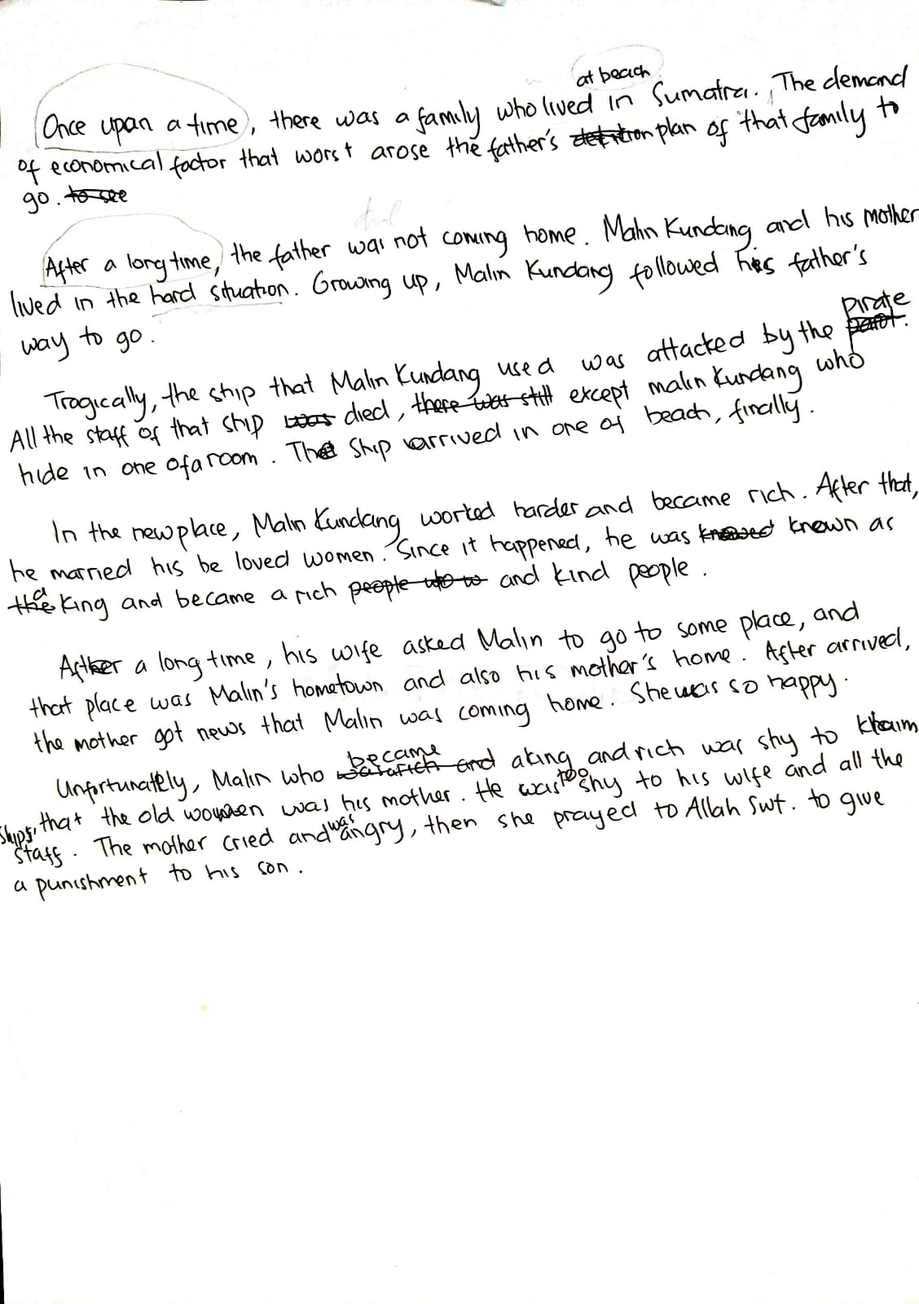
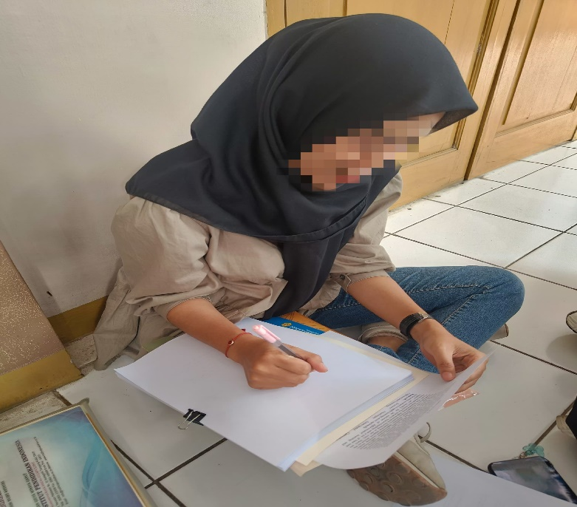
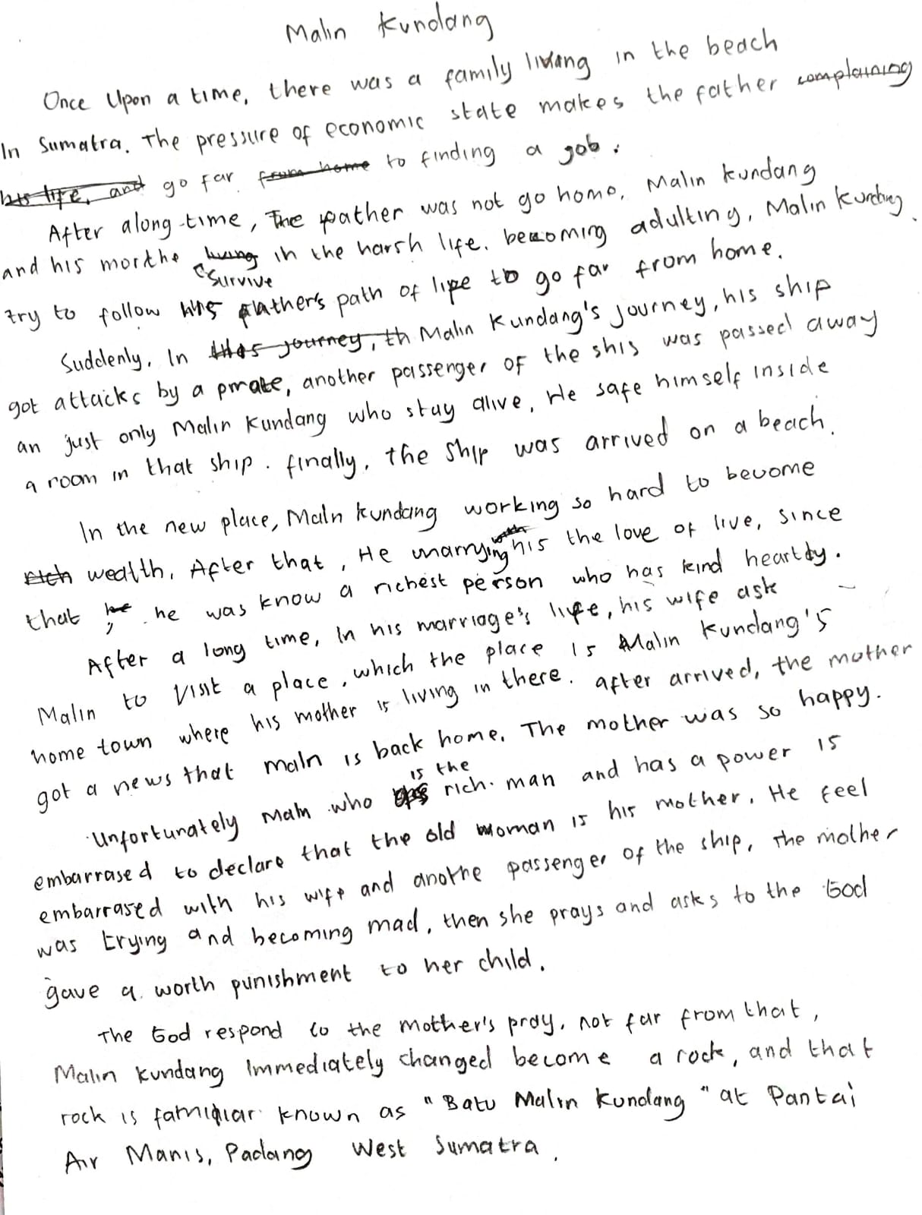

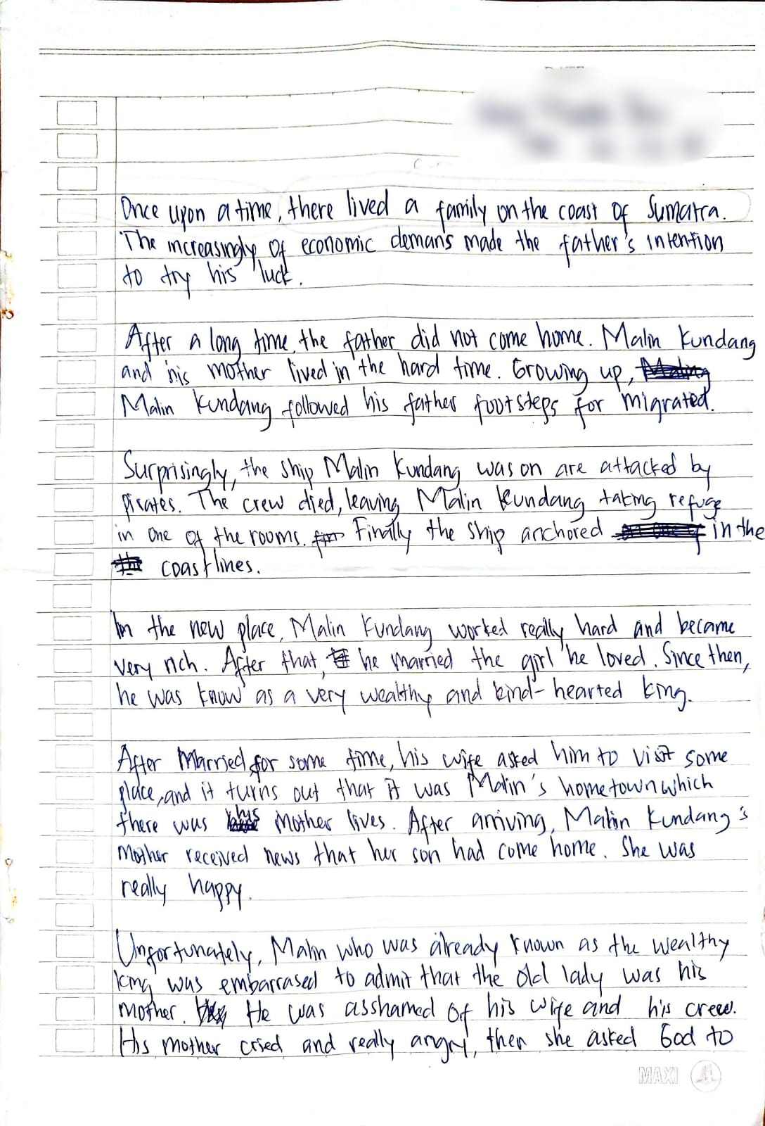

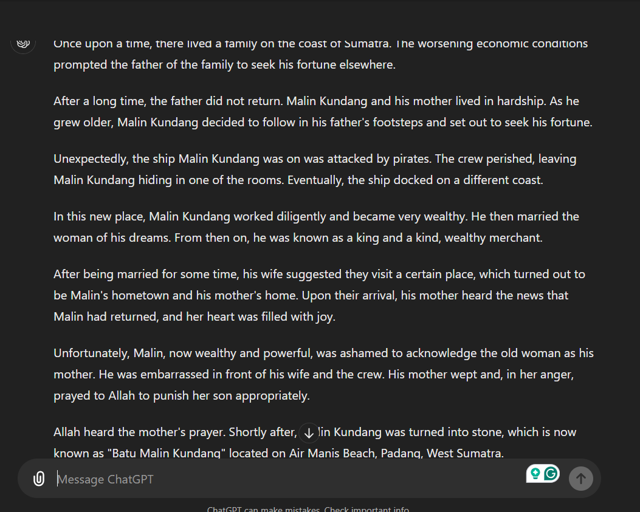
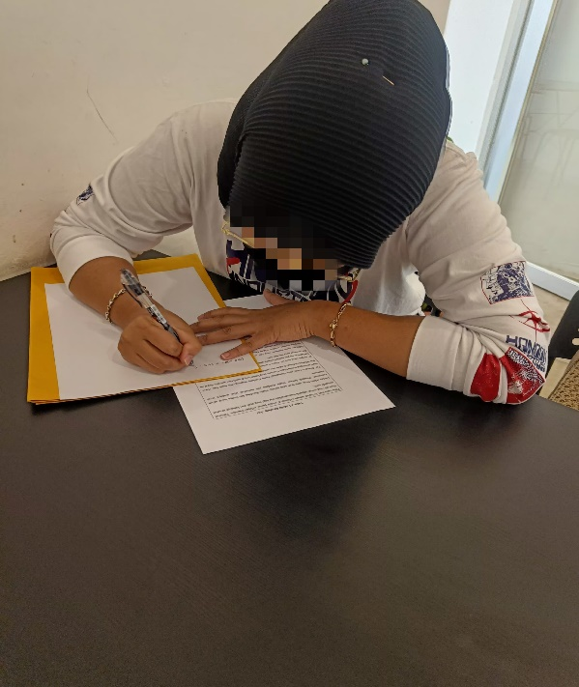
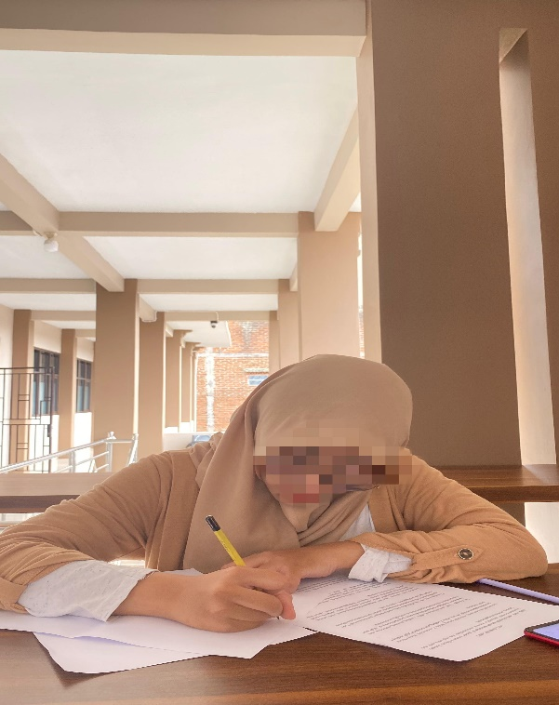
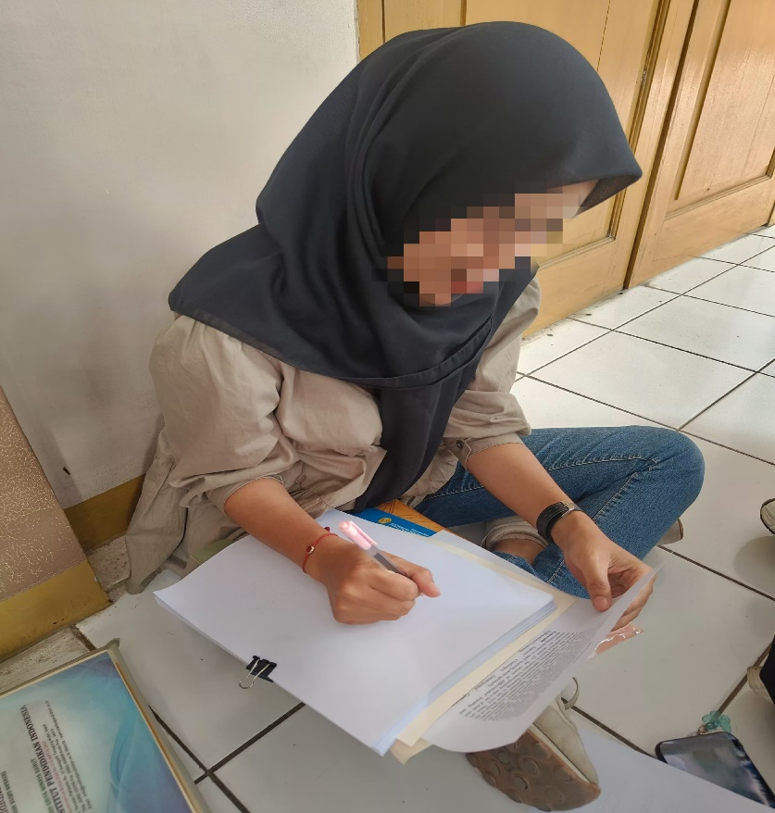

APPENDIX B
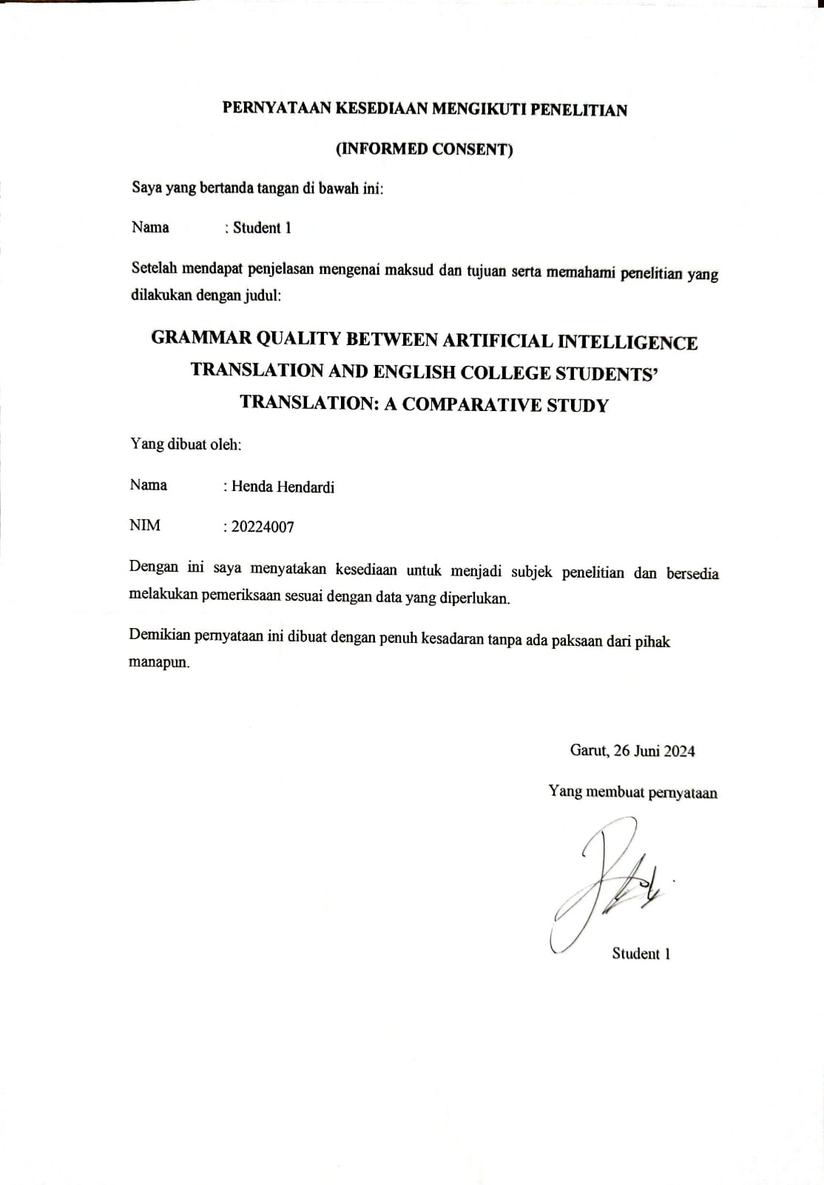
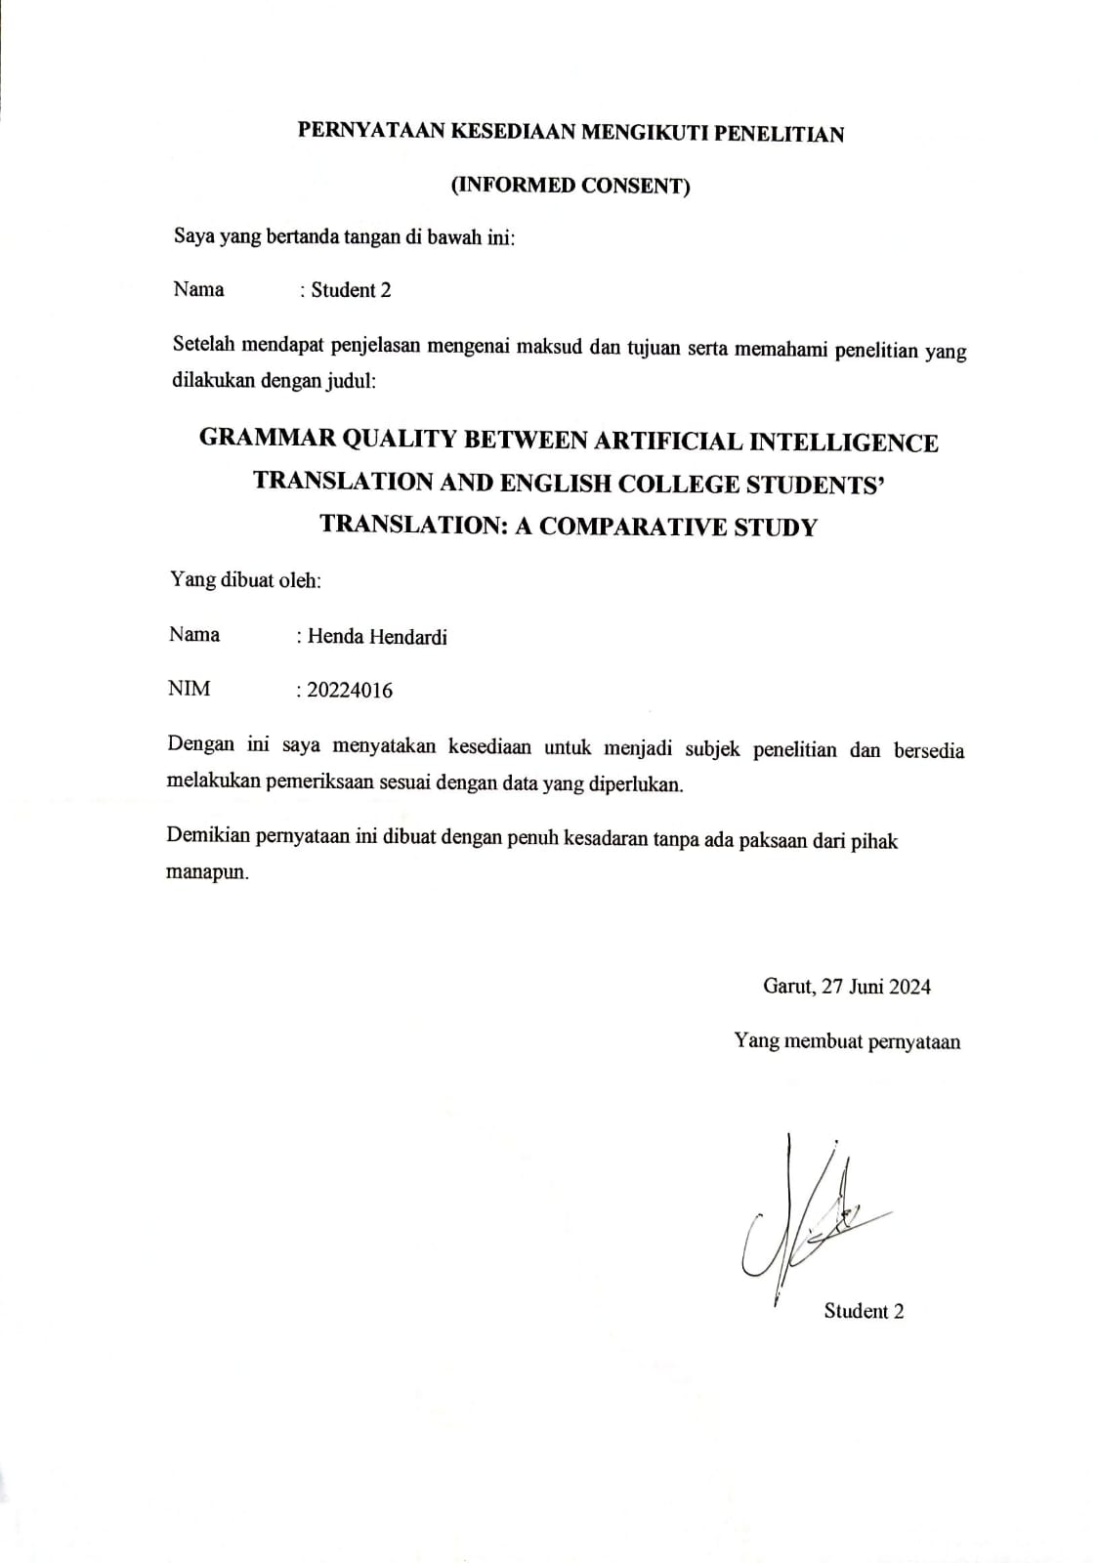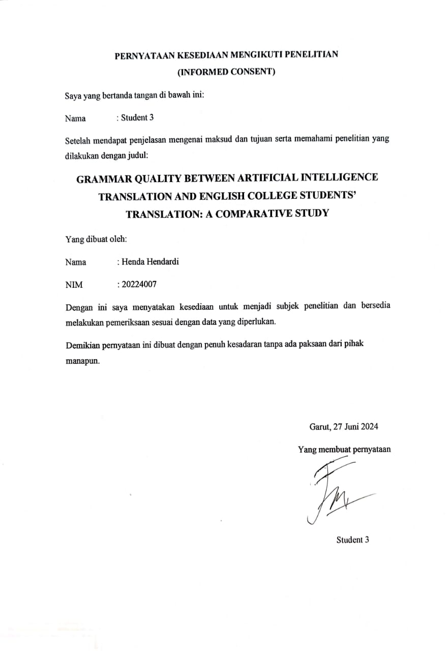

APPENDIX C

CURRICULUM VITAE
 | : | Henda Hendardi
ADDRESS | : | Jl. Raya Cipanas no.210 B RT/002 RW/005 Ds. Langensari Kec. Tarogong Kaler Kab. Garut Prov. Jawa Barat 44151
E-MAIL | : | hendardi91@gmail.com
SUMMARY | : | Henda Hendardi was born in Garut on July 07, 2001. He is the fourth of four siblings, the one and only man of his parent’s children. He is a person who can boost a mood to his friends and the most handsome friend for his friends according to his mother. He has a hobby and passion at sport, especially martial arts.

EDUCATION | TK Al-Falah | 2005 — 2006
EDUCATION | SDN Paminggir IV | 2007 — 2013
EDUCATION | SMPN 1 Garut | 2013 — 2016
EDUCATION | SMAN 1 Garut | 2017 — 2019
EDUCATION | Institut Pendidikan Indonesia (IPI) Garut | September 2020 – Juli 2024

