A QUALITATIVE INVESTIGATION: STUDENT PERCEPTIONS OF GOOGLE TRANSLATE IN ENGLISH VOCABULARY ACQUISITION

A PAPER
Submitted to the English Education Program of IPI Garut as a Partial
Fulfillment of the Requirements for the Sarjana Pendidikan Degree



Written by:
Dea Marwah Afgany
20226002

ENGLISH EDUCATION PROGRAM
FACULTY OF SOCIAL SCIENCE, LANGUAGE, AND LITERATURE EDUCATION
INSTITUT PENDIDIKAN INDONESIA GARUT
2024

APPROVAL SHEET

A QUALITATIVE INVESTIGATION: STUDENT PERCEPTIONS OF GOOGLE TRANSLATE IN ENGLISH VOCABULARY ACQUISITION

By:
Dea Marwah Afgany
20226002

Approved by:

First Supervisor | Second Supervisor
Muhamad Taufik Hidayat, M.Pd.  NIDN. 0423038501 | Pipih Setiawati, M.Pd.  NIDN. 0410059701
Acknowledged by:
Head of English Education Program
Anne Ratna Suminar, M.Pd.
NIDN. 0415038601

LEGITIMATION OF EXAMINATION BOARD

MOTTO
“All our dreams can come true if we dare to realize them”

-Walt Disney-

DECLARATION
The researcher hereby declares that this paper is entitled “A Qualitative Investigation: Student Perceptions Of Google Translate In English Vocabulary Acquisition” with the content is completely the writer’s work. The opinions or findings of other authors presented in this paper are quoted based on citation rules by applicable scientific ethics. Therefore, it is the researcher's responsibility if anything inappropriate is discovered.

Garut, June 2024
The Researcher

Dea Marwah Afgany
NIM. 20226002

PERNYATAAN
Peneliti dengan ini menyatakan bahwa skripsi yang berjudul “Investigasi Kualitatif: Persepsi Siswa terhadap Google Terjemahan dalam Pemerolehan Kosakata Bahasa Inggris” dengan isi sepenuhnya merupakan hasil karya penulis. Pendapat atau temuan dari penulis lain yang terdapat dalam karya tulis ini dikutip berdasarkan kaidah pengutipan sesuai dengan etika keilmuan yang berlaku. Oleh karena itu, menjadi tanggung jawab peneliti jika ditemukan hal-hal yang tidak sesuai.

Garut, Juni 2024
Yang membuat pernyataan

Dea Marwah Afgany
NIM. 20226002

PREFACE
All praise and gratitude are due to Allah SWT who has given His mercy and grace so that the researcher can complete the thesis entitled “A Qualitative Investigation: Student Perceptions Of Google Translate In English Vocabulary Acquisition” on time. Sholawat and Salam to the Prophet Muhammad SAW, his family, friends, and us as his followers.
This thesis is submitted to the English Education Study Program of IPI Garut as a partial fulfillment of the requirements to complete a Bachelor of Education degree. The researcher realizes that this paper is far from perfect. Therefore, constructive criticism and suggestions are highly expected for the perfection of this paper. The researcher also hopes that this thesis can be useful for readers and future researchers.

Garut, June 2024

The Researcher

ACKNOWLEDGEMENT
In the name of Allah, the Most Gracious, the Most Merciful.
All praise and thanks be to Allah, Lord of the Worlds, and may peace and blessings be upon the last Prophet and Messenger, Muhammad (peace be upon him).
I would like to express my gratitude and thanks to Allah SWT for giving me the strength, knowledge, and ability to complete this thesis. Without His guidance and blessings, this work would not have been possible.
I would also like to extend my appreciation and gratitude to my first and second supervisors, Muhamad Taufik Hidayat, M.Pd., and Pipih Setiawati, M.Pd., whose valuable feedback, guidance, and support have been instrumental in shaping this thesis. May Allah bless them for his/her dedication and commitment to my academic progress.
I would also like to thank my parents, older brother, younger brother, and friend R for their support and encouragement.
I also want to thank my PBI A friends and seniors, Melinia Hardin and Novi Risnawati, who always motivate and inspire me. May Allah SWT reward their unwavering love and support.
In addition, I would also like to thank the participants in this study. Your contributions have been very beneficial to me in writing this thesis.
Finally, I pray to Allah SWT that He will acknowledge this work as an honest attempt to further science and grant me the freedom to keep learning and doing what I can to better serve His creation.

ABSTRACT
In today's world, the ability to acquire a diverse vocabulary is an important skill that influences aspects of life, especially in English. So various resources have emerged to make it easier for someone to learn English, one of which is Google Translate a digital resource which are currently widely used. Therefore, this study aims to investigate how students perceive using Google Translate for English Vocabulary Acquisition which offers a new avenue for language learners. This research uses a qualitative method, focusing on a case study design conducted in two different locations, a University and a Senior High School in Garut. Four participants were involved in semi-structured interviews to gather information on how students use this tool to learn English vocabulary. The results showed that the majority of the participants had a positive view of the tool's use in improving English vocabulary acquisition as it is flexible, practical, and accessible, with a variety of features and languages. Despite inaccuracies and dependency, most students responded positively. Students used it for vocabulary acquisition through copying and pasting, taking pictures, typing, and voice dictation. Therefore, this study is expected to provide additional information for further research on students' perceptions of using Google Translate as a digital resource for vocabulary learning in English language learning.

Keywords: Vocabulary Acquisition, Digital Resources, Google Translate

ABSTRAK
Di dunia saat ini, kemampuan untuk menguasai kosakata yang beragam merupakan kemampuan penting yang mempengaruhi aspek kehidupan, terutama dalam bahasa Inggris. Sehingga berbagai sumber daya telah muncul untuk memudahkan seseorang dalam mempelajari bahasa Inggris, salah satunya adalah Google Translate, sebuah sumber daya digital yang saat ini banyak digunakan. Oleh karena itu, penelitian ini bertujuan untuk menyelidiki bagaimana persepsi siswa dalam menggunakan Google Translate untuk pemerolehan kosakata bahasa Inggris yang menawarkan jalan baru bagi pelajar bahasa. Penelitian ini menggunakan metode kualitatif, dengan fokus pada desain studi kasus yang dilakukan di dua lokasi yang berbeda, yaitu Universitas dan Sekolah Menengah Atas di Garut. Empat partisipan dilibatkan dalam wawancara semi-terstruktur untuk mengumpulkan informasi tentang bagaimana siswa menggunakan alat ini untuk mempelajari kosakata bahasa Inggris. Hasil penelitian menunjukkan bahwa mayoritas partisipan memiliki pandangan positif terhadap penggunaan alat ini dalam meningkatkan penguasaan kosakata bahasa Inggris karena alat ini fleksibel, praktis, dan mudah diakses, dengan fitur dan bahasa yang beragam. Meskipun terdapat ketidakakuratan dan ketergantungan, sebagian besar siswa memberikan respon positif. Siswa menggunakannya untuk akuisisi kosakata melalui copy paste, mengambil gambar, mengetik, dan dikte suara. Oleh karena itu, penelitian ini diharapkan dapat memberikan informasi tambahan untuk penelitian lebih lanjut tentang persepsi siswa dalam penggunaan Google Translate sebagai sumber digital untuk pembelajaran kosakata dalam pembelajaran bahasa Inggris.

Kata kunci: Pemerolehan kosakata, Sumber Daya Digital, Google Translate

TABLE OF CONTENTS
APPROVAL SHEET i
LEGITIMATION OF EXAMINATION BOARD ii
MOTTO iii
DECLARATION iv
PERNYATAAN v
PREFACE vi
ACKNOWLEDGEMENT vii
ABSTRACT viii
ABSTRAK ix
TABLE OF CONTENTS x
LIST OF TABLES xiii
CHAPTER I INTRODUCTION 1
1.1 Background of the Study 1
1.2 Reasons for Choosing the Topic 4
1.3 Research Question 4
1.4 Research Objective 4
1.5 Significance of the Study 4
1.5.1 Theoretical Benefits 4
1.5.2 Practical Benefits 4
1.6 Definition of Terminologies 5
1.6.1 Qualitative 5
1.6.2 Digital Resources 5
1.6.3 Google Translate 5
1.6.4 Vocabulary 5
1.6.5 Acquisition 5
CHAPTER II LITERATURE REVIEW 6
2.1. Vocabulary 6
2.2. Acquisition 6
2.3. Vocabulary Acquisition 7
2.4. Digital Resources 8
2.4.1 Definition of Digital Resources 8
2.4.2 Types of Digital Resources 8
2.4.3 The Role of Digital Resources in Language Learning 12
2.5. Google Translate 13
2.5.1 Definition of Google Translate 13
2.5.2 Techniques for Using Google Translate to Learn English Vocabulary 14
2.5.3 Benefits of Using Google Translate in Learning English Vocabulary 15
2.5.4 Drawbacks of Using Google Translate in Learning English Vocabulary 15
2.6. Previous Studies 16
CHAPTER III RESEARCH METHODOLOGY 19
3.1 Research Method 19
3.2 Research Design 19
3.3 Research Setting, Participants, and Instruments 20
3.3.1. Research Setting 20
3.3.2. Research Participants 20
3.3.3. Research Instrument 21
3.4 Technique of Data Collection 21
3.5 Technique of Data Analysis 22
3.6 Research Procedure 23
CHAPTER IV RESEARCH FINDINGS AND DISCUSSION 25
4.1 Research Findings 25
4.1.1 Knowledge Aspects 25
4.1.2 Experience Aspects 26
4.1.3 Belief Aspects 28
4.2 Discussion 31
4.2.1 Knowledge Aspects 31
4.2.2 Experience Aspects 32
4.2.3 Belief Aspects 33
CHAPTER V CONCLUSION AND SUGGESTIONS 36
5.1 Conclusion 36
5.2 Suggestions 36
5.2.1 The Suggestion for Teachers 36
5.2.2 The Suggestion for Students 37
5.2.3 The Suggestion for Further Researchers 37
REFERENCES 38
APPENDICES 43
APPENDIX 1 RESEARCH LETTER 44
APPENDIX 2 INFORMED CONSENTS 46
APPENDIX 3 RESEARCH INSTRUMENT GRID 50
APPENDIX 4 INTERVIEW QUESTION 55
APPENDIX 5 INTERVIEW TRANSCRIPTS 57
APPENDIX 6 THESIS GUIDANCE CARD 69
APPENDIX 7 TURNITIN CHECK RESULTS 70
APPENDIX 8 CURRICULUM VITAE 72

LIST OF TABLES
Table 4. 1 Benefits and Drawbacks of Using Google Translate for English Vocabulary Acquisition 31

CHAPTER I

INTRODUCTION
In this introduction section, the researcher provides an overview of the field's everyday issues and previous research. This chapter also defines the background of the study, the reasons for choosing the topic, the research question, the research objective, the benefits of research in theory and practice, and the definition of terminologies.

Background of the Study
In today's globalized world, proficiency in the English language is a vital skill that significantly impacts academic success, career opportunities, and social interactions. To attain language proficiency, vocabulary development plays a crucial role in effective communication and comprehension. Acquiring new vocabulary involves more than just learning how to spell and pronounce words. It also encompasses understanding word formation, pronunciation, and collocations. As Castillo-Cuesta and Quinonez-Beltran (2022) note, acquiring new vocabulary is a comprehensive process that requires various skills. Additionally, Odinokaya et al. (2021) stated that developing proficiency in vocabulary is essential for learning any foreign language.
Traditional vocabulary teaching methods have evolved in EFL students' learning context. According to Maqsood et al. (2023), innovative digital educational resources have replaced traditional conventional language courses, providing new opportunities for the acquisition of languages and communication. The emergence of digital resources as dynamic tools that have the potential to enhance the process of vocabulary acquisition among language learners has changed the landscape of language education significantly. This is supported by Hayde et al. (2006), who state that students can create their learning environments by integrating both the virtual and real worlds. This enables individuals to save and access information on new (related) words, phrases, or strategies from any location via digital resources they hear, see or study. Currently, digital resources are widely used in the learning process. According to Lazebna and Prykhodko (2021), diverse resources are essential for successful learning facilitated by interaction, good teacher-student collaboration, and audio files and video clips in ESL lessons.
However, highlighting the researcher's experience while participating in the Independent Teaching Campus (KMM) program at one of the MTS schools in the city of Tasikmalaya, English language learning still needs to be developed, considering several factors that hinder the success of the learning process. First, students experience difficulties in learning English, especially in acquiring vocabulary. Some students at this school do not know the English alphabet and numbers because they did not have English subjects during elementary school. Difficulties were also seen when students were asked to introduce themselves, but some needed help. Apart from that, the lack of student interest in learning material is caused by the lack of development of the teaching and learning process that attracts students' attention.
Another factor is the limited learning resources, such as exciting learning and teaching media. This can be seen from the fact that only some students have dictionaries, and others have to borrow them from the school library because the school prohibits students from bringing or using smartphones. Schools are closely related to the Islamic boarding school environment, where the rule applies not to bring cell phones into Islamic boarding schools or schools. However, if this continues, it will impact the lack of mastery of subject matter and the ability to master various vocabulary. In line with Achmad (2013), the reason for students' inadequate proficiency in English is their limited vocabulary, especially in academic subjects. This makes it harder for them to comprehend written and spoken English.
Therefore, an in-depth understanding of vocabulary development is essential to help students overcome obstacles in the English language learning process. To overcome these problems in this research, researchers are interested in investigating how creative vocabulary learning is carried out by optimizing various digital resources.
This diversity of digital resources encompasses various technologies, including language learning applications, online dictionaries, interactive multimedia, and educational websites. In line with Misir (2018), with the use of well-known digital sources, interactive chat rooms, audio, video, image, and machine translation tools, the richness of digital language instruction can enhance student learning. Free online dictionary sites from Oxford, Cambridge, Macmillan, Langenscheidt, and Longman are also accessible. This resource offers a variety of interactive and engaging content and strengthens their understanding of English vocabulary. This is due to Patra et al.'s (2022) research that shows students' engagement in digital activities increases their vocabulary and knowledge. In line with Muddin (2018), the virtualization of the learning process can facilitate students' comprehension and memorization of words and increase their interest in, enjoyment of, and happiness with their studies.
Several studies report using digital resources to improve English language skills, including vocabulary mastery. One example of research carried out by Castillo-Cuesta Quinonez-Beltran (2022) focuses on the effects of implementing digital comics to improve vocabulary in English as a Foreign Language (EFL) during the COVID-19 pandemic. The experimental group's vocabulary learning significantly improved, according to the data. Because comics allowed students to construct original digital stories and customize them to their interests, this group also showed a good impression of using comics to enhance EFL vocabulary knowledge. Another research conducted by Efl & No (2021) used a mixed methods thematic narrative study of interview information combined with a quantitative examination of survey data. Because of the pressure-free environment, enhanced focus, and shift from incidental learning to self-directed learning, video games benefit incidental vocabulary acquisition. Interactions in real-life English, a broader vocabulary, and a heightened knowledge of teenage culture were reported by interviewees.
Although there are studies on digital resources in education, research on students' perceptions of digital resources highlighting vocabulary acquisition skills using qualitative research methods still needs to be made available. Therefore, to fill this gap, the researcher extended the discussion to investigate students' perceptions of digital resources, focusing on one of the most widely used digital resources, namely Google Translate, for English vocabulary acquisition with diverse participants.

Reasons for Choosing the Topic
The most important reason for choosing this topic comes from the researcher's interest in seeing the utilization of Google Translate as a digital resource in one's vocabulary acquisition. Another reason is to see how vital vocabulary acquisition is, especially using digital resources, and what the students' perceptions of Google Translate as a digital resource are in the context of EFL learners. In addition, it is still rare to find research examining how students use Google Translate as a digital resource focusing on vocabulary acquisition only and sampling participants from different school levels and genders as a gap between previous research.

Research Question
Based on the background of the study, this research will investigate the following question:
How do students perceive using Google Translate for English Vocabulary Acquisition?

Research Objective
Based on the research questions, this study aims to investigate how students perceive using Google Translate for English Vocabulary Acquisition.

Significance of the Study

Theoretical Benefits
This research provides new insights into how students use Google Translate as a digital resource for vocabulary learning. This can be valuable for teaching and learning in various contexts. For example, it can be used as a learning method in the English Education study program. In addition, this research is helpful for future studies.

Practical Benefits
This research can help English education programs make the most of Google Translate as a digital resource in teaching proficiency courses, such as media that can be developed or created to help students or prospective teachers improve their English vocabulary. Additionally, research findings may provide opportunities to create platforms or applications that enhance learning more successfully.

Definition of Terminologies

Qualitative
Crowther and Lauesen (2017) state that qualitative research uses natural language, small sample sizes, and instances selected with purpose or opportunism in mind. Because qualitative research frequently focuses on specific people, occasions, and environments, it lends itself to idiographic analysis.

Digital Resources
Gaur and Tripathi (2012) state that a digital resource, or "e-resource," is anything that can be accessed through a device, including digital information that can be accessed directly or online. It also involves using of information technology systems.

Google Translate
BOUGUELMOUNA & BOUHENNI (2023) state that Google Translate is a famous translation application that uses complex machines and technology to support simple language interaction among individuals of other languages, especially EFL learners.

Vocabulary
Rasouli (2016) states that vocabulary is a comprehension of word meanings and related definitions.

Acquisition
Lindner & Hohenberger (2009) state that the process of learning a language with a purposeful start in a target tongue is called "acquisition," it is analogous to learning the primary language in that it is spontaneous and natural.

CHAPTER II

LITERATURE REVIEW
In this section, the researcher provides the theoretical basis and literature review relevant to the study. The researcher explains some theories related to vocabulary, acquisition, vocabulary acquisition, and digital resources. Furthermore, the researcher explains the theories related to Google Translate and previous research.

Vocabulary
Vocabulary is a collection of familiar words speakers use in learning and developing a language. Yanti's (2017) study of vocabulary involves words and their underlying meanings. Supported by Iman (2016), vocabulary is part of knowledge about the meaning of words that are arranged into written form (spelling) or spoken form. Apart from that, Susanto (2017) states that one of the most critical aspects of teaching languages to people is vocabulary, which is regarded as crucial. A foreign language student's foundation is their vocabulary. In line with Nguyen Nguyen (2021), writing, speaking, listening, and reading abilities are closely related to vocabulary, a key component to comprehending a foreign language. Therefore, vocabulary dramatically influences a person's language skills. This is supported by Monica-Ariana, S., & Anamaria-Mirabela (2014), who state that studying vocabulary, the foundation of every language, is likely the most complex and time-consuming aspect of studying a foreign language.

Acquisition
In vocabulary acquisition, "acquisition" refers to acquiring or accumulating new words in a language. This can happen through reading, listening, or everyday experiences. According to DeKeyser in Www.Ebook777.Com, n.d.), the acquisition of abilities refers to the process by which people acquire new abilities, from basic knowledge form to skilled knowledge. Arung's (2016) research revealed two methods for the acquisition process: unaware and aware. Acquisition occurs by chance, naturally, and on several occasions. The acquisition occurs during formation. However, the procedure ought to occur naturally. In line with Lindner & Hohenberger (2009), similar to the primary language learning process, "acquisition" refers to the unconsciously natural process of taking up a language with a meaningful speech in the target language. Therefore, understanding and using language is an innate human ability that develops through daily experience and interaction. This is supported by Uyun & Kulsum's (2023) research; most acquisitions are unconsciously made, indicating that individuals or students are often unaware of their improving abilities.

Vocabulary Acquisition
Vocabulary acquisition is essential in an individual's ability to understand and communicate effectively. According to Yanti (2017), vocabulary acquisition is the ability to identify, comprehend, and generate a significant vocabulary of language and its meanings. In line with Sutrisna (2021), he also stated that the importance of vocabulary as a linguistic component in language acquisition is undeniable. Thus, vocabulary knowledge is essential for comprehending a new language, especially a foreign one. This makes developing one's vocabulary an essential component of language learning. This is in line with Orawiwatnakul (2011), who states that the best way to provide students with a better vocabulary in English is to give them more words from which to choose. Razali & Razali (2013) also stated that the process of improving one's vocabulary when understanding a new language is known as vocabulary acquisition.
Mastering vocabulary in a second or foreign language is crucial because it helps the person who speaks and readers understand written material even when one lacks the grammar skills to construct a coherent statement. Other research conducted by Orawiwatnakul (2011) also states that speaking, listening, reading, and writing skills largely depend on one's vocabulary, a fundamental aspect of language skills. This is supported by Karakoc and Durmusoglu Kose (2017), who state that students must develop vocabulary knowledge to succeed when studying a foreign language. The more vocab comprehension they have, the more competent they become in language. Therefore, vocabulary mastery must be developed through various learning resources that can increase vocabulary mastery. As Sharafi-Nejad et al. (2014) stated, various English vocabulary-improving strategies facilitated the acquisition of particular vocabulary.

Digital Resources

Definition of Digital Resources
Digital resources refer to any form of content, information, or material presented through a digital format that can be accessed via electronic devices such as computers, tablets, or smartphones. In line with Gaur & Tripathi (2012), a digital resource, or "e-resource," is anything that can be accessed through a device, including digital information that can be accessed directly or online. It also involves using of information technology systems. As technology advances, digital resources bring various benefits to education, including their essential role in enriching students' vocabulary acquisition. According to S. Thanuskodi & S. Ravi (2011), digital resources are a significant successful method of collecting and accessing knowledge. This is supported by research by Rezaei et al. (2014), who state that nowadays, pupils have access to various resources as their curiosity in vocabulary acquisition improves, with applications that include some of the most used and beneficial types.
Additionally, digital resources offer a variety of dynamic and interactive media. According to Haleem et al. (2022), digital learning spaces change the context of education to provide significantly enhanced lessons by utilizing digital means like social media, audiovisual content, and smartphones for lessons. Another study by Martin (2008) also revealed that digital resources encompass a wide range of materials saved as electronic files, such as written content, images, visuals, video, audio, news reports, research articles, movies, games, educational resources, and information sets. Heine et al. (2023) also mentioned that this category involves a variety of digital resources, such as web pages, blogs, digital data, social media sites, ebooks, and online educational platforms.

Types of Digital Resources
Various digital resources can be used for language learning, especially for improving vocabulary. According to (Redecker, 2017), digital resources are products that can be read by computers and easily understood by humans. Based on the classification found in DigCompEdu (Redecker, 2017), the following seven subcategories are used to classify it:
- Online information (platforms, websites)
Knowing how online resources are reliable is a part of digital education. Several studies have provided concrete examples, including online information Fessakis and Zoumpatianou (2012) expressed. Learners should verify the accuracy and reliability of any content, mainly sourced online. There is an overall belief that students frequently use Wikipedia as a source of information for their assignments. Like any other resource, Wikipedia can inspire knowledge for education. However, using Wikipedia to support interactive teaching methods is a unique approach that is unsupported by conventional sources. Apart from that, Deifell (2013) also provided another example of an online information source: machine translation. This ensures the accuracy of new word translations; participants often rely on digital resources such as e-dictionaries and translators to verify spelling, pronunciation, and accents in English writing.
- Virtual Learning Environments
Studies J & Rahmi (2019) provide examples of types of virtual learning environments. For example, Edmodo is an innovative provider of digital teaching resources designed to increase students' enjoyment and motivation to study.
- Multimedia content (images, video, audio)
This type of digital resource is also beneficial in language learning; the effectiveness of using audiovisuals in enriching vocabulary was revealed in research by Nassor Faiza Ali (2013) that applying media with audio or video as a method of instruction for vocabulary is proper because it supports the students boosting their vocabularies. Another thing also explained in Sismona's research is that video-based learning greatly enhances college students' vocabulary comprehension compared to conventional teaching methods. With video-based training, everyone participates in the vocabulary processes, from preparation to writing and editing.
- Online games
Another form of interactive digital resource is gamification in English language learning, as proposed by (Putu Wulantari et al., 2023). With fun games integrating vocabulary acquisition, grammatical behaviour, and creating sentences, game-based learning supports dynamic participation in learning. It offers an enjoyable setting where learners can play around, put their competence into practice, and improve their language abilities. One example of gamification revealed in Brahmana's research states that another excellent method for secondary school students to expand their vocabulary is using Quizizz, a popular digital game-based platform. Students tend to feel more challenged and motivated to complete quizzes, resulting in higher scores, which enhances the educational experience and motivation. This study supports the effectiveness of vocabulary development through this approach.
- Learning materials
Other digital means, namely Ebooks, can also improve vocabulary. As Bickel (2017) states, electronic books may help people improve their vocabulary and understanding. Easy access to many ebooks and digital interactive features are two benefits of ebooks for students who prefer learning individually. In line with Xodabande & Hashemi's (2023) research results, based on those surveyed, ebooks offer several advantages for mobile-assisted vocabulary acquisition. These benefits include the ability to study in sections, the flexibility of having each resource needed in one location, and increased motivation and enjoyment during learning.
- Social networks
Another alternative digital resource is social networks, providing students with authentic, interactive, and personalized learning experiences. In line with Lomicka & Lord (2016), Social Networking (SN) is a type of social media where individuals can interact, join, and create groups by sharing and creating content. This is supported by Zainal and Rahmat's (2020) research that social media is essential for language acquisition and interaction, encouraging increased vocabulary and language study across all generations. The increasing amount of English vocabulary can be significantly affected by the use of social media. Research conducted by Monica-Ariana, S., & Anamaria-Mirabela (2014) also found that, compared to learners who benefited just from conventional lessons, pupils learning vocabulary through the social media platform reported little change in vocabulary ability and self-confidence.
Liu's (2010) research revealed examples of social networking or social media sources(Liu, 2010). It showed that students extensively utilize social media sites such as Facebook, YouTube, LinkedIn, blogging, and Twitter. Zainal and Rahmat (2020) added that social networking sites such as Facebook, Instagram, Skype, YouTube, and Twitter have multiple uses. They indirectly support English language learners due to the frequent use of English on these platforms.
- Educational software (programs, apps)
Numerous studies suggest that well-designed software dramatically benefits students in language learning, particularly in improving their vocabulary skills. Research by Nguyen Nguyen (2021) strongly supports this; their usage of the interactive software significantly helped the students improve their understanding of vocabulary acquisition. Studies by (Rezaei et al., 2014) show that utilizing mobile applications supports the acquisition of vocabulary to gain more profound knowledge. Because mobile software interestingly made images of the meanings, the topics displayed more inspiration to learn vocabulary when supplied with tools.
Machine translation is an example of an application often used for language learning. According to BOUGUELMOUNA & BOUHENNI (2023), automated applications or software to translate text between languages, known as machine translation (MT), significantly impact learning and communication. With programs like Microsoft Translator, DeepL, Google Translate, and Systran Translate, learners can easily understand content and overcome language barriers. In line with (Translate et al., 2014), online users and language students can already use a variety of online machine translation (MT) solutions, including BingTranslator, Google Translate (GT), and Yahoo Babelfish.
Hence, these diverse learning resources can be utilized to enhance vocabulary acquisition in a language, employing a range of learning strategies tailored to each student's needs. According to Orawiwatnakul (2011), this is most likely because there are various methods to learn English, and learners were not compelled to subscribe unthinkingly to a single strategy for expanding their vocabulary. Based on several studies, researchers focused on the digital source studied, namely Google Translate, with the research question of how do students perceive using Google Translate for English Vocabulary Acquisition. This is supported by (Translate et al., 2014), who stated that GT is regarded as one of the best MT programs and is highly recommended.

The Role of Digital Resources in Language Learning
In many aspects of human life, such as business, educational institutions, communications, and technological advances, digital resources are becoming increasingly important. One of them is digital resources for teaching that offer dynamic learning and easy access to knowledge. In line with Heine et al. (2023), digital resources for education are sources of information, ideas, and interactivity with functionality. Other research conducted by Ломоносова & Москва (2018) also states that in today's method of learning, digital learning resources are currently an essential aspect.
Several studies show that digital resources can stimulate language learning. As stated by Heine et al. (2023), applying digital resources can draw focus on the purpose of interaction between students and instructors or interactions between learners. In line with Kukulska-hulme & Traxler's (2013) recognition that knowing that digital resources are more flexible in terms of access, development, and influence, learners may learn at their specific schedule and convenience, which has a significant impact on how they interact with basic knowledge. In addition, Pepin et al. (2017) research states that digital resources utilize animations or visualizations to teach ideas and interest pupils in changing learning environments, especially in educating themselves areas. In line with Heine et al. (2023), audiovisual material can be used as a digital resource for development and delivery. Teachers contribute to creativity by using their helpful ability and considering current conditions to improve education.
Utilizing these digital resources can optimize study time and improve understanding and mastery of the language. According to Richards (2015), providing technology, direct interaction, digital games, social media, electronics, and multimedia improves language acquisition by promoting language learning and enhancing the potential for education. Digital resources such as online dictionary applications, interactive platforms, and multimedia can also improve word acquisition. In line with Sharma and Unger (2016), digital innovations speed up learning, improve comprehension, and help expand vocabulary. Specific feedback, meaningful activity selection, multimedia considerations, and combination academic vocabulary teaching are all essential skills for teachers to develop.
Adaptive learning tools allow students to practice vocabulary tailored to their ability level. It is supported by Fu (2018) that electronic resources give learners more flexibility in their learning, improve their ability to manage understanding, and offer realistic conditions for engaging with content in actual life. They offer engaging and entertaining educational resources when paired with game-based learning. As Abrams and Walsh (2014) point out, The Challenge and other digital vocabulary resources are dynamic, ever-evolving, and responsive to students' effects, promoting independent study. With its instant feedback and scoring system, gamified learning enhances optimism and vocabulary skills—two things that are crucial for achievement in academics as well as life. Therefore, digital resources not only expand vocabulary but also provide meaningful and compelling learning experiences, allowing users to measure progress and identify areas of improvement, thereby improving the quality of language learning.

Google Translate

Definition of Google Translate
As one of the digital resources that students are familiar with and is part of the recommended educational software, Google Translate is a language translation service. Based on research (BOUGUELMOUNA & BOUHENNI, 2023), Google Translate is a multilingual neural machine translation technology that was first made available in 2006. It offers a mobile app and an online interface, and it can translate text, documents, and web pages between 100 different languages. In addition, (Medvedev, 2016) states that a well-liked product in the Google family, Google Translate attracts students from both inside and outside the classroom with its fast and accurate dual translation services in multiple languages. In the context of language learning, Google Translate makes it easier for students to understand foreign language subject matter and enriches their vocabulary. Chandra and Yuyun, 2018) revealed that participants use GT as a dictionary to help students learn the language and identify new words in English. This digital resource support has proven to be very beneficial in improving language skills, especially in helping learners acquire vocabulary and facilitate independent learning.

Techniques for Using Google Translate to Learn English Vocabulary
There are several ways to utilize these digital resources (GT) in language learning, especially for vocabulary acquisition. According to Bin Dahmash (2020), five techniques were available for producing the English language with Google Translate: copying and pasting information, taking pictures, using a keyboard, making drawings, and voice dictation.
Users can easily translate text from various sources by copying and pasting information. In line with Basalama (2018), by entering text or pasting copied statements into a site package, students can instantly translate English-written content using Google Translate. Then, image capture techniques make it easy for users to quickly translate printed text using a camera, and using a keyboard makes it easy for users to type or write vocabulary directly. This is explained in the research (Putri, 2021). Students use Google Translate because it provides potential, including quick camera translation, downloadable translation, handwritten translation, and time-saving translation without needing a language dictionary. In addition, drawing is an exciting way to translate vocabulary. In line with (BOUGUELMOUNA & BOUHENNI, 2023), when drawing with the fingers, Google Translate can show you the correct way to compose your words. Finally, voice dictation allows users to translate text through voice input, which is helpful for vocabulary pronunciation practice. Putri (2021) states that Google Translate can translate what is said instantly when this option is selected; this is a voice-activated translation technique.

Benefits of Using Google Translate in Learning English Vocabulary
Some of the benefits of Google Translate for language learning, especially English vocabulary learning. In line with (Soisuwan et al., 2022), Google Translation helps students practice pronouncing words correctly, expand their vocabulary, and communicate. In line with (Translate et al., 2014), learners gave GT good marks for being free, simple to apply, fast translating, excellent quality, and helpful in acquiring new vocabulary. Research (Zafitri & Harida, 2017) also revealed that students frequently utilize Google Translate because it is reliable and dedicated to providing word-for-word, sentence-for-sentence, and paragraph-for-paragraph translations.
In addition, GT also helps students understand the definition of terms in English. According to Maulidiyah (2018), Google Translate (GT) is widely used by students for comprehension, writing, vocabulary acquisition, and translation. Because GT offers general definitions of words and aids in comprehending English sentences, they find it quicker, easier, and more efficient than their translations. Therefore, GT provides support for independent learning. As stated by (Van Lieshout and Cardoso, 2022), Google Translate can be an independent study in teaching second and foreign languages. Students can develop learning strategies and habits with this assistance.

Drawbacks of Using Google Translate in Learning English Vocabulary
On the other hand, Google Translate also has several disadvantages. One of its main weaknesses is accuracy in translating specific contexts. This can lead to misunderstandings and inappropriate use of words. According to (BOUGUELMOUNA & BOUHENNI, 2023), Google Translate helps expand one's vocabulary but needs to be more accurate for lengthy documents. Accurate translations require human intervention. In addition, excessive dependence on Google Translate can hinder the development of critical thinking skills in understanding and processing vocabulary. Research (Hardini & Dewi, 2021) states that learners found that their language skills had not progressed much, the use of GT during lessons was addictive, they could not enhance their vocabulary on their own, and it was challenging to translate effectively.

Previous Studies
Numerous studies have been conducted on students' language learning experiences using Google Translate, one of which highlights the potential to enhance their vocabulary. In this article, the researcher adapts a few previous studies from several journals, specifically (Soisuwan et al., 2022). The research examines how the Rajamangala University of Technology Thanyaburi fourth-year engineering students can improve their vocabulary, reading comprehension, and writing in English by using GT. However, due to the COVID-19 pandemic, interview times for health and safety policies were limited. Therefore, data from university participants had to be obtained utilizing Google Forms and uploaded through the LINE application. After using structured interviews and a five-point Likert scale to assess how students used GT, the study found that students' vocabulary, reading, and writing skills significantly improved. The discussion of vocabulary skills is an interconnection between this type of research. The varied participant group, which includes more than just college students, and the fact that the study was not conducted during the COVID-19 pandemic highlight the differences between this study and earlier studies.
Apart from that, research discussing Google Translate was also carried out (Chandra & Yuyun, 2018), which involved eight students from the Ukrida Department of English who participated in the survey carried out at Universitas Kristen Krida Wacana to explore the implementation of GT in language learning essay writing and its function in studying a language in more detail. Two approaches were employed: interviewing and mediated observation. For every respondent, a writing task was assigned, and an application for screen recording was used to document the writing process. When the interview results were transcribed, the data from the writing activities were examined by categorizing them into relevant writing elements. The results showed that students used GT mainly for grammar, spelling, and vocabulary.
On the other side, previous research discusses using Google Translate as a medium for independent learning and classroom learning. A study by Van Lieshout and Cardoso (2022) aims to help with self-directed learning and the acquisition of Dutch vocabulary and pronunciation; the study investigates the use of Google Translate and its functionalities, such as TTS and ASR. The study assessed the learning of Dutch vocabulary and pronunciation using a pre-test, post-test, and delayed post-test method, as well as qualitative analysis of participants' video replies to GT. The results show that participants quickly picked up Dutch words and pronunciation and responded differently to text-to-speech, automatic speech recognition, and GT's translation.
In addition, M. Yanti and Martha Meka's (2019) research explored students' perceptions of using Google Translate as a translation tool in the classroom. This study examined the perception of Google Translate and its impact on students' translation process. Sixty-four sixth-semester students participated in this descriptive study, which used interviews, translation assignments, and questionnaires to examine the function that Google Translate helped them with. Findings indicated that 96% of students often utilized Google Translate as a quick dictionary, primarily for vocabulary development and sentence-by-sentence translation.
Hence, based on several previous studies, there are similarities between this research and prior research. Both discuss students' perceptions of Google Translate in aiding language learning. However, the difference in this research can be seen from only focusing on vocabulary acquisition skills, which still need to be clarified in EFL contexts. Apart from that, previous research used more quantitative methods. In contrast, in this study, researchers conducted qualitative research to determine how high school and college students use Google Translate for vocabulary acquisition. Unlike previous qualitative research using questionnaires and observations to collect data, this research uses an interview method with a case study design and sampling participants from various school levels as a gap between previous research.

CHAPTER III

RESEARCH METHODOLOGY
In this section, the researcher explains the research methods, the selection of the research design, the research setting, the participants, and the research instrument. In addition, it discusses the data collection used and explains the data analysis process in this study.

Research Method
This study aims to investigate how students perceive using Google Translate for English Vocabulary Acquisition. Therefore, qualitative research methodology was applied in this research. This approach was chosen because of the need for this research to investigate how students use Google Translate as a digital resource, especially for English vocabulary acquisition. As stated by Creswell (2007), in qualitative studies, participants provide information about a topic, which is then addressed with the investigation by the researcher, who examines the participants' experiences and comprehension due to their own previous experiences, situations, and prior knowledge.
In line with Hamilton and Finle (2020), qualitative methods have been used to explain the current situation in various settings. By using approaches such as observing participants and conducting personal or group interviews, qualitative research sheds light on what is happening and the reasoning behind it. Crowther & Lauesen (2017) also state that qualitative studies are characterized by implementing simple words, relatively small samples, reference to situations selected with purpose or chance, and a tendency to focus on specific individuals, incidents, and situations that give personally to a specific investigation. Based on experts' descriptions of qualitative methods, the researcher chose it to investigate how students use Google Translate for English vocabulary acquisition.

Research Design
To gather the necessary data for this research, the researcher utilized a case study design to investigate this issue. There is a background that Google Translate is more widely used for other English skills. Please take a look at Chapter II, section 2.6, for more. Meanwhile, this research focuses on how students use Google Translate, especially in acquiring English vocabulary. According to Schoch (2009), the design case study aims to provide a thorough understanding of an issue, condition, group, or social thing within its actual context by analyzing information sources such as interviews, records, investigations, and surveys. This is supported by Creswell's (2007) research, which states that a case study involves investigating a specific situation within a constraints framework, collecting detailed data from various sources, and summarizing the case along with the case's issues. Based on these considerations, a case study was suitable for this research design to investigate how students use Google Translate to acquire English vocabulary.

Research Setting, Participants, and Instruments

Research Setting
This research was conducted at two locations, namely a University and a Senior High School in Garut. This location selection was based on several reasons. First, this location supports research because it uses technology to learn English. Second, the two sites' diverse educational backgrounds demonstrate the capacity of this research to gather more comprehensive and detailed information. Third, the results of previous field observations conducted by the researcher showed that almost all students in both locations had a mobile phone and used it. Students used digital resources such as Google Translate to learn vocabulary. Therefore, the researcher chose these two locations for this research.

Research Participants
Four participants in this research sample were two University students and two Senior High School students. In this case, participants are selected based on the following specific criteria:
- Students who have used Google Translate consistently and regularly to learn English vocabulary for at least the past year.
- Students with diverse English language ability backgrounds.
- Students who are diverse in terms of education level and gender.
- Students aged 16-21 years old.
Thus, purposive sampling was used to select these participants. In line with Mirhosseini (2020), purposive sampling is a qualitative technique that uses specific and prepared ways to include a selection of research participants. It aims to involve various individuals from the community by connecting researchers to participants according to their characteristics and significance to the context.
Hence, using Google Translate as a learning aid is one of the main focuses of this research. Students from various backgrounds with English language abilities obtain variations in how to use Google Translate. Then, four participants from different educational levels were selected to provide a broader and deeper perspective following the research objectives, namely investigating how students use Google Translate to acquire English vocabulary.
In addition, the mix of the participants consisted of two females and two males. The strategy is grounded in discussing the limits of prior research, indicating the necessity for further studies using a diverse range of participants concerning age, gender, and levels of education. See Chapter II, section 2.6 for more. Because of this, it is expected that the research can provide an increased and representative understanding of students' perceptions of using Google Translator for vocabulary development today.

Research Instrument
In this research, the researcher chose to use an interview research instrument to answer research questions more broadly. According to Utibe Monday (2020), in social science studies, interviews are an organized strategy for collecting data and understanding from individuals. They enable the subjects to offer in-depth information and relate their experiences.
Then, data was obtained through semi-structured interviews to explore how students use Google Translate to acquire English vocabulary, as Adeoye-Olatunde and Olenik (2021) stated. The semi-structured interview is a qualitative research technique that facilitates the continuous collection and evaluation of data by helping the researcher explore ideas using flexible inquiries and follow-up investigation questions.

Technique of Data Collection
This study was conducted with preliminary observations at two research locations, a University and a Senior High School in Garut, to determine the characteristics of the students who were selected as participants. Then, the researcher asked permission from each institution to select some English students who used Google Translate from two different locations. Thus, this study involved four English students, two senior high school students, and two university students as research participants. Before the researcher conducted the interviews, the participants were informed that the interviews would be face-to-face, with a series of questions to investigate how students use Google Translate to acquire English vocabulary.
Interviews with four participants were conducted at each research location based on consent between the researcher and the participant. Each student was interviewed for 15-20 minutes with 14 pre-prepared questions about how students used Google Translate for English vocabulary acquisition. A few examples of questions include 1) What do you think Google Translate is?; 2) Does Google Translate help you in doing English assignments, and how does Google Translate help you master English vocabulary?; 3) Since using Google Translate, have you ever noticed an increase in your vocabulary? Give an example. Thus, the responses of all participants were recorded with their consent, and the audio results were transcribed into text for analysis.

Technique of Data Analysis
Here, the researcher chose the interactive model of data analysis. Miles and Huberman (1994) state that data analysis involves data reduction, presentation, and conclusion drawing/verification. These analytical methods are connected from the beginning to the end of information collection, thus creating a dynamic and continuous process that the researcher obtains while conducting research. The steps are explained as follows:
- Data Reduction
At this stage, the researcher processed the data by transcribing and classifying primary data in semi-structured interviews by the focus of this research. In line with Rijali (2018), sorting and cutting information into various aspects, categories, and subjects is an essential step in the method of qualitative analysis known as “data reduction.” This is supported by Miles Huberman (1994), who states that a critical step in qualitative research is reducing information, which entails choosing, concentrating, rationalizing, taking, and changing data into note-taking or transcripts.
- Data Presentation
The researcher presents the information narratively and represents the display form mostly used for presenting qualitative information. According to Miles & Huberman (1994), an essential investigation process is the display, which organizes and collects information so that decisions can be made and responses are possible.
- Conclusion/Verification
The last results in the analysis procedure are conclusions and verification developed from the information-gathering process, increasing validity and clarity (Miles & Huberman, 1994). In this case, the researcher interpreted and summarized the information using research questions regarding how do students perceive using Google Translate for English Vocabulary Acquisition.

Research Procedure
This research procedure consists of several stages. The research was conducted for one month, from May 14 to June 8, 2024. First, the researcher determined the research topic, then the research method and made some interview question instruments. After that, the researcher looked for the theoretical source of the question as the validity of the instrument, then the researcher determined two educational institutions, namely one of the High Schools and Universities in Garut which would be the object of research, and determined the criteria for participants from the reference source. The researcher asked permission from each school to choose two students who studied English consisting of one female student and one male student from the two schools where the research was conducted, so that this study had four students who studied English as research participants. After that, the researcher met the students concerned to agree to the research. Next, the researcher conducted face-to-face interviews to collect data with the four English language learners from the two schools at different times. The researcher interviewed four English students who had experience using Google Translate for English vocabulary acquisition by using a recording device for data collection. After the data collection process was completed, the researcher thanked the four students and the school for their participation. Finally, the collected data were analyzed and processed in written form based on the research question and research objective.

CHAPTER IV

RESEARCH FINDINGS AND DISCUSSION
In this chapter, the researcher presents the research findings and discusses the research question of how do students perceive using Google Translate for English Vocabulary Acquisition. Specifically, the data in this section is broken down into three aspects, namely the knowledge aspect, which consists of knowledge about vocabulary acquisition and Google Translate. Second, the experience aspect of using digital sources, especially Google Translate, for acquiring English vocabulary and techniques for using Google Translate to learn English vocabulary. Third, students' beliefs about the benefits of Google Translate include their views on the importance of having a broad vocabulary using Google Translate, the drawbacks of using Google Translate in learning English vocabulary, and the discussion.

Research Findings
This study aims to investigate how students perceive using Google Translate for English Vocabulary Acquisition. The findings indicate that Google Translate is a practical, effective, and flexible digital resource for learning English vocabulary.
In other words, it shows that the majority of the participants in both research sites, consisting of 4 EFL learners, 2 Senior High School students (P1, P2), and 2 University students (P3, P4) who used Google Translate, responded positively and understood every question asked by the researcher in the 15-20 minute face-to-face semi-structured interviews. The interviews were audio recorded and transcribed verbatim. Therefore, the findings can be seen in the following points. However, more complete answers or statements from each participant in this study can be seen in the appendix.

Knowledge Aspects
One of the interview questions was about knowledge. In this case, the researcher investigated each participant's understanding with two questions about vocabulary acquisition and what Google Translate means.
The researcher found that all participants explained the meaning of English vocabulary acquisition. Below are details of representative participants' answers.
P2 = “Vocabulary acquisition in the context of English is the process of acquiring and understanding words that are used daily, making it easier to communicate and interact without feeling confused when looking for new words.”
P4 = “Vocabulary acquisition in English involves interpreting and understanding new information, which allows for greater vocabulary variety and understanding of sentences or words in our language.”
Based on these answers, both participants showed a good understanding of vocabulary mastery, although from slightly different perspectives. High School students (P2) focus on practical use and application in daily communication, while University students (P4) emphasize cognitive aspects and the ability to understand new information. However, overall, participants (P1, P2, P3, & P4) admitted that mastering vocabulary is a process that involves understanding new words and is essential for improving language skills.
On the other hand, the students were also asked about their knowledge of Google Translate. Here is one of the student answers that best represents all participants.
P1 = “Google Translate is an application or website tool used to translate vocabulary, sentences, or text from one language to another to facilitate communication and help understand foreign languages.”
Based on this statement, this answer was considered the most representative as it contained descriptions of the essential functions, forms, and purposes of use, all mentioned by other participants. Therefore, it is clear that all participants seem to have a uniform basic understanding of Google Translate as a language translation tool that facilitates communication and understanding of foreign language vocabulary, such as:
- Basic functions (P1, P2, P3, and P4)
- Format and platform (P1, P2, P3)
- Purpose of use (P1, P2, P4)

Experience Aspects
This point is about how students use Google Translate to acquire vocabulary. In this case, students were asked about their experience using Google Translate as a digital resource for English learning, especially for vocabulary acquisition, and how they acquired English vocabulary by using Google Translate.
In this aspect of experience, the findings show that all participants stated that they utilized digital resources to learn English. The following is an explanation from each student.
P1 = “Yes, usually Google Translate, TikTok, and Youtube. Most often from Google Translate itself.”
P2 = “Yes, most often Google Translate, I also like Brainly, the English dictionary is also on the mobile phone.”
P3 = “Yes, I use Google Translate, DeepL, and Grammarly. However, the one I use the most is Google Translate.”
P4 = “Yes, I use Google Translate, DeepL, and ChatGpt too, but more often Google Translate.”
The four students' answers indicate that they have used various digital resources. However, Google Translate is the most frequently used tool for learning English.
Students also stated that Google Translate is often used to search for vocabulary. Two participants, representing senior high school students (P1) and university students (P4) below, explained this.
P1 = “Yes, most of the time, almost every English lesson uses Google Translate to translate words, and I like having synonyms for words so I know that “study” in English doesn't just mean “study” but there are “learn” too.”
P4 = “Yes, it is used very often in almost all courses to do assignments, create content on social media, and look for the meaning of words that are not understood.”
Based on this statement, this finding shows that Google Translate is a valuable tool often used by students to support their English learning in academic and non-academic contexts. The use of GT is not limited to translating words or texts but also helps students understand and broaden their horizons, understand synonyms in English, and look up the meaning of foreign words when viewing social media.
Then, in this case, students were asked how they acquired English vocabulary using Google Translate. The findings show that they utilize various techniques that Google Translate offers, such as copying and pasting words or sentences, taking pictures, typing using the keyboard, and the voice-dictation feature. The full answer can be seen below.
P1 = “Yes, use Google Translate by entering words from Indonesian to get translations and synonyms in English or listen to the pronunciation of words through the speaker feature to learn the correct pronunciation of vocabulary.”
P2 = “Yes. So the way to enter words from Indonesian is to get new English vocabulary or use the Google Lens feature to take a photo of text and translate it. Then, Google Translate also helps me understand abbreviations, such as “TBH” (To Be Honest).”
P3 = “I think Google Translate is very helpful for everyday needs, for example helping with pronunciation and writing, as well as looking for synonyms for words that are difficult to remember.”
P4 = “Yes, use Google Translate on your cellphone by typing words or phrases via Google Chrome or Google Engine to get a translation, for example, if you want to translate from English to Indonesian.”
Based on the findings, the students used various methods provided by Google Translate to support their learning process, which included translation, synonyms, pronunciation, and understanding of abbreviations. This shows that Google Translate is a helpful tool for students to learn and enrich their English vocabulary.

Belief Aspects
The last question in the interview was about students' beliefs. In this case, students were asked for their opinions on the benefits of using Google Translate, including their views on the importance of having an extensive vocabulary by using GT and the drawbacks of Google Translate when used to acquire English vocabulary.
The research results show that all students agree that the benefits of Google Translate can improve English language skills, especially mastery of English vocabulary with easy and fast access, useful, practical, flexible features, and a comprehensive language range. The detailed answer can be seen below.
P1 = “Google Translate improves my English vocabulary with quick access, a wide range of synonyms, and confidence-boosting conversational features.”
P2 = “Google Translate helps learn English vocabulary with practical access, there are picture capture features, audio pronunciations, synonyms, and native language detection, and can be used outside the classroom.”
P3 = “Google Translate adds variety to English vocabulary with easy access, offline language download features, and can identify types of vocabulary.”
P4 = “Google Translate is simple, easy to access for everyone, there is a voice feature, Google Lens for photo translation, many language options, and synonyms that help to learn inside and outside the classroom.”
Based on the research results, this analysis shows that the majority of participants support the use of Google Translate to improve English language skills, especially in the acquisition of English vocabulary through easy access, various features, and practicality of use.
In addition, the students were also asked about the importance of having a diverse vocabulary. In this case, the students emphasized the importance of a broad understanding of English vocabulary. Using Google Translate as a digital tool has been proven to help improve their vocabulary acquisition through direct learning and daily activities such as playing games and communicating. Details of the answers can be seen below.
P1 = “Having a diverse English vocabulary is very important as it is a basic skill needed everywhere. Since using Google Translate, the vocabulary I use in daily conversation has increased.”
P2 = “Very important because English is like a mandatory language in the world, especially when traveling abroad. Google Translate helps me understand words like in a game.”
P3 = “Important to facilitate communication and express myself better. Google Translate helps me with vocabulary learning.”
P4 = “Very important because communication requires a lot of vocabulary, not just basic words. Google Translate helps me improve my language skills, helping me understand tasks and conversations in English.”
Based on the students' views, both High school (P1, P2) and University students (P3, P4) agreed that having a diverse English vocabulary is very important, and all participants mentioned other positive benefits of Google Translate in helping them improve their English vocabulary. Using Google Translate proved beneficial as it helped students quickly understand the meaning of new words and apply them in daily activities. Therefore, Google Translate effectively supports students' English learning and expands their vocabulary, improving overall communication skills.
However, the findings also show that participants mentioned the disadvantages of using Google Translate to look up vocabulary. Here are the participants' answers.
P1 = “The translation often does not match the original structure. Then, Google Translate cannot identify verb 1 or verb 2.”
P2 = “Translations are sometimes not as desired, especially for long texts that often contain small errors.”
P3 = “The shortcomings are sometimes not suitable, for example, what I need in formal form but the result of informal GT and the limited number of words when translating.”
P4 = “I have never experienced a difference in translation results, but it makes me addicted because GT is very easy to access.”
In this finding, the participants revealed their problems when using Google Translate. Some students (P1, P2, and P3) experienced vocabulary translation inaccuracies and were prone to errors when using Google Translate, especially on long texts. However, one student (P4) did not experience accuracy problems but felt dependent on Google Translate.
The researcher summarizes the category findings in the figure below based on the results above.
Benefits | Drawbacks
Easy and fast access | Inaccuracies
Useful features | Creates dependency
Flexible and Practical
Wide language range
Effective as a vocabulary learning tool
Table 4. 1 Benefits and Drawbacks of Using Google Translate for English Vocabulary Acquisition

Discussion
As mentioned in Chapter I, this study aimed to investigate how students perceive using Google Translate for English Vocabulary Acquisition. This section presents a discussion of the research findings divided into three parts. The first part discusses the knowledge aspect. The second is the experience aspect. The third is the belief aspect. Based on these objectives, the research findings are discussed as follows.

Knowledge Aspects
In response to the findings regarding the first aspect of knowledge, namely students' understanding of the meaning of vocabulary acquisition. P2, representing Senior High School participants, and P4, representing University students, showed that these answers were considered the most representative as they summarized the participants' common knowledge and understanding. The findings show that all students can define vocabulary acquisition and understand that improving their English proficiency is a necessary process. They realized that vocabulary acquisition involves understanding new words and is essential for effective communication. This knowledge is relevant to previous research presented by Yanti (2017), which states that the ability to identify, understand, and produce significant language vocabulary and its meaning is known as vocabulary acquisition.
In addition, the above findings regarding students' knowledge of Google Translate will be discussed. P1, who represented the other three students, understood Google Translate well. Although they are from different educational backgrounds, they (P1, P2, P3, and P4) know the essential functions, formats, and purposes of using Google Translate as a language translation tool that helps communication and foreign language vocabulary learning. This understanding shows that all students know sufficiently about this digital tool and its role in supporting English language learning. In line with Simanungkalit (2020) states, with the correct and quick translator capabilities, Google Translate is an accessible online resource that can translate words, phrases, and online content across various languages. This is supported by research (BOUGUELMOUNA & BOUHENNI, 2023), which states that First released in 2006, Google Translate is a multilingual neural machine translation technology capable of translating text, documents, and webpages between 100 languages, offering an API, mobile app, and website interface.

Experience Aspects
Based on the research findings, the first aspect of the experience is students' experience using digital resources, especially Google Translate, to learn English. According to the students' explanations, Google Translate appears to be the dominant and most frequently used digital resource for learning English. This shows that students feel more comfortable and helped by digital tools (GT) in enriching their learning experience, especially in learning foreign languages such as English. This is revealed in previous research (Wirantaka & Fijanah, 2022), which states that a well-liked educational service, Google Translate (GT), offers automatic translations in more than 100 languages to help learners with their assignments.
Then, discussing the findings of students' frequent use of Google Translate for learning English mainly focuses on learning English vocabulary, suggesting that this tool is very useful in supporting academic and non-academic learning. Participants (P1, P4) representing other students reported using Google Translate to understand and expand vocabulary, find synonyms, and translate foreign words when using social media, completing assignments, creating content, and understanding lecture materials. According to (Translate et al., 2014), students routinely use GT for writing, reading, translating, and acquiring vocabulary. Most use it for word definitions, homework for English classes, and online communication. In line with (Van Lieshout Cardoso, 2022), although Google Translate is not a traditional educational tool, it can be used as one in the context of self-directed learning in second and foreign language education. This can help learners develop personal learning habits and techniques.
In response to these experiential findings, the students have techniques in using Google Translate to acquire English vocabulary. In the experiential aspect of using GT, all participants reported using various features offered by Google Translate, such as typing to translate words and sentences, copying and pasting text, listening to audio of word pronunciation, finding synonyms, and understanding abbreviations. The participants also used additional features such as Google Lens to take pictures of the text and translate it. This aligns with previous research; see Chapter II for more details.

Belief Aspects
The last aspect discussed was belief. The study found that the factors influencing students' trust in using Google Translate were that all students recognized significant benefits from using GT. The most frequently mentioned benefits included the ease of access, practicality, range of useful features, and flexibility offered by the tool. The ease of access and practicality of GT allows students to quickly translate words and phrases they do not know, which is in line with previous findings by (Translate et al., 2014) as free, simple, quick, and better than their translation, and beneficial for vocabulary study, students gave GT excellent marks. This is supported by (BOUGUELMOUNA & BOUHENNI, 2023), who said that GT has transformed machine translation by making it freely accessible to many humans worldwide.
In addition, the benefits of GT are relevant to the findings of the students who consider that GT helps them to increase vocabulary quickly and effectively and supports comprehension in various communication situations so that all students realize that having a diverse vocabulary is an essential process in improving English language skills. This finding is supported by research from Sutrisna (2021), who said there is no preventing the significance of vocabulary as a linguistic element in language acquisition. So, understanding language is crucial when learning a new language, especially one foreign, and making vocabulary growth a crucial part of language acquisition results from this. Using GT as a learning tool can accelerate vocabulary acquisition and facilitate better context understanding. In line with this, Bahri (2016) stated that there were significant advantages to using GT for language acquisition. With GT, learning was more organized, enjoyable, and less complicated. It also made things easier and improved student interest in the classroom. Additionally, GT reduced students' anxiety and made the teacher feel friendly. It also assisted pupils with vocabulary problems.
Despite the many benefits, students also identified some disadvantages in using GT. Vocabulary translation inaccuracies, especially for long texts, are one of the main problems. In addition, there is a potential dependency on GT, which can hinder the independent development of language skills. According to (Translate et al., 2014), students noted that GT does not always translate words accurately and occasionally provides incorrect word meanings; as a result, they had to double-check word definitions in dictionaries or seek assistance from friends and teachers. The potential dependency on GT is also emphasized by (Hardini & Dewi, 2021). Students discovered that using GT in class was addicting, that it was difficult to improve their English on their own, that it was difficult to translate accurately, and that they had not made much progress. With GT, many felt secure in the classroom and needed to be more indolent to pick up new vocabulary.
Based on the findings and discussion, this study provides several practical implications. First, teachers need to understand the benefits and limitations of Google Translate (GT), teach it wisely, and use it as an additional learning tool while prioritizing other learning methods. Second, developers like Google need to improve the accuracy of vocabulary translation, especially for long and complex texts. This finding supports previous research, which shows that digital translation tools can help students' language skills, especially for vocabulary acquisition, and provide significant support in independent learning (See Chapter II). By utilizing Google Translate as a learning medium in the EFL classroom, educators can provide opportunities for students to utilize technology in English language learning, especially for vocabulary learning. The findings also contribute to existing research on using Google Translate and provide valuable insights for practitioners looking for practical approaches to improve EFL learners' vocabulary acquisition.
In conclusion, the results showed that most participants had a favourable view of using Google Translate to improve their English language skills, especially their vocabulary acquisition. Despite some disadvantages, such as translation inaccuracies and potential dependency, Google Translate is still considered an effective tool.
This finding also answers the research question of how do students perceive using Google Translate for English Vocabulary Acquisition. Students use Google Translate for vocabulary acquisition by copying and pasting vocabulary, taking pictures with Google Lens, typing with the keyboard, and voice dictation to translate vocabulary. However, sometimes, they face accuracy issues, especially in technical or formal texts. Overall, Google Translate is widely used in daily life for various needs, including language learning, communication, and text comprehension, so it can support the English learning process, especially for effective vocabulary acquisition.

CHAPTER V

CONCLUSION AND SUGGESTIONS
This chapter presents the research conclusion and suggestions for teachers, students, and further researchers.

Conclusion
This study aims to answer the question, "How do students perceive using Google Translate for English Vocabulary Acquisition?". In this study, four students were interviewed regarding their knowledge, experience, and beliefs on the benefits and drawbacks of using Google Translate. The results show that Google Translate is assumed effective students' English vocabulary knowledge and motivates them to learn because they realize how important it is to have an extensive vocabulary. Students rated Google Translate as flexible, practical, effective, and accessible, with diverse features and a wide range of languages, although there are drawbacks such as inaccuracy and potential dependency.
However, the majority of students gave positive responses in the interviews. Students use Google Translate to learn vocabulary by copying and pasting vocabulary or sentences, using Google Lens, typing, and voice dictation. Although there are sometimes accuracy issues, especially in technical or formal texts, overall, Google Translate is widely used in various contexts and supports English language learning, especially for vocabulary acquisition.

Suggestions
There are some suggestions addressed by the researcher according to the result of the research findings that could be described as follows:

The Suggestion for Teachers
Teachers are advised to introduce and recommend that students use Google Translate to learn vocabulary and provide guidance. Teachers must also attend technology training to understand Google Translate, develop relevant learning materials, and encourage students to utilize the various features of Google Translate and other digital learning resources.

The Suggestion for Students
Students are advised to use Google Translate wisely, check the translation results, and understand the context. They should learn vocabulary independently, not rely on Google Translate, and use other learning methods. Students are encouraged to try Google Translate features such as Google Lens, translation history, and voice input and use them consistently for more valuable purposes.

The Suggestion for Further Researchers
Researchers are advised to continue their research on the quality of Google Translate and its impact on other English language skills. To enrich the research, researchers are also advised to consider other types of digital resources. In addition, they are developing evaluation tools and conducting in-depth interviews to understand students' experiences and views on using Google Translate in vocabulary learning. This study is expected to provide additional information for further research on the students' perceptions of Google Translate in vocabulary learning as a digital resource in English language learning.

REFERENCES
Abrams, S. S., & Walsh, S. (2014). Gamified vocabulary: Online resources and enriched language learning. Journal of Adolescent and Adult Literacy, 58(1), 49–58. https://doi.org/10.1002/jaal.315
Achmad, S. (2013). Developing English Vocabulary Mastery through Meaningful Learning Approach. International Journal of Linguistics, 5(5), 75. https://doi.org/10.5296/ijl.v5i5.4454
Adeoye-Olatunde, O. A., & Olenik, N. L. (2021). Research and scholarly methods: Semi-structured interviews. JACCP Journal of the American College of Clinical Pharmacy, 4(10), 1358–1367. https://doi.org/10.1002/jac5.1441
Arung, F. (2016). Language Acquisition and Learning on Children. Journal of English Education, 1(1), 1–9. https://doi.org/https://doi.org/10.31327/jee.v1i1.76
Bahri, H. (2016). Google Translate as a Supplementary Tool for Learning Malay: A Case Study at Universiti Sains Malaysia. Advances in Language and Literary Studies, 7(3). https://doi.org/10.7575/aiac.alls.v.7n.3p.161
Basalama, N. (2018). The Asian EFL Journal. Asian EFL Journal, 20(12). http://www.asian-efl-journal.com
Bickel, J. M. (2017). Electronic Books or Print Books for Increased Reading. July, i–50.
Bin Dahmash, N. (2020). I Can’t Live Without Google Translate: A Close Look at the Use of Google Translate App by Second Language Learners in Saudi Arabia. Arab World English Journal, 11(3), 226–240. https://doi.org/10.24093/awej/vol11no3.14
BOUGUELMOUNA, H., & BOUHENNI, Y. (2023). Investigating the impact of Google Translate on EFL Learners’ Memory and Vocabulary Mastery Case study: 3rd Year Students of the English Department at Ibn …. http://dspace.univ-tiaret.dz/handle/123456789/13287
Castillo-Cuesta, L., & Quinonez-Beltran, A. (2022). Using Digital Comics for Enhancing EFL Vocabulary Learning during the COVID-19 Pandemic. International Journal of Learning, Teaching and Educational Research, 21(5), 478–491. https://doi.org/10.26803/ijlter.21.5.24
Chandra, S. O., & Yuyun, I. (2018). the Use of Google Translate in EFL Essay Writing. LLT Journal: A Journal on Language and Language Teaching, 21(2), 228–238. https://doi.org/10.24071/llt.v21i2.1539
Creswell, J. W. (2007). Choosing Among Five Approaches Choosing Among Five Approaches. In Sage publications (Issue June). https://www.researchgate.net/profile/Rulinawaty-Kasmad/publication/342229325_Second_Edition_QUALITATIVE_INQUIRY_RESEARCH_DESIGN_Choosing_Among_Five_Approaches/links/5eec7025458515814a6ac263/Second-Edition-QUALITATIVE-INQUIRY-RESEARCH-DESIGN-Choosing-Among
Crowther, D., & Lauesen, L. M. (2017). Qualitative methods. Handbook of Research Methods in Corporate Social Responsibility, 225–229. https://doi.org/10.1177/0010414006296344
Deifell, E. (2013). Foreign Language Learners ’ Use and Perception of Online Dictionaries : A Survey Study. 9(4), 515–533.
Dull, E., & Reinhardt, S. P. (2014). An analytic approach for discovery. In CEUR Workshop Proceedings (Vol. 1304, pp. 89–92).
Efl, A., & No, I. (2021). Asian EFL Journal Research Articles. Vol. 28 Issue No. 2.3 April 2021. 28(2), 38–60.
Fessakis, G., & Zoumpatianou, M. (2012). Wikipedia uses in learning design : A literature review. 5, 97–106.
Fu, Q. K. (2018). Impacts of mobile technologies, systems and resources on language learning: A systematic review of selected journal publications from 2007-2016. Knowledge Management and E-Learning, 10(4), 375–388. https://doi.org/10.34105/j.kmel.2018.10.023
Gaur, R. C., & Tripathi, M. (2012). Digital preservation of electronic resources. DESIDOC Journal of Library and Information Technology, 32(4), 293–301. https://doi.org/10.14429/djlit.32.4.2522
Haleem, A., Javaid, M., Qadri, M. A., & Suman, R. (2022). Understanding the role of digital technologies in education: A review. Sustainable Operations and Computers, 3(February), 275–285. https://doi.org/10.1016/j.susoc.2022.05.004
Hamilton, A. B., & Finley, E. P. (2020). Reprint of: Qualitative methods in implementation research: An introduction. Psychiatry Research, 283(November 2019), 112629. https://doi.org/10.1016/j.psychres.2019.112629
Hardini, F., & Dewi, R. C. (2021). Tackling The Negative Impacts of Student’s Addiction to Google Translate. Journal of Education and Development Institut Pendidikan Tapanuli Selatan, 9(4), 415–420.
Hayde, S., Development, B., Esol, C., Rayner, D., Asia, R. M., Esol, C., & Warren, C. (2006). Research Notes. Leadership, 2(1), 115. https://doi.org/10.1177/1742715006057239
Heine, S., Krepf, M., & König, J. (2023). Digital resources as an aspect of teacher professional digital competence: One term, different definitions – a systematic review. Education and Information Technologies, 28(4), 3711–3738. https://doi.org/10.1007/s10639-022-11321-z
Iman, A. (2016). Vocabulary teaching techniques: A review of common practices. International Journal of Research in English Education, 1(1), 22–30. http://ijreeonline.com/article-1-25-en.html
Karakoc, D., & Durmusoglu Kose, G. (2017). The impact of vocabulary knowledge on reading, writing and proficiency scores of EFL learners. Journal of Language and Linguistic Studies, 13(1), 352–378. www.jlls.org
Kukulska-hulme, A., & Traxler, J. (2013). Rethinking Pedagogy for a Digital Age （book chapter）. In in Rethinking pedagogy for the Digital Age.
Lazebna, N., & Prykhodko, A. (2021). Digital discourse of english language acquisition. Journal of Language and Linguistic Studies, 17(2), 971–982. https://doi.org/10.52462/jlls.67
Lindner, K., & Hohenberger, A. (2009). Introduction : concepts of development ,. Linguistics, 2, 211–239.
Liu, Y. (2010). Social Media Tools as a Learning Resource. 3, 101–114.
Lomicka, L., & Lord, G. (2016). Social networking and language learning. The Routledge Handbook of Language Learning and Technology, Thorne 2010, 255–268. https://doi.org/10.4324/9781315657899
Malang, P. N. (2025). JLT-v8-2-01. 8(November 2018).
Maqsood, M., Sheikh, S., Akbar Shah, S., Haider, Z., Gul, S., Gul, A., & Gul Sociolinguistic, A. (2023). Implications Of Online Efl Learning: An Empirical Study Of Language Use And Interaction In Teacher Education-Palarch’s. Journal Of Archaeology Of Egypt/Egyptology, 20(2), 1960–1980.
Martin, A. (2008). Digital_literacy_and_participation_in_on. 151–176.
Medvedev, G. (2016). Google Translate in Teaching English. Journal of Teaching English for Specific and Academic Purposes, 4(1), 181–193.
Mirhosseini, S. A. (2020). Doing qualitative research in language education. In Doing Qualitative Research in Language Education. https://doi.org/10.1007/978-3-030-56492-6
Misir, H. (2018). Digital Literacies and Interactive Multimedia-. International Online Journal of Education and Teaching (IOJET), 5(September), 514–523. http://iojet.org/index.php/IOJET/article/view/178/250
Monica-Ariana, S., & Anamaria-Mirabela, P. (2014). International Business, European Integration, Foreign Languages and Business Environment. The Annals of the University of Oradea. Economic Sciences, 23(2).
Muddin, A. (2018). The Use of Duolingo To Improve Students’ Vocabulary. Thesis, 231324418, 1–81. https://repository.ar-raniry.ac.id/4114/1/Addal Muddin.pdf
Nassor Faiza Ali. (2013). No 主観的健康感を中心とした在宅高齢者における 健康関連指標に関する共分散構造分析Title. 26(4), 1–37.
Nguyen Nguyen, T. T. (2021). A review of the effects of media on foreign language vocabulary acquisition. International Journal of TESOL & Education, 1(1), 30–37. https://i-jte.org/index.php/journal/article/view/5
Odinokaya, M. A., Krylova, E. A., Rubtsova, A. V., & Almazova, N. I. (2021). Using the discord application to facilitate EFL vocabulary acquisition. Education Sciences, 11(9). https://doi.org/10.3390/educsci11090470
Orawiwatnakul, W. (2011). Impacts Of Vocabulary Acquisition Techniques Instruction On Students Learning. Journal of College Teaching & Learning (TLC), 8(1), 47–54. https://doi.org/10.19030/tlc.v8i1.985
Patra, I., Shanmugam, N., Ismail, S. M., & Mandal, G. (2022). An Investigation of EFL Learners’ Vocabulary Retention and Recall in a Technology-Based Instructional Environment: Focusing on Digital Games. Education Research International, 2022. https://doi.org/10.1155/2022/7435477
Pepin, B., Choppin, J., Ruthven, K., & Sinclair, N. (2017). Digital curriculum resources in mathematics education: foundations for change. ZDM - Mathematics Education, 49(5), 645–661. https://doi.org/10.1007/s11858-017-0879-z
Putri, A. E. (2021). Students Dependence on Using Google Translate. 97.
Putu Wulantari, N., Rachman, A., Nurmalia Sari, M., Jola Uktolseja, L., Rofi, A., Saraswati Tabanan, I., Pahlawan No, J., Peken, D., Tabanan, K., Tabanan, K., Halu Oleo, U., Hijau Bumi Tridharma, K., Kambu, K., Kendari, K., Tenggara, S., Muhammadiyah Sungai Penuh, S., Martadinata No, J. R., Sungai Penuh, P., Sungai Penuh, K., & Sungai Penuh, K. (2023). The Role Of Gamification In English Language Teaching: A Literature Review. Journal on Education, 06(01), 2847–2856.
Rasouli, F. (2016). A Deeper Understanding of L2 Vocabulary Learning and Teaching: A Review Study. International Journal of Language and Linguistics, 4(1), 40. https://doi.org/10.11648/j.ijll.20160401.16
Razali, K., & Razali, I. (2013). Strategies in Improving Reading Comprehension Through Vocabulary Acquisition. Englisia Journal, 1(1), 1–15. https://doi.org/10.22373/ej.v1i1.136
Redecker, C. (2017). European framework for the digital competence of educators: DigCompEdu. In Joint Research Centre (JRC) Science for Policy report. https://doi.org/10.2760/159770
Rezaei, A., Mai, N., & Pesaranghader, A. (2014). The effect of mobile applications on English vocabulary acquisition. Jurnal Teknologi (Sciences and Engineering), 68(2), 73–83. https://doi.org/10.11113/jt.v68.2912
Richards, J. C. (2015). The changing face of language learning: Learning beyond the classroom. RELC Journal, 46(1), 5–22. https://doi.org/10.1177/0033688214561621
Rijali, A. (2018). Analisis Data Kualitatif Ahmad Rijali UIN Antasari Banjarmasin. 17(33), 81–95.
S. Thanuskodi, & S. Ravi. (2011). 759-Article Text-3014-1-10-20110111. DESIDOC Journal of Library & Information Technology, 31(1), 25–30.
Schoch, K. (2009). 6: Three Case Studies. 119–137. https://doi.org/10.1484/m.lmems-eb.4.000093
Sharafi-Nejad, M., Raftari, S., Bijami, M., Khavari, Z., Ismail, S. A. M. M., & Eng, L. S. (2014). The impact of vocabulary enhancement activities on vocabulary acquisition and retention among male and female EFL learners in Iran. English Language Teaching, 7(4), 126–135. https://doi.org/10.5539/elt.v7n4p126
Sharma, S. A., & Unger, S. (2016). Employing Web 2.0 Technologies to Support Students’ Academic Vocabulary Acquisition. Michigan Reading Journal, 48(3), 5.
Soisuwan, T., Lekdumrongsak, P., Iamlaor, A., & Chaisiri, T. (2022). An Investigation on the Use of Google Translate in Studying English Language: A case study in a university at Pathumthani Province. Rangsit Journal of Educational Studies, 9(2), 1–24. https://www.researchgate.net/publication/371275791
Susanto, A. (2017). the Teaching of Vocabulary: a Perspective. Jurnal KATA, 1(2), 182. https://doi.org/10.22216/jk.v1i2.2136
Sutrisna, G. (2021). Vocabulary Acquisition in EFL: A Literature Review of Innovative Vocabulary Teaching Strategies. Yavana Bhasha : Journal of English Language Education, 4(1), 8. https://doi.org/10.25078/yb.v4i1.2215
Translate, G., Sukkhwan, A., Submitted, T., Fulfillment, P., Degree, A., English, T., & Prince, I. L. (2014). No Title.
Utibe Monday, T. (2020). Impacts of Interview as Research Instrument of Data Collection in Social Sciences. Journal of Digital Art & Humanities, 1(1), 15–24. https://doi.org/10.33847/2712-8148.1.1_2
Uyun, A. S., & Kulsum, E. M. (2023). The Role of Second Language Acquisition (SLA) Theories in TESOL Methodology. Gunung Djati Conference Series, 20, 50–58.
Van Lieshout, C., & Cardoso, W. (2022). Google Translate as a Tool for Self-Directed Language Learning. Language Learning & Technology, 26(1), 1–19. http://hdl.handle.net/10125/73460
Wirantaka, A., & Fijanah, M. S. (2022). Effective Use of Google Translate in Writing. Proceedings of the International Conference on Sustainable Innovation Track Humanities Education and Social Sciences (ICSIHESS 2021), 626(Icsihess), 15–23. https://doi.org/10.2991/assehr.k.211227.003
www.ebook777.com. (n.d.).
Xodabande, I., & Hashemi, M. R. (2023). Learning English with electronic textbooks on mobile devices: Impacts on university students’ vocabulary development. Education and Information Technologies, 28(2), 1587–1611. https://doi.org/10.1007/s10639-022-11230-1
Yanti, M., & Martha Meka, L. C. (2019). The students’ perception in using Google Translate as a media in translation class. Proceedings of International Conference on English Language Teaching (INACELT), 3(1), 128–146. http://e-proceedings.iain-palangkaraya.ac.id/index.php/inacelt
Yanti, S. (2017). Improving Students� Vocabulary Mastery Through Electronic Dictionary. Indonesian EFL Journal, 2(2), 88. https://doi.org/10.25134/ieflj.v2i2.641
Yeni, F., Eldarni, & Rahmi, U. (2019). The Validation of Digital Learning Materials Using Edmodo for Elementary School. Advances in Social Science, Education and Humanities Research, Volume 372, 372(ICoET), 4–7.
Zafitri, L., & Harida, E. S. (2017). The effectiveness of using google translateon students’ translation at mathematic faculty of universitas negeri padang. Proceedings of the Fifth International Seminar on English Language and Teaching, 80–85.
Zainal, Z., & Rahmat, N. H. (2020). Social Media and Its Influence on Vocabulary and Language Learning: a Case Study. European Journal of Education Studies, 7(11), 1–18. https://doi.org/10.46827/ejes.v7i11.3331
Ломоносова, Н. В., & Москва, А. В. З. (2018). РЕСУРСОВ В СИСТЕМЕ СМЕШАННОГО ОБУЧЕНИЯ СТУДЕНТОВ ВУЗОВ. https://doi.org/10.15293/2226
寺嶋, 浩介; 林朋美. (2006). No Titleルーブリックの構築により自己評価を促す問題解決学習 の開発. 1–34.
{Bibliography

APPENDICES

APPENDIX 1 RESEARCH LETTER
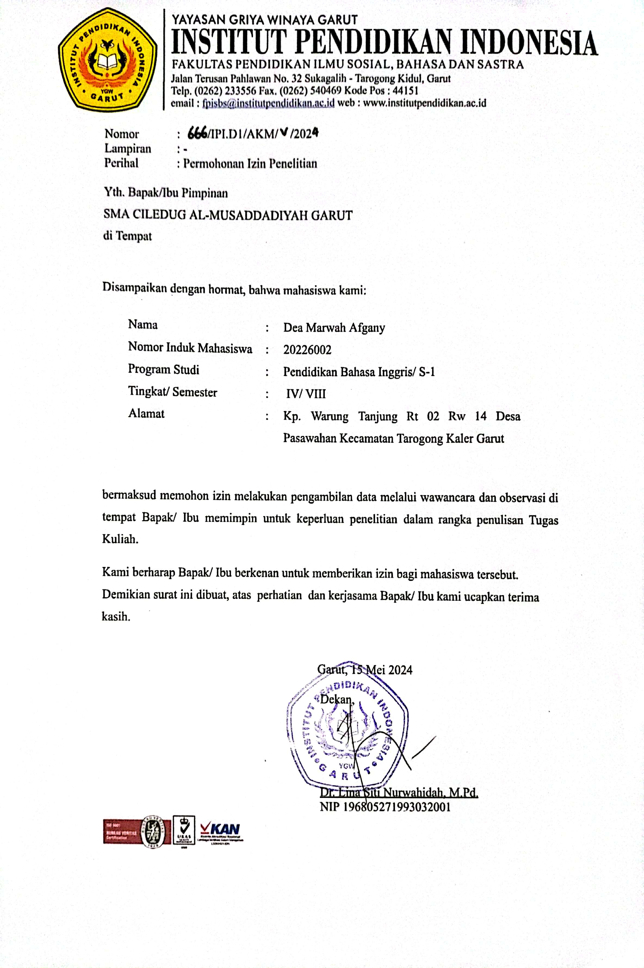
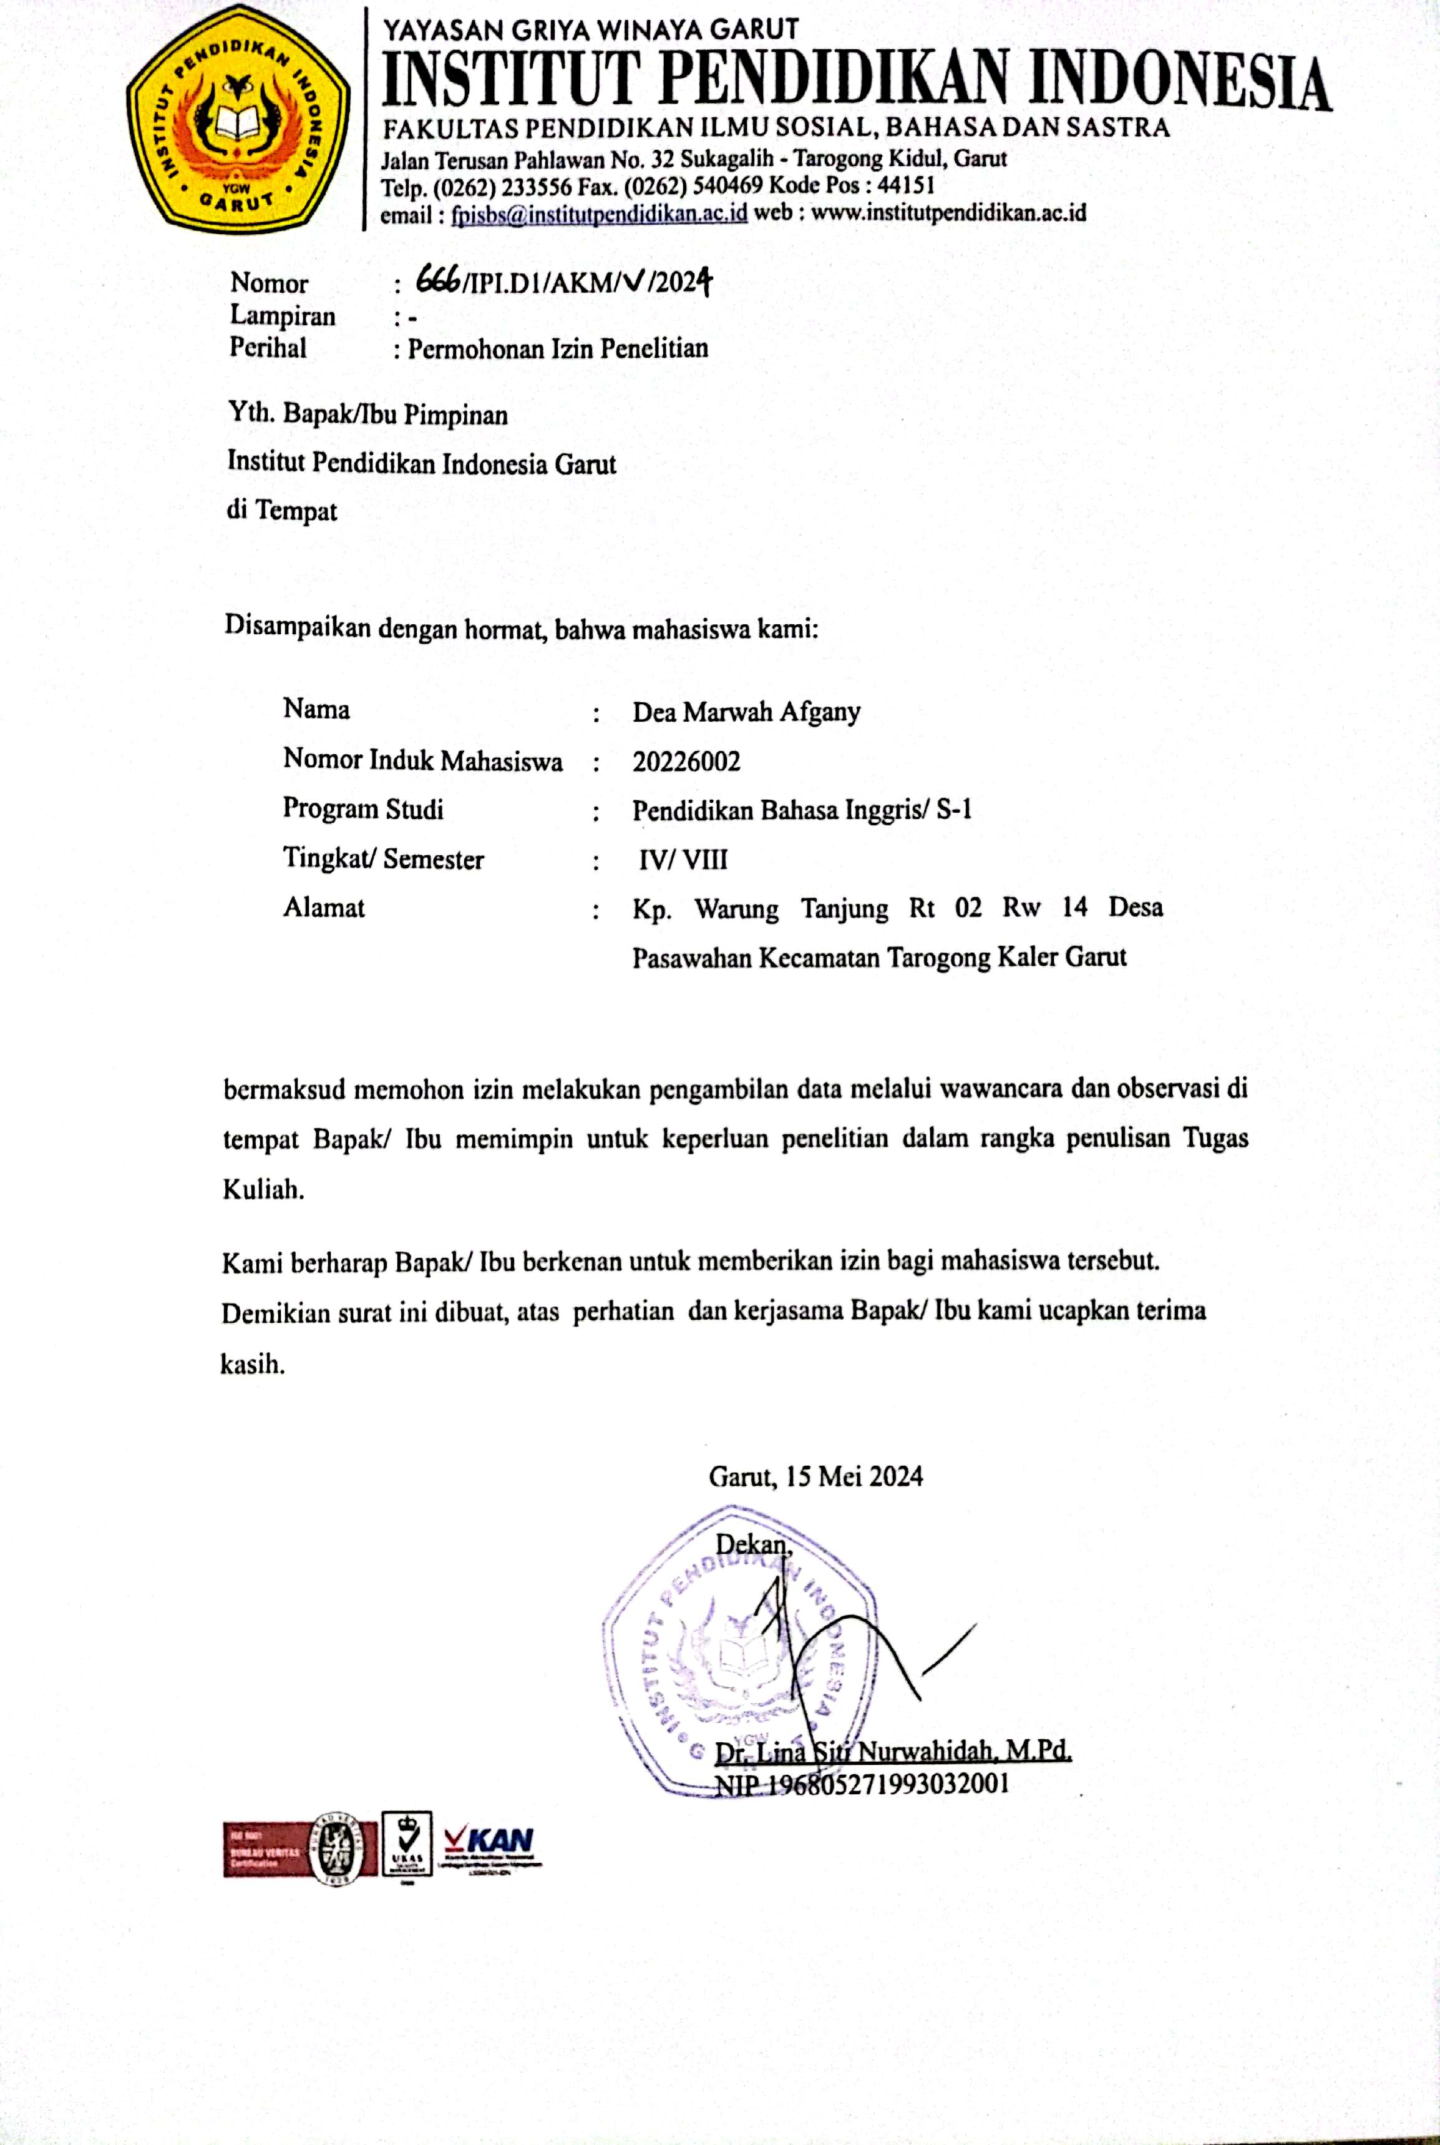

APPENDIX 2 INFORMED CONSENTS
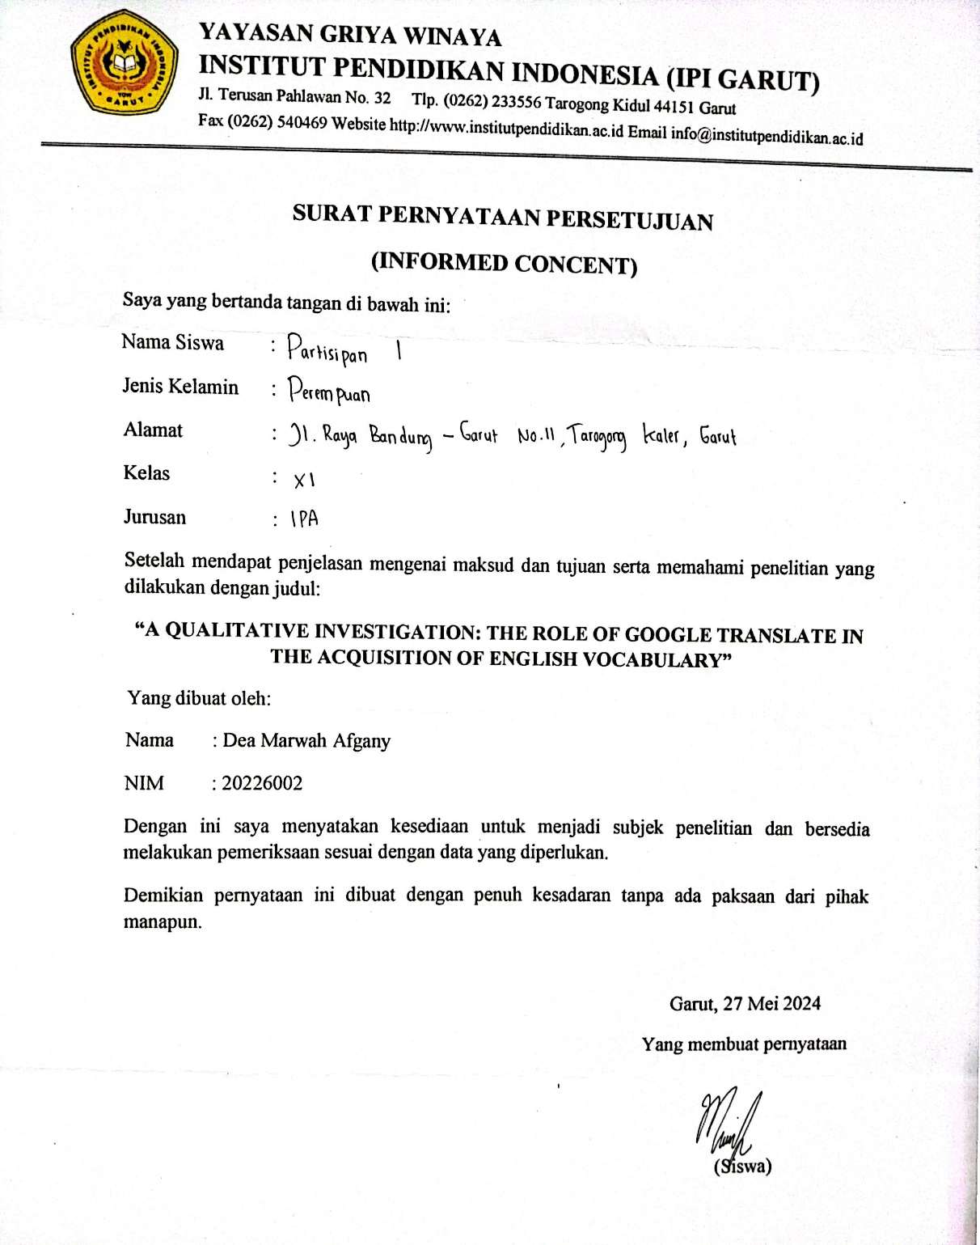

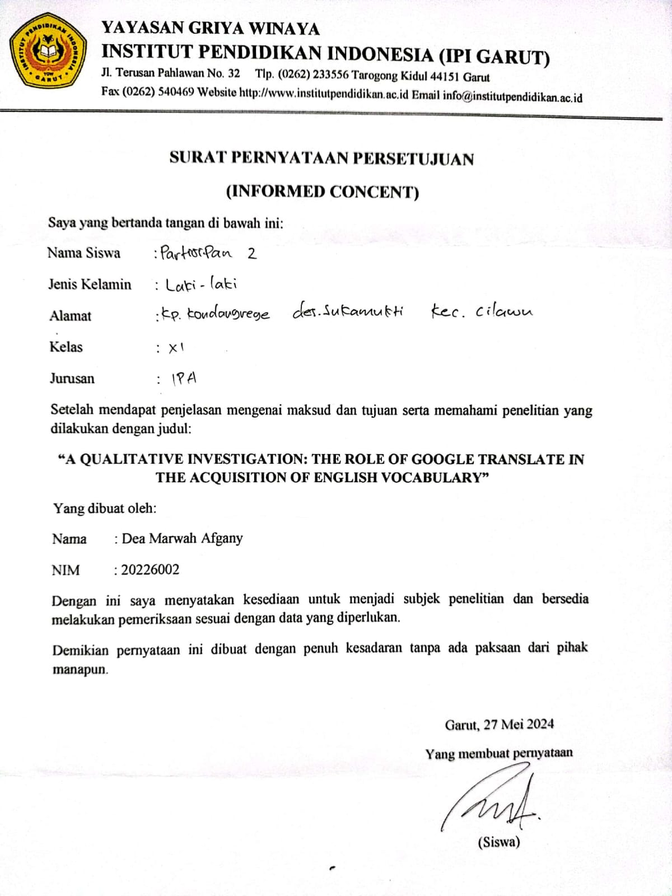
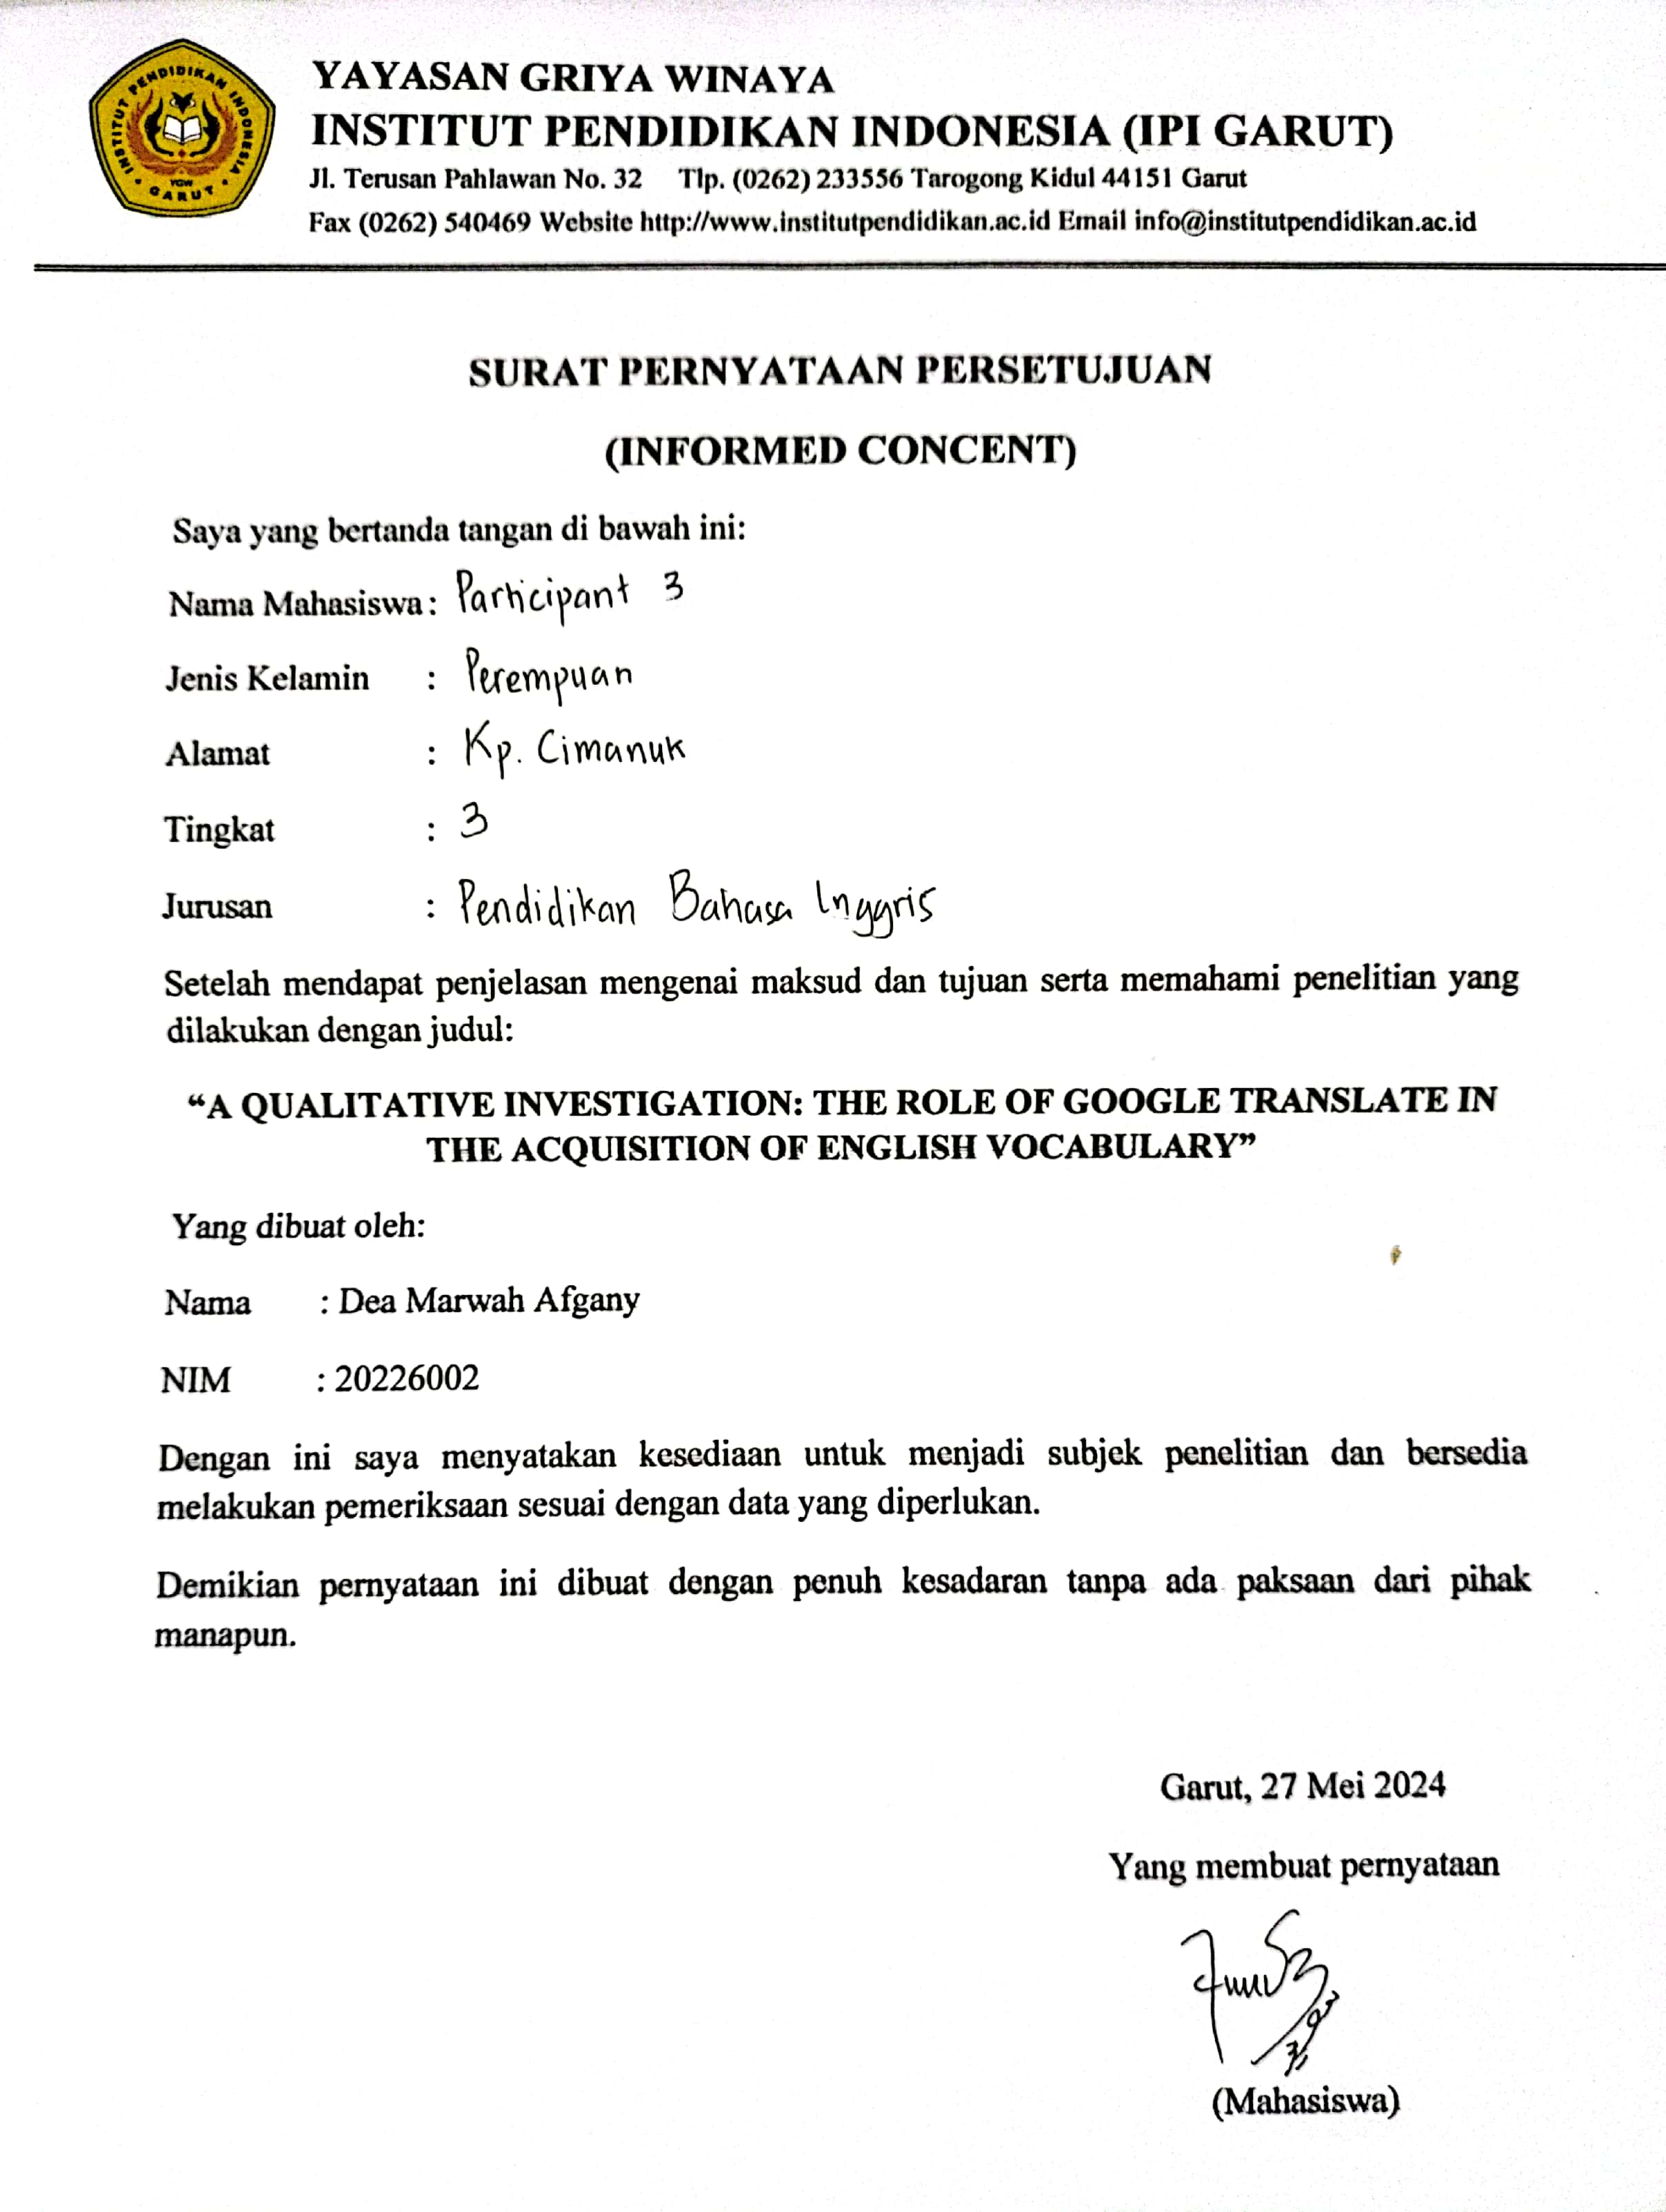
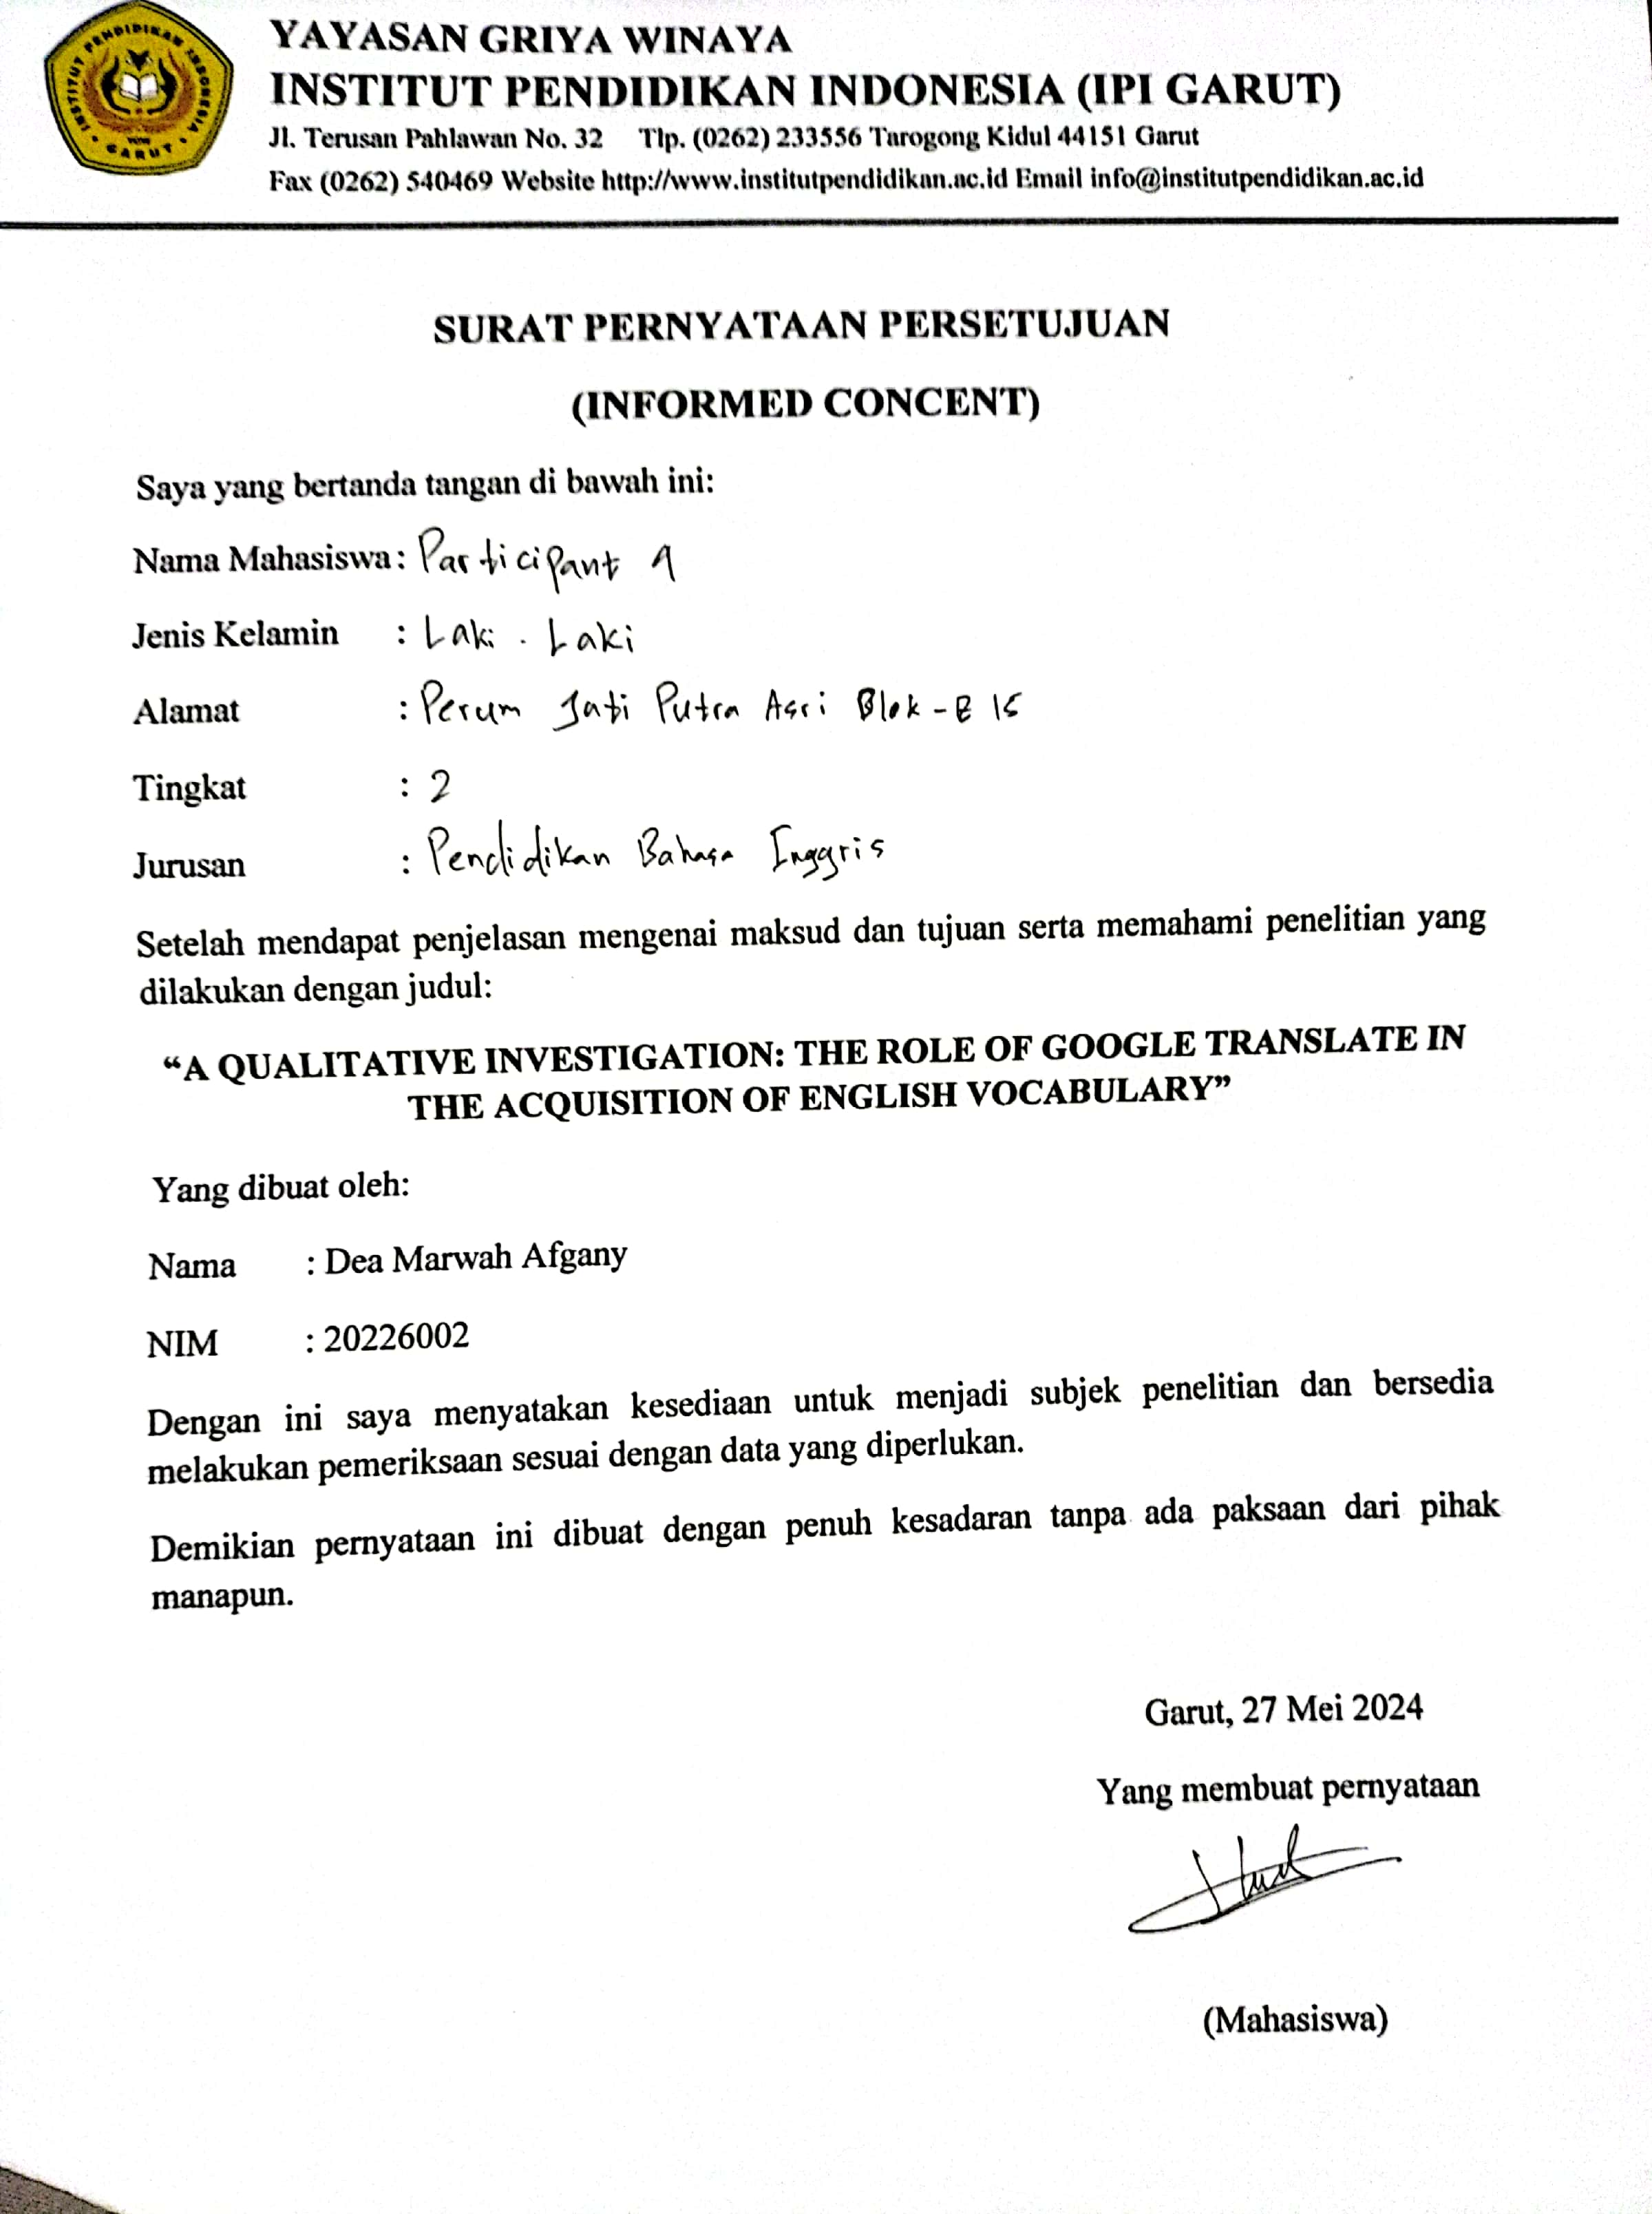

APPENDIX 3 RESEARCH INSTRUMENT GRID
Research Instrument Grid
A QUALITATIVE INVESTIGATION: STUDENT PERCEPTIONS OF GOOGLE TRANSLATE IN ENGLISH VOCABULARY ACQUISITION

No | Variables | Sub-variables | Indicator | Data collection | Data source
1. | Google Translate | Knowledge | Explaining Google Translate | Interview | Students  (siswa&mahasiswa)
1. |  | Experience | Using Google Translate | Interview | Students  (siswa&mahasiswa)
1. |  | Experience | Explains the experience of using Google Translate for English vocabulary acquisition | Interview | Students  (siswa&mahasiswa)
1. |  | Belief | Expressing personal opinions regarding Google Translate for acquiring English vocabulary | Interview | Students  (siswa&mahasiswa)
2. | Acquisition of English Vocabulary | Knowledge | Explains the definition of English vocabulary acquisition | Interview | Students  (siswa&mahasiswa)
2. | Acquisition of English Vocabulary | Belief | Provides perceptions about the acquisition of English vocabulary | Interview | Students  (siswa&mahasiswa)

Guide Questions
No | Sub-variables | Questions | References
1. | Knowledge | - Menurut Anda, apa itu Google Translate? | (BOUGUELMOUNA & BOUHENNI, 2023) states that First released in 2006, Google Translate is a multilingual neural machine translation technology capable of translating text, documents, and webpages between 100 languages, offering an API, mobile app, and website interface.
 | Experience | - Apakah Anda menggunakan sumber daya digital untuk belajar Bahasa Inggris? Apa saja? | According to BOUGUELMOUNA & BOUHENNI (2023), automated applications or software to translate text between languages, known as machine translation (MT), significantly impact learning and communication. With programs like Microsoft Translator, DeepL, Google Translate, and Systran Translate, learners can easily understand content and overcome language barriers.
 |  | - Sumber digital mana yang paling sering Anda gunakan untuk belajar Bahasa Inggris? | This is supported by (Translate et al., 2014), who stated that GT is regarded as one of the best MT programs and is highly recommended.
 |  | - Pernahkah Anda menggunakan Google Translate? Biasanya digunakan untuk apa? | (BOUGUELMOUNA & BOUHENNI, 2023) states in summary, that GT has transformed machine translation by making it freely accessible to a lot of humans worldwide.
 |  | - Pernahkah Anda menggunakan Google Translate untuk belajar kosakata baru Bahasa Inggris? | According to Chandra & Yuyun, (2018), the majority of respondents' uses of GT are for vocabulary translation or search. primarily translating Bahasa Indonesian into English. This indicates that GT is utilized as a dictionary since the respondents look up terms in English that they are unfamiliar with.
 |  | - Dalam pembelajaran Bahasa Inggris, seberapa sering Anda menggunakan Google Translate untuk memperoleh kosakata? Contohnya? | According to Translate et al., (2014), students routinely use GT for writing, reading, translating, and acquiring vocabulary. The majority of them use it for word definitions, homework for their English classes, and online communication.
 |  | - Apakah Google Translate membantu Anda dalam mengerjakan tugas Bahasa Inggris dan Bagaimana cara Google Translate membantu Anda dalam mendapatkan kosakata Bahasa Inggris? | According to Bin Dahmash (2020), five techniques were available for producing the English language with Google Translate: copying and pasting information, taking pictures, using a keyboard, making drawings, and voice dictation.
 |  | - Sejak menggunakan Google Translate, apakah Anda melihat peningkatan dalam kosakata Anda? Contohnya? | Bin Dahmash, (2020) study revealed that utilizing GTA features like "translate" and "definition" from English to Arabic improved participants' English vocabulary usage, while also aiding in understanding translated terms.
 |  | - Apakah Anda pernah mengalami situasi di mana terjemahan dari Google Translate tidak sesuai dengan konteks atau makna sebenarnya dari kosakata yang Anda pelajari? Contohnya? | Translate et al., (2014), Students noted that GT does not always translate words accurately and that it occasionally provides incorrect word meanings; as a result, they had to double-check word definitions in dictionaries or seek assistance from friends and teachers.
 | Belief | - Menurut Anda, apa kelebihan Google Translate saat digunakan untuk pembelajaran kosakata? | Translate et al., (2014) As free, simple, quick, better than their own translation, and beneficial for vocabulary study, students gave GT excellent marks.
 |  | - Apa kekurangan Google Translate saat digunakan untuk pembelajaran kosakata? | Hardini & Dewi, (2021) students discovered that using GT in class was addicting, that it was difficult to improve their English on their own, that it was difficult to translate accurately, and that they had not made much progress. Without GT, many felt insecure in the classroom and too indolent to pick up new vocabulary.
2. | Knowledge | - Apa yang Anda ketahui tentang kosakata? | Rasouli, (2016) states that vocabulary is a comprehension of both word meanings and the related definitions.
 |  | - Ketika Anda menggunakan Google Translate. Anda menyadari tidak bahwa pengetahuan kata dalam bahasa Inggris kalian itu bertambah dan Menurut Anda, apa itu pendapatan atau penambahan kosakata dalam konteks Bahasa Inggris? | Yanti, (2017) states that the ability to identify, comprehend, and generate a significant vocabulary of language and its meanings is known as the acquisition of vocabulary.
 | Belief | - Menurut Anda, pentingkah seseorang memiliki pemahaman atau pengetahuan mengenai kosakata yang beragam dalam konteks Bahasa Inggris? Mengapa? | Karakoc & Durmusoglu Kose, (2017) that to succeed when studying a foreign language, students must develop vocabulary knowledge. The more vocab comprehension they have, the more competent they become in language.

APPENDIX 4 INTERVIEW QUESTION
- Apakah Anda menggunakan sumber daya digital untuk belajar Bahasa Inggris? Apa saja?
- Sumber digital mana yang paling sering Anda gunakan untuk belajar Bahasa Inggris?
- Menurut Anda, apa itu Google Translate?
- Pernahkah Anda menggunakan Google Translate? Biasanya digunakan untuk apa?
- Pernahkah Anda menggunakan Google Translate untuk belajar mencari kosakata baru Bahasa Inggris?
- Apa yang Anda ketahui tentang kosakata?
- Ketika Anda menggunakan Google Translate. Anda menyadari tidak bahwa pengetahuan kata dalam bahasa Inggris kalian itu bertambah? Menurut Anda, apa itu pendapatan atau penambahan kosakata dalam konteks Bahasa Inggris?
- Dalam pembelajaran Bahasa Inggris, seberapa sering Anda menggunakan Google Translate untuk memperoleh kosakata? Contohnya?
- Apakah Google Translate membantu Anda dalam mengerjakan tugas Bahasa Inggris? Bagaimana cara Google Translate membantu Anda dalam mendapatkan kosakata Bahasa Inggris?
- Sejak menggunakan Google Translate, apakah Anda melihat peningkatan dalam kosakata Anda? Contohnya?
- Menurut Anda, pentingkah seseorang memiliki pemahaman atau pengetahuan mengenai kosakata yang beragam dalam konteks Bahasa Inggris? Mengapa?
- Apakah Anda pernah mengalami situasi di mana terjemahan dari Google Translate tidak sesuai dengan konteks atau makna sebenarnya dari kosakata yang Anda pelajari? Contohnya?
- Menurut Anda, apa kelebihan Google Translate saat digunakan untuk pembelajaran kosakata?
- Apa kekurangan Google Translate saat digunakan untuk pembelajaran kosakata?

APPENDIX 5 INTERVIEW TRANSCRIPTS
INTERVIEW TRANSCRIPT
*P1-P4 = Participants
Questions | Answer
- Apakah Anda menggunakan sumber daya digital untuk belajar Bahasa Inggris? Apa saja? | P1: Iya, biasanya Google Translate, Tiktok, dan Youtube.  P2: Ya, biasanya Google Translate, Brainly, ada juga Kamus Bahasa Inggris di Hp.  P3: Iya pakai, seperti Google Translate, DeepL, Grammarly.  P4: Ya menggunakan kaya Google Translate, DeepL, ChatGpt juga.
- Sumber digital mana yang paling sering Anda gunakan untuk belajar Bahasa Inggris? | P1: Biasanya dari Google Translate itu sendiri.  P2: Google Translate.  P3: Paling sering Google Translate.  P4: Semuanya sih tapi kalau untuk translate lebih sering Google Translate.
- Menurut Anda, apa itu Google Translate? | P1: Menurut saya, Google Translate itu alat untuk menterjemahkan dari satu Bahasa ke Bahasa yang lain, dan ada yang berupa web dan aplikasi khusus translate nya.  P2: Google Translate itu kaya aplikasi atau website buat menterjemahkan dari satu Bahasa ke Bahasa lainnya untuk mempermudah komunikasi.  P3: Menurut saya, Google Translate itu aplikasi untuk menterjemahkan kosakata, kalimat atau teks dari satu Bahasa ke Bahasa lainnya.  P4: Menurut saya, GT sebuah alat untuk membantu kita dalam mengenal atau memahami bahasa asing. GT itu berupa web karena saya suka pake yang web.
- Pernahkah Anda menggunakan Google Translate? Biasanya digunakan untuk apa? | P1: Ya sering, tiap belajar Bahasa Inggris dan Bahasa Arab misal mau menterjemahkan dari Bahasa Indonesia ke Bahasa Inggris biasanya pake Google Translate, terus kan sekarang ada fitur buat belajar speaking juga jadi suka belajar speaking juga di GT.  P2: Ya, digunakan untuk terjemahin cerita atau teks-teks lainnya kalau ada tugas menterjemahkan. Terus suka dipake kalau lagi liat-liat tiktok atau apa terus nemuin kata yang asing yang belum pernah kita tau atau denger suka dicari di GT apa artinya. Terus lebih sering digunakan buat translate nya per kata jadi dalam satu kalimat gak semua ditranslate paling yang gatau nya aja nanti tinggal digabungkan.  P3: Kalau lagi mengerjakan tugas misalnya mau translate satu per satu kadang suka membuat saya bingung jadi suka pakai bantuan GT biar lebih mudah aja.  P4: Ya pernah dan masih digunakan. Biasanya buat mengerjakan tugas, buat konten di social media kadang ada bahasa Inggris yang saya tidak paham pasti larinya ke GT.
- Pernahkah Anda menggunakan Google Translate untuk belajar kosakata baru Bahasa Inggris? | P1: Ya sering. Pakai yang di web Google.  P2: Ya. Saya suka pakai yang di website Google.  P3: Iya pernah. Saya pakai Google Translate yang aplikasinya di download di Playstore soalnya pemakaiannya sering jadi supaya memudahkan aja.  P4: Iya sering. Saya pakai yang di web.
- Apa yang Anda ketahui tentang kosakata? | P1: Yang saya tahu tentang kosakata itu kata-kata yang emang sering diucapkan sehari-hari kaya basic-basic nya gitu.  P2: Kosakata kaya sekumpulan kata yang dimiliki oleh bahasa-bahasa.  P3: Kan bahasa itu untuk berkomunikasi nah kosakata itu kaya mewakili misalnya ini sebuah barang namanya ini, nah kosakata itu seperti itu atau kata-kata gitu.  P4: Kata-kata yang biasanya digunakan dalam sehari-hari untuk berkomunikasi contohnya saat menggunakan bahasa Inggris.
- Ketika Anda menggunakan Google Translate. Anda menyadari tidak bahwa pengetahuan kata dalam bahasa Inggris kalian itu bertambah dan Menurut Anda, apa itu pendapatan atau penambahan kosakata dalam konteks Bahasa Inggris? | P1: Iya menyadari. Penambahan kosakata itu jadi kita lebih paham dan tidak merasa bingung lagi jika ada sebuah kata yang kita temukan.  P2: Menurut saya, perolehan kosakata itu kaya kita mendapatkan kata baru dalam Bahasa Inggris yang memudahkan kita untuk berinteraksi atau berbicara dalam Bahasa Inggris tersebut.  P3: Perolehan kosakata itu kaya interpretasi misalnya dari sebuah barang yang kita liat tapi kita gak tahu nama barang tersebut, nah kita cari ke GT nah itu kaya proses penerimaan atau pemahaman informasi ke otak kita.  P4: Ada pasti. Pendapatan kosakata baru jadi bisa menggunakan variasi kosakata yang lebih banyak dan jadi bisa memahami sebuah kalimat atau kata-kata dalam Bahasa Inggris.
- Dalam pembelajaran Bahasa Inggris, seberapa sering Anda menggunakan Google Translate untuk memperoleh kosakata? Contohnya? | P1: Sering hampir setiap pelajaran Bahasa Inggris pake GT, kaya kata-kata yang dibawah GT suka ada sinonim gitu, nah jadi tahu oh ternyata misal Bahasa inggris “belajar” itu bukan hanya “study” tapi ada “learn” juga.  P2: Kalau dalam pembelajaran gak terlalu sering karena jarang juga tugas mentranslate. Terus dalam jangka waktu tertentu kalau lagi nonton film inggris yang gak ada translate nya suka pake GT buat nyari translate nya. Jadi gak terlalu ketergantungan paling dipake buat nyari kosakata yang gatau aja.  P3: Sering terutama hampir semua mata kuliah apalagi awal masuk perkuliahan tapi sekarang udah enggak terlalu karena sudah ada peningkatan kosakata dalam diri saya dan GT jarang dipake buat diluar kelas.  P4: Sering banget, contohnya kaya cari kosakata yang aneh atau baru tau atau yang ga paham langsung pake GT. Contoh kata “distinguish” itu banyak sih artinya, terus “beautiful” juga banyak artinya. Terus GT dipake hampir semua mata kuliah tapi lebih sering buat speaking.
- Apakah Google Translate membantu Anda dalam mengerjakan tugas Bahasa Inggris dan Bagaimana cara Google Translate membantu Anda dalam mendapatkan kosakata Bahasa Inggris? | P1: Iya membantu. Caranya dengan memasukkan kata dari Bahasa Indonesia nanti otomatis diubah ke Bahasa Inggris. Selain translate ada juga tadi kaya sinonim yang ternyata dari satu kata Bahasa Inggris masih banyak persamaan kata lainnya yang memiliki arti sama. Terus ada cara pengucapan juga kan suka ada kaya speaker disampingnya suka didengerin dan diulang-ulang jadi tahu cara mengucapkannya.  P2: Ya. Jadi caranya masukin dulu Bahasa Indonesia baru nanti keluar kosakata Bahasa inggris yang belum kita ketahuinya. Terus sekarang kan ada fitur Google Lens itu yang bisa langsung di foto jadi pake itu. Terus google translate juga suka membantu saya dalam mencari singkatan-singkatan kata contohnya kalo lagi scroll tiktok ada singkatan kata misalnya “TBH” awalnya tidak tahu terus cari tahu singkatan “TBH” itu singkatan dari “To Be Honest” terus saya translate ke Google Translate munculah artinya yaitu “Sejujurnya” jadi saya yang awalnya tidak tahu menjadi tahu singkatan dari apa sekaligus artinya dari “TBH” itu.  P3: Menurut saya membantu banget karena membuat saya yang awalnya gak tahu menjadi tahu terus karena udah keseringan menggunakan GT jadi merasa sangat terbantu untuk sehari-hari dalam hal pengucapan dan writing memudahkan dalam mengingat kata-kata tapi kalau kosakata yang susah diingat suka nyari kata lain atau sinonimnya. Jadi menurut saya berdampak positif karena kalau disebut ketergantungan juga enggak, lebih ke membantu banget jadi gak terlalu negative, tapi tergantung perspektif sih kalau digunakan terus menerus atau selalu bergantung pada GT bisa jadi berdampak negative kaya ketergantungan tapi kalau dipakai seperlunya lebih ke dampak positif sih.  P4: Ya membantu banget. Membantu jadi memahami kosakata baru bahasa Inggris. Caranya ke Google Chrome atau Google Engine nya terus search Google Translate nanti muncul tinggal pilih Bahasa misalnya mau translate dari Bahasa Inggris ke Bahasa Indonesia dan saya suka pakai GT di hp.
- Sejak menggunakan Google Translate, apakah Anda melihat peningkatan dalam kosakata Anda? Contohnya? | P1: Ya ada perubahannya, contohnya ketika ada yang gatau vocab Bahasa Inggris langsung pake GT jadi tahu artinya. Terus dari peningkatan itu suka diterapkan dalam sehari-hari contohnya kalo lagi ngobrol suka di selip-selipkan pake Bahasa inggris.  P2: Ya, kan saya main game jadi tahu Bahasa inggris yang ada di game itu apa maksudnya kaya “attack” dan lainnya.  P3: Ya, ada secara signifikan khususnya untuk pembelajaran writing dan pengucapan. Jadi membuat saya tidak terus menerus pakai GT setiap kosakata yang ditemukan.  P4: Ada. Contohnya dari pemahaman skill reading jadi lebih paham kalau ada tugas bahasa Inggris, keterampilan speaking juga jadi bisa mengemukakan pendapat pakai Bahasa Inggris, dalam hal listening dan writing juga lebih meningkat karena lebih paham dengan yang orang lain ucapkan atau tulis menggunakan Bahasa Inggris.
- Menurut Anda, pentingkah seseorang memiliki pemahaman atau pengetahuan mengenai kosakata yang beragam dalam konteks Bahasa Inggris? Mengapa? | P1: Ya penting, karena menurut saya Bahasa Inggris itu adalah basic skill yang harus kita punya soalnya mau kemanapun kita pergi pasti Bahasa Inggris itu dibutuhkan dan harus bisa minimal ya beberapa kata yang kita paham.  P2: Iya sangat penting, karena bahasa inggris sekarang itu kaya bahasa yang wajib di dunia kaya kita mau ke luar negeri pasti ada orang yang bicara pake bahasa inggris.  P3: Penting karena biar lebih mudah untuk berkomunikasi terus membuat kita lebih bisa mengekspresikan sesuatu.  P4: Penting banget soalnya kita gabisa dalam satu bahasa cuma mengenal “selamat pagi” “hai”, atau menyebutkan nama tempat aja kan gak bisa. Cara kita berkomunikasi menggunakan bahasa kan banyak menggunakan kosakatanya jadi gabisa stuck disitu aja.
- Apakah Anda pernah mengalami situasi di mana terjemahan dari Google Translate tidak sesuai dengan konteks atau makna sebenarnya dari kosakata yang Anda pelajari? Contohnya? | P1: Ya pernah, contohnya kalau ngambil dari struktur misal past tense atau present tense suka beda gitu gak sesuai sama struktur nya. Solusi kalau ngalami situasi itu biasanya suka terjemahin satu kata-satu kata baru nanti digabungkan, soalnya kalau langsung perkalimat suka beda. Kalau udah per kata terus digabung jadi per kalimat terus suka ditranslate lagi buat memastikan ini benar dan nyambung gak. Dan biasanya hasilnya lebih nyambung sama yang diharapkan.  P2: Pernah, kadang translate yang muncul ga sesuai dengan yang disoal atau teks. Apalagi dipake buat translate yang panjang kadang suka ada error sedikit-sedikit. Solusinya suka cari kosakata di aplikasi lain kaya dikamus hp atau bertanya ke orang yang lebih tahu.  P3: Pernah, misalnya dalam pembelajaran writing saya mengetik dalam Bahasa Indonesia terus kadang hasil translate nya itu ga sesuai sama yang kita pikirkan. Jadi kadang membuat saya lebih percaya hasil translate saya dibandingkan hasil dari GT tersebut karena itu kan teknologi ya pasti ada kekurangannya. Solusinya kadang kalau saya gak tahu sama sekali dan merasa ragu paling pindah cari alternative mesin translate lain seperti DeepL tapi kadang suka sama aja kurang akurat.  P4: Belum pernah sih selama menggunakan GT.
- Menurut Anda, apa kelebihan Google Translate saat digunakan untuk pembelajaran kosakata? | P1: Kelebihannya itu kita jadi tahu cara pengucapan yang benar gimana terus ya tadi kata-kata yang ditranslate bukan hanya itu doang masih banyak sinonim lain. Terus menurut saya GT sangat-sangat membantu apalagi yang saya tahu sekarang ada gitu fitur yang kita tuh speaking terus didengerin sama GT nya terus dikoreksi mana yang salah dan mana yang benar membantu banget buat skill speaking, listening.  P2: Ya kaya lebih praktis dan simple gak perlu download tinggal ke google chrome atau web, terus banyak fitur kaya ketika kita lagi translate langsung muncul gambar yang sesuai dengan translate nya itu, terus kita juga jadi tahu cara mengucapkan kosakata itu kaya ada audio buat melatih berbicara atau pronounce dalam bahasa Inggris, terus ada sinonim dari hasil translate nya dan ada fitur pendeteksi Bahasa yang bisa digunakan kalau kita gatau Bahasa tersebut berasal dari Bahasa apa. Selain dalam pembelajaran dikelas GT juga bermanfaat misal kalau ketemu orang asing lagi tour untuk minta foto kita bisa pake GT buat terjemahin.  P3: Bisa membantu menambah kosakata jadi lebih beragam, mudah diakses, terus membantu juga pas masa perkuliahan seperti sekarang, terus kalau digunakan untuk translate satu kata suka ada hasil transkrip nya, bisa di switch gitu language nya, terus kalau kita mau tahu pronounciation nya ada sound nya apalagi ketika mau presentasi itu sangat membantu kalau saya gak tahu cara pengucapannya bagaimana jadi suka langsung buka GT, kelebihan lain GT itu bisa di download language nya jadi bisa diakses secara offline juga, terus ada sinonim kata yang suka dipake tapi kadang muncul atau ngga sinonimnya. Lalu, GT suka membantu buat mengidentifikasi jenis kosakata tersebut termasuk part of speech yang mana jadi saya bisa tahu kosakata itu termasuk verb/noun.  P4: Penggunaan simple gak perlu download aplikasi, mudah d akses oleh semua orang. Dari segi fiturnya memudahkan banget bisa voice, bisa membantu pronoun sama bisa membantu translate teks yang kita foto namanya Google Lens, pilihan Bahasa nya juga banyak dan ada kata-kata sinonim nya kalau translate sebuah kata dan suka saya pake soalnya kepake banget buat di organisasi misalnya buat konten.
- Apa kekurangan Google Translate saat digunakan untuk pembelajaran kosakata? | P1: Ya itu kata-kata nya kadang kurang akurat apalagi buat dipake perkalimat kadang suka ga sesuai dengan strukturnya, terus apalagi kalau udah nyari verb kan gabisa ya kalau mau nyari verb 1 atau verb 2 nya itu apa kadang susah gitu.  P2: Kadang error terjemahannya ga sesuai sama yang kita mau dalam soal terus kadang kalo lagi menterjemahkan suka tidak terdeteksi jadi masih kata-kata dalam bentuk semula.  P3: Kadang ga sesuai misalnya yang saya butuhkan dalam bentuk formal tapi hasil dari GT informal, terus pilihan per kata kadang ada pilihannya buat diganti-ganti kadang enggak, kekurangan lain kaya keterbatasan dalam jumlah kata misalnya kalau translate satu paragraph yang banyak jumlah kata nya ternyata kalimat-kalimat dibagian akhir paragraph tersebut malah makin gak nyambung dan kadang tidak terdeteksi. Jadi solusinya suka translate per kalimat atau per kata aja.  P4: Untuk diri saya pribadi membuat ketergantungan karena mudah banget gitu diaksesnya, tapi kalau digunakan buat basic dan engga keseringan kayanya enggak menimbulkan dampak ketergantungan.

APPENDIX 6 THESIS GUIDANCE CARD
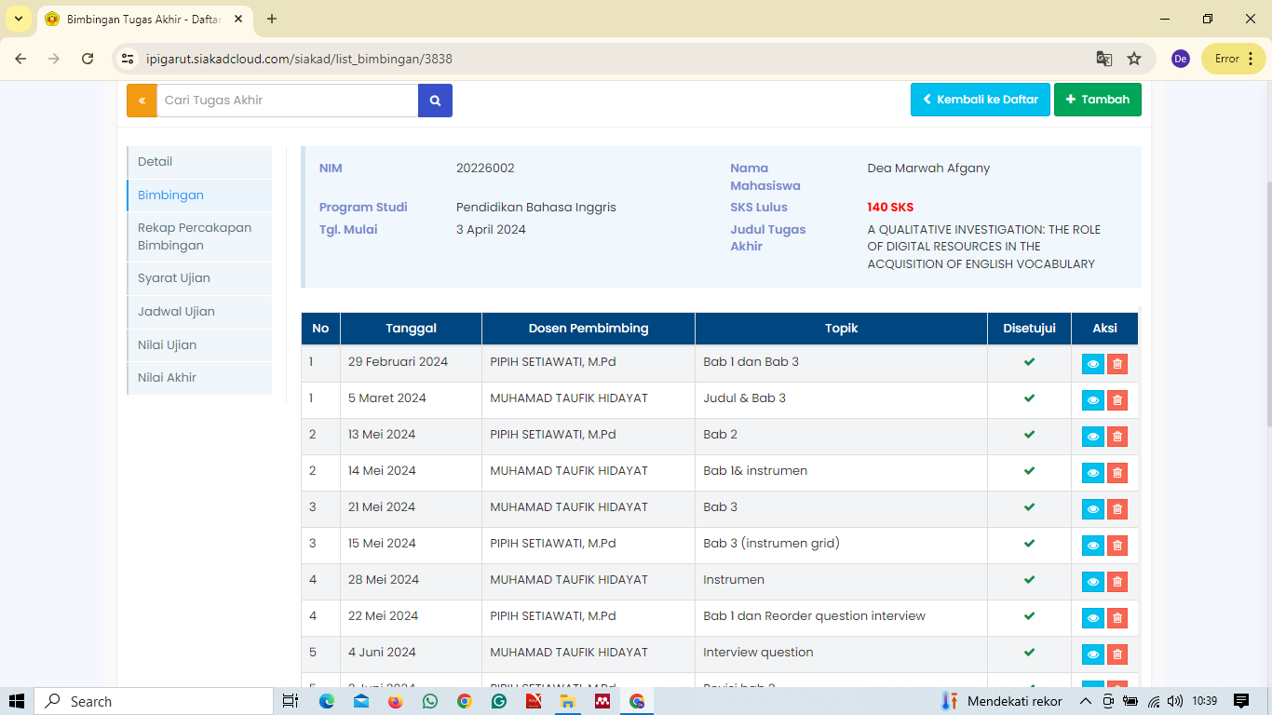

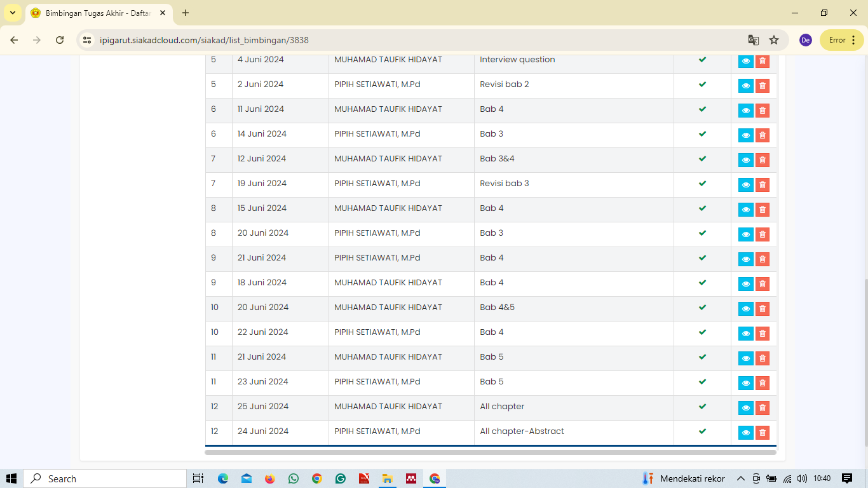

APPENDIX 7 TURNITIN CHECK RESULTS
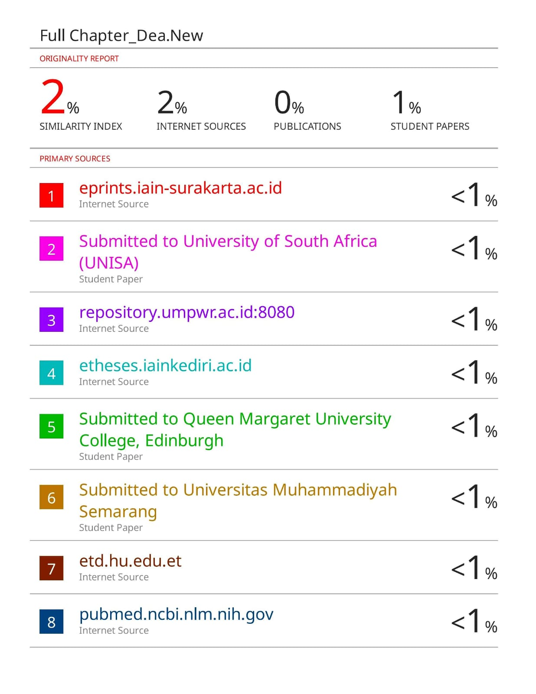

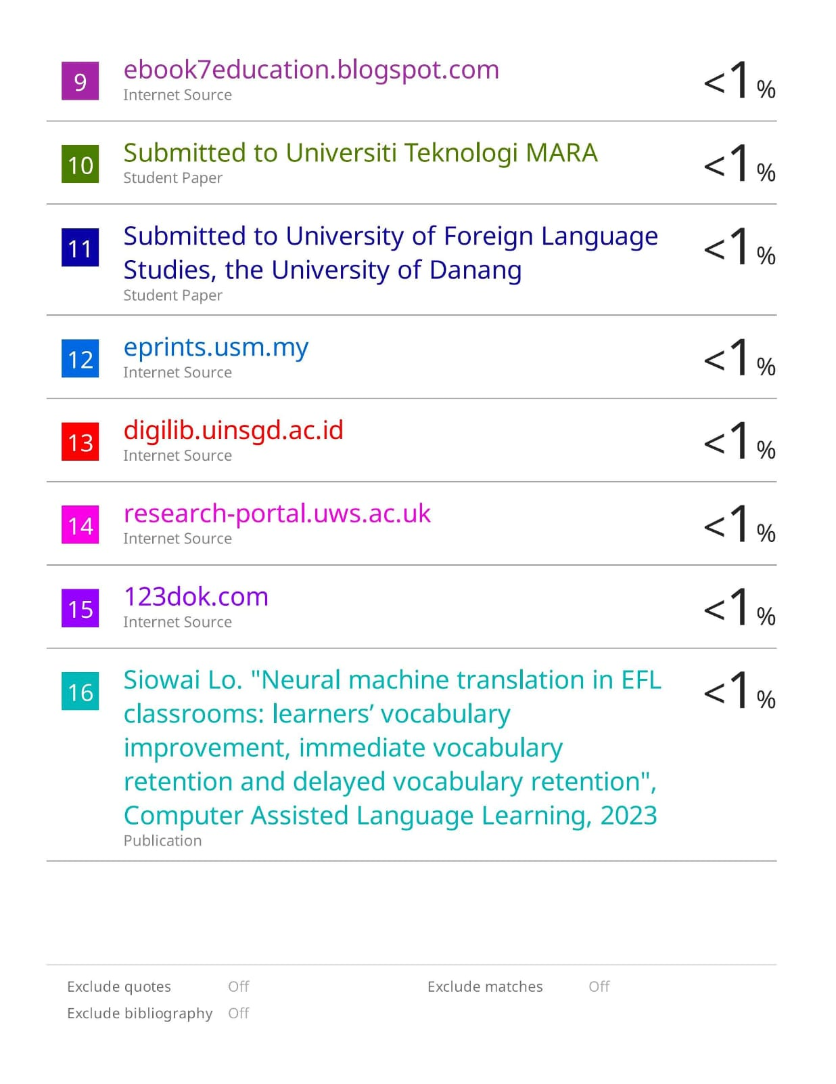

APPENDIX 8 CURRICULUM VITAE
