CHAPTER I
INTRODUCTION
This chapter provide the general introduction of the study. It concludes the background of the study, the reason for choosing the topic, the research question, the objective of the study, the significances of the study, and the definition of terminology.
  - The Background of the Study
Writing is a means of expressing ideas or communicating with others. It is a productive skill like speaking, but the difference is writing can be drafted and re- drafted and changed many times before it is acceptable to the researcher. (Waylink English, 2017) And there are situations in which the ability of writing is crucial or written language is a need. Through writing, students can share their ideas and their knowledge about facts and opinions of what they have received. Thus, the students also can express their feeling and their experiences to others in written form.
Most students found difficulties in choosing appropriate words and connectives to be used. They have problems to develop their idea well based on the topics that given by the teacher. It happens because they don‟t have enough vocabulary power and the rules of writing like grammar. Hence, the teacher focused more on teaching grammar. The teacher also tended to apply teacher-centered activities which do not encourage students learning maximally because it is more focus on the teacher. It also happens in most English foreign language students in Indonesia, they find difficulties writing in English.(Imelda, 2016) It happens because they have to use correct English grammar and vocabulary and writing is so different from the other skills such as listening, speaking and reading.
In order to solve the problem, it is important to pay attention to the teacher‟s technique in teaching writing. So, it is important for the researcher to make some effort in the English teaching and learning process also identifying any actions that will improve the writing learning process in the class. The researcher want to know the effect of project based learning for improving the writing skill of class XI at Senior High School in Garut whether it will improve the students‟ writing skill or not. Project-Based Learning (PjBL) approach was introduced to change teacher-centered learning activities to be learner-centered learning activities to help students comprehend writing Analytical Exposition text in joyful learning atmosphere. Moreover, PjBL challenged the students to think critically in solving complex problems in group working (Mehmet Akif, 2017)
Project based learning propose a student-centered, cooperative, interdisciplinary and integrated teaching-learning process which contextualizes their life. A project based learning lesson provides them with the opportunity to learn in an authentic, challenging, multidisciplinary environment, to learn how to design, carry out, and evaluate a project that requires sustained effort over a significant period of time (John, 2017). Project-Based Learning is a model that organizes learning around projects and it involves completing complex tasks that typically result in a realistic product, event, or presentation to an audience (Mehmet, 2017).
A lot of studies have been done, some of them gave the result; It was no doubt that the students’ writing skills with Project based learning was better compared with the approach of guided writing procedure (Yusri, 2021), (Andyani,2015) the result show that; The use of project-based learning was able to improve the students’ writing skills based on the several evidences, (Dian,2019) The research findings indicate that the implementation of project-based learning combined with process writing and Instagram could improve the students’ writing achievement, and (Behnam,2019) The analysis of the obtained data revealed that project-based learning had significant effect on the learners’ writing ability. Based on the numerous studies above, the researcher choose to improve students’ writing skills by using project based learning as the topic.
  - Reason for Choosing The Topic
Choosing the topic of " Improving Student’s Writing Skills Through Project Based Learning Technique : A Quasi-Experimental Research Design at an Senior High School in Garut" is crucial for several compelling reasons. This writing difficulty was caused by several factors, those are:
- Factors related to students. First of all, the factor during the teaching and learning process of writing came from the students. This factor aroused because students had lack motivation in writing. They were not able to generate any ideas because of their unwillingness towards writing. Other than that, they tended to be passive to participate in the teaching and learning activities. On the other hand, they had no strong desire to learn about writing.
- Factors related to the teacher. When explaining the materials, the teacher did it in a traditional way. The teacher did not involve the students to participate actively in the teaching and learning activities. The teacher used direct Indonesian to English translation technique while teaching writing. The teacher often asked the students to make use of their dictionary, gadget, or mobile phone to translate the words. The teacher rarely combined and developed the activities found in LKS (Lembar Kerja Siswa) with the other interesting and interactive activities. Therefore, the tasks and activities seemed to be monotonous.
- Factors related to the teaching media. Lastly, the factor which causes difficulty in writing was related to the teaching media. The use of teaching media is very prominent in teaching writing because it can help students to grow their motivation during the teaching and learning process. However, the use of the teaching media, particularly in writing, was very limited. The teacher rarely used attractive teaching media to deliver the materials.
Due to the problems which aroused in the teaching and learning process of writing, it is clear that there was an urgent need of an instructional technique which could overcome the problems of writing. Hence, the researcher looked for an appropriate way which could solve it. The researcher noticed that the use of project-based learning in the English instructional process has become more popular and taken into account recently.
  - The Research Question
Considering to the problems of teaching and learning in writing which has been identified above, this study is addressed to answer the following question:
“Does project-based learning improve students’ writing skills?”

  - The Objective of the Study
The objective of the study is to obtain the empirical evidence about the effect of project-based learning in improving the students’ writing skills at one of Senior High School in Garut.
  - The Significant Of the Study
    - For English teachers, this study is supposed to be one of the techniques that can be implemented in the classroom activities in order to gain the students‟ writing skils.
    - For students, project-based learning is a technique that very useful to improve their writing skills especially in writing Analytical Exposition text. Moreover, it also improves their creativity.
    - For further researchers, this study is intended to be one of the references for relevant study.
  - The Definition of Terminologies
    - Definition of writing
Writing is a productive skill that people have to master. According to Meyers, (2004) writing is a way to produce a language which you do naturally when you speak. Writing is one way of conveying something to others through texts or writing. It becomes complicated because we need to pay attention on the rules, different from speaking skill as the other productive skill.
Brown(2001) stated that a writing is a product of thinking, drafting, and revising that requires specialized skills on how to generate ideas, how to organize them coherently, how to use discourse markers and rhetorical conventions to put then cohesively into a written text, how to revise a text for clearer meaning, how to edit a text for appropriate grammar, and how to produce a final product.
    - Definition of Analytical Exposition Text
Analytical exposition is a text that elaborates the researcher’s opinion on phenomena/issues, without persuading the readers to do something. This text will only persuade the readers that the phenomena/issues, are important/worth it to be discussed by providing the argument/opinions to support the topic. Because analytical exposition text contains the thoughts of the author about things that happen around him, whether objects, events, or places.
Analytical exposition is one of the texts which is recommended to be taught at Senior High School. The communicative purpose of analytical exposition text is to argue that something is the case. It is a type of oral or written discourse that is used to explain, describe, give information or inform on what is being discussed. (Illusia, Stevanus and Zainal Arifin,). Analytical exposition text is a text that elaborated the researcher’s idea, point of view argument about a problem surrounding (Maria, 2014). According to Anderson (1997) analytical exposition is a piece of text that presents one side of an issue.
    - Definition of Project Based Learning
Project-based learning is centered on the learners and affords learners the opportunity for in depth investigations of worthy topics (M.Grant, 2002). According to Bell (2010) Project- Based Learning (PjBL) is a student-driven, teacher-facilitated approach to learning. Project-based learning is an instructional method centered on the learner. Students elaborate a question and lead through study under the teacher„s supervision. PjBL is an approach to instruction that teaches curriculum concepts through a project. The project is guided by an inquiry question that drives the study and allows students to apply their acquired knowledge. In addition, Fried-Booth states the definition of project-based learning as student-centered and driven by the need to create an end- product. PjBL is a means to create an end-product in real-world environment with confidence and independence.
    - The Definition of Infographic
An infographic is basically an artistic representation of data and information using different elements, such as: graphs, pictures, diagrams, Analytical Exposition, timelines, check lists, etc. Infographics allow us to tell a more complete story of the data and more engaging than most traditional ways of communicating data and information. More formally according to Mark Smiciklas (2012) an infographic is defined as a visualization of data or ideas that tries to convey complex information to an audience in a manner that can be quickly consumed and easily understood. The process of developing and publishing infographics is called data visualization, information design, or information architecture.
Alrwele (2017) defines infographics as a blend of brief descriptive text along with pertinent imageries that together convey the idea evidently and expediently. This tool has gained widespread importance to teach a variety of concepts and skills including language-related skills like reading, writing, speaking, etc. Writing can be more straightforward to learn by using media to help people or the researchers. One of the media can be used in learning writing is infographic. Infographic stands for information and graphic. It is also defined as the collection of imagery, data visualizations such as bar graphs and charts, and minimal text that makes the readers easy to understand about a topic. Infographic is stated as media which can be used in teaching and learning as stated by Mitayo & Nakanitanon (2021) that infographics have a lot of usages in many fields such as politics, business, advertisings, educations, health, and other fields.

CHAPTER II
A REVIEW OF RELATED LITERATURE
Second chapter contains the expert theories that are related with this study. It will be discussed into some subchapters, there are writing, Analytical Exposition text, realia project based learning, infographic and some previous studies.
2.1 Theoretical Foundations of Writing
2.1.1 The Definition of Writing
Brown (2001) stated that a writing is a product of thinking, drafting, and revising that requires specialized skills on how to generate ideas, how to organize them coherently, how to use discourse markers and rhetorical conventions to put then cohesively into a written text, how to revise a text for clearer meaning, how to edit a text for appropriate grammar, and how to produce a final product.
Writing as one of the four skills in English has an important role for undergraduate students. This is because writing is productive skill which can build and rebuild the student’s motivation in mastering language. Writing is a basic skill for students, because it can improve students’ abilities in mastering language. In the process, writing skills has so many problems and solutions to enrich student’s capabilities (Nugraha, 2022)
According to Rass (2001), due to the complexity of writing aspects, such as content, organization, purpose, vocabularies or punctuation, writing is a hard skill in learning English. It is a hard work of inventing ideas, thinking about how to express the ideas and organizing them into sentences, into paragraphs that will be clear for the readers. In other words, the writing quality of students needs to be increased (Nugraha at al, 2019)
On the other hand, Troia (2017) said that writing is one of the most complex literate activities in which children and adults engage. Composing text entails dissemination and coordination of multiple cognitive and linguistic in order to complete goals associated with genre-specific conventions, audience needs, communicative purposes. Because writing is one of the skills which have high level of difficulties than others, it needs more time and also strategies to develop it. Writing is particularly a challenging language domain for ELLs (English Language Learners) to master, perhaps due to the lack of intensity and intentionality that we devote to it, (Judy, 2010). In addition, learning to write involves being able to communicate and convey ideas meaningfully. In other words, someone learns how to combine both presenting ideas and communicating through writing or texts. From the definition above, it can be concluded that writing is one of the productive skills which means that students need a lot of practices to master writing skill. In order to produce a good text, writing cannot be done in short times; it needs some stages in the process of writing. It is different from other skills which can be done in short times.
2.1.2 Characteristics of Written Language
Written language has some characteristics. According to Brown (2001) there are seven characteristics of written language.

a. Performance
Written language can be read and reread for many times. Writing works such as literary works, important documents, and letters from many years ago still can be read at present.
b. Production time
The writing process needs much time to plan, edit, and revise writing before finally it is finished as a final product.
c. Distance
Between the reader and the researcher, there is a distance both in time and space that bound them in negotiating meaning and message. As a result, the purpose and the audience must be planned well to minimize different of opinions between the reader and the researcher.
d. Orthography
Written language is supported by the use of orthography in order to send the message as the role of stress, intonation, pitch, volume and pausing in speaking. For example, the use of an exclamation mark is to express surprise. Then a question mark is used for questions.
e. Complexity
Written language is characterized by the use of longer clauses and more subordinators that make the written language complex. However, a piece of writing which has many longer clauses and more subordinators are not always considered as a good product. Brief, clear, and meaningful sentences are actually needed, and those, therefore are written in high complexity.
f. Vocabulary
Written language needs a high variety of vocabulary. The frequency of word repetition is controlled in order to make a piece of writing more interesting, finding another synonym for a word is one way to do this.
g. Formality
Written texts are typically formal because of the social and cultural uses. It minimizes the misunderstanding which is caused by language varieties in society. Formality is considered as an agreement for all people of different societies.
These characteristics of written language will be used as a guide to develop the scoring rubric. Based on its characteristic English teacher could help their students to create a good written either in English as a second or foreign language. So that student's writing will be better.
2.1.3 The Process of Writing
Richards and Renandya (2002) say that the process of teaching writing consists of four basic stages. They are planning, drafting, revising, and editing. For each stage, various learning activities that can support the learning specific writing skills are suggested. For instance, in the planning stage, teachers can help their students to improve their writing skills in generating ideas by giving activities, like brain storming and clustering. The planned writing experiences for the students can be described below.
- Planning
Planning or pre-writing is an activity of writing that aimed to encourage and stimulate the students to write. Since its function is to stimulate students‟ ideas, the writing activities must be prepared to provide them learning experiences of writing similar to brainstorming.There must be three considerations in this stage. The first one is thinking the purpose of writing. It will influence other features, like the text type, language use, and information or content of the text. The second one is related to the audience students refer to. It will impacts the language choice, whether they will use formal or informal language. The last consideration is the content structure. It is about the sequence of the text.
- Drafting
Drafting is recognized as the first version production in a writing process. Next, the draft may be edited and revised before becoming a fixed written work. At this stage, the students will focus on the fluency of the writing and write without having much intention to the accuracy of their works. During the process of writing, they must also focus on the content and the meaning of the writing. Besides, they may be encouraged to deliver their message to different audiences such as peers and other classmates.
- Revising
In this stage readers allowed the researcher to reflect and revise the works. The students review and examine the text to see how effectively they have communicated their ideas to the reader. Revising is not a simple activity of checking language errors but it is done to improve global content and organization of the ideas so the researcher‟s intention is clearer for the reader.
- Editing
At this stage, the students are focused on tidying up their works as they prepared the final draft to be evaluated by the teacher. The main activity done by them at this stage is editing their mistakes on grammar, spelling, punctuation, sentences and diction.
The process of writing from planning, drafting, revising and editing may be condensed in a timed writing, but they are addressed, even briefly. Internalizing the writing process helps students improve “on demand” or timed essay performance. In a professional environment, the same steps in the writing process should be employed for presentations and even emails. In scientific and technical contexts, where the purpose for writing may not be production within a limited time frame but rather ease of replication, working through the writing process is still a valuable exercise. Learning, implementing, and internalizing the writing process helps students to produce effective writing for a variety of purposes including writings that may not proceed through the full writing process.
2.1.4 Teaching Writing in Senior High School
When it comes to the discussion of teaching writing in senior high school, there are several things which need to take into accounts. The first one is the regulation of ministry of education in the form of content standard and the other one is the age range of senior high school students. Writing is one of the indicators of measuring students‟ communication competence in learning English.
According to BSNP, one of the scopes of English language teaching and learning is students‟ communicative competence, including students‟ ability to understanding and producing text, either written or spoken, that is carried out through four language skills, they are: reading, listening, writing, and speaking.
BSNP also urges students to be taught literacy which covers the following levels:
1. Performative
At this level, students are hoped to masters the skills of English, which are reading, writing, listening, and speaking.
2. Functional
At the functional level, students are supposed to be able to make use the language as a tool to fulfill their needs in daily life, for example to read news or manual.
3) Informational
At the informational level, students should be able to access knowledge by making use their knowledge in English. Students are expected to reach informational level since they need to be prepared for their further educational level, whether it is in university or college.

2.2 Analytical Exposition Text
2.2.1 Definition of Analytical Exposition Text
Exposition text serves as a fundamental genre within written discourse, dedicated to exploring and discussing issues or problems in depth. It encompasses two primary types: analytical and hortatory texts, each with distinct purposes and approaches. Analytical exposition, specifically, delves deeply into presenting the author's nuanced thoughts and opinions regarding a specific issue. This type of text is categorized within argumentative discourse due to its inherent aim of advocating a particular viewpoint or perspective on a contentious topic. The social function of analytical exposition is twofold: firstly, it aims to persuade and convince readers or listeners of the relevance and importance of the discussed issue. Secondly, it seeks to provide a comprehensive analysis and justification of the author's stance through logical reasoning and coherent argumentation.
Anderson, as cited in Fitriana (2022, p. 33), defines analytical exposition as a written discourse that systematically discusses and presents a single perspective on a chosen issue. This definition underscores the structured and purposeful nature of analytical exposition, highlighting its role in shaping and influencing reader perspectives through clear, well-supported arguments. Moreover, analytical exposition is highly recommended for inclusion in the curriculum of Senior High Schools, as it not only enhances students' critical thinking skills but also sharpens their ability to construct coherent and persuasive arguments.

2.2.2 The Social Function of Analytical Exposition
The social function of analytical exposition, as articulated by Hartono in Farikah (2015, p. 556), emphasizes its role in persuading readers or listeners to adopt a specific stance or viewpoint on a given issue. This persuasive intent is further elucidated by Afriliyasanti (2021, p. 119), who underscores the analytical exposition's function in validating a particular perspective through meticulous analysis and the development of compelling supporting arguments. In summary, analytical exposition emerges as a critical genre within educational contexts, fostering both critical thinking and persuasive writing skills among students. By mastering the art of crafting analytical exposition texts, students not only enhance their ability to articulate and defend viewpoints but also contribute to broader discussions and debates within society, thereby shaping informed and engaged citizens
2.2.3 The Generic Structure of Analytical Exposition Text
According to Afrilyasanti (2021, p. 126), an analytical exposition text is composed of three key parts: the thesis (introduction), arguments, and conclusion (reiteration).
2.2.3.1 Thesis (Introduction)
The thesis, or introduction, presents the writer's opinion about a particular topic. This section introduces the subject and clearly indicates the writer's stance on the issue. It serves as the foundation for the entire text, providing the reader with an understanding of the writer's perspective and the main point that will be argued throughout the piece.

2.2.3.2 Arguments
The arguments section is the core of the analytical exposition text. Here, the writer presents various arguments to support their thesis. Each argument is backed by evidence and detailed explanations. The arguments should be logical and well- structured to effectively persuade the reader of the writer's viewpoint. This section often contains multiple paragraphs, with each paragraph dedicated to a specific argument and its supporting details. The writer must ensure that the evidence provided is credible and relevant, enhancing the overall strength of the argument.
2.2.2.3 Conclusion (Reiteration)
In the conclusion, or reiteration, the writer restates their position to reinforce the thesis. This section revisits the main idea of the text and serves as the closing statement. Unlike other types of writing, the conclusion in an analytical exposition does not include invitations for further action or recommendations. Instead, it focuses on reaffirming the writer's stance and summarizing the key points made in the arguments. This helps to leave a lasting impression on the reader and solidifies the writer's position on the topic.
2.2.4 Language Features of Analytical Exposition
To understanding the generic structure of an analytical exposition text, writers must also be familiar with the specific language features used in this type of writing. According to Afrilyasanti (2021, pp. 127-128), these language features include:

2.2.4.1 Using Simple Present Tense
The simple present tense is typically used in analytical exposition texts to present facts, generalizations, and opinions. This tense helps to convey a sense of immediacy and relevance, making the arguments more persuasive and authoritative.
2.2.4.2 Using Thinking Verbs
Thinking verbs such as "believe," "think," "consider," and "assume" are commonly used in analytical exposition texts. These verbs indicate the writer's cognitive processes and help to express their viewpoints and reasoning. By using thinking verbs, writers can articulate their arguments more clearly and convincingly.
2.2.4.3 Using Connective Words
Connective words, also known as transition words or linking words, are essential in analytical exposition texts. They help to connect ideas, create coherence, and guide the reader through the arguments. Examples of connective words include "therefore," "however," "furthermore," and "consequently." These words and phrases ensure that the text flows smoothly and that the relationships between different points are clear.
To produce a well-written analytical exposition text, writers must master these language features and apply them effectively in their writing. By doing so, they can create a structured, coherent, and persuasive text that clearly communicates their viewpoint and supports their thesis with strong, evidence-based arguments. Understanding and utilizing these components are crucial for anyone aiming to excel in writing analytical exposition texts.
2.3 Project-Based Learning
2.3.1 Definition of Project-based Learning
John Dewey, one of the most influential educational philosophers and theorists of the 20th century, introduced the concept of progressive education, a new approach in the educational field. He describes progressive education as simpler in theory but more challenging to implement. Unlike traditional education, progressive education focuses on students' interests and experiences, connecting them to real-life situations (Dewey, 1938, p. 9). Additionally, it emphasizes student freedom (Dewey, 1938, p. 22).
Dewey posits that when the learning process is grounded in personal experiences connected to educational content, the teachers’ role shifts from being an authoritarian figure to a facilitator of group discussions (Dewey, 1938, p. 59). When students can relate school topics to real-world issues, learning becomes more meaningful. Teachers play a crucial role in helping students’ bridge classroom discussions with societal problems.
Based on Dewey's education theory about experience and education, when students are able to relate topics studied at school to problems in real life, learning will become more meaningful. It is related to Indonesia's new Curriculum called the Merdeka Curriculum. The Merdeka Curriculum policy initiative, launched by Indonesian Education and Culture Minister Nadiem Anwar Makarim, seeks to provide students with the autonomy to explore their interests and skills, rooted in the belief of Ki Hajar Dewantara that children grow and develop according to their natural abilities. This approach aligns with the objectives of the 2003 National Education System Law, which aims to cultivate students into well-rounded individuals with strong moral values, intellectual curiosity, physical well-being, and civic responsibility. According to Sumaludin (2022, p. 196) the concept of Merdeka Curriculum goes beyond mere collaboration between teachers and students, but rather a learning process that is intrinsically linked to the development of the nation's education system. This approach emphasizes the importance of fostering independent and responsible learners who are equipped to contribute positively to society.
According to Dewey’s experience of education, it is similar with project based learning. In addition, Bell (2010, p. 39) stated Project-Based Learning (PJBL) is an approach to education where students take the lead in their learning, guided by the teacher. Project-based learning is an instructional method centered on the learner. Furthermore, Thomas in Bytyqi (2022, p. 776) mentioned that PJBL as a teaching model that structures learning around projects, describing projects as complex tasks centered on challenging questions or problems. These tasks engage students in activities such as design, problem-solving, decision-making, and investigation. They provide opportunities for students to work independently over extended periods and conclude with realistic products or presentations Students elaborate a question and lead through study under the teachers supervision. PJBL is an approach to instruction that teaches curriculum concepts through a project. The project is guided by an inquiry question that drives the study and allows students to apply their acquired knowledge.
Project-Based Learning (PJBL) is a powerful method for both studying and evaluating progress. It motivates students to investigate concepts, solve problems, share knowledge, and work both collaboratively and independently (Ummi Kultsum, 2021, p. 159). Students formulate a question and conduct research with the teacher’s guidance. (Bell, Project-based Learning for 21stCentury: Skill for the Future, 2010, p. 39). It can be inferred that PJBL is not only do the project collaboratively, but also foster natural curiosity of real issues that enable students to rely on strategies to resolve complex problems.
Dr. Hj. Leli Halimah (2022, p. 30) mentioned that PJBL method was based on constructivism, where the key principal and some implication of learning are:
1) The students bring unique knowledge and faith to the learning environment
2) Knowledge is built uniquely and individually, in many ways, through a lot of tools, context, and resource
3) Learning is an active process and reflective
4) Learning is a process, and the individual comprehend his world through assimilation, accommodation, and refuse new insight
5) Social interaction introduce to many perspectives
6) Learning is controlled by internal and distributed by learner.
In addition, on (2022, p. 32) the application of PJBL is not like learning which moved by text book, but PJBL is placing students to take responsibility onto ordering self-question and finding the answer on their own. Also, in order to find out the answer which not directly be found, it may needs several days, weeks, or months to seek out and also needs some process as observation, identification, analysis, evaluation, reflection, and synthesis Even, after find out the answer, it possibly just emerged new question regards to the topic and attract to explore more in broad context. Hamidah Hasanatul (2020, p. 18) mentioned that there are differences between project based learning and learning ended by projects in terms of process and project results. The differences as stated in table below:
Table 2.1
The Differences Between Project Based Learning And Learning Ended By Projects
Stages | Project-Based Learning | Learning ended by Projects
Process | Teacher’s guidance and working in group are needed  while the process running on. | Students can finish the project without teacher’s guidance and  group members’ assistance.
Process | Students have options in terms  of planning and working the project. | Students do not have many  chances to make decision in every detail of the project.
Process | Projects refer to the essential  question which teacher Mentioned | Projects are based on the teacher’s instruction
Process | There is an inquiry process | Without inquiry process
Result | The results of the project are  the answers refer to the essential questions. | The project results are practice based on students’ knowledge.
Result | The results are presented in the public whether inside or outside the class. | The results are collected to the teachers to assess.
Result | The assessment of the results is depended on the rubric the teacher made officially for the  project. | The assessment of the project based on the teacher perceptions.

Based on the explanation above the writer could conclude that project- based learning is a teaching method which direct students to make a project work which relate to real life or in a daily life context and empowers them to find out the information by themselves, and at the end student should demonstrate their new understanding regarded to the topic that they discuss (greeting expression) through variety of presentation model. By using PJBL method in class, it teaches students in constructing their ideas in problem solving which means that they are learning contextual materials.
2.3.2 The Characteristics of Project-based Learning
MacDonell, as cited in Sujana (2020, p. 158), states that the Project-Based Learning (PjBL) process impacts the mastery of some or all critical thinking skills, work skills, life skills, and other competencies. Moreover, it involves students directly and concretely in project-based tasks. Therefore, the specific characteristics of PjBL are as follows:
2.3.2.1. Involves students directly in the learning process
In PjBL, students are active participants rather than passive receivers of information. This involvement means they engage in hands-on activities, collaborate with peers, and take on meaningful tasks. By directly engaging in the learning process, students develop a deeper understanding of the subject matter. This direct involvement fosters critical thinking and problem-solving skills as students navigate through the complexities of their projects.

2.3.2.2. Connects learning with the real world
PjBL emphasizes the application of classroom knowledge to real-world scenarios. This connection helps students see the relevance of what they are learning and understand how their skills and knowledge can be applied outside the classroom. By tackling real-life problems and challenges, students gain practical experience and insights, making their education more meaningful and motivating.
2.3.2.3. Conducted based on research
Research is a fundamental component of PjBL. Students are encouraged to explore, inquire, and investigate as they work on their projects. This research-based approach ensures that students are not only consuming information but also critically evaluating and generating new knowledge. It promotes a deeper understanding of the subject and develops students' abilities to conduct independent research and apply their findings effectively.
2.3.2.4. Integrates knowledge and skills
PjBL requires students to draw on various areas of knowledge and skills to complete their projects. This integration can include academic content, technical skills, soft skills like communication and teamwork, and critical thinking abilities. By synthesizing different areas of learning, students develop a more comprehensive skill set and understand the interdisciplinary nature of real-world problems.

2.3.2.5. Implemented over time
PjBL is not a quick, one-off activity; it spans an extended period, allowing students to delve deeply into their projects. This extended timeline provides opportunities for reflection, iteration, and refinement. Students can explore topics in depth, face and overcome challenges, and produce higher-quality work. The sustained effort required in PjBL helps students develop persistence and resilience.
2.3.2.6. Concludes with a final product
The culmination of PjBL is the creation of a final product, which can take various forms such as a presentation, report, model, or digital artifact. This final product is a tangible outcome that demonstrates the students' learning and achievements. It provides a sense of accomplishment and allows students to showcase their work to peers, teachers, and potentially a broader audience. The process of creating a final product also helps students develop project management and presentation skills, preparing them for future academic and professional endeavors.
Meanwhile, the characteristics of the PjBL model as outlined by Dr. H Leli Halimah (2020, p. 59) are as follows:
2.3.2.1 Centrally
This means that the type of project in PjBL is very important in curriculum development, because it helps connect learning with real situations, develops 21st century skills such as critical thinking and collaboration, and increases student motivation and involvement. Well-chosen projects allow for deep learning and authentic assessment, providing a more comprehensive picture of a student's abilities.
2.3.2.2 Driving Question
Projects must focus on questions or problems that lead students to face or try to understand the main concepts and principles in a scientific discipline or subject that students are studying.
2.3.2.3 Constructive Investigation
The main activities of the project must be carried out by students to build knowledge, skills and attitudes through exploration and research, collaborative work, problem solving, product creation and presentation, as well as reflection and feedback. By actively engaging in these activities, students can deepen their understanding, hone practical skills, and develop a proactive and critical attitude.
2.3.2.4 Autonomy
Meaning that the project challenges students at a significant level of ability. This allows students to take ownership of their learning process, make decisions, and develop independence skills. A good project should provide space for students to express their creativity, determine the direction of their research, and solve problems in their own way.
2.3.2.5. Realism
Means that the project must be realistic or authentic in relation to real-world problems. A well-designed project should reflect actual situations and challenges faced in everyday life or in a particular profession. This helps students see the relevance of what they are learning and how they can apply their knowledge and skills outside the school environment.
Project-Based Learning (PjBL) is a dynamic and impactful educational approach characterized by several key features. First, it transforms students into active participants in their education through hands-on activities, collaboration, and meaningful tasks, fostering critical thinking and problem-solving skills. Second, PjBL bridges classroom knowledge with real-world scenarios, enhancing the relevance and practical application of education. Third, research-based learning is central to PjBL, encouraging students to explore, inquire, and generate new knowledge independently. Additionally, PjBL integrates various disciplines and skills, promoting a comprehensive understanding of complex real-world issues. Unlike quick activities, PjBL projects span an extended period, allowing for deep exploration and sustained effort, which cultivates persistence and resilience. The creation of a final product, such as a presentation or report, is a key aspect, demonstrating students' learning and achievements while developing project management and presentation skills.
Moreover, PjBL connects learning with real situations, develops 21st-century skills, and increases student motivation through well-chosen projects. Driving questions and constructive investigations guide students to explore main concepts and principles in their field of study, while the significant challenges posed by PjBL projects foster student autonomy, creativity, and problem-solving independence. Lastly, the realism and authenticity of PjBL projects help students see the relevance of their learning and its application outside the classroom. Overall, these characteristics create a rich, engaging, and effective learning environment that prepares students for real-world challenges.
2.3.3 Procedure of Project Based Learning
There are six steps in conducting project-based learning in the classroom based Dr. H Leli Halimah (2022, pp. 105-106):
2.3.3.1 Start with the essential question
Learning initiates with essential questions that prompt students to engage in activities such as exploration and investigation. These questions should be derived from topics grounded in real-world contexts, supported by thorough research and analysis. Educators play a crucial role in selecting topics that align with both the curriculum objectives and the students' developmental needs, guided by predetermined guiding questions. This approach ensures that learning is meaningful and relevant, fostering a deeper understanding and application of knowledge within practical contexts.
2.3.3.2 Design a plan for the project
Collaborative planning between educators and students aims to foster a sense of ownership over projects. This involves integrating various subjects around a central theme or sub-theme, ensuring cohesion and relevance across disciplines. Key components of collaborative planning include defining the project's scope and objectives, articulating the rules of engagement, and selecting activities that effectively address essential questions. Educators and students collaborate to identify appropriate tools and materials essential for project completion, ensuring access to resources that facilitate meaningful learning experiences. This approach not only encourages active participation and engagement but also empowers students to take responsibility for their learning journey, promoting deeper understanding and application of knowledge across diverse contexts.
2.3.3.3 Create a schedule
Educators and students engage in collaborative planning to establish a structured schedule of activities aimed at completing the project effectively. This process involves several key steps:
- Creating a Timeline: Together, educators and students create a detailed timeline outlining milestones and deadlines for completing different phases of the project. This timeline serves as a roadmap to ensure progress is tracked and deadlines are met.
- Setting Project Deadlines: Clear deadlines are established for the overall completion of the project and for each milestone within the timeline. This helps maintain focus and accountability throughout the project duration.
- Encouraging Creative Planning: Students are encouraged to plan creatively, exploring innovative approaches and solutions to address project requirements. This fosters critical thinking and problem-solving skills as they navigate the project's challenges.
- Guiding Methodological Alignment: Educators provide guidance to ensure that students' chosen methods and approaches align effectively with the project's objectives and scope. This guidance helps maintain relevance and coherence in project execution.
- Eliciting Explanations: Students are prompted to articulate their rationale behind selecting specific methods or strategies for the project. This practice encourages reflection and justification of their decisions, enhancing their understanding of how their methods contribute to achieving project goals.
By collaboratively planning and implementing these activities, educators and students cultivate a shared sense of ownership and responsibility for the project. This approach not only facilitates effective project management but also promotes meaningful learning experiences where students actively engage in decision-making and problem-solving processes.
2.3.3.4 Monitor the students and the progress of the project
Educators play a pivotal role in monitoring and guiding student activities throughout the project completion process. As mentors, they facilitate students at each stage, providing support and feedback to ensure progress aligns with project goals. Monitoring involves actively observing and assessing student work, intervening when necessary to offer guidance and encouragement. To streamline this process, educators utilize a rubric specifically designed to record and evaluate key project activities. This rubric serves as a structured tool for assessing student performance against predefined criteria, capturing important aspects such as creativity, adherence to timelines, methodological rigor, and overall project impact. By employing such a rubric, educators can effectively track student progress, provide targeted feedback, and foster continuous improvement throughout the project lifecycle. This approach enhances accountability, clarity of expectations, and ultimately contributes to the successful completion of the project while promoting valuable learning outcomes for students.
2.3.3.5 Assess the outcome
Assessments serve multiple crucial functions in education. They enable educators to measure students' achievement of standards and competencies, providing a clear gauge of their progress and learning outcomes. By evaluating individual student performance, assessments offer valuable insights into the level of understanding attained, highlighting areas of strength and areas needing improvement. This feedback not only informs educators about students' learning trajectories but also guides the development of tailored learning strategies and interventions to support ongoing growth and development. Assessments, therefore, play a pivotal role in ensuring educational effectiveness, promoting continuous improvement, and fostering a supportive learning environment where each student can thrive and reach their full potential.
2.3.3.6 Evaluate the experience
At the conclusion of the learning process, educators and students engage in reflective practices to evaluate their experiences and outcomes from working on projects and the products thereof. This reflection occurs both individually and collaboratively within groups. Students are encouraged to articulate their emotions, thoughts, and insights gained throughout the project completion. Educators facilitate discussions aimed at identifying strengths, challenges, and areas for improvement during the learning journey. The goal is to enhance performance and deepen understanding by generating new insights and inquiries that address the initial questions or challenges posed at the outset of the learning process. This reflective approach not only fosters personal growth and critical thinking but also promotes continuous learning and the development of innovative solutions to real-world problems.
2.3.4 Teachers’ and Students’ Role in Project Based Learning
Tan & Chapman cited in Dr H Leli Halimah (2022, p. 164) stated the role of educators and students in PjBL shifts the learning process, from an educator-centered learning approach to a more student-centered approach. PjBL prioritizes efforts to stimulate students to start learning and implementing projects independently and also in groups. The role of the PjBL educator then shifts to the position of a mentor who provides resources, provides support and tools to students. In addiction, Guntur (2020,p. 109) the teacher's role is to guide classroom learning to ensure it remains focused, and the initial requirement for the teacher is to have a positive outlook on the approach being used.
Based on the explanation above, we can conclude the student's role in Project- Based Learning (PjBL) is to actively engage in and take ownership of their learning process by independently and collaboratively initiating, exploring, investigating, and implementing projects. This involves working both individually and in groups, fostering critical thinking and problem-solving skills, while the teacher provides guidance, resources, and support as a mentor.

2.3.5 Advantages and Disadvantages of Project Based Learning
Stivers (2010) cited in Dr. H Leli Halimah (2022, p. 68) stated that almost forty years of accumulated evidence shows that learning models with procedures that make up PjBL have proven effective in building a deep understanding of learning material. Research also shows that PjBL improves academic achievement and encourages students’ learning motivation. In detail, the research results show the advantages of PjBL, which are stated as follows;
- More effective than conventional learning in improving students’ academic achievement from the results of annual tests (national exams) administered by the state;
- More practical in improving memory skills in the long term, effective in developing students' skills and satisfaction than conventional learning;
- More useful in preparing students’ to have the ability to integrate and explain concepts than conventional learning;
- Be very effective for low achieving students;
- Increasing students' mastery of 21st century skills, such as critical thinking, communication, collaboration, creativity and innovation;
- Provides a useful model for overall school reform.
In connection with the many advantages of PJBL, the Buck Institute for Education (2018) cited in Dr H Leli Halimah (2020, pp. 73-74) explains the impact of PJBL on students, as stated below;
  - Hearts and minds are involved.
  - Learners are actively engaged with PJBL projects that provide real relevance to learning. Students can solve problems that are important to themselves and their communities.
  - Study more deeply.
  - PJBL projects lead to deeper understanding and greater retention of content knowledge. Students are better able to apply what they know to new situations.
  - Introduced (exposure) to adults and careers
  - Through PJBL, students interact with adults, the world of business and organizations, and the surrounding community, and can develop interest in a career.
  - Be aware of the goal.
  - A great project can be transformative for students. They see the real world, and the impact on them makes them aware of the purpose of learning.
  - Beyond basic knowledge, students learn to have initiative, responsibility, be able to solve problems, and be skilled at communicating various ideas.
  - Value relationships with educators
  - Educators work by actively engaging students, doing meaningful work, and sharing in the joy of learning.
The description above highlights many of the advantages of PJBL, therefore PJBL provides many advantages for teaching and/or learning, seen from the perspective of students and educators. The advantages of PJBL for students include: PJBL is able to increase learning motivation and provide a sense of satisfaction for students, also provides long-term learning skills, develops a deep understanding of content or subject matter and in-depth and integrated processes, students learn a lot to work together solve problems, collaborate in sharing ideas to find answers to guiding questions, and promote responsibility and independent learning. Another advantage is that PJBL is able to actively involve students in various types of tasks, thereby meeting the learning needs of different students.
In short, Project-Based Learning (PJBL) offers several key advantages. It promotes active learning among students who engage deeply with interdisciplinary knowledge in real-world contexts. Learners develop a comprehensive understanding of both content and processes, focusing on central ideas and significant issues. By tackling relevant problems, students' motivation naturally increases. PJBL encourages responsibility and independent learning, providing diverse opportunities for students to participate actively and demonstrate their acquired knowledge. Moreover, it can be tailored to accommodate various learning styles, making it a versatile approach to education.

2.3.5.2 Disadvantages
Even though Project Based Learning (PJBL) has many benefits, several significant weaknesses in its implementation cannot be ignored, as citred from Dr. H Leli Halimah (2022, p. 76), there are several studies that have pointed out the shortcomings of PJBL. According to Pucher and Lehner (2011), although PJBL offers great benefits to students, its implementation is often complicated and its evaluation is difficult to standardize. The frequent changes in PJBL can cause the class to become chaotic according to the students' perceptions, and the project results are very dependent on the subjective viewpoint of the educator.
In addition, Milentijevic, Ciric, and Vojinovic (2008) added that PJBL which is less structured than conventional learning can introduce significant side effects, such as difficulties in identifying project stages and controlling cooperation and collaboration, which ultimately affects the clarity of mentoring and evaluation of individual performance. learners. Stivers (2010) emphasized that although PJBL has many benefits for educators, there are several challenges in its implementation. These challenges include educators' lack of in-depth knowledge regarding content, lack of experience in implementing PJBL, and attachment to more structured conventional approaches. Reynolds (2017) argues that although PJBL is an ideal learning model because it is learner-centered, schools are still slow to implement it widely. A complete transformation from a conventional classroom to a PJBL model requires rethinking from all parties, which often involves major risks and can turn into misunderstandings.

2.3.5.3 Solution
Considering the many shortcomings of the PjBL method, several solutions from Sujana (2020, p. 153) can be implemented to reduce the shortcomings of PjBL, such as:
- Not all material contained in the content standards (curriculum content) must be delivered directly by the teacher in class, but teachers can assign students to read it at home
- Utilizing items that are no longer used so that they can become an opportunity for valuable recycling
- Direct students to look for adequate sources of information or learning resources, such as school libraries, regional libraries, and also the use of technology
- To prepare students, notification can be given the day before regarding the topics that will be taught with PjBL and the requirements needed so that students are better prepared.
- To reduce the possibility that students only master one topic of discussion, a presentation can be made for each group, and the listening group is asked to review or make a summary of the topic being presented by the group presenting
Project-Based Learning (PjBL) offers a wealth of benefits, including improved motivation, enhanced problem-solving skills, active and collaborative learning environments, and the development of critical communication and management skills. While it has some disadvantages, such as time and resource demands, these can be addressed through careful planning and resource management. Overall, PjBL is an effective teaching method that prepares students for real-world challenges and helps them develop essential 21st-century skills.
2.4 Infographic
An infographic is basically an artistic representation of data and information using different elements, such as: graphs, pictures, diagrams, Analytical Exposition, timelines, check lists, etc. Infographics allow us to tell a more complete story of the data and more engaging than most traditional ways of communicating data and information. More formally according to Mark Smiciklas an infographic is defined as a visualization of data or ideas that tries to convey complex information to an audience in a manner that can be quickly consumed and easily understood (Mark Smiciklas, 2012) The process of developing and publishing infographics is called data visualization, information design, or information architecture.
Alrwele (2017) defines infographics as a blend of brief descriptive text along with pertinent imageries that together convey the idea evidently and expediently. This tool has gained widespread importance to teach a variety of concepts and skills including language-related skills like reading, writing, speaking, etc. Writing can be more straightforward to learn by using media to help people or the researchers. One of the media can be used in learning writing is infographic. Infographic stands for information and graphic. It is also defined as the collection of imagery, data visualizations such as bar graphs and charts, and minimal text that makes the readers easy to understand about a topic. Infographic is stated as media which can be used in teaching and learning as stated by Mitayo & Nakanitanon (2021) that infographics have a lot of usages in many fields such as politics, business, advertisings, educations, health, and other fields.
2.5 Previous Study
The researcher adds some previous studies that are relevant to the study. Those previous studies are needed to support this study and also to prove that the other researchers have conducted the study.
One notable study conducted by Idawati et al. (2023) titled “Writing with Cultural Insight: Elevating Analytical Exposition through Local Culture and Project-Based Learning” explores the effectiveness of integrating project-based learning (PJBL) with the Latemmamala cultural approach to enhance analytical exposition writing skills among grade XI students at SMA Negeri 3 Soppeng. This quantitative research observed significant improvements in students' writing abilities, focusing on grammar, vocabulary, mechanics, fluency, and organization. Results indicated a substantial increase in mean scores from 1425 to 2240, with reduced standard deviation, suggesting more consistent progress across students. Moreover, the study highlighted enhanced student motivation, creativity, and engagement when PJBL was enriched with cultural perspectives, underscoring its potential for inclusive and effective learning environments.
Another relevant study by Etika (2023), titled “Improving Students’ Ability to Develop Ideas in Writing Analytical Exposition Text through Project-Based Learning,” employed a classroom action research approach to address students' challenges in idea generation during analytical exposition writing at SMA Kesatrian 2 Semarang. This qualitative study incorporated mind mapping exercises within PJBL to analyze students' outputs, revealing significant improvements in writing proficiency, with an average score of 81.7. The findings underscored the effectiveness of integrating mind mapping activities in PJBL to enhance students' capacity for developing ideas in analytical exposition texts over two learning cycles.
The previous study which related to the study was conducted by Marcela Diaz Ramires (2014) She studied The Impact of Project Work and The Writing Process Method on Writing Production. She used the case study can generate more human interests as this study did because it dealt with the effects on students‟ written production. This study was applied to students of third level English, there were 24 students in the third-level English class. Most of them came from public schools and belonged to low income families. The findings were before the implementation of project work, students had a negative perception about writing. Twenty-nine percent of the students refused to write in the diagnostic test and most of the students agreed that one of the most difficult parts of the diagnostic test was the writing section. They did not like to write in English since they considered writing and speaking to be the most difficult skills to master in English. Based on data collected, four factors were developed in the process of learning to write when project work and the writing process method are implemented: accuracy, fluency, integrative language skills, and a positive perception towards writing.
Another relevant study by Duangkamol Thitivesa and Abigail Melad Essien (2013) entitled The Use of Project to Enhance Writing Skill. This study focused on he use of project work in a content-based instruction in a Rajabhat University, a teacher college, where student teachers are instructed to perform teaching roles mainly bas education level. Its aim is to link theory to practice, and to help language teachers maximize the full potential of project work for genuine communication and give real meaning to writing activity. The data was collected by means of achievement test, student writing works, and project diary. The scores in the summative achievement test were analyzed by mean score, standard deviation, and t-test. Project diary serves as students‟ record of the language acquired during the project. List of structures and vocabulary noted in the diary has shown students‟ ability to attend to, recognize, and focus on meaningful patterns of language forms.
The next previous study was conducted by Andayani Larasati (2015) She studied at Yogyakarta State University. The study aims at improving the students‟ writing skills at grade XI of SMAN 2 Sleman through the use of project-based learning. She conducted in two cycles, which each cycle consisted of two meetings. She used qualitative and quantitative forms for the data obtained. And the result of her study shows the use of project-based learning was able to improve students‟ writing skills.
Lastly, Fitriani (2020) conducted a study titled “The Implementation of Grammarly Tool to Boost Students’ Writing Skill of Analytical Exposition Text” at Syarif Hidayatullah State Islamic University. This Classroom Action Research (CAR) focused on improving eleventh-grade students' writing skills at SMA Dharma Karya UT by integrating the Grammarly tool. The study demonstrated a marked improvement in students' writing abilities, with scores rising from 66.85% in the pre-test to 79.10% in post-test 2, affirming the positive impact of Grammarly on enhancing students' writing proficiency.

CHAPTER III
RESEARCH METHODOLOGY
This chapter is intended to explain about the methodology of the study clearly. In particular, this chapter starts with an elaboration of research method, research design, research setting and participants. Further, this chapter also describes technique of data collection, technique of data analysis, research timeline and statistical hypothesis.
3.1 Research Method
This research applied a quantitative approach. In principle, experimental research was conducted to examine the effect of the treatment that has been given to something. Cresswell (2012) also said that the experimental method is a research method used to look for the effect of certain treatments on others under controlled conditions. In this study, the researcher used pre-test and post-test as the written test. The pre-test was intended to know the students’ writing ability before the treatment given. While the post-test was given to measure whether the project-based learning had a significant effect toward the students’ writing ability of Analytical Exposition text or not.
The idea and the topic between pre-test and post-test were different. For the pre-test, the students were instructed to make a Analytical Exposition text after the researcher explained them about the nature of Analytical Exposition.
Furthermore, before conducting the pre-test, the researcher did a pilot study. Pilot study is conducted after selecting experiment and control classes. This study is carry out to solve problems in administering the instrument. The instruments are distributed to other class but in non-sample of study class.
Moreover, a validity also was needed in providing the test. Hughes stated that validity was used to measure accurately what it was intended to be measured (Hughes, 1989). To measure the test given, the researcher used content validity. Analytical Exposition texts would be the main part of the test and it was related to the school syllabus. The analysis could be checked in the appendix.

3.2 Research Design
This study was classified as a quantitative study. The method used in this study was Quasi-experimental method. Quantitative emphasized the researchers use statistical procedure that provided the information discussed in the study questions or hypotheses (Creswell, 2012) . On the other hand, the information showed in the statistical data could help the researchers to analyze the data, relate the variables and compare the groups. A quantitative study, moreover, focused on the possible cause and its effect between the independent variable and dependent variable.
The researcher verifies two variables, the independent variable, and the dependent variable. They were project-based learning as the independent variable and the students’ writing ability of Analytical Exposition text as the dependent variable. A quasi-experimental design in this study needed to select the students who would represent the population of the study. Then, after selecting the students, they would be assigned to the experimental class and controlled class. The researcher considered to choose the students in both experimental class and controlled class based on the students’ scores while learning English in one ofe senior high school in Garut. Quasi-experimental designs identify a comparison group that is as similar as possible to the treatment group in terms of base line (pre- intervention) characteristics. The comparison group captures what would have been the outcomes if the program or policy had not been implemented (i.e., the counter factual). Hence, the program or policy can be said to have caused any difference in outcomes between the treatment and comparison groups (Howard, 2014).
Further, the researcher gave pre-test and post-test to both groups. Also, the researcher gave different treatments to the students in order to obtain the significant results between the experimental class and the controlled class. Providing a pre- test to the students was useful for them to examine their background knowledge and their writing ability. Meanwhile, giving a post-test was important to examine whether the project-based learning showed the effect in improving the students’ writing ability of Analytical Exposition text or not.
3.3 Research Setting and Participants
This study took place at one of senior high school in Garut. Population of this study was the whole student on the first semester of academic year 2024/2025. There are 8 class of grade 11th in one of senior high school in Garut, they are XI-1, XI-2, XI-3, XI-4, XI-5, XI-6, XI-7, XI-8. There are 288 (Two hundred and eighty eigh students) altogether who had been become the population of this study. Then, the researcher intends to use a purposive sampling technique to conduct this study. It is use because the sample is taken based on some intention of the study. To choose the sample of study, the researcher administered the test for choosing the sample of study to consider experimental class and control class.
3.4 Techniques of Data Collection
The resercher collected the data by giving pre-test, giving different treatments in experimental class and controlled class and giving post-test for investigating the effect of project-based learning on students’ writing ability of Analytical Exposition text. Meanwhile, giving different treatment was useful to obtain the significant result between experimental class and controlled class.
During the treatment, the researcher gave fun learning and some example of Analytical Exposition in infographic and then asked the students in the experimental class to make Analytical Exposition text in infographic. Whereas, the students in the controlled class were asked to do written exercises and answered the questions based on the Analytical Exposition text given. At the end of the study, the researcher gave post-test to examine the result whether the project-based learning showed the significant effect on students’ writing ability of Analytical Exposition text or not.
According to Weigle (2002, p. 116) there are five components presented in the analytical scoring rubric for writing, are: content, organization, vocabulary, language use, and mechanics. The writer uses analytical scoring rubric to analyze the data related to the students’ paragraph writing test of writing ability. The analytical scoring rubric using as follows:

Tabel 3.1
Analytical scoring rubric adapted from Weigle
Components  of Writing | Scores | Indicators
Content | 4 | Relevant to the topic and easy to understand
Content | 3 | rather relevant to the topic and easy to understand
Content | 2 | relevant to the topic but is not quite easy to understand
Content | 1 | quite relevant to the topic but is not quite easy to
Content |  | Understand
Organization | 4 | most of the sentences are related to the main idea
Organization | 3  2 | some sentences are related to the main idea  few sentences related to the main idea
Organization | 1 | the sentences are unrelated to each other
 | 4 | a few errors in choice of words, spelling and punctuation
 | 3 | some errors in choice of words, spelling and punctuation
Vocabulary | 2 | occasional errors in choice of words, spelling and
& | 1 | Punctuation
Mechanic |  | frequent errors in choice of words, spelling and
 |  | Punctuation
Grammar | 4 | a few grammatical inaccuracies
Grammar | 3  2 | some grammatical inaccuracies  numerous grammatical inaccuracies
Grammar | 1 | frequent grammatical inaccuracies

Table 3.2 Classification students’ score
No. | Classification | Score
1. | Very good | 86-100
2. | Good | 71-85
3. | Fair | 56-70
4. | Poor | 41-55
5 | Very poor | ≤ 40
(Dirjen Pendidikan Dasar dan Menengah, 2005:2)

3.5 Technique of Data Analysis
The process of analyzing the data were carried out after the researcher collected all the data of the study. The data of the tests in this study were calculated by using Microsoft Excel 2021. After that, all of the data would be analyzed automatically by using SPSS (Statistic Product and Statistic Solution) version 25 with the significance level of 0.05. Those are some steps in analyzing the data of the study:
3.5.1 Preliminary Analysis
Preliminary analysis was the first step that should be done after collecting all of the data of the study. It was useful to know whether the data were qualified or not by using t-test to test the hypothesis. In this step, the normality test and the homogeneity test were analysis.
- Normality Test
Normality test was one of the important requirements that might be followed in analyzing the data of the study. It was done to examine if the distribution of data which had been collected was normal or not. The analysis of normality test in this study used Kolmogorov Swirnnov and Shapiro Wilk by using SPSS version 25 software. Then, if the normality score was more than 0.05, it could be said that the data distribution was normal. On the contrary, If the score of normality test showed less than 0.05, it could be said that the data distribution was not normal. The steps to check the normality test as follows:
1. Open SPSS version 25 software program
2. Click variable view and complete these columns:
a. Name: write class in the first row. This is to indicate and differentiate between the experimental class and the controlled class. Write score in the second row
b. Type column is numeric
c. Width column is filled with 8
d. Decimal is changed from 2 to 0
e. Label column is left blank Value column is none
f. Missing column is none
g. Column is filled with 8
h. Align column is right
i. Measure column is unknown
j. Role column is filled with input
3. Click data view, in score column, compute”1” as representing experimental class and “2” representing the controlled class.
4. In score column, compute score of each class
5. Click analyze >> Descriptive Statistics>> Explore
6. Fill in the dependent list with pre-test score and then fill in the factor list of class.
7. Click plots >> checklist normality plot with test, histograms, power estimation >> Continue
- Homogenity Test
Homogenity test was used to test whether the data from the two groups had the same variant in other that the hypothesis could be tested by t-test. Like normality test, this kind of test also used SPSS version 25 software. The steps were same like those of normality test.
3.5.2 Analysis of Data
The data which is collected from pre- and post-test were analyzed by using SPSS as follows:
1. Open SPSS.
2. Click Data View, insert the data, In Variable View in Values,
In column 1 type number 1 for experimental group and number 2 for controlled group, then in column 2, input the score of the two of group. Click Analyze, choose Compare Means, click Independent Sample test.
3. Input the score in Test Variable(s), class into Grouping Variable.
4. Type number 1 for experimental group and number 2 for controlled group, then Continue, click OK.
3.5.3 Effect Size Measure: Cohen’s d
The use of calculating size measure in this study to know whether the effect is strong or weak (Daniel Muijs,2004) The formula for this effect size is as follows:
D = effect size
Mean for group A = mean for experimental group
Mean for group B= mean for controlled group
Pooled standard deviation= (Standard deviation of group 1 + standard deviation of group 2) / 2
There are some guidelines for determining whether the effect size is strong.
Cohen suggests the following:
0-0.20 = weak effect
0.21-0.50 = modest effect
0.51-1.00 = moderate effect
>1.00 = strong effect

3.6 Research Timeline
This study is conducted in 7 meetings. The first meeting was for pre-test, second until seventh meeting were applying project-based learning in the experimental class. And the eighth meeting was for the post-test.
For the first meeting, the researcher would like to do the pre-test. In pre-test the students were making an Analytical Exposition text. After the pre-test was over, the researcher explained about the nature of Analytical Exposition text. The researcher gave the definition, characteristics, structure, purpose, kind and also example of Analytical Exposition text to the students. The students were free to ask what they wanted to ask about Analytical Exposition. After that, the researcher showed the students about Analytical Exposition text in infographics. The researcher leads to plan a project. In this stage, the researcher and the students in the experimental class discuss about the topic and theme of the project. And they also discussed about the due time to end the product. They decided to make Analytical Exposition text in infographic.
In the next meeting until the 6th meeting, the researcher applied active learning in the class. The researcher let the students’ to discuss about the project and also gave them many examples and definition about the Analytical Exposition in infographics. The researcher showed the students the steps for making a good Analytical Exposition. The students’ also involved explaining the Analytical Exposition given and developed their own opinion about the text. For the last meeting, the students collect their project and it also became their post-test. On the contrary, in the controlled class was applied by other teaching technique which was conventional teaching. Students in the controlled class was trained by their teacher’ learning style which was traditional and text-book oriented.
3.7 Statistical Hypothesis
This study was aimed to get the empirical evidence about the effect of project-based learning through Infographic in improving the students’ writing ability of Analytical Exposition text at the XIth grade in one of senior high school in Garut. The researcher identified the statistical hypothesis that can be seen as follows:
- Null Hypothesis (H0)
The hypothesis could be identified as the null hypothesis if the project- based learning through infographic did not give the significant effect in improving the students’ writing ability of Analytical Exposition text at the XIth grade students in one senior high school in Garut.
- Alternative Hypothesis (Ha)
The hypothesis could be identified as the alternative hypothesis if the project-based learning through infographic showed the significant effect in improving the students’ writing ability of Analytical Exposition text at the XIth grade students in one senior high school in Garut.
Then, the criteria of the hypothesis were showed as follows:
1. If t-test (t0) < t-table (tt) in the significant degree of 0.05, H0 (null hypothesis) was rejected. It meant that the rates of the means score of the experimental class are higher than the controlled class. The project-based learning through infographic gave the effect on the students’ writing ability of Analytical Exposition text.
2. If t-test (t0) > t-table (tt) in the significant degree of 0.05, H0 (null hypothesis) was accepted. It could be said that the rates of the mean score of the experimental class were same as or lower than the controlled class. The project-based learning through infographic did not give the effect on the students’ writing ability of Analytical Exposition text.

CHAPTER IV
FINDING AND DISCUSSION
This chapter is intended to answer the research questions for this research. The researcher explains the description of the data in descriptive statistics, descriptive analysis and the discussion of the data.
4.1 Findings
According to Dr.H. Leli Halimah ( 2022,pp. 105-106) there are six steps in conducting project-based learning in the classroom : Start with the essential question, design a plan for the project, create a schedule, monitor the students and the progress of the project, assess the outcome and evaluate the experience.
4.1.1 Descriptive Statistics of the Data
The researcher conducted the pre-test to the subject of the research. It is use to measure students’ writing skill in analytical exposition text before the treatment given in the experimental class and controlled class which is not. The data showed as follows:

Table 4.1
The Score of Pre-test
Score | Experimental Class |  | Controlled Class
Score | Freq. | F(%) | Freq. | F(%)
05- 60 | 17 | 42.5 | 18 | 45
61-70 | 19 | 47.5 | 17 | 42.5
71-80 | 4 | 10 | 3 | 7.5
81-90 | - | 0 | 2 | 5
Max | 75 |  | 81
Min | 41 |  | 41
Mean Score | 60.47 |  | 59.57

Based on the data, it can be seen in Table 4.1 above that the maximum score of experimental class on the pre-test is 75 and the maximum score of controlled class is 81. In addition, the minimum score in the experimental class and the controlled class are 41. Furthermore, the data shows that 42.5% students get scores betwen 05- 60 in the experimental class and 45% students get scores between 05-60 in the controlled class. It means that almost half of the students in both classes still had poor knowledge and less understanding about how to write analytical expotion text. Although almost half of them got scores between 05-60 in the pre-test, there were many students who got scores between 60-70. 47.5% students in the experimental class and 42.5% students who got scores between 60-70 in controlled class. Those students had medium or standard knowledge and understanding on writing analytical exposition text, and a few students got scores between 71 to 80 in writing analytical exposition text. It was represented by four students from the experimental class and three students from the controlled class.
Furthermore, there were no students who achive the score more than 75 in the experimental class. But there are two students in the controlled class whose have high score which are 81. Based on table showed above, the mean score of the experimental class was 60.47 and the mean score of the controlled class was 59.57. As the result, the mean scores in pre-test indicate that the experimental class and controlled class have similar mean scores.
After the students wrote analytical exposition text through infographic, then their assignments were assessed by using a writing rubric which was adapted from Weigle (2002, p. 116) . In particular, this rubric is used specifically for assessing writing analytical exposition text. The following tables shows the students’ score in both pre-test and posttest. The researcher devided the students’ score into 4 categories from low to very high. It was recommendation from the teacher, he wanted to know the students' ability clearly.

Table 4.2
The Score of Posttest
Score | Experimental Class |  | Controlled Class
Score | Freq. | F(%) | Freq. | F(%)
05- 60 | - | - | 3 | 7.5
60-70 | 6 | 15 | 14 | 35
71-80 | 14 | 35 | 14 | 35
81-90 | 20 | 50 | 9 | 22.5
Max | 93 |  | 81
Min | 68 |  | 56
Mean Score | 78.67 |  | 71.12

The posttest is given to the students in both classes, for the experimental class was after the treatments given. The students’ mean score is getting increase from 60.47 to 78.67. On the other hand, students who get the lower score can be minimized which is the lowest score on the post-test is 68. For the mean score in the controlled class is 71.12. There is no special treatment given to the controlled class, but the mean score on the post-test of controlled class increased from 59.57 to 71.12. Although, there are still many students who have score between 05-60. The posttest was carried out after the researcher gave the treatments for about four times. Based on the table above the maximum score in the experimental class is 93 and the maximum score in the controlled class are 81. The minimum scores between the experimental class and the controlled class is different. The experimental class gets 68 for the minimum score and the controlled gets 56 for the minimum score. Furthermore, the data shows there is no students got scores between 05-60 in the experimental class while there are 3 students or 7.5% of students get scores between 05-60 in the controlled class. The researcher analyses and calculates the students’ gained scores in both classes after calculating the pre-test scores and the posttest scores. The following table shows the gained scores in the two classes experimental class and controlled class.
Table 4.3
The Gained Scores
Gain Score | Experimental Class |  | Controlled Class
Gain Score | Freq. | F(%) | Freq. | F(%)
-15-0 | 2 | 5 | 7 | 17.5
1-10 | 4 | 10 | 10 | 25
11-20 | 21 | 52.5 | 17 | 42.5
21-30 | 7 | 17.5 | 5 | 12.5
31-40 | 6 | 15 | 1 | 2.5
41-50 | - | - | - | -
51-60 | - | - | - | -
Max | 37 |  | 34
Min | 0 |  | -6
Mean Score | 18.2 |  | 11.55

Based on Table 4.3 above, there were still some students in both classes whose scores were not improved, it means that their posttest scores were actually the same with their pre-test or even lower than their pre-test. Subsequently, the maximum gained score in the experimental class is 37 and the maximum gained score in the controlled class is 34. On the other hand, the minimum gained score showed in the experimental class is 0 and the minimum score showed in the controlled class is -6.
4.1.2 Analysis of the Data
In this research, the normality test is performed before the calculation of t-test value. It is to determine if the data set is well-modeled by a normal distribution. It also to compute how likely it is for a random variable underlying the data set to be normally distributed. The data is analyzed by using SPSS Statistics 2.1. The result of the test can be seen as follows:
4.1.2.1 Normality of the Test
4.1.2.1.1 Result of normality test from the pre-test
Table 4. 4
The Result of Normality Test of Pre-test Experimental
and Controlled Class
One-Sample Kolmogorov-Smirnov Test
 | Pretest_Experi ment | Pretest_Control
N | 40 | 40
Normal Mean | 60,4750 | 59,5750
Parametersª Std. Deviation  ,b | 9,08362 | 9,80290
Most Absolute | ,142 | ,177
Extreme Positive | ,114 | ,177
Differences Negative | -,142 | -,173
Test Statistic | ,142 | ,177
Asymp. Sig. (2-tailed) | ,042^{c} | ,003^{c}

The Table 4.4 shows that Sig value of the pre-test of the experimental class and controlled class are 0.042 and 0.003.If the data is higher in a significance α =0.05 the data was normally distributed. Based on the data, the result showed p ≤ α (0.042≤0.05) and (0.003≤0.05) meaning that the pre-test data in this study were not normally distributed. The scores of p can be checked through the Sig. In the table of Kolmogorov-Smirnov columns.
Table 4.5
The Result of Normality Test of Posttest Experimental and Controlled Class
One-Sample Kolmogorov-Smirnov Test
 |  | posttest_score  _experiment | posttest_score  _control
N |  | 40 | 40
Normal Parameters^{a,b} | Mean | 78,6750 | 71,1250
 | Std. Deviation | 6,68480 | 7,87136
Most Extreme | Absolute | ,184 | ,264
Differences | Positive | ,184 | ,152
 | Negative | -,161 | -,264
Test Statistic |  | ,184 | ,264
Asymp. Sig. (2-tailed) |  | ,002^{c} | ,000^{c}

Based on the data in Table 4.5 above, the result showed p ≤ α (0.0020≤0.05) and (0.0004≤0.05) meaning that the post-test data in this study were not normally distributed. The scores of p can be checked through the Sig. In the table of Kolmogorov-Smirnov columns.

4.1.2.1.2 Homogeneity of the Test
After doing the normality test, the homogeneity test was conducted in order to test the similarity of the sample in both classes. The Levene statistic test was used to calculate the homogeneity test, therefore the results are presented as follows:
Table 4.6
Test of Homogeneity of Variances
Levene Statistic | df1 | df2 | Sig.
,127 | 1 | 78 | ,722
Pretest score

The result of the data in the Table 4.6 showed that the significance of pre-test between experimental class and control class was 0.722. therefore, the data of pre-test was homogeneous because it was higher than 0.05.
Table 4.7
Test of Homogeneity of Variances
Levene Statistic | df1 | df2 | Sig.
2,428 | 1 | 78 | ,123
Postest_Score

Based on the data in Table 4.7, the significance of post-test between experimental class and control class was 0.123. Therefore, the data of post-test was homogeneous because it was higher than 0.05.
Furthermore, the writer proposes the statistical hypotheses in this research. There statistical hypotheses are explained as follows:
- H0 (Null Hypotheses)= project based learning through Infographic is not effective to improve students writing skill.
- Ha (Alternative Hypotheses)= project based learning through Infographic is effective to improve students writing skill.
Futhermore, Mann-Whitney U formula was used to get empirical evidence about the effectiveness of implementing project-based learning on students’ writing ability of Analytical Exposition text. Here, the result of hypothesis test by using SPSS 21 could be presented as follows:
Table 4.8
Result of Hypothesis Test with Mann-Whitney U
Test Statisticsª
 | Postest_Score
Mann-Whitney U | 405,500
Wilcoxon W | 1225,500
Z | -3,923
Asymp. Sig. (2-  tailed) | ,000
- Grouping Variable: Class_
Table 4.8 shows the score of Mann-Whitney U = 405.50 and the score of Asymp. Sig. (2-tailed) = 0.000088, then for testing one way, the score was divided by two, and 0.000044< 0.05, it can be concluded that the H0 was rejected but H1 was accepted. H1 stated that there is an effect of using project-based learning on students’ writing skill.
- Test of Effect Size
The use of calculating size measure in this study to know whether the effect is strong or weak. The formula for this effect size is as follows:
Mean for group A − Mean for group B
d =
Pooled standard deviation
Mean for experimental class = 78.67
Mean for controlled class = 71.12
Mean for experimental class - mean for controlled class = 7.55 Standard deviation of experimental class = 6.684
Standard deviation of controlled class = 7.871
Pooled standard deviation = (Standard deviation of experimental class +
Standard deviation of controlled class) / 2

= ( 6.684 + 7.871 ) / 2
= 7. 27
d = (78.67 – 71.12)
7.27
d = 7.55
7.27
d = 1.03
Based on the calculation, the result of effect size formulation in this study was 1.03. As the criterion that had been mentioned in chapter III that Effect Size Measure by Cohen’s d,Cohen suggests the following:
0-0.20 = weak effect
0.21-0.50 = modest effect
0.51-1.00 = moderate effect
>1.00 = strong effect
It is proved that there was a strong effect of using project-based learning through infographic on students’ writing skills.
4.2 Discussions
This research reveals that the use of project based learning through infographic was effective to enhance students’ writing skills at grade XI students at one of senior high school in Garut. Therefore, the result had positively answered the research question stated in the beginning of the research. Also, this result supported the findings of previous research conducted by Marcela Diaz (2014), Duangkamol Thitivesa and Abigail Melad Essien (2013) and Andayani(2015) that the use of project based learning affects students writing ability.
Actually, the procedure of this research was rather similar with the previous research conducted by Marcela Diaz (2014) because in both research, project based learning was the method for improving writing skill. However, the design and the number of participant were rather different. The number of participant involved in the Marcela’s study was 24 participants. The participants consisted of students in the third-level English class (third semester) in environmental engineering at public university located in Facatativá near Bogotá (the capital of Colombia). Then, the Duangkamol and Abigail (2013) study had 38 fourth-year English major students as participants whose English proficiency was lower intermediate. All of the participants were asked to make a project and there was no controlled group because the design for the previous study was qualitative design. Hence, all member of sample did the treatment. It was different from this study which used quasi- experimental design. This research divided sample into experimental and controlled group which totally consisted of 80 students of Senior High School. The experimental group did the treatment while the controlled group did not.
Furthermore, the previous studies also used descriptive statistics to analyze project however, they used qualitative analysis technique to get finall conclusion. In contrast, this research used students’ score in pre- and post-test as the prominent data sources. Moreover, the result of statistical analysis was used as the data for testing hypothesis and to get finall result. According to the data analysis, the output from the score calculation showed that both experimental and controlled group underwent improvement. However, the improvement of controlled class was not as significant as experimental class. It was proven by the gained score produced by the classes, that the experimental class gained score was higher than the controlled class. Based on the result of the data analysis, it showed that using project based learning in teaching analytical exposition text gave significant effect to the students.

The data showed that the mean score of both classes was increased. The mean score in experimental class increased 18.2 points, from 60.47 become 78.67. Contrastly, the controlled class increased 11.55 points, from 59.57 become 71.12. By using project based learning through infographic, the students can explore and practice their ability in writing.Then, it can be synthesized that project based learning through infographic can improve students’ writing skilss of analytical exposition text.
On the contrary with the previous research conducted by Marcela (2014) which was a case study, and it used test, interview, and questionnaire as the data instruments. This research only use test as the instrument to collect the data, test was became the most important data source as same as the other previous research from Duangkamol Thitivesa and Abigail Melad Essien (2013). Both research were quantitative design, and description of how the project was implemented in this study were also similar. The first step includes choosing a suitable topic for the project and negotiation between class and the teacher for the choices of the finall outcome of the project. Then, asks for determining the content and structuring the project, prepares students for the demands required by a project work in both content and language until finally they collected the project. In PjBL, children are constructing knowledge and building on their background knowledge. Children retain more information when they learn by doing. Stephanie Bell (2010) These kinds of activities have helped and prepared students for the demands required by a project work in both content and language the objectives were designed to direct students toward the shared goal – project completion. This allows students to become fully engaged with learning through activities that immerse students in meaningful ways for language use for real communication. It is because Project- based learning (PjBL) is the learning method that places students at the center of the teacher, who is the center, strictly follows the teaching plan. In a PjBL classroom, the teacher leads the students to the learning that they desire or the learning following the project objectives. The PBL process thus includes an in-depth learning process with systematic learning management to get useful and applicable results, create motivation, and strengthen necessary living skills. Timur komparan (2014) It also happen in this research and bring positive impact.

CHAPTER V
CONCLUSION AND RECOMMENDATION
In this chapter contains of the conclusion and recommendation. The conclution deived from the findings nd discussion. Meanwhile the recommendation is expected to give suggestion for the practical teaching and learning and further study.
  - Conclussion
This research had quasi-experimental design which was intended to investigate an empirical evidence of the effect of project-based learning in improving students‘ writing skills of analytical exposition text at grade XI students at one of senior high school in Garut.The hypothesis test showed that the sig. 2 tailed (p) was 0.000044 and the alpha (α) was 0.05. It would be accepted, Ha (Alternative Hypothesis), if the sig. 2 tailed was lower than alpha (α) or p < α. It means that there is a significant effect of Project-based learning on students’ writing skills of analytical exposition text. The mean score in experimental class increased 18.2 points, from 60.47 become 78.67. Contrastly, the controlled class increased 11.55 points, from 59.57 become 71.12. Moreover, the result of effect size formulation in this study was 1.03. It indicated that Project-based learning through infographic has given a strong effect on students’ writing skills of analytical exposition text. Finally, it can be concluded that there was a significant effect on students’ writing skills at grade XI students at one of senior high school in Garut.
5.2 Recommendation
This research result have lead the researcher to point out some suggestions for several different focuses like teachers, students, and further reasearchers. Teachers should be more creative and active in teaching and delivering lessons by giving new method of learning in class such as project-based learning in learning analytical exposition text so students become more interested and engaged. Teachers should implement different techniques and strategies to help students improve their skills and create such activity that can help students practice and use the lesson learned at the classroom so they will have better understanding about it. Students should participate more actively by discusssing their thoughts and feelings in class. They could share and ask about anything refer to the lesson and project from teachers. And for people who want to look for the same field, hopefully the result of this research can be used as an additional reference.

REFERENCES
Akif Ocak & Uluyol (2010) “Investigation of College Students‟ Intrinsic Motivation in Project-Based Learning”.
http://www.jhumansciences.com/ojs/index.php/IJHS/article/viewFile/1222/543
Alrwele, N. S. (2017). Effects of Infographics on Student Achievement and Students' Perceptions of the Impacts of Infographics. Journal of Education and Human Development, 6(3), 104-117.
https://www.semanticscholar.org/paper/Effects-of-Infographics-on-Student Achievement-andAlrwele/d54d2b21676aaee99ced23b1bd66136c7b38fb33
Behnam and Hajmohammadi (2019) Project-Based Learning: Promoting EFL Learners’ Writing Skills.
http://e-journal.usd.ac.id/index.php/LLT
Bell (2010) Project-based Learning for 21 Century: Skill for the Future (Clearing House.
https://knilt.arcc.albany.edu/images/4/45/ProjectBased_Learning_for_the_21st_Century-_Skills_for_the_future.pdf
Brown (2001) Teaching by Priciples: an Interactive Approach to Language Pedagogy. Second edition,
https://octovany.wordpress.com/wp-content/uploads/2013/12/ok-teaching-by-principles-h-douglas-brown.pdf

Brown (2003) Language Assessment Principles and Classroom Practices,
https://evelintampubolon.wordpress.com/wp-content/uploads/2016/09/h-_douglas_brown_-_language_assessment.pdf
Creswell (2012) Educational Research Planning, Conducting and Evaluating Quantitative Research Fourth Edition
https://repository.unmas.ac.id/medias/journal/EBK-00121.pdf
Cresswell, J. W. (2012). Educational Research (Fourth Edition). USA: Pearson.
https://id.scribd.com/document/713796239/Creswell-2012-educational-research
Dian and Yazid (2019) Project-Based Learning, Process Writing , and Instagram: an Attempt to Enhance the Students’ Writing Skill.
http://journal.um.ac.id/index.php/jph
Dirjen. (2005) Pendidikan dasar dan menengah peraturan directort jendral pendidikan dasar dan menengah tentang: Penilaian perkembangan anak didik. (Jakarta: Depdiknas).
https://repositori.kemdikbud.go.id/24999/1/Buku%202D%20Standar%20Penilaian.pdf
Duangkamol and Abigail (2013) The Use of Project to Enhance Writing Skill.
https://www.academia.edu/77376240/The_Use_Of_Project_To_Enhance_Writing_Skill
Ernest Neo (2015) Analytical Exposition for „O‟ Level http://repository.iainbengkulu.ac.id/4958/1/cover%20skripsi%20bakar%20SIAP.pdf
Etika (2023), “Improving Students’ Ability to Develop Ideas in Writing Analytical Exposition Text through Project-Based Learning,”
Fitriani (2020) “The Implementation of Grammarly Tool to Boost Students’ Writing Skill of Analytical Exposition Text”
Fragoulis (2009) Project-Based Learning in the Teaching of English as A Foreign Language in Greek Primary Schools
https://files.eric.ed.gov/fulltext/EJ1083088.pdf
Fragoulis (2009) “Project-Based Learning in the Teaching of English as A Foreign Language in Greek Primary Schools
https://files.eric.ed.gov/fulltext/EJ1083088.pdf
G. Salomon (2003) “Project-based learning: A primer.” Technology & Learning.
https://www.scirp.org/reference/referencespapers?referenceid=1850183
Gultekin (2012) “The Effect of Project Based Learning on Learning Outcomes in the 5th Grade Social Studies Course in Primary Education”.
https://www.academia.edu/1456133/The_Effect_of_Project_Based_Learning_on_Learning_Outcomes_in_the_5th_Grade_Social_Studies_Course_in_Primary_Education
Grant (2002) Getting a Grip on Project-based Learning: Theory, Cases and Recommendations
https://www.researchgate.net/publication/228908690_Getting_a_grip_on_project-based_learning_Theory_cases_and_recommendations

Hayness and Zacarian (2010) Teaching English Language Learners across the content area.
https://www.amazon.com/Teaching-English-Language-Learners-Content/dp/1416609121
Halimah, L. (2022). Project Based Learning untuk pembelajaran Abad 21. Bandung: PT Refika Adiatama.
https://refika.co.id/585-project-based-learning.html
Hermilinda Abas (2016) “Indonesian EFL Students‟ Perspective on Writing Process
https://files.eric.ed.gov/fulltext/EJ1127206.pdf
Heaton J.B. (1988). Writing English Languange Tests.Longman Handbook for Languange Teachers.
https://octovany.wordpress.com/wp-content/uploads/2013/12/ok-writing-english-language-tests-j-b-heaton.pdf
Howard White and Shagun Sabarawal (2014) Quasi-Experimental Design and Methods
https://www.betterevaluation.org/sites/default/files/Quasi-Experimental_Design_and_Methods_ENG.pdf
Idawati (2023) “Writing with Cultural Insight: Elevating Analytical Exposition through Local Culture and Project-Based Learning”
I. Fragoulis (2009) “Project-Based Learning in the Teaching of English as A Foreign Language in Greek Primary Schools
https://files.eric.ed.gov/fulltext/EJ1083088.pdf
Illusia, Buan stevanus, Arifin Zainal (2013) The Implementation of Strategy to Improve Students’Reading Comprehension on Analytical Exposition Text.
https://media.neliti.com/media/publications/215343-the-implementation-of- kwl-strategy-to-im.pdf
Larasati (2015) Improving Students’ writing skills trough Project-Based Learning Technique at Grade XI SMAN 2 Sleman. (UNY: 2015) https://eprints.uny.ac.id/23955/1/Andyani%20Larasati-11202241031.pdf
Mark & Kethy Anderson (1997). Text Type in English .South Yarra: Mackmillan.
https://books.google.co.id/books/about/Text_Types_in_English.html?hl=id&id=yfr8OGxyDaEC&redir_esc=y
Mitayo & Nakanitanon (2021). The use of infographics to enhance the English writing skill of mathayomsuksa 3 students in a private school context.
https://edu.snru.ac.th/wp-content/uploads/2022/01/30.1.pdf
Nugraha (2022) “ An analysis of difficulties in writing essay at second grade of education colledge of STKIP
https://www.researchgate.net/publication/360933163_AN_ANALYSIS_OF_DIFFICULTIES_IN_WRITING_ESSAY_AT_SECOND_GRADE_OF_EDUCATION_COLLEGE_OF_STKIP
Nugraha at al (2019) “ AN ANALYSIS OF STUDENTS’ DIFFICULTIES IN WRITING RECOUNT TEXTS
https://pdfs.semanticscholar.org/fbe4/3ceb38dc3942db52c8147fe3d3e5ce96784f.pdf

Pardiyono (2007) Teaching Genre-based Writing.
https://download.garuda.kemdikbud.go.id/article.php?article=900595&val=14184&title=The%20Development%20of%20English%20Writing%20Learning%20Material%20through%20a%20Genre%20Based%20Approach%20for%20English%20Department%20at%20University
Ramires (2014) The Impact of of Project Work and The Writing Process Method on Writing Production.
https://www.howjournalcolombia.org/index.php/how/article/view/3
Richard and Renandya (2002) Methodology in Language Teaching
https://viancep2012.wordpress.com/wpcontent/uploads/2011/12/methodology_in_language_teaching_2002_scanned.pdf
Simpson (2011) Integrating Project-based Learning in an English Language Tourism Classroom in a Thai University.
https://acuresearchbank.acu.edu.au/download/3b2a4e91aed4fc2fc60c732cee0755cab56d531b892edb14d9f318dd2b424d65/1045234/02whole.pdf
SPSS, www.spssindonesia.com/uji-normalitas-kolmogorov-smirnov- spss.html
Smiciklas (2012) The Power of Infographic.
https://books.google.co.id/books/about/The_Power_of_Infographics.html?id=Lkf5DKSWoJsC&redir_esc=y
Thomas (2000) A Review of Research on Project-Based Learning.
http://www.bie.org/research/study/review_of_project_based_learning_2000

Troia Effective Writing Instruction across the Grades: What Every Educational Consultant Should know‖.
https://www.researchgate.net/publication/232898494_Effective_Writing_Instruction_Across_the_Grades_What_Every_Educational_Consultant_Should_Know
Veneranda (2014) Teaching Learning Reading Comprehension on Analytical Exposition Text By Using Multipass Strategy.
https://jurnal.untan.ac.id/index.php/jpdpb/article/viewFile/7011/7208
Waylink English (2017) N. N, Academic Writing: ‘Speaking and Writing’
http://www.waylink-english.co.uk/?page=61030
Weigle (2002). Assessing Writing. Cambridge: Cambridge University Press.
https://scholar.google.co.id/scholar?q=Weigle,+S.+C.+(2002).+Assessing+Writing.+Cambridge:+Cambridge+University+Press.&hl=id&as_sdt=0&as_vis=1&oi=scholart
Yusri, Sri, Tiur and Evi (2021)The Effectiveness of Project Based Learning to Improve Students’ Report Writing.
https://www.researchgate.net/publication/349142730_The_Effectiveness_of_Project_Based_Learning_to_Improve_Students'_Report_Writing

APPENDICES
Appendix 1 : Alur Tujuan Pembelajaran (ATP) SMA Kelas IX KURMER
ALUR TUJUAN PEMBELAJARAN
BAHASA INGGRIS TINGKAT LANJUT KELAS XI

Capaian Pembelajaran (CP) Mata Pelajaran Bahasa Inggris Tingkat Lanjut Fase F, yaitu:
Pada akhir fase F, peserta didik menggunakan teks lisan, tulisan dan visual dalam bahasa Inggris untuk berkomunikasi sesuai dengan situasi, tujuan, dan pemirsa/pembacanya. Berbagai jenis teks seperti naratif, eksposisi, diskusi, teks sastra, teks asli maupun multi teks menjadi rujukan utama dalam mempelajari bahasa Inggris di fase ini. Peserta didik menggunakan kemampuan bahasa Inggris untuk mengeksplorasi teks naratif, eksposisi,
dan diskusi dalam berbagai macam topik termasuk isu sosial dan konteks budaya. Pada fase ini, bukan hanya kemampuan berbahasa peserta didik yang semakin berkembang tapi juga kemampuan berpikir kritis, kreatif, komunikatif, kolaboratif, dan percaya diri demi terwujudnya profil pembelajar Pancasila.
Genre | Tujuan Pembelajaran | Perkiraan Alokasi Waktu | Tema | Profil Pelajar Pancasila yang berkaitan dengan Tujuan Pembelajaran
Narrative | - Mengidentifikasi karakteristik dari teks naratif, termasuk fungsi social dan struktur teks;  - Mengidentifikasi ciri-ciri kebahasaan dari teks naratif, pada bab ini difokuskan pada pembahasan noun phrase, past tense, past tense, action verbs, and sequence words;  - Memahami informasi implisit dan eksplisit (ide pokok dan informasi detail) dari teks yang dibaca dan didengar;  - Menulis teks naratif dengan memperhatikan fungsi sosial, struktur teks, dan unsur kebahasaan, secara benar dan sesuai konteks; dan  - Mempresentasikan teks naratif secara lisan baik dalam bentuk monolog maupun dialog yang telah ditulis dengan memperhatikan fungsi sosial, struktur teks, dan unsur kebahasaan, secara benar dan sesuai konteks. | 5 jp/minggu | Legend | - (semakin) beriman, bertakwa kepada Tuhan YME, dan berakhlak mulia, mandiri, bernalar kritis, kreatif, bergotong royong, dan berkebinekaan global;  - berfikir kritis untuk memecahkan masalah (kecakapan abad 21);  - menganalisis, mengevaluasi, dan mencipta teks lisan dan tulis dengan lancar dan spontan secara teratur tanpa ada hambatan dalam berinteraksi dan berkomunikasi dalam jenis teks eksposisi hortatorik;  - mentransfer informasi verbal menjadi informasi visual (keterampilan literasi).
Narrative | - Mengidentifikasi kharakteristik dari teks naratif, termasuk fungsi social dan struktur teks;  - Mengidentifikasi ciri-ciri kebahasaan dari teks naratif, diantaranya noun phrases and adverbs of time, place and manner;  - Memahami informasi implisit dan eksplisit (ide pokok dan informasi detail) dari teks yang dibaca dan didengar;  - Menulis teks naratif dengan memperhatikan fungsi sosial, struktur teks, dan unsur kebahasaan, secara benar dan sesuai konteks; dan  - Menceritakan kembali teks naratif yang telah ditulis dengan  memperhatikan fungsi sosial, struktur teks, dan unsur kebahasaan, secara benar dan sesuai konteks. | 5 jp/minggu | Fairy tale
Narrative | - Mengidentifikasi kharakteristik dari teks naratif, termasuk fungsi sosial dan struktur teks;  - Mengidentifikasi ciri-ciri kebahasaan dari teks naratif, pada bab ini difokuskan pada pembahasan adjective clauses and reported speech.  - Memahami informasi implisit dan eksplisit (ide pokok dan informasi detail) | 5 jp/minggu | Fantasy

dari teks yang dibaca dan didengar;
- Menulis teks naratif dengan memperhatikan fungsi sosial, struktur teks, dan unsur kebahasaan, secara benar dan sesuai konteks; dan
- Mempresentasikan teks naratif secara lisan dengan memperhatikan fungsi sosial, struktur teks, dan unsur kebahasaan, secara benar dan sesuai konteks.
Analytical exposition | - Mengidentifikasi karakteristik dari teks eksposisi analitis, yaitu: tesis, argumen, dan reiterasi;  - Mengidentifikasi ciri-ciri kebahasaan dari teks eksposisi analitis, pada bab ini difokuskan pada pembahasan fact and opinion, internal conjunction, frase nominal, dan simple present tense;  - Memahami informasi implisit dan eksplisit (ide pokok dan informasi detail) dari teks yang dibaca dan didengar;  - Menulis teks eksposisi analitis dengan memperhatikan fungsi sosial, struktur teks, dan unsur kebahasaan, secara benar dan sesuai konteks secara lisan; dan  - Mempresentasikan teks eksposisi analitis yang telah ditulis dengan memperhatikan fungsi sosial, struktur teks, dan unsur kebahasaan, secara benar dan sesuai konteks. | 5 jp/minggu | Health
Hortatory exposition | - Mengidentifikasi karakteristik dari teks eksposisi hortatorik, yaitu adanya: tesis, argumen, dan rekomendasi;.  - Mengidentifikasi ciri-ciri kebahasaan dari teks eksposisi hortatorik. Bab ini difokuskan pada pembahasan abstract noun, modal adverb, dan temporal connective;  - Memahami informasi implisit dan eksplisit (ide pokok dan informasi detail) dari teks yang dibaca dan didengar;  - Menulis teks eksposisi hortatorik dengan memperhatikan struktur teks, unsur kebahasaan, dan fungsi sosial secara benar dan sesuai konteks; dan  - Mempresentasikan teks eksposisi hortatorik yang telah ditulis dengan memperhatikan struktur teks, unsur kebahasaan, dan fungsi sosial secara benar dan sesuai konteks. | 5 jp/minggu | Communication Technology

Appendix 2 : Lesson Plan

Penyusun : Rita Nuraeni
Kelas XI
Mata Pelajaran : Bahasa Inggris Fase : F

Alokasi Waktu : Pertemuan Pertama-3 Jam Pembelajaran (135 Menit)
Pelaksanaan : Kamis, 10 Oktober 2024
- Capaian Pembelajaran

Dalam proses pembelajaran, peserta didik menggunakan teks eksposisi (analytical exposition) dalam berbagai bentuk: lisan, tulisan, dan visual dalam bahasa Inggris, sesuai dengan konteks situasi, tujuan komunikasi, dan audiens mereka. Mereka menggunakan bahasa Inggris untuk mengungkapkan keinginan, perasaan, dan berpartisipasi dalam diskusi mengenai isu-isu yang relevan dengan kehidupan sehari- hari atau topik yang sedang hangat sesuai dengan usia mereka. Selain itu, mereka membaca teks eksposisi untuk memperluas pengetahuan dan memperoleh informasi baru. Keterampilan inferensi dalam memahami makna tersirat dalam teks, khususnya dalam bahasa Inggris, mulai berkembang di antara mereka. Peserta didik juga aktif dalam memproduksi teks eksposisi baik dalam bentuk tulisan maupun visual dengan lebih beragam, dengan kesadaran akan tujuan komunikasi dan sasaran pembaca yang ingin mereka capai.
- Indikator Capaian Pembelajaran
Peserta didik mampu mengenali karakteristik (generic structure) dan unsur kebahasaan (language features) teks eksposisi (analytical exposition).
- Tujuan Pembelajaran
Melalui metode pembelajaran berbasis ceramah, peserta didik mampu:
  - Mengenali karakteristik teks eksposisi (analytical exposition)

  - Mengenali language features teks eksposisi (analytical exposition)

- Lingkup Materi

Teks eksposisi (analytical exposition)

- Profil Pelajar Pancasia
  - Beriman, Bertakwa kepada Tuhan yang Maha Esa dan Berakhlak mulia.

  - Berkebhinekaan global

  - Mandiri

  - Gotong royong

  - Bernalar Kritis

  - Kreatif

- Pemahaman Bermakna

Teks eksposisi (analytical exposition) ditemukan dalam buku-buku ilmiah, artikel, jurnal, majalah, pidato akademis, dan lain sebagainya. Teks ini mengajak pembaca memahami suatu isu yang diangkat oleh penulis
- Pertanyaan Pemantik

- Do you have breakfast before going to school?
- Why we shouldnt skip breakfast?

- Model dan Metode Pembelajaran

- Model : Project-Based Learning
- Metode : Ceramah, diskusi dan tanya jawab

- Sumber Belajar

- Buku Pegangan siswa
- Internet
- Artikel dalam webiste yang relevan
- Video youtube yang relevan

- Media dan Bahan Pembelajaran

- Media Pembelajaran

  - Presentasi powerpoint, video youtube
  - Media penunjang seperti Google Form, Whatsapp Group

- Bahan/Alat Pembelajaran

  - Internet
  - Laptop
  - Alat Tulis

- Langkah -Langkah Pembelajaran

Kegiatan | Waktu
Pembukaan  - Melakukan pembukaan dengan salam pembuka dan berdoa untuk memulai pembelajaran  - Mengingatkan untuk selalu hidup bersih dan sehat dengan lingkungan yang sehat.  - Memeriksa kehadiran peserta didik sebagai sikap disiplin  - Membangun konteks dengan memberikan pertanyaan:  - “Jenis karangan ada beberapa macam,  dapatkah kalian menyebutkannya?”  - “Ada yang pernah | 10 Menit
dengar analytical exposition text?”
- “Berita yang lagi viral apa aja ya? Ada yang tau?”
Inti:  - Peserta didik melakukan pretest membuat text analytical exposition text dengan judul “Pembunuhan Vina pada 2016”  - Peserta didik ditayangkan contoh teks eksposisi yang berjudul, “The Impact of Social Media on Society”  - Peserta didik mencermati hal- hal penting yang terdapat pada tayangan teks eksposisi tersebut.  - Guru meminta peserta didik untuk menanggapi hal-hal yang penting dari teks ekposisi tersebut.  - Peserta didik menyampaikan tanggapannya mengenai hal-hal penting tersebut.  - Guru menayangkan slide mengenai struktur, kaidah kebahasaan, ciri dari teks  eksposisi. | 115 Menit

- Peserta didik memperhatikan dengan seksama dan mencatat hal-hal penting dari penjelasan tayangan materi teks eksposisi.
- Guru menayangkan kembali contoh teks eksposisi.
- Peserta didik memperhatikan kembali penayangan contoh teks eksposisi.
- Guru memancing pertanyaan yang berkaitan dengan materi pada teks eks posisi yang ditayangkan.
- Peserta diminta untuk menjawab dan menanggapi dengan pengetahuan yang telah dimilikinya.
- Peserta didik diminta membuat kesimpulan materi pada hari itu dengan guru memberikan kesimpulan akhir dari pembelajaran hari itu.
- Peserta didik diberikan motivasi pembelajaran pada pertemuan
hari ini.
Penutup:  - Guru memberikan pertanyaan yang  berkaitan dengan materi yang telah dipelajari. | 10 Menit

- Peserta didik memberikan tanggapan- tanggapan terhadap materi yang dibahas. Refleksi
- Peserta didik memberikan jawaban- jawaban atas pertanyaan
- pembelajaran hari ini dengan jujur. Peserta didik memberikan kesimpulan materi pembelajaran hari ini beserta
dengan kelompok dan gurunya

MODUL AJAR ANALYTICAL EXPOSITION

Penyusun : Rita Nuraeni
Kelas XI
Mata Pelajaran : Bahasa Inggris Fase : F
Alokasi Waktu : Pertemuan Kedua-3 Jam Pembelajaran (135 Menit)
Pelaksanaan : Kamis, 17 Oktober 2024
- Capaian Pembelajaran

Peserta didik menggunakan teks eksoposisi (analytical exposition) dalam bentuk lisan, tulisan dan visual dalam bahasa Inggris untuk berkomunikasi sesuai dengan situasi, tujuan, dan pemirsa/pembacanya. Peserta didik menggunakan bahasa Inggris untuk menyampaikan keinginan/perasaan dan berdiskusi mengenai teks eksposisi (analytical exposition) yang dekat dengan keseharian mereka atau isu yang hangat sesuai usia peserta didik. Mereka membaca teks eksposisi (analytical exposition) untuk mempelajari sesuatu/mendapatkan informasi. Keterampilan inferensi tersirat ketika memahami informasi, dalam bahasa Inggris mulai berkembang. Peserta didik memproduksi teks eksposisi (analytical exposition)dalam bentuk tulisan dan visual yang lebih beragam, dengan kesadaran terhadap tujuan dan target pembaca
- Indikator Capaian Pembelajaran

Peserta didik mampu mengidentifikasi karakteristik (generic structure) dan unsur kebahasaan (language features) teks eksposisi (analytical exposition).
- Tujuan Pembelajaran

Melalui metode pembelajaran berbasis proyek, peserta didik mampu:

- Mengenali karakteristik teks eksposisi (analytical exposition)
- Mengenali language features teks eksposisi (analytical exposition)
- Lingkup Materi

Teks eksposisi (analytical exposition)
- Profil Pelajar Pancasia
- Beriman, bertakwa kepada Tuhan yang Maha Esa, dan berakhlak mulia.
- Berkebhinekaan global.
- Mandiri.
- Gotong royong.
- Bernalar kritis.
- Kreatif.
- Pemahaman Bermakna

Teks eksposisi (analytical exposition) dapat ditemukan dalam buku-buku ilmiah, artikel, jurnal, majalah, pidato akademis, dan sejenisnya. Teks ini bertujuan untuk mengajak pembaca memahami isu yang diangkat oleh penulis.
- Pertanyaan Pemantik
- Do you have breakfast before going to school?
- Why we shouldn’t skrip breakfast?
- Model dan Metode Pembelajaran
- Model : Project-Based Learning
- Metode : Diskusi
- Sumber Belajar
- Buku Pegangan siswa
- Internet
- Artikel dalam webiste yang relevan
- Video youtube yang relevan

- Media dan Bahan Pembelajaran

  - Media Pembelajaran

    - Presentasi powerpoint, video youtube
    - Media penunjang seperti Google Form, Whatsapp Group
    - LKPD
    - Artikel, gambar, video yang relevan.

  - Bahan/Alat Pembelajaran

    - Internet
    - Laptop
    - Alat Tulis

- Langkah -Langkah Pembelajaran

Kegiatan | Waktu
- Mengucapkan salam kepada para siswa dan menanyakan keadaan mereka pada hari itu.  - Mengingatkan untuk selalu hidup bersih dan sehat di lingkungan yang sehat dan bersih.  - Memeriksa kehadiran peserta didik sebagai sikap disiplin  - Mengingatkan kembali materi prasyarat dengan bertanya.  - Mengajukan pertanyaan  yang ada keterkaitannya dengan pelajaran yang akan | 10 Menit

dilakukan dan pertanyaan pada materi sebelumnya.
Inti:  - Peserta didik dikelompokan menjadi beberapa kelompok.  - Peserta didik disajikan materi atau slide berisi struktur, kaidah kebahasaan dari teks eksposisi untuk mengingatkan kembali. Peserta didik diminta mencermati dari slide atau materi tersebut.  - Peserta didik membuka kembali pretest yang dibuat pada pertemuan pertama  - Guru membagikan LKPD tentang Generic Structure validity check dan Language Features Validity check  - Peserta didik dalam group mendiskusikan hasil pretest dan ditulis kedalam LKPD apakah struktur dan unsur kebahasaan sudah tersedia di hasil pretest  - Peserta didik mengerjakan  LKPD Language features | 115 Menit

validity check dengan menggaris bawahi unsur kebahasaan yang ditemukan dalam contoh analytical
exposition text di LKPD
Penutup:  - Guru memberikan pertanyaan yang berkaitan dengan materi yang telah dipelajari.  - Peserta didik memberikan tanggapan- tanggapan terhadap materi yang dibahas. Refleksi  - Peserta didik memberikan jawaban- jawaban atas pertanyaan pembelajaran hari ini dengan jujur. Peserta didik memberikan kesimpulan materi pembelajaran hari ini beserta  dengan kelompok dan gurunya | 10 Menit

Language Features Validity Check!
Underline the language features of analytical exposition text from the paragraph below!
You must find:

Connective Words

Thinking Verb

Simple Present Tense

Controlling Children Using Computer

Computers and the internet are both useful and powerful tools. Families should have information about the health and safe use of computers and the internet, particularly for children. A computer connected to the internet offers a strong means of socializing, which can have both positive and negative effects. Recently, there have been many reports of children benefiting from social networking sites, but there are also frequent news stories about the potential dangers these sites pose for kids. Promoting healthy and safe computer and internet use should be an ongoing effort.

Parental involvement in guiding and monitoring children's computer use is crucial. Software monitors, like key loggers that track keyboard activity, can be helpful but are not sufficient on their own to protect children from potential dangers. Children often conceal their online activities from their parents, viewing them as private and not to be shared.

Preventing children from using computers is not feasible due to their multifunctional. However, many parents worry about their kids' activities on the computer, whether they are doing homework, playing games, or spending excessive time browsing the internet on age-inappropriate sites. Teenagers, in particular, may have a tendency to connect with strangers online. Lack of parental supervision can expose children to various risks. Therefore, parents need to monitor their children's computer use regularly.

Generic Structure Validity!
Take a look at your pre-test sheet and please circle the emoticons below. If you think the generic structure avail in the paragraph you made then please circle the smiley emoticon.




Thesis

Argument

Conclusion

INFORMASI UMUM
A. IDENTITAS SEKOLAH
Nama Penyusun | Rita Nuraeni
Nama Sekolah | -
Tahun Pelajaran | 2024-2025
Jenjang Sekolah | Sekolah Menengah Atas
Mapel | Bahasa Inggris Tingkat Lanjut
Kelas | XI
Fase | F
Domain | Peserta didik mampu mengamati, mempertanyakan, mengekplorasi, membuat, mengasosiasi, menyampaikan , mengkomunikasikan, dan mampu bekerja secara kelompok  ataupun mandiri dalam pembelajaran teks eksposisi analitis
Elemen | - Membaca-Memirsa  - Menulis-Mempresentasikan
Capaian Pembelajaran | Pada akhir fase F, peserta didik menggunakan teks lisan, tulisan, dan visual dalam Bahasa Inggris untuk berkomunikasi sesuai dengan situasi, tujuan, dan pemirsa/pembacanya.  Pada fase ini, bukan hanya kemampuan berbahasa peserta didik yang berkembang, tapi juga kemampuan berpikir kritis, kreatif, komunikatif, kolaboratif, dan percaya diri demi terwujudnya  Profil Pelajar Pancasila
Alokasi Waktu | 6 x 45 Menit (2 Pertemuan) / Pertemuan 3-4
B. KOMPETENSI AWAL
Definisi Teks Eksposisi Analitis, Analytical Exposition Text adalah salah satu jenis teks yang berfungsi menginformasikan kepada pembaca tentang bahasan yang berkaitan dengan fenomena atau isu yang ada.
C. PROFIL PELAJAR PANCASILA
- Gotong royong | Bekerja sama mencari informasi terkait teks eksposisi analitis
- Mandiri | Melakukan proses brainstorming pada kegiatan awal  pembelajaran.
- Kreatif | Membuat teks eksposisi analitis sederhana dengan menggunakan kalimat sendiri dengan media infografic.
- Berfikir Kritis | Mengembangkan dan mengaitkan materi dalam kehidupan  sehari-hari.
D. SARANA DAN PRASARANA
Media | Lembar kerja peserta didik, laptop, handphone, LCD  Proyektor, Sound Sistem
Sumber Belajar | Lembar kerja peserta didik, Teks Analytical Exposition, Buku Bacaan (Bahasa Inggris Tingkat Lanjut  hal. 145-Kemdikbud 2021), Youtube,( https://youtu.be/XRmpgQdkSz8 )
E. TARGET PESERTA DIDIK
- Peserta didik regular : dalam pembelajaran diberikan pelayanan secara umum
- Peserta didik dengan : dalam pembelajaran diberikan perhatian khusus dan pendampingan Kesulitan belajar
- Peserta didik dengan : dalam pembelajaran diberikan pengayaan dengan menyelesaikan soal HOTS Pencapaian tinggi

F. MODEL PEMBALAJARAN
- Model pembelajaran : Project Based Learning
- Metode Pembelajaran : Collaborative Learning, Presentasi, Diskusi, Tanya Jawab
KOMPONEN INTI
A. TUJUAN PEMBELAJARAN
Sejalan dengan capaian pembelajaran di kelas XI, unit 4 bertujuan menjadikan peserta didik mampu:
1. Mengidentifikasi karakteristik dari teks eksposisi analitis, yaitu: tesis, argument, dan reiterasi
2. Mengidentifikasi ciri-ciri kebahasaan dari teks eksposisi analisis, pada bab ini difokuskan pada pembahasan fact and opinion, internal conjunction, frase nominal, dan simple present tense.
3. Memahami informasi implisist dan eksplisist (ide pokok dan informasi detail) dari teks yang dibaca dan didengar
4. Menyimpulkan isi teks eksposisi analisis dengan kalimat sederhana menggunakan kalimat sendiri secara mandiri
5. Menulis teks Eksposisi Analitis dengan memperhatikan fungsi social, struktur teks dan unsur kebahasaan, secara benar dan sesuai konteks seacara lisan.
6. Mempresentasikan teks eksposisi analitis yang telah ditulis dengan memperhatikan fungsi social, struktur teks, undur kebahasaan, secara benar dan sesuai konteks.
B. PEMAHAMAN BERMAKNA
Analytical Exposition Text adalah salah satu jenis teks yang berfungsi menginformasikan kepada pembaca tentang bahasan yang berkaitan dengan fenomena atau isu yang ada.
General Structure teks Eksposisi Analitis yaitu: Tesis, Argument, dan Reiterasi
Language Features atau unsur kebahasaan, Simple Present Tense
C. PERTANYAAN PEMANTIK
Pertemuan 3
- What do you know about new year?
- What do you do during your new year holiday?
- Tell us the resolution of a narrative we have learn last semester?
Pertemuan 4
- What do you know about vaccine?
- Why should people be vaccinated?
- Have you ever been vaccinated?
D. PERSIAPAN PEMBELAJARAN
- Guru menyusun LKPD
- Guru memonitor kegiatan peserta didik baik di kelas maupun di luar kelas
- Guru menyusun instrument assesmen yang digunakan
- Guru melakukan tes diagnostic
E. KEGIATAN PEMBELAJARAN
PERTEMUAN KE-3
Kamis, 24 Oktober 2024
- Penentuan Proyek
- Perancangan perencanaan langkah-langkah proyek
- Penyusunan jadwal Pelaksanaan Proyek
Kegiatan Pendahuluan
Guru |  |  |  |  | Siswa | Waktu
 | Memberi salam kepada peserta didik |  |  |  | - membalas salam guru | Total 15 menit
 | Mengajak peserta didik berdoa |  |  |  | - berdoa bersama dengan guru  dipimpin oleh ketua kelas
 | Mengecek kehadiran peserta didik dengan cara menyebutkan nama |  |  |  | - menyatakan kehadirannya dengan berkata, “I am here.”
 | Melakukan apersepsi dengan mereview pelajaran tentang teks eksposisi analitis |  |  |  | - menjawab dan merespon  teks eksposisi analitisyang diberikan oleh guru
 | Menampilkan video tentang percakapan keseharian yang berhubungan dengan analytical exposition menggunakan Simple Present Tense  https://youtu.be/1eSeGiMyiTI |  |  |  | - mengamati video yang berupa percakapan keseharian yang menggunakan Simple Present Tense
 | Meminta peserta didik untuk menyampaikan pendapat mereka secara individu tentang video yang diberikan oleh  Guru |  |  |  | - megutarakan pendapat mereka setelah melihat video
 | Meminta peserta didik yang tidak maju untuk memberikan feedback pada siswa yang telah menjelaskan pendapatnya  didepan kelas |  |  |  | - memberikan feedback pada siswa yang berada didepan kelas
 | Memberikan teka-teki kepada peserta didik  untuk menerka materi yang akan diajarkan sesuai dengan brainstorming |  |  |  | - menerka materi yang akan diajarkan
 | Kegiatan Inti
 | TAHAPAN |  |  | KEGIATAN |  |  | WAKTU
 | 1. Penentuan Proyek dan Pertanyaan Mendasar |  |  | - Peserta didik diminta untuk membaca sebuah teks eksposisi analitis yang ada di buku paket  - Peserta didik membuat pertanyaan dari teks yang dibaca dengan “question word” untuk mengemukakan rasa ingin tahunya tentang teks…, misalnya:  - What is the text about?  - Why do we have to learn this material?  - Peserta didik bekerja kelompok terdiri dari 4 orang.  - Masing-masing kelompok menjawab kuis yang telah disediakan guru, kelompok yang  bisa mnejawab dengan cepat dan benar |  |  | 20 menit
 |  |  |  | memilih topik terlebih dahulu yang telah disediakan guru.
 |  | 2. Perancangan |  | - Peserta didik mendengarkan penjelasan guru  - peserta didik merencanakan sebuah proyek membuat teks eksposisi analitis yang inovatif berdasarkan topik yang telah mereka pilih menggunakan media infogrhapic.  - Peserta didik mengumpulkan informasi tentang teks eksposisi analitis beserta fungsi social dan unsur kebahasaannya.  - Peserta didik mengasosiasi informasi yang diperoleh sehingga dapat membuat daftar dan strukturnya secara kolaboratif  - Peserta didik membuat aturan penyelesaian proyek, misalnya:  - Dilakukan secara berkelompok/sendiri  - Waktu kegiatan  - Bahan-bahan yang harus dipelajari. |  |  | 20 menit
 |  | Perencanaan | dan
 |  | langkah-langkah
 |  | Proyek
 |  | 3. Penyusunan Jadwal |  | - Masing- masing kelompok menyusun jadwal |  |  | 20 menit
 |  | Pelaksanaan Proyek |  | dalam pengerjaan dan penyelesaian proyek.
 |  |  |  | JADWAL RENCANA KEGIATAN
Perancangan - Mengkaji konsep pembuatan teks Proyek eksposisi analitis
(tatap muka 1) - Merancang daftar dan kerangka teks
- Melaporkan rancangan daftar dan
kerangka teks
Pembuatan - Peserta didik memperbaiki Proyek rancangan daftar dan kerangka teks
(diluar tatap - Membuat teks eksposisi analitis
muka/di berdasarkan rancangan yang sudah rumah) diperbaiki
- Mencatat proses pembuatan teks
eksposisi analitis
- Membuat laporan pembuatan teks
eksposisi analitis
Pelaporan - Melaporkan hasil pembuatan teks proyek eksposisi analistis
(tatap muka 2)
 |  |  |  | - Peserta didik mendengarkan penjelasan
 |  |  |  | guru tentang penyusunan dan
 |  |  |  | penyelesaian proyek melalui WA Group.

a

a
Kegiatan Penutup
Guru | Siswa | Waktu
Memberikan simpulan atas apa yang telah  Dipelajari | mendengarkan dan menyimak  simpulan dari guru | 15 menit
Memfasilitasi peserta didik menyampaikan pendapat atau perasaan atas pembelajaran  yang dilakukan | - menyampaikan pendapat atau perasaan atas  pembelajaran yang dilakukan | 15 menit
Memberikan penugasan terstruktur individu  dengan membaca pelajaran berikutnya | - membaca pelajaran  Berikutnya | 15 menit
Menyampaikan rencana kegiatan pertemuan berikutnya, yaitu pembahasan fase 4, 5, dan  6 | - mendengarkan penjelasan guru tentang kegiatan pada  pertemuan berikutnya | 15 menit
Mengajak peserta didik untuk berdoa | Berdoa bersama dipimpin oleh  ketua kelas | 15 menit
PERTEMUAN KE-4
Kamis, 31 Oktober 2024
- Penyelesaian Proyek dengan fasilitasi dan monitoring guru
- Penyusunan Laporan dan Presentasi/Publikasi Hasil Proyek
- Evaluasi Proses dan Hasil Proyek
Kegiatan Pendahuluan
Guru | Siswa | Waktu
Memberi salam kepada peserta didik | - membalas salam guru | Total 15 menit
Mengajak peserta didik berdoa | - berdoa bersama dengan guru  dipimpin oleh ketua kelas | Total 15 menit
Mengecek kehadiran peserta didik dengan cara menyebutkan nama | - menyatakan kehadirannya dengan berkata, “I am here.” | Total 15 menit
Melakukan apersepsi dengan mereview pelajaran tentang teks eksposisi analitis yang sudah dipelajari pada pertemuan sebelumnya, yaitu pelaksanaan fase 1, 2,  dan 3. | - menjawab dan merespon review teks eksposisi analitis yang diberikan oleh guru | Total 15 menit
Menampilkan teks eksposisi analitis melalui  power point yang ditayangkan menggunakan proyektor | - mengamati teks yang  ditampilkan melalui power point | Total 15 menit
Meminta peserta didik untuk  menyampaikan pendapat mereka secara individu tentang video yang diberikan oleh | - megutarakan pendapat mereka setelah melihat video | Total 15 menit

 | Guru
 | Meminta peserta didik yang tidak maju untuk memberikan feedback pada siswa yang telah menjelaskan pendapatnya  didepan kelas |  | - memberikan feedback pada siswa yang berada didepan kelas
 | Memberikan kegiatan brainstorming dengan memutar sebuah lagu berbahasa Inggris beserta teks nya.  https://youtu.be/1-Co-zK3Jk8 |  | Menyanyikan lagu berbahasa Inggris Bersama sama
 | Kegiatan Inti
 | TAHAPAN | KEGIATAN |  |  |  | WAKTU
 | 4. Penyelesaian Proyek dengan fasilitasi dan monitoring guru | - Peserta didik membuat projek membuat teks eksposisi analitis sesuai rancangan Bersama- sama kelompoknya atau secara personal.  - Peserta didik mencatat hasil proyek  - Selama penyelesaian proyek, guru memonitor aktivitas yang penting dari peserta didik, menanyakan masalah-masalah yang ditemui pada saat pengerjaan proyek  - Peserta didik membuat laporan proyek |  |  |  | 20 menit
 | 5. Penyusunan Laporan dan Presentasi/Publikasi Hasil Proyek | - Peserta didik mengkomunikasikan hasil proyek membuat teks eksposisi analitis dengan cara presentasi dan demonstrasi di depan kelas, dan mempublikasikan melalui madding, dan media social.  - Guru memberikan pertanyaan yang berkaitan dengan teks eksposisi analitis  - Peserta didik menjawab pertanyaan- pertanyaan yang diberikan guru.  - Guru memberikan penilaian laporan rancangan dan laporan hasil pembuatan teks eksposisi analitis.  - Guru memberikan saran dan motivasi untuk  perbaikan pembuatan teks eksposisi analitis |  |  |  | 20 menit
 | 6. Evaluasi Proses dan Hasil Proyek | - Peserta didik diminta untuk mengungkapkan pengalamannya selama menyelesaikan proyek.  - Pada akhir proses pembelajaran, peserta didik dan guru melakukan refleksi terhadap  aktivitas selama merancang dan membuat |  |  |  | 20 menit
teks eksposisi analitis
- Peserta didik dan guru mengembangkan diskusi untuk memperbaiki kinerja selama
proses pembelajaran.
Kegiatan Penutup
Guru |  |  | Siswa |  | Waktu
Memberikan simpulan atas apa yang telah  Dipelajari |  |  | mendengarkan dan menyimak  simpulan dari guru |  | 15 menit
Memfasilitasi peserta didik menyampaikan  pendapat atau perasaan atas pembelajaran yang dilakukan |  |  | - menyampaikan pendapat  atau perasaan atas pembelajaran yang dilakukan
Memberikan penugasan terstruktur individu  dengan membaca pelajaran berikutnya |  |  | - membaca pelajaran  berikutnya
Menyampaikan rencana kegiatan pertemuan  Berikutnya |  |  | - mendengarkan penjelasan  guru
Mengajak peserta didik untuk berdoa |  |  | Berdoa bersama dipimpin oleh  ketua kelas

PERTEMUAN KE-5
Kamis, 07 November 2024
- Penentuan Proyek
- Perancangan perencanaan langkah-langkah proyek
- Penyusunan jadwal Pelaksanaan Proyek
Kegiatan Pendahuluan
Guru |  |  |  |  | Siswa | Waktu
 | Memberi salam kepada peserta didik |  |  |  | - membalas salam guru | Total 15 menit
 | Mengajak peserta didik berdoa |  |  |  | - berdoa bersama dengan guru  dipimpin oleh ketua kelas
 | Mengecek kehadiran peserta didik dengan cara menyebutkan nama |  |  |  | - menyatakan kehadirannya dengan berkata, “I am here.”
 | Melakukan apersepsi dengan mereview pelajaran tentang teks eksposisi analitis |  |  |  | - menjawab dan merespon  teks eksposisi analitisyang diberikan oleh guru
 | Menampilkan video tentang percakapan keseharian yang berhubungan dengan analytical exposition menggunakan Simple Present Tense  https://youtu.be/1eSeGiMyiTI |  |  |  | - mengamati video yang berupa percakapan keseharian yang menggunakan Simple Present Tense
 | Meminta peserta didik untuk menyampaikan pendapat mereka secara individu tentang video yang diberikan oleh  Guru |  |  |  | - megutarakan pendapat mereka setelah melihat video
 | Meminta peserta didik yang tidak maju untuk memberikan feedback pada siswa yang telah menjelaskan pendapatnya  didepan kelas |  |  |  | - memberikan feedback pada siswa yang berada didepan kelas
 | Memberikan teka-teki kepada peserta didik  untuk menerka materi yang akan diajarkan sesuai dengan brainstorming |  |  |  | - menerka materi yang akan diajarkan
 | Kegiatan Inti
 | TAHAPAN |  |  | KEGIATAN |  |  | WAKTU
 | 1. Penentuan Proyek dan Pertanyaan Mendasar |  |  | - Peserta didik diminta untuk membaca sebuah teks eksposisi analitis yang ada di buku paket  - Peserta didik membuat pertanyaan dari teks yang dibaca dengan “question word” untuk mengemukakan rasa ingin tahunya tentang teks…, misalnya:  - What is the text about?  - Why do we have to learn this material?  - Peserta didik bekerja kelompok terdiri dari 4 orang.  - Masing-masing kelompok menjawab kuis yang telah disediakan guru, kelompok yang  bisa mnejawab dengan cepat dan benar |  |  | 20 menit
 |  |  |  | memilih topik terlebih dahulu yang telah disediakan guru.
 |  | 2. Perancangan |  | - Peserta didik mendengarkan penjelasan guru  - peserta didik merencanakan sebuah proyek membuat teks eksposisi analitis yang inovatif berdasarkan topik yang telah mereka pilih menggunakan media infogrhapic.  - Peserta didik mengumpulkan informasi tentang teks eksposisi analitis beserta fungsi social dan unsur kebahasaannya.  - Peserta didik mengasosiasi informasi yang diperoleh sehingga dapat membuat daftar dan strukturnya secara kolaboratif  - Peserta didik membuat aturan penyelesaian proyek, misalnya:  - Dilakukan secara berkelompok/sendiri  - Waktu kegiatan  - Bahan-bahan yang harus dipelajari. |  |  | 20 menit
 |  | Perencanaan | dan
 |  | langkah-langkah
 |  | Proyek
 |  | 3. Penyusunan Jadwal |  | - Masing- masing kelompok menyusun jadwal |  |  | 20 menit
 |  | Pelaksanaan Proyek |  | dalam pengerjaan dan penyelesaian proyek.
 |  |  |  | JADWAL RENCANA KEGIATAN
Perancangan - Mengkaji konsep pembuatan teks Proyek eksposisi analitis
(tatap muka 1) - Merancang daftar dan kerangka teks
- Melaporkan rancangan daftar dan
kerangka teks
Pembuatan - Peserta didik memperbaiki Proyek rancangan daftar dan kerangka teks
(diluar tatap - Membuat teks eksposisi analitis
muka/di berdasarkan rancangan yang sudah rumah) diperbaiki
- Mencatat proses pembuatan teks
eksposisi analitis
- Membuat laporan pembuatan teks
eksposisi analitis
Pelaporan - Melaporkan hasil pembuatan teks proyek eksposisi analistis
(tatap muka 2)
 |  |  |  | - Peserta didik mendengarkan penjelasan
 |  |  |  | guru tentang penyusunan dan
 |  |  |  | penyelesaian proyek melalui WA Group.

Kegiatan Penutup
Guru | Siswa | Waktu
Memberikan simpulan atas apa yang telah  Dipelajari | mendengarkan dan menyimak  simpulan dari guru | 15 menit
Memfasilitasi peserta didik menyampaikan pendapat atau perasaan atas pembelajaran  yang dilakukan | - menyampaikan pendapat atau perasaan atas  pembelajaran yang dilakukan | 15 menit
Memberikan penugasan terstruktur individu  dengan membaca pelajaran berikutnya | - membaca pelajaran  Berikutnya | 15 menit
Menyampaikan rencana kegiatan pertemuan berikutnya, yaitu pembahasan fase 4, 5, dan  6 | - mendengarkan penjelasan guru tentang kegiatan pada  pertemuan berikutnya | 15 menit
Mengajak peserta didik untuk berdoa | Berdoa bersama dipimpin oleh  ketua kelas | 15 menit
PERTEMUAN KE-6
Kamis, 14 November 2024
- Penyelesaian Proyek dengan fasilitasi dan monitoring guru
- Penyusunan Laporan dan Presentasi/Publikasi Hasil Proyek
- Evaluasi Proses dan Hasil Proyek
Kegiatan Pendahuluan
Guru | Siswa | Waktu
Memberi salam kepada peserta didik | - membalas salam guru | Total 15 menit
Mengajak peserta didik berdoa | - berdoa bersama dengan guru  dipimpin oleh ketua kelas | Total 15 menit
Mengecek kehadiran peserta didik dengan cara menyebutkan nama | - menyatakan kehadirannya dengan berkata, “I am here.” | Total 15 menit
Melakukan apersepsi dengan mereview pelajaran tentang teks eksposisi analitis yang sudah dipelajari pada pertemuan sebelumnya, yaitu pelaksanaan fase 1, 2,  dan 3. | - menjawab dan merespon review teks eksposisi analitis yang diberikan oleh guru | Total 15 menit
Menampilkan teks eksposisi analitis melalui  power point yang ditayangkan menggunakan proyektor | - mengamati teks yang  ditampilkan melalui power point | Total 15 menit
Meminta peserta didik untuk  menyampaikan pendapat mereka secara individu tentang video yang diberikan oleh | - megutarakan pendapat mereka setelah melihat video | Total 15 menit

Guru
Meminta peserta didik yang tidak maju untuk memberikan feedback pada siswa yang telah menjelaskan pendapatnya  didepan kelas |  | - memberikan feedback pada siswa yang berada didepan kelas
Memberikan kegiatan brainstorming dengan memutar sebuah lagu berbahasa Inggris beserta teks nya.  https://youtu.be/1-Co-zK3Jk8 |  | Menyanyikan lagu berbahasa Inggris Bersama sama
Kegiatan Inti
TAHAPAN | KEGIATAN |  |  | WAKTU
4. Penyelesaian Proyek dengan fasilitasi dan monitoring guru | - Peserta didik membuat projek membuat teks eksposisi analitis sesuai rancangan Bersama- sama kelompoknya atau secara personal.  - Peserta didik mencatat dat hasil proyek  - Selama penyelesaian proyek, guru memonitor aktivitas yang penting dari peserta didik, menanyakan masalah-masalah yang ditemui pada saat pengerjaan proyek  - Peserta didik membuat laporan proyek |  |  | 20 menit
5. Penyusunan Laporan dan Presentasi/Publikasi Hasil Proyek | - Peserta didik mengkomunikasikan hasil proyek membuat teks eksposisi analitis dengan cara presentasi dan demonstrasi di depan kelas, dan mempublikasikan melalui madding, dan media social.  - Guru memberikan pertanyaan yang berkaitan dengan teks eksposisi analitis  - Peserta didik menjawab pertanyaan- pertanyaan yang diberikan guru.  - Guru memberikan penilaian laporan rancangan dan laporan hasil pembuatan teks eksposisi analitis.  - Guru memberikan saran dan motivasi untuk  perbaikan pembuatan teks eksposisi analitis |  |  | 20 menit
6. Evaluasi Proses dan Hasil Proyek | - Peserta didik diminta untuk mengungkapkan pengalamannya selama menyelesaikan proyek.  - Pada akhir proses pembelajaran, peserta didik dan guru melakukan refleksi terhadap  aktivitas selama merancang dan membuat |  |  | 20 menit

teks eksposisi analitis
- Peserta didik dan guru mengembangkan diskusi untuk memperbaiki kinerja selama
proses pembelajaran.
Kegiatan Penutup
Guru |  | Siswa | Waktu
Memberikan simpulan atas apa yang telah  Dipelajari |  | mendengarkan dan menyimak  simpulan dari guru | 15 menit
Memfasilitasi peserta didik menyampaikan  pendapat atau perasaan atas pembelajaran yang dilakukan |  | - menyampaikan pendapat  atau perasaan atas pembelajaran yang dilakukan
Memberikan penugasan terstruktur individu  dengan membaca pelajaran berikutnya |  | - membaca pelajaran  berikutnya
Menyampaikan rencana kegiatan pertemuan  Berikutnya |  | - mendengarkan penjelasan  guru
Mengajak peserta didik untuk berdoa |  | Berdoa bersama dipimpin oleh  ketua kelas

PERTEMUAN KE-7
Kamis, 21 November 2024
- Peserta didik melaksanakan posttest dengan tema yang telah ditentukan.

Appendix 4

Students’ Pre-test Scores of Experimental Class
Number of the Students | Pre-test
1 | 50
2 | 50
3 | 62
4 | 50
5 | 56
6 | 56
7 | 56
8 | 62
9 | 56
10 | 62
11 | 75
12 | 41
13 | 68
14 | 75
15 | 41
16 | 50
17 | 75
18 | 50
19 | 62
20 | 68
21 | 56
22 | 62
23 | 62
24 | 62
25 | 75
26 | 68
27 | 56
28 | 50
29 | 62
30 | 68
31 | 68
32 | 75
33 | 56
34 | 62
35 | 62
36 | 68
37 | 68
38 | 56
39 | 50
40 | 68
TOTAL | 2419
MEAN | 60.47

Appendix 5
Students’ Pre-test Scores of Controlled Class
Number of the Students | Pre-test
1 | 62
2 | 62
3 | 62
4 | 41
5 | 62
6 | 81
7 | 50
8 | 50
9 | 62
10 | 62
11 | 50
12 | 75
13 | 62
14 | 62
15 | 50
16 | 81
17 | 56
18 | 68
19 | 68
20 | 50
21 | 62
22 | 75
23 | 62
24 | 50
25 | 68
26 | 68
27 | 62
28 | 50
29 | 50
30 | 62
31 | 56
32 | 41
33 | 62
34 | 56
35 | 62
36 | 75
37 | 50
38 | 50
39 | 56
40 | 50
TOTAL | 2383
MEAN | 59.57

Appendik 6
Students’ Posttest Scores of Experimental Class

Number of Students | Post-test
1 | 68
2 | 75
3 | 75
4 | 75
5 | 75
6 | 75
7 | 75
8 | 81
9 | 68
10 | 81
11 | 75
12 | 75
13 | 81
14 | 81
15 | 75
16 | 87
17 | 87
18 | 75
19 | 87
20 | 75
21 | 68
22 | 87
23 | 93
24 | 75
25 | 87
26 | 68
27 | 68
28 | 81
29 | 81
30 | 81
31 | 87
32 | 81
33 | 81
34 | 81
35 | 87
36 | 75
37 | 81
38 | 90
39 | 68
40 | 81
TOTAL | 3147
MEAN | 78.67

Appendix 7
Students’ Posttest Scores of Controlled Class

Number of Students | Post-test
1 | 75
2 | 81
3 | 68
4 | 68
5 | 75
6 | 81
7 | 62
8 | 56
9 | 62
10 | 68
11 | 56
12 | 75
13 | 75
14 | 75
15 | 68
16 | 81
17 | 62
18 | 81
19 | 81
20 | 62
21 | 62
22 | 81
23 | 56
24 | 75
25 | 75
26 | 81
27 | 75
28 | 75
29 | 75
30 | 75
31 | 62
32 | 75
33 | 68
34 | 62
35 | 81
36 | 75
37 | 75
38 | 68
39 | 75
40 | 62
TOTAL | 2845
MEAN | 71.12

Appendix 8
Students’ writings (pre-test and post-test)
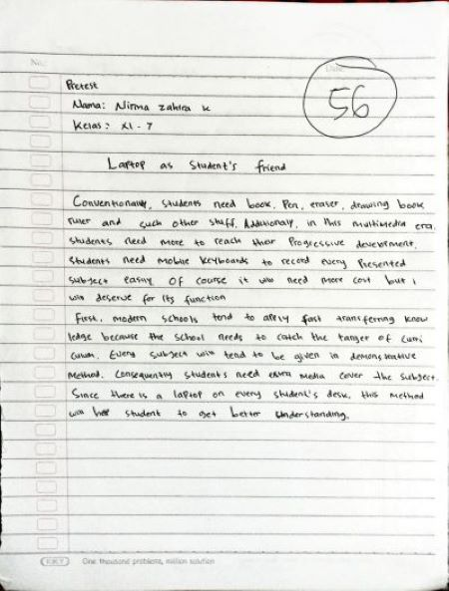
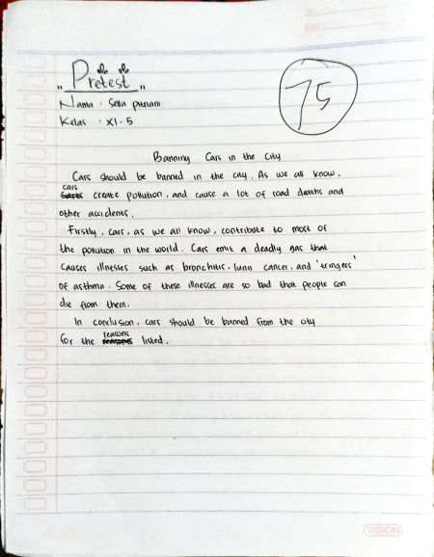
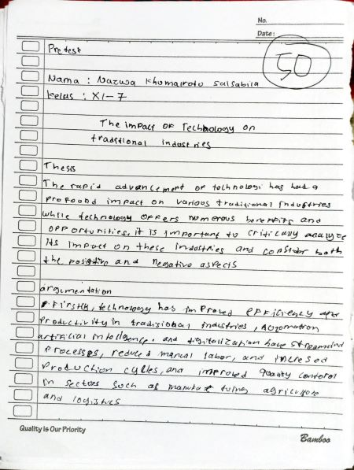
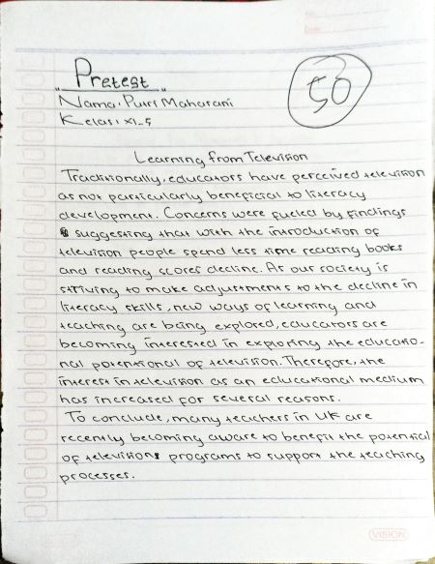
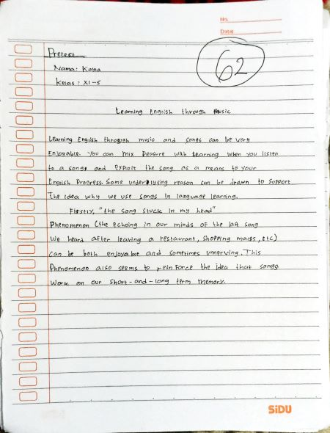
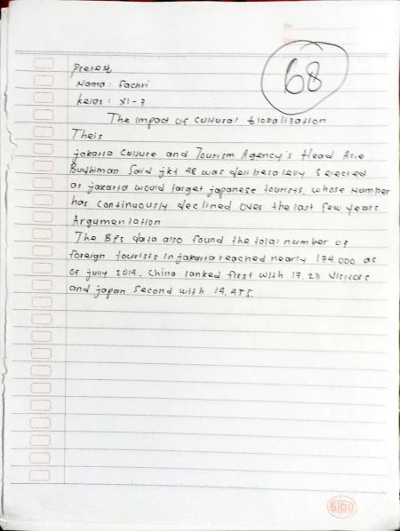
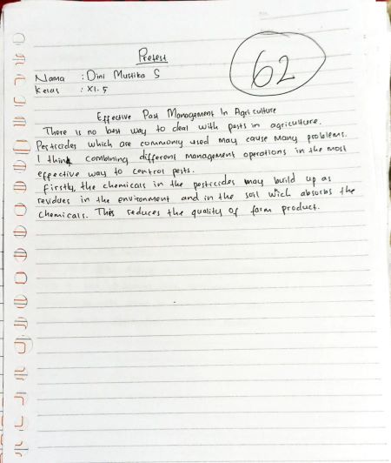
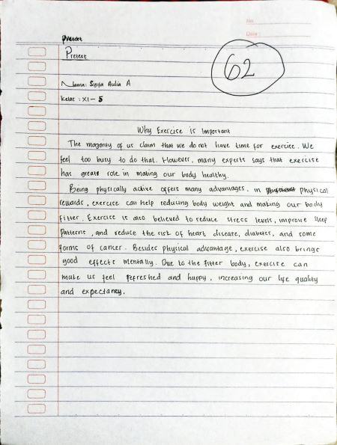
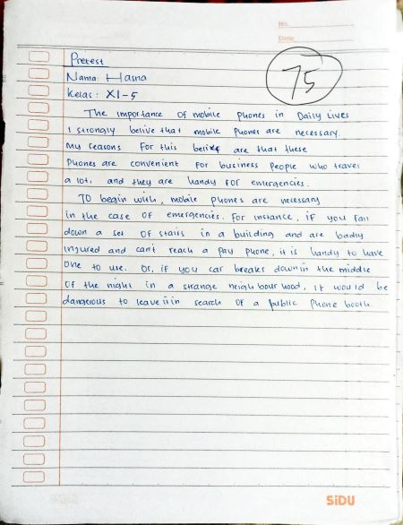
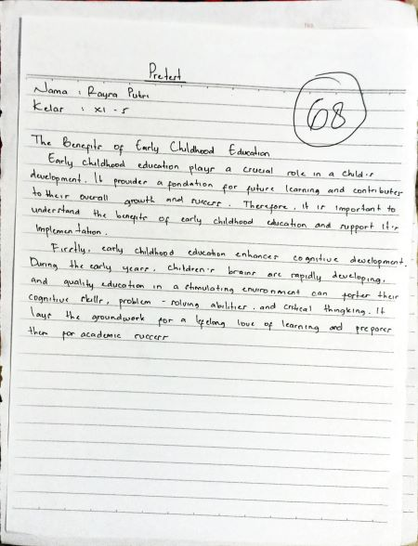
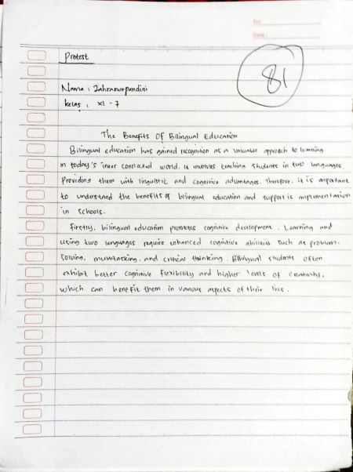
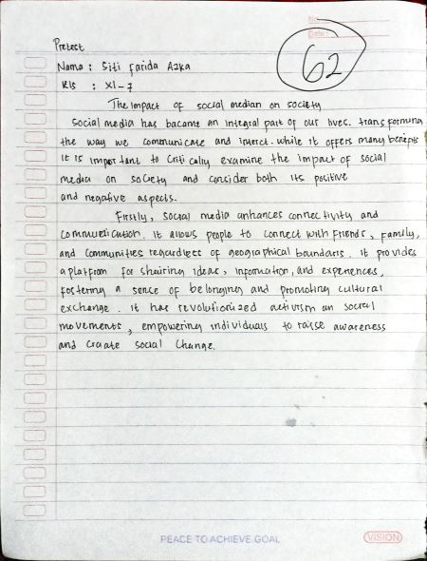

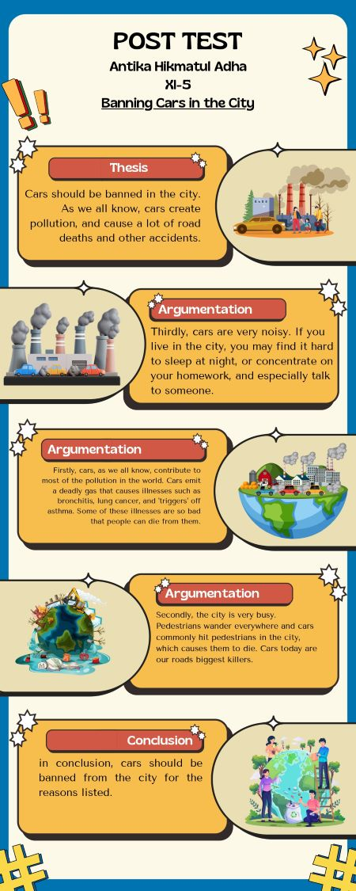
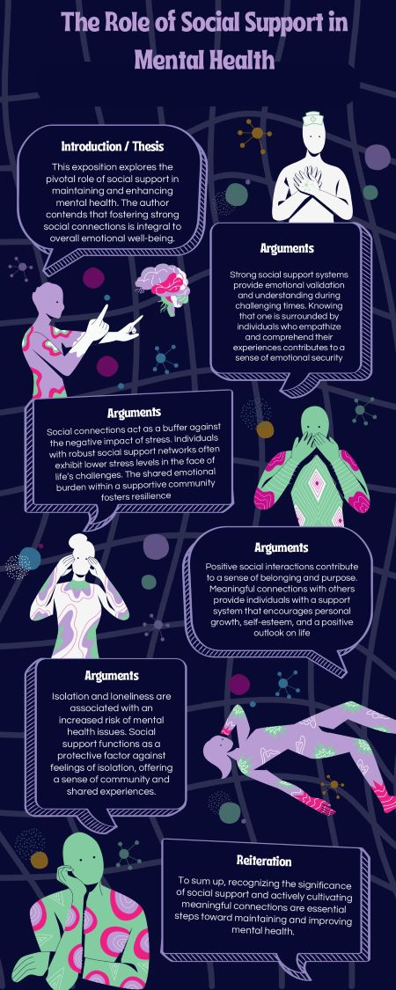
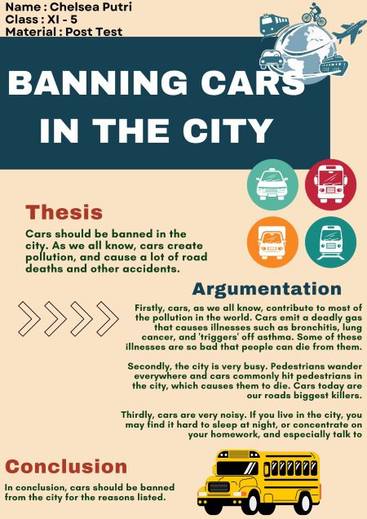
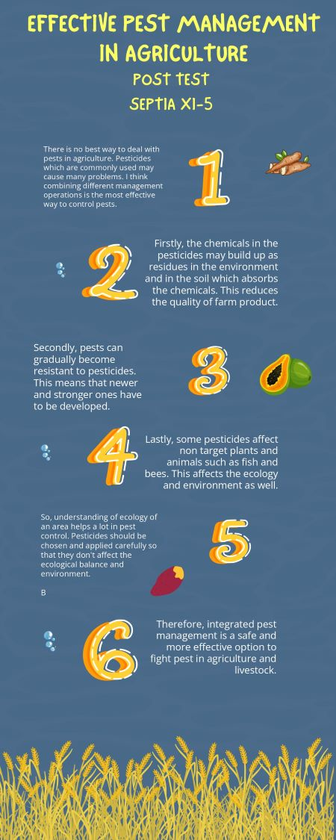
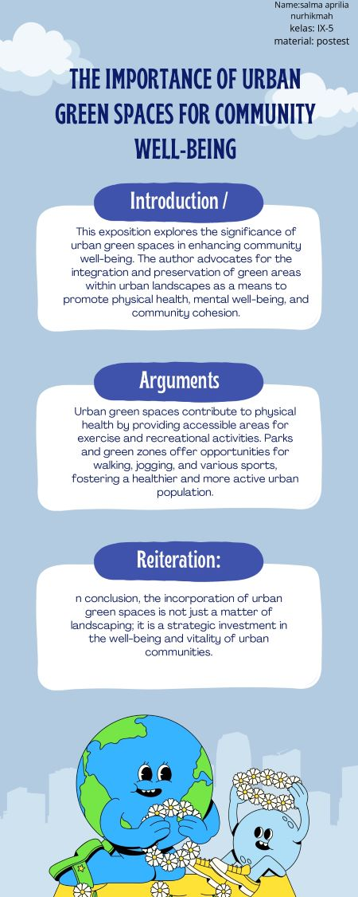
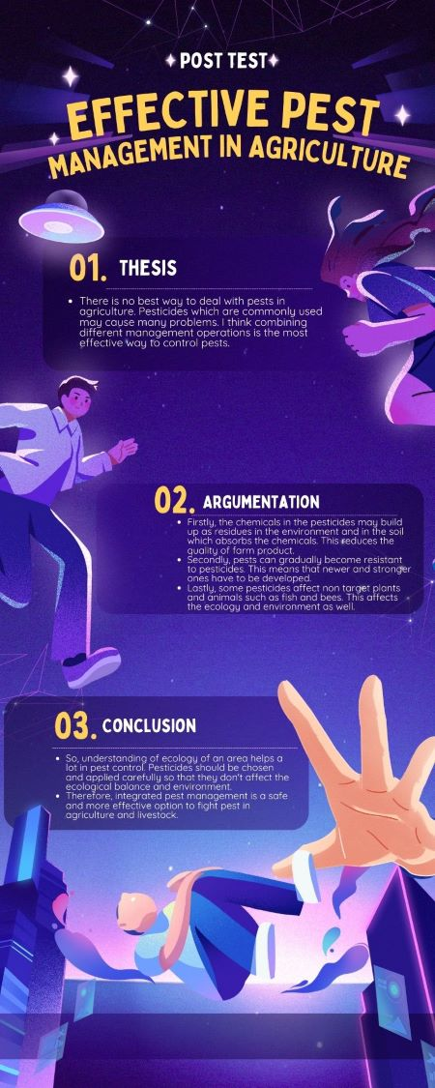

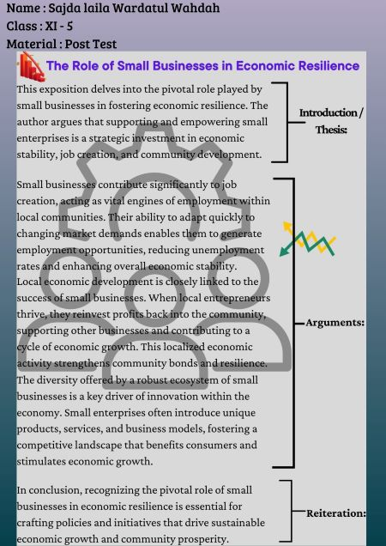

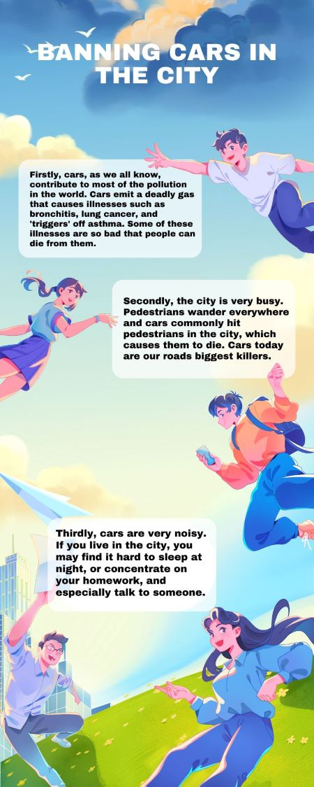

Appendix 9
Documentation
