**STUDENTS’ PERCEPTION OF ONLINE LEARNING**

**IN SPEAKING CLASS DURING COVID**-**19 PANDEMIC**

**A PAPER**

Submitted to the English Education program of IPI Garut

as a Partial Fulfilment of the Requirements for the Sarjana Pendidikan Degree

By

**Praja Faisal Abdau**

**17223028**

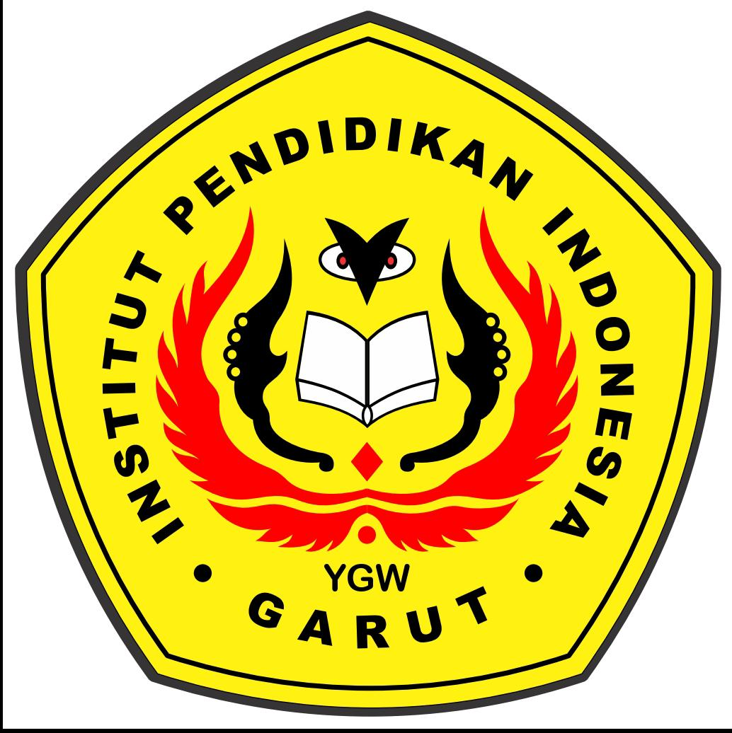

**ENGLISH EDUCATION PROGRAM**

**FACULTY OF SOCIAL SCIENCE, LANGUAGE, AND LITERATURE EDUCATION**

**INSTITUT PENDIDIKAN INDONESIA**

**2021**