**Barriers of Online Reading Learning Faced by College Students**

**A PAPER**

Submitted to the English Education Program of IPI Garut as a Partial Fulfilment

to Achieve BachelorDegree 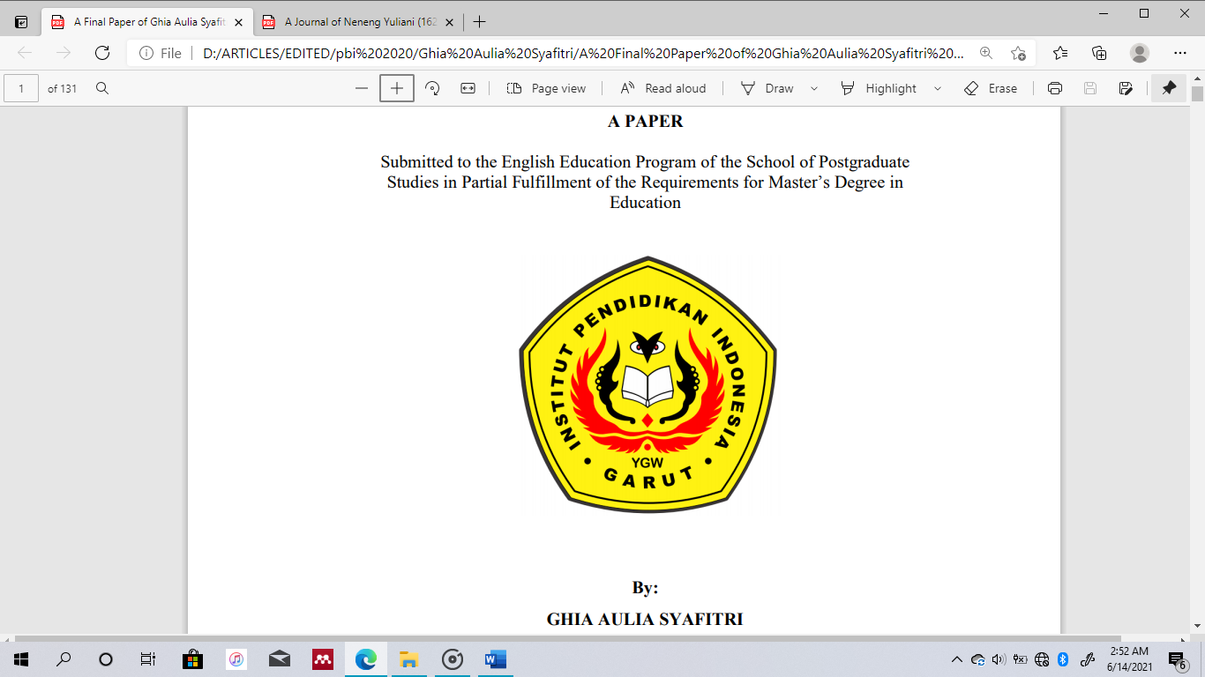in Education

**By:**

**Gesha Lailatul Fauziyyah**

**17223011**

**ENGLISH EDUCATIONAL PROGRAM**

**FACULTY OF SOCIAL SCIENCE, LANGUAGE, AND LITERATURE EDUCATION**

**INSTITUT PENDIDIKAN INDONESIA GARUT**

**2021**