**THE EFFECTIVENESS OF VISUAL DICTIONARY IN TEACHING VOCABULARY**

**A PAPER**

*Submitted to the English Education Program of IPI Garut in Partial Fulfillment of the Requirements for the Degree of Sarjana Pendidikan (S.Pd.)*

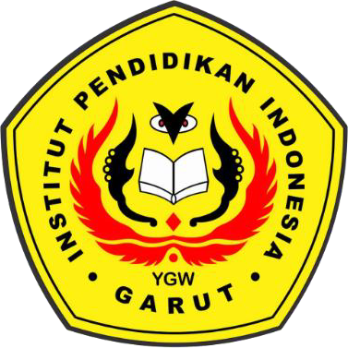

**By:**

**VINA NURAMALIA**

**18223013**

**ENGLISH EDUCATION PROGRAM**

**FACULTY OF SOCIAL SCIENCES, LANGUAGE, AND LITERATURE**

**INSTITUT PENDIDIKAN INDONESIA**

**2022**