**READING COMPREHENSION OF NARRATIVE TEXT: STUDENTS' PROBLEMS AND TEACHERS' SOLUTIONS**

**A PAPER**

*Submitted to the English Education Program of IPI Garut as a Partial Fulfillment of the Reqruitments for the Sarjana Pendidikan Degree*

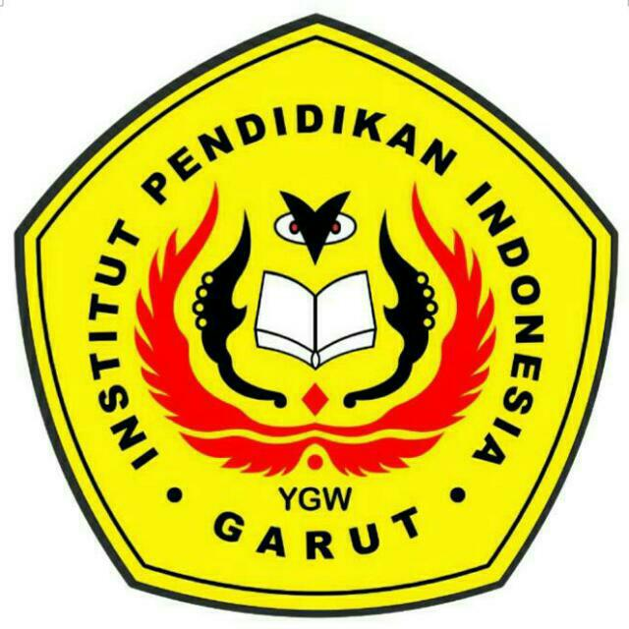

**By :**

**Teuis Merlinda Karina Futri**

**NIM 18224011**

**ENGLISH EDUCATION PROGRAM**

**FACULTY OF SOCIAL SCIENCE, LANGUAGE, AND LITERATURE**

**INSTITUT PENDIDIKAN INDONESIA**

**2022**