**AN ANALYSIS OF STUDENTS' DIFFICULTIES IN TRANSLATING ENGLISH TO INDONESIAN**

**A PAPER**

Submitted to the English Program of IPI Garut as a Partial Fulfillment of the requirements for the Sarjana Pendidikan Degree

**By:**

**Teni Nurfani**

**18221020**

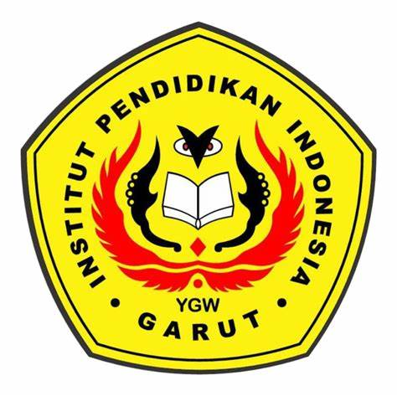

**ENGLISH EDUCATION PROGRAM**

**INSTITUT PENDIDIKAN INDONESIA**

**(IPI) GARUT**

**2022**