**STUDENTS’ DIFFICULTIES IN ACADEMIC WRITING DURING UNDERGRADUATE THESIS COMPLETION**

**(A Case of Study of Undergraduate Thesis in a University in Garut)**

**A PAPER**

Submitted to the English Education Program of IPI Garut as a Partial

Fulfillment of the Requirements for the Bachelor's Degree in Education

**By:**

**TANTI ROSTINI**

**18223005**

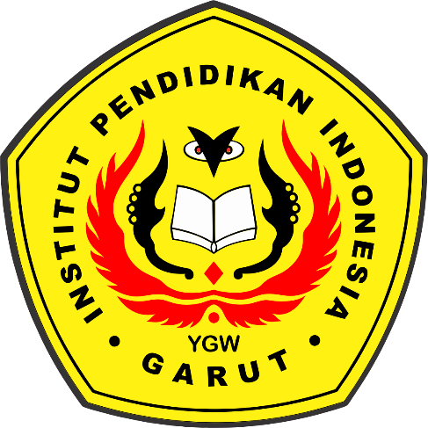

**ENGLISH EDUCATION PROGRAM**

**FACULTY OF SOCIAL SCIENCES, LANGUAGE, AND LITERATURE EDUCATION**

**INSTITUT PENDIDIKAN INDONESIA**

**GARUT**

**2022**