**TEACHERS’ PERCEPTIONS REGARDING ENGLISH LANGUAGE PROFICIENCY AND TEACHING EFFECTIVENESS**

**A PAPER**

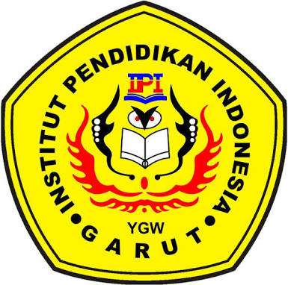Submitted to the English Education Department of IPI Garut as a Partial Fulfillment of the Requirements for the *Sarjana Pendidikan* Degree

Arranged by:

**SYIFA AISYAH**

**18222005**

**ENGLISH EDUCATION PROGRAM**

**FACULTY OF SOCIAL SCIENCE, LANGUAGE, AND LITERATURE**

**INSTITUT PENDIDIKAN INDONESIA GARUT**

**2022**