**SEEING MAXIM VIOLATION IN EFL CLASSROOM INTERACTION**

**A PAPER**

Submitted to the English Education Program of IPI Garut in Partial Fulfillment of the Requirements for the Bachelor of Education Degree

**Arranged by**

**SULISTIA ALAWIAH**

**18223032**

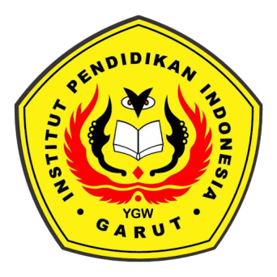

**ENGLISH EDUCATION PROGRAM**

**FACULTY OF SOCIAL SCIENCE, LANGUAGE, AND LITERATURE**

**INSTITUT PENDIDIKAN INDONESIA**

**2022**