**THE INFLUENCE OF DISTANCE LEARNING ON STUDENTS' ENGLISH LEARNING OUTCOMES**

**A PAPER**

Submitted to the English Education Program of IPI Garut as the Partial Fulfillment of the Requirements for the Bachelor of Education Degree

**By**

**SISKA PEBRIANI**

**(18221024)**

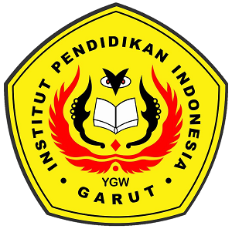

**ENGLISH EDUCATION PROGRAM**

**FACULTY OF SOCIAL SCIENCE, LANGUAGE, AND LITERATURE**

**INSTITUT PENDIDIKAN INDONESIA**

**2022**