**THE ANALYSIS OF STUDENTS’ CRITICAL THINKING IN WRITING ARGUMENTATIVE TEXT**

**A PAPER**

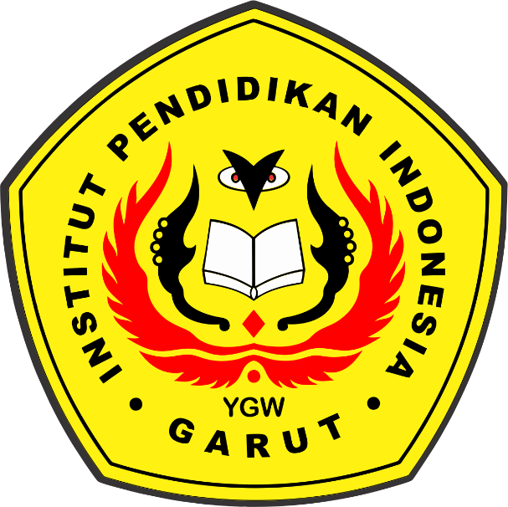Submitted to the English Education Program of IPI Garut as a Partial Fulfillment of the Requirements for the *Sarjana Pendidikan* Degree

**Arranged by:**

**Saumi Ridhawati**

**18223049**

**ENGLISH EDUCATION PROGRAM**

**FACULTY OF SOCIAL SCIENCE, LANGUAGE, AND LITERATURE**

**INDONESIA INSTITUTE OF EDUCATION**

**2022**