# CHAPTER III RESEARCH METHODOLOGY

## General Remarks

This chapter presents the research methodology, briefly introduced in chapter one. In addition, this chapter covers a method of research, the subject and the object of the study, the writer's role in the study, the time and place of the analysis, research design, classroom action research procedures, the techniques of data collecting and the method of data analyzing.

## Method of Research

The method utilized in this study is called classroom action research (CAR). According to (Santrock, 2018), action research is research used to solve a specific classroom or school problem, improve teaching and other educational practices, or make a particular choice. The researcher's ideal initial step is to recognize the situation in the classroom to continue his search for a solution.

Planning, acting, observing, and reflecting are the four processes that the researcher must go through when conducting action research. Those phases are believed to be on a cycle, as stated in detail in the following explanation.

## The Subject and the Object of the Study

It is the 2nd grade of Senior High School students located at Bayongbong-Garut. The number of students in this class is 30 students. The writer chooses this subject because of the Teacher’s teaching experience in this class. She looks like this subject have had the lowest achievement in speaking.

The object of the study here is the role of digital stories in developing students’ speaking skills.

## The Writers’ Role in the Study

## In classroom action research, the researcher is a teacher in one of the Senior High schools in Bayongbong-Garut 2nd grade who acts as an observer and conducts the research cooperatively.

## The Time and Place of the Study

This research is carried out for five months, from April to August 2022. The study takes place in the 2nd grade of one of the Senior High schools in Bayongbong-Garut. The academic year 2021/2022.

**Table 3. 1 Data Collection Date**

|  |  |  |  |  |  |  |  |  |  |  |
| --- | --- | --- | --- | --- | --- | --- | --- | --- | --- | --- |
| **No** | **Activities** | **Month and Date** | | | | | | | | |
|  |  | **April** | | | **June** | **July** | | | | **August** |
| **1** | **2** | **4** | **1** | **16** | **23** | | **30** | **6** |
| 1. | Pre-Observation | **X** |  |  |  |  |  |  | |  |
| 2. | Pre-Test |  |  |  | **X** |  |  | |  |  |
| 3. | Test Cycle 1 |  |  |  |  | **X** |  | |  |  |
| 4. | Test cycle 2 |  |  |  |  |  | **X** | | **X** |  |
| 5. | Post-Observation |  |  |  |  |  |  | |  | **X** |

## Research Design

Classroom Action Research is the research approach employed by the author. According to (Wallace, 2010), classroom action research is "a sort of classroom research carried out by the instructor to solve difficulties or find answers to context-specific challenges." The following describes the classroom action research design that will be employed.

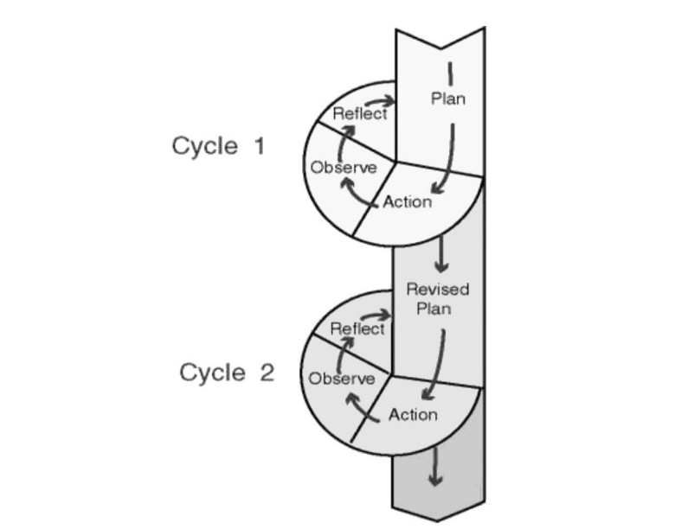

**Diagram 3. 1 Cycle of Action Research**

The picture above means that there are 2 cycles in action research. The stages in the first and second cycles are the same: planning, acting, observing, and reflecting.

Based on the design above, the writer tries to apply in his Classroom Action Research as follows:

**Pre observation**

- observing the teaching and learning process to clarify the problem.

**Planning 1:**

* Making lesson planning
* Developing an evaluation form for student.

**Acting 1:**

* Applying of the lesson plan
* Students perform in front of the class

**Reflecting 1:**

* Evaluating teaching
* Discussing with English teacher

**CYCLE 1k**

**Observing 1:**

* Observing the students’ activities in the class
* Observing students’ understanding of the materials given by using determined techniques
* Analyzing the data

**Revised planning 2:**

* Making lesson planning
* Collecting the data
* Develop the evaluation form for the cycle two

**CYCLE 2**

**Reflecting II:**

* Evaluating and analyzing students’ progress

**Acting II:**

* Giving material and topic
* Encouraging students to do more practice using material and digital stories
* Students perform in the front of the class

**Observing II:**

* Observing the student’ activities in class
* Observing the student achievement in pair work

**Diagram 3. 2 Action Research Cycle Explanation**

The writer collected data using the CAR approach in this Classroom Action Research (CAR). The research is divided into two cycles, each having four elements. The following is how the writer explains the cycles using McTaggart's framework of action research design:

### Cycle 1

* 1. Planning

In this phase, the writer creates a lesson plan, selects a topic, and assists in enhancing the digital stories in developing students’ speaking skills. During this phase, the writer prepares the teaching materials, such as providing two digital stories presented through YouTube media. The writer additionally creates an evaluation form to determine the pupils' progress at the end of the cycle.

* 1. Acting

After establishing the lesson plan, teaching, and research instrument, the writer uses those preparations to implement the technique. The writer has also decided to teach, while the English Teacher will serve as an observer of the teaching and learning process. The writer employs a three-phase technique in the implementation of digital stories, in which she goes through three stages, notably; the *opening phase:* involving saying salam and asking about students' readiness. *Core phase,* the Teacher gives materials and applies digital stories to stimulate students to speak. Here, the writer also takes students' scores using a point sheet. *Finally, in the closing phase;* here the Teacher asks students concerning the materials they have been learning during the learning process. If there were problems, the Teacher would give little time and opportunities to share and solve the problem. Sometimes she provides advice to students, and at last, she closes the class by saying salam.

1. Observing

The writer watches the students' reactions, participation, achievement, and everything else during this phase's teaching and learning process. The writer may also inquire about some students' thoughts on the process of teaching and learning through digital stories.

1. Reflecting

The writer will analyze the data of the teaching-learning process after gathering it. The writer will next reflect on the findings of the observation to determine if the teaching-learning process of speaking through digital stories is appropriate to include in the teaching-learning process or not. If the initial plan fails, as evidenced by the student's achievement, the writer should devise a new strategy (replanning) to remedy the student's difficulty while simultaneously achieving a satisfactory result.

### Cycle 2

* 1. Planning

After recognizing the issues in cycle 1, the writer will rewrite the lesson plan and reselect subjects and teaching aids to motivate students and improve their speaking performance.

* 1. Acting

It is similar to the acting phase in the first cycle, in which a revised lesson plan will be implemented in teaching English in the classroom.

* 1. Observing

In this phase, the writer observes the students’ response, participation, achievement, and everything found during the teaching and learning process. The writer uses photography several times to collect data.

* 1. Reflecting

In this phase, the writer evaluates students' speaking ability after teaching using digital stories. The writer will also ask the English Teacher’s opinion about the students’ improvement in speaking.

## The Techniques of Data Collecting

According to (Santrock, 2018, two techniques were used by the researcher in collecting the data: observation and test.

### Observation

The writer did observation directly toward the English teaching and learning process in one of the Senior High schools in Bayongbong-Garut 2021/2022 academic year. In this research, the writer acted as an active observer. The writer interacted with the students as well as the Teacher. In the speaking lesson, the writer observes their speaking skills, such as pronunciation, vocabulary, and grammar, and they're brave in speaking.

### Test

According to (Terry & Madsen 2012), the test is taken to know how well students achieve the materials they have been learning. In this research, the writer conducts twice and uses the oral form. First, it is a pre-test, a test given to students before implementing the action research to diagnose and know students’ speaking ability. Second, a post-test; is given to students after implementing digital stories in teaching English, especially speaking skills, within the classroom action research to evaluate students’ achievement and know their progress.

## The Techniques of Data Analysis

The data analysis technique in this research is descriptive analysis (percentage). The qualitative data used in this study is the observation of students’ activities during the teaching-learning process, the interview before and after classroom action research, the teacher activity in the classroom, and the classroom situation.

In completing the numerical data, the writer tries to get the average of students’ speaking scores before the implementation and every cycle to know the technique well by using digital stories to develop students’ speaking skills. According to (Sudijono, 2013), it is the formula;

∑x

X=

N

∑: Sum

X: Mean

x: Individual score

N: Number of students

Then, the writer tries to get class percentages that pass the KKM (72) English lesson at one of the Senior High schools in Garut. It is the formula:

F

P= X 100%

N

P: The class percentage

F: Total percentage score

N: Number of students

Then, the writer analyzes students’ speaking scores from pre-test up to post-test, and she uses the formula:

P = yl-y x 100%

y

p: percentage of students’ improvement

y: pre-test result

yl: post-test result cycle 1

P = y2 x 100%

y

p: percentage of students’ improvement

y: pre-test result

y2: post-test result cycle 2

## Research Procedure

In this study, the writer will describe several procedures used in data collection, including:

### Pre-Observation

Pre-observation will be carried out on April 1st, 2022. The writer conducted this pre-observation in class XI A in one of the Senior High schools in Bayongbong-Garut.

### Pre-Test

The pre-test will be conducted on June 1st, 2022, in class XI A at the Senior High School in Bayongbong-Garut.

### Test Cycle 1

Test Cycle 1 will be held on 16th July 2022. In the Cycle 1 test, students will first be introduced to digital stories. After that, students will be given an exercise.

### Test Cycle 2

Test Cycle 2 will be conducted on 23th July and 30th July 2022. This stage is the final test stage for students to implement digital stories in the class.

### Observation

Observation will be held on 6th August 2022. This observation aims to see if there are any changes in students learning English, especially speaking, after implementing digital stories.

## Chapter Summary

This chapter discusses the research methodology. This research uses the action research method. Sample and population This research was conducted in one of the senior high schools in Bayongbong-Garut in first grade with a total of 30 students. For data collection techniques, there are 3 stages, namely interview, observation, and test.