**THE IMPLEMENTATION OF SPEAKING ENGLISH LEARNING SYSTEM IN AN ISLAMIC BOARDING SCHOOL**

A PAPER

Submitted to the English Education Program of IPI Garut as a Partial Fulfilment of the Requirements for the Bachelor of Education Degree

**RIFAATU SADIYAH**

**18222008**

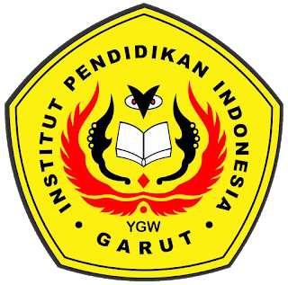

**ENGLISH EDUCATION PROGRAM**

**THE FACULTY OF SOCIAL SCIENCE, LANGUAGE, AND LITERATURE EDUCATION**

**INSTITUT PENDIDIKAN INDONESIA**

**(IPI) GARUT**

**2022**