**USING SPINNING WHEEL GAMES AS A MEDIA IN LEARNING ENGLISH VOCABULARY FOR ELEMENTARY SCHOOL STUDENTS**

**A PAPER**

Submitted to the English Education Department of Institute Pendidikan Indonesia Garut as a Partial Fulfilment of the Requirement for Sarjana Pendidikan Degree

**Arranged by:**

**Nursyipa Sri Setiani**

**18222018**

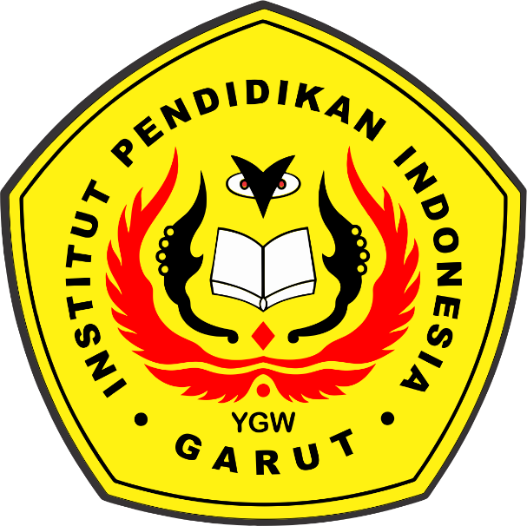

**ENGLISH EDUCATION PROGRAM**

**FACULTY OF SOCIAL SCIENCE, LANGUAGE, AND LITERATURE EDUCATION**

**INSTITUT PENDIDIKAN INDONESIA**

**2022**