**MOBILE ASSISTED LANGUAGE LEARNING:**

**EFL STUDENTS' VOICES ON THE USE OF MOBILE APPLICATIONS IN SUPPORTING VOCABULARY MASTERY**

**A PAPER**

Submitted to the English Education Program of Institut Pendidikan Indonesia (IPI) Garut as the Partial Fulfilment of the Requirement for the Bachelor of Education Degree

By:

**NISRINA NABILA DZAKIYYAH AINI**

**NIM 18223021**

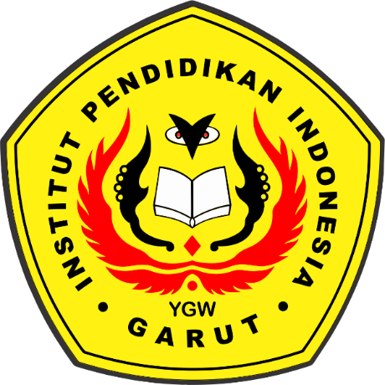

**ENGLISH EDUCATION PROGRAM**

**FACULTY OF SOCIAL SCIENCE LANGUAGE AND LITERATURE EDUCATION**

**INSTITUT PENDIDIKAN INDONESIA GARUT**

**2022**