**JUNIOR HIGH SCHOOL TEACHERS’ DIFFICULTIES IN IMPLEMENTING THE PSP *(PROGRAM SEKOLAH PENGGERAK)* CURRICULUM**

Submitted to the English Education Program of IPI Garut as a Partial Fulfillment of the Requirements for The Bachelor’s Degree

Arranged By

**Mulyani**

17221012

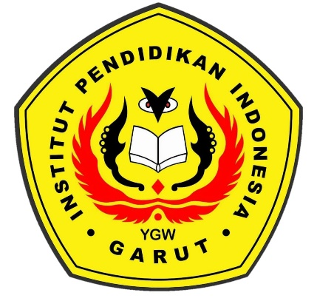

**ENGLISH EDUCATION PROGRAM**

**FACULTY OF SOCIAL SCIENCE, LANGUAGE, AND LITERATURE EDUCATION**

**INDONESIAN INSTITUTE OF EDUCATION**

**GARUT**

**2022**