**POLITENESS STRATEGIES USED BY STUDENTS IN CLASSROOM INTERACTION**

**A JOURNAL**

Submitted to English Education Program of Faculty Social Science, Language and Literature Education of Institut Pendidikan Indonesia as Partial Fulfilment of the Requirements for the Sarjana Pendidikan Degree

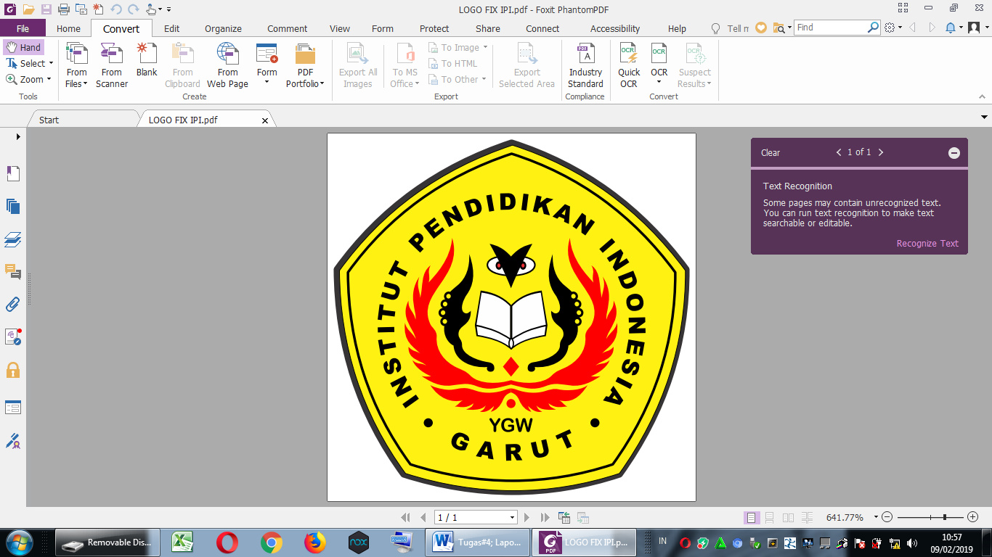

**By:**

**MUHAMAD LUTHFI  
NIM. 18222024**

**ENGLISH EDUCATION DEPARTMENT**

**FACULTY OF SOCIAL SCIENCE, LANGUAGE AND LITERATURE EDUCATION**

**INSTITUT PENDIDIKAN INDONESIA**

**2022**