**STUDENTS LEARNING DISCIPLINE AND ENGLISH LEARNING ACHIEVEMENT IN E-LEARNING ENVIRONMENT**

**A PAPER**

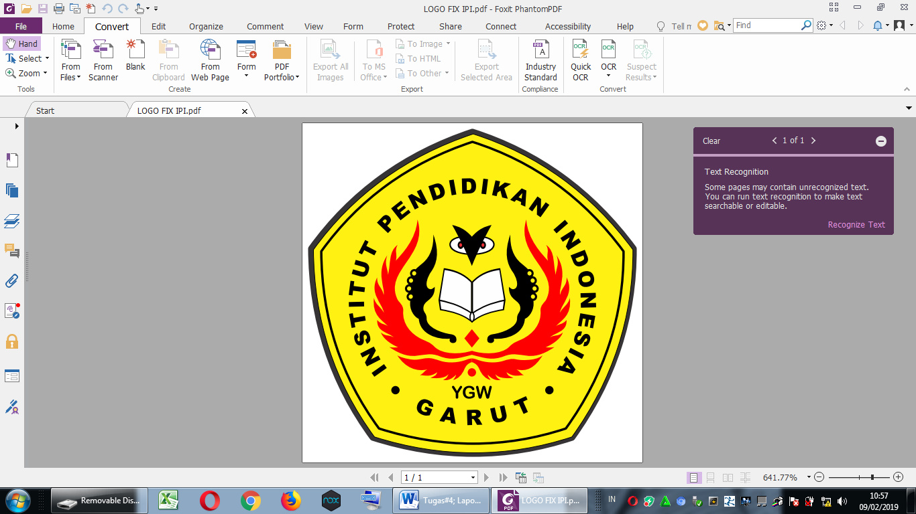

**By:**

**Muhamad Ihsan Abduh**

**18223004**

**English Education Program**

**Faculty of Social Science, Language, and Literature Education**

**Institut Pendidikan Indonesia**

**2022**