**TEACHER CANDIDATES’ UNDERSTANDING OF PROJECT-BASED LEARNING**

A Research Paper

Submited to the English Education Program of IPI Garut as the Partial Fulfillment of the Requirements for the Bachelor of Education Degree

**Arranged by:**

**Melis Siti Maghfirah Razni**

**18221016**

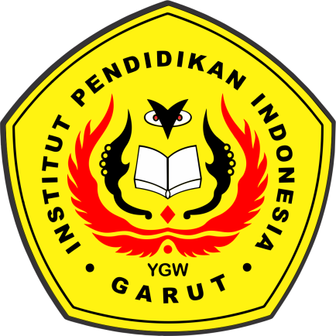

**ENGLISH EDUCATION PROGRAM**

**FACULTY OF SOCIAL SCIENCE, LANGUAGE, AND LITERATURE EDUCATION**

**INSTITUT PENDIDIKAN INDONESIA (IPI)**

**2022**