**THE ANALYSIS OF TEACHERS’ CLASSROOM MANAGEMENT STYLE AND STUDENTS’ ENGAGEMENT IN ONLINE CLASSES**

**A PAPER**

Submitted as a Partial Requirements for Sarjana Degree in English Education Program

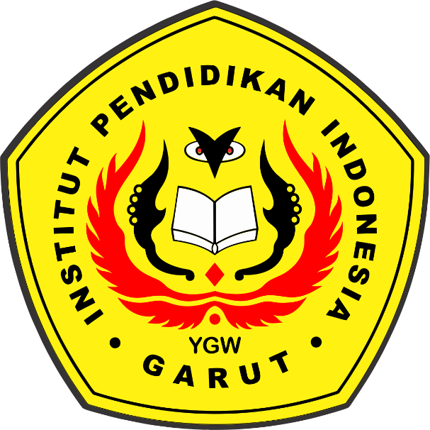

**Arranged by:**

**Manar Aulia Utama**

**18223037**

**ENGLISH EDUCATION PROGRAM**

**FACULTY OF SOCIAL STUDIES, LANGUAGE, AND LITERATURE**

**INDONESIA INSTITUTE OF EDUCATION**

**2022**