**THE USE OF DISCORD APPLICATION IN ONLINE CLASSROOM LEARNING**

**A PAPER**

Submitted to the English Program of IPI Garut as a partial fulfillment of the requirements for bachelor’s degree

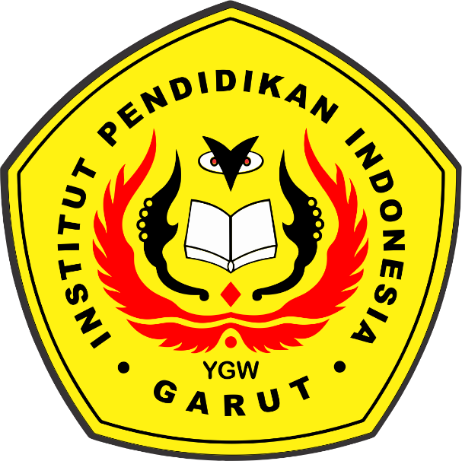

**by:**

**Luqman Muhammad Ridwan**

**18223020**

**ENGLISH EDUCATION PROGRAM**

**FACULTY OF SOCIAL SCIENCE LANGUAGE AND LITERATURE**

**INDONESIA EDUCATIONAL INSTITUTION**

**2022**