# CHAPTER 1 INTRODUCTION

This chapter consists of the background of the study, the research question, the aim of the study, the scope of the study, the significance of the study, research methodology, organization of paper, and definition of terms.

## Background of the Study

Globalization in the world of work and the continued use of English has meant increase in the demand for language courses addressing or workplace needs Paltridge & Starfield (2012). English is the language for international communication and science, will be used for communication in many countries. There are also many supporting books for education that use English. Rahardi (2014) in his research stated that in the realm of education, the use of linguistics form that mix Indonesian, Javanese, and English occurs a lot in daily communication. So that, learn English is one way to giving or finding information and to communicate each other.

In Indonesia, English is taught both formally and informally. Formally, English is taught in every school as a compulsory subject from elementary school to high school or vocational school, while at the level of higher education language, English is a compulsory subject. Informally, English can be learned with take English courses (Dja’far, 2017). According to lesson plans English in biology department, there are two English learning models in Biology Department in one of University in Garut. The first is General English (GE) learned before midterm exam which focus to speaking, writing, and reading that consists of the materials introducing yourself, introducing yourself and others, telling about family and friends, telling about habitual activities, telling about last experience, telling about wish and hope, and telling about critical issue. The second is English for Specific Purpose (ESP) learned after midterm exam which focus on terms and vocabulary that consists of the materials process fotosintesis, fisiologi, food chain, and etc. So, English in biology is expected that student can communicate each other use simple English communication. In order to make the material in line with the students’ need. Need analysis should be required. So, ESP which is an approach to design a curriculum and starts with the question of why the students need to learn English for all departments in the university. Starfield (2016) said that ESP is an approach focused on both of the learner’s needs and expectations. ESP researchers have argued that the use English also fits into government education policies that emphasize the goal of learning English, specifically for their academic and careers (Starfield, 2016).

Many studies have been done on this subject. Some studies which focus of English language in specific purpose does not mean to the students need. The first, (Chostelidou, 2010) his research conducted need analysis on accountancy students, the result shows that students have different expectations with respect to their need to use the target language for study or profesional purposes. Secondly, (Aliakbari & Boghayeri, 2014) the researchers tried to investigate the needs and views or architecture students and graduates, and the effectiveness of their ESP courses, the result show that the syllabus has different, so the revision of the programs seem to be necessary to offer effective ESP course. Third, (Nurpahmi et al., 2020) conducted need analysis of English for math in UIN Alauddin Makassar, the result show that 1) students have fair ability in English skills, listening, speaking, reading, writing, vocabulary, and grammar, and pronunciation; 2) students need to learn more in reading than others skills. Vocabulary relates to their major, and grammar; 3) students need to learn auditorily and visual through video. Students need to learn in a small group and work in pairs.

From the above research, it can be concluded that their research has several focuses, namely need analysis on accountancy, the needs and views or architecture students and graduates, and the need analysis of English for math in UIN Alauddin Makassar. It means that it is still necessary to conduct studies with different focus. Therefore, this research aims to the analysis of Biology students’ needs in English language learning

## The Reason for choosing the topic

The researcher chooses this topic because English has a compulsory subject that must be studied for all majors in university, and every major has a uniqueness and distinctiveness in learning English. Therefore, this study tries to investigate what the uniqueness and distinctiveness of biology students in learning English.

## Research Questions

The main objectives of this research are to find out is the biology students’ needs in learning English. Therefore, the question in this research is:

1. What are the English language skills that is most needed by students of Biology?

## The Purpose of the Study

Based on the research questions, the research has the following objectives: to find out the analysis of Biology students’ needs in English language learning.

## Scope of this Study

The study is limited to the following research to find out the biology students’ needs in English language learning. The population of the research is limited at the fourth grade of Biology Education Program in IPI Garut.

## The Significance of the Study

This research is expected to be able to contribute several some parties:

1. For the ESP teachers, the result of this study will be used as a reference for formulating the syllabus and compiling, developing teaching materials that are in accordance with the biology department.
2. For the students, will make it easier for them to learn English because the selection of the material is compatible the field they are currently teaching. These students are expected will become competent graduates who ready to work in schools’ educational environments in outside the country.
3. For the next researcher, it was reference which related of this research to make the types of research in other educational programs.

## Research Methodology

Given the purpose of this study is descriptive qualitative design with case study. This design deemed appropriate for this study because the study aims to find the answer of research question posed in this research. In this research, there are three types of instruments utilized in this study; document analysis, interview and questionnaire. First, document analysis is used book science bilingual and lesson plans English in biology. Second, interview is used for various questions to know deeply about the problem of interviewee. Last, questionnaire is used to as additional evidence and reinforcing the results of the interview. In addition, it will be focused on phenomenon that happens in natural settings (Creswell, 2018). This study will employ content analysis of Biology students’ needs in learning English.

## Research Design

Based on the purpose of this study, the qualitative case study method will be applied in this study, because this focused one analyzing the biology students’ needs in learning English. According to Creswell (2018) the reason conducting qualitative research because researcher want to exploring and understanding the meaning individuals or groups ascribe to a social or human problems. So, this study conducted for exploring and understanding of the biology students’ need in English language learning.

**Figure 1.2 Inductive logic of**

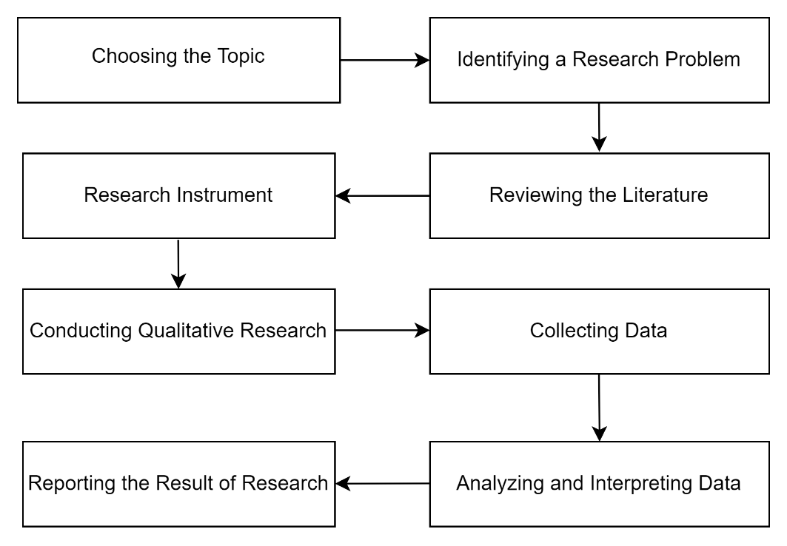

*Adapted from (J. W. Creswell, 2012)*

Inside the diagram above there are 8 steps. The first step was choosing the topic in this research. This study chose the topic about “The Analysis of Biology Students’ Needs in English Language Learning”

The second step was identifying research problem. The research issue occurs because English is a compulsory subject in university.

The third step was reviewing literature. The literature explained about the process of writing, transitivity system and hortatory.

The fourth step was research instrument. This study used document analysis, interview and questionnaire.

The fifth step was conducting qualitative research. Qualitative method is used to understand and interpret the meaning of an event of human behavior interaction in certain situation.

The seventh was data analysis. There are three steps in data analysis, they are: data reduction, data display, and conclusion (Miles et al., 2014).

The last step was reporting the result. The data were described by arranging the report in the form of brief explanations that are suitable to the reader.

## Definition of Terms

The following terms are considered important to be clarified to make mutual understanding between the researcher and the reader. The terms are as follow:

1. **Need Analysis**

Saragih (2014)said that need analysis is very important before designing teaching materials for English Specific Purpose. It means of establishing the how and who the ESP design to use for the target.

1. **ESP (English for Specific Purpose)**

In the book by Richards and Schmidt (2010) said that ESP is defined as “a language course or program of instruction in which the content and aims of the course are fixed by the specific needs of a particular or group. The theory explains that English should be taught in order to achieve certain goals in real situations, in a manner that apply in their area of specialty. In this study, ESP refers to English for Biology programs that are in the process of teaching English, teacher have to teach English material related the biology students’ needs.

1. **English for Biology Students**

ESP courses in the Department of Biology are still limited to studying a particular lexicon and translating texts through scientific reading and technical articles (Bouabdallah, 2015). Therefore, need analysis of Biology students in learning English is required based on their necessities, lacks, wants in English language module.