**THE ANALYSIS OF BIOLOGY STUDENTS’ NEEDS**

**IN ENGLISH LANGUAGE LEARNING**

A Research Paper

Submitted to the English Education Program of IPI Garut

as a partial fulfillment of the requirements

for the *Sarjana Pendidikan* Degree

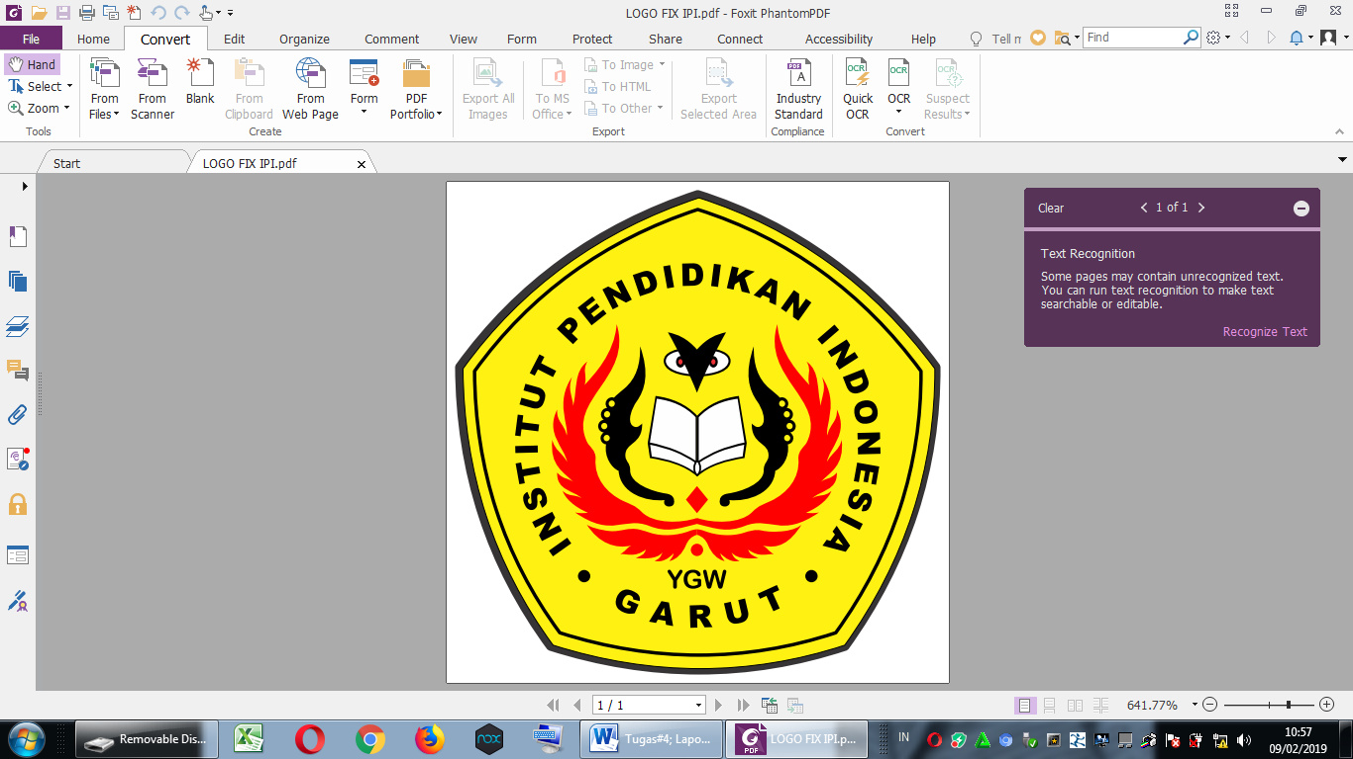

**By**

**Hermawan**

**18223003**

**English Education Program**

**Faculty of Social Science, Language, and Literature Education**

**Institut Pendidikan Indonesia**

**2022**