**THE STUDENTS’ PERCEPTION OF BRITISH AND AMERICAN CULTURES IN SENIOR HIGH SCHOOL INTERLANGUAGE ENGLISH TEXTBOOK**

**(This Case Study at One of Senior High School in Garut)**

**A PAPER**

Submitted to the English Education Department of Institut Pendidikan Indonesia Garut as a Partial Fulfilment of the Requirements

for the *Sarjana Pendidikan* Degree

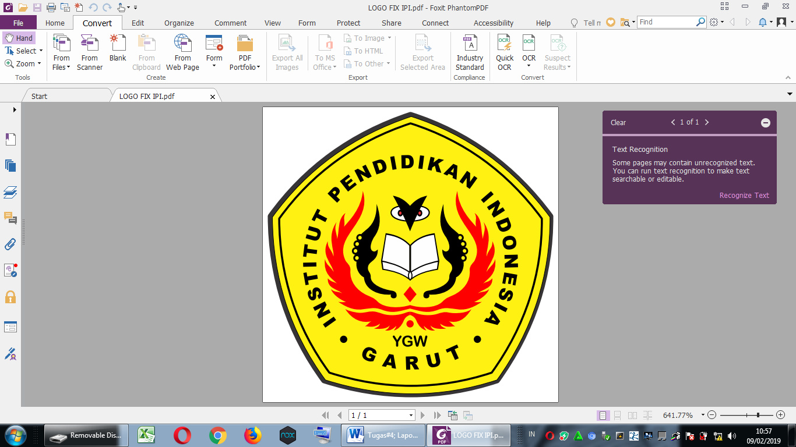

Arranged by:

**Euis Patimah**

**NIM. 18223027**

**ENGLISH EDUCATION DEPARTMENT**

**FACULTY OF SOCIAL SCIENCE, LANGUAGE AND LITERATURE EDUCATION**

**INSTITUT PENDIDIKAN INDONESIA**

**2022**