**TEACHERS’ STRATEGY IN MANAGING ONLINE CLASSES FOR READING SKILL**

## (A Case Study at One of Islamic Junior High Schools in Garut )

**A Paper**

Submitted to the English Education Program of IPI Garut in Partial Fulfillment of the Requirements for the Sarjana Degree

## By:

**ESI SRI RAHAYU 18222014**

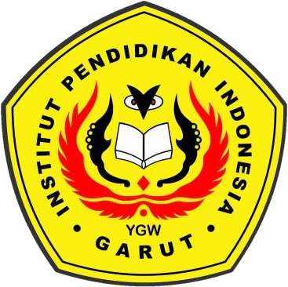

## ENGLISH EDUCATION PROGRAM

**FACULTY OF SOCIAL SCIENCES LANGUAGE AND LITERATURE EDUCATION**

## INSTITUT PENDIDIKAN INDONESIA GARUT 2022