**THINK-ALOUD METHOD: DEVELOPING STUDENTS' READING COMPREHENSION**

**A RESEARCH PAPER**

Submitted to the English Education Program of Institut Pendidikan Indonesia (IPI) Garut as a Partial Fulfillment of the Requirements for the Bachelor Education Degree

**Arranged by:**

**DITA AYU PRATIWI**

**18221013**

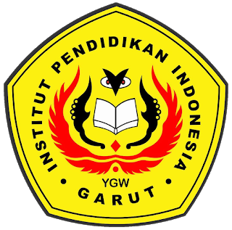

**ENGLISH EDUCATION PROGRAM**

**Faculty of Social Society, Language, and Literature Education**

**INSTITUT PENDIDIKAN INDONESIA GARUT**

**2022**