**CRITICAL PEDAGOGY OF ENGLISH TEACHING POLICY IN INDONESIA CONTEXT: CASE STUDY TEACHER’S PERCEPTION**

**(A Case Study of elementary school Teachers)**

**A PAPER**

*Submitted to the English Education Program of IPI Garut as a Partial Fulfillment of the Requirements for the Bachelor’s Degree in Education*

**BY:**

**DEWI SARTIKA**

**18223008**

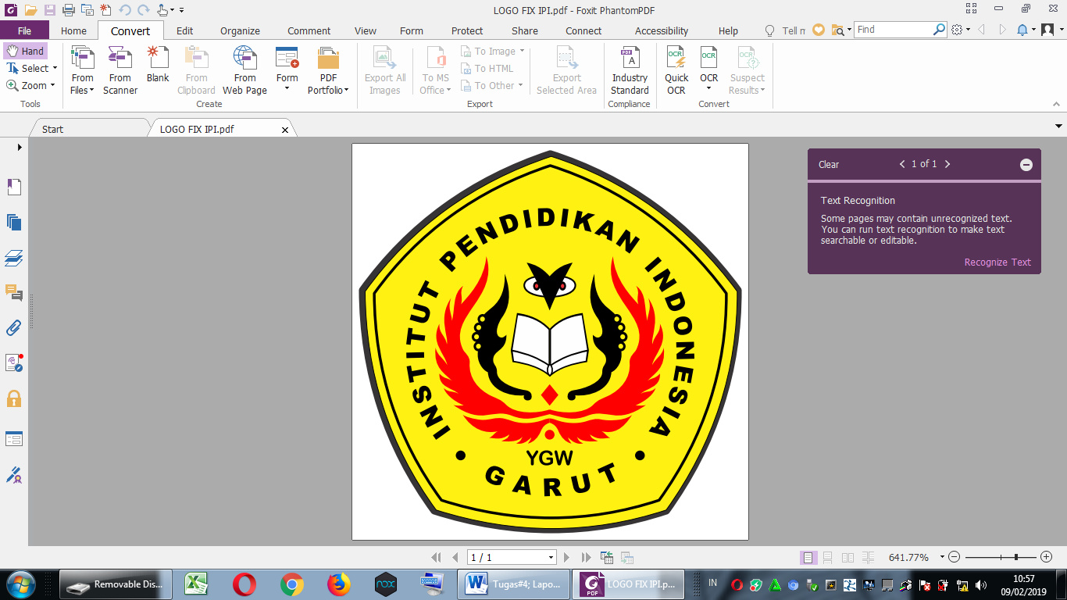

**English Education Program**

**Faculty of Social Science, Language, and Literature Education**

**Institut Pendidikan Indonesia**

**2022**