**STUDENTS' EXPERIENCES AND CHALLENGES OF LEARNING ENGLISH THROUGH ONLINE LEARNING SYSTEM DURING COVID-19 OUTBREAK**

**A PAPER**

Submitted to the English Educational Program of IPI Garut in Partial Fulfillment

of the Requirements for the Sarjana Pendidikan Degree

By

**DEVI SITI NURAENI**

**NIM 18222017**

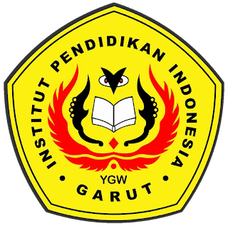

**ENGLISH EDUCATION PROGRAM**

**FACULTY OF SOCIAL SCIENCE, LANGUAGE, AND LITERATURE**

**INSTITUT PENDIDIKAN INDONESIA (IPI)**

**GARUT**

**2022**