**THE EFFECTIVENESS OF INQUIRY-BASED LEARNING ON ENGLISH VOCABULARY ACHIEVEMENT**

***(A Pre-Experimental Study at the $7^{th}$ Grade of one of Junior High Schools in Garut Regency)***

**A PAPER**

Submitted to English Education Program of Faculty of Social Science, Language, and Literature in partial fulfillment of the requirements for a bachelor’s degree

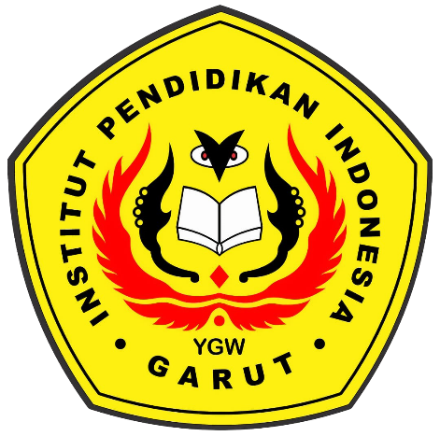

By:

**DEA AGUSTINA**

**18224019**

**ENGLISH EDUCATION PROGRAM**

**FACULTY OF SOCIAL SCIENCE, LANGUAGE, AND LITERATURE**

**INSTITUT PENDIDIKAN INDONESIA**

**2022**