**THE BENEFITS AND CHALLENGES OF USING VIDEO AS A MEDIUM IN ENGLISH LEARNING AT JUNIOR HIGH SCHOOL**

**A PAPER**

Submitted to the English Education Program of IPI Garut as partial fulfillment of the requirements for the Bachelor of Education Degree

Arranged by:

**Clarisa Putri Cahyani**

**18221009**

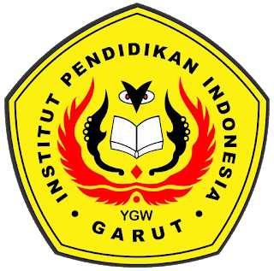

**ENGLISH EDUCATION PROGRAM**

**FACULTY OF SOCIAL SCIENCE, LANGUAGE, AND LITERATURE**

**INSTITUT PENDIDIKAN INDONESIA GARUT**

**2022**