**ENHANCING EFL YOUNG LEARNERS’ VOCABULARY USING**

**LANGUAGE LEARNING APPLICATION**

**A PAPER**

Submitted to the English Education Program of IPI Garut as a Partial Fulfillment of Requirements for Bachelor Degree

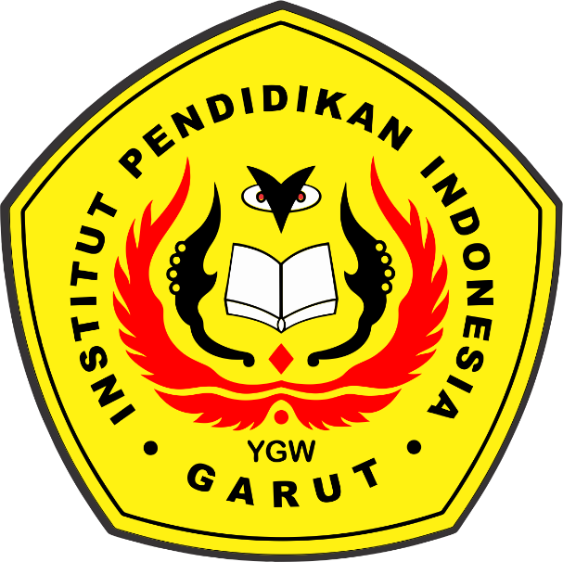

**By:**

**AYUANDIRA TRIAGUSTIN**

**18221027**

**ENGLISH EDUCATION PROGRAM**

**FACULTY OF SOCIAL SCIENCE LANGUAGE AND LITERATURE**

**INSTITUT PENDIDIKAN INDONESIA GARUT**

**2022**