**AN ANALYSIS OF TEACHER QUESTIONING STRATEGIES IN YOUNG LEARNERS DURING THE CLASSROOM INTERACTIONS**

**A PAPER**

Submitted to the English Education Program of the Faculty of Social Science, Language, and Literature in Partial Fulfillment of the Requirements for a Bachelor’s Degree

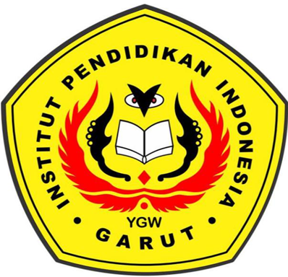

**by:**

**Argina Sopi Suryalillah**

**18224015**

**English Education Program**

**The Faculty of Social Science, Language, and Literature Education**

**Institut Pendidikan Indonesia Garut**

**2022**