**USING TED TALKS FOR IMPROVING STUDENTS’ SPEAKING SKILL**

(A Pre-Experimental Research at one of Senior High Schools in Garut)

**A PAPER**

*Submitted to the English Education Program of IPI Garut as a Partial of the Requirements for the Degree of Sarjana Pendidikan (S.Pd.)*

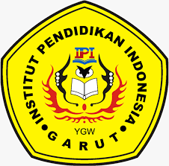

**By:**

**Ai Nurul Sipa Paujiah**

**18223010**

**ENGLISH EDUCATION PROGRAM**

**FACULTY OF SOCIAL SCIENCE, LANGUAGE AND LITERATURE**

**INDONESIA INSTITUTE OF EDUCATION**

**2022**