CHAPTER II
A REVIEW OF RELATED LITERATURE

- General Remarks
The teacher is the key variable in reading class. Teachers have the important role in students reading activities, include in choosing or using strategy. Teacher should choose the suitable strategies to achieve a good achievement in reading comprehension. Reading comprehension is primarily a matter developing appropriate, efficient comprehension strategies among others are Multiple-Strategy Instruction (Reciprocal Teaching Technique).
Finally in this chapter the writer discusses about reading, reading comprehension, Multiple-Strategy Instruction (Reciprocal Teaching Technique), Rules in Reciprocal Teaching, The Advantage of Reciprocal Teaching.

- Definition of Reading
Reading is a process and product of human learning; it is not just receiving meaning in literal sense but also involves an individual’s entire life experience and thinking power to understand what the writer has encoded. Kennedy (1984) stated that reading is an activity that binds together perceptual, memorial and linguistic functions, once mastered, allows the mind of people-reader and writer to be more intimately joined than any other form of social encounter. In addition according to Coman (1992) there are levels in reading:
- Reading to learn language:
Reading material is language input. By giving students a variety of materials to read, instructors provide multiple opportunities for students to absorb vocabulary, grammar, sentence structure, and discourse structure as they occur in authentic contexts. Students of language work together to convey meaning.
- Reading for content information:
Student purpose for reading in their native language is often to obtain information about a subject they are studying, and this purpose can be useful in the language learning classroom gives students both authentic reading material and authentic purpose for reading.
- Reading for cultural knowledge and awareness:
Reading everyday materials that designed for native speaker can give students insight into the life style and worldviews of the people whose language they are studying. When students have access to newspaper, magazines, and websites, they are exposed to culture in all its variety, and monolithic cultural stereotype begin to break down.

- Definition of Reading Comprehension
Reading is important part in learning language. The importance of reading is evident not merely in association with the language-related skills that students have to acquire in order to graduate, but also in relation to the requirement for them in the program to be able to read content books written in English. In order to make them success in learning language they have to comprehend the content of books they read. Reading comprehension is basically an interactive process of meaning making between the reader and the author through the text, which involves mental activities and background knowledge (Weir, 1993; Singhal, 1999). Moreover, Anderson & Armbruster (1982) stated that comprehension will be enhanced to the extent that the texts are well written, that is, they follow a familiar structure and their syntax, style, and clarity of presentation and coherence reach an acceptable level. Such texts have been called reader-friendly or considerate. Comprehension is also influenced by the extent of overlap between the readers' prior knowledge and the content of the text. Studies demonstrating the influence of schematic constructive processes in text comprehension are legion (Anderson, 1978; Mandler, 1983; Stein & Trabasso, 1982)

- Definition of Multiple-Strategy Instruction (Reciprocal Teaching Technique)
Reciprocal teaching is an instructional technique developed by Palincsar and Brown (1984) and described by them as “a dialogue between teachers and students for the purpose of jointly constructing the meaning of text.” It is designed to improve students’ reading comprehension by multiple teaching strategies. They are Summarizing, Questioning, Predicting, and Clarifying.
Each reciprocal teaching strategy has an important role in reading comprehension process. The four strategies are part of comprehensive reading comprehension program that is based on all the strategies that good readers use, such as previewing, self-questioning, visualizing, and making connections, monitoring, knowing how word work, summarizing, and evaluating (McLaughlin and Allen,2002).

- The Four Strategies of Reciprocal Teaching
2.5.1 Summarizing the main content
Summarizing is a complex process that requires the orchestration of various skills and strategies. To summarize effectively, students must recall and arrange in order only the important events in a text-either narrative or expository (Lipson,1996).
Using the first strategy, teacher begins summarizing the reading and beginning the discussion with questions about the main content of the text. The teacher synthesizes for the purpose of identifying the gist of the reading and their discussion. There is then more discussion for the purpose of agreeing on the summary. Summarization requires the reader to perform the task of discriminating between important and less-important information in the text. It must then be organized into a coherent whole (Palincsar & Brown, 1984).
2.5.2 Formulating questions
Good readers ask questions throughout the reading process (Cooper,1993; Palinscar and Brown. 1986). When students know the prior to reading that they each need to think of question about the text, they read with awareness of the text’s important ideas. They automatically increase their reading comprehension when they read the text, process the meaning, make inferences and connection to prior knowledge, and, finally generate a question (Lubliner, 2001).
Using the second strategy, students respond to the questions given by teacher, raise additional questions, and in the case of disagreement or misunderstanding, and reread the text.
2.5.3 Clarifying ambiguities
Although students can be taught to identify difficult words readily and work through them, it is far more difficult for some students to recognize unclear sentences, passages, or chapter. The difficulties occur because even though students can read every word they still do not understand the passage’s main idea.
Using the third strategy, clarification, teacher and students seek to clarify words or concepts they do not understand. The teacher may lead students to discover word meanings or prompt them to apply previously learned clarification strategies (e.g., using context for identifying the meaning of unfamiliar words).
2.5.4 Predicting
Predicting involves previewing the text to anticipate what may happen next. Students can use the information from the text and their prior knowledge to make logical prediction before and during reading.
In this step, the teacher offers or asks for predictions regarding what will come next in the text. Students base their predictions on their prior knowledge of the topic, clues that are provided in the text, or perhaps just what they hope the author will address. Throughout the dialogue, the teacher is modeling how to go about applying the strategies when reading

- Roles in Reciprocal Teaching
The roles of the teacher and students were characterized as multi-faceted and included problem solving, collaborating to construct the meaning of the text, and diagnosing where difficulties were arising in understanding the text.

Representing Reciprocal Teaching
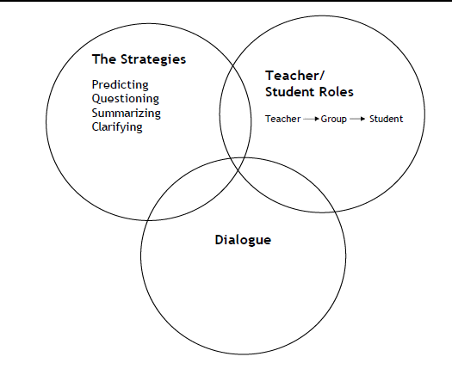
The representations of Reciprocal Teaching included three intersecting circles. To understand Reciprocal Teaching is not only understood the strategies, but also the role that dialogue played in Reciprocal Teaching.

- The Advantage of Reciprocal Teaching
Research from Palincsar and Brown over the last five years has established a strong basis for reciprocal teaching. In several studies, students involved in a reciprocal reading activity scored higher on reading comprehension tests than students in a control group not using this teaching strategy. A strong research base for an instructional strategy helps validate its effectiveness and use in the classroom.
2.7.1 The Cognitive Advantage
In the studies conducted by the researchers, students using reciprocal teaching improved their summaries with practice and worked more independently than the students not using this teaching strategy. Additionally, the reciprocal teaching classes saw fewer disruptive student behaviors, possibly because the students were more cognitively engaged in the material.
2.7.2 The Advantage of Communication and Collaboration
Reciprocal teaching has also been shown to help students develop interpersonal communication skills since they have to interact with other students and the teacher. Since students team and help each other, this teaching strategy involves students helping and teaching other students. This is thought to boost student self-efficacy and self-esteem.

