AN ANALYSIS OF STUDENTS’ ERROR IN USING COMPARATIVE AND SUPERLATIVE DEGREE

A PAPER

Submitted to the English Education Program of STKIP Garut
as a Partial Fulfilment of the Requirements
for the Sarjana Pendidikan Degree

By
IRA ASMARA
NIM: 08221169

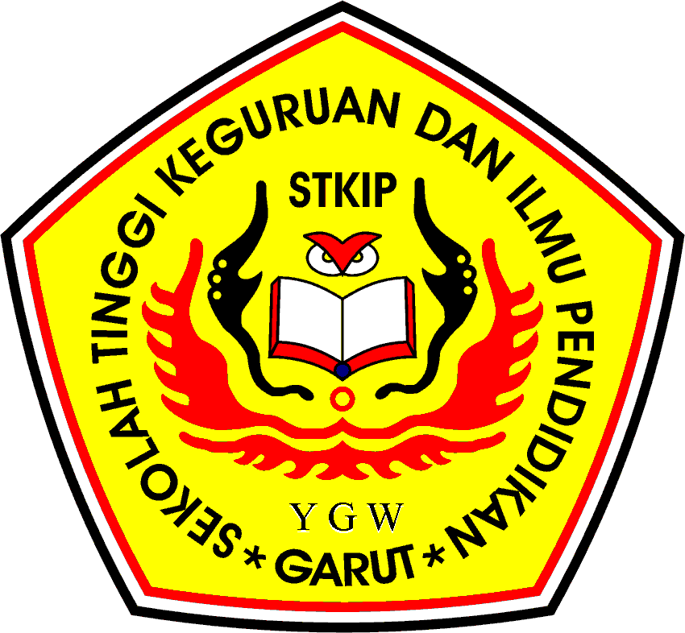

ENGLISH EDUCATION PROGRAM
SEKOLAH TINGGI KEGURUAN DAN ILMU PENDIDIKAN
(STKIP) GARUT
2012

